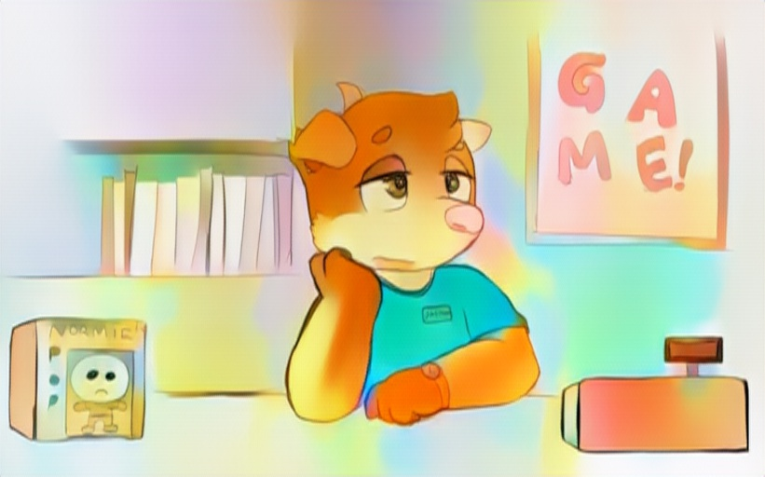
Wednesday. There was a reason that people called it “hump day”, and it certainly didn’t have any relation to the more exciting definition of the word “hump”. Jason sighed a slight bit, listening to the hum of the store air conditioning and the title-screen music that had been looping since he clocked in a few hours, unbroken save for two truant kids coming in to waste some of their school-time on the demo unit.
The shepherd mix glanced down at his watch, nostrils twitching just a slight bit as he read off the digits. 3:45. A strange furrow brushed across the male’s brow, and he looked towards the shop’s door—just in time for the bell upon its corner to jingle, and for a young cat to walk inside, backpack on and tee-shirt lightly stained with a bit of sweat from the heat outdoors.
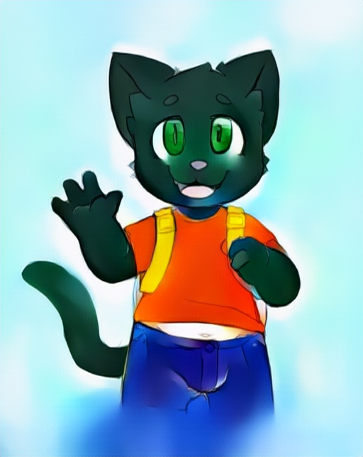
“You’re a bit late, ain’t ya, Tommy?” that dog uttered—just a little humor in his voice and a slight grin on his face. The kid was a little bit of a “regular” to that Mom ‘n Pop game-shop—though he could barely manage to buy a game maybe once in a blue moon. That much would’ve been obvious just looking at the boy; his clothes, while clean, looked a bit worn from being handed down from his older siblings, and his backpack even had the wrong name written on it in sharpie.
“Mister Gladstone held us late since we were talkin’ while he was handing out summer homework…” the boy muttered—obviously a bit sore with his teacher. He slid that backpack off and dropped it on the ground by the demo machine, taking hold of the controller and finally interrupting that loop of music that had tittered away within the shepherd’s ears for too long.
“Uh-huh. And you’re gonna do your homework this time, right, instead of spendin’ all summer on our demo-unit, right?” Jason replied, perhaps a bit too dryly. The kitten’s ears flicked and bristled, the inside of them turning a little darker pink.
“Hmph! I’ll do it!” he said, pink nose twitching just a slight bit, eyes gluing towards that screen. He craned his head backwards—the TV was at a moderately awkward angle to prevent kids from loitering too long, after all—and started to play. The black cat’s tail twitched and swayed from side to side, one of the few signs of enjoyment the kid made while playing with the demo-game—even if it was only limited to just a few levels.
Jason leaned back over the counter, resting his chin in his palm-pad, lazily looking at the cat as he played. It wouldn’t be too terribly long before the feline got bored of that game as well, and practically beg him to put in a new demo—after all, it had been almost three or four days since Tommy had started grinding a few hours a day on it. The kitten was pretty decent, too—though that much could be said for anyone who repeated the same levels over and over again.
“Aah—darn!” the boy suddenly uttered, and Jason flicked his eyes up from the kid towards the screen; a red GAME OVER hovering in the center. “Hff, not fair,” the kid mumbled, rolling his head to the left and right, stretching strained neck. “Jay, are there any new guides I can read?” he finally asked, returning the controller back to its hanger.
“Done already?” Jason started, before looking at his watch again. How on Earth had he spent half an hour staring at the cat without even realizing it? “Ah, well, uh,” the dog cleared his throat. “I guess I can ‘find’ an opened copy that someone returned,” the shepherd said, walking around that counter and plucking a strategy guide from the shelf. A claw flicked out and tore into the shrink-wrap sealing the book, with Jason peeling it the rest of the way down. “Y’know the rules, don’t bend the pages or the spine or I’ll have to kick you out ‘til you can pay for it,” the canine uttered.
For the poor cat, it’d be a terrible punishment—after all, the game store was pretty much the only one he could be in for so long that had air conditioning and a nice enough guy to talk to! Tommy took hold of the book with care, and padded off to a somewhat secluded corner to flick through the pages—far enough out of the way that any new customer would barely notice him peeking through merchandise.
That strategy guide bought the boy’s silence for nearly an hour—though the store was still alive with the hum of the AC and demo-unit in tandem. Other than that, however, not a single customer more had come, and closing time was rapidly approaching. It was hard to justify long hours on a weekday—especially with the chain store at the mall just a few miles away was sapping at their customers. The fact that they got any at all was probably just due to the fact that the shop was only a few blocks away from the middle and elementary schools.
The dog grasped hold of Tommy’s backpack, his fingers gripping around the semi-tattered strap with “Jack” written blockily on it as he brought it over to the kid’s little hidden corner. The boy was captivated by the book—a good thirty or forty pages into the dense thing.
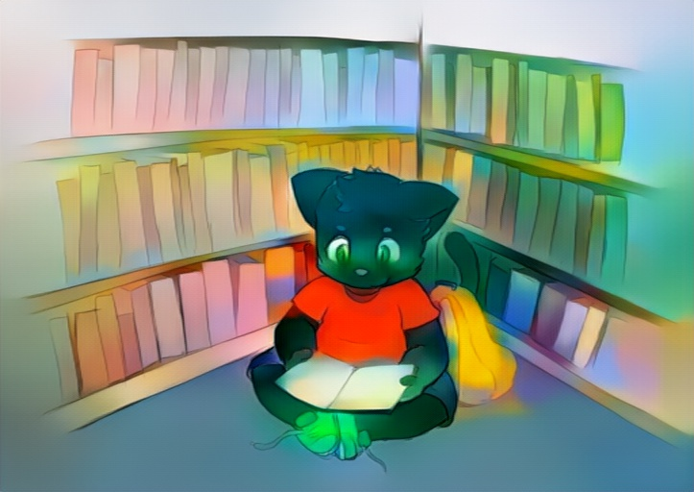
“Oh? Looks like you’re enjoying the read, huh?” Jason said, setting that backpack down, and taking a cross-legged seat across from the young boy.
“Uh-huh! It looks super fun!” the kid said, looking up and beaming a wide smile. “It’s my birthday tomorrow, so I hope I can convince Mom to get it for me… but it’s rated M and she says that’s too violent…” Tommy continued, voice lowering just a little. “She won’t even let me get teen games—and I’m almost twelve!” he added with a little louder huff.
“Well, they got rules like that for a reason, I guess,” Jason replied, reaching a hand up to ruffle the kid’s head, right between pointed kitten-ears. That black pelt was silky soft against his palm—utterly smooth. “Anyway kiddo, it’s about closing time. I’m gonna need the guide back so I can reseal it up and put it back on the shelf,” the dog said.
“Can… um… can you just keep it behind the counter for tomorrow? I wanna finish it, if I can,” the kid said with a hopeful look in his yellow-green eyes.
“Hmm… well, I guess, since it’s your birthday…”
“Alright! Thanks Jay!”
Tommy let that guide close in his hands and crawled forward, giving the adult a hug. The dog could feel that young heart beating quickly away underneath the thin tee, the kitten’s body warm to the touch and light. He could practically sweep the boy right off his feet, despite the slight pudge to his belly.
“Heh… not a problem, kiddo,” the dog uttered, his hand patting the cat on the back. That hug lingered for a moment longer, and Jason swallowed a little bit of spit in his throat. It was certainly a precarious position, hugging a preteen kid in a back-corner of the store where the cameras (or more realistically, camera) didn’t reach. An urge bubbled up from inside Jason’s body—something he had thought he squashed away long ago. “Erm… you don’t gotta hug me that long, though…” he said—trying to keep his mind off of a slight bit of stirring in his loins.
“Oh… sorry,” Tommy muttered, finally breaking his squeezing hug. “I’m just… umm… I’m just glad I get to spend my birthday here, since Mom’s gonna be busy all night,” he said. Jason didn’t pry into ‘what about Dad’—though not for lack of thinking of it. His left hand had dropped (semi)-subtly to his groin, hiding himself with a forearm while right and dominant paw stroked the kid’s ears.
“You put it like that, and I might just have to bring in a few cupcakes for my lunch… and maybe leave one left over,” the dog said, baring his teeth in a wide smile. “But…” he said, glancing again at his wrist. “It’s closin’ time, and you better get home, right?” said he, finally standing up, strategy guide in hand. Tommy’s eyes were locked with his own—and Jason could swear he saw a little bit of moisture at their edges.
“Yeah… I’ll see ya tomorrow Jay!” the cat said, scooping up his backpack in a quick motion, and making for the door. As the boy darted down the aisle, Jason felt his eyes lock themselves upon the kid’s slightly curvy rear with a budding guilt growing in his gut. He later left that store with the shameful scent of musk on his hands.

Thursday arrived, though Jason felt no different than he had on Wednesday. Once more it was a tepid and eventless morning—save from a quick trip to the employee bathroom to spray out the lingering scent of masculinity within it. With that task done, and the impossible task of trying to forget just what it was he had pleasured himself to, the dog waited again for that fateful hour, uncomfortably standing behind that counter whenever customer popped in to pre-order a game or trade in a purchase. For once, Jason was thankful for the lack of business—even if it meant that eventually his comfortable 9 to 5 gig would be downsized to a 12 to 5 or even less.
The bell on that door jingled, and Jason looked towards it—catching sight of a smiling cat-kid, who happily trotted up to the counter, not even tall enough to look over the stomach-high thing. With beaming grin, Tommy dropped his backpack down to his feet and pulled a nylon wallet out from a pocket.
“Look Jay! Mom gave me twenty five dollars! I could get a good game with that, right?” he said, that feline tail wagging back and forth almost like a dog’s would, and the thought of it twitching sent a knot into Jason’s throat.
“Mmn—yeah, I’m sure we’ve got a good used game for that price around… though y’know I can’t sell you any teen or mature games without your Mom here,” the dog said. Of course, selling those games wouldn’t’ve been as much of a crime as the other things that were swirling around in his mind. “Ah, but before you go searchin’ around…” Jason began, reaching under the counter. “I just happened to have an extra cupcake from my lunch… so, seeing as it’s your birthday, you should have it,” the canine said.
After the deed he had done last night, offering the boy a cupcake seemed… well, wrong. Very wrong. Groomingly wrong. But the kid, innocent as can be, accepted the pastry with an even wider smile.
“Wow! Thanks!”
And like that, the frosted treat was gone in a flash—the only remnants being a few crumbs on counter and carpet—and a lick of vanilla frosting over the boy’s lips. Jason’s heart thumped harder as the kid licked fingers and muzzle clean before darting off to the games. How could he not start noticing the way the kid’s body looked with that ill-fitting shirt occasionally showing off midriff, and oversized shorts that were practically a tug away from dropping to the floor.
“Fuck… c’mon Jason, the kid’s got enough problems without you lustin’ after him…” the canine muttered to himself, trying to get back to reality. His eyes watched that twitch and swish of tail—practically the only thing he could see of the boy hidden behind a game-packed shelf (and probably a blessing).
It didn’t take long for the kid to find a game that he could afford… after all, the boy practically knew the shop’s stock as well as Jason did from how often he browsed through it, waiting for a new demo to be installed. He came to the front with just a little nervous look in his eye and set the game upon the counter.
“Uhm… I know it’s rated T… but I’m twelve now, isn’t that close enough?” the kid asked, giving those eyes the dog again—pretty, wide and begging eyes that hit Jason in the heart almost as much as they hit him in the groin. The shepherd was thankful for his darker fur—otherwise the hot flush on his face would’ve embarrassed (and incriminated) him quicker than a blue hedgehog.
“Ngh, well, y’know the rules,” Jason started to say, finding them sticking in his throat. A devil on his shoulder urged him otherwise.
“C’mon, it’s the boy’s birthday and ain’t no-one gonna find out. Look at those cute eyes and tell him no,” the devil purred temptingly. The dog glanced to his other shoulder, but it was empty. “That guy’s been gone for a long time, remember? And after what you did last night… well, he ain’t coming back any time soon,” uttered his Id.
“The rules… uhh…” continued the canine, his throat feeling dry and parched. A brief thought had passed through his mind at the devil’s reminder, a dirty, deviant thought that made the fur on his neck stiffen up just a little. “…I mean… there’s nothing stopping me from buying it and trading it to you,” Jason uttered, dabbing his lips wet with a quick swish of tongue across them. Tommy beamed even wider.
“Oh, thanks Jay! You’re the best!” he said, dropping the wad of ones and fives onto the counter. Jason pushed them back towards the boy.
“No, no… I can’t have you pay me for it like that,” Jason said, feeling as if the devil on his shoulder—who had long since disappeared with a little cackle once the canine’s mind had been made up—had taken control over his body. “I’ve got a different kinda trade in mind,” he continued, lifting the hatch on that counter and inviting the cub onto the cashier’s side.
That innocent kid swapped over to the other side without any coaxing—after all, he was a little curious as to what the counter looked like from behind! It was… well, pretty boring, not that the kid had any references in mind. After all, it was just a bunch of filing cabinets with the actual games locked up, and the back of those display-shelves underneath the cash register.
“Whatcha got in min—mff!” the boy began, only to be interrupted by a hand brushing between the ears and pulling him face-forwards to the canine’s groin. His sensitive nose picked up a familiar scent—something that his Mom had come home smelling of in the early, early morning, usually with another guy on her arm. His eyes squeezed shut for a moment, body reacting to the pheromones of musk in a way that his tender mind couldn’t. “J-jay…?” he asked, nose somewhat squished to a zipper and pants-button, muzzle rubbing against something firm beneath the cloth.
“Shhh… you want that game, don’t you?” the dog rumbled—his voice sounding just a slight bit deeper… though that could’ve been the close proximity that cat-kid’s head was to the canine’s stomach.
“Y-yeah but…”
“The game and your birthday money?”
The kitten remained quiet for a few breaths, taking in more and more of the canine’s scent. It didn’t seem as foreign and strange as it had just a few moments ago—and that heat from the dog’s groin was almost a little comforting as it made that black-furred face flush slightly.
“I want it…” he finally muttered softly, eyes looking down and to the side—almost embarrassed to make contact with Jason’s own. He winced as a hand patted onto his head again, rubbing the silky fur behind his ears, fingers running right along the back of his skull.
“That’s good,” Jason uttered—a small growl curling up in the back of his throat that he squashed. “Just do a few things for me and I’ll give you the game,” the canine coerced, eyes flicking towards the store door. No one was lurking around outside—hell, even the parking lot was empty. “If someone comes in, just keep quiet. I can’t give you that game if you get caught behind the counter,” he said. Of course, the boy being behind the counter was hardly the problem.
“O-okay,” the cat said, stumbling over his words. He was nervous, of course—not knowing quite what the canine had planned, though that twelve year-old had just taken the school’s first sex-ed course. Each breath that Tommy took in seemed to befuddle his mind further, making his young body tingle down the back of his neck and along his loins in a particular, special way.
Jason dropped a palm down from the counter, brushing it along the side of Tommy’s short snout. He pushed the kitten’s face away by just a few inches, hooking thumb to button and flicking open his fly—that zipper soon dropping to follow. The warm scent of that canine’s malehood grew stronger, of course, and Tommy’s knees bumped together as he took in that aroma.
“Nn… nhh…” he vocalized—quiet little mewls as the inside of his ears burned with a flush pinkish-red. That fly-opening thumb snagged the waistline of Jason’s underwear next, tugging them downwards and out flicked a sturdy, uncut shaft, smushing along the smooth and soft fur of that kitten’s face, dabbling a little precum onto the fluff.
“Ghff… damn…” Jason groaned, feeling that silk-like touch of the boy’s face along his shaft, and slowly dragging his hips backwards, grinding that malehood along the cub’s cheek until it poked at Tommy’s lips. “Open up… careful with the teeth,” that canine instructed, bringing both hands to the side of that cat’s head, fingers stroking along the back of Tommy’s jaw. He gazed down at that cute little face with his cock twitching right at lips—a bead of precum dabbled upon the cat’s muzzle.
Tommy hesitated for just a brief moment as that thick cockhead pushed up against his maw. It had a deep scent on it that couldn’t really compare to what he had been smelling on the outside of the dog’s pants and underwear—and the closest he could compare it to was one kiss on the forehead his mom had given him after work. The cat shut his eyes, opening his mouth as instructed and took the hooded tip of that member into his maw, slowly suckling it further inside. He rolled his lips over teeth—that seemed right, as Jason gave an encouraging stroke behind his ear—and dipped a little further down towards the canine’s base—still several inches from taking that prick in deep.
As maw slid down bit-by-bit over that shaft, the dog’s foreskin peeled backwards from his cockhead, drooling a more copious splash of precum across Tommy’s tongue. The flavor tingled and soaked onto the boy’s tastebuds—certainly a lot stronger than his usual microwaved meals at home, and the cat winced a bit as he swallowed down the first splurt of pre.
Black paws placed themselves on Jason’s thighs, trying to hold onto something—grasping hold of a bundle of pants-fabric to steady himself with. The ridge of that cockhead slipped past his lips and teeth, rubbing along the roof of his muzzle, and Tommy swallowed down again, feeling that prick twitch a little closer to the back of his throat.
“Nnhh… fuck that’s…” Jason groaned—before tsking in the air. “Shit… just keep quiet and don’t move,” he said, right as the bell chimed from that front door. Asking Tommy to keep silent and still seemed like a fairly difficult task… especially as that dog turned his hips against the counter and leaned forward, his belly brushing atop the boy’s head and blocking the lights above—all while pinning the cat between groin and counter.
Off-balance, Tommy grasped firmer hold of the canine’s thighs, reaching further around and gripping the back—which only sank that prick a half-inch deeper into his throat. His ears flushed red and eyes burned, watering a little as he felt that strain in his jaw inch a little deeper and start to ache. That pink nose puffed and huffed against the older male’s groin—thankfully drowned out by the sound of that store’s HVAC unit whirring on.
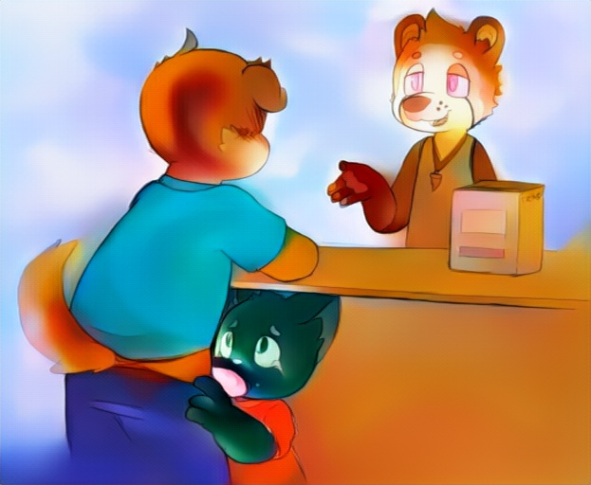
Precum steadily built up in the back of his throat, the cat’s grip on the canine’s pants tightening just a little as he felt that breathing space shrink down bit by bit. Who knew how long he was holding his breath for!? His ears strained to hear what Jason and that customer were talking about, flicking just barely under the hem of the dog’s shirt, but it was hard to hear with the increasing thump-thump-thump of his heartbeat pounding in his head. Tommy’s reddened face darkened to a purplish tint—starting to become bluer and bluer before the store’s bell rang again, and Jason pulled his hips back with a wet, sloppy pop.
Spit and precum strung from lips to that hooded shaft, the boy taking in a few deep breaths to replenish the air in his burning lungs. He coughed a bit, dick prodding against his cheek, leaving a little glazing of preseed upon it. A broad, adult-sized paw pressed atop and between the cub’s ears, stroking just a slight bit, pulling that face in against groin once more.
“Phew… sorry about that, buddy… good thing he only wanted a gift-card, huh?” Jason said with a little smile. Broad, canid tongue swept over his lips as he gazed down his belly at the puffing cat-kid. Tommy had a little frown on his face—perhaps from being choked for so long by the adult’s dick, and he pushed his head slightly to the side, away from the dribbling tip of that canine’s shaft. “How about… we do somethin’ a little different, hm? I’ll even throw in the strategy guide you were readin’, too,” the cashier said, hoping to sweeten the deal a bit for the soured kitten.
“Like what…?” the boy muttered in reply, his breathing slowly evening out, and that slick spit and preseed on his facial-fur wiped off on the boy’s sleeves. His voice sounded a little hoarse, sore from the fat cockhead that had managed to stretch right down into his neck, and there were still a few little remnants of tear-stains at the corners of his eyes.
“Somethin’ a little like… this!” Jason began, scooping his hands under the boy’s shoulders and hefting him upwards a bit. He lifted and turned the cat to face away from himself, resting the cub’s front onto the counter, while settling his hips up against the boy’s backside, giving the shorts-wearing just enough leverage to keep from sliding off of the countertop. A hand freely cupped and groped that kitten’s chubby rear, flicking undone the strap over the boy’s tail and dropping the back of those pants just enough to frame under Tommy’s cheeks, exposing the boy’s underwear.
“Nngh! W-wait!” the kitten squeaked out, feeling thumb slide along his clothed crack, finally reaching the waistband of his undies and yanking them down as well, leaving his rump exposed… until a firm prick nudged up between fuzzy cheeks, hot-dogging under black tail. Tommy squeezed his eyes shut, feeling the slick heat of that prick nudge against his pucker, kissing and drooling a little precum upon that virgin entrance.
“M-ma said that… doin’ stuff there is extra…” Tommy mumbled out—not quite wanting to recall that memory in particular. He felt the adult shift and press a little firmer against that taut pucker, wincing as the tip of that uncut malehood started to nudge into that barely slickened tunnel.
“A game, a guide, a cupcake… and you’re wantin’ more?” Jason rumbled—sounding half-chiding, but half-humored. “Well, I suppose I could toss in another used game… but you gotta promise you won’t tell anyone, right?”
“Mm!” the kid replied, with an affirmative nod. Jason’s eyes flicked towards the shop door and then back down, one hand scooping underneath Tommy’s belly, lifting that rear up a little higher as he aligned with the boy’s entrance. That kid had a nice, warm body to grind up against… it made his tail wag and swish a little quicker as his bare member kissed that pucker intimately, precum leaking into those untouched walls.
“Good. Try not to tense up, then…” the adult rumbled back, pressing forward with his hips, pinning the cat-kid up against the counter as his glans pressed inwards and past that puckered rim, making Tommy mewl out loudly. Jason wasn’t particularly small—a fact evident by the way that dick had stretched out his throat just a few minutes before.
“Aa… aahhnn…!” that kitten vocalized, eyes squeezed shut again. He tried to follow Jay’s advice and not clench… but it was hard! There was only a thin layer of spit and precum over that shaft as it intruded into his passage, deflowering his hole with a slow and steady grind inwards. “Hhnnee…!” he finally groaned out when Jason’s groin smushed up against the underside of his tail, and that steady plunge inward seemed to stop.
“There we go… just relax a little and get used to it…” Jason said with a soft tone, his free hand rubbing at the cat’s ear-base, running dull claws against their root. A few little sniffles and kitten-mewls were his response—that pucker clenching down around the base of that canid shaft with even the slightest of movements from the older male—especially with how often Tommy had to be pushed back up onto the counter after sliding back.
“Nnghh… it’s hot, Jay…” Tommy grunted, managing to spit out the words through clenched teeth. His silky-smooth tail twitched and flicked at the tip, feeling each throb of the dog’s heartbeat through that shaft, and the slow, steady drooling of precum into inner walls. It sent a slick pressure up his spine—a pressure that only grew once Jason rolled hips backwards a few inches and bumped against that rear again, pushing the kitten back over the counter proper.
That steady push against prostate and the warmth of the dog’s belly against his back sent strange feelings through the cub’s body—his toes splaying and curling within shoes, and a bizarre tingling in his loins tented out the front of his shorts. With eyes closed and jaw clenched, that sensation of discomfort gradually faded away as the dog rolled back and forth into rear. That ached hurt waned into a small bit of pleasure—and Jason’s steady pace made those waves of spine-tingling relief easier and easier to predict and push back into.
“Hff… hff… fuck…” the canine uttered, licking over his lips again, eager to blow his load inside that kid. It was a feeling that the adult hadn’t expected to feel again since… well, since he had moved to town and promised himself he’d refrain from doing the same exact thing he did last time! Sure, the boy last time was a calico who was coerced by sharing some dirty magazines at the playground… but was this any better? The dog swallowed his doubts, his hips starting to rock and bump a little faster against Tommy’s own.
“Hhnn! Aahh… aahh… oohh…!” the kitten moaned—finally past that point of discomfort and into the steady heat of pleasure surging through his small, young body. A leg kicked, that tail tensed up tight as he let out another squeak of pleasure, and that rim clenched down tightly over the dog’s shaft, practically milking it with rhythmic, steady pulses around its base. From the boy’s mouth, a mumbled mess of words and moaning left—undoubtedly the boy’s first orgasm… with just a small few sputters of preteen seed into his underwear, adding a damp spot to the front of his shorts.
Jason didn’t need a devil on his shoulder to tell him that he had gone much further than the point of no return. His hips pressed in firmly against the boy’s rear as that kid came, feeling those clenching, steady contractions around his shaft pulling him in just a little deeper. A deep barking grunt left his lips as his nuts pulled in close and released the first jet of spunk into Tommy’s body—a sullying, defiling spatter of pedophile lust.
Second, third, and fourth soon followed—each pushing that first load in deeper, until the boy’s belly bumped out just a slight bit from the sheer amount of seed spilt inside. Cum leaked out from the seal of that cherry-popped rim around the dog’s length, dribbling across the dog’s lap and drooling down between the boy’s thighs. There was a rich, deep scent of sex in the store’s air, circulating through the entire shop.
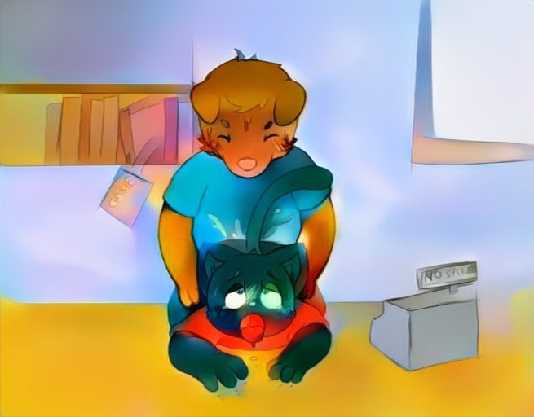
“Nnghh… I get the games now… right Jay?” the boy said, slowly coming down from his orgasmic high—just about at the same time the older male slid backwards slow and steadily, dick popping loudly as it slipped free from Tommy’s entrance. Cum dripped onto the tile floor below once Jason had slid the kid back off of the counter, a sticky mess webbing under tail and between the cheeks of that boy.
“Yeah… yeah kid…” Jason muttered, a heavy sigh leaving his lips. He tucked away himself back into underwear, and helped Tommy reaffix that strap over his tail, though there was a light stain of seed soaking through the cub’s underwear and shorts alike. “Remember… it’s our secret, right?” the cashier said, knelt down on a knee, looking the cat in the eyes.
“Yeah, our secret!” Tommy beamed back—though, of course, he didn’t know much better. That tail’s underside was starting to throb a bit sorely… though the slick squish of seed against rim seemed to help just barely with the kitten’s management of that ache.
“Heh, good kid. We can do it again if you want another game… but maybe only once a month, okay?” Jason said with a little smile—rubbing the boy between the ears, before sliding the game and guide into a bag. “You can pick out the other one tomorrow, I gotta close early and air out the place,” that dog said.
“Awe, really…?” the boy whined, giving a pair of wide, sad eyes to the canine.
“Really, really! Don’t worry, I’ll be here tomorrow, pinkie-promise.”
Jason held out his hand, pinkie extended. The kitten curled his own little-finger around it, giving the two a little shake.
“Okay… bye-bye Jay…!” Tommy finally said, slipping back through to customer territory and slinging his backpack over shoulder.
As the boy left, the dog flicked his eyes up towards the security camera pointing down at the counter. “And I’ve gotta take care of that video, too… maybe save it someplace special,” he muttered under his breath.

