Test Day
By Seraph LeSabre
For Gavin

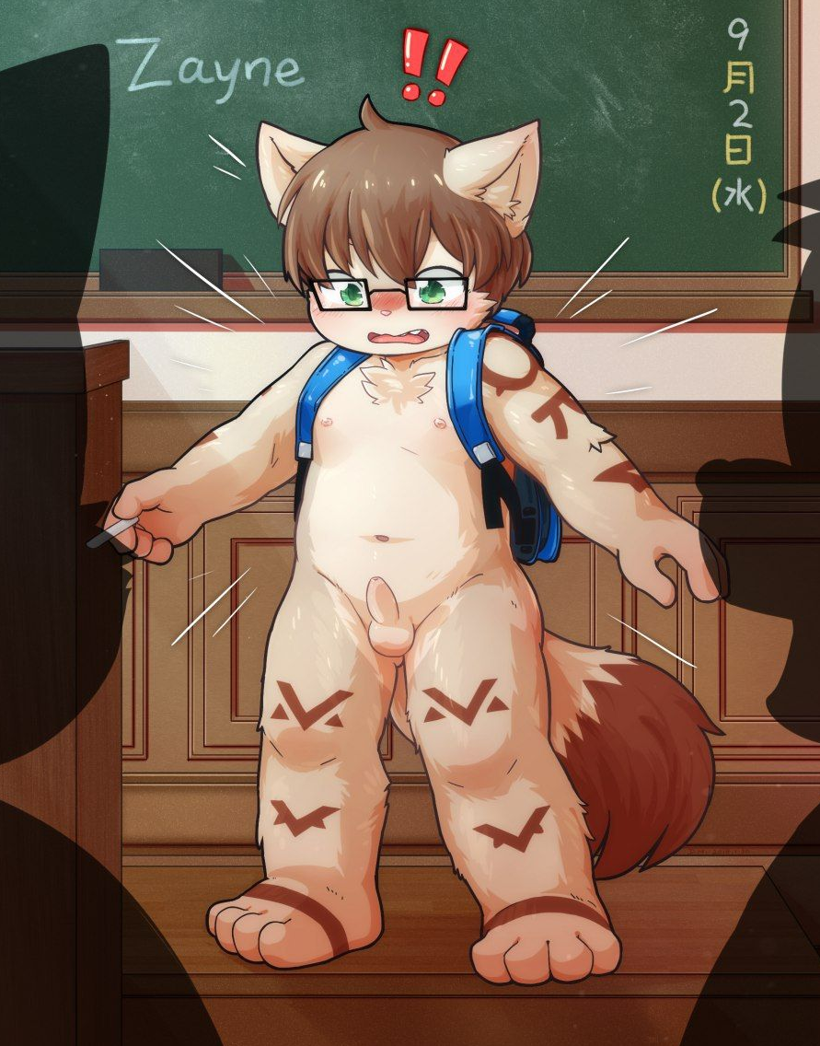

Stumbling out of his house, Gavin frantically began rushing to school. He'd stayed up all night playing the new Pokemon, and managed to sleep through his alarm clock again, and had to make a mad dash to make it there before his 6th period History class. Normally he would have just made some excuse to stay in bed, but today was an exam worth 20% of his final grade! There was no way he was going to risk taking that penalty when his grade was already teetering as it was.

The fox-chipmunk hybrid clutched his phone as he ran, checking the time. Only 20 minutes before the bell rang, he'd have to hurry! He didn’t have time to go to the bathroom before he rushed out of the house, but that was hardly a priority. What's worse, the school's truant officer could be lurking around any corner just waiting to bust any kids not at school. With how old Officer Landa was, and the unabated glee he seemed to take in ruining the days of kids for the pettiest reasons possible, Gavin was sure he was secretly a Nazi officer who had somehow escaped trial at Nuremberg.

He turned the last corner and saw the school building, thank goodness. He checked his phone, only five minutes to spare. Luckily for him there was a nice cool breeze that seemed to wash over his fur as he ran – last thing he was going to want was to be a sweaty mess when he got into class, right? He ran up to the building, ignoring the people watching him as he sprinted now, bursting through the doors and rushing to the stairs. The first bell rang… shit, he was just barely going to make it at this rate! He ran up the stairs past a small crowd of stunned students, rushing down towards the open classroom door at the end of the hallway.

At the last possible second before the second bell rang, Gavin skidded into his classroom and immediately breathed a sigh of relief. He was a little chubby around the middle, so having to run like that was hardly something he relished. It had to be pretty comical to watch too, he figured as he unslung his backpack and sat down at his desk, that must be why everyone seems to be staring and snickering. Whatever though, he was at his desk with his test in front of him, and he was going to crush it without any distractions.

As he caught his breath and started to fill in bubbles on the test sheet, he could feel everyone else’s eyes on him. The chipmunk’s little ears flicked as he heard stifled giggles from the other kids around him… but what was so funny? He couldn’t have looked THAT silly running through the halls in a panic. Was his hair a mess? He’d only had time to quickly run his fingers through it to straighten it out. Was it something off with his clothes…. He felt his blood turn to ice as he slowly looked down to see his bare chestfur, and even lower, his completely exposed….

“Oh my god, did he really come to school like this?”

“How do you just not put on clothes in the morning?”

“This isn’t even the first time. I bet he’s doing it on purpose like some little pervert.”

No, no, no, no, Gavin thought to himself, this couldn’t be happening. In his frantic rush to make it to class on time, he had completely forgotten to get dressed, and he now found himself right in the middle of his classroom with everyone staring right at him. He immediately reached to grab his brown vulpine tail, pulling it over his lap, which just made everyone laugh and point harder.

“Like that’s gonna do any good now that we’ve all seen it!”

“Guuuuuuys,” Gavin whined, his ears folding back in shame as he shakily picked up his pencil to try and work on his test, “C’mon, it was an accident! I was late, and I just forgot!”

As Gavin shook in his desk, his teacher began to approach, arms crossed over his chest as he looked down at the ‘munk in disapproval. The red panda gave an exasperated sigh as he scribbled down a detention slip for the teen, just shaking his head in disbelief.

“Gavin, I’ll be expecting you to stay late so we can discuss this… little indiscretion of yours,” Mr. Frazier scolded before turning his attention back to the rest of the class, “The rest of you, back to work. If you don’t finish in time, I won’t be allowing any extra credit.”

The laughter died down to a dull murmur as the other kids found themselves more concerned with their grades than the naked teen. Gavin still shook in his seat as he tried to focus on the exam, suddenly having a lot of trouble remembering if it was Claus von Stauffenberg or Rudol von Stroheim who tried to kill Hitler by shining ultraviolet lights on him… no, wait, that wasn’t it either! It was no use, Gavin could still hear the snickers surrounding him as he sat there in just his soft brown fur. He could hardly think straight, and by the time he noticed the fur in his lap start to grow wet and warm, it was already too late.

“Hey, do you hear something?”

Gavin dropped his head into his desk in shame as he felt his bladder release. He had completely forgotten all about it, and now he couldn't stop himself as the flow spread throughout his tail and his lap. He quivered in his seat, unable to bring himself to get up. Mr. Frazier snuffed the air and looked up, his eyes widening as he saw the golden puddle start to form on the white tile beneath the chipmunk. He took his glasses off to run his temples, now wanting to make sure he wasn’t about to encourage this behavior with leniency.

“Well don't even think about getting up out of that chair until you've finished your exam!” he announced as the other students started to move their backpacks and scoot their desks away, now erupting once again in uproarious laughter.

Gavin whimpered to himself as he clutched his pencil, trying to write and just scribbling random gibberish on the paper. It couldn’t have been bad enough that he was naked in the middle of his class, now he’d peed himself all over his crotch and his tail. He just wanted to melt away and run out of the room, but what would that accomplish? If he did that, then everyone who happened to be in the hall would see him, and he’d just be exposing himself to that many more people on the way. Mr. Frazier just gave a defeated sigh and produced a roll of paper towels from his desk, tearing several off and walking over to Gavin’s desk, kneeling down and delicately starting to wipe away some of the urine without actually getting on his own paws.

“Alright, this has gone far enough,” he groaned, “Get up and stand in the corner for the rest of class. You’ll finish your test in detention.”

The teacher gave Gavin a few paper towels for his own fur – yeah, like that was going to do much good at this point – and sent him off to the corner. Gavin shuffled over to the corner with his paws over his sheath, ears folded back flat. As he walked he patted his fur dry as best as he could, but it was only enough to keep from dripping everywhere as he walked. He stood with his face to the corner, shoulders slumped with his paws over his groin and his tail tucked between his legs, as he waited for the bell to finally ring.

After all the other students had gone home for the day, Gavin was allowed to sit back at his desk and work on his exam. While having the extra time to think about his answers in the corner would have been a boon for many students, Gavin’s mind had been such a jumbled mess there was no way he could possibly have taken advantage of it. He had to go back and erase some horribly wrong answers, but after thirty minutes, he finally finished.

With a paw still covering between his legs, the chipmunk approached his teacher’s desk and dropped off the paper with a relieved sigh. Mr. Frazier looked up at him, furrowing his brow and accepting the paper.

“I’m finished, Mr. Frazier.” Gavin meekly announced, “Can I go home now?”

“Not quite,” the teacher denied, taking out a red pen and shuffling the papers on his desk, “You’ve still got some work to be done. While I’m grading this you’ll be responsible for erasing the whiteboard.”

Gavin sighed and nodded – couldn’t be that easy, could it? – approaching the whiteboard. Luckily with today being an exam day, there wasn’t too terribly much scrawled out across it, so the munk was able to pick up an eraser and get to work. It wasn’t so bad at least – he’d been worried that he was going to have to write out “I will come to school fully clothed” a hundred times like in a cartoon sitcom.

As Gavin dragged the squeaky eraser along the whiteboard, he could feel Mr. Frazier's eyes on him. His fluffy tail swayed over his rear as he stood on his toes to reach higher on the board, making for quite the sight. The teen working hard completely nude for him… had Gavin been paying closer attention to his surroundings, he might have noticed the red panda's paw casually resting over the bulge in his slacks.

“Alright, Gavin, I think that's enough of that,” Mr. Frazier announced, standing and approaching the munk, “Besides, I think I've thought of a much better way to drive the lesson home.”

The teacher placed a paw on Gavin’s buttock, giving it a possessive squeeze and ushering him back toward his desk. Gavin finally noticed the tent in the front of Mr. Frazier’s pants and swallowed hard, knowing what was coming. The panda pushed him forward to brace himself against the front of that desk, pulling that tail aside to eye that soft rear presented before him. With a predatory grin, Mr. Frazier undid his belt and unzipped his pants, letting a thick pink length of meat spring out.

As his teacher smeared a glob of lube onto his length – why did a high school teacher even have that on hand, Gavin wondered – the munk braced himself in the desk in front of him. He saw his exam on top of a pile of papers, the first page already graded. It didn't look promising. His poor study habits were the least of his problems now though, as Mr. Frazier pushed the teen's cheeks apart and rubbed the tip of his cock against Gavin’s tailhole.

“Parading your ass around like that…” Mr. Frazier growled as he started to slowly sink himself past that tight little ring, “It’s a good thing there's nobody else to come interrupt us until the janitors start making their rounds. I'm so going to enjoy this.”

Gavin let out a squeak as the red panda's dick stretched his little pink hole. He squeezed his eyes shut and clenched his fists as his teacher filled his ass. It definitely hurt at first… but not for long, the munk was surprised to find. He didn't have long enough to consider whether that was necessarily a good or bad thing as Mr. Frazier started to slide halfway out and shove his hips forward again. The red panda growled and placed his paws on the teen's hips, pulling him backwards with every thrust.

“Sure hope you… unf… learn your lesson this time….”

While Gavin tried to adjust, he stood on his toes to lift his rear just a little higher for his teacher. As Mr. Frazier rammed forward, Gavin felt his own dick flopping between his legs and slapping against his balls with each thrust. He bit down on his lower lip and stifled a moan, feeling himself actually starting to get a bit hard as the pandacock roughly pressed against his prostate. The red panda could feel the teen tense up around him, and as he reached forward to give Gavin’s bits a squeeze, he gave a triumphant laugh.

“Well at least you’re getting into the lesson,” he laughed, his sac plapping against Gavin’s rear over and over, “But if you cum on my desk, I’ll make sure you have detention for the rest of the year.”

Gavin winced as he felt his bits were roughly fondled. He sure didn’t want to give in to his teacher taking advantage of him like this, but the little thread of precum that started dangling from his own cocktip was a sure sign it wasn’t up to his better judgement anymore. He let himself moan softly as the red panda humped into his student over and over until finally, with one last thrust, he buried himself deep inside the munk and started to fill his insides with thick cum. He growled and leaned forward on top of Gavin, giving the scruff of his neck a bite before finally collecting himself and pulling out with an audible schlorp, wiping himself off on the teen’s tail.

Feeling a wave of relief at finally being emptied (save for the warm sticky mess left inside him), Gavin leaned forward onto the desk and tried to catch his breath. His reprieve was interrupted, though, by a swift and firm slap to his ass, which seemed to echo throughout the empty classroom with a loud crack. Gavin yelped, biting his tongue from the surprise as he looked back to see Mr. Frazier flexing his wrist, winding up for another open-palmed slap.

“Wh-why?” Gavin whimpered, his knees shaking as he tried to keep himself in position.

“You know why,” Mr. Frazier sighed, bringing his paw back for another loud slap on the munk’s bare cheeks, “This is the fourth time this has happened in the last few months, and you’re clearly not learning. I told you last time, it would be five swats for each time you’d come to school naked before, so now you’re up to twenty.”

Gavin winced as he felt tears well up as Mr. Frazier delivered on his punishment, each slap resounding like the crack of a whip. The munk could feel his cheeks burning, though not nearly as bright red as his rear. Each one felt harder than the last, and by the time he counted out twenty in his head, Gavin was slumped over the desk with his glasses askew.

Finally satisfied with his punishment, Mr. Frazier helped the teen back to his feet and turned him around. Gavin’s length was still rock hard and dripping pre, much to the red panda’s annoyance. He sighed, figuring he’d already learned his lesson for the day, and used his finger to wipe away the string of fluid, holding it up to Gavin’s lips.

“Come now, the janitors will already have their work cut out for them, the least you can do is clean this.”

With a nod, Gavin stuck his tongue out and dragged it along the black-furred fingertip, slowly and deliberately cleaning it. Mr. Frazier patted him on the head after, tucking his bits back into his pants and zipping them back up.

“Alright now, I think detention’s about up. You can go home now, and I expect you to come back tomorrow with a spare change of clothes to keep in your locker.”

Gavin swallowed hard as his eyes widened. He’s forgotten about the walk home! Football practice would still be in full swing, with cheerleading practice right next to it! There was no way Gavin would be able to get home without having to run right past them, now not only naked but probably hobbling a bit with the sticky mess under his tail. And shit… Mr. Frazier didn’t let him touch himself, so now he was going to have an erection the whole time? Why did the day just keep getting worse?

“Well, what’re you waiting for?” Mr. Frazier’s face now had a knowing grin spread across it, as though he was thinking the exact same thing as Gavin, “Run along now.”

