July Patreon Reward: Shiuk
By Seraph LeSabre

The worst part about summer was not being able to use the privacy of the school’s pool.

The best part about summer was getting to show off at the public pool.

Alex confidently strolled into the changing room with Martin following close behind. It was a scorching hot day to the point where even air conditioning was just a suggestion. Sitting inside playing video games with a fan on may have been Martin’s first choice, but Alex had just bought a pair of matching blue speedos and was determined to find an excuse to show them off. Braving the hot sun long enough to walk the several blocks to the large public pool, the two finally made it inside the surprisingly-empty locker room and tossed their backpacks in a locker.

Martin wasted no time peeling off his shorts and shirt, the light brown rabbit looking down at his chest and the bright blue swimsuit Alex had picked out. He gingerly ran a paw over the fabric, feeling it far lighter and smoother than the racing suits they usually wore. As he unthinkingly traced the outline of his sheath through that tight, clinging spandex, his gaze slowly rose to find even more of the same shade of blue at eye-level. Shorts around his ankles, Alex gave a predatory grin down at Martin as he showed off just how much that swimsuit stretched.

“C’mon,” the sabertooth cat goaded Martin, “There’s nobody in here right now. You wouldn’t make me go out there hard in front of everyone, would you?”

The bunny gulped as the tented speedo just barely booped his nose. He suspected that being seen like that would have been perfectly acceptable for his friend, but as Martin eyed that growing bulge, curiosity got the better of him. He reached his paws up and, looking back and forth to make sure the coast was clear, carefully lowered Alex’s speedo
and let that pink cock spring free.

Alex gave a toothy grin – well, it was the only sort of grin the sabertooth COULD give – and held up his shirt. Martin’s heart pounded as he took his friend’s length in his paw, stroking it up and down as his ears twitched, trying to pick out any sound of other people around. Once he was absolutely convinced that the only sounds were coming from the splashing and cavorting outside, the bunny finally wrapped his lips around Alex’s warm, hard shaft. The taste hit him quickly, as Alex seemed to carry an even stronger musk than normal.

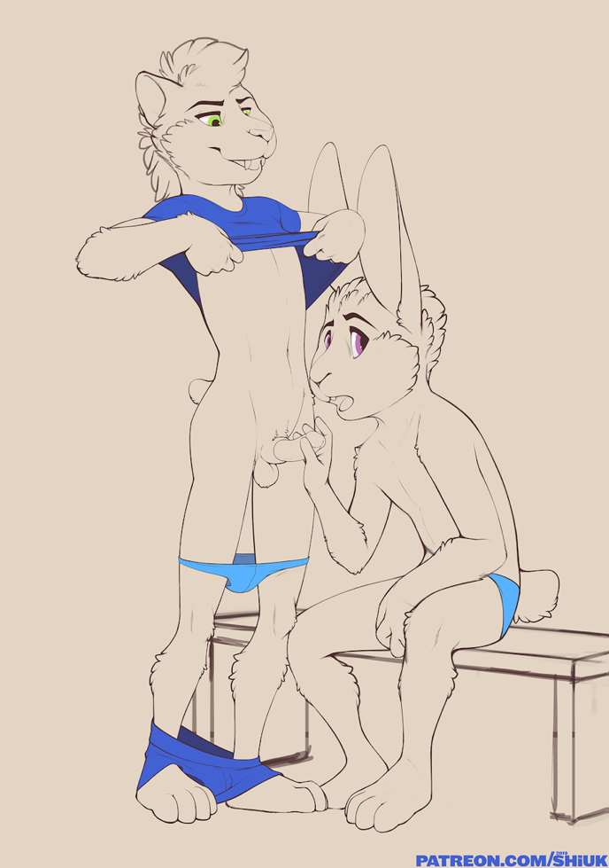
Immediately starting to purr as those lips locked around him, Alex sighed and moaned as Martin bobbed his head up and down. The bunny was quite skilled with his tongue, as ever, and Alex had spent most of the morning pawing himself right to the edge and then pulling back. Coupled with the extreme heat of the day, the cat was giving Martin’s senses quite the treat as the bunny’s nose reached his pubic fur. Indeed, as the bun lapped and suckled on his friend, he couldn’t help but rub at his own bulge through the tight swimsuit, teasing at himself until he was also starting to strain.

They wound up not having long, though. Right as Alex felt like he was close, his balls starting to draw up, the two heard the door to the locker room swing open, a loud group barging their way in. The two jolted, Alex pulling up his speedo just in time for Martin to draw his head away. The sabertooth was still rock hard and tenting under his swimsuit, but he grabbed both of their towels just in time to casually hold them in front of himself as four boys rounded the corner.

“Well, you ready to take a dip?” Alex casually asked, “It’s pretty hot even in here, I think it’ll be even nice out there!”

As Alex turned and flounced out the door, his rear bouncing under his docked tail, Martin slowly turned up to realize the predicament he was left in. With his sensitive ears he couldn’t help but pick up the other boys in the locker room snickering, as his hard cock was now jutting straight out in front of him, with Alex making off with both their towels.

“Well, guess that’s it,” Martin huffed as he stumbled clumsily toward the door, “Gonna have to think of some way to get him!”

