Central Indies:
In a world similar to our own there exists a region at the center of the world. This region is called the Central Indies, due to its position in the center of trade winds and currents it’s a region where all other countries and continents have had to travel through to get to each other. This has led the region to develop in unique ways.
Being around the equator and having weather that is consistent all year around leading to the name the region is also known by ‘the land of always summer’. Seeing as it’s weather is nice all year round it ensures that is a high tourist destination. The region also Filled with lots of untapped riches and wealth led to it having it’s final name. The Jewel of the ocean.

Central indies is split into three distinct set of islands. The Grand Antilles, made up of the larger islands consisting of the Twin islands Meles and Denes, The desert island of Sak Lajan and it’s servient Island Esklav, The Island of beauty Sinokara and finally the island of St Luz. These five make up the grand Antilles and are generally closer to the western countries.
The Middle Antilles are islands that a bit smaller than those before and have had more calm geography. It consists of the Islands of Guyba, Ikaua, Ibeyne, Nanka and Emikkann. These islands have been more tribal in times and have always lagged behind in development with the Grand Antilles.
Finally rounding out the Central indies is the tribal lands of the Lesser Antilles. These islands are small but numerous and besides the main island where a tribal council is based on the islands are home to twelve unique tribes. The tribes were once wiped out during colonization leaving only twelve left but to this day these tribes exist in these small lands that have held on to their many traditions.
This is the Central indies and these islands each have their own personality and cultures and unique history that leads them to have fun interactions. So care to find out how each island operates? Here is one such island.

St. Luz
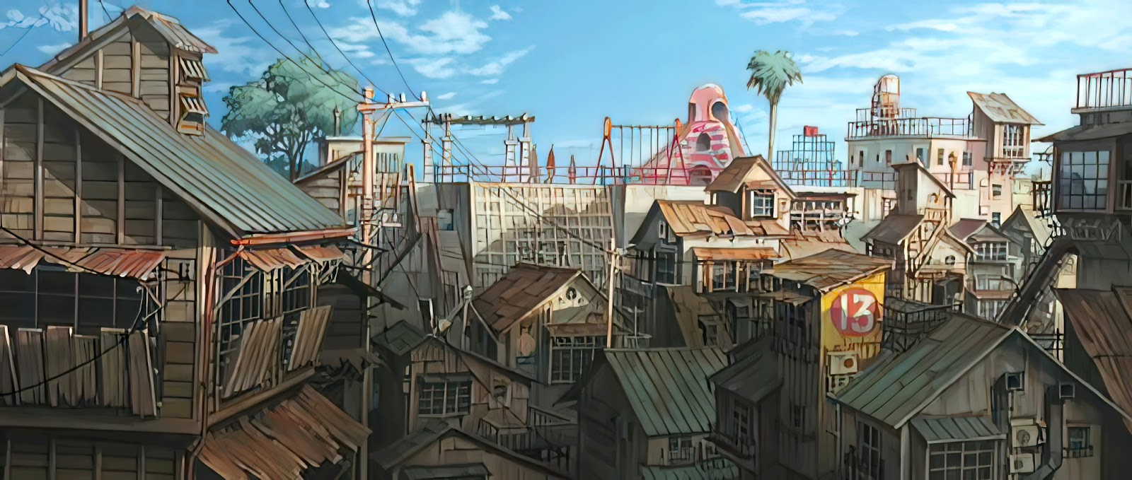
Size: 17,234 square miles
Geography: The Island St. Luz lies farthest to the east but ironically thus also the closest to the western part of the world. They aren’t that much richer than Meles or Denes but they’re also a lot more urbanized and in some cases too much for their own good. While some of what used to be dense jungle areas have been converted into farmland the rest of it is all urban and suburban settlements. While urbanization in itself may not be too bad overpopulation and terrible management has eventually led it to be a lot more polluted. The suburban area is decent living space but the cities are dense concrete jungles. Buildings everywhere, and where there aren’t, there are cramped makeshift living spaces made of scrap filling out the area, and within that city area the building living spaces are mostly cramped apartments. These Urban areas also aren’t all too nice and modern looking but rather a little worn down and kind of dirty. For reference one might want to look at places like Kowloon city.
With their geographical location St. Luz is uniquely situated to be the hottest, most humid island within the Summer Isles. People have jokingly referred to the place at points as the rice cooker. When the island isn’t unbearably hot it’s soaking wet. Like Meles and Denes St. Luz is often at the mercy of strong tropical storms. Most buildings around surprisingly though are built for this being resistant to winds however what they weren’t built for is flooding. The same cannot be said however for suburban homes and the slums with storms wreaking havoc on these less well put together houses. Due to poor planning when the cities were built and due to pollution the area tends to flood regularly whenever a storm hits and the storms happen quite often, however with how frequent it is most of the inhabitants are basically all used to it.
Culture: Being closest now to the western world being the easternmost island St. Luz is actually very westernized, one may even say Americanized. The place has a decently high population for its size but the population density increases the more urban you go. Most of the time the general population wants to leave for greener pastures, sometimes even literally just to get somewhere with fresh air. Generally everybody hates how cramped the city area has become. While the area is more urban that doesn’t necessarily mean everybody’s better off. Most of the population is on the poorer end of things having originally come from the more agricultural areas of the island. Rich people do still exist and here you can see both eating in front of the same food vendor.
The island is split weather wise in three different kinds. Stormy, heatwave or mix. Stormy areas are typical low line areas with lots of breeze but in turn have lots of rain and storms that make living there a challenge. Many houses are built so that the first floor is useless because it is expected to be flooded. The biggest example is the flooded city that is flooded all year round and thus everyone has adjusted to living in a water drenched city. This cities tend to have it worse when it comes to electricity but easier with water. People here can be seen getting home and putting their clothes to dry as most have to either walk through rain or swim through floods to get where they need to go.
On the other hand is the heatwave cities that are super hot all year round and are also super crowded. They have heatwaves constantly with only brief respites with rain and wind once in a while. The people here have adjusted to constantly sweating and being turned on by the muskiness of air around them but most can only afford to live here and it causes them to be extra overcrowded with the worst traffic. Most men can barely wear a shirt and sitting in front of fan is a daily activity. They have reliable electricity but struggle with water supply. The most known heatwave city is the capital city that is the most crowded of them all.
In between these areas and the suburbs which suffer from both since they get both heatwaves and storms. These areas are generally less populated but also rough to live in because of the randomness of the weather.
Nature in the island used to be a lot more prevalent with it having white sandy beaches and dense forested areas. The island used to have a lot of great beautiful tourists and it’s this tourism that originally used to make a lot of the income of the island but as times changed the beaches were no longer clean, the forests were gone, the green jungle had been replaced by a concrete one… But the memories of the island's former greener glory are still fresh within the inhabitants’ minds.
The Island is mostly densely packed city scape owing to a lack of planning that really shows. The infrastructure of the city is so terrible that the traffic barely moves. Most tourists would be shocked to find the locals running through traffic with reckless abandon which seems dangerous until you realize that traffic barely moves so nobody gets seriously injured anyways. With the poor planning in mind the city is very densely packed having buildings with lots of informal settlements in between them leaving hardly any space left uninhabited. The locals have all grown accustomed to living in these cramped settlements forming tightly knit communities. There are less densely inhabited more rural areas but all the best higher paying jobs are in the city so most people tend to move there with little regard to the overpopulation problem.
With the prevalence of heavy storms and flooding people have eventually gotten used to it. With it flooding often and sometimes flooding pretty high some people in the areas where it floods the most have actually gotten used to not just wading through the flood water but outright swimming through the floods. You may even see some boys suddenly emerging from the flood water completely naked.
Even though the island is mostly urbanized it’d still feel like your average 3rd world country most of the time with a sizable portion of the population living in those cramped slums. Like any 3rd world country, when not counting food, there’s always problems with water, electricity, and the internet. They have a bit of a limited water supply and with the horribly planned out city, the water would often cut off due to either maintenance or that limited water supply which sucks for a country that’s nearly always unbearably hot. With the constant storms and floods Electricity also often goes out though not as much as the water. Last but not least of their problems is the internet. It is just for some reason always slow.
With the prevalence of poverty within the region one shouldn’t be surprised about the seedy underbelly of the city. On one hand you have the gangs and on the other you have the prostitution. With a good amount of the population under the poverty line some have resorted to prostitution, not even just the women, but even young men, boys even. The gangs around deal in your typical extortion and drug peddling but these weren’t just normal drugs… There are rumors that in addition to stuff like narcotics that they sell powerful… aphrodisiacs.
Thanks to their horrible infrastructure water delivery services are a must and
In terms of sexual culture there is a huge emphasis on being as manly as possible and showing others how manly you can be. This leads to lots of comparing, Comparing cock sizes, lengths, cum output and volume. Lots of challenges to compare the manhood of each other such as soggy biscuits or cum competition. Boys do this when hanging out and cooling off while men do it while drinking. They also have a thing for embarrassing each other by pantsing or other forms of nude teasing.
They also have a weird relationship with homosexuality as its not something they hate however they see it as lowering your manhood unless one or more of those involved reaches the pinnacle of manhood which few can achieve. Which is huge body, good sized cock and lots of sexual output. If someone can be the best of those then being gay is more than its actually expected. They also have a very casual relationship with images of Penis and cocks. Many houses will have random cock shaped objects in display and it is seen as good luck to place one in front of a young boys room for blessings.
Clothing: Generally wear vests with shorts or boxers where you can’t tell if someone is wearing a boxer or a pair of shorts but they never wear more than one layer. The difference between the cities also shows as more men are shirtless in the hotter cities.
Notable landmarks:
The Tubeways: A set of flea markets where you can get things that are real cheap but with low product standards. Notably there is an issue where clothing tends to rip and tear easily but still since it is so cheap it is easy to justify buying the low standards.
The tubeways are named after an old subway system development plan that ended up falling through due to the St. Luz’s easily flooded nature. This left a sizable underground space that wasn’t really officially used for anything. Around the area developed a large informal commercial sector as it's fairly cheap to set up a business there with some brave vendors even setting up shop in the underground along with some informal settlers despite the obvious danger.
Within the markets one can find a myriad of unreasonably cheap goods with a lot of bootleg products that are clearly made to rip something off. Not all the products are bad however. There’s a market of high quality bootlegs that are near indistinguishable from the original that you’d only know is fake because of the price you’ve bought them at.
Electronics are also an interesting sector of the market here. Within the tubeways there are people who specifically sell aftermarket parts for all kinds of devices and services to root, jailbreak, hack, and etc. your phones and consoles, and speaking of consoles, apart from bootleg consoles there’s also a plethora of pirated games. There are specific shops that will help mod your consoles or sell special cartridges for retro games that pirate games for you. You’ll also find lots of pirated DVDs of many low-quality-rip movies and series that come in simple flat cardboard containers whose covers may even sometimes mistitle movies or use terrible translations.
Supposedly deep within the underground lies a black market for illegal substances and places where you can get firearms ludicrously cheap.
The Slums: these exist in nearly every city with one or more. It’s a small complex of apartments all built with unstable materials in a very cramped space where the average living space is so small compared to anywhere else even. They also are where the drug problem is most severe, where gangs are often set up.
Summer hot city: The hottest city in St luz, it is so hot during the summer months that clothes just can’t be worn and thus during the hottest season this city will be in the nude.
Endless rain city: In contrast the hottest city this one suffers from so much rain during the summer months that most can’t wear clothes as water is everywhere and thus they can’t get their clothes to dry. At most those who can afford it will be wearing swim outfits like speedos and swim shorts but nothing else. During the non-summer months though they will only be wearing briefs.
Notable festival: Whitebeard’s Eve: In St luz their Christmas was based on a pirate from their lore. A white-bearded pirate who on the eve before Christmas with his naked boys in tow would bring gifts to the poor families that he had stolen from the rich. As a result their Santa is dressed as a pirate in a white beard in just a speedo. This worshipping of the pirate extends to the tradition of young boys especially poor ones to go around singing holiday songs on this night however only in their underwear or naked if their underwear was too unclean for them.
The other notable event if the gathering of the family. With Christmas being the next day families gather together and have a nice family night. While the women and younger kids sleep in one side of the house the men and boys sleep in another part but not before partaking in a pirate tradition. This is the one night of year that they drink the white rum that the pirate was famous for. Even allow their teenage and prepubescent sons partake which leads to huge drunken night of stripping naked and comparing cocks while also some jacking off. Some families will have a few people who go father but generally the drunken haze leads to a family fap session. However in the slums after conversion this night is basically an endless orgy.

