CW: This story contains elements of dubious consent, emotional manipulation/abuse, and violence. Reader discretion is advised.
This also contains explicit scenes of sex, and is for adults only.

PHOERU
By Limewah
A fan-work based on settings and characters depicted in
The Legend of Zelda : Tears of the Kingdom

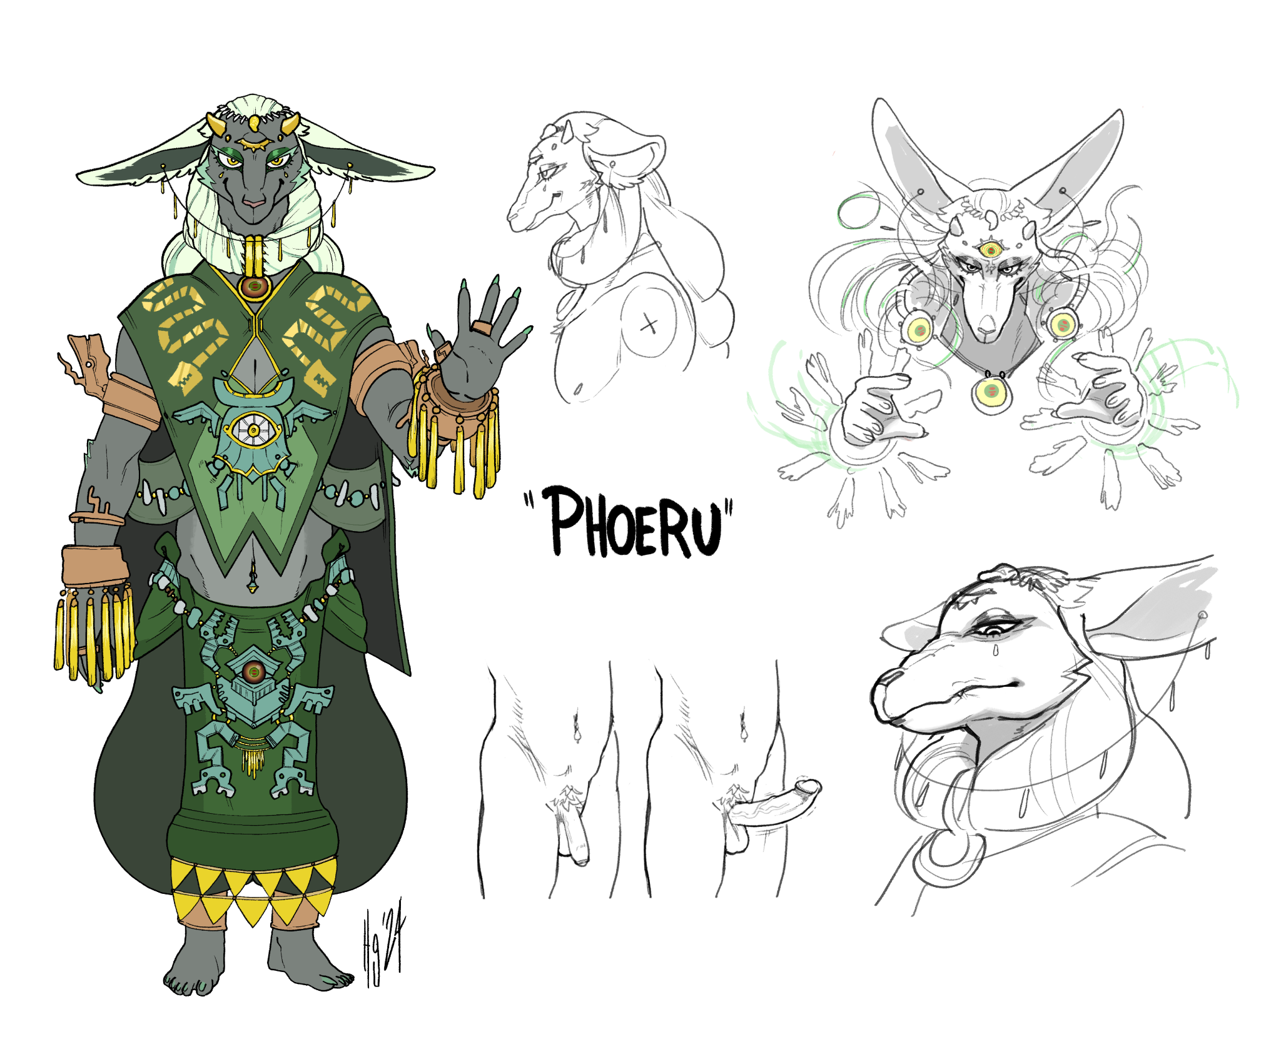

Art by @chibi-chaser

2.

Your world has changed practically overnight.
The Zonai assist the Lurelin tribe in your daily routines, bringing their incredible powers and amazing technology to bear. Your crops flourish and your fishing trips become more and more bountiful, thanks to the nets and cages the leader’s sister, Mineru, has designed. Your buildings grow taller and more robust. The heat of summer is quelled by small stone devices that continually blow cool air. Work is easier, and there’s more time for rest, conversation, and music.

Your life is close to paradise.
You see less and less of your Chieftain, though. When you do, she is almost always joined at the hip with Rauru. And who can blame her? He is beautiful, and is equally as dazzled by her.
You wish you could be as open with Phoeru as they can be. But he has barely even acknowledged your existence since that first night.
You’ve stayed up for countless nights, hoping that he would slip in and explore your body once again. No luck. You begin to doubt yourself; it might have just been a feverish dream brought on from rich fish and strong alcohol.
You cling on to the memory of his finger in your mouth. You rub your tongue against the roof to try and hold onto that rough texture, that slight tang. That part feels real. It’s the only convincing bit of evidence you have for yourself.
But it’s not really enough anymore, and the doubt has crept in.

With all this new found free time, you sneak off to forage on your own. Some nuts and berries for yourself, just to snack on. There’s more than enough food to go around, after all. And a little compulsive eating does help calm the anxiety, at least for a little bit.
But partly, it’s a chance to be away from the village, to be nowhere near that beautiful creature. It hurts to even think of looking at him, hoping for his smile to shine upon you, longing to hear your name slip from his lips. But that never happens. Why would it? He’s probably ashamed of what he did and wants to pretend he never spoke to you at all.
Why would he settle for a mortal like you?
You’re an idiot for even thinking that.
But maybe that’s just what love is - wanting someone so much that it makes you a fool.
What could be so bad about that?

These thoughts churn in your head every time you forage, each time finding yourself wandering further and further west until you start to end up in the humid climes of the jungle. Hours are lost in gathering and contemplation - mostly the second one, as the pickings get scarcer.
The longer you travel, the more you lose track of the day, finding it more and more difficult to arrive back in time for dinner. You get some grumbling reprimands from your elders, but not enough for it to dissuade you. They tell you to stop wandering off, that it’s dangerous to go alone. That you’re acting like a child.
You ignore them. What do they know about being in love?

One day, on your wanders, you get a distinct tingle on the back of your neck. Instincts telling you that someone is following from a distance. You pause, and glance, and peer all around but never catch a sight of anything. You always kept a spear close at hand - If a wild beast caught you off guard, no one would notice your absence until it was too late to find what remained of you.
You wanted to disappear, but not in that way.
Eventually, you no longer sense the presence; you assume that whatever beast it was got bored and wandered off.
The wind is at your back, though, and you do swear you pick up a familiar scent. Sea-breeze, mostly, but…
No, it couldn’t be.
When you reach the jungle with its gently rolling streams, it’s impossible not to see him.
His hair is still braided in the usual manner, but his clothes are folded neatly on a nearby rock.
Otherwise, he’s nude.
He’s nude.
Your face burns.

He hasn’t stepped into the water just yet, his fur glistening and oily. Your breath hitches in your throat, your eyes drawn to his bare rump.
“Come here,” he says, without gesturing, or even looking at you.
You swallow and freeze. Not sure how to respond - you feel like you should apologise rather than greet him, but instead, a question escapes your throat.
“What are you doing here?”
“I followed you,” he says, simply. “I was curious as to why you kept wandering away from the village. Now come.”
It’s not forceful, but it is commanding, and you don’t want to resist.
He looks down into the water as you approach him, regarding its glistening sheen, his feet not quite touching the surface just yet.
“This water - it will not make me sick, will it?”
“As long as you don’t drink it, no,” you say cautiously.
“Good.” he sits down on the rock, next to his clothing. One foot dips into the water, his toe-claws glistening a pearlescent white. “Would you wash them for me?”
Your breath hitches. Does that mean… you’re allowed to touch him?
“Yes Sir,” you say quickly and deferentially. You hastily kneel at his ankles and look up at him. His body is pungent, but in a way that makes you salivate. That licorice savoury scent.
The hunger isn’t one you get with the scent of cooked fish. But you feel a deep, primal, visceral desire to taste it, to breathe it in deeper.
You focus on his feet, slowly collecting water in your cupped hands and pouring it onto the arches. You massage it into the flesh and fur - you’re surprised by how soft they feel, considering how the Zonai always seem to be barefoot.
He sighs. “The water is warmer than I thought it would be. It is quite pleasant.”
“Yes,” you say, as you continue to wash.
You say nothing for a time; the only sounds are the chorus of croaks and chirps from the insects and fauna, and the soft drip and splash of water as you work thoroughly.
The silence feels strangely charged. It starts to push down on your mind and you feel a need to have something fill it.

Your lips are pursed, and you hum nervously - a tune your mother used to sing to you when you were restless, to guide you to slumber.
“What is that?”
“It-”
“Continue. I find it soothing.”
“Yes, Sir.”
His feet are glistening and sodden, now, the fur sheer and shining against the firm flesh.
“Will I wash your ankles?” you ask, trying not to look too long at his bared chest, his slender stomach.
“There is no need. Just my feet will suffice.” Phoeru looks down at you, and you feel you need to look into his eyes in turn. His inscrutable gaze deepens.
“I would like to stay here for a while. Will you remain with me?”
“...Yes, Sir.” You want to scream it. But you keep your desire under control.
You can see that movement of his tongue once more, and his hand reaches out towards you.

His claws stroke along your throat and you’re paralyzed with pleasure. His claws move just behind your ear and slowly caress the length of your jawline, his palm pressed under your chin.
The secret stone gleams. His free hand starts to trace and sketch green lines in the air, and you find yourself feeling quite profoundly relaxed again, releasing you from that tension.
Your mouth falls open, and your eyes follow the trails of light as they lead you up towards his face. His hair shimmers like grass disturbed by wind, and ripples of green and red flow and pulsate through them. The braid in the back comes undone, and the clasp in front clicks open again.
The hair radiates out behind and around him. An aurora-like backdrop frames his face, and every swirl of colour keeps your gaze locked to him. You fall deeper under his spell, that melting sensation, that tiredness even more delicious than that brief taste you had before.
The thumping of your heart from that very first glance returns, too, like you’re falling in love all over again. Your eyes feel tired, but you can’t close them, not when you could be looking at Phoeru. Not when looking at him makes all your thoughts and cares trickle away like that stream. Your hands continue to massage, still gently bathing them, though now they work with a careless, automatic motion, like one of Mineru’s constructs.

His eyes remain severe, but he smiles an odd, tight smile that you might have found unnerving.
You're too mesmerised to mind. He is beautiful.
His mouth opens, and his head turns, and his tongue slips into your mouth.
His tongue is thick, quite long, and a little rough. You’ve never been kissed like this before. Your mind explodes.
You welcome the fat slick tongue into your mouth, and your hands go slack as he shifts himself to deepen the kiss.
Your body is limp, and you’re unable to kiss him back, as much as you want to. The hypnotic float and flow of his magic drains all the ability to move from your body, letting you be perfectly still and helpless as his greedy tongue invades. He doesn’t seem to care whether you can breathe or not. He just wants to taste you.

His claws don’t draw blood, but you feel a slight sharp pain. You don’t mind it.
He leans into you even more, and the scratching claw travels down into your loose clothing to rake along your stomach next.
“So soft…” he growls to himself as he pulls back, before diving in for another kiss.
The wisps of green remain, and you continue to gaze at them with dream-like awe, as that hand now travels down between your legs.
You don’t remember much else from that - just flashes. The cold rock on your back as he spreads your legs open. The firmness and heat of his body as he leans over you. The slow prod and grind, the shimmering of his glamour helping you relax and guide him inside. It’s all tinged with wisps of green, like a strange prophetic vision, distant and faint.
When he bids you leave the grove ahead of him, you stagger home with delicious pain between your thighs, your legs like chu-chu jelly, and you’re barely able to remain upright.

You recall the sound of his voice, too, growled into your ear at your most vulnerable moments, where the words he whispered slipped past your consciousness and into your soul.
You know what he said was important, and it makes your heart sing when you think of his lips at your ear. But for the life of you you can’t remember.
You will, when the time is right.
When he allows you to.

–

“I will take this one with me,” Phoeru says. His hand rests on your shoulder. “Just them, for now. If I require anything, I will send word. I’ll see you in a few weeks.”
“Be safe, Phoeru.” Rauru smiles down at you. “And you, as well.”
You smile back, though you try not to look too closely at him.
Your chieftain, on the other hand, is looking long and hard at you.
You’re not sure whether she’s angry at you or worried, but she must see something in your eyes that’s giving her pause.
She must know you’re in love too.
Your face burns a little.
“If I may,” she says, quickly. “I think there are a few things you might need for the road. Might I borrow your ward, Phoeru?”
Phoeru pauses. You look at him. He only gives you a nectar-droplet of eye contact with him.
“Be my guest,” he says to Sonia, before returning his attention to the vehicle prepared for him. You keep glancing over your shoulder to watch him as you go - examining the wheels, checking the packs, but paying you no heed.
He has to keep up appearances. You understand.
Sonia leads you to her hut, and you remain silent. She does start to ask you questions - how you feel about leaving, what you know about the rest of the world. Your answers are simple and short.
“You should stop by the Dueling Peaks on your way, if you have time. The view from there is breathtaking. It was only thanks to Mineru’s inventions that I was able to get up there… you should bring some capsules with you. We have plenty for the first stages of construction for the castle. I’m sure there are some spares.”
At first, you think that this was the purpose for the chat, as she hands you the translucent cerulean spheres. But then her gaze turns…not colder exactly, but more stern. Direct. In keeping with the role of a Chieftain, whose decisions mean life or death for dozens upon dozens of her kin.
“I’m concerned for you,” she says. “I’ve noticed how much you’ve changed.”
“What makes you say that?” you ask, your slight stammer giving the game away.
“You’ve barely eaten the last month, you’ve been slacking off a little on your duties… and you’ve been following Phoeru around like a puppy. It is obvious to everyone how you feel about him.”
You shrink under her stare, and your blush makes her features soften and a smile spread across her face.
“It’s all right. I’d be a hypocrite if I forbade you from loving a Zonai, wouldn’t I?”
Her slight laugh makes you feel a little more at ease.
“I wanted to make sure that you know what you’re getting into. With him, I mean…”
You ask her what she means, with a little bit of iron in your voice. She inhales through her nose, and her gaze sets again.
“Rauru has… spoken with me about Phoeru, privately. He has known him for a long time. Phoeru is a little older, but Rauru was chosen to lead the Zonai. It was a unanimous decision, but Rauru’s… always gotten a slight hint of resentment from Phoeru. And it’s probably nothing, he’s said as much himself, but…from my read on Phoeru, I think you should be-”
“Sonia!”
“Queen Sonia!” several insistent voices call out for her. Her gaze flicks away and you can see her mind calculating what to say, what to do next. You hear distant screaming, and dread only flicks across her face for a moment.
“Let’s see what the fuss is about.”
You hear before you see it. The shrieking squeal of pig-like demons lunging and lurching towards the village. As you emerge, you see arc after arc of flaming arrows, spearing the woven roofs and setting them smouldering.
Sonia is undeterred. She barks over the din, calling the able bodied Lurelin to defend, javelins, spears and bows at the ready.
She is fearsome, as are the rest of you.
You answer her call with the others, though shakily.

Your thoughts are addled. Not with the fear of death or revulsion at those beasts… but more with worry for the Zonai. More specifically, your love.
And anger at these creatures for attempting to ruin your journey with him.
The Zonai have joined the fight, too. A massive tree trunk wreathed in pale green flies over your head and crashes into several of the creatures with bone-shattering force. Thin beams of light cut others down - both from Mineru’s constructs, and Rauru’s third eye.

You charge towards a group of them with a shout, righteously galvanised. The ruddy-red pig-things squeal-scream at you, swinging their clubs and blades over their heads wildly with abandon. It’s such a ludicrously telegraphed action, but that predictability catches you off guard - a blow to the side of the head sends you tumbling and crumpling over, your head hitting the mercifully soft sand as your legs tumble over you.
Your ears scream and your vision blurs as you try to right yourself.
As you manage to look up, you can smell the stench of the goblin just over you. Jagged teeth grinning, eyes full of bloodthirst. It has your spear clutched in its hands.
This position feels familiar…
They raise up the spear, the point aimed directly at your face, and you push your mind towards the last thought you desire to have…
Phoeru…

The Bokoblin petrifies in place, body quivering with shock as though it had been struck by lightning. It looks past you. Your vision is still blurry with pain and tears, but through the stinging fog you can see a supernatural glow in their eyes. You’ve seen that colour before, woven in little strings of air, flowing through long strands of hair…
As your vision finally corrects, you see your would-be killer’s not the only one affected. Four more just behind it, varying shades of blue and silver-grey, are equally stopped in their tracks. Their heads gently sway, their faces turning almost innocently placid, colour reflected in their eyes, their jaws hanging open.
As Phoeru steps past you, you only get a brief taste of his glamour. But it doesn’t matter. Relief and joy spreads through you. You’re saved.

He does not speak, merely waves one of his light-trailing hands. But the creatures obey the unspoken command. They sluggishly turn to one another, deadly weapons in hand. With a dreamlike sort of stumble, they hold the points of their weapons out and simply walk into each other, each one sinking their blade into the gut of the next one. They don’t scream, or even whimper. They just crumple silently, then vanish into puffs of dark smoke, leaving only their weapons and a scant few teeth behind.

His hair gently settles back into place, and only when the gleam has faded does he turn his gaze on you again. You only get a brief glimpse of his third eye before it closes - even from this distance, it was magnificent. You fall more and more in love with him every time you see him.
Even as the battle continues to rage, he seems completely unbothered.
He just stares down at you.
“Well?” he says. “Can you stand?”
Is he impatient, or concerned? His brusque tone and expression make it hard to tell. But you do manage to stumble to your feet.
“Come,” he says. “We should leave now.”
“But there’re still monsters,” you protest. “What about the rest of the village?”
“They will be fine. Time is of the essence.”
“But-”
He waves his hand - dismissive, hypnotic - and your concerns evaporate.
“You will come with me.”
“Yes Sir,” you sigh - relief swims through you as you’re liberated of the burden of arguing with him.
Now he moves with pace - towards your vehicle, through the fray. Your fellows are too busy fighting, protecting one another, or shepherding the young and the infirm towards safer spaces, to pay you or the tall Zonai any notice.
You clamber aboard. He guides you towards a panel in the centre, with a long stick jammed into the middle - a steering stick, one that he’s taught you to use before.

“Phoeru!” you hear Mineru’s voice calling out, just as you clamber on.
His gaze shoots towards her. She’s keeping a safe distance, screwing glowing batteries to her belt as the previous ones drain to power her many instruments of death. She looks confused, her gaze flicking to you, then to him - and then it softens, for a moment, and you swear that for a second her eyes gleam that familiar shade…
But then the look is gone.
“Good luck!” she calls.
“Drive,” Phoeru says, his palm resting on your shoulder as you take control. The cart lurches to life and you surge it forward, the stone chassis and the heavy wheels pushing the pig-beasts aside and clearing a path.

You don’t know it now, but you will not see your village again for quite some time.
Even if you wanted to, you can’t look back - you have to keep your eyes ahead and on the road.
You feel the shifting of weight as he takes his hand off you and sits, cross legged, behind you.
The sound of the fray and the flame lessens as you drive further and further away from the only home you’ve known.
You feel his breath on the back of your neck as he leans in, once you’re well out of sight.
He whispers a phrase into your ear, and your body becomes an empty shell, a quiet, obedient pilot.
Your mind melts and your thoughts slip back in time to the humid pool where he first tasted you.

Your body relents to mine.

“Your body relents to mine,” he said. One hand was on the back of your head, gripping tightly and keeping your gaze focused on his. His other hand was down between your thighs, his soft palm pushing and kneading against you.
No one had touched you like that, nor that firmly, nor that relentlessly.
Your mouth was perfectly round, your eyelids fluttering, your body arcing, and you could feel it coming again, the climax that would shatter your mind into more pieces for him to rebuild in a new shape.
His grip slackened and pulled away, leaving you, once again, desperate and unsatisfied.
“Recite,” he said.
“My b…body… relents to yours,” you said, with some effort.
“Clearer. Recite.”
“My body relents to yours,” you blurted out, barely managing to get it out in one breath.
“Slower. Recite.”
He slipped his hand between your legs just as you said it, and your voice quavered.

You remember now.
The first time you saw him smile, truly smile, an array of predatory teeth. Hungry for you. You want him to taste you more.

“My body relents to yours,” your lips say as your body pilots. Your mind is locked inside. But you don’t mind. You swim in bliss, the vision of his frightening, beautiful, world-defining smile an endless fixation for the long journey.
He plays with you as you drive. His hands go under your clothes, his claws raking along your relenting flesh. His shuddering in-breaths tickle your ear, and his outbreaths, warm, aromatic, reach your nostrils.
His grip is rough, leaving long streaks along the softest parts of you - marks that will remain along your stomach, your chest, your neck. You would have complained or tried to pull away from anyone else.
But he is different. He is your love. You’d let him do anything to you.
Your body relents to his.

To read the entire story now, become a Subscriber!
https://www.subscribestar.adult/limewah

