CW: This story contains elements of dubious consent, emotional manipulation/abuse, and violence. Reader discretion is advised.
This also contains explicit scenes of sex, and is for adults only.

PHOERU
By Limewah
A fan-work based on settings and characters depicted in
The Legend of Zelda : Tears of the Kingdom

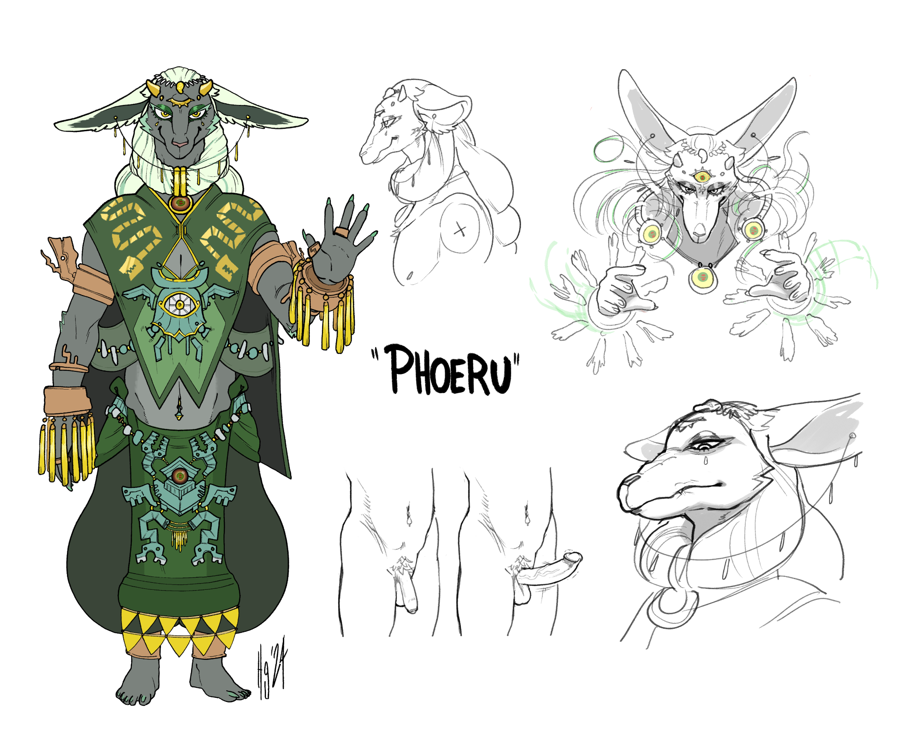

Art by @chibi-chaser

4.

The challenges to Phoeru's project were inevitable. You know this. He’s told you as much. You know the rest of the world hates him - and you.
You’ve not left the Plateau in some time. There is no one out there worth trusting. Not even the other Zonai.
He’s not dictated any letters in quite some time. But he has been receiving them. You deliver them obediently, and as he reads them he explores your body with a grasping, groping hand. His grip hardens and firms at times you don’t expect, and makes you almost whimper with pain. But you’ve been trained not to show it.

You’ve been trained to be obedient, unquestioning, and unerring. Your shackles were removed.

As have the lesser slaves. But they don’t get the access you get. You’re the first. You’re his love. And you always will be.
The first ‘challenge’ comes from one of his kin. You recall her face from the first arrival, and the time she spent in that seaside hovel you used to live in.
Gutanbac is her name. Her hair is short, thin, and receding, and the clothing she wears is tighter, more athletic, less flowing than her kin’s, and she has the physique of a swimmer. Fitting for her particular skills.
She comes with a very small retinue; if you didn’t know any better, you’d think she was just coming for a visit.
You have a hunch. It must be related to why Mineru has not returned in some time, why there have been no new constructs and devices delivered to you.

You’re not privy to the conversation Rauru and Gutanbac have down in the main meeting hall; the lesser slaves are down there, flanking him and gradually surrounding her.
You’re up on the roof above - the slopes are a little difficult to keep a foothold on, but you’re well used to it.
You requested it - just to keep a lookout from above, so you said. But you’ve got another plan in mind.
You recall what she can do, after all, and if your hunch is correct, and she attempts something -

You hear the sounds of movement below. The echo has only carried the timbre of their voices, but you hear them getting raised. The united clank of booted feet against the floor, and the soft rattle of spears and swords at the ready.
You grip your own weapon, and wait.
You hear her grunt and feel the rush of her body approaching from beneath. A whirlpool of green appears just at the ridge of the roof. You’re already in position behind it, and as Gutanbac leaps from it like a dolphin cresting a wave, you drive your spear up through her back.
Her flesh doesn’t have much more give than a fish’s flesh.
She reflexively tries to pull herself away. You angle the spear upwards and push, and feel something give.
She wheezes and chokes.
You twist and pull the spear free, and she collapses onto her knees, dark blood staining her clothes and matting her fur.. You stand behind her and wait for her to fall. You choose not to look away from her.
Her breaths gurgle and rattle as she turns her head towards you.
How strange. She doesn’t look like a godly being. She’s just as mortal as you. Has she always been that way? Have all of the Zonai been mortal all along?
Aside from your love.
She looks at you like a dazed, dying deer might view its hunter.
Or that… hmm. This reminds you of something else, but you can’t quite place what…
In her dilated eyes, you see she’s trying to place where she’s seen you before. Even through the visor and the armour there must be something familiar about the shape of your face, the colour of your skin.
Before she can solve the puzzle, her gaze unfocuses and she topples with a dull sigh. The body slides and rolls along the sloped tiles with a series of sharp scrapes and thuds, its limbs flailing and splaying in a way that might have disturbed you, once.
It falls off the east side of the hall’s roof, out of sight, punctuated with one final crunch.
When you climb down to the ground level and head around the side, you see her mourning retinue swarming around where she fell. They are tearing at their clothes and at each other, horrified by the sight.
One of them looks up towards you, but can’t meet your eyes.

By the time you’ve climbed down, Phoeru is there, standing over Gutanbac’s corpse, holding her secret stone. He steps back to allow her to cradle and tend to her.You can tell even from this distance, he almost looks… sad.
It’s strange to see that sadness crease his snout.
“You may give her a proper burial wherever you please. And I hope this will serve as a message for the rest of them-”
He feels your eyes on him. He sees you, and the blood dripping from your spear.
His expression is stern as he approaches you, and your stomach briefly drops - fear breaks through your programming and you feel the primal urge to flee.
He glows with an intensity that you’ve never seen - is it fury?! Is he angry with you…? Did you do something wrong?

“Sir, I thought you wanted her dealt with, so I-”
He grabs you firmly by the arm just before you can turn to run. His other hand grabs the back of your head, and pulls you into the deepest, most intense kiss you’ve ever felt.
“Go to my study, and wait for me,” he growls into your ear. “I will be there once I’ve disposed of her. You have done so very well, my beloved little slave.”
“Thank you, Sir, I love you,” you whimper needily, your ruthlessness and fear melting like butter in a skillet.

You race back up the hill to Phoeru’s - your home, and up into the bedroom. You wait as patiently as you can. But that giddiness you felt from the first time he touched you is overwhelming you, making you fidget and squirm and making your mind race with the sheer possibility of what might come next.
You wait for what feels like hours, until, at last, you hear the door opening downstairs.
He doesn’t come up straight away. You wait. You hear him moving through the house. Picturing his footfalls, trying to trace the route he’s taking. What’s he doing? Checking the storeroom?
Are there others with him? You hear him speak - he’s not hiding his voice but you can’t hear him well enough to follow the conversation.
Finally - finally - you hear him go up to the study, and you wonder if he’ll linger there. But no, you hear his footfalls come up the last set of stairs. You wonder if you should kneel, or assume some other submissive position. You don’t get the time to decide before he opens the door, and you settle for dropping to your knees.
“Stand up,” he breathes, and in his almost feral expression you see he’s filled with desire. “I’ve been waiting for this long enough.”
He pushes you back onto the bed, and as you squirm and fumble at his cowl, he bites down on your neck -

He bit your neck as he came inside you that first time. Your hips were in the air, your ankles wrapped under his armpits, his claws digging into your rear. The bite made your insides leap and constrict, and you felt your warm fluids dribbling down over your stomach and chest as he held you in place. Your gut throbbed and your hips melted as he emptied himself into you. Each pulse of his shaft was accompanied by a thrust, a slap, and a low grunt from the Zonai.
You had never known how wonderful this sensation was - you’d touched yourself before, but this was… bliss.
And in that bliss, he slipped his words into your mind, and you forgot it ever happened.

It’s back in your mind now, though, a reward for your good work.
“Good work, my dear little thing,” he growls. “I’ve trained you so well, and look at you now… I always knew you were special, that you were worthy of me…”
Your truth leaps from your throat. You love him. You’re so happy you’re worthy of him.
He pulls away from you and grasps at the chains and the cage around your pelvis. His palm glows, and the locked cage glows with it before splitting apart with a click.
It’s strange seeing him so hurried, almost sloppy as he paws and fumbles at the pieces - but it’s because he wants you that badly. He’s always wanted you that badly.
As he pulls the lock aside, he lowers his trousers and lifts up his cowl. His toned body bared for you. The most beautiful body you’ve ever known.
Your needy, sensitive nethers twitch and burn for him, free for the first time in so long, and desperate to be used.
There’s only one thing that’ll make this more perfect.
“Sir?” you gasp as he collapses himself on top of you.
“Call me Phoeru,” he says with a growl, his hands pulling your thighs apart.
“Phoeru…” you whisper, rotating your tailbone towards him to allow him easier access.
“Go on,” he says, his snout buried in your neck once again as his shaft drapes against you.
“Will you… use your power on me?” you gasp.
“Mmmnh…” he chuckles and hugs you closer as he shuffles over you, onto the bed, the sweat and warmth of his body intoxicating you. “But I already control you, your body relents to mine… why?”
“I’m at my happiest when you do it,” you admit, and the words pour from you as he presses the tip of his shaft between your cheeks. “It takes all the pain and worry away, and it… It makes you look even more beautiful. I fall in love with you every s-single time… and I wish I c-could remember it. I just…”
“Shhh. I see.” he pushes himself against you again, and you try to relax yourself, to allow the thick tip inside. “But this time, I won’t make you forget what we’ve done. I will make you feel everything. Is that what you desire?”
“Yes, Phoeru, my love, more than anything…!”
His warm mouth pulls from your neck, and his nose presses to yours. You feel the cold clasp of his hair-clip come undone, his hair brushing against your chest as it lifts and floats into a corona around his face. The secret stone glows bright, brighter than it ever has before. His third eye opens, and strobes, and swirls, and your gaze goes soft as you take in the aurora of bliss.
You sink into the soft cushion of the bed, fall through it, through the floor, through the world itself. It all melts to nothing. It’s just you, and your love, and his grey-green fur, and his shaft spearing you, the way you speared-

The memory is wiped from your mind before it can distract you, like a still wet painting being splashed with water. The colour from the memory runs away, leaving just green, and blue, and red, and him.
Your arms are heavy, almost dead, but still, you manage to lift them, even as he thrusts into you with possessive force. Your hands find their target - his face. His eyes roll up for a moment as he groans, breathing his hot, sweet breath over you as the pace of his thrusts quicken, and his hypnotic control flickers and fades for a second. He does not lose control for long.
Your back sinks deeper, your legs raise higher, and the aurora of his spell scalds your soul.
Eventually, you can’t even look anymore, your eyes ceasing to take in the world. Your mind has been rewired to feel nothing but pleasure. Your sight fails you, your sense of hearing, your sense of self. You dissociate from the world entirely, just feeling the painful ecstasy radiating from your hips through your body with each intense thrust. Your body is a receptacle, his to fill…
The only change to that endless melting swirl of pleasure is when your climax arrives.
It’s been a very long time. You feel the orgasm racing to embrace you like a long lost friend, and you cry out louder than you ever have before.
He stops up your mouth with his own, his tongue pushing in and reclaiming it. You moan, your lips squeeze against it, quivering as your lower half turns to jelly, and you nearly asphyxiate on his delicious kiss.
What was done with the other Zonai’s body?
He pushes himself deeper inside you.
What will the rest of Hyrule, the other Zonai, do…?
His breath hitches, and you feel it on your neck.
What will become of him? What will become of you?
He growls, and empties himself into you. His warmth floods into you, like a salve soothing all your pain and worries. Those questions cease to matter, and will never trouble you again.

Neither of you leave the bed after he finishes - in fact, you stay there until the sky turns amber, then dark blue, and the stars emerge. Your sweaty body clinging to his, anticipating when he will put you to sleep before him.
It never comes. You feel his breathing slow, his stomach’s rise and fall growing deeper with each peak and trough. His shaft, still wet and slick and smelling of sex, rests against his stomach, close to your hand.
When you realise that, you look up towards his face.
He looks relaxed. Content, peaceful. Like the hard mask that he wore on his face at all times had just slid off for the first time.
He looks younger than he ever has.
But… you still feel like he’s more beautiful when he wears that severe face. When he’s conscious.
Even so… you stroke his face gently, and he grunts, but is undisturbed.
You stare at him for as long as it takes for your eyes to fall closed, and for you to drift asleep.

–

You remain closely hewed to Phoeru’s side. His hand rests on your shoulder and squeezes - so tightly it stings your nerves.
But you hold firm. As you have against all the other threats to your love. The Gerudo King, young and impetuous, had resisted Phoeru’s attempts to convert him, and that had kicked the hornet’s nest; now that he was refusing to meet with Rauru, your love had become a problem to his own attempts at dominance, through sly, ‘peaceful’ means. At least your love was more open and direct with his dictatorship.
It had all come to a head, and Hyrule Castle had mustered a force against Phoeru. They now stand on your doorstep.

You are in the courtyard. Stretching ahead of you, as far as you can see, are scores of your kin, gathered to arms, against Phoeru. Your beloved.
You clench your spear tighter, your jaw set. You have been clad in armour made of stone and Zonaite, bearing Phoeru’s crest. Yours is far more beautiful and ornate than the lesser slaves, still standing behind the two of you. Surrounding the temple, up on vantage points and cliffs nearby, bows at the ready. All of them are well versed in this, your home turf.
All of them are ready to die for their Master.
None more so than you.
And he would do the same for you. Now that all has been mended.

Rauru stands in front of his battalion.
“Phoeru!” he calls. “I would rather settle this with words than violence, you know that!”
Phoeru laughs. It’s so beautiful. He squeezes your shoulder tighter, and begins to walk forward. You move alongside him.
“You come with your flock, to be slaughtered by mine, and you think you have the leverage to parlay with me? You overestimate your sway, Rauru. Which is exactly why you have never been fit to rule.”
“And what would make you a superior ruler?” Rauru shoots back. “Having everyone serve you, blindly, without any will of their own?”
“Precisely,” Phoeru says, and you nod along, ready to agree. “You have seen how obstinate the Gerudo are.”
“Hardly surprising, considering what you attempted to do to their King!”
“And now the Zora are rattling their spears, to preserve their own sovereignty. Do you really expect they will simply bow to you?”
“They will not be part of the Kingdom,” Rauru says. “It’s simple. We do not need to control the entire continent; it would be foolish to try.”
“Your lack of ambition is disappointing, but not surprising.”
“We’re willing to forgive you, Phoeru. All of us. Even Mineru. Even after you brainwashed her, used her… she’s willing to give you another chance.”
“Wouldn’t that besmirch the memory of poor, sweet Gutanbac?” Phoeru replies. “Surely you must want revenge for that.”
“We would rather have justice,” Rauru replies, though you can see the remark hit him hard.
Your love can be cruel, but it’s necessary.
“If you’ll just have your army stand down… we can continue to make Hyrule a better place. For all of us.”
Phoeru laughs again.
“Patronising as ever, Rauru. It’s a shame it will have to end this way. But, if you prefer to end this fight dead on your back, than alive on your knees… I will oblige you.”
Phoeru raises up one of his hands, and snaps his fingers.
The shadows of arrows arc overhead and rain down. Screams of anticipatory fear, then pain ring out in the distance as the missiles fall amongst Rauru’s army.
“Charge!” Rauru shouts, and the sea moves forward. Phoeru simply stands. You start to move, but he grasps you again, as the other sea, your allies, your fellow slaves, pour around you like a river around a boulder.
“You stay with me.” Phoeru says. His eyes gleam, his hair pulses. A brief taste. A hint of the reward coming for you once you’re victorious. “You will always stay with me.”
“I love you, sir,” you say.
He scoffs, and smiles, and you know that means he loves you, too.
The rank and file of Rauru’s army are more focused on each other, none of them coming towards Phoeru. You are too fearsome for them to dare approach you.
Rauru’s secret stone gleams, you can hear its chiming glow, and you lower your gaze to the floor to avoid being caught in its sheen.
The waves of hypnotic glamour spread through the ranks, making Rito drop from the sky in their trances, making Gorons pause long enough for a spear to find the soft weak points, and making Hylians fall to their knees and be run through.
You wade amongst them, spearing and capturing and carving.
It’s effortless for you, even easier than gutting fish.
The “King” approaches, you can see him. His hands are clasped together, and you can see the green gleam of his own secret stone. Can Phoeru not see him? He’s distracted. He’s vulnerable and you see what will happen next-
“PHOERU!” you shout for him over the din. He looks at you, then sees where you’re staring.
A halo of blue light starts to shrink inwards around Rauru’s still-closed third eye. His fur bristling. His snout snarling. He wades through his army, shrugging off every blow that comes his way, his eyes fixated on his target, getting closer, closer, almost point-blank, no chance of Phoeru evading -
Phoeru only notices Rauru with seconds to spare, he’s surprised, he wasn’t paying attention-
You know what will happen next.
He won’t die. He won’t let that happen.
He will order you to leap in front of him, to take the fatal blow.
And that will weigh on his mind forever.
You don’t want him to make that choice.
With all your might, you race towards Phoeru, and leap towards him, shoulder first, please forgive me my love, I want to be there by your side forever, but at least I can save you-
Your eyes are clenched as you bash into him and send him stumbling, and as you fly you feel the inevitable piercing through your chest.
You’re surprised to find the only pain you feel is on your shoulder when you impact with the ground.
Your chest feels sort of dull and hollow. It’s disconcerting, but not painful.
It’s hard to breathe - it feels like the air just isn’t settling in your lungs. You feel a vibration in your throat, like what you imagine a cat’s purr might feel like.

Then-
Pain.
It tears through you and sears your nerves.
You writhe and flop, feeling your hot blood soak your skin and leak onto the stone courtyard. You can barely see through the pain, your stinging tears, your ears ringing, and roaring, blood rushing through your head. You try to breathe, to scream, but there’s a rattle and bubble in your throat, and you taste copper, and everything burns your shriveled, painful lungs
The battle continues around you, but seems to recede into the far distance - a distant desert, while you lie in a painful oasis. Just you… and the two Zonai.
When you look towards Rauru, there’s nothing but hatred and pain in your eyes. And nothing but pity and sadness in his - why is that? It’s… his fault…
You roll onto your side - PAIN searing through you - and look up at Phoeru.
His head is turned towards Rauru’s. His eye glances in your direction.
There’s..
There’s got to be something in there.
Some sort of shock, or sadness, or grief.
Just a trace of it in his eyes.
But you don’t see…
Phoeru, your love, he must be holding back his grief, and he'll cry for you once he avenges you, he…
There’s got to be a hint of..
of…

He’s…
He’s not…
Where’s the…
You try to

Think
Back
To the fir
St time
You…

Want him to glow at you
To smile at you
To put you
Into a trance
To dull the pain
One last
Kin
dness
But that look

Wasn’t that
Look

You saw him look
At you
The plains
The others
Stretching out

But there
Is
Something else th-
That…
That
That look is
Nothing

You’re on a boat.
It rocks back and forth.
It’s sunny.

Your throat burns
You c
C
Cant breathe
Writhe
Flop
Flutter
On the boat
Looking up
At
Y
Our
your
Your
Killer

Your face
His face
Looks down at you
The dying thing.
Suffocating.
Flopping.
Going still.

The dying fish.

–

Y have asken Mineru where-for she ond the kinge Rauru hath no kindered alive.
Spaken she of a greate conflit that betideth the londe of Hyrule in the kindomes infanci.
An eldere Zonai Woth magik ivel enthrallen the souls divers innocente beinges of londe, ond the Zonai aswele, ewen Mineru. They taken as armes gainst Hyrule ond the kinge, with constructes of Mineru’s creacioun.
So depe was the ensorcelled enternesse of his sclaven, thot throuen themselfes upon the sword in his name. Werken mych blod-shed of Zonai ond Hylian alich. The traitor enden lif bi the honde of Rauru.
So greate was the betrayale of this Zonai, that the betrayers name stricken frome histori hath, ond his secret ston breken.
His halle of worshippe hath ben repurposed, with no trac of its original selfe, ond stonde the Temple of Time in its place.
Mineru parten with y hire hope none-kinnes like come ayein.

- Inscription on a stone slab, in Ancient Hyrulean, never discovered.

