LIMEWAH’S 100K VIEW RAFFLE
www.furaffinity.net/user/lmann
Prize # 3 : VampBirb
Accidental
Self-Hypnosis
PocketWatch
Reversal
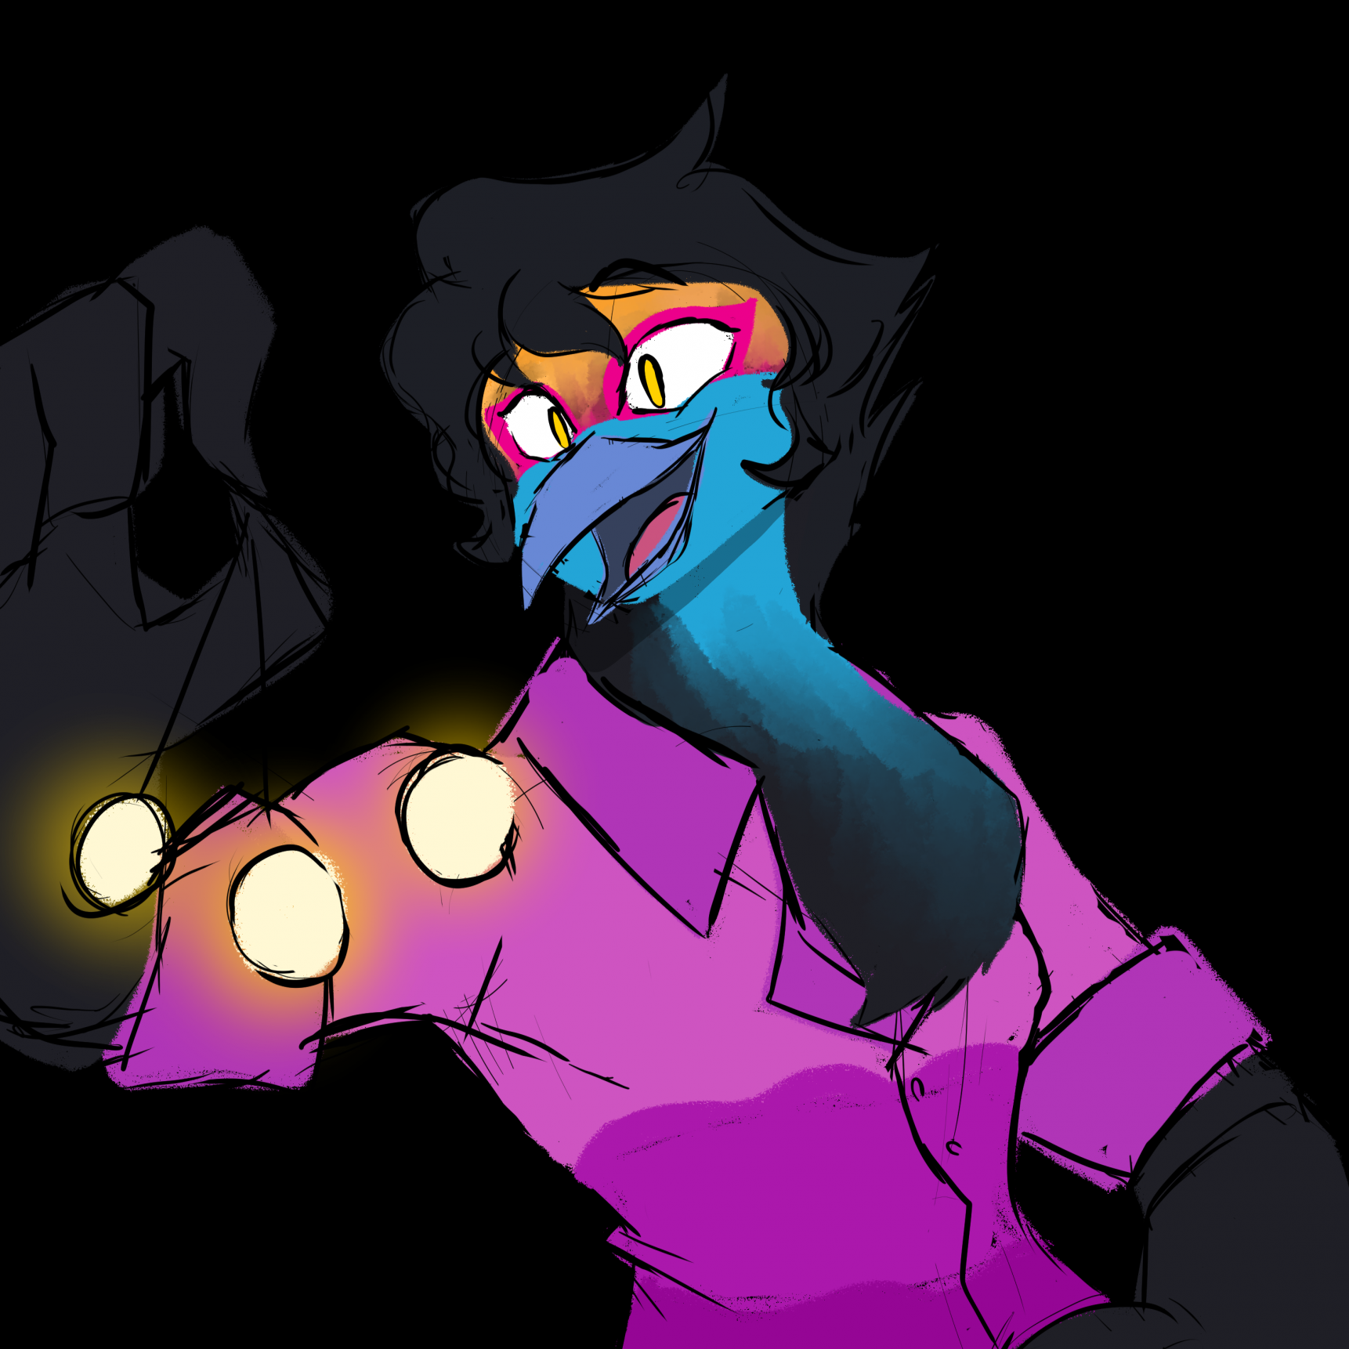

Art by Kuro-Freak
www.twitter.com/KuroFreak
www.furaffinity.net/user/Kuro-Freak

That handsome bird keeps catching your eye from the other side of the dive bar, and not just because of the bright colour of his tail and face, both running a beautiful gradient from gold, to crimson, to blue. He looks overdressed for this place too; he must be doing cheaper pre-drinks here before hitting a club. It isn’t stopping him from eye-fucking you from across the room, not that you mind all that much.
He is really cute. Do you want to make a move on him…? Are you brave enough?
He makes that decision for you, a slight peacocking supermodel strut to his gait as he approaches. His mating ritual’s already underway by the looks of it; it’s hard not to feel a bit flustered and seduced by a colourful bird when he puts moves like this on you.
“So, what’s a cutie like you doing in a place like this?” he asks smoothly. “Can I get you your next drink?”
Who are you to say no?
Florian’s a very charming bird. It’s hard not to be attracted to someone so confident in himself. You’re inspired to make the first move - a gentle brush along his feathered hand on the bar as you chat. He seems to take notice, and soon you find his other hand brushing your knee as he excuses himself to nip to the toilet.
You feel that familiar shiver of excitement, feeling the memory of that touch linger on your knee long after he returns.
“Have you got any plans for the rest of the night?” Florian eventually asks, his eyes slightly narrowed in a seductive glower. You were meeting a friend here, but they haven’t shown yet, and you’re too charmed by this boy to pass this up.
You lie and tell him you have none.

Once your last drinks are finished and your tab is settled, you sojourn into the cool night, and Florian leads you back to his flat.
You’ve noticed that he’s got a rather fetching pendant around his neck, just nestled in the blue fluffy down of his chest. It’s a golden pocketwatch tied with a silver string, and it seems to catch the light quite well…
It’s the first thing he removes when you step through the door. When he turns to face you, he holds it aloft, and it turns slightly in the air.
“I caught you staring at this earlier,” he says. “Mind getting the door behind you?”
You don’t look away from the pocketwatch as you ease the door shut with your foot.
You ask him what he’s up to, unable to hide the smile from your face. Just what does he think hes…?
“It’s pretty, isn’t it…” Florian continues, his gaze fixed on you as the coin swings, sweeping back and forth across his vision. “I’m told that the longer you stare at it, the better you feel. What do you think? Do you like what you see? Listen, can you hear it ticking?”
You admit it is quite pretty, and you can hear the ticking but you start to ask him why he’s doing it before he hushes you.
“No need to say anything,” Florian coos. “Just follow me, follow the pretty golden watch, and we’ll get nice and… comfortable together.”
You’re not sure if this hypnosis thing is actually working, or if it’s just his natural charm, but you do follow. His gaze remains focused on you, though it does flick to follow the pendulum now and again.
“Each step we take… each shift of weight, it makes you notice just how tired you really are. And you get… more and more tired with each step, don’t you?”
You do feel a little tired, and that realisation pushes a yawn out of your throat.
“That’s r..riiight…” Florian ends up yawning too. When he opens his eyes, they seem to be focusing more on the pendulum than on you, wiggling back and forth to follow it rather than fix you with that piercing glare.
“And the more tired you get, the sleepier you get, the better it feels…”
You feel pretty good. But it looks like he’s having a bit more fun. His wrist is drooping a little, and he has to consciously pull it back upright.
You stop following, but he continues to walk backwards slowly towards a couch he’s got set up in his little living space.
He’s forgotten about you.
He’s hypnotising himself.
You weren’t sure if you believed in that stuff, but he’s basically proving it works; at least, it works on him.
“And when I snap my fingers…” he mumbles, seemingly on auto-pilot. “You’ll sleep for me, won’t you… feeling ssso good, and ssso happy to rest… and in that open, sleepy state, you’ll be able to tell me all your deepest desires, so I can fulfill them…”
Aww. Okay. So he wasn’t going to try and take advantage of you… you’ll make sure to show him the same courtesy. For now, you think it’s best to let him finish the job.
“And you’ll be c…completely n’trance, ‘n three… two… one.” Florian snaps his fingers, and practically ragdolls backwards onto the couch. His legs go up in the air and the watch falls to the rug.
It’s hard not to laugh. It’s an adorably dorky sight. Especially when you get closer and you hear a soft high little whistle come from his beak. Is that what his snore sounds like?
You stoop close to Florian and ask if he can hear you.
“Yesh… Master…” he mumbles. You snicker again. Maybe he takes more to the submissive side of things than the dominant one…? Shame, maybe he’ll get you next time.
You grab him by the armpits and pull him along the couch so he can lie properly. There’s a lot of fun you could have with him; he seems to be into being helpless, judging by the bulge in his tight trousers. But you are pretty tired, truth be told. And you’ve spent the whole night wondering what that chest-fluff will feel like against your face.
So you crawl on top of him and wrap your arms around him before resting your head on his chest.
It’s heavenly soft.
You gently command him to cuddle you, and he obeys slowly, fluidly.
Between the whistling snore and the pillowy chest, it takes you no time at all to succumb to a sleepy spell as well.

Thanks for your support!
Please consider Subscribing at
https://subscribestar.adult/Limewah

