LIMEWAH’S 100K VIEW RAFFLE
www.furaffinity.net/user/lmann
Prize # 2 : Razz
Pokémon
Wild
Coils
Hypnosis
Captured
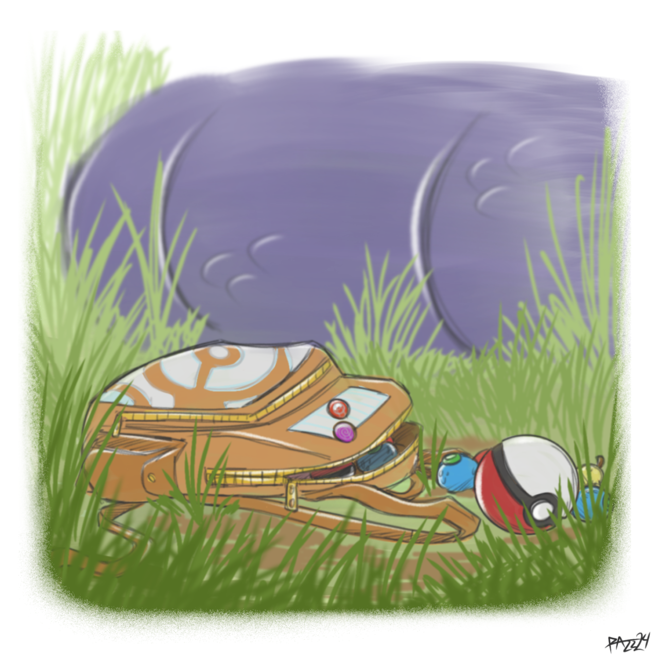
Art by Razz
www.furaffinity.net/user/Razzfox
www.twitter.com/BoxIdle

The Lucario jogged briskly along the route through the forest. He was on his way back from a shopping trip, his knapsack full of potions and Pokéballs for his trainer, and some berries for himself. Every now and again, a noise made him flinch, freeze, and lock eyes with a familiar pair in the grass.
Razz always got a little bit anxious, or maybe self-conscious, when he saw a wild Lucario. One who wasn’t capable of speech, or socialised the way he was. There were a lot of them in this area too, bristling with apprehension when they locked eyes before they ran off into the bushes. Maybe his yellow-brown eyes caught them off guard too; that plus the fact that his dreadlocks were tied back into a ponytail probably made him look just as uncanny to them as they did to him.
Either way, he was staying well away from the tall grass, specifically to avoid causing a fight. Thankfully this route was nicely pruned, and he wouldn’t have to risk an encounter.
He didn’t expect how bold some of them would be.
The purple-segmented tail wrapped around Razz’s ankle and tugged sharply. Razz yipped and went flying, only barely managing to hold on to his bag as he hit the ground and was pulled along the dirt, into the grass.
Razz tried to regain control, his paws gleaming with blue aura energy. The moment he had a clear shot at what he assumed was an Arbok, he’d fire off a shot…
His hunch was correct. But he wasn’t expecting the cobra pokemon’s markings to be quite so…
vibrant…
The grinning visage just beneath the snake Pokémon’s head had yellow and red eyes like most, but the colours were shifting and rippling in concentric patterns, flickering so fast that Razz’s canine eyes could barely keep up with them. Razz tried to pull his gaze away, but his eyes were immediately snapped on to look at the Arbok’s head, into its eyes. They, too, were whirling with colour. Just as potent and mesmerising, irresistible.
It was… so hard… to think…
Razz’s aura ball faded from his hand as his struggles stilled, and he went limp, placid, and blank-faced. The Arbok hissed with delight, and its tail began to wind further up the jackal Pokémon’s body. It cinched Razz’s legs together around his thighs before continuing up his torso. It left his paws free, seeing little need to worry about Razz fighting back.
When the tail was cradling Razz’ neck, the Arbok lifted him effortlessly by the ankle and held him aloft, swinging him back and forth upside down. The blood rushed away from Razz’s head, which only made his vision warp more, and the colors seem even more irresistibly hypnotic. The tail began to curl downwards along his body, holding him still even as it pressed into his lithe body and squeezed tight.
The knapsack slid right off his arms and fell to the forest floor. Razz only faintly noticed, so comfortable in the coiling spiral.
“Nnuh…” he groaned, his eyes drooping as they began to fill with the same rings of colour, a sure sign that his fate was sealed, and he was at the snake’s mercy. He stared at the giant, swirling patterns on the Arbok’s hood, drool dripping from his smiling muzzle to the floor. He felt so sleepy, pleasantly so… like all the other times he’d been hypnotised. Being entranced was like breathing for him, an almost unconscious automatic action. And this was no exception.
The Arbok looked down towards the floor, at the discarded bag, and draped Razz onto the ground. Razz stared at nothing at all, eyes swirling, lips closing as he continued to smile like a happy puppet.
The snake rummaged through the bag, its tail wrapping around the berries the Lucario had bought. It wasted no time devouring them, and searching for more, until a red and white ball rolled out from the back of the bag.
The snake flinched back for a moment, being well acquainted with the sight. When it was clear nothing was going to happen, though… it looked from the ball, to the Lucario, to the ball again. It picked up the ball and very carefully pushed the little button on the Pokéball, making it balloon to its full size before throwing it at the prone Lucario. It hit him, opened wide, and sucked him in in a burst of red energy.
The sudden jolt, the pull and enclosure, was an alien sensation to Razz. He was born in ‘captivity’, and had never been unwillingly captured. He tried to fight free of the darkness surrounding him as the ball enclosed, feeling the ball pitch and roll against his struggles.
And then the first wave of pleasure hit him. A pulsing pond-like ripple of red flowed all around him, encircling Razz and bathing him in such intense warmth… Being hypnotised was one thing, but this felt like something deeper. More powerful, more pleasurable…
He struggled again, feeling the Pokéball nudge. But more waves pulsed in resistance to him, weakening his own. Something reaching into his mind and rewriting his thoughts. Undoing old memories and creating new ones. His trainer vanishing from his mind, replaced with the Arbok.
He struggled again. He could see a glimpse of the outside world. He could get himself free…
The red ribbons of colour suddenly latched onto him, lashing his arms and legs together and keeping him from struggling any longer. It pulled him into shibari knots, putting his paws behind his back and his legs together and forcing him to gaze into the endless aurora of red.
His last gasp of resistance had failed. He relinquished it willingly.
He had to give up.
He wanted to give in.
He needed… to…

PING!

The Arbok cautiously stared at the now-still Pokéball, before gingerly slithering over and throwing it through the grass. It popped open and with an almost magical whir of life, it released a red shape that coalesced into the Lucario it had captured.
It looked the same… save for a blank, docile look in its eyes. As soon as it saw the Arbok, its tail wagged quickly and it barked happily.
The Lucario that once was Razz bounded eagerly right into that Arbok’s coils, happy to be close to its new master - the only one it had ever known.
Thanks for your support!
Please consider Subscribing at
https://subscribestar.adult/Limewah

