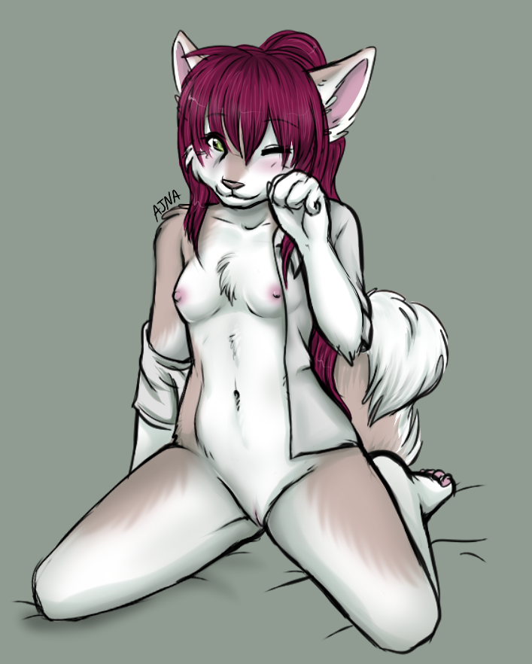

CUB TALES 2

ANYA THE HUSKY

2339

The rain fell on the city, drenching the inhabitants with the downpour, those who were unlucky to be caught out on a cold miserable night. While a majority of the humans and furs who ran from shelter to shelter had some place to go, some were homeless and poor. One of these was shivering in the alley way between a block of buildings in the industrial district. She was a husky pup, only 15 years old, naked and curled up behind a large dumpster, trying to get some shelter from the rain.

Her story was tragic, and sad. 8 years ago, her parents had died in one of the terrible H1 riots, and she had survived by cowering inside a drain pipe, whimpering with fear from the yelling and screaming. When the noise had died down, she crept out of the drainpipe, and looked for her parents. She found them both dead, her mother had her head smashed in, while her father was gutted. And that was where she was found by the authorities, crying and covered in blood, dirt and urine, with smears of shit on her face.

The next 8 years she was the ward of the state by the Terran Government. Social services tried to put her into a stable home environment. But to no avail.

She was shipped from foster care too foster care, as she had a habit of running away from the parents, or made the life unbearable by acting out and being a nuisance. Then she ran away one day, and had gotten lost on the streets, where she had to hide from strangers and scrounged for food in the bins.

She was shivering with an empty belly, when one of the doors to the building opened up, revealing a strange creature she had ever seen. It was feline, but it had seven limbs, four legs, two arms and a tail. Also, she had nice boobs and wearing a top. As she was putting the rubbish in the dumpster, she noticed the husky morph, cold and shivering.

“Oh my god sweety, you’ll catch your death of cold out here. Why not come inside where it’s warm?” she replied, arm outstretched. Against her better judgment, the girl complied, unsure why she felt safe with this felinetaur. Unknown to her, the creature was called a chakat, and shi was using hir ability to install calm and trust into the cub.

“Tell me child, what’s your name?” the white furred chakat asked, wrapping hir arms around the husky pup, trying to get rid of the chill by using hir body warmth.

The pup looked up at the feline and smiled weakly, noticing the red hair and bright blue eyes. She also happened to see the sheath and stiffen slightly.

“Um my name’s Anya. Umm why do you have a sheath? I thought you were a girl?” she asked, puzzled.

“Hello Anya, my name’s Twinkie. And yes, I do have a sheath, and a vagina, and boobs. I am a chakat. And a hermaphrodite.” Shi said, smiling and rubbing hir arms up and down Anya’s body, starting with her shoulders then arms. Then shi started rubbing Anya’s chest and belly, which was followed by her back.

“OH! THAT’S COOL!” Anya exclaimed, then she started murring and snuggling in closer to Twinkies body, enjoying the warmth and security. Soon she started panting and whimpering as the ministrations awoke her body’s sexual needs and desires, as her heat kicked in.

“Oh, oh dear.” Twinkie purred, as that all familiar scent assaulted hir nose, making hir male member respond, swelling and twitch. Fortunately, hir embarrassment was interrupted by another visitor. Francine entered the kitchen too find hir cook preoccupied with more than hir chores.

“Now Twinkie, what have I told you about entertaining clients in public places? If you wanna go yiff, at least take them up to your room, at least you will have privacy.” Shi said, arms crossed.
Twinkie’s face went bright red in embarrassment, as hir erection was plainly visible, and it didn’t help that Anya’s vagina was also visible, obviously showing signs of her arousal brought on by her heat cycle.

“I… I wasn’t… I mean I didn’t… You don’t understand.” Shi stammered.

“Yiff?” Anya exclaimed. Then she saw the erection protruding from the sheath and screamed, kicked poor Twinkie right on hir erection. The kicked brought Twinkie to hir bellies as Anya ran from the kitchen and out through the doors that lead outside, crying.

“Oh dear! What did I do?” Francine exclaimed, rushing to Twinkies side as shi whimpered and cried in pain, trembling as shi protected hir injured male member.

Shortly, after explaining everything too the herm rabbit through gasps and heavy breathing, Twinkie retired for the evening to be cared for by hir wolf morph mate Ghostshadow.

Francine with the help of Blacktail and a skunktaur named Deuce and the mice Peta and Darla, scoured the alley ways and streets, calling for Anya. They found her huddled in a large drainage pipe, shivering and crying. It took both the skunktaur and the chakat to coax her out, where Francine profusely apologized for hir behaviour earlier. Shi even explained Twinkie’s erection by showing Blacktail’s as well, as her heat had made hir erection appear. Fortunately, Deuce was in female phase, so the heat didn’t affect hym.

Francine wrapped the poor husky pup in a thick blanket and escorted her back to the building, going through the front doors, where the words on them read; The HH Club.

Anya told her story too Francine as shi was lead up too hir private room, where shi told her too shower and wash herself. Soon after a long hot shower, which included shampoo and conditioner, Anya emerged feeling clean, fresh and happy. Waiting on the bed when she came out were clothing. A blouse, jacket, panties and tracksuit pants. Once she was dressed, Anya found that Francine had already laid out a tray of food, with a note saying that shi was going too check up on Twinkie, and that she should just help herself until she was full or the food was gone. Anya felt guilty about hurting poor Twinkie, but her stomach need much attention also.

Her muzzle practically drooled at the abundance of food waiting for her, chicken, ham, turkey, beef, roast potatoes, pizza slices, potato salad, soup of every kind, with labels telling her which was which.
Soon Anya was busily stuffing her muzzle, filling that empty belly that had not been fed in days.

Soon, she was full, and tired. So she curled up on the floor behind the sofa and fell asleep.

And that was where Francine found her, asleep on the carpet, behind the sofa, curled up in a foetal position with her fluffy tail draped over her waist. Smiling, Francine lifted the sleepy cub and moved her to the spare room, where she murmured and whimpered with bad dreams. Cooing and rubbing the cub’s hair, which was clean and shone with a rich reddish hue, Francine snuggled behind the cub and held her close before falling asleep hirself.

