Special Note of acknowledgement:
All pictures used in this story belong to the respected artists, and use of them for Lupone’s art book is a tribute to their work and talent. Permission was not asked for using them, but I hope that they would forgive me....

TALES OF LUPONE # 1©
By
Lupone Silverpaw

New Friend.

2349.

The young male wolftaur made his way into the classroom, he was 30 minutes early, but he didn’t mind. He was a new student and he didn’t know anyone.

He sat himself down and took out a book to read. He only got to read 2 pages when a noise made him look up. Then he just stared, mouth open in wonder at the beauty before him.

The young white stellar foxtaur, slowly padded into the room, quickly looked around, and noticing the young wolftaur, shi smiled and came in and made hir way to a spot and settled down.

Lupone quickly composed himself and put his book away, then gave a wave to the newcomer. He was delighted when shi waved back and said “Hello”

“Umm may I join you?” he asked, uncertain about what shi’ll say.

“S..sure” shi answered, slightly blushing.

Lupone got up, grabbing his backpack, he made his way over and sat down on his hunches, his own bushy tail resting gently on hir’s, but shi pretended not to notice, and he pretended that it was nothing to it.

“Hi, my name is Lupone Silverpaw, I’m 9”

“Hhhey..I’m.. Morgan Duskstar I’m 10.”

Lupone thought for a moment, then opened his arms for a hug. Morgan paused, then returned the hug, slowly, very slowly.

“Is this right?” he asked, running his arms up and down hir soft fur, rubbing hir back and shoulders.

“What…what do you mean?” shi replies.. confused.

“How you greet people, by hugging? I wasn’t to sure.”

“Yeah.. wwe.. do..” shi said, flushing for a moment.

“Cool, were I live, we don’t do a lot of hugging. We only get to hug family members but only rarely, or new found mates, but it is usually before mating occurs.” He replied, looking a little sad.

Shi nods, and hir tail starting wagging, remembering hir family, and all the hugs that was shared between families and friends and even strangers. Shi felt so sorry for the young wolftaur, and shi was about to put hir arm around him, when he giggled.

Perplexed, shi asked. “What’s wrong?”

“That tickles.” He said, indicating to the moving tail.

Shi gasped, and moved the tail away, and disengaged from his embraced suddenly, and noticed his embarrassed look and disappointment on his face, shi regretted acting too hastily. Before shi could apologise, he beat hir too it.

“I’m sorry.”

Smiling, shi said, “It’s..it’s ok..Lupone.”

He looked down, and with a sigh, he continued. “You see, I never get any affection where I live, no hugging, no kisslicking, except from my mom, but that’s only when I go to bed. See, I think I’m different from the others, I like…… touching……and holding, the closeness of another. The other wolftaur cubs tease me… but…” sighing, he rummaged through his bag, he brought out 2 red apples and offered one to Morgan.

Shi accepted the apple with a ‘Thanks’ and thought for a moment before replying. Shi waited until he finished his apple.

“Ummm.. well.. you can hug and hold me.. If you like?”

"Really?" he said his maw filled with the apple, his face beaming with happiness.

“Sure, I don't min...” shi was interrupted by the young wolftaur hugging hir, apple juice drooling from his muzzle, and shi returned it, hir tail brushing against his. This time, he didn't giggle; instead, he started making a happy cooing noise. He broke from the embrace again, much happier that before, then he looked at hir for a moment, mesmerized by hir bright blue eyes. Then he looked down, slightly embarrassed.

“What’s wrong?” shi asked.

“Ummmm well... is it.... no, it’s too rude to ask. Forget it.” He said, ears bright red from embarrassment for think those thoughts.
He couldn’t ask such a lovely beautiful person like Morgan that kind of question, it’ll be disrespectful and indecent.

“Nnno... ask me...don’t be...shy like me, ask mee anything.”

Looking once again into hir sincere eyes, Lupone swallowed and took a huge breath to calm himself, and asked the dreaded question, unsure of what the response would be.......

“Is it true.... that you are a hermaphrodite?” he asked, holding his breath. Hir response caught him off guard.

“Yes, I am... why do you ask?”

“I have never met one before, I have read up on them, but haven’t met on in real life.”

“Well, now you have.” Shi replied, giving him another hug.

He nodded, then broke away, and started rummaging in his bag, and took out a drawing book and pencil.

“Where is everyone?” shi asked, looking around at the empty class room.

“Ummm, I don’t know, we still have 15 minutes to go, ummm, do you mind if a draw you?” he asked, licking the tip on the pencil, and finding a fresh page.

“I don’t mind Lupone” shi said, taking hir book bag from hir back.

“Ummm would you like me to draw you as you are now, or as you would be... when you are older...?”

“Mmmmm... older.. I think.”

Smiling, Lupone started drawing, his tongue sticking out, looking at Morgan for a few seconds, and then going back to the drawing he was working on.

4 minutes later, he had finished, looking at the pic, he handed the book to hir to look at...

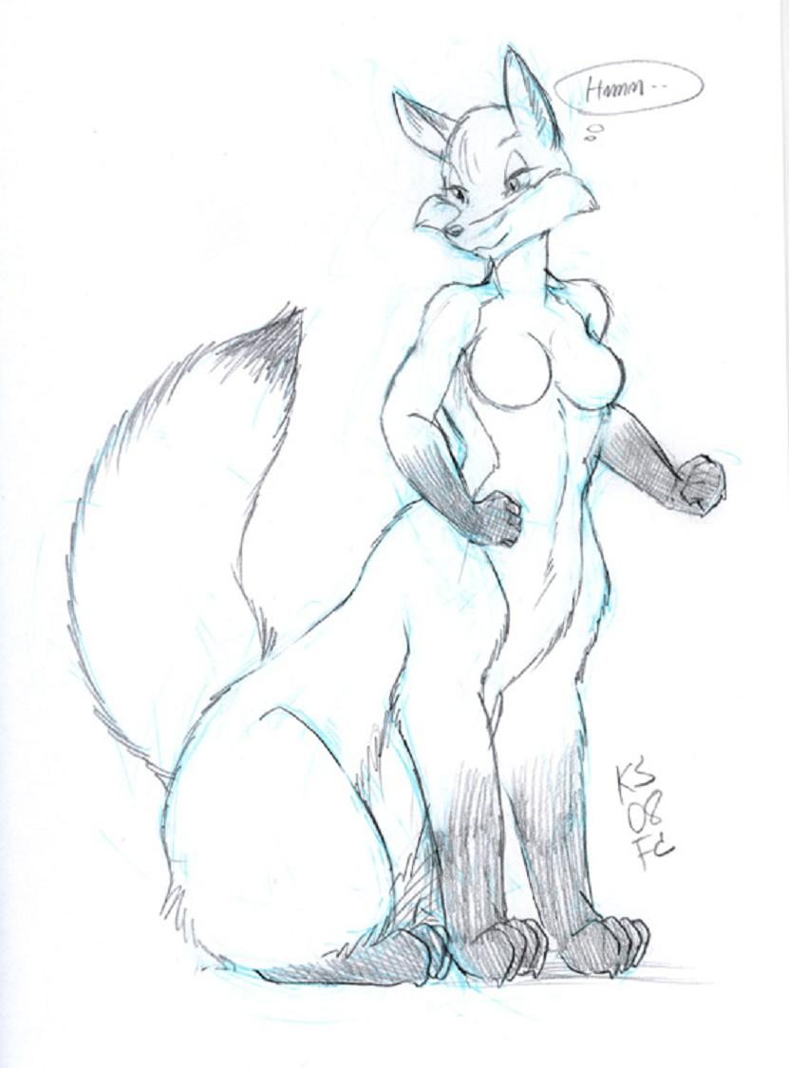

“Oh wow...you’re really good.” Shi said, giving him another quick hug.

“Thanks, do you like.... the.... ummm you know?” he asked, blushing again.

“Like the what?” shi asked, pretending like shi was ignorant.

“Your breasts?” he asked, looking down again.

It was hir turn to blush now, smiling shi said “They are nice, and.. accurate..”

Lupone smiles, then opened the book to the previous pages, and asked “Would you like to see the other drawings?”

“I would love too.” Morgan replied, snuggling up close so that they could share the book between then. He put the book on his lap and showed hir the first picture....
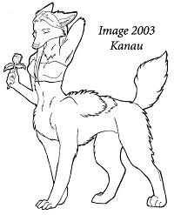
“This is my mom, her name is Kanau...”

“She looks very pretty.”

“Thanks, and..” turning another page; “this is our healer and shaman; Bluemyst. I’m hoping to be like her one day, I feel like I belong helping and healing, not hunting.” He said, with longing in his eyes.
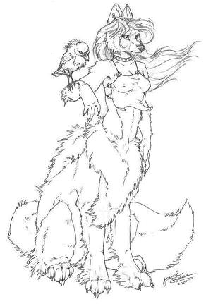Morgan gave his back a soft rub, going from the neck too the join. Shi smiled when his tail started wagging.

Turning the page one more time, he showed hir the last drawing.

This one was more detailed, showing not only a wolftaur, but the landscape.

“And this is my older sister, Shesha, she had just lost her mate in a hunting accident....” he replied, sadness in his voice.

“Oh, so sad, but, you really are a good artist.” Shi said, lightly tracing the lines of his drawings.

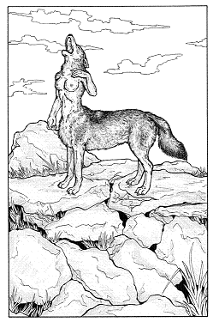

“Thank you, but, my elders, and the Alpha leader believe it’s a waste of energy and talent and time. They say that I should be learning something more constructive, like hunting not drawing.” He said, letting out a heavy sigh, his ears drooping down.

“Wow, your elders are mean.” Shi said.

“Not really, it’s just that they’re set in their old traditions and clan laws.” He replied, looking up again, a little pride in his voice. “They’re only looking out for the survival and welfare of the pack.”

“I see, well, my mom encourages me to follow my heart and to do well in what I want to do... which isn’t much.”

Lupone smiled, then holding hir hands firmly, looking in hir blue eyes, asked, with affection in his voice.

"So, would you like to be my friend?"

Shi blushes as he held hir paw "Sure Lupone.."

Lupone smiled and gave hir a hug, which shi returned in kind. Then they broke from their embrace as the chakat teacher and the rest of the students entered the room.

The other students were 2 chakats, 3 foxtaurs, a tod and 2 vixens, a female wolftaur and a skunktaur. The teacher asked the new students to introduce themselves.

Morgan stood up in front of the class.

“Hello everyone, My name is Morgan Duskstar, I’m 10, and I’m a Tundra Stellar Foxtaur.” Shi said with a smile.

“Any questions?” the teacher asked the class. The female wolftaur asked.. “When will you be getting boobies?”

The class erupted with laughter, the only ones that weren’t laughing was the teacher and Lupone. Morgan blushed, then one of the chakats asked. “What do you wanna be when you grow up?”

"Uh...Well..I'm not sure right now." Shi replied.

The tod asked; "What do you use? Boys or Girls loo?" Then he yelped when the teacher clipped him behind the ear. He looked down in shame.

Morgan frowns at the tod for asking the question. “Enough of the silly questions, does anyone have any decent ones to ask?”

The vixen asked “What’s it like where you’re from?”

"Its very cold...snowing all of the time.."

"Brrr, how do you keep warm?" asked the second chakat.

"Well we already have a lot of fur on our bodies...but we also make fur coats and jackets to wear as well" shi answered, showing hir thick jacket.

“Cool.” Said the first chakat.

“No, warm.. silly billy.” replied the second chakat.

Morgan giggled as shi wagged hir tail.

“I’m not a billy, I’m a chakat.” The first said.

“Quiet,” the teacher shouted, "Now, Morgan my dear, please take your seat, Ummm Lupone, your next, please tell us about your self."

Lupone stood up in front of the class, holding his book of pictures. Taking a deep breath, he told them his name. “Hello, my name is Lupone Silverpaw, I’m 9, and my father is head hunter in my clan." Noticing the wolftaur bitch winking at him, he ignored her. “and I like drawing pictures.” He said, opening the book and showing the class his drawings, blushing as giggles and laughter erupted from some of the class mates at the nudity in the drawings.

"Why are you laughing?" Morgan asked, hands on hir hip.

One foxtaur vixen replies, "He has a tit fetish." laughing hysterically. "Ohh lookie, that's Morgan..." one Chakat said, rolling on the floor laughing. "Shi's got boobies..." The tod foxtaur snickered.

Lupone’s face and ears went bright red with embarrassment, wanting to sink into the floor.

"He does have a tit fetish." the wolftaur bitch replied.

Morgan just stood up and growled, "Your just jealous that he didn't draw you" shi said to the bitch, hir tail twitching wilding in anger.

Lupone just couldn’t deal with the teasing and comments any more, he suddenly burst into tears ran out of the class room.

"Class, quiet!" the teacher roared, and there was absolute silence.

Morgan noticed Lupone running out, and dashed after him, the teacher shouted for hir to stop, but shi wasn’t listening. Turning to the skunktaur, shi told hym to find Lupone and Morgan and get them both back to class.

“Yes miss.” Hy replied, leaving the room.

Morgan and the skunktaur found Lupone under the large tree in the school play ground, he was clutching the book tightly, crying and trembling.

"Lupone!!" shi cried out, stopping next to him and hugging him close, caressing his head of fur and his ears, he cried on hir shoulders, soaking hir fur, hugging hir back.

“They were all meanies..." shi tells him, petting his head softly. He held hir, slowly stroking hir fur as his crying subsided. Whispering how much he loves hir.... Then stops. Uncertain about hir feelings, and look in hir beautiful blue eyes.

Morgan blushes... smiling a bit.. "Really?"

"Yes..." then he looks at the skunktaur, who was smiling, hy got up and said hy'll inform the teacher that you both will return in a little bit, but don't wait to long. Then hy left.

Shi looked back at him, still smiling "If that vixen messes with you again, I'll make her regret it.." He kisslicks hir on the cheek.

"Can I do another picture of you, my sweet?" he asked, looking into hir eyes, smiling.

Shi murrs softly, nodding "Of course Lupone...You can do as many pictures of me as you want...."

Lupone got up, and made hir stand near the tree, then he gave hir a long branch and told hir to hold it both hands, and pose hir head so that shi was looking at him, but not directly. Then he gave hir his coat to wear. Then he sat down, and started drawing, first with pencil, his tongue sticking out of the side of his mouth, as his hands flew with a fury.

After 5 minutes, he nodded, then reached in his bag and produced fine crayons and markers. While he was adding colours, the teacher came out to see what was taking them so long, upon seeing him drawing, and a smile on his face, shi decided to let him be. Shi returned back to the class room.
Morgan held the pose he had put hir in, waiting for him to finish, watching him work so diligently.

Finally, he looked at the picture, and smiled, not a small smile, but a huge smile, then he told hir that he was finished, and that shi could see the final piece. "I hope you like it hun, I imagined you at home, all grown up."
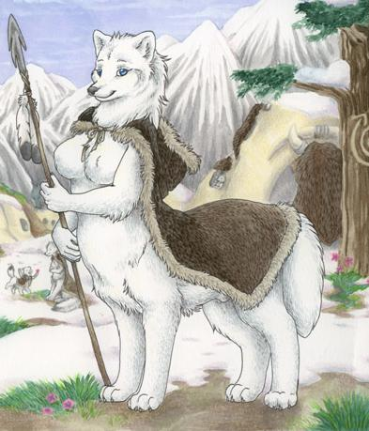
"Oh WOW!!...Lupone...This is quite...amazing.." shi says blushing, hir tail wagging fast, then giving him a great big hug and kisslicks all over his face. He hugged back, feeling hir quickening heart rate, hir fur, hir tail brushing against his hands as he held hir close. He was crying with joy.
"Lets go back and show the teacher and those untalented jerks how good I am, eh?" he said.

Shi nods, he then held hir hand, and holding his book, he slung his backpack over his shoulder and they both made their way back to the classroom. When they got back, the teacher made them both stand at the front, and one by one, the students who made rude teasing remarks, came up, apologised to Morgan and Lupone and gave them both a hug. Then afterwards, when they were seated, Lupone showed the class his latest drawing. There was not one word from the class as his drawing was looked at. Then they all erupted with thunderous applause.

He looked and smiled at Morgan, shi smiled back at him, hir tail wagging fast. He sat back down next to hir, and placed his arm around hir shoulders and gave hir a squeeze. Then his tail curled around hirs, shi murrs softly, cuddling the wolftaur back....

Epilogue.

Sadly, Lupone and Morgan didn’t stay together long in school, while shi continued hir education, he was forced to leave at the end of the week due to his father being injured, and he had to look after the family business.

Before he left, he gave hir the coloured picture he had drawn of hir, to remind hir of him. Giving a heart felt hug and kiss on the lips and tears in their eyes, they bid each other farewell....

