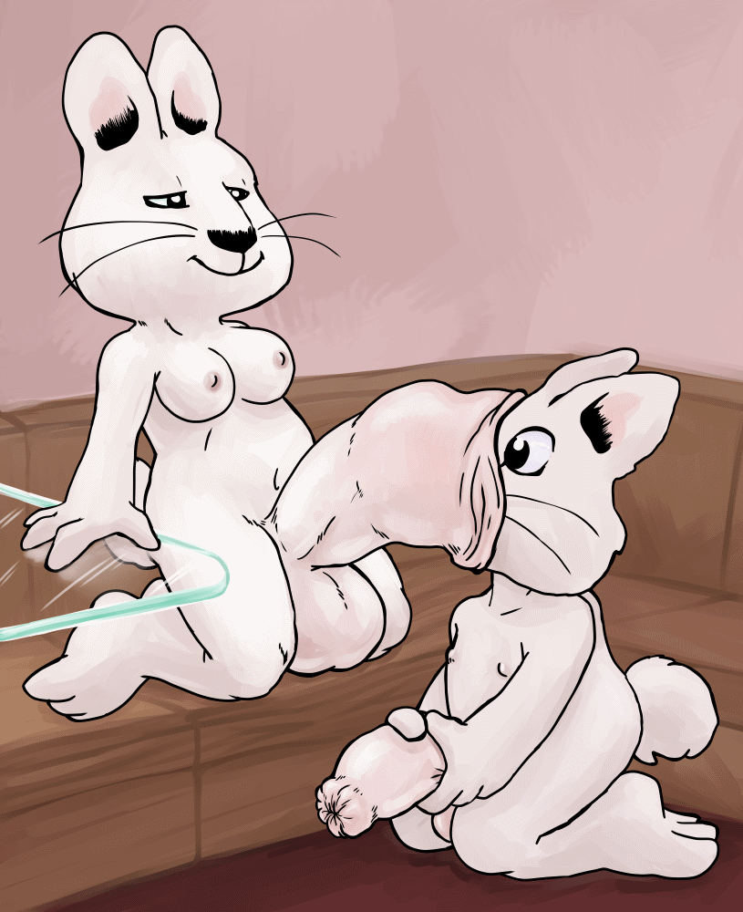
Night night, Max.
An erotic fan fiction by Daniel Mckenzie

Rain fell heavily upon the small house where Max & Ruby lived. It was getting to be quite late in the evening, the darkness outside made even darker by the heavy storm clouds. This thunderous rain made sure that the two young bunnies were inside sitting on the couch together and watching TV, albeit with the signal randomly cutting off due to the weather. Max found it quite amusing, giggling every time the weatherman was interrupted mid-sentence. According to what they had heard of this report, it was supposed to be raining like this all day tomorrow too.
Ruby sighed heavily and glanced to her right to the large grandfather clock sitting against the wall, starting slightly as she realized that it was already half past eight. She had been so bored that she hadn’t even heard the clock chime. She slid off the couch and turned to her brother, still giggling at the broken speech of the people on TV.
"Oh, Max! It’s getting late, we need to get your PJs now. Come along!"
For once, the fairly disobedient rabbit that Max usually was decided to listen to Ruby and got up, stretching a bit before hopping to the floor and following after Ruby as she made her way upstairs. Max's bedroom light was dark, causing Ruby to blindly feel along the wall for the light switch. When she found it, she flipped on the lights, jumping when the bulb popped instantly.
"Not good!" Max exclaimed, tugging on the hem of Ruby's skirt.
Ruby looked down at her brother, framed by the light of the hall and said, “Don’t worry about it Max, you can change in my room.” She smiled, patting Max’s head gently, trying to comfort him. He smiled a bit and Ruby turn from Max’s room, walking away to hers while saying, "I'll change the bulb in the morning. Your room won’t be dark tomorrow."
She stopped before she got to her room as Max pointed into his room and said, “Pajamas!”
Ruby looked back at the room, giggling to herself at her own absentminded tendency and went back to Max’s room. Even in the dark, it wasn’t hard for her to find her brother’s pajamas, which were always in the same drawer her mother put them in. After grabbing his pajamas, she made her way to her room with Max following behind her. When she finally did find the light switch to her room, she flipped it, only for the bulb in her room to blink out as well!
"Well, great!" Ruby muttered to herself. "I think we'll have to get changed downstairs then." Max nodded his agreement to this idea and turned to head back down the stairs while Ruby quickly went to grab her own pajamas.
After catching up with Max, they both walked back downstairs to the living room with Ruby carrying both of their pajamas in her arms. Once back in the living room she turned off the TV and the shut the blinds to stop their peeping tom neighbor from watching them change. Ruby handed over Max's pajamas and sat on the couch, beginning to slowly undress herself. Max dropped heavily onto the floor unbuttoning his overalls and pulling them off. When they came clear, she got a nice eyeful of his flaccid cock. She thought about telling him off for not wearing his underwear, but she couldn’t find it within herself to do it. She was for some reason transfixed by his cock. For his age, Max was well hung down below, easily three times the size any male his age should be. His penis gently swayed from side to side as he struggled to get off his shirt.
Ruby blushed heavily as she let her skirt fall to the floor. Max eventually threw his shirt off and moved to put his pajama bottoms on. Before he could do more than slide a single paw in Ruby slid from the couch and said, “M…Max…can I ask you something?” Max paused, looking over at his sister curiously, wondering why her face had gone so red. Ruby took a deep breath and asked, “Hey Max…have you ever…touched your thing before?” Ruby pointed at his sizable junk and he looked down at it. After a moment he kicked his pants away and spread his legs, gripping his cock with one paw and slowly jerking it off. He looked at Ruby and asked, “Like this?”
Ruby felt her face burning from the erotic display and nodded, stammering, “Y…y…yes, like that…” She fidgeted slightly twisting the hem of her shirt. Rarely changed in the same room as Max, and when she did, she usually kept her underwear on. For some reason though, she had brought a new pair of panties to change into. She took a deep breath then smiled and said “I wanted to show you something...well... Special to me, since we are changing together."
Max smirked at Ruby for a moment and then shuffled forwards towards her, still naked, with his uncircumcised bunny cock gently dragging across the carpet.
"Ok then Max." Ruby's hands were trembling from nerves as she took a deep breath. She gripped her underwear and said, "Promise to me that you won't tell anyone about this."
"Promise!" Replied Max crossing his fingers to enforce his honesty.
Ruby took another deep breath and said, "Alright. Look what I have too!" She pulled down her panties to reveal a soft penis of her own! It was slightly larger than Max's own and her foreskin was slightly looser. Ruby giggled as she watched Max’s eyes going wide, her previous embarrassment fading away. Max was completely mesmerized by the shaft before him. Considering his age, he had never seen another penis other than his own or cared about it for that matter. Max came closer to Ruby, reaching out with a paw to touch her cock. It felt just like his, it was soft and squishy. He wrapped his paw around it as best he could and pumped it experimentally to see if it would behave like his did. Ruby gasped at the sudden wave of pleasure that his her and her cock stiffened slightly.
Ruby bit her lip slightly and asked, "Well...do you like it, Max?" Max didn’t respond as he continued to masturbate his sister. Ruby moaned slightly feeling her cock harden noticeably, jerking slightly as each stroke of Max’s paw sent a wave of pleasure through her. She noticed that Max’s own cock was beginning to stiffen as well. Even at his young age, he was clearly capable of experiencing arousal.
"Okay, I think you've had quite enough fun now, Max!" Ruby quickly stepped back before things got out of hand, pulling up her panties as fast as she could to hide her now rigid cock. She winced slightly as her junk was forced to bend into the fabric. She had had no intention of getting off on Max. Max on the other hand had other ideas. He crouched and suddenly leapt forward, catching Ruby off guard as she fell back against the couch with Max against her. Max grabbed her panties and pulled them down, letting his sister’s still rigid cock spring free. Max slid down between her legs and said, "No! Me wanna lick it!"
Max slowly ran his tongue the underside of his sister’s cock, teasing the tip before running it back down, enjoying it as he would a large lollipop. Ruby tried to stop him, but the pleasure she was feeling was too great. She flopped back against the couch, letting out a soft moan as Max pulled down Ruby’s foreskin licking around the tip before licking back down the rest of her cock, swirling his tongue around her heavy balls, which he hefted like apples.
"Oh heavens Max! That feels really good!" Ruby moaned plaintively with her eyes now completely fixated on Max. Her cock bounced and swayed as Max orally pleasured it, precum was starting to leak out of her cock, Max’s cock dripping a small portion of it to the floor below him. If she had been in any sound frame of mind, she would have wondered where on earth Max learned to do this. But as it was, that was something she didn’t care about.
Ruby groaned heavily, rolling her head on her shoulders as she panted out, “M…Max…No more of that…I want to see you suck it… I want to see my cock buried in your mouth!” Max smiled and gave one final lick up her cock, wrapping his mouth around the tip of it, suckling gently as he was candy. He sank even more of her hard member into his mouth and finally, with a wet pop, into his throat as well. He kissed the base of her cock, gulping and sucking on her shaft in sweet, pleasant rhythms. He pulled back off to her tip and proceeded to give her an honest blowjob. He could taste her precum, which tasted like thick and sweet water with every return to her cockhead that he made, pausing every so often to run his tongue around the tip for extra effect. Ruby was lost in a world of pleasure she had never felt in all of her life, her tongue hanging out of her mouth as she dug her fingers into the seat of the couch, straining as hard as she could to not have an explosive orgasm right at this very moment.
Ruby could finally hold back no more and sprang up, moaning heavily reaching out to grab Max’s head as she came hard. Her hot cum sprayed into his mouth, filling it quickly to capacity, what couldn’t fit oozed from around the cock wedged in his maw, dribbling down his chin and onto his chest. Ruby finally came down from her orgasmic high and flopped back against the couch, breathing heavily from the effort. Max pulled off her cock with a wet “schlorp” and opened his mouth to show off the cum packed inside. Ruby’s cock nearly went erect again at the sight of it. Max smiled at his sister at closed his mouth and swallowed the seed in one big gulp. He licked his lips a bit and patted Ruby’s cock playfully, signifying how much he had enjoyed it
Ruby continued to pant heavily and eventually said, "Oh wow… Max! That was amazing…" Ruby started to recover from her orgasm, managing to push herself into a sitting position. She rubbed her face a bit and said, "I wasn't expecting that to happen, but it felt so good!" She peered over towards her cum stained brother who had her cum all around his mouth and chin. Her cock gave an appreciative twich and she said, "And it looks like you enjoyed the taste of my seed…"
Max nodded but then he noticed a really weird sensation coming from his own cock. Even though he was already erect, it was starting to get even bigger! His balls started to swell, ballooning out as fluid filled them. His shaft started to get fatter and longer, tingling all over as the process continued on. His foreskin even became tighter too, outlining the shaped of his cockhead even more. When the enlargement stopped, his penis was just over twice the size than before.
"Hmm...that's odd." Ruby pondered on why his cock had done this as she looked down intensely at her brother's enlarged member. She scratched her head and said, "I guess it had to do with you slurping up my seed.” After a moment she grinned and said, “I think it's only fair if I return the favor and do the same thing to you, Max."
Ruby slid off the couch and gripped Max’s erect cock between both her paws. Smiling, she slid the tip of his cock into her mouth and attempted to give him a blowjob. Due to his being wider and fatter than he had been before, she had a very hard time to getting it in very far. Getting it deeper than halfway past her tongue seemed impossible, not only was Max's foreskin so tight that it was tricky for her to lick his glans, but also his penis wasn't leaking any precum. This made his cock dryer and her saliva wasn’t doing enough to lubricate it. Even still, Max did start to feel pleasure from his sister’s attentions and when he did finally orgasm, due to his age, it was dry and none of the thick, white cum came out of his penis like it had with Ruby.
Ruby frowned and dislodged his cock from her mouth, the softening penis falling away. She sat back and said, "Well, that’s odd… You didn’t cum anything! I remember reading that boys are supposed to shoot their seed when you rub or suck their penis for long enough."
Max, who had fallen backwards onto the floor, got up and shrugged his shoulders, looking a bit annoyed that he didn't have a climax like his sister had. After a few moments of thinking, Ruby remembered something and smiled smugly as she said, “Oh, Max! I just remember, there are a few other things I can do with my cock." She smiled broader as Max perked up at the prospect of doing more naughty things with his sister. Max stumbled over to her, unused to the new weight of his cock and said excitedly, “Show me!”
Ruby spread her legs out in response and showed off her penis once again to Max. she closed her eyes and focused for a moment. Her cock soon began grow in size, just like how Max's did after he swallowed his sister's cum. However, it kept on growing till it was roughly twice the size it had been before. Her foreskin did not tighten like Max's. If anything, it became looser to the point where a significant amount of foreskin was drooping down, though still looking normal.
Ruby grinned and said, "See? I can make mine bigger too!" She wrapped her paws around her hyper bunny cock and started to stroke it, bringing it back to full hardness once more. Max meanwhile was masturbating his own fully erect cock, clearly enjoying this strange scene. Ruby giggled and said, "And there's more you can do! Try and stick your cock inside mine, Max"
Max looked up at Ruby with a clear look of confusion on his face. He thought that it would be very painful to try and do something like that to Ruby’s cock. His was so sensitive so surely hers must be as well. Nonetheless, he trusted Ruby and got into position, his cock angled towards the tip of her raging erection. After a deep breath, he started to slowly slide his penis into her own. Since her foreskin was really loose, he easily managed to get it in there, her foreskin sliding over his cock like a warm blanket. His progress was stopped however when the tip of his cock pressed against hers. He tried to press on, feeling her urethra opening slightly, but it was very difficult going.
Ruby peered down at the struggling bunny and said, "Here Max, let me try and help you..." She made her cock grow a bit more and suddenly, Max felt his cocktip push its way into her urethra, sinking deeper into her cock. He looked up at her and said, “I’m in!” Ruby smiled and said, “Yes you are! But the funs not over yet.”
At that moment, Max started to feel another weird sensation at the head of his penis, the part that was firmly wrapped inside Ruby's urethra. A strong but gentle force rippled through Ruby’s cock that slowly pulled him further inside her cock. His rigid flesh sinking in deeper and deeper, causing him to move forward until her foreskin was covering most of Max's groin and bit of his balls. Max looked up at Ruby nervously but then started to giggle as a tingling started to spread over his cock. He giggled slightly, forgetting about the situation and said, “It tickles!" Max continued to giggle and the sensations running over his cock. Ruby smiled and said, "Well, it's about to get a lot better!"
Ruby groaned in pleasure as she made her cock ripple and suck the bunny cock wedge inside her in a slow, steady rhythm, the ripples of muscle flowing up and down Max’s cock while the suck made him thrust slowly in and out. It gave both of the two rabbits an immeasurable amount of pleasure, greater than the blowjobs shared by them earlier. She continued making her cock suck and rub Max’s cock occasionally glancing down at Max, who seemed to be really enjoying the feeling of his cock being sucked in and out of his sisters own massive cock. He even wrapped his arms around it, hugging the pale one eyed snake in the process.
As Ruby started to edge closer to her second orgasm, some sticky precum started to slowly dribble out of her, the liquid lubricating Max’s cock, making the movements easier and even better than before. Max was starting to feel odd, a deep, strange feeling was brewing in the pit of his stomach, spreading down to his cock and balls, tingling and warming him from the inside. He felt a deep preasure from within, one that sat in his balls, getting harder and more powerfully with each passing moment that he edged closer to cumming. Ruby’s hyper cock continued to pleasure her brother’s penis faster and faster, sucking vigorously as she desperately tried to get the bunny further inside her
Max panted heavily and groaned as he finally managed to climax properly, shooting several bursts of his fresh and warm cum directly into Ruby's urethra. Ruby gasped and climaxed a moment after Max did, the force of her climax almost as powerful as the last one. Her cock tightened like a vice around Max’s cock and her cum blasted up against his cock. With nowhere to go, Max’s eyes went wide as both his and his sisters cum was forced down his cock and back into his balls, making them swell up larger than before. Ruby eventually loosened her grip on his cock and he fell backward onto the floor, his cock coming free with a wet “pop”.
Ruby was trembling a bit from those last two orgasms that she had with Max. She rubbed her face and asked, "How did that feel? Was it good?"
Max got back up onto his knees, still feeling a bit weird from the sensation of having cum forced back into his nuts. He got a good view of Ruby's cockhead, tucked inside her foreskin, still gaping slightly from the cock that had been recently buried in it. He smiled back at Ruby and nodded.
Ruby grinned and said, "Great! Okay, before we go to bed, I have one last thing to show you, Max."
Max gave Ruby a surprised look. After all they had done this evening, what could possibly be next. Ruby smirked evily and asked, “Are you ready, Max?" Max was too transfixed by her cock as she lined her cock with his head. Max fidgeted excitedly and shouted, "Yes, yes!"
Ruby edged closer to Max and pulled back her foreskin a bit so that it wasn't drooping as much, her cumslit undulating slightly, still oozing cum from the effort before. Max was amazed by the size Ruby's penis, it seemed to be getting slightly larger the more he stared at it. He reached out to touch the foreskin, feeling the warm flesh and the slickness of the cum and pre that had been caught in it.
Max eventually stopped playing with her foreskin, and made to sit back and ask Ruby what was going on. Before could move, Ruby suddenly shouted, "Gotcha!” Max jumped slightly at the sudden shout but before he could move, Ruby thrust forward, her foreskin sliding over Max’s snout and part way on his face, his cold wet nose wrapped by Ruby’s cumslit. The grip of Ruby’s cock was like iron and Max now felt genuinely worried about what was going on. He gripped at the foreskin and tried to pull it back, it was getting hard to breathe with his snout clamped in her the way it was.
Ruby chuckled darkly and said, "This is for all the times you've annoyed me and never listened to me, Max!" There was a danger in her voice that made it clear to Max that this had long since stopped becoming a game. Max desperately tried to pull off Ruby's foreskin from his face, tried to pull his nose from her cockhead, but nothing he tried had any effect on the unyielding cock. It was then that a strong ripple flowed through the cock, vibrating the poor bunny’s whole body as the cumslit widened slowly, a sucking force pulling forwards on his head. He felt the air being pulled from around him, giving him a brief chance to breathe before the cumslit closed around him again, tighter than before and even further up his snout. The bunny began to whimper as Ruby’s foreskin creeped up over his face, blinding him to all except the tunnel of flesh. He tugged and pulled, calling out to Ruby, but it was too late. There was only one place he was going.
Ruby was loving the feeling of Max being inside her cock and being swallowed by it. Her penis was secreting precum in copious amounts to lubricate Max's plump body as he was dragged further in. She could feel him sobbing through her cock as his head was sucked deeper into her urethra. With that done, she hefted her cock and Max up vertically so the going would be easier, Max’s feet and body dangling uselessly in the air. She brought it closer to her, eying the large lump Max made as he sank in past his tummy in her. She squeezed the bulge that Max was making, almost as though she was hugging him through her cock, making him thrash around all the more.
"Yes Max, keep doing that! It feels really good!" Ruby moaned, loving the whole process of cockvoring her brother. The same can't be said for Max. With only his feet and his cock left to the air, Max was crying now, wanting Ruby to let him out, wanting the game to end. He was so tightly constricted that he couldn’t do anything more than squirm. Ruby, smiling at Max’s exposed cock, decided to taste it one last time before Max vanished inside her. She quickly suckled on his penis, sticking her tongue into his own urethra, tasting his and her cum left over from their fun. She gave one last suck of his cock before pulling off with a pop. She then pressed his cock into her stretched wide urethra. With a couple of more tugs and lots of precum and semen oozing out of her penis, Ruby finally pulled the rest of Max into her penis. His feet were yanked down with a gentle 'pop'. The bulge that was max continued to slide down her cock unassisted until he finally passed through into her balls, which stretch out to accomidate her brother’s size, with Max coming to rest in one of her balls.
Ruby collapsed back onto the sofa, her mind fogged due to the immense amounts pleasure and effort it took to cockvore Max. Her cock continued to ooze precum and small amounts of seed onto the floor, adding to the large pool that had accumulated there while she had sucked Max down. Her massive cock slowly began to shrink down, her foreskin settling into place where it had been before this evening began. Ruby smiled as she watched the squirming lump that was Max pressing against her nuts. She cooed at the pleasing sensation and rubbed her swollen balls as Max’s struggling was starting to slow.
She grinned one last time before sitting back and closing her eyes, saying to her balls, "Night, night Max..."
The following morning, Ruby woke up groggily from her deep sleep, the sound of the rain hammering against the windows of her home. She sat up and stretched broadly before looking around the room. It was still dark from the heavy raincloud’s outside, despite the grandfather clock saying that it was after 10 in the morning. She sat up a bit straighter, noticing as she did so that she felt heavier than usually, as she slid off the edge of the coach, it soon became clear why. Her balls were huge in size, and the sloshed heavily from side to side with cum. Ruby wondered why on earth that was until the memories of the night before returned to her. She looked down at her nuts again, remembering that she had put Max in them the night before. But it didn’t sound like he was in there anymore. She reached down and squeezed her nuts, the yielding flesh squishing and moving, with no sign of anything solid inside.
The thought of this brought a powerful wave of arousal over her and she sighed heavily, feeling her cock harden immensely. She also felt a little bad about what she had done, digesting her Brother into cum. She was grateful then that she knew how to reverse it. She hefted her heavy balls up and climbed up the stairs, trying not to lose her balance as she moved. When she finally reached the bathroom, she leaned over the bathtub and plugged the drain, making sure that it was a tight seal before grabbing her cock, pumping away at it with slow careful movements. She seemed to be unusually sensitive today, as she soon felt her orgasm approaching. She groaned and gripped the edge of the tub, aiming her quivering cock down inside as she feverishly jerked off, quickly reaching and flying past her orgasm. She let out a long moan as the first volley of cum fired straight into the Tub. Following on the heels of that one, wad after wad of cumified Max flew from her cock and into the tub until finally, on the last spurt of cum, Max’s cute little bunny tail landed on the mound of cum. Ruby looked at the tail for a moment, smiling a little and leaning against the tub for support after her last, mind numbing orgasm. After a few moments of glooping noise, small patches of color became obvious in the mound of cum, the goopy wads moving and changing shape as they slowly began to reform. Once the shaped of Max became obvious, Ruby reached out and poked the mound. It was still squishy, but steadily becoming more and more solid. Soon, all that was left was Max, laying naked in the tub, covered in cum. His eyes were closed and his breathing easy. Ruby grabbed the fauset and turned on the shower, spraying Max with the cool water. He came awake at once, waving his arms around in an attempt to project himself. He caught sight of Ruby and immediately started to snivel. Ruby knew it was coming and didn’t stop him as he bawled and said, “Ruby! That wasn’t fun at all! It was scary, all dark! I fell asleep and couldn’t feel myself.” Ruby frowned and pulled her brother into a wet hug, patting him gently on the back. When he calmed she pulled away and said, “I know, I’m sorry Max, I don’t know what came over me.” She rubbed his head gently and said, “I’ll make it up to you. I know other ways to make you feel good.” She winked at him and he hiccupped and said, “Do I have to go in there again?” She smiled and said, “No, it’ll be fun this time. I promise.” Max grinned a little and hugged his sister again, glad that everything was better now.
The End.

