Three Volunteers, Four Nooses
9:18 AM
The opening bars of Chopin's Funeral March: "Pray for the dead…"
The skunk picked up his phone. "Simms."
"Your 9:30 is here."
He looked around the room. Clean. No spots, no puddles. "They're early for once. Okay, send them in."
The door opened a minute later. Two uniformed prison guards, a hyena and a wolverine, escorted a bobcat in an orange jumpsuit, "DOC" on front and back. One of the guards handed Simms a sheet of paper.
The skunk read it aloud. "Jarrell Dobbs, you have been brought to the Execution Center to pay for your crimes. You will get the same treatment you gave your victims: to be ass-fucked and then hanged by your neck until you are dead."
"No way! You can hang me, but I ain't lettin' no damn limp-wristed faggot fuck me."
Look, here's the court order. It says to you are to get fucked, just like you did to your victims."
"Yeah, but they enjoyed it. I won't."
"They enjoyed it? All of them?"
"Well, most of them. But there were a couple that yelled for me to stop when I fucked them, and never came."
"So why do you think you're entitled to any better treatment than you gave them?"
"You're getting me all confused. Now I don't know what to do."
"Think of it in practical terms then. There are three of us. These two guards, Wilkie and Garry, have martial arts training. And you're in handcuffs. Do you really think you can resist us?"
"Well…"
"There's an old Chinese proverb, attributed to Confucius: if rape is inevitable, relax and enjoy it. I can guarantee you it'll be less unpleasant if you cooperate. I'll give you half an hour to think about it. Then these guards will put you in the position whether you like it or not. If you decide to cooperate, just let me know."
Dobbs just stood there, scowling. He looked up after about 15 minutes. "Well, I guess you're right. I do deserve it, and I might as well go along with it."
"Good. I'll be as easy on you as I can. One last piece of advice: it won't hurt as much if you just relax. Take a few deep breaths and pretend you're at the doctor's office for a prostate exam, yeah?"
"Uhhh… well, I'll try.
"Smart move."
Simms opened a drawer and got out a short chain with a padlock on each end. He looped one end around Dobb's right ankle, then the left ankle, then locked it in place. He pulled it up, wrapped it around the handcuffs, pulled until Dobb's feet were less than a foot from his handcuffs, then inserted the other padlock. "That should hold you."
"Just do whatever you're going to do."
"Oh, I will, I will."
Simms pulled his own clothes off and laid them neatly on a table, then got out a bottle of lubricant and spread it on his cock. He moved so the head was touching Dobb's little rosebud, then slowly pressed it in.
Dobbs gasped.
"Breathe in, then let it out slowly."
"Ahh… just do it already."
"What? Are you in a hurry to feel the noose squeeze your neck?"
"Not exactly, but I want to get this over with."
"Did you just get it over with when you fucked your victims?"
"No. I wanted them to feel me inside them and know there was nothing they could do about it."
"The same applies here."
"Whatever."
Simms pulled back most of the way, then slowly stroked in again. And again. "Mmmm…. You're so tight." He moved in and out until he found a rhythm that provoked a short moan from the prisoner.
"Hey!"
"What's the matter? You don't want a little pleasure?"
"As the top, yeah. Not as a bottom. And especially not from the guy that's gonna do me in."
"Well, you're going to get some anyway." Simms sped up a little, making sure to rub his glans against Dobbs's prostate on each in-stroke.
"Shit! You're…"
"Yeah, that's the idea."
"I'm gonna… I'm… AHHHHHHH!!!!"
Simms moved in and out as fast as he could. and hilted himself in Dobbs as he spurted again and again."
"Ahhhhh….. damn it, that was good! Why'd you have to do that? Does that make me a faggot?"
"That's for you to decide, not me." Simms pulled out, then got some tissues and cleaned himself off.
"Well, now that's over, you can finish me."
"Well, yes, if you want. But I have almost two hours until my next appointment. That's enough time for you to rest so you can cum while you're hanging."
"Nah. Let's just get it over with. And how about cleaning me off?"
"Nah. You're going to hang with your ass glistening and that last drop of jizz at the end of your dick."
"Shit! Goddam homo!"
Simms took the bobcat by one elbow, marched him up the stairs, and positioned him over the trapdoor split. He slipped the noose around Dobbs's neck, then clipped a pulse-oximeter onto Dobbs's left index finger.
"Now's the time for your last words. Regrets? Curses?"
"Well… If I'd known I was queer I would've treated those guys nicer. Maybe given 'em a handjob before pulling them up. Or even…. oh damn! Maybe just fucked them and let them go? Well, seeing as I'm a homo too, guess I deserve to hang. So do it!"
Simms counted down, "Three. Two. One," and pulled the lever.
The trapdoor opened, leaving Dobbs with nothing but air to stand on. His mouth opened as he fell, but the noose tightened as he came to a sudden stop, choking off the scream before it could get out. His fists clenched behind him. He seemed surprised to find himself still alive. His feet kicked once, then he went rigid as he fought the urge to struggle. He managed to stay in control for nearly two minutes, then started kicking in desperation. His cock slowly stiffened, pointing about 30° above horizontal. He kept kicking wildly in every direction up for nearly three more minutes, then slowly raised his knees to his chest, held them there for a few seconds, then slowly lowered them again.
After that, Dobbs just spun slowly, a half turn to the right, then back to center, and a half turn to the left. And again, and again. A few more, and the pulse sensor went off. Beep beep beep beep…
Another minute and it went to a sustained beep, then went silent.
Simms waited another five minutes, then pushed a button. There was a humming sound as a motor lowered the body to the floor. He picked up his phone again and called for the disposal team, then turned to the guards. "You guys can go now."
They saluted and left.
10:55 AM
The "new text" music sounded. Simms picked up his cell and read the message:
Your 11AM in the waiting room
Simms smiled. This is going to be even more fun than hanging that bastard Dobbs. He walked down the hall and found three men sitting in chairs. All three stood up when they saw him.
"Sir," said the badger.
"You three are my eleven o'clock, right?"
"Yes, sir. I'm Hayden, this," he touched the jackal, "is Bryce, and this," he pointed to the Springer Spaniel, "is Aristide."
"Thank you. I'm Remington Simms. Any special requests?"
Hayden held out a 5"x8" memo pad sheet. Simms took it and looked at it briefly. "Okay. It says here that Master Jordan sent you to be terminated by hanging, right?"
All three nodded, smiling. "Yes," Hayden said. "Master decided to discard us, and we begged to be snuffed instead of freed."
"And Aristide is afraid of heights. Hayden, you and Bryce get hanged, and… Hmm… I should arrange things so your weights strangle him while you dance." He thought a moment. "I know just what you need. Come with me." Simms led them to an elevator, followed them in, and pushed "B".
The doors opened again on a cement-floored corridor. "This way," Simms said, leading them down the corridor to the left. He stopped at a door with "B04" and "Special Executions" stenciled on the doorplate. He held his badge up to the plate. There was a click and he pushed the door open, then turned to face them.
"Once you enter this room, your lives end for legal purposes. You will die in accordance with this." He held up the memo.
"Yes, sir." The three walked in, he followed and closed the door.
"Are you guys in a hurry? You could watch your immediate predecessor's execution if you want to.
"Who's that?"
"Jarrell Dobbs, the serial killer."
"Oh, yeah, that would be hot," Hayden said. The other two nodded.
Simms touched a button and a screen lit up. He tapped the "previous executions" button and got a list. A couple more taps selected "Jarrell Dobbs" and four screens lit up on the back wall of the room. One more tap and the whole scene started playing back.
The three would-be hangees watched, fascinated. All three had bulges in their trousers by the time Dobbs's trapdoor opened, and Bryce's hand strayed toward his crotch, then he realized what was happening and put it back by his side, only to have the same thing happen twice more.
"Wow! That was…" Hayden started, then trailed off.
"Just wow!" Bryce said.
Simms turned off the screens. "I don't have any other customers until 3. We could make a daisy chain. Then you could have an hour or two to recover so you can properly enjoy your hangings."
The three ex-slaves looked at each other and made some hand gestures that Simms didn't understand. Then the badger shook his head. "That would be enjoyable, but Master Jordan expected us to get terminated fairly quickly. Watching Dobbs get fucked and then short-dropped didn't take much time, but waiting an extra hour to regain our ability to cum just wouldn't… seem right."
"Okay, it's your necks."
"True," Bryce said, then paused. "But… one of us could give you a blowjob. Whoever gets the honor would sure enjoy that."
The other two looked at him, then Aristide said, "Yeah. But how do we choose?"
"Coin flip?" Bryce asked.
The other two nodded.
Simms opened a drawer and got out three dimes and gave them to the discards. "Here. Odd man sucks."
All three nodded.
"On my count. Three…two…one…Go!"
All three flipped their coins, then caught them on their wrists with their other hands. They uncovered to reveal… all three had "tails".
"Let's try again. Three…two…one…Go!"
This time Hayden and Aristide both had "tails", but Bryce had "heads".
Brice said, "Oh, good." He started to kneel down, then said, "I have an idea. Imagine the three of us, me and Hayden kneeling on our trapdoors, ari in the middle. I suck our executioner. Then I collect his cum in my mouth, he pulls the lever, and there we are, me and Hayden dangling in our nooses, Aristide strangling in the middle. I'll be tasting cum while I hang, and all of us get to enjoy our final ride. What do you think?"
The other two ex-slaves nodded enthusiastically. "Sure. We can arrange that," Simms said. He picked up his phone and dialed.
A few minutes later two workmen in dungarees came in with a powered cart and a folding ladder. The room was reconfigured in less than five minutes. Hayden and Bryce were kneeling on the two trapdoors. A small table was bolted to the floor halfway between them, with Aristide's calves firmly tied to it. The two ropes dangling from the ceiling now had pulleys at the ends, and a single long rope encircled Aristide's neck, then passed through the pulleys to end in two nooses. and Hayden and Bryce were kneeling on the trapdoors with nooses around their necks, and Aristide was kneeling on a low table with the connecting rope looped around his neck, Bryce had a cuff around his left wrist, the other cuff open; the other two discards had their hands cuffed behind them. And all four were naked and half-erect in anticipation.
Simms brought out three pulse sensors and clipped one to each of the soon-to-be hangees' left index fingers, then stood in front of Bryce, who wrapped his free hand around Simms's cock and squeezed it a few times until it was hard. Then he wrapped his lips around it and licked the frenum.
'Oh, that's nice," the skunk said.
After a few seconds, Bryce slid his lips all the way down Simms's cock, then up until his lips touched the area where the head and the shaft meet. Then down again and up again. He kept this up for a few minutes until Simms started moaning, then shortened his strokes.
After another few minutes, the skunk was begging. "Please… please…"
Bryce started flicking Simms's frenum with his tongue on every upstroke. Less than a minute later Simms howled as he came.
Bryce moved slowly up and down a few more times, then pulled away and opened his mouth to show Simm's jizz. He reached back and fastened the other cuff around his right wrist. Then he smiled. "I think we're ready."
Hayden and Aristide nodded.
Simms, still looking blissful, pressed a button. Two trapdoors opened. Bryce's and Hayden's feet fell, jerking the noose tight around their necks. The tension on the rope squeezed Aristide's throat shut.
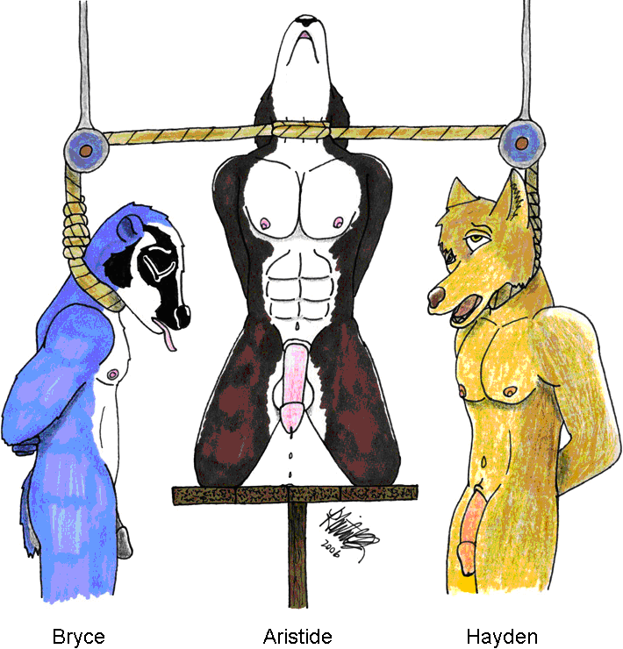
Drawing by Felixpath
The badger went completely rigid, fighting the urge to struggle. Bryce forced himself to relax - except for his fists clenched in the handcuffs. Aristide tried to stand up, but that increased the tension on the rope, pulling it even tighter, so he stayed on his knees.
After a minute, Bryce was the first to give in to the strangling sensation, his feet pointing down, then up, then down again, then kicking forward and back. Hayden stayed unmoving for another thirty seconds, then also started kicking.
Bryce knew it was useless to fight the rope: any motion made the rope tighter, but he occasionally leaned forward or back just to be doing something. Or, perhaps, to extract maximum enjoyment from his last few minutes. No way for Simms to know.
The jackal, already excited from sucking Simms, was fully erect in less than a minute. Aristide was next, at just over two minutes, Hayden following suit a few seconds later.
All three were leaking precum within three minutes after the trapdoors fell.
Aristide was the first to cum, his semen spurting up into the air, then falling between his knees onto the table. Simms had expected Bryce to be first: he'd been quite excited from sucking Simms off. But the spaniel was closer to losing consciousness: the rope was squeezing his neck with the combined weight of the other two discards.
Bryce had his turn a couple of minutes later, his jizz arcing up, then down to the floor of the death chamber under the floor.
Aristide's pulse sensor beeped a half-minute later. Hayden came only a few seconds after, perhaps triggered by the spaniel's death, perhaps Hayden had just reached that point in his path to eternity. Bryce survived another minute before his sensor went off.
Simms watched as Hayden's kicking slowed, then stopped, and he dangled limp in the noose. Then one knee came slowly up to his chest, relaxed leaving his toes pointing downward. Then the other knee. There was no more movement after that except for the slow twisting back and forth in the noose.
Hayden's heart stopped beating three minutes later. The job was done; it had been a very enjoyable morning.
Simms summoned the disposal team and went to a nearby Chinese restaurant for lunch. He returned to his room, just in case another volunteer showed up, and watched YouTube until 5:30 PM, then unlocked his bike and pedaled home.

