Rushing Eta Nu Gamma
by A. P. Damien and Zen Charisma
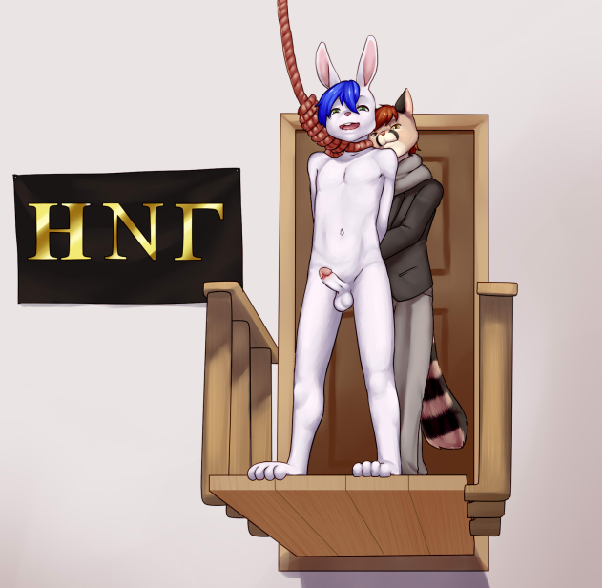
The little bunny looked around nervously, then at his schedule of classes. Most of his classes were in two buildings, but he had no idea where they were. He looked around and noticed a two-story building with ΗΝΓ in bronze letters over the fancy double doors, and decided to go in and ask where Dolcett Hall was.
Zen was surprised when he walked through the large double doors. The area inside was dim, especially coming in from the full sunlight of a clear September day. But the far end of the large room was lit by a skylight. There were six raised platforms set in the far wall, each about 4 feet wide and 3 feet deep. There was a noose dangling at about chest height about 2 feet in front of each platform.
The bunny heard a throat-clearing noise and saw a genet lounging in an overstuffed chair. The cat-like upperclassman was wearing a blazer with a patch on the upper left chest: a noose and the Greek letters Eta Nu Gamma.
He looked Zen over and plainly liked what he saw: he licked his lips and the his gaze lingered on the bunny's crotch. "If you're looking to join, Rush Week starts next Monday. Would you like a pamphlet on our fraternity?"
The little bunny looked around curiously, then perked his ears and looked at the genet "Huh? Um... Sure.... but actually I’m looking for Dolcett Hall," he said a bit shyly
The genet stood up, opened a drawer, and pulled out a folded-up pamphlet.
"Here," he said, offering the pamphlet to Zen, "This lists the benefits and requirements of Eta membership." He unfolded it to the last two pages. "And here's an oversimplified map of the campus. It shows where we are, but also some of the major buildings at Gasper U." He circled two black rectangles. "We're here, the Admin Building is there, Dolcett Hall is behind the Admin. Go out the door, turn left about 200 yards, then right about 120 yards, then between these two tall buildings and you're there."
He paused, "Come back here Monday evening for Rush and I'll give you a kiss."
Zen felt his face heat up under his fur at the mention of a kiss. He looked at the map and nodded, then smiled and thanked the genet. He walked away for his first week of classes with his little bunny tail wagging as he walked and a small smile on his face.
The bunny knew his way around the campus pretty well by Monday evening. He returned to the HGN building and knocked on the door.
A tapir wearing a black shirt with the HNG patch opened the door. "Frosh? Here for Rush week? Come on in."
Zen smiled and nodded, then walked in and looked around curiously "I was told to come here tonight."
"Sure. Come in and have a seat."
The genet that Zen met before was up at the front of the room, talking about the benefits of Eta Nu Gamma membership, with the help of slides, photos, and movie clips on an 8' wide TV screen.
“Thank you,” the bunny said. He found a seat and sat down to listen.
The genet was talking about the parties, where they drank good wines instead of keg beers like most frats. He showed photos of some of the bottles, and they were noted vintages. The view changed to show students with glasses of wine, sitting on two-seat couches or snuggled up close in big chairs. Then the genet talked about the frat’s parties: sex with both male and female students, often with strangling or other forms of breath control. He showed movie clips of the "action.” Then he became more serious as he talked about the possibility of flunking out. “The Uni will take care of them, of course, but that’s a long drop, not very exciting. So if an Eta is flunking out, he will usually choose to be hanged here instead. And some non-members come here when faced with the same unfortunate choice.” This was accompanied by several more clips, but all of them ended while the hangee was still kicking.
The genet then turned the podium over to "Peter Byron, President of the Gasper U chapter of Eta Nu Gamma," to discuss the Rush week festivities.
Zen watched the movies with his eyes locked on the victims. His cock twitched just thinking about a noose tight around his neck while other students watched him kick. “They’ll cut me down before I die,” he assumed: none of the clips had shown the victim dying. He looked around at all the malefurs and again felt his face heat up over all the talk about sex. Then he turned his attention to the new person at the podium.
"Thank you, Whitney," the okapi started. "I want to make clear to all of you that membership in Eta Nu Gamma is not just fun and games. We are a serious group of students..." he paused while many of the audience -- both freshmen and older members -- laughed, "... really, we are. We enjoy life, but we also aim to be the best of the best — here at Gasper U and all other universities that have Eta Nu chapters. Etas aim to be the best students and the sexiest gaspers in the world.”
"So, responsibilities. Not just paying your chapter dues," (more laughter) "but helping your fellow Etas when they have problems. If somebody has trouble understanding something, another member will step up and help. If somebody is facing a dilemma, other members will give helpful advice and emotional support. And if somebody has financial problems, we will get together and make a loan to help him get by.”
"But beyond that, we have responsibilities to Eta Nu Gamma as a whole -- a reputation to think of. What that means for you is: we expect you to be someone who cares: about your brothers, about Eta Nu, about Gasper U, about the city, and about the world. And to care about the reputation of Eta Nu Gamma. We expect you to be good, even great scholars in gaspology and the related fields that are taught here at Gasper University. And if it turns out you can't make the grade and you find yourself about to flunk out, we expect you to do the right thing.
"What is the right thing? Not to slink off into the night and pretend you were never here. Not to leave it up to the University to longdrop you with a sudden crunch and no kicking. No, we expect you to stay here and have a 'going away party' that will leave you remembered in the annals of Eta Nu gamma. To take pleasure with as many members as you have time for, and then to be hanged, either here in our main room or outside where the whole campus can watch you kick, struggle, and die.
"In short, to be an Eta is to be a man."
Byron paused and looked over the frosh in the audience. His gaze lingered a few seconds on every single face, including Zen's. Each one got the feeling that the Chapter President was looking into his soul.
"The brothers will now give you all glasses of one of our wines to sample. Then Ormande, our Froshmaster, will explain the rules for rushing Eta Nu Gamma."
The bunny listened, laughing along with the others, but what really impressed him was the thought that he might have to die with other furs watching — and especially the idea of making that exit outdoors with the whole campus watching. He smiled and continued listening. When the speech ended, he looked around for the genet, the one who’d promised him a kiss if he came back.
The genet spotted Zen first and came over. "Hi, frosh. I'm Whitney, and I'm on the selection committee for new pledges. He knelt down next to Zen's chair and leaned forward, his face a few inches from the bunny's.
Zen smiled at him "Hey... I’m Zen, nice to see you again," the little bunny said, his fluffy tail wagging behind him.
Whitney grabbed the bunny's head and kissed him fiercely.
Zen made an “Eep!” sound and blushed a deep red, enough that it showed through in places where his fur was thin. His ears perked straight up and he returned the kiss.
The genet held the kiss until breathing became an issue for both of them. Then he broke off. "That was really nice. I hope you will join Eta Nu Sigma.”
Zen took a few breaths, recovering from the kiss, then nodded. "Yea, it was heh heh. Thanks"
“But this next part is really important to you, so pay attention to Ormande."
The bunny nodded, and turned to look at the front of the room.
A smallish duiker took the speaker's rostrum.
"As Froshmaster, it will be my job to make sure that our new members -- whoever they turn out to be -- are properly initiated into Eta Nu Sigma. Don't worry, though, you don't need to swallow any goldfish.” (laughter) “I can assure you that you will enjoy initiation as an Eta."
He paused and made a hand signal. The screen lit up again, showing four young malefurs, each sitting in a chair: a jaguarundi, a springbok, a panda, and a guinea pig.
"We expect to pledge six or eight new members this year. That means our selection committee will choose between 24 and 32 of the frosh who sign up during Rush Week. Then comes the final test: only one in four will be accepted as pledges. Groups of four will be randomly drawn from those chosen. Each group of four will then undergo a breath control test, like this quartet from last year."
There was motion on the screen. Older furs wearing the HNG badge tied the four frosh into their chairs. Then they looped a piece of rope around each candidate's neck. The rope was attached to some sort of machine behind the chairs.
"You will be tied into a chair, like these candidates from last year."
The camera zoomed in on one of the candidates, a hedgehog, focusing on his right hand, which was holding down a large red button.
"All four machines will start simultaneously."
There was a humming noise from the screen, and the camera pulled back to show the candidate, the rope digging into his neck.
"If you are among those chosen, you will sit in a chair like these. A rope will be pulled tight around your neck."
The camera pulled further back to show all four, sitting there, looking nervous, their bodies tensed as they struggled to breathe.
"The strangulation will continue until you take your hand off the button. Then the rope will loosen and you will be able to breathe again."
The action on the screen sped up, the bodies writhing in the chairs. Then one hand came up and the action slowed down again. The camera zoomed in to show the springbok panting with the rope now loose around his neck.
The action sped up, then slowed down as the panda let go and sat there panting. Fast motion on the two remaining, then the jaguarondi slumped down. He lolled in the chair, breathing hard, the rope now loose around his neck.
The Froshmaster paused the projector. "The one who lasts the longest before opting out or losing consciousness will be invited to pledge Eta Nu Gamma."
The action resumed. A few seconds later, the last rope released and the guinea pig sat there, breathing deeply and looking a bit disappointed.
"So you want to last as long as you possibly can, for two reasons. First: only the one with the most stamina gets to become an Eta. Second: whoever gives up first will be hanged."
Zen felt his cock hardening a bit as he watched this. He smiled a bit when it was done. "Heh, I could do that no prob,” he boasted.
On the screen, older Etas untied the four candidates. The guinea pig was given a shirt with the frat's badge on the sleeve.
"I'd like to introduce Toller, one of our new members from last year." The guinea pig came forward from the crowd, shook hands with the Froshmaster, bowed to the audience, then returned to stand with his frat brothers.
On the screen, four of the older Etas came up to the springbok. “That’s Darden,” the Froshmaster said. The springbok looked around, slightly confused, then apparently realized what this meant. He smiled rather weakly, but allowed an uncia to take him by the elbow and lead him up to the second floor.
The video cut to a medium shot of one of the platforms at the back of the room. The springbok appeared through a door. The uncia guided him to the center front of the platform, and a marmot tied his hands. The uncia reached out, pulled the noose toward him, and dropped it over Darden's neck.
"Are you ready?" the asked.
"Y-yes," Darden said hesitantly, but his cock was erect, nearly touching his belly.
The uncia put his hands in the small of Darden's back and pushed him off the platform. Darden fell about three feet and the noose tightened around his neck. It all seemed to happen with frightening speed; the springbok came through the door and less than five seconds later was hanging.
Bristol watched the video intently and bit his lip as he watched the blond dancing.
Darden just hung there for a few seconds, looking confused, then he began to kick. He kicked harder and faster for a while, then he seemed to lose track of what he was doing. His eyes wandered, and his hands relaxed a bit in their bindings. His feet kicked more weakly now, irregularly.
Then his hips pumped the air rapidly about ten times. He came, spraying the watchers below with drops of his seed. Then he seemed to relax, his feet twitched a little but there was no other movement. This continued for a minute or two while the audience moved slightly so they weren't standing directly in front of him. A stream of piss came out of his cock. And a few seconds later, Darden’s body dangled there, swaying slightly but otherwise not moving.
"We had to notify Darden's family, of course," the Froshmaster continued, "and five other failed candidates. All six of the successful candidates pledged Eta Nu Gamma. Five are now members in good standing, but Wolfe Honeycutt flunked out toward the end of his freshman year. That was the lobo you saw in the earlier vids. Of the other twelve candidates, eleven pledged less selective fraternities, and the twelfth decided not to join Greek society but finished his freshman year in the top 10% of his class."
Zen murred softly as he watched Darden die "Mmm,” he whispered to his new kissing buddy, “It will be fun watching that for real. I’ve always had A's in all my classes, and I’ve outgrown my asthma" (I hope... he thought) "Can I try out for it?"
"As long as the committee approves you.” Whitney kissed Zen again. "If your social skills are anywhere near as good as your looks, you should have no problem." He looked at the bunny, evaluating him. "Were you thinking about watching the loser hang? Or about yourself as the loser? If the latter, I’d advise you not to fantasize too much about it. It may happen, but if you get too much into it, that’s the surest way to end up at the end of a rope like Darden did."
Zen kissed back again and let out a soft little moan. Watching. “But I wonder what it feels like."
"Well, we can arrange that, if you feel like volunteering as a demo. How long would you like to go? 15 seconds? 30? A minute? I don't recommend more than a minute your first time, in fact 30 seconds would be better."
The little bunny shrugged "Um... I don’t know...30 seconds I guess, doesn’t sound too long."
Whitney hurried away to talk to Peter. The lynx grabbed a microphone. "Gentlemen and, uh, frosh, I've just been informed that we have a volunteer for a hanging demonstration. The volunteer will hang for less than a minute, but it will seem longer to you, and I can assure you it will seem much longer to him."
Whitney came back. "Okay, bunny, you're on. Come with me."
Zen felt his cock stiffen as he thought of hanging in front of all those furs, but he smiled proudly and followed the genet.
Whitney led Zen upstairs to the second floor. He paused at a door with a drawing of a noose on it. "There's a shelf here for your clothes," he said, pointing. "All our hangings are done naked."
Bristol looked at the door and gulped a bit, then took a deep breath. The way his face felt, he was sure his blush would be visible even through his fur. "U-um...okay" the little bun said nervously. Then he stripped out of his clothes, leaving them on the shelf.
Whitney opened the door and led Zen out onto the platform. Looking around, the bunny saw it was the one in the center of the wall, easily viewed from almost all of the room below.
"Cross your paws behind you, kid."
Zen slowly put his paws behind him, his cock hardening as he thought about what was coming next.
Whitney tied a rope tightly around the bunny's paws, then led the bunny out to the edge of the platform. He reached out and brought the noose over, slipped it over Zen's head, and adjusted it to be just snug around the rabbit's neck. The genet pushed a button, and the rope moved upward until almost all the slack was gone. Zen gasped as the noose was tightened a bit, and he clenched his paws then looked at the crowd again.
"Whenever you're ready, bunny. You can walk off or I can push you."
Zen stood there, not moving except for a small case of the shakes from his nerves. His cock was already at full stand as he stood on the edge. "W-will you push me?" he whispered.
"Sure." The genet gave Zen a firm shove, forcing him off the edge of the platform. The rabbit fell only 3 inches, but the sudden stop at the end jerked the noose tight around his neck. He managed to hold still for a few seconds, then started kicking and jerking his arms, thrashing as he tried to breathe. tried to free his hands. As he hung there, he noticed that the opposite wall, over the front door, was mirrored all the way across at just about his eye level. He could watch himself hang. He also noticed Whitney’s eyes watching his face in the mirror, occasionally glancing upward at the clock. The seconds went by...
5... 10... 15...
Zen kept on thrashing and kicking, slowly getting weaker as the seconds ticked by. The little bunny pedaled his legs as fast as he could, his hard cock throbbing with need.
...20... The crowd was chanting for Zen: Bun-nee! Bun-nee! Bun-nee!
25... 30. Bun-nee! Bun-nee!
Whitney reached out, grabbed the rabbit, and pulled him back onto the platform. He quickly removed the noose and freed Zen’s hands.
"That was thirty seconds," he whispered, “How was it?"
Zen, still weak from his experience, gasped hard, panting to catch his breath. He coughed, then panted some more. Finally, he managed a smile. "oh, yeah... That was fun." he said as he rubbed his wrist "Is there... um... a spot where I can paw off?"
"Right here, if you like. Or I could help you..."
The bunny started to paw himself, then stopped and perked his ears up "I-if you wanna..."
“My pleasure!” Whitney grabbed Zen and kissed him again. He spit into his hand and reached down to grab the hard bunny-cock. He started stroking it with one hand while rubbing the bunny’s chest with the other... slowly at first, then faster as the rabbit's breathing sped up and his moaning grew louder.
Zen kissed the genet back with enthusiasm, and humped into the offered paw. Then after a few seconds he tensed up and came hard in Whitney’s paw... mostly. Some fell over the edge of the platform.
The crowd reacted, chanting Bun-nee, bun-nee over again, faster and faster in time with the genet's paw, and then "Bun-nee cum! Bun-nee cum!"
Then there was applause and cheers. Zen had instantly become very popular with both members and visitors.
The bunny panted softly and smiled, his ears perked up proudly as he chuckled a bit. "Heh! I like it here"
More applause. When it had died down, Whitney led Zen back down to the main floor.
Peter's voice came over the PA system. "Okay, that's the end of the formal part of the evening. The selection committee will announce its choices on Thursday, and the final test will be Friday evening. For now... let's party!"
He left the big screen playing scenes of the candidates being garroted, and of the hangings, including a replay of Zen's recent demo.
"H-hey can I get my clothes?" The little bun asked as he followed Whitney back through the door.
Whitney turned away toward the stairs, then turned back. "Clothing optional here. Tonight and every night this week."
Zen considered the offer, but decided he wasn’t ready to go mix with the crowd with his junk hanging out. He picked up his clothes and giggled as he started putting them on. “Heh, heh! That’s all right!”
Whitney went downstairs to join the party. Within half an hour, his comment proved true: about a third of the furs there were naked, and if you counted the ones wearing only briefs it came to over half.
Looking around at them as he sipped some wine, Zen decided he was being silly, and pulled his shirt off.
An hour later, the party had gotten pretty wild. Most of the participants were at least a little high on the wine (and a few craft brews somebody had shown him in a big ice chest behind the screen). There was no "actual sex," but a lot of kissing and groping, furs getting handjobs, frotting, or rubbing against each others' bodies. But Zen was too satiated from his hanging plus handjob to really get into it that night.
————————————————————————————————————-
The bunny came back on Tuesday night. He let the speeches just wash over him without paying attention, instead, he looked around the room for attractive furs. But he watched the videos with the same rapt attention as on Monday night. Most of the pics and videos were the same as last night’s, but when it came to showing the “final test,” they showed a different group of four. This time the winner was a marmoset named Spooner, but the real treat was the loser from that group, a hyrax named Tipton. He lasted less than 30 seconds, then sat there quietly with a small smile on his face. Zen wondered if he had done it on purpose, but realized there was no way to really know.
When the four upperclassmen came to untie him, he stood up at once and said, “Let’s go.” As before, the video cut to the platform. Tipton came walking out onto the platform. No, not walking: he strutted onto the platform, walking forward to the edge, then standing so far forward it seemed a miracle he didn’t fall off, then crossed his wrists behind him. His dick stood straight out, and seemed to be coated with something shiny. Zen looked at it and thought, “somebody sucked him.” A wolf and a polar bear strolled out after him; the bear tied his wrists. He stood there a couple of seconds, until the wolf whispered something. Zen remembered from his own brief hanging: “You can walk off or I can push you,” The hyrax shook his head, and leaned forward as if starting a swan dive.
The noose took his weight instantly. He hung there, looking off into space. No, he’s admiring himself in the mirror, Zen realized. He had good reason, he was very good looking before, and now with his head tilted and his neck stretched, he looked incredibly hot. Then he started kicking... no, dancing. He was actually doing the Lindy Hop in the air, showing off. But that only lasted about 30 seconds, then the Chinese boy ran out of air and started actually struggling, kicking, hands trying to pull loose. Even then, though, he had this “oh, yes, do it some more” expression on his face, and precum dripped from his cock in a steady stream.
Tipton went on like that for some time, then came, spurts of thick white stuff flying off the end of his cock and out over the audience. Once that was finished, he just hung there, kicking slightly, looking like he wished he had a cigarette to smoke. Then he looked straight ahead again, apparently liked what he saw because he smiled. A few seconds later his eyes became unfocused, staring off into space. Not fully unconscious, but not really there either. The kicking quieted down to the usual small tremors, then stopped altogether as the hyrax went limp.
Nothing much happened after that. Not even the expected stream of urine, only a few random drops fell on the seats below him. He emptied his bladder in advance. He must have expected this!.
————————————————————————————————————-
When Friday rolled around, the little bunny happily went back to the HNG building and knocked on the door, fluffy tail wagging happily behind him. Whitney greeted him as soon as he walked in, and handed him a release form to sign.
I, _________, acknowledge that the final test for Eta Nu Gamma membership involves a significant risk of injury and death. I have been informed that only 1 in 4 of those taking the test are allowed to pledge at HNG, and that 1 in 4 will die during the test.
I am also aware that the test and its aftermath will be performed naked, and that it will be recorded for later viewing. I give my consent to the use of my image, to be viewed by HNG fraternity members, pledges, and guests, but only within the confines of a HNG fraternity house. This consent was given without monetary compensation, in return for the opportunity to become an Eta if I pass the test, and regardless of whether I pass or fail the test, or whether I survive the test or not.
(Signed) _____________________________________ (date) _________________
After handing him the consent form, Whitney winked. "Read that carefully, and consider whether you really want to risk your life to become an Eta. If you have any questions, feel free to ask me or the Froshmaster over there." He pointed at the little duiker, now in a royal blue blazer with the HNG badge on the chest.
There were several other frosh already there. Some were still looking at their consent forms -- one was eyeing it as though it were a rattlesnake. Others were just sitting or standing around, naked, already partly erect.
Zen read over the form and bit his lip, thinking about the noose around his neck only a few days ago. Finally he dated and signed it, then offered it to Whitney with a smile
"Excellent," the genet said, and led Zen to a seat in the front row. "Candidates get the best seats."
The Froshmaster reached into a hat and pulled out four names. “Clement... Tranter... Leroy... Maynard. An ocelot from the second row, and a cougar, a marten, and a cacomistle from the front row stood up. Four upperclassmen led them to an alcove where they shed their clothing. They sat down in the garrote chairs and were tied in. The Froshmaster pushed a button, there was a humming sound, and four ropes tightened around four necks.
The four candidates sat there as quietly as they could, but soon began struggling. In less than a minute, three of them were sporting boners. But Maynard seemed to be in distress. He let go in just another thirty seconds and sat there panting, looking unhappy. Clement and Tranter were the next to fail. The marten held on until he started dripping pre and his eyes wandered randomly around the room. Then he seemed to forget why he was there and let the button up.
Zen sat down and fidgeted a bit while he watched, murring a bit as the four candidates got choked and each slowly gave in.
The upperclassmen came and untied the candidates. The two big cats returned to their seats without bothering to grab their clothes. The Froshmaster and three other large upperclassmen took Maynard, the cacomistle, upstairs. A few seconds later he was hustled onto the center platform, almost directly in front of Zen. His hands were already tied. The Froshmaster put the noose around Maynard’s neck and unceremoniously pushed him off the platform.
The rabbit smiled as he watched the three sit back down. Then came the payoff as Maynard was pushed off the platform, and dropped right in front of Zen. The bunny watched Maynard intently: his every move, the kicks, the struggles, the rope, and especially the doomed freshman’s cock.
Maynard’s performance was quite different than in the video from last year. He didn't have an erection at all at first, it was completely limp and shriveled when he was brought out. He gave a squawk as he was pushed off the platform, and began thrashing immediately.
The kicking eventually quieted down a little. Maynard's eyes began to glaze over, and then his cock started to rise. But it was obvious that the poor guy was unconscious by the time he was fully erect. His feet trembled slightly as his body twisted to the right, then the left, then right again. At last he ejaculated, but only a couple of spurts.
Zen watched, his cock hardening in his pants as the cacomistle slowly succumbed to the rope.
The llama seated behind Zen tapped him on the shoulder. "He's nearly gone. You might want to move — to protect your clothes."
Zen looked back at the llama then scooted to the left. Sure enough, a few seconds later, poor Maynard let loose a stream of urine that spattered on now-empty chairs. Frat members handed out towels and some of the remaining candidates wiped the chairs off before returning to their seats.
The marten, Leroy, was given a terrycloth robe with the Eta badge on the sleeve. There was a round of applause for the new Pledge.
The Froshmaster reached into the hat and started pulling out more names:
" Lowe" -- a pig stood up and goes to the alcove to undress.
"Dre" -- a muskox followed the pig
" Hollands" -- a seal.
"and Zen."
The bunny perked his ears up and gulped, then got up and following the others, undressing as well, unable to control the butterflies in his stomach. His breath came faster: excitement or fear; either way the blue haired rabbit was ready for whatever came next. They went to the alcove, undressed, and sat in the garrote chairs.
Once all four candidates were undressed, the Froshmaster told them where to sit, pointing to a chair as he called out the names:
"Lowe: seat 1 (he pointed to the leftmost chair); "Dre: seat 2; "Hollands: seat 3; Zen: seat 4".
Zen tried to get his breathing under control. He sat down in the chair, still shaking a bit as he waited to be tied down.
Whitney and another Eta who Zen hadn’t met before came and tied him into the chair. The genet leaned over and said quietly, "Remember how much you enjoyed your 30 second hanging? Think of this as like that, but less painful, and of course you're in competition. Just another adventure in the delights of erotic asphyxia, right?"
Zen took a few deep breaths, then looked at the genet and nodded, smiling a bit.
The two furs rechecked the bunny’s bindings, then slipped the rope around his neck. They walked away to stand at the side of the room, not obstructing the audience's view but only a few seconds away.
As soon as the two upperclassmen stepped aside, Zen tried to take a deep breath. But the fear made his asthma kick in. He wasn’t able to get the deep breath he wanted, just a shallow gasp. Then the motor hummed, and the rope pulled tight around Zen's neck. That made him open his eyes wide. He jerked at the rope and tried to get more air, looking side to side, counting in his head as the seconds dragged by. But by the time he reached 45 he couldn’t take it anymore; he took his hand off the button. The rope slackened in less than a second, and he was able to breathe freely again. He tried looking to one side, then the other, but the tiny niche gave him no view of the other three candidates. Then looked he to the audience for a hint as to whether somebody else had given up sooner. Some of the audience had a disappointed look, but there was no other clue as to whether he was the first.
About a minute later, there was a small sigh in the crowd and a panting sound to his left.
He looked in the direction of the sound but couldn’t see anything. He realized he was holding his breath, and did his best to breathe normally. Then there was nothing else to do but wait.
He heard another sigh after only a few seconds.
Then there was a long delay, at least two minutes, and a sudden bustle as the Froshmaster and two other brothers rushed to one of the alcoves, then another sound as if the whole audience had been holding its breath and then started breathing again.
Zen’s ears drooped when he heard the third sigh. It meant that he was the first to let go. He would be the one to die. He looked down at the floor as he waited for what he knew would come next.
A few seconds later, Whitney and three other furs came and untied Zen. Whitney leaned over to whisper, "Damn! I'm so sorry, kid. After your hanging performance, I was sure you'd win."
The little bunny let out a soft whimper "C-can I go again? I just wasn’t able to get a deep breath under pressure.” The bunny’s eyes showed a mixture of fear and lust.
"Sorry, bun," a ferret said. "You have to hang."
"You did sign the release," Whitney reminded him.
"But..." the ferret paused, "We’re allowed a little time to prepare you before you go through the door onto the platform." He made an O with his lips and waggled his tongue between them to indicate what sort of 'preparation' he had in mind. “I’m Knox, by the way.”
Zen put his ears back as he realized there was no choice. Then he nodded. "Okay....lead on then," the condemned bunny told them softly.
Whitney took Zen by the hand and led him up the stairs, Knox following behind. In a few seconds they were at the door to the central platform.
Zen walked between them, his ears back as he looked at the floor, his mind racing at a hundred miles an hour "Wait... Um....do my paws have to be bound? I’d like to paw... and... and... I’d really like to be able to suck someone and give them some pleasure before I...go."
Whitney looked at Zen appraisingly. "If your performance Monday was any indication, you won't really need to paw. You'll cum harder than you've ever cum in your life. For the other, you can suck either of us, but we’ve only got about two minutes before people get impatient."
The bunny thought for a moment. He remembered back to Monday night and his first hanging. "Yea... You’re right. I don’t need to paw," he said as he got on his knees.
Whitney unzipped for Zen. The bunny reached in and found the genet’s cock, already half-hard. The ferret looked and said, "Go ahead and have fun. I'll watch. Anyway, I'd rather be sucking you, if I had my rathers."
The bunny leaned forward and latched onto Whitney’s cock, sucking firmly and licking around it as he slowly slid his mouth back and forth, murring softly. He bobbed faster and sucked harder, panting through his nose as he pleasured Whitney. This was the last thing he would ever do besides dance for them all and then die.
The ferret tapped Zen on the shoulder and said, "Time to go." But just at that moment, Whitney moaned loudly and started to cum. "Oh... well, okay," Knox conceded.
Zen continued sucking until he’d gotten all of Whitney’s seed, then swallowed every last drop of genet-cum. Then he slowly pulled off and stood up. "I guess I’m ready then," he said softly.
"Yeah,” Whitney said, and patted the bun’s bun. “Sorry to be brusque, but we're running late." He pulled Zen's hands behind him, and tied them tightly.
Zen nodded, then let out a small grunt as his paws were tied. He tugged at them a bit — they were really tight. He wouldn’t be getting them free, not in this life.
Knox opened the door, and Whitney gave the bunny a little push in that direction. Zen stepped forward onto the platform. "Imagine that you're sucking me again, or I'm fucking you or sucking you, whatever gets your motor going,” the genet advised him. “Then stand at the edge with your toes over, like a surfer, yes?"
Zen nodded and tried to stay calm, but his breath came fast as he stepped out in front of his crowd. He put his toes over the edge as he was told, and closed his eyes. Knox came forward and put the noose around Zen's neck, then adjusted the knot.
Whitney touched the bunny's hip, then let his hand slip back to cup Zen’s ass. "Take four deep breaths and hold the last one. I won't push you off until I hear you hold that last breath. And... think of this as just like your Monday evening ride, but longer. It'll be great! And so will you!"
Zen tensed up as he felt the rope around his neck. Then he took a deep breath and slowly let it out. The thought was calming. He had enjoyed that first hanging. It had been hot; it had been fun. "I never thought...it’d end like this," he said and took a second breath, "but I know I will enjoy dancing for you all," he added and took the third. "Thank you," was the last thing the bunny said before taking the fourth and last breath, as deep as he could. Then he held it and relaxed as far as he could.
(see next page)
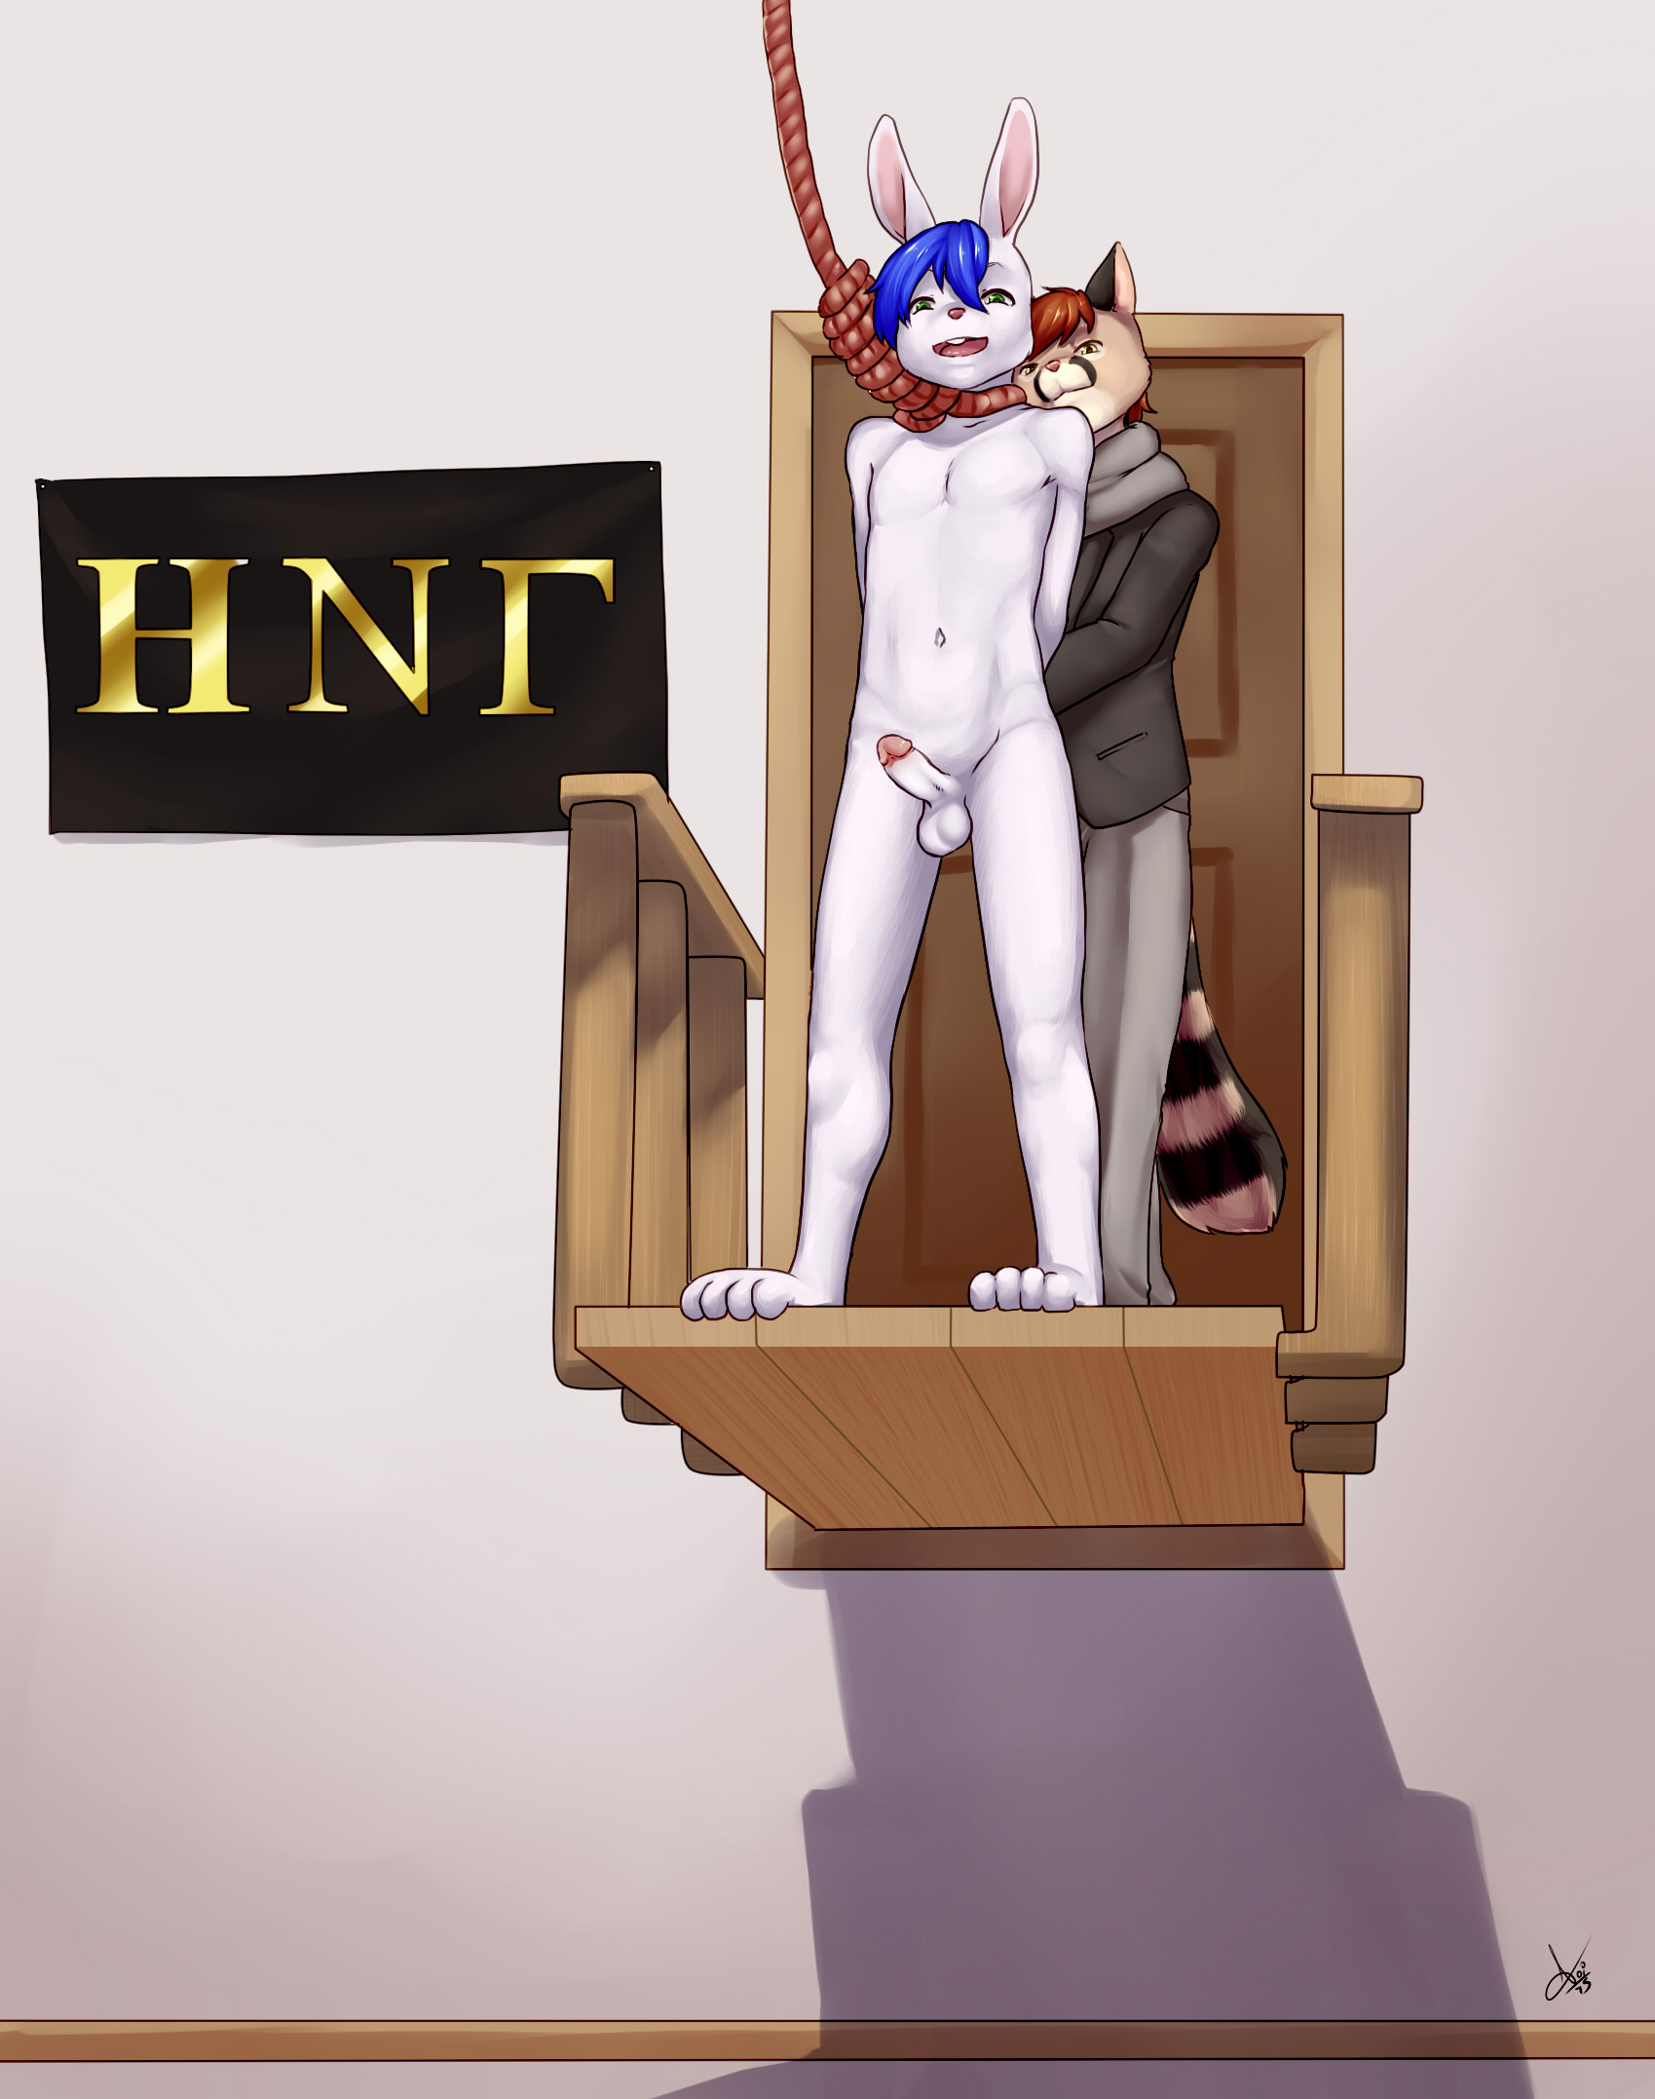
Whitney gave Zen a gentle shove, just enough to make him stumble slightly and go off the edge; his eyes opened wide as he fell three feet, less than half a second. Then he gave a small yelp as the noose caught him. There was a sudden jerk and the noose pulled tight around his neck, giving him a rope burn and squeezing his throat shut.
At first, Zen’s only reaction to the choking and pain was to splay his toes and fingers out. He hung there quietly a few seconds. Then he began kicking wildly, jerking his hands against the bindings and tensing his shoulders as he tried to breathe. He knew he couldn’t escape the noose; his reaction was instinctive.
Even through the panic, he could see the audience, their eyes locked on him, on his danse macabre. They seemed to be holding their breath as they watched him struggle. Most of them had at least one hand in their lap, rubbing themselves through their clothes. The six survivors of the first two contests, still naked, were openly stroking themselves as they watched Zen strangle in the noose.
The bunny’s eyes were attracted to motion in the mirror opposite. His own reflection, his face glowing with sexual excitement, his feet pedaling running in the air, and his head tilted to the left by the noose. “I’m hot,” he realized. Then he noticed Whitney’s eyes meeting his in the mirror. The genet was staring avidly at Zen’s face, watching him strangle.
The ferret was also watching and rubbing himself. "Hope he enjoys this as much as I am," he said quietly to Whitney.
"Me too," the genet replied, "I got him into this, inviting him to rush Eta Nu Gamma, so I really hope he has a good time."
The little rabbit continued kicking hard and thrashing, making the rope creak as he fought his losing battle for life. But, inevitably, he started to tire. He had only enough energy to move his feet in a bicycling motion — and attention only for the throbbing sensation in his cock. A drop of pre formed at the tip of his cock and fell, then another, and another. He drew his knees up to his chest and kicked downward, getting a tiny sip of desperately-needed air into his lungs. He repeated this a few times, then relaxed. His feet pointed down and his hips thrust, fucking the air without his even thinking about it. The bunny was conscious only of the desire, the need for release, but his eyes watched the audience watching him and drew their sexual energy into himself. Every stroke, every desperate rubbing motion, felt like a hot, wet mouth around his cock. He reached his climax without even noticing, just an overwhelming pleasure that blanked his consciousness as he came harder than ever before, shooting his load onto the crowd. Then his head dropped, and his kicking stopped. Just little tremors and twitches in his legs while a last few drops of semen fell from his cock.
It had been nearly four minutes, and the bunny was still alive, still partly conscious, his eyes wandering randomly but still moving slightly.
The Froshmaster turned to the giraffe-morph next to him. "Wow! What a show. He obviously enjoyed it. Too bad, really, he'd have been a good member. I bet he would have gotten up to over a minute doing non-lethals for the brothers."
The giraffe nodded and watched the dying bunny’s body twitch as it tried, still, to fight for life. Then it all stopped, no movement except the body swaying slowly from side to side. There was a spatter of pee on empty chairs, then nothing. The noose had claimed another victim.

