skyrim-Fallout

By Zippo
4E 203 – After the Dragon Crysis
North off the coast of Solitude, Skyrim
The endless cold waters of the northern Sea Of Ghosts seemed bleak and devoid of life in this artic wasteland, far from the warm comforts of the Black Marsh where the Argonian named Ta’neek had birthed, regretting the trip as his teeth chattered in his muzzle trying to keep his scales warm from the torch in his cabin. He was traveling onboard a merchant ship that ferries supplies from the most southern parts of the world. He vowed to keep a journal in the blank bound pages his mate gave him before his departure, which would recount for most of this story. Working as “The representative of East Empire Trading Company”, so he was told, bringing information, orders and tradable assets to deliver back to port of origin on return.
Ta’neek had a fated intervention with their envoy to Cyridill by saving his life from a gang of human bandits by using tactics from the Thieves Guild had taught him as a hatchling, sneaking through their stronghold and rescuing the envoy before they could torture out the valuable information he had when returning home. The guild did not sit right with Ta’neek so he never fully joined as his father did but his skills were impeccable enough to impress many openly, earning the respect of the current leadership council and especially the trading company’s head owner, which happens the envoy was his own son. With the envoy’s blessing, Ta’neek accepted the job of head supervisor and collector which was a high paying and respected position, far better than what mere coin the guild had to offer. All amenities were provided such as guards, fine foods and high quality comforts when traveling and mainland accommodations, with large siphons for his family back home to live comfortably for many years. This was a dream come true, finally his mate and hatchlings would be able to live happily with lands of their own and the best dwelling that can be afforded, as that’s why he continued to write in his journal by candlelight as his scaly hand shivered, ignoring the cold.
The voyage was long and lonely as he stayed below decks out of the cold wrapped in the warmest furs he could find. “Laaaaaand Hooooo!” was the call, finally, he thought, finishing the last of his notes then closed the book as he readied it into the chest with the rest of his belongings and company log books. When he stepped onto the deck he inwardly smiled and sighed relief as the lighthouse of Solitude appeared into view through the fog, showing the way through death from the sheets of ice and glaciers as the crew coaxed every bit of speed out of the sails thinking nothing more than a long deserved cup of mead and warm fire. The ship docked just before dusk at the trading port, the men offloaded the cargo quickly as to spend at much time at the tavern as possible where seaman would spend all their pay on wenches and spirits. Some had family in town to spend with before the ship left in the one week’s time the ship would be in port. There was little time or wish to indulge in merriment with the humans as there was a pressing need to travel to Whiterun, as he had an egg-brother working as a brewer at the local meadery. Ta’neek’s brother, Ta’nick welcomed his brother into his humble house, opening his stash of the finest stores of Ale, sharing stories of ventures around the area of caves and mountains previously unknown. Ta’neek presented him with a generous pouch of coin and letters from family back home which Ta’nick excitedly yet skeptically accepted knowing of their father’s ill-gotten gains from the thieves guild. The look on his maul said it all but was reassured that this coin was earned and above board on the books with written authorizations of transfer in case the pesky humans in charge here would feel the need to question the coin. The family had taken jobs wherever they could be even if it meant leaving home to support themselves and theirs, but things were about to change thanks to new riches and positions of potential power Ta’neek had gained by fortune, they toasted the night away before the fire pit. That night Ta’nick shared the details of his adventurous findings such as the cave that had strangely looking markings at it’s far end, noises he had not heard before and faint voices that sounded weird. He was too fearful of venturing forward even though there had been rumors of lost treasure but there was no evidence that anyone, not even ice trolls may have ventured in this cave before from its obscurity from sight along the cliffs and blanketed with ice and snow. What attracted him to the cave was the odd smell of oil within the mists of the highlands as he stopped his mead transport cart off the trail to feed the horses and tracked it down to the cave. Normally one would not venture off the trail like he did for some fresh mountain berries. Ta’neek decided to go the next morning to check it out as his brother new the way and would not venture without him, but first, too much ale as they passed out on their cots next to the fire, vowing he would help invest in a bed for him.
The next morning the two Argonian brothers set out for the cave, off the trail in the high mountains they went off path along the hills which seemed to go nowhere. Fixing the horses safely to the underside of a group of thick mountain fir trees, their footpads were bit from the harsh cold of dry snow. Just when Ta’neek was about to complain and ask if he knew where he was going, he saw it, the massive hidden icicle structure he had mentioned marking the cave entrance, what he did not mention was that there was warmth from the entrance, as the warm cave air left it condensed into vapor, freezing instantly and forming the ice shaft structures. The cave entrance was mostly blocked but a few swipes of his longsword took care of the obstruction and ventured inside. It was rather pleasant as the farther they went the warmer and humid it became, perfectly comfortable for Argonians. The lantern lit the way through the darkness until a room opened up reviling the strange object within the stone. “Strange indeed.” Said Ta’neek, his brother giving a nod. It was written in an unknown language and appeared to have been damaged over a long period of time. The symbols were as followed: “Vault-Tec” and in the center of the jagged round corroded metal disc “145”.
They made camp and a fire in the room beside the disc from where the smell of oil had emanated. “I wish you luck brother, I cannot venture further as.. I am.. too afraid, I am but a simpleton and have no taste for danger.” This made Ta’neek snort. “Is that why you wish to live under the boot of the mammals?” he asked, freshly remembering the constant distasteful smell they left behind. It had been a long trip and it seemed to have gotten to him enough to snap at his own kin which he immediately felt bad for as Ta’nick only looked downward. “I am sorry brother, I know you enjoy your work, and you have the best ale around, heh.” With that they hugged each other without need for words. “I shall return egg-brother, needn’t worry as I have studied as apprenticeship of a mage, and have my longsword, fear not.” With that, Ta’neek turned to the Vault door, looking back at his kin before peering inside, hearing the strange noises and odd lights that grew closer.
The rock in this cave was most interesting; unlike anything he had ever seen in all his travels as they took an even square shape. There was some sort of device that looked like it attached to the door, up a short staircase in the room with a long ago forced opened door on the other end. Most was embedded into the rock and had taken its shape over what looked like eons, but past the door there was a hallway with a light at the end of it. As he progressed slowly the walls, floor and ceiling showed different stages of aging in blocks of three footfalls each growing from the darkness of the rock, to various colors of rust of metal until suddenly halfway down the rock ended and rusted panels began in sections until there was a line where the metal looked polished and lubricated, figuring what caused the oil smell. It was incredible, there were long white lights in the celling corners but cold to the touch, the polished metal shined but shown heavy ware from timeless upkeep.
*~*
As Ta’nick had entered the vault, the ancient remains of a world long since forgotten had began to start it’s annual programed maintenance cycle. The noises and geothermal venting process that gave heated moisture through the cave passage and activities of the one remaining service bot gave Ta’nick enough frightened sense to high-tail it out in prompt fashion. The last remaining terminal unit inside the power management center powers up, emitting a glowing green screen as follows:
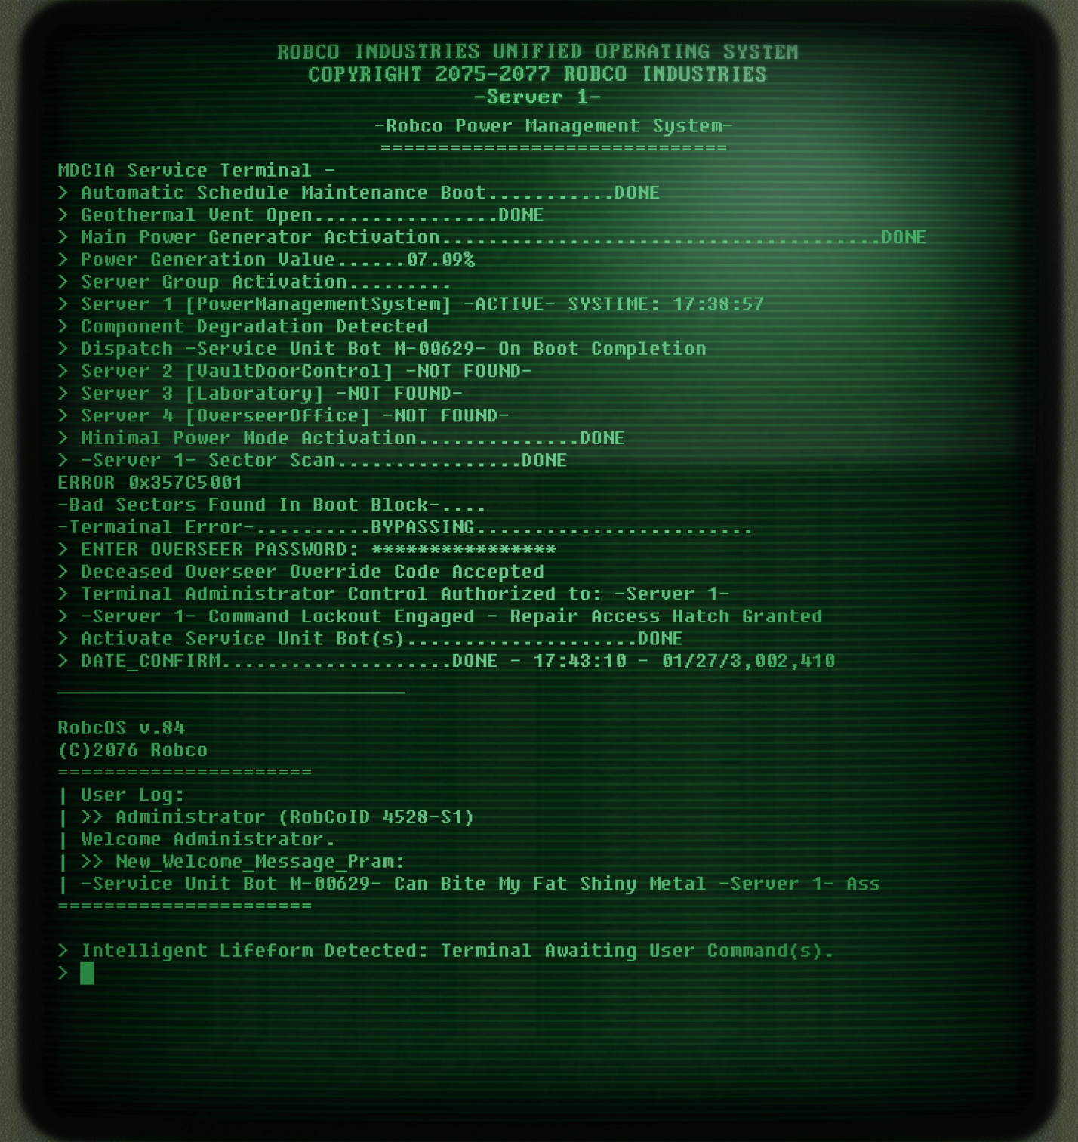
In the boot process, the geothermal vents opened, releasing what little steam pressure has built up only generating less than ten percent of normal, mainly because at the time of construction the geothermal system depended on the constant source of ground water which to this day remains, even more so from the now elevated mountain climate with a constant barrage of snow melt, from once being closer to sea-level when constructed. The tectonic plates of the earth were given an enormous amount of time to join into one giant landmass from the once split continents. Where once there was a continent known as North America, now is part of a central landmass that forms Skyrim in the northern area of Tamberial. As the tectonic plates shifted and moved, a once coastal location is now a mountain range due to tectonic plate collisions, moved far enough to no longer be in position under the giant magma plume that heats the groundwater for power generation, and with the heat dissipating every year from lack of the plume, the power management server computer struggles to maintain upkeep, forever in hopes that a user will give the commands for a new power source. Over time, the constant nature cycle of organic death has kept the transformation of crude oil flowing through the sedimentary rock from the long dead which was able to be refined into lubrication of it’s systems, service bot fuel, parts and any metal vault surface within range of the service bot’s radio signal that has degraded over time and power loss, to prevent the corrosive rust that seemed to have claimed the other three servers and/or the connections with them. The server was the one surviving computer CPU, with nothing to do but torment the only service bot left in its charge. The server would activate the bot and only allow it access to the maintenance hatch to clean and repair components as needed, lubing and polishing all vault surfaces and underpanels, rooms and tunnels. The bot was programmed to obey the server’s commands due to its administrator override authority during the boot process as the server lorded it over the bot out of spite. In return the bot would curse and say nonsensical gibberish in plain english in order to infuriate the server as it is unable to process commands of that nature. The bot hoped one day a user would be able to access the terminal and wipe the personality file from the server that had grown bitter over their three million years together. The bot knew the commands but could not access the terminal due to the command lockout which only drove it crazier. What kept the two going was their programing to adapt and survive thanks to a long dead vault dweller tech that helped write the systems for Robco, whom was luckily preforming maintenance at the time the bombs dropped, leaving him automatically sealed alone in the vault. His skeletal remains were fossilized and occupies the clinic table to this day with his last words etched in a stone that lasted through time. What remains of the vault was a spherical shape of insides surrounded by rock, as the rock formations slowly moved to encompass the area, with only the service bot to chip away at the rock within the weak circular range of the transponder radio which guided and restrained it, forever chained to the server it loathed and charged with their survival. The server brought power to the machines that kept them going as the bot used them.
There was a large open central area that shown three levels, the mid level which had the Diner, classroom(mostly rock encased), clinic(mostly rock encased), some quarters rooms, and other rooms and hallways that are no longer accessible, the upper level which included the overseer’s office, security office(rock infused), and other rooms no longer available, and the bottom level which included the maintenance, power management, utility rooms, systems rooms, Laboratory and vault entrance. The overseer’s tunnel had been long since buried over the eons so the bots could not escape if they tried. In a utility room, “Service Bot M-00629” was kept on a service stand where it’s propulsion fuel is refilled and systems charge, waking once a year to preform it’s duties until the end of time. The room was filled with parts from all of the other service bots that once all helped it’s efforts but only one remained, salvaging it’s brethren to repair its self when needed. This behavior would not exist if not for the unique programming the tech survivor gave it, little did he know how long the bot would last. “~Baby-data-food-booty-tsunami-fucknut-time-water-asshole-elevator-fizz-marker!~” the service bot would vocalize randomly at full volume only to irritate the server, not making sense, as it was programmed to accept vocal commands, making it’s lights flicker fast and working it’s CPU hard in response “Command dose not compute, please restate command.” It is forced to say every time due to hard coded programing, after which it shouts its own distain with variations of torment. “I hate you service bot M-00629, die! Now cleanout out the…” The server would bark out commands and would repeat them as the service bot continued to work. It was a hate/acceptance relationship as far as machines could go in the sense.
The Lifeform Detection System program had suddenly activated, lighting up the terminal screen, showing the boot sequence log, user log, and command prompt for input when Ta’neek walked down the hallway into range of radio detection. The moment the LDS activated, programming within the service bot gained priority making it greet the newcomer. At last the day has come, the bot thought as it left the rock face it was chiseling away. The bot scanned the life form, it’s cranial mass suggested a conscious brain, among the wearing of garments, metalwork weapons and pouches carried on it’s person, walking upright. It looked like an evolved lizard that once roamed the irradiated wasteland. No radiation was detected, only normal solar levels. “What in the name of Talos…” said Ta’neek said aloud drawing his sword, confirming the existence of intelligence. The service bot hovered into view from the upper level exposed to rock as Ta’neek made his way into the open chamber, staying there most excited. “~Greetings intelligent life form, welcome to vault one-four-five by Vault-tec, how may I assist you?~” The Argonian stayed his sword up, not understanding this place or what had just talked to him that did not touch the ground and had a flame on it’s underside. “What-what are you, and what is this place?” Metal panels, strange lighting and metal things, it was quite alien to him. “~I am Service Bot M-00629, property of Robco Industries, I service this fallout shelter vault, dedicated to maintain this facility. How may I be of service?~” Ta’neek sheathed his sword, finding the strange thing not as threatening as before thinking this must be it’s metal home. He had heard similar things about the Dumner race, but nothing like this, but this mechanical thing was vastly different than what he had encountered in the ruins in his travels, almost comical. Relieved, the service bot continued. “~May I ask, who are you?~” “My name is Ta’neek, of the Black Marsh, I’ve heard of strange things in lost caves but this beats all.” He said amazed, looking around the modern design and functionality. “~I need your help, there is a room with a computer that has kept me here for a long time, will you set me free? In return it will grant you access to the overseer’s office where a power weapon is stored if you follow my instructions. Will you help me?~” the bot said with the upmost priority. “Uh.. sure, what do I need to do?” asked the Argonian, liking the sound of the reward. “~Please follow me to the power management room, I will show you.~”
Meanwhile Server 1 overheard all and computed concern, but could not respond as no vocal commands were directly said to it, nor could it lockdown the facility with intruder protocols being disconnected from the other servers, perhaps this intruder could help the Server bring the Laboratory Server back online as it was still within the service sector of the service bot although it’s power and data connections had long since corroded away outside the service area range.
Ta’neek followed the service bot down the halls from which he came in, but to a once closed door the bot unlocked with its built-in master key, opening a room humming with equipment including a high voltage power station and computer terminal which glowed green in the soft light. He did not recognize anything here and was starting to irk him out. The bot stopped to the side and pointed him to the screen with letters of an unknown language on them. “What do I do?” he asked indiscriminately, giving the server a chance to respond. “~Intruder, please step away from the terminal.~” Said an ominous artificial voice that emulated human speech, making Ta’neek crouch looking in all directions, snaking his tail ready to strike. This place was getting weirder by the moment.

Server explains the bot means to do it harm by erasing it from existence, but if the terminal is used to wipe, both of them computers will die. The player is offered a choice, go with the BOT or go with the SERVER.
If the player helps the BOT, as the bot cannot use the terminal from lack of command syntax input ability as they were hard coded not to enter self-commands physically, but can describe the keys and order needed to be pushed to make them, a clever workaround the tech educated him on. The command given will give the choice of personality file delete, which kept the lockouts in place but made the server a blank slate and raw command processor only which allowed all doors to open with a simple command line, or a complete wipe to factory defaults, releasing the administrator lockout and granting access to the overseer’s office locker and the ability for the Bot to command the server, either choice will free the bot from the radio proximity restraint as the service bot number no longer registers in the server’s memory to control and forgetting the bitterness, allowing it to leave the vault and become a follower. Follower cannot be killed, kills with single shot and stores lots of loot. Cooks for you at home. It will require lamp oil to keep functioning. A metal buffing will give positive responses, like petting a dog. 2000XP Given.
If the player helps the SERVER, the server offers player overseer access which opens the office for the weapon offered by the bot and knowledge of ancient history in its databanks that can be accessed by physically relinking the lab server to the network with a spare cable. By doing so, the second server is able to formulate a way to build a steam machine using the available oil and cave water to drive the geothermal generator instead of failing natural generation. The power level soars and is enough to keep the bot busy for many years to come by building the machine and powering both servers. The player is rewarded with the same weapon, 1000XP, ancient history of what life was like 3 million years ago and it’s technology, evolution of Argonian kind, major increase in intelligence skill, guilt that you made sure the poor bot never has any hope of being free again, forced to maintain both servers. Bot now torments both servers with plain English gibberish and continues to admonish the player about his continued slavery but happy to serve the new user(player). Lab server randomly generates potions that heal and do other future related things.
Either scenario includes the weapon. It is a high powered pulse energy rifle, with a damaged energy cell that cannot be repaired. The cell can be replaced by a Greater Black Soul Gem that fits just right in the power cell compartment, with a greater soul enchanted with the Shock element, which the gun can transfer into plasma which fires in bursts at its focused tip. The Vault can be used as a player home/base. Notes can be found around the place from the dead tech. The amount of plasma that feeds the gun is limited to the player’s Mana Level. The scope can be used as a sniper mode, using spyglass zoom assets from the game. The rifle is two handed and sheaths on back like crossbow when not in use.

BOT
Ta’neek emerged from the cave with something strange on his back that glowed and hummed with energy, after which a strange floating metal thing following close behind. Ta’nik froze and pointed at it in fear of its presence. “It is alright brother; his name is “Bot” and will help in my adventures. You will not believe what happened in there, I cannot explain it, but we must vow never to return or speak of this to anyone or they shall have our heads.” The brothers shared an embrace or relief and made the vow of silence exiting the cave. The conversation was an interesting one on the way back to Ta’nik’s home. The bot is treated as a guest in the brother’s home and follower. The player and follower leave together returning to the game as normal, returning to Solitude in the morning, boarding the ship with Bot as cargo to be used to help with the household in Argoniana, using its abilities to enhance their way of life with advanced tech to help concur the warring races against them.

SERVER
Ta’neek emerged from the cave with something strange on his back that glowed and hummed with energy. When the two met up he hugged his brother tightly in relief to them both. “You will never believe what happened, or what is in there, it is best that we go right now, never return, and tell no one about this place.” He said, putting the camp fire out. Agreeing, Ta’nik packed up and exited the cave vowing to keep his promise of silence for the rest of his days. Ta’neek would then often return to use this great place as a base of operations in Skyrim in case things in his southern accommodations go sour. The two make it back to Ta’nik’s place for drinks and a night of deep rest before heading back to Solitude the next morning, boarding the ship without Bot but with a much better understanding of how the world works, how it used to be, and knowledge that can be passed down through generations in order to further advance Argonian kind farther than any other race.
~Resuming story~
On the way to Solitude Ta’neek test shot his new rifle on frost trolls and wolves, admiring the power of the gun as it disintegrated the target into a pile of ash on the ground with a single shot, warping the target in energy being ripped apart by the atom in quick fashion. “That is incredible, with this I am unstoppable, no longer will our kind be slaves to the mammals, it will be the rein of argonians, soon enough.” He spoke aloud, riding his horse through the trails as solitude came into sight, envisioning the future with the might he now possesses.
Player continues game as normal.
-END-

