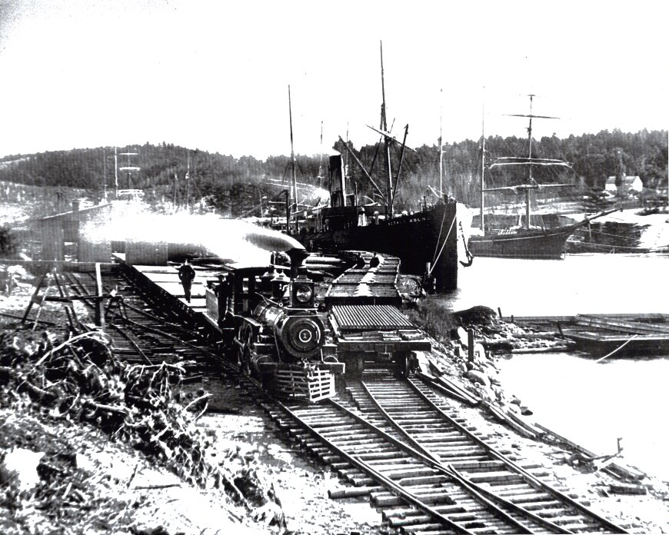
Smudge Pot

By

Vixyy Fox

Tears welled up in my eyes and stars danced around me in the dimness of the boiler room as I held my head in pain. The place was insufferably hot and the noise was such that it un-nerved the soul. Both were a constant in bowels of the ship, and the noises were not the comforting noises of a womb, but the sounds of a belly gone bad from sickness. The rattling chains… the thump-a-thump of the bellows feeding air to the fires… the grate and scrape of the shovels and coal sleds… the curses of the stokers as they labored like souls lost in hell, feeding the number one boiler, which gave the ship its steam engine heart beat.

I had been knocked from my feet by a solid body of something, just as I readied to heave my shovel of coal through the iron door of the number 2; which the Chief Engineer was attempting to light off. We were heading into heavy weather and the Captain decided to place priority on that rather than our coal consumption; and so the order to light off number 2 had been given.

“I have seen the belly of Hell,” grated a voice in my ear. “It’s the fire ya know… the fire releases all the power of the world’n nothing less than that. Ya stand in front of the mouth of the boiler when he opens that door and you’ll see the belly of Hell same’s I did.”

Wiping my tears away with a forearm, I managed to sit up. I looked around, but found no one near enough to me that his voice would have carried so well through the noise.

“Come on now ya bastard stowaway!” yelled the Chief Engineer, standing at the iron door’s chain. “Get yor Goddemmed shovel full up again, and make ready to toss the lot when I pull the chain to the door!”

“No sir, I won’t! Someone told me not to stand there sir!” I yelled back to the man, bracing a hand on the deck against the ever increasing roll and pitch. “He said fire’s gonna come out when you open it up!”

I was found stowed away among the cargo and roughly thrown into the boiler room to shuttle coal from the bunkers to the stokers in order to earn my passage. I was black from head to foot in the dust of the stuff and I had not seen the light of day in a week. Nor had I bathed so much as my sore hands in that time same amount of time.

‘Ya gotta piss,’ I was told roughly by the Chief, ‘Ya don’t do it in the bilge. Ya gotta poop; ya do it in the bucket what the watch cleaner tosses. We gots no time for the frilly things down here boy. Maybe next time you’ll know to pay for your passage eh?!”

This same Chief Engineer became enraged that a mere boy would defy his orders. He yelled out, “There ain’t a bloody thing to worry about ya stupid twit… Old Nellie is as cold as a witch’s tit! I said toss the coal in the damn ting… and I mean toss the coal!”

With that, he yanked on the chain opening the boiler’s iron door; I suppose to emphasize the fact of the words he had yelled. As soon as the door came open a little bit the boiler sucked in the air and there was an explosion blasting the door the rest of the way open. Huge flames shot out engulfing the man who had set them free. The Chief was thrown backwards, his hair on fire, and his jacket smoldering from the sudden heat. The only thing that saved him from bursting completely into flames was the fact that an errant wave had soaked him good on his way back to the boiler room after receiving his orders from the Captain. We never knew if this was God’s mercy, or the Devil’s mean streak, since leaving the man alive among us was a terrible doing.

“Look at’im dance… heeheehee… look at’im dance… black hearted bastard! Wish to hell he had been closer… I woulda delivered him to Old Scratch myself!”

I turned quickly and caught sight of a pale grinning black streaked face attached to a lean body leaning up against the coal bunker. Hearing again the Chief’s terrible screams, I turned to see the stokers throwing a wet towel over his head, and then they began pummeling the smoldering jacket.

When I turned back, the thin man was gone.

That was the first time I saw the ghost of Durvin McDonald.

With the exception of the Chief, the boiler room crew took me in as one of their own right after this incident. Most of them had seen signs of Durvin’s handiwork. On occasion they had even heard the screams he had screamed when he had, indeed, gazed upon the bowels of Hell. On that day a back flash had roasted him in the very place we inhabited. His curses were common place during the peaceful times when the ship was tied up. These were usually heard echoing in one of the cold boilers, it being shut down for maintenance… but no one had ever seen him.

No one… except me.

