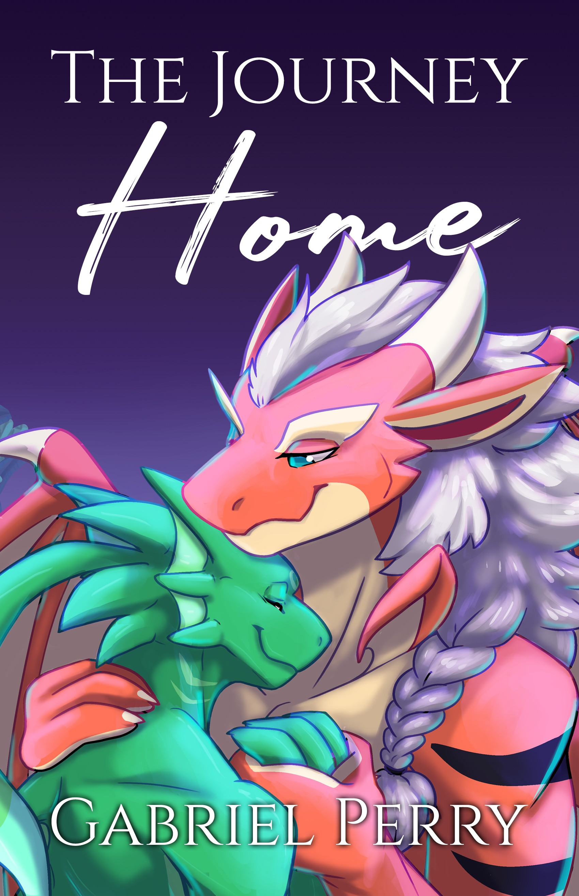

The Journey Home PREVIEW
Written by Gabriel Perry Illustrated by Chitafokkusu

This is a work of fiction. Names, characters, places, events, locales, and incidents are either the products of the author’s imagination or used in a fictitious manner. Any resemblance to actual persons, living or dead, or actual events is purely coinci- dental.
Copyright © 2021 TwistedSnakes ISBN 978-981-14-9757-5 (Paperback)
ISBN 978-981-14-9758-2 (E-book)

All rights reserved. No part of this publication may be repro- duced, distributed, or transmitted in any form or by any means, including photocopying, recording, or other electronic or me- chanical methods, without the prior written permission of the author, except in the case of brief quotations embodied in crit- ical reviews and certain other noncommercial uses permitted by copyright law. For permission requests, send an email to twistedsnakes@live.com.

Characters belong to Rpadi https://twitter.com/rpadi2

Cover design and illustrations by Chitafokkusu https://www.furaffinity.net/user/chitafokkusu/

Acknowledgements
What a journey. This is the biggest project I’ve done, and without the support of my friends Kerac and Espilax, this story would not have been possible.
I would also like to thank Rpadi for supporting me and my writing. You took a chance on a commission of this scale and I’m grateful to you for believing in me.
A very special thanks to Chitafokkusu for illustrating the scenes in the story. It’s been a pleasure working with you, and I’m glad to have been able to collaborate with you on this book.
To Kerac, Espilax, Kazuki, Empyrean, Gadzooks, and Kon Shiroe; thank you for reading my numerous drafts. Your feedback has helped polish this story to what it is today.
Last but not least, thank you for buying this book and giving it the time of day. Your support helps me pursue my passion in writing. Thank you.

Contents
Chapter 1

The Fall
- 1 -
Chapter 2

The Wrong Planet
- 13 -
Chapter 3

Against All Odds
- 31 -
Chapter 4

Escape
- 57 -
Chapter 5

Illuminating the Way Home
- 75 -
Epilogue

Home
- 101 -

CHAPTER 1

The Fall

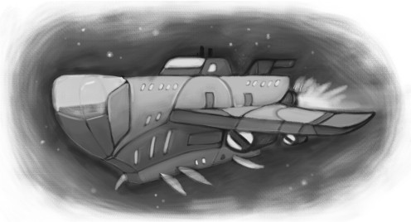

For the moment, YongSeop was home. But an incessant beeping sliced through the fabric of space, tearing away the illusion like a flimsy curtain and sucking it into the void of the cosmos. Reality took its place as he woke up: the white ceiling over his bed, barely an arm’s length away from his face.
The dragon grunted as his body woke up after him. He preferred waking up naturally to the rising of the sun, but for a spaceship drifting through the vast emptiness of space, such a luxury wasn’t his to have. Instead, an alarm clock would have to do.
He slid out of bed, careful not to hit his head against the ceiling. Stepping on the bunk bed beneath his, he climbed
1
2 Gabriel Perry

down and stumbled about on the ground. The world was still spinning about him: a reminder that mornings weren’t really his thing. He spread his arms and steadied himself on the only table in the small room, taking deep breaths.
His roommate had already left for the lab, having woken up hours ago. YongSeop, on the other hand, preferred his schedule back on Enides: sleeping at midnight, and waking up to the beams of the late-morning sun. Only then would he lazily get up and get on with his day.
YongSeop trudged into the adjacent bathroom, taking a step in. The bathroom, too, was small and cramped. There was barely any standing space: a toilet bowl sat directly in front of him, and a showerhead hung from the ceiling. A sink and a mirror were mounted on the wall beside him, reflecting the dragon’s sleepy face.
He turned the shower on, pouring a stream of water over him. He let the warm water soak the grey fur on the back of his head and flow down the orange scales of his body. The dragon stood there for a few moments, taking in the comforting warmth of the shower. He closed his eyes, imagining himself back at home on the planet Enides.
The warm, silky blankets. The soft mattress on his bed.
The sweet company of family.
He let his thoughts take him away to a place that was literally galaxies away. A place he had missed for 2 years, 7 months, and 14 days. He stood there in the confines of the tiny bathroom. In a few minutes, he should be getting ready for another banal day of work.
But for the moment, he was home.
Chapter 1: The Fall 3

* * * * * * *

“Morning YongSeop!” A cheery voice chimed as the orange dragon entered the laboratory.
The dragon grunted back from behind the oversized cof- fee mug he was clutching. Working in a laboratory required a fair amount of mental effort, and he needed his daily dose of caffeine. He was on board a research vessel: apart from a few security, service, and maintenance staff, the rest of the crew of 52 scientists.
Their ship was one of the 20 laboratory crafts encircling a huge spaceship a hundred times their combined size. They were a reconnaissance team. The main spaceship would travel the galaxy and map out each solar system. When they arrived at one, the main ship would send scouting teams out to each planet to take readings and map the terrain. Live specimens would be brought back, and the laboratory crafts would contain, study, and analyse them.
This was a consistent effort by Enides. They sent out spaceship clusters like these regularly to maintain their un- derstanding of the galaxy. It was a vast place, and despite all the ships they were sending out, it would be a few centuries before another ship would come back to this solar system again. A lot would have changed in the meantime, and they would have to update their maps once more.
This wasn’t YongSeop’s dream job; but it paid, and it paid well. Lodging and food were free, and he didn’t have to worry about the petty politics back on Enides. Even if
4 Gabriel Perry

his contractors wanted to fire him, they would be stuck with him for the next five years until they were done with this part of the galaxy.
Still…
“Good morning!” The same, happy voice called again as a red fox bounded over.
“Morn’ Jinho,” YongSeop muttered, just loud enough for the fox to hear.
“Had a good sleep?” his roommate asked, peering at a display panel mounted on the wall. Beside it was a glass pod with a luminous blue plant growing on an orange, slimy substrate covering the bottom of the pod. The plant had a bulbous stem with fins along its branches instead of leaves. Its roots formed a web-like network over the orange sub- strate. Tendrils grew out of them, waving in the air to catch food particles.
“Yeah, was alright,” the dragon shrugged.
“Good,” the fox nodded, half at the dragon, half at the metrics he saw on the display panel. The living conditions within the pod were stable, and the plant’s vitals looked fine. He noted this on the holographic clipboard he was carrying.
YongSeop would’ve asked how his morning went, but the fox would’ve told him either way. The fox had started work two hours earlier, and a lot could happen in two hours.
“Was checking up on Specimen A-924,” the fox started. “You know, the one we call ‘space bunny’?” he added, seeing the dragon’s face of confusion.
“Ah yes, space bunny,” YongSeop grinned, thinking of the yellow puffball that was kept in the other lab. It looked
Chapter 1: The Fall 5

like a small ball of fur, except for two feelers on top which the scientists had initially mistaken for ears. Apart from that, the creature had no discernable features. The dragon enjoyed feeding it: they would drop food pellets into the glass pod, and the ball of fur would bounce over. As it nibbled on the food, one could make out a small mouth with two front teeth slowly munching on the pellet. “What about it?”
“It started making this clicky sound with its feelers. The other scientists are not sure what’s going on either, maybe it’s some mating call?”
YongSeop shrugged with a half-grin. The imagery of multiple puffballs congregating and dancing in mating ritu- als came to mind, and the dragon had to hold in his chuckle. Then again, the specimen was all alone in its pod, calling for a non-existent partner in its isolated world.
He hoped it wasn’t a mating call.
“Anyway, apart from that, nothing much happened this morning,” the fox had already moved on to the next pod. Within it, a silver plant had grown to reach its ceiling. “It looks like we’ll need to transfer F-7337 over to a tier-three pod, there’s barely enough space to—”
YongSeop felt his heart lurch as a deafening siren blared through the ship’s announcement system. The lights in the room turned off, and red emergency lights replaced them. The metal door to the laboratory flung open with a clang, and a flustered cheetah stood there, panting breathlessly.
6 Gabriel Perry

“637 escaped,” he gasped between his pants. “Run. Es- cape pod. Now.” He scrambled down the corridor as fast as he could.
YongSeop already knew this specimen: a monstrous lizard-like creature so huge, it had to be contained in a laboratory sector of its own.
If it had escaped…
His roommate had already bolted for the door. “YongSeop!” he turned back and shouted at the dragon who stood rooted to the ground. “What are you waiting for?”
The dragon snapped out of his shock. He took a step for- ward and stopped, “But how about the other specimens?”
“What?” the fox gasped incredulously, shouting over the noise of the sirens. “We can’t stay; we need to go!”
“And leave them behind to die?”
“If you stay, you’ll die with them! The ship is going down!”
YongSeop remained silent, letting the blaring sounds ac- company them.
“Please...” the fox pleaded with desperate eyes. “We can’t—”
The sound of an explosion echoed through the ship as the ground beneath them shuddered.
“I’m going,” the fox declared with a torn look in his eyes. “Please be fast. I’ll see you on the main ship.”
YongSeop nodded, and the fox bolted out the door. The dragon tried to clear his panicked mind, looking around him. This laboratory was where sedentary plant-like specimens
Chapter 1: The Fall 7

were studied, so saving them was out of the question. But the laboratory next door was where the animal-like speci- mens were contained, and he could try to bring as many of them as possible into his escape ship.
He ran out of the laboratory as fast as his legs could carry him. Another explosion shook the ship and he stum- bled. Smoke was leaking through the vents in the corridor, turning the air black with toxic fumes. Coughing, YongSeop covered his face with his hand as he bolted into the next laboratory.
This laboratory had a tall ceiling almost two storeys high. More glass pods lined the walls of the laboratory, housing creatures of all shapes and sizes. Most of them were hopping around their pods frantically, trying to escape.
The release switch was a lever secured behind a clear panel. “IN CASE OF EMERGENCY, BREAK GLASS”
said the label. YongSeop didn’t wait: within seconds he had smashed the glass and pulled the lever.
The sirens blared as the pods opened up. Water gushed out of some of them, depositing aquatic creatures onto the ground. The amphibious ones scuttled away, while the rest suffocated. Most of the land critters bolted out of their pods and hid in a corner, trying to escape from some unseen threat.
YongSeop had never felt so helpless in his life. Here were the animals he was supposed to care for, and he couldn’t save them all. His eyes darted from one empty pod to the next. There was a yellow ball of fur, bouncing about but unable to hop over the ledge of the pod.
8 Gabriel Perry

Space bunny!
The dragon ran over to pick up the curious creature, cradling it carefully in his arms.
At least he could save this one.
The sound of tearing metal screeched behind him. YongSeop turned around to see a giant clawed arm grip- ping the side of the laboratory entrance, ripping out the metal walls as it strained its muscles. A heavily scarred face with vicious green eyes peered through the gaping hole and into the room, sniffing the air heavily. The beast must have followed YongSeop’s scent into the laboratory, for it was now tearing a bigger hole in the wall and crawling into the room.
The dragon stood there in shock. Terror gripped ev- ery fibre of his being as his heart threatened to tear out of his chest with its incessant beating. However, that fear was tucked away behind a veil of numbness. Morbid curiosity seemed to take precedence as he stared at the creature. Stomping into the laboratory on its four trunk-like legs, it rose to full height, scraping its scaly horns against the ceiling as it roared.
It then turned to glare at YongSeop with its fiery eyes. Its face was covered with numerous sharp scales, grinding against each other as its jaws moved. Decades of hunting in the harsh environment of its native planet had bent and twisted the six horns on its head.
“Shit.”
Still holding on to the space bunny, YongSeop dashed to the side of the room, trying to circle the beast to find an
Chapter 1: The Fall 9

opening for the exit. The beast was relentless, refusing to let the dragon escape as it lunged for him, snapping its four rows of teeth. The glass containment pods shattered as the beast’s tail swung into them. Its heavy feet left deep dents in the steel floor of the laboratory as it stomped around to face the dragon.
YongSeop dashed to the left. Then to the right. But for something of that size, the beast was extremely agile, reacting to the dragon’s movements and refusing to let him pass. It raised an arm and swiped at the dragon. YongSeop jumped back instinctively. But the next swipe came imme- diately, hitting YongSeop across his side, sending him flying back. The dragon sailed through the air, hitting the wall with a loud thud before collapsing onto the ground.
The space bunny let out a high-pitched squeak as it scrambled out from beneath the fallen dragon, diving into the shadows. YongSeop grunted.
He couldn’t even save one animal.
The creature stormed its way up to the orange dragon. YongSeop tried his best to get up, but the impact had left him in a weak state. But it was either do or die: a few more steps and the monster would be upon him. The beast reared back, ready to strike the killing blow.
YongSeop closed his eyes.
Did dying hurt?
He hoped not.
A sensation he could not describe seized him. Something fast-moving had engulfed him, forcing him into a barrel roll. Without him consciously moving, his body got up into a standing position.
10 Gabriel Perry

Huh?
YongSeop opened his eyes. The world around him was covered in a green tint. He seemed to be floating above the ground. He instinctively looked down; his feet were suspended above the ground, raising them to the height of the desks in the laboratory. The dragon squinted his eyes, trying to understand what was going on.
Then it dawned on him. Specimen J-3110.
The specimen was a green humanoid creature, but in- stead of a solid body, it had one made up of goo. Able to control its form, it could stay solid or turn pliable as required. A shapeshifter.
It had grown to twice its height and engulfed YongSeop’s body. Its green, glassy form looked like a mix between a draconic and an aquatic creature. Horns grew from the back of a dragon-like head and fins grew from its webbed arms and legs. It took a few steps toward the beast, bringing YongSeop along in its body.
The beast stepped back in surprise at the boldness of the green specimen, but it recovered and gave a threatening roar! The green creature was unfazed. Its arms grew in size, forming large limbs with sharp claws. With a forward step, it swung a clawed arm and left a gash on the side of the beast’s face.
The beast roared again before going for a quick lunge! YongSeop closed his eyes in terror. The sight of the an- gry beast pouncing on him was too much to bear. But he needn’t have worried: the specimen threw a hard uppercut, hitting the beast square in the jaw and throwing it back.
The beast was relentless. It dashed forward, spinning around at the last moment. Its tail swung at the
Chapter 1: The Fall 11

specimen. YongSeop felt his heart stop as the piercing spikes of the beast’s tail came for him. His green ally reacted too, dexterously dodging the hit as it jumped to the side. The flashing of the emergency lights accompanied by the piercing sirens gave YongSeop a headache, and it didn’t help that he was in such a precarious situation.
The specimen, too, was ready to end this. It circled the beast, avoiding its attacks as it tried to close the distance between them. When it was close enough, it avoided the stomping legs of the monster and ducked beneath the beast’s chest. Gathering all its strength, it plunged its claws upwards into the beast’s ribcage, piercing its heart.
Yellow blood poured out from the wound and down the specimen’s hydrophobic body without sticking. The beast let out a final piercing cry before its legs buckled beneath it. The specimen raised its arms, holding up the beast’s massive torso so it wouldn’t crush YongSeop. It let the beast’s corpse fall to the side, oozing its blood all over the ground.
YongSeop barely had any time to register what had just happened when the ship shuddered again. This time, how- ever, the shaking didn’t stop. The entire ship vibrated vi- olently, threatening to fall apart at any moment. Even the specimen looked confused, remaining in its guarded stance as it looked around.
A gripping sense of dread gripped YongSeop as he re- alised what was happening. The beast must’ve damaged vital electronics during its rampage, causing many of the ship’s systems to fail. Without a crew to run the space- ship…
The ship was going down!
12 Gabriel Perry

The spaceship had entered a planet’s gravity well, and without its thrusters to keep it in space, the ship would crash-land on the ground below. The ship shook turbulently as the air resistance battered its sides. The friction was also heating its hull, making the inside of the ship unbearably hot.
There was nothing YongSeop could do.
“Save yourself!” he yelled at the specimen, hoping at
least one of them would survive the crash. The specimen looked down at him curiously but didn’t let him go.
Instead, it picked up a metal desk and brought it over to the corner of the room. It crouched down, holding the desk over them like a shield.
They waited.
The shaking got worse and worse. There was no captain to steer the ship into a gliding descent: they were falling like a meteor. Would they survive? The suspense was killing YongSeop.
His life flashed before his eyes. Enides. Home. His two nephews. He could’ve sworn a tear rolled down his cheek. He didn’t have much time left.
There was a loud crash, and the world went black.
A lot could happen in two hours.

End of Preview
You’ve reached the end of the preview of The Journey Home. To follow YongSeop’s adventures on the alien planet, please support the author and buy the full version of this book. More information is available at the link below.

https://twistedsnakes.com/the-journey-home-book

About the Author
Gabriel Perry is a Singaporean author who has written more erotica than he would care to admit. By day he writes code, by night he writes erotica.
Join him in the breathtaking worlds he paints through words on a page. Many of his short stories are available for free on his website.

Website: twistedsnakes.com
FurAffinity: furaffinity.net/user/twistedsnakes Twitter: twitter.com/TwistedSnakes


