Cocotoy
Gift for Qundium
Written by TwistedSnakes
Illustrated by Qundium

“No, please! I’m innocent!” the shark screamed as he struggled, but his captors ignored his pleas. The depths of the prisoner processing plant was too isolated for anyone outside to hear his voice. They dragged him to a conveyor belt with a square frame with a cuff at each corner. “Please, you have to listen to me. Tell them I did nothing wrong!”
The two captors stared back at him. Or at least, the shark thought they did. They were wearing black, faceless visors over their heads, concealing their identities and expressions. Their forms were suited up in shiny latex, squeaking as they cuffed him to the frame. His wrists were secured tightly, followed by his ankles. A fifth cuff at the bottom of the frame was clamped around his tail.
His struggles were in vain, but what else could he do? He didn’t do it. He wasn’t responsible for the heinous crimes for which he was blamed for. Blinking back tears, he pleaded “Please, it’s not me. It really isn’t.”
The conveyor belt was already moving, dragging the shark’s metal frame into the large opening of a giant machine. The steel doors slid close behind him, plunging him into darkness for a second. Then lights in the machine flicked on, illuminating the area. He was in a small chamber filled with various tools mounted on mechanical arms.
“Commencing conversion phase,” said a mechanical voice.
“W-what’s going on?”
A few mechanical arms came to life, aiming their nozzles at various points on his body. With a deafening hiss, they began spraying his body with a thick, white liquid. The shark closed his eyes and mouth, shaking his head in an attempt to shake the liquid off. It clung to his skin, refusing to drip off his body.
He held his breath until the nozzles stopped. When he opened his eyes, his body was coated entirely in the shiny, white liquid. It seemed to be quickly drying up, turning into a smooth, tight surface over his restrained form. But it seemed to be doing more than just covering him. It was as if the white stuff was…
“Body-to-silicone conversion is at 20%,” the voice said.
Wait…
“40%.”
He was being turned into silicone! He struggled frantically, but the cuffs held him tightly. As he struggled, he could feel his arms and legs soften, as if his bones had disappeared, leaving him with nothing but malleable flesh. Or living silicone.
“80%.”
No, please.
“90%.”
There was nothing he could do.
“100%. Conversion complete. Proceeding with mounting.”
A pole rose up from below the shark. Mounted on its tip was a ribbed dildo, aimed directly at his tailhole. The shark tried to move out of the way, but the pole plunged upwards forcefully. It penetrated his silicone hole violently, lodging itself halfway in the shark’s abdomen. The shark let out a painful whine as the steel intruder spread his insides open. He clenched, trying to expel the metal dildo but to no avail.
“Mounting complete. Proceeding with limb removal.”
“No! Please don’t!”
Two robotic arms rose up in front of the shark, each with a sharp blade at its end. Unable to bear the sight of flesh and blood, the shark closed his eyes and turned his head away. But there was no blood, no pain. Each blade descended on either side of him, slicing through his shoulder joints. It cleaved through his body like a hot knife through butter, severing his arms in an instant. The shark opened his eyes. His amputated arms were hanging from the cuffs lifelessly. A smooth, shiny surface remained where his arms used to be. His body had been converted into silicone from the inside out.
“No—”
The two blades sliced through his pelvic joints while he was distracted. His detached legs flopped down, hanging from the frame by its ankle cuffs. Another swift swipe of a blade and his tail was cut off. Without his limbs, the only source of support for the shark was the metal pole inside him. He had to clench around the pole to keep his flexible body upright.
The cuffs around the frame released his limbs, letting all 5 of them flop to the bottom of the machine. A claw moved towards his crotch and grabbed his silicone cock in its firm grip.
“No! No, no, no, no, no!”
The blade moved quickly, and a smooth crotch was all that was left. The shark let out a helpless whimper. What was happening to him?
“Limbs removed. Proceeding with moulding.”
Moulding?!

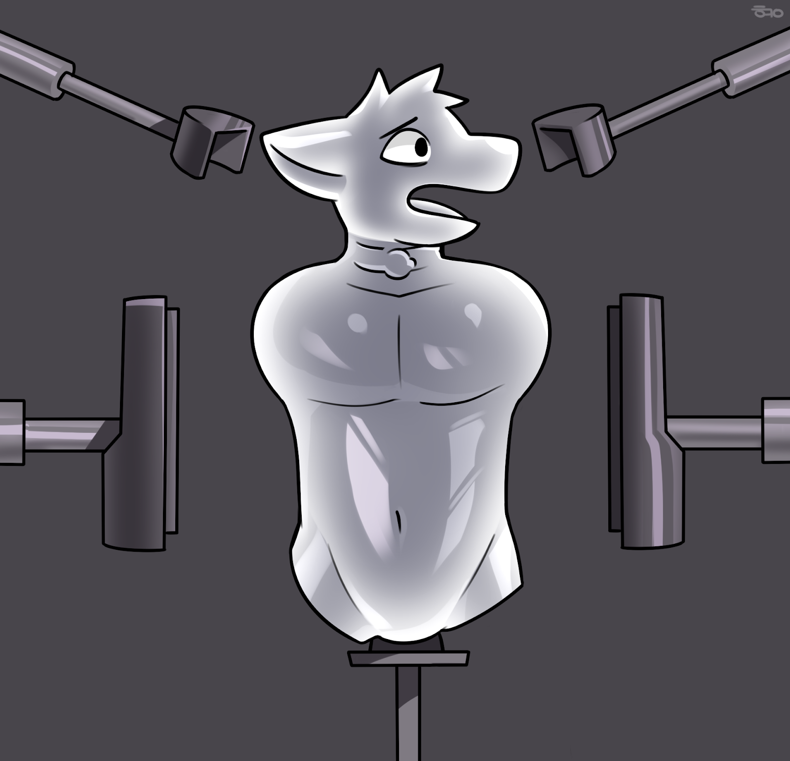
Two metal arms came up to him, each with a half-cylindrical mould. Another two round caps aimed for his head. The shark closed his eyes.
“Please—”
All of them slammed together with perfect precision. The shiny shark was plunged back into darkness within the mould. His entire body had been squeezed downwards onto the dildo, allowing it to extend up his chest, throat, and into his maw. Its girth compressed his sides against the mould, leaving him no space to move. The two caps flattened his head down over the top of the dildo, compressing the rest of his body down.
Everything was still. Then the pole pushed upwards, compressing the shark deeper into the mould. With his throat filled by the dildo, the shark couldn’t make even the softest of sounds. His insides were squeezed against the ribs of the dildo, and his head was compacted against the top of the mould.

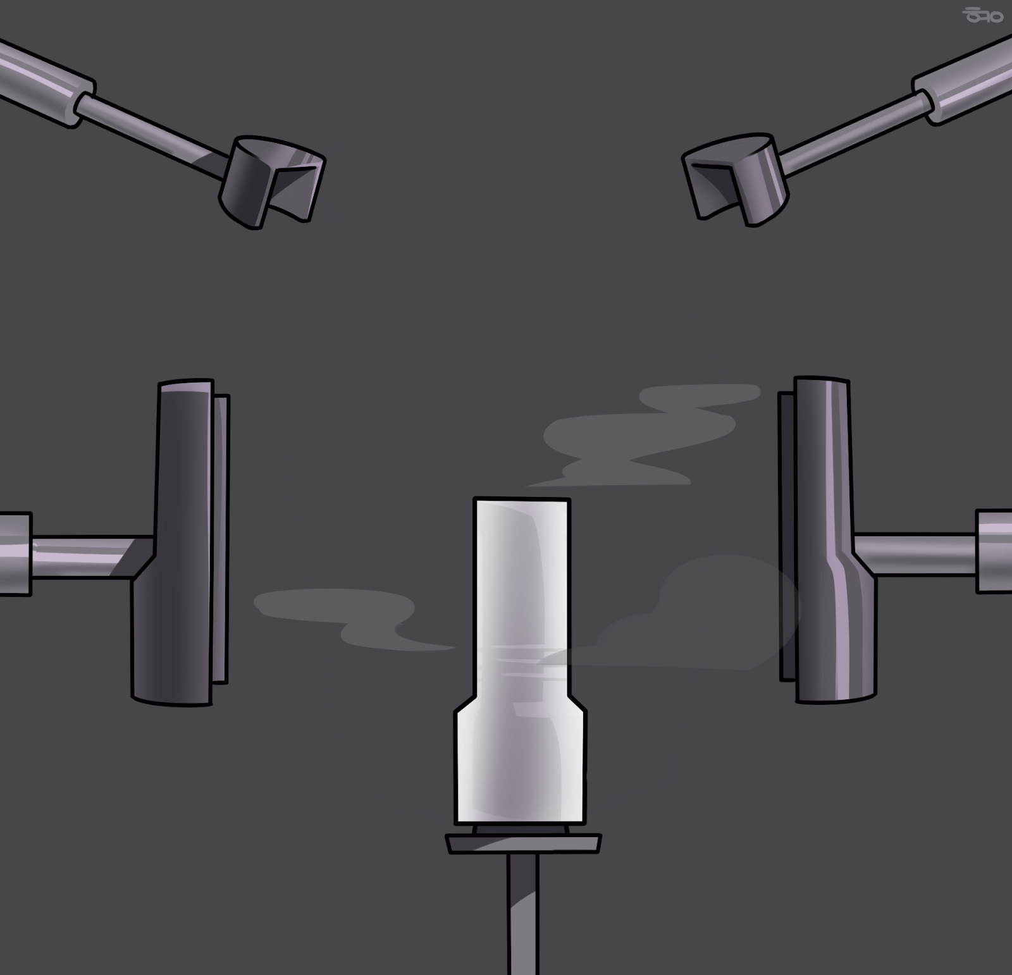
Just when the shark couldn’t take any more compression, the metal mould was dismantled. The white shark was gone, and in its place was a silicone fleshlight. The fleshlight was perfectly sleek and shiny, giving no sign that it was once a shark. Its facial features had fused together in the compression, leaving behind smooth surfaces.
The doors to the machine opened and the pole slid out. One of the captors came over and lifted the fleshlight. There was a squelch as the dildo was extracted from the fleshlight’s insides, leaving behind a ribbed tunnel. The dildo had moulded ridges in its tunnel, making it an effective fleshlight.
The fleshlight couldn’t speak or move. All it could do was to clench its inner tunnel in helpless dread. Its future would be filled with a lot more clenching around throbbing dicks, pleasuring them as they abused its tight, silicone fuckhole.
What else were prisoners good for, anyway?

~ End ~

