Garchomp, I Choose You!
Written by TwistedSnakes
Illustrated by Qundium

The air in the office was cold and crisp, with the faintest of hums coming from unseen vents in its walls. The walls and ceiling were lined with pristine white panels, separated by discreet strips of LED light, bathing the entire room in sterile brilliance.
Decro studied the contract in front of him: a stack of papers filled with legal jargon and complex clauses. The meaning of those words refused to stick in the wolf’s mind, and he found himself reading the same lines over and over. The harsh white around him didn’t help.
“You plan on signing the contract today?” Cyrius groaned.
The lizard slumped on the table.
“Hehh, don’t be so dramatic.”
Cyrius, Decro’s college mate and friend, was the one who dragged the wolf to this gig. Given his family’s financial situation, the lizard was always looking for jobs to pay for college and living expenses. Decro tried to help wherever he could, from treating him to meals and hanging out at cheaper options, but there was only so much he could do to support his friend. Which was why when Cyrius found this mascotting gig, Decro agreed to follow.
“Where’s your contract?” the wolf asked.
“Already signed.”
“When? Because when I arrived, you were already—”
“Are you going to sign your contract, or are you going to keep talking?” Cyrius snapped. “Because if we want to be on time, we need to have suited up 10 minutes ago.”
“Okay, okay.”
Decro skimmed the contract again. Realising that nothing was registering in his mind, he gave up.
“Ugh, let me just sign it.”
After all, this was just a mascotting show. How bad could it be?
He flipped to the last page and signed his name. Cyrius hastily snatched the papers off the table and pranced to the door. Decro chuckled. It was rare to see his friend this excited.
The lizard banged on the door, and an employee opened it. The cheetah was dressed in a skintight Greninja suit up to his neck.
“Has he signed it?”
“Yeah, here.” Cyrius thrust the stack of papers into the cheetah’s hands.
The cheetah looked at the contract, then glanced up at the wolf. Decro could swear there was a skeptical look in his eye, but that quickly disappeared as the cheetah shrugged.
“Let’s go.”
The pair of friends followed the cheetah down the white corridor, with featureless doors on either side of them. Everything was so suffocatingly sterile, Decro felt like he was in a high-tech science laboratory rather than a mascot company.
The cheetah’s outfit, too, was concerning. Upon closer inspection, it was a latex suit coloured with the markings of a Greninja. It was skillfully created: the colours were true to life, the fins and bumps were latex attachments fused to the suit, and even the seams were unnoticeable. However, the shiny rubber bulge on the crotch of the suit was a worrying addition.
Was this appropriate for a mascotting event?
The wolf almost opened his mouth to say something when Cyrius interrupted his thoughts.
“Aren’t you excited?”
“I’m a bit unsure about—”
“You have no idea how much this means to me. After this gig, I don’t think I’ll have to worry about tuition fees for the next few semesters.”
“But—”
“We can go for a fancy meal after this, my treat. Where do you want to eat? You like going to Sealight Bistro, right?”
Sealight Bistro. It’s been a while since Decro had last been there. In fact, the last time he went, it had been with the lizard. Decro had wanted to introduce Cyrius to his favourite restaurant, only for the lizard’s jaw to drop when he saw the menu’s prices. Decro had hastily offered to pay for Cyrius’ meal to prevent any further embarrassment on either of their parts. Since then, the wolf hadn’t had the opportunity to go back there.
“You’re smiling already. That’s a yes then?”
Decro nodded.
The cheetah stopped at a wide door made of two panels of frosted glass. Above it was a plain steel sign that read “Processing Hub 17-D”. He tapped his staff pass against a scanner on the wall, and the two panels slid aside. He stepped in, and the pair of friends followed.
This room felt like a mix between a workshop, an office space, and a waiting room. A few desks were situated throughout the room, each with a computer and messy stacks of documents. Industrial frames were mounted on wheels, with chains and cuffs welded onto their steel bodies. A couch was placed in the corner, providing a sole source of comfort in a room of oppressive white and soulless furniture.
Against the left side of the room were two doors. The first looked like an ordinary door, just like the one they came through. However, the other one was a heavy reinforced door. It had no handle, so it had to be opened from elsewhere.
“Wait here,” the cheetah instructed.
The cheetah went into the normal-looking door. After a few seconds, there was a hiss as the reinforced door opened. The cheetah reappeared.
“Get into the suiting chamber.”
Decro stepped through the reinforced door. The chamber wasn’t particularly big: just three steps would take him from one side to the other. Instead of panels, the walls and ceilings were made of white square tiles. A black one-way window separated him from the other room that the cheetah had been in. That must be the control room. The wolf turned and saw that Cyrius was still standing outside the chamber.
“Cyrius, you can wait here while—”
“I’ll get changed too,” the lizard interrupted. “My suit’s in the other room, right?”
“Uh… sure.” The cheetah shrugged.
The latex-clad feline went back to the control room. There was a second hiss, and the door slid shut, confining Decro in the chamber. The subtle hum of the outside world was suddenly shut off, plunging the wolf into a deep silence.
“Take off your clothes and put it in a box at the corner,” the cheetah’s voice came in through hidden speakers in the chamber.
Decro took off his jacket and shirt, folding them neatly before putting them into the clear plastic box. He took off his shoes and socks next, then pulled down his pants.
“Underwear too.”
As the wolf stripped himself bare, he could hear a whir behind him. He turned around to see the wall flip around, revealing a dark blue latex suit with red and yellow highlights. A rubber shark-like mask and long finned tail hung from hooks on the panel. It was a Garchomp suit.
As the wolf put the rest of his clothes into the box, the cheetah gave more instructions.
“Face me, stand shoulder-width apart, then spread your arms.”
The wolf stood awkwardly facing the one-way window, feeling vulnerable in his position. There was an uneasy feeling in his gut. Something was off about this whole situation, but he couldn’t quite place his finger on it.
“Before we go on, could I ask some questions? Something’s bothering me—”
A wall tile slid away, and a metal tendril slid out of it. It grabbed the plastic box with its clawed end, pulling it into the wall opening. A floor tile opened up in front of him, allowing two more tendrils to emerge and grip his ankles. Decro tried to step back in a panic, but the claws’ grips were too strong.
“Hey! What’s going on?”
“The suiting process is automated. This will help us get a better fit on your body.”
“Okay…”
More robotic tendrils appeared from the wall behind him, grabbing his shoulders, waist, and neck with their strong claws. They dug into his flesh, practically squeezing against his bones and making it impossible for him to move. Two more tendrils appeared with nozzles at their tips. Pointing at his feet, they began spraying a clear, shiny liquid onto his fur.
“What’s that?”
“Suiting lubricant.”
A strong, familiar scent filled the room as the lubricant was applied. It soaked into Decro’s thick coat of fur, causing it to flatten against his body like a smooth, shiny skin. The sprays moved up, encasing his legs in the shiny coat. Tendrils picked up the latex Garchomp suit and brought it near the wolf’s feet.
Everything happened swiftly and efficiently. The claws lifted Decro’s left foot, guiding it into the leg of the latex suit. The shiny material was quickly tugged upwards, pulling out the creases as the suit was guided up his ankle, calves, and thigh. As his left leg was lowered to the ground, his right leg was pulled up and suited in a similar way. The latex was cold against his fur, making him shiver.
The suit was masterfully crafted. The clawed toes gave Decro’s feet a draconic form. On each thigh were two pointed spikes made of firm rubber, bringing out the features of a Garchomp. The stretched latex was sleek and shiny beneath the white lights.
“Wha?!”
A claw cupped the underside of the wolf’s genitals, making him feel violated. A nozzle sprayed copious amounts of lubricant onto his sheathed cock and balls. The claw then guided his package into the crotch bulge of the latex suit. The rubber material was pulled taut against his pelvic region, accentuating his promiscuous bulge.
The feeling of dread grew stronger as his instincts warned him of danger.
“Is… is this really appropriate?”
Something pressed against his rear pucker and Decro yelled. The wolf struggled, but the intruder was persistent. Despite his desperate clenching, the slippery lubricant allowed the probe to enter his rear tunnel.
“What’s going on? Get that out of me!”
“Stop trying to move.”
Decro whimpered as the probe delved deeper and deeper into his sensitive insides. He had never taken anything up his rump before, much less something so big. Each time he thought it was as deep as it could go, the probe would somehow push deeper into him.
“S…stop this, please!”
“No can do. You agreed to all of this in the contract.”
The wolf could almost hear the cheetah’s grin in those words.
“What the fuck was in that contract?”
“If you haven’t already read it, then you’ll find out soon enough.”
The probe’s entire length was finally hilted within Decro. Then its metal rod slid out of him, leaving its rubber sleeve stuck inside the wolf’s tunnel. Decro clenched his rear muscles, feeling the pliable but firm tube inside him.
“What the fuck did you put in me?!”
The cheetah didn’t reply as the tendrils continued to move around Decro. The suit was pulled up to his rump, while more lubricant was sprayed over his tail and hips.
Bzzt!
There was a short, biting pain around his tailhole.
Bzzt! Bzzt Bzzt!
“What’s that?”
“It’s using heat to seal the suit parts together.”
“Oh, fuck…”
Decro clenched his rear, but the tube inside him was stuck inside, forming an anal sleeve. It spread him wide open, making his inner muscles ache from the amount of stretching it was subjected to. He wanted to beg for mercy, but it didn’t look like the cheetah was going to budge. The stiff rubber tail was pulled over his tail, turning his fluffy fur into a streamlined latex tail.
Bzzzzzzzzt!
He could feel the heat zapping against the base of his spine, fusing the suit and tail together. More lubricant coated his abs and chest, and the blue and red latex was pulled up his hips and lower torso.
Bzzzzzzzzzzzzzzt!
The latex was stretched around his abdomen, with the seam against his back melted until it was a smooth surface. He was being enclosed in his latex suit so tightly it could be his second skin. His arms were swiftly coated in lubricant, with the nozzles paying extra attention to his hands. The tendrils pulled out two rubber claws. Each one was long and curved, starting with a rounded end and tapering to a sharp tip. Their blunt ends were thrust against his palms.
“Oww!”
The tendrils squeezed his fingers around the rubber claws, and more lubricant was sprayed over it. The left arm of the latex suit was pulled over the claw, then up Decro’s left hand, arm, then shoulder. Tendrils pulled the excess material up his arm, easing out the creases in the material. As the latex was pulled tight, the wolf’s fingers were trapped against the rubber claw like a balled-up mitt. Another tendril pulled the right arm up in the same way. Each arm of the latex suit had a large fin on the forearm and two white spikes on the upper arm.

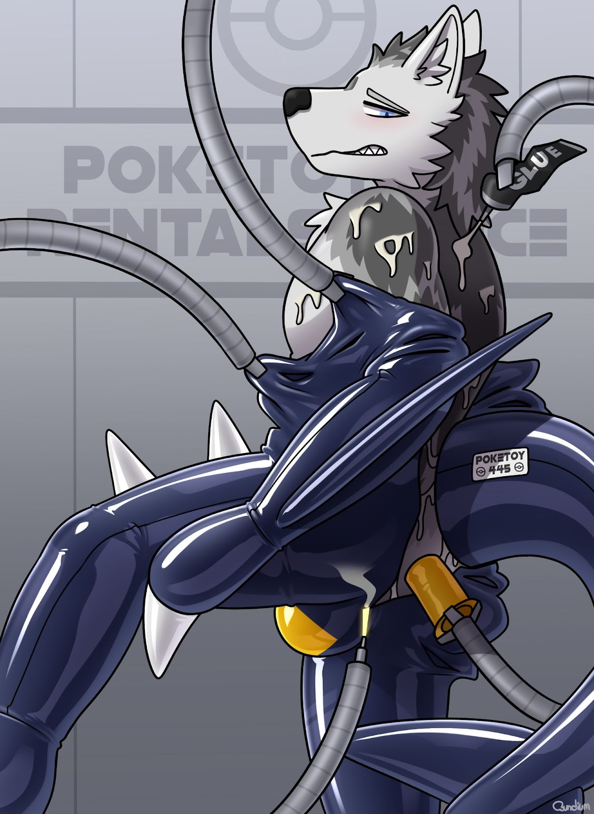
The two halves of the back of the suit were pulled together, compressing the wolf’s chest. The latex material was thick and restrictive, making it hard to breathe.
Bzzzzzzzzzzzzzzt!
He could feel the suit being sealed behind him. The latex suit rose halfway up his neck, and the tension around his windpipe caused a sense of discomfort. He had to breathe deeply, feeling his chest push against the firm latex. The tendrils let go of him, allowing the wolf to move. The shiny latex hugged his body snugly. The tight material dug into his elbows, armpits, and crotch. As he took a step forward, the stretched rubber massaged his groin. His null bulge trembled.
He pulled his hand back to feel his tailhole. Without the use of his hands, he had to manipulate the rubber claw to where he wanted to go. It took some time, but he managed to nudge his claw against the entrance of his pucker. He could feel the latex tube form a ribbed tunnel inside him, keeping his passage spread open.
“F-fuck…”
His breaths were shallow. Was it from the compressing rubber, or the mild panic that was setting in? Something was very wrong, and he needed to work it out before it was too late.
“Can I get a moment?” Decro panted. “I’m… I’m not feeling well.”
“Bear with it. You’re almost done.”
“No, no! I just… It’s not… Something’s wrong. Please, stop.”
“You don’t have a choice.”
With the latex suited up to Decro’s neck, all that was left was the mask. As the tendrils took the Garchomp mask off the hook and brought it over, the wolf saw that the inside of the mask contained a long rubber tube at the mouth. It was almost as long as his forearm.
Was that going into his mouth?!
“Wait! That’s not going to fit!”
The nozzles sprayed the inside of the mask with the lubricant, giving a generous coat to the long tube. Decro caught sight of the words printed on the base of a nozzle: “PERMA-GLUE”.
“What the fuck?!”
Had the tendrils been gluing him into the suit this whole time?!
“I didn’t sign up for this!”
The wolf ran to the door and banged on it with his fists, but it didn’t budge. Instead, the tendrils grabbed his arms with their claws and dragged him back to the middle of the room. More tendrils clamped hard on his ankles, taking away his ability to run.
“P-please, don’t do this!”

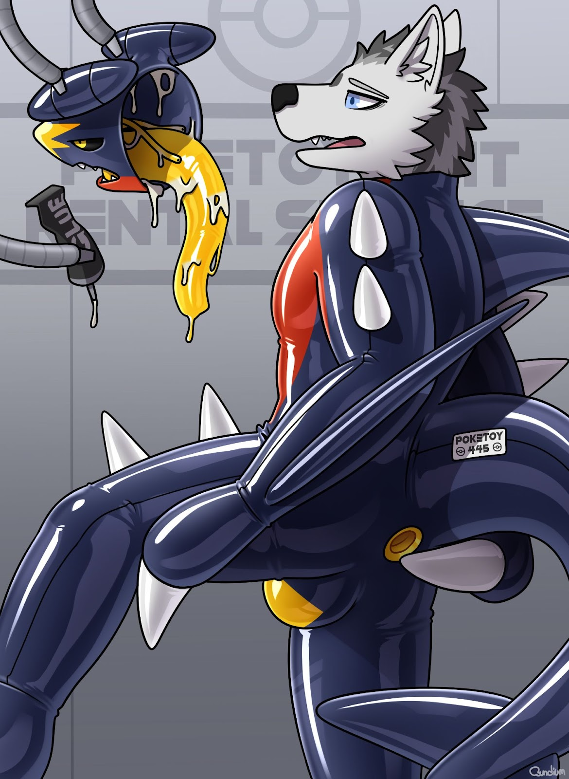
In front of him, the rubber mask loomed ominously, dripping with glue. The mask that would be affixed to his face permanently, just like the rest of the latex suit. A pair of tendrils gripped the sides of his jaws, prying his mouth open to take the large tube gag. More arms grabbed his shoulders, stopping him from struggling.
“Harr… harr… harr…”
His panicked huffs were desperate and pathetic. The nozzles sprayed a thick layer of lubricant over his head, forcing Decro to close his eyes, but his maw was still stuck open. It sprayed into his maw, leaving a bitter chemical taste and a sticky sensation.
The wolf felt a sickening sensation as the tube gag was thrust into his mouth. He tried to push it out with his tongue, but the tendrils were persistent and forceful.
“Grrhhk!”
The slippery sleeve slid past the wolf’s tongue and hit the back of his throat, triggering his gag reflex. Tears welled his eyes as his throat convulsed violently. His chest heaved up and down as he choked painfully on the rubbery sleeve inside his maw.
He clenched his throat, trying to hold back the slippery intrusion, but to no avail. The tendrils kept pushing, forcing the slimy sleeve down his gullet. In there, the tube felt ten times bigger than it looked. It was pressing against the sides of his tensed muscles, as if trying to stretch him out from the inside.
“Gurrrhhh!”
He let out a guttural groan from the back of his throat. Saliva spilled from the corners of his mouth, mixing with the sticky glue on his fur. His muffled retches echoed the primal discomfort of his body rejecting what his mind was trying to endure.

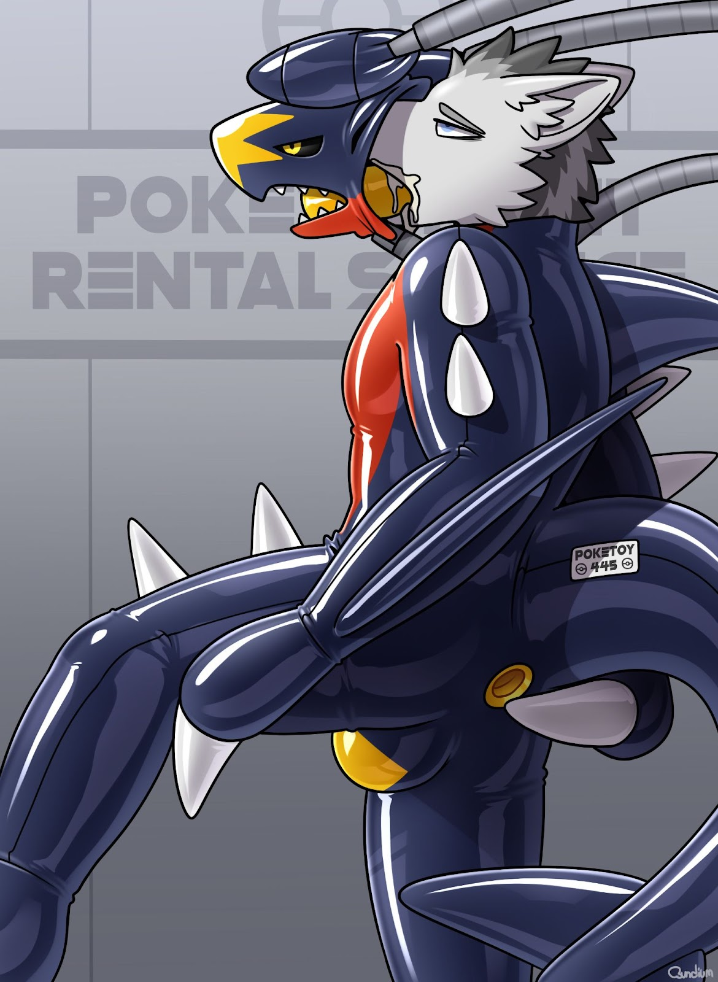
The horrible cramming sensation spread down to the centre of his chest. As the end of the tube approached the entrance of his maw, so did the glue-coated inside of the mask.
“Gffht!”
Decro shook his head violently in protest, but only managed to tremble slightly as the tendrils held him in place. The mask was pressed against his face, adhering tightly to his cheeks, jaws, and forehead. The rubber sides of the mask were pulled over his head, flattening his ears against his scalp. The wolf’s body convulsed as the tube was hilted within his throat and gullet.
The wolf blinked through the tears, trying to clear his vision. Despite its rubbery exterior, the inside of the mask was hard and rigid, helping it keep its streamlined shape and obscuring Decro’s canine muzzle. The mask’s eyes were covered by tinted lenses, allowing him limited vision while obscuring his eyes from the rest of the world. All people would see now was his painted Garchomp eyes.
With the mask encasing his head, the only thing left for the tendrils to do was to seal him in.

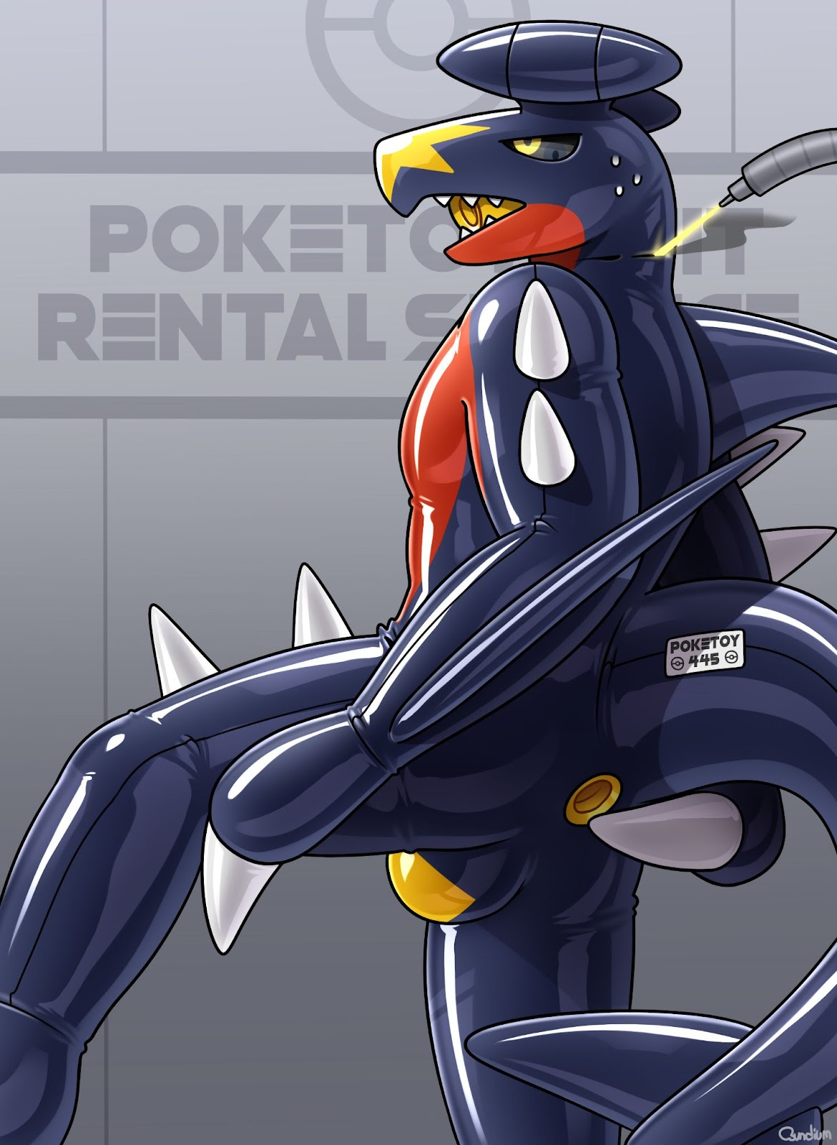
Bzzzzzzzzzzzzzzt!
The back of the mask was melted closed, and the overlap between the mask and the suit was quickly turned into a seamless sheet. With that, the arms let go, leaving the former wolf as a latex Garchomp.
“Gnffrr!”
With the tube filling his throat, his struggling groans came out like low-pitched growls. He clenched his throat repeatedly, trying to ease the aching in his neck and chest. As he tensed his muscles, he could feel it shift inside him. The glue had already adhered the rubber sleeve to his inner passages. He tensed his throat, trying to stifle a choke.

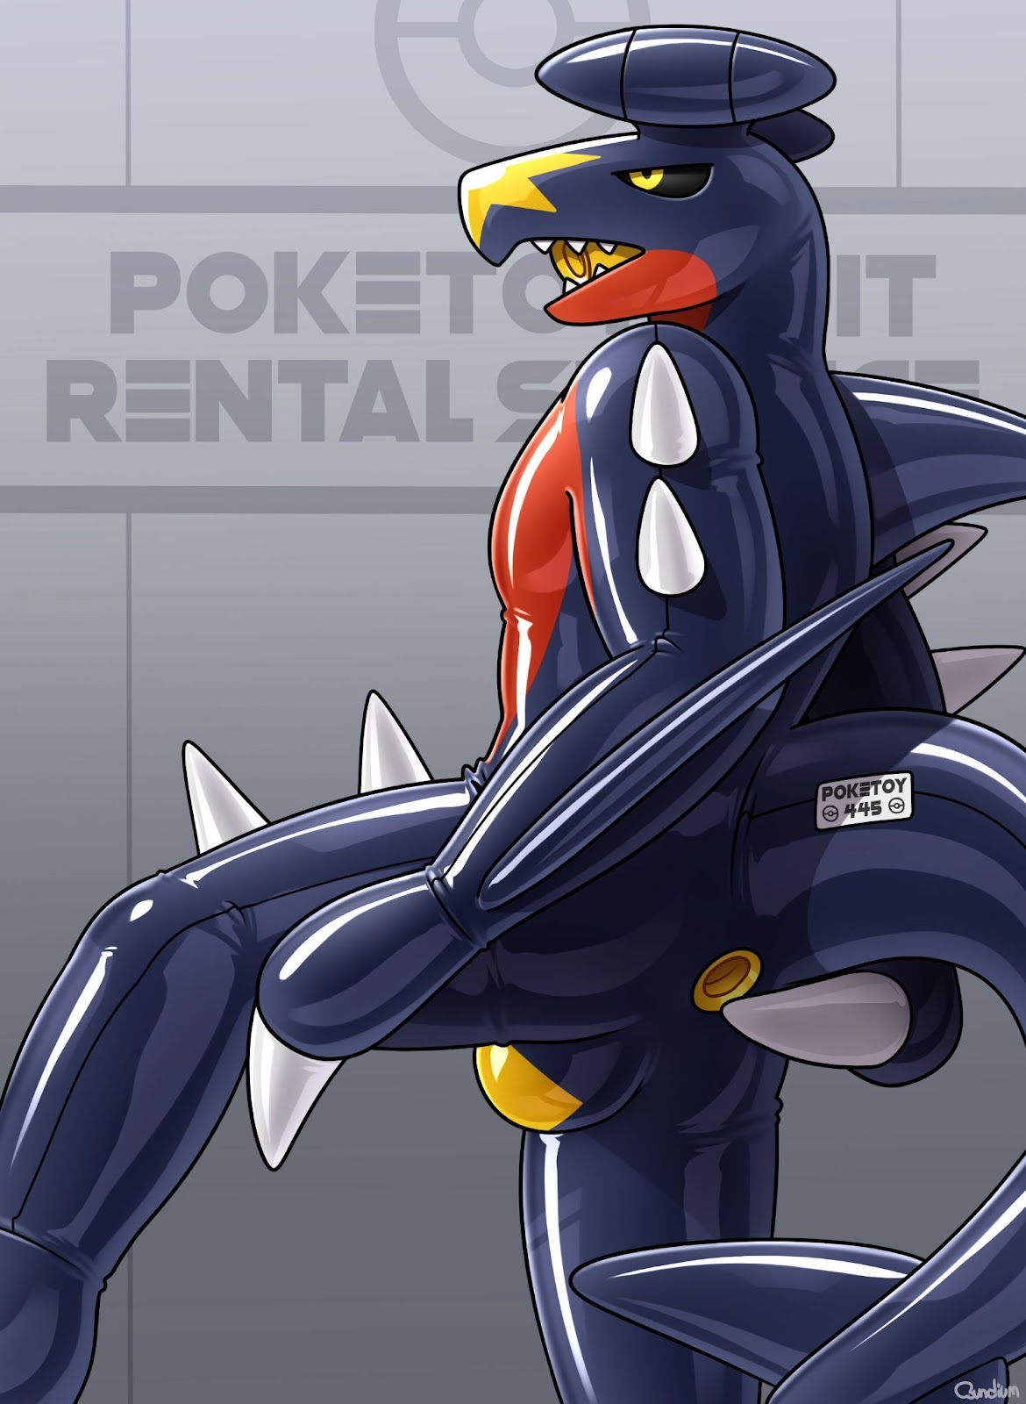
He put his mitted hands against his face. Without the use of his fingers, he could only squeeze his clawed fists against the mask to get a flimsy grip as he tried to pull it off his face. He felt a bit of tugging on his face as he pulled; the glue was working too well. He yanked harder, trying to get it off before the adhesive set properly. The latex suit stretched, squeezing the rest of his head.
“Grrrk!”
He relaxed his throat a bit, enough for a choking sound to escape. Was he making progress? If he were, he couldn’t feel it without the tactile sensations in his fingers. He pulled harder, squeezing his useless paws against the mask. It was agonising; it felt like he was trying to rip the fur off his face. But when the alternative is a permanent Garchomp face, the pain was a price he was willing to pay.
Snap!
His grip slipped, and the mask slammed against his skull. Decro choked again as the throat sleeve shifted, hitting a sensitive spot at the back of his throat. He grabbed the mask again, but this time, it wouldn’t budge from his face. After a few moments of useless grabbing, he gave up trying to take the mask off. He dug his rubber claws into the thighs of his suit, trying to tear it off. But as he pressed and tugged, he felt pain against his flesh. It felt like he was pulling not just his fur, but also his skin. The glue must’ve seeped down to his skin, merging it with the fur and latex.
He took an unsteady step forward, but tripped on his Garchomp feet. He tumbled to the ground and landed with a painful thud.
“Gnnff!”
A mess of emotions welled up within him. He felt violated, confused, and frightened. Tears welled up in his eyes, creating a blurry fog on the lens. Thoughts crashed through his mind like a raging storm.
What the fuck did he do to me?
And why?
What sort of gig did Cyrius get me into?
Wait. Cyrius! Is he okay? Or had he been sealed in latex, like me?
If he hasn’t been suited yet… I have to warn him!
Fumbling with his clawed hands, he pushed himself off the ground and stood up unsteadily. There was a hiss as the chamber door opened and the cheetah stepped in.
“Come with me.”
Decro charged at the cheetah, taking him by surprise. He shoved the feline aside and stumbled out the door. Cyrius was standing just outside, thankfully still unsuited.
“Decro!” the lizard chuckled. “Do you like your new suit?”
The latex Garchomp shook his head.
“Gnrrgf!”
Unable to form words, he was forced to grunt and use hand signals to communicate. He formed an “X” with his forearms, trying to tell Cyrius “no”.
“Grrrhgg hrffft!”
“Aww, you’re getting into character too. I didn’t know you were that kind of person.”
The lizard reached out and patted the Garchomp’s rubber mask.
“Nhhff!” Decro protested.
Fuck. Cyrias wasn’t understanding him.
But there was no time to explain. The cheetah was already getting up with a furious expression. Decro grabbed his friend’s hand with both his mitted paws and pulled him towards the exit.
“What are you doing?” Cyrius gave him a look of concern and confusion. “Is there something wrong?”
Decro stared at him with pleading eyes, as if trying to get his point across. Then he realised that Cyrius could only see his tinted eye lenses.
“Hfgg grrf!”
Desperation filled his grunts. They needed to escape now, while Cyrius was still unharmed. Otherwise, who knew what the cheetah had in store for them? Because it certainly wasn’t a mascotting gig.
“Speak to me, Decro!”
The lizard gave the Garchomp an earnest look. He held his gaze for a few seconds, then a grin crept up his lips. The smile turned into chuckling, and then into violent laughter.
“You really don’t know what’s going on, do you?” he guffawed.
Decro stumbled back in shock, tripping over his latex tail and falling back onto his rump. The impact forced the rear tunnel deeper into him, making him squirm.
“It’s really simple.” The lizard squatted in front of the latex Garchomp. “You’ve just been processed to be sold off as a Pokémon sex slave. And how nice of them to turn you into my favourite Pokémon.”
He pinched the chin of the Garchomp mask, and Decro twisted free in protest.
“Wrhhg!”
“Why you? Because you’re so nice, so trusting. Always wanting to help, right?”
The encased wolf let out a soft whimper as tears filled his eyes.
“If you really wanted to help, you could’ve just given me cash rather than flaunt your wealth by treating me to meals. But now… you can help by getting out of my way and being a good Garchomp. With the money you’ll bring in as a Pokémon sex slave, I’ll have all the help I’ll ever need from you.”
The cheetah secured a pair of steel cuffs to Decro’s wrists and helped him to his feet.
“Thank you and goodbye Decro, or should I say, Garchomp?”
Two burly staff members came in through the door and grabbed the latex Garchomp by his upper arms. One of them was a snake dressed in a Charizard suit, while the other was a panther geared up in a Solgaleo suit.
“Take him to storage.” The cheetah instructed them before turning to Cyrius. “I’ll lead you out.”
The cheetah guided Cyrius out the door, and the two staff members shoved the newly-suited Pokémon after them. While the lizard was led towards the exit, the Garchomp was escorted deeper into the facility. The wolf felt a profound numbness, as if he were merely a detached observer within his body. He could feel the latex squeeze his body, digging into his joints as he moved. The sleeve in his rear kept his passage open, while his throat got used to the constant torment of being plugged up.
The latex Garchomp was led into another room with more white walls. However, unlike the others, this room was empty save for a giant shiny Pokéball. The lid of the Pokéball was open, revealing a padded interior. A large steel dildo was mounted on the base of the ball.
“Gnnff!” the Garchomp protested feebly.
The panther lifted the Pokémon with a cradle carry, supporting him with one hand under his knees, and the other beneath his back. The Garchomp’s anal sleeve was fully exposed, allowing the snake to guide the rubber tunnel down onto the dildo.
“Gnnnnnrrfffggg…”
The Garchomp let out a groan of discomfort as the anal probe slid into his sleek passage. The latex sleeve kept his rear open, making it impossible for him to clench to prevent the intruder from delving into him. The employees lowered him until his rubbery rump was resting on the padded base of the Pokéball, and the dildo was hilted in his rear.
The employees strapped the Garchomp’s legs to the base of the Pokéball, keeping him in a kneeling position and unable to get off the dildo. The snake pulled out a tube from the inner lid of the Pokéball, directing its cock-shaped tip into the Garchomp’s maw tube. After inserting it halfway down the Garchomp’s throat, he strapped it in place around the slave’s head.
“Nfff!”
The draconian Pokémon shook his head, but there was no escaping his fate. The lid of the Pokéball was closed shut, forcing him to lean forward until his head was between his thighs. There was a loud hiss as the padded walls of the began to inflate. They pressed against the Pokémon from all sides, enclosing him snugly and making it impossible for him to move.
Whirrrrrr.
The tube in his mouth began pumping a sweet but chemical-tasting liquid straight down the rubber throat sleeve and into his stomach. Within seconds, he can feel his body heat up as if he were coming down with a fever.
Bzzzzzz.
The dildo in his rear came to life with pulsating vibrations. Were they trying to arouse him? The idea of being violated like that was sickening. But something felt wrong. The heat in his body was amplifying the arousal, making it wash through his body like through shuddering waves.
The hose was feeding him an aphrodisiac!
He tried to resist, but there was no stopping the arousal. His dick hardened and tried to escape his sheath, only to be blocked by a rubbery barrier. The adhesives in the suit’s crotch had cured, permanently melding the latex bulge to the wolf’s genitals.
“Hnfff…”
He whimpered at the permanent modifications to his body, but there was nothing he could do. His arms were starting to ache from being cuffed behind him. With his body forced to bend over in his enclosed space, his muscles started to feel the strain. He shifted his body, trying to ease the burning sensation in his muscles.
Trapped in darkness with nothing to do, questions raced through his mind.
How long were they going to keep him here?
What did the future have in store for him?
Will they ever let him go?
Unfortunately for him, he would only find out the hard way, and the answers were not pleasant. After all, the company already had a plan for him. First, the Pokéball would be his home, keeping him trapped in that confined space with no sights or sounds to be had. The tube in his mouth would feed him a nutrient solution mixed with an aphrodisiac. Whenever he took a piss, the bulge would drain it into his rear port, where all his wastes would be cleared out through the anal dildo.
The endless stimulation would become his reality, seizing his waking moments with its relentless arousal, only to follow him into his sleep, too. His cock would remain painfully trapped within the latex bulge, with no way to reach it to ease the agony. Hours would turn into days, which would turn into weeks. He would drift in and out of sleep until there was no difference between slumber and wakefulness: they were two sides of the same void.
After that, he would be taken out, a broken and subdued Garchomp perfect for obedience lessons. He would be put through a schedule of training, from listening to commands to serving others as a latex toy. Disobedience would be met with punishment of both mental and physical pain. At night, he would be put into a hypnosis helmet to destroy any remaining sense of self.
And when he was nothing but a broken and subservient Garchomp, he’d be used and abused as a sex toy for the rest of his life.

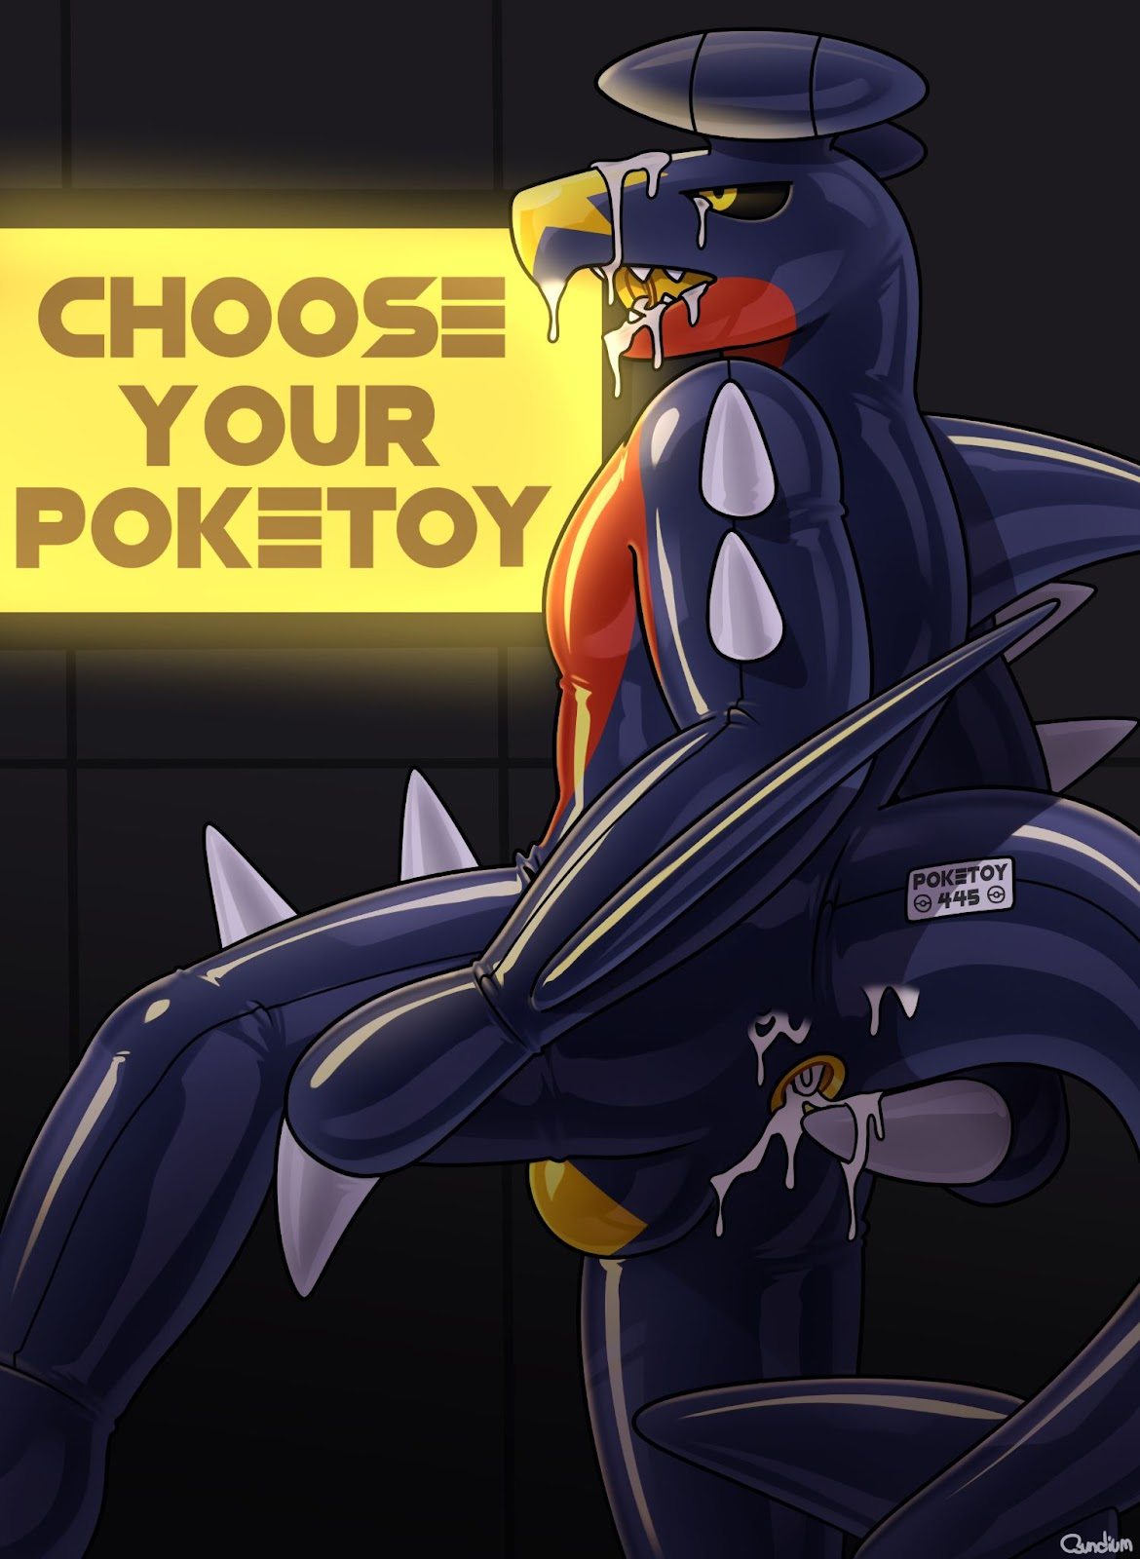

~ End ~

