A Villain’s Trap
Written by TwistedSnakes
Illustrated by JackalLabs

Skyhawk ran down the corridors of the Zolaris Research Foundation, hastily surveying the wreckage around him as he rushed forward with his superspeed powers. Guards laid unconscious on the floor. The ceiling lights flashed red, accompanied by screeching sirens. That meant that the authorities had been alerted. Not that it’d matter. By the time the police arrive, the culprits would be long gone, taking with them priceless valuables and leaving behind a trail of destruction.
The hawk continued deeper into the building. The walls, floor, and ceiling here were made of solid steel panels. Some of the panels were torn off the walls, flung further down the corridor with bullet dents in them. There were more knocked-out guards, their guns dropped on the floor.
Skyhawk frowned, gripping the yo-yo in his hand, ready to strike at the first sign of danger. Whoever caused this was extremely dangerous. The intruder was powerful enough to tear the panels off the walls to use them as a makeshift shield against the guards. But that meant that the intruder wasn’t bulletproof. The superhero mentally ran through the list of villains.
Not Chronos, he didn’t have the strength.
Not Steel Skin, he wouldn’t need defenses against bullets.
Not Hornet, he prefers the sneaky approach rather than destructive entries.
Hmm…
The trail of chaos led Skyhawk to a steel doorway. The double doors had been forcefully pried apart, deforming the metal and snapping the reinforcement rods within. Someone was standing in the other room, and Skyhawk hid behind a broken door to avoid being seen.
“Firewall… down. Now for the security decryption…”
Skyhawk peeked into the next room. It was a giant hall with a high ceiling, lit only by red glowing light strips across the walls and ceiling. In the middle was a tall metal pillar. Cables and pipes ran across its surface, connecting to ports on the floor and ceiling. Desks surrounded the central device, each covered with computers and scientific equipment. All of them faced the middle. To the side was a control panel that a jackal was tapping away on.
Noise.
Skyhawk recognised the villain immediately by his distinctive goggles and lab coat. He considered his strategy. The jackal had hypnotic powers, as well as a set of gravity rings. He’d have to go for a sneak attack and avoid looking into the jackal’s goggles directly. After that, close-range combat should render the gravity rings useless. He’d just need to avoid the jackal’s electric gloves and he should be fine. Physical combat wasn’t the villain’s strong suit.
The hero looked around. “Electrum Crystal Vault” read a sign in the corridor. This must be what Noise was looking for: a crystal network with near-limitless power. It could cause mass destruction if it fell into the wrong hands. If Noise invented a device to harness his power… Skyhawk didn’t want to think of that. He needed to stop this here.
He readied himself, preparing to strike once the opportunity arose. His mind flashed to the wreckage in the corridors.
Wait.
Noise could not have caused that level of destruction. That meant…
“Can I help you?” A steely voice spoke behind him.
Skyhawk turned around to see a white-furred wolf glaring at him.
“Kinesis!”
Kinesis only had one power: the ability to move things with his mind. But that alone made him highly dangerous, even to superheroes like Skyhawk.
There was no time to think. A steel beam hurtled towards him and he quickly swung his yo-yo. The spinning disc hit the beam, deflecting it into the wall beside him. A second one was already flying at him, which he dodged. It pierced the ground where he had previously stood.
That was close.
“Missed me!” Skyhawk chuckled.
As much as he found these taunts inappropriate, it had driven some of his opponents into a careless rage, allowing him to target their weakness. The narrow corridor made it hard to dodge the villain’s projectiles, so he dashed into the vault, avoiding the flurry of debris the wolf was flinging at him.
“Is the police here?” Noise was still focused on the control panel. “I need more time.”
“Just a pesky hero,” Kinesis replied, walking into the vault. “I’ll deal with him.”
A large block of concrete tore out of the ground and floated in the air as the wolf took aim. It shot towards Skyhawk at alarming speed. The bird was ready. With his superspeed, he lept over the flying block and swung his yo-yo. It hit Kinesis on his wrists, causing him to drop a computer monitor he was preparing to throw.
“You gotta work on your aim.” Skyhawk chuckled.
Kinesis snarled. “You will pay for this.”
“Make me.”
The wolf raised his arms, and five desks floated into the air around him. Skyhawk wasn’t about to be a sitting duck. He flung his yo-yo towards the ceiling, allowing it to wrap around a support beam. Using it like a grappling hook, he swung into the air as a desk crashed below him, shooting wooden splinters everywhere.
“Missed again!” He stuck close to the ceiling, swinging from beam to beam.
Kinesis floated into the air behind him, surrounded by spinning rings of small debris that had gotten caught in his force field. Raising his hands, the wolf lifted more objects into the air and propelled them at Skyhawk. The hero dodged projectile after projectile that Kinesis fired at him. A concrete block. A steel spike. Another wooden desk.
A flying metal panel hit a gigantic pipe that was mounted against the wall, tearing a gash through it. A pale, glowing liquid gushed out, forming transparent crystals over everything it touched.
Note to self: keep away from the pipes.
A piece of lab equipment hit the wall behind him, exploding in a burst of flames. Skyhawk hastily swung away from the heat.
“Practice makes perfect! Maybe after a few hours, you’ll even be able to leave a scratch on me.”
The hawk was getting desperate. Kinesis wasn’t falling for his taunts, so it was hard to get an opening on him. Thankfully, though, the heavier the projectiles, the harder it was for Kinesis to take aim. As long as the hawk kept moving, he’d be fine. He circled the central device, looking for an opening to strike.
“Got it!” Noise called out from below.
There was a piercing hiss. Blue light escaped from gaps in the steel column as its top half rose into the ceiling. Smoke spilled out from it, covering the floor in a thin layer of translucent mist. In the heart of the central device was a large crystal. The air around it shimmered, bending the fabric of reality with its immense power.
Crud. He forgot about Noise.
“We’re done?” Kinesis hurled a metal shard at Skyhawk.
“I just need a while to disengage the containment lattice.”
The hawk needed a different approach. If he got down to the control panel and disabled it, he could prevent the next step in their plan. In his contemplation, he almost missed a projectile that Kinesis hurled at him. He swung to the side, only to fall into the villain’s trap. His yo-yo string was sliced by a metal shard that Kinesis had earlier stuck into the ceiling beams.
Gravity reared its ugly head as Skyhawk as the steel floor rushed to meet him. There was a deafening thud and a burst of pain as he landed on his shoulder.
“Argh…”
The misty air stirred as Kinesis floated to the ground a few paces away. It took Skyhawk every ounce of effort in his body to stand up. He couldn’t go down, not like this. A sharp pain shot up his left shoulder, and he used his other hand to squeeze it.
“Not so cocky now, bird?” Kinesis stepped closer.
Skyhawk felt the tingly sensations of static on his skin. Kinesis was using his powers on him. Ordinarily, it’d be easy to shake off the effect, but the pain was weakening his resistance. Kinesis lifted the hawk into the air and floated him closer. The air around Kinesis pulsed with vigour, almost like a heartbeat.
Dmpft-dmpft. Dmpft-dmpft.
He was dragged face to face with the wolf. His expression was cold, but his eyes had a piercing sharpness to them.
“S-stop.” Skyhawk groaned. “Y-you don’t have to do this.”
Kinesis clenched his fist, and Skyhawk felt the muscles around his chest tighten.
“Ack! Listen,” the hero pleaded through laboured breaths, “in Noise’s hands, this crystal will destroy Greenville, or even the world!”
“We will build a new one.”
Shards of sharp metal and shattered glass floated into the air behind Kinesis, all of them pointing at the hero, ready to puncture a million holes in the hawk, rendering him very, very dead. As Skyhawk opened his beak to buy himself more time, he noticed a flickering blue light. It came from a glowing gem in the middle of the wolf’s chest.
Huh?
It looked like an accessory, strapped in place by the wolf’s chest harness. However, its light was pulsing with a rhythm.
Dmpft-dmpft. Dmpft-dmpft.
Just like the force-field. Was this the source of Kinesis’ powers? Was that his heartbeat? Maybe if he…
“There’s another way out. If we just—wait, what’s that?”
Kinesis turned his head, and that was enough to break his focus. Skyhawk swung his right fist at the wolf’s chest. His knuckles came in contact with the gem, and there was a blinding flash of light. The bird was flung through the air, landing on the ground and skidding away. When he regained his vision, Kinesis was lying unconscious on the ground. The shards of glass and metal were strewn around him on the floor.
Was the villain’s powers disabled? Skyhawk hoped so, but he stayed cautious. One wrong step could put him in danger again. He could—
BZZT!
A burst of electricity surged through his body, and he collapsed on the floor.
“Looks like flying type is weak to electric.” Noise chuckled behind him.
Noise! He forgot the other villain again. The hawk cursed himself silently as he tried to get up, but his shuddering muscles refused to comply.
“Hgngg…”
The incapacitated hero couldn’t defend himself as the villain crouched in front of him. Noise whipped out two golden cuffs and snapped them on Skyhawk’s wrists.
“What’s—”
"You’ll see, Feathers.”
Skyhawk grimaced at the nickname. The cuffs floated into the air, lifting the hero up by his arms. Burning agony shot through his shoulder, but there was nothing he could do. With his feet floating off the ground, his arms held the weight of his body. He was more vulnerable than he’d like to be.
“What do you think of my gravity rings?”
“Put me down!”
“You’re not in a position to make demands, my dear little Feathers.”
The jackal smirked. He stepped in front of Skyhawk and stroked his chin teasingly. The hero pulled away.
“Hands off me!”
“Feisty, aren’t you?” Noise chuckled. “Well, I wouldn't have it any other way. But to make sure you don’t try anything else…”
The jackal snapped another pair of cuffs around the hawk’s ankles. Skyhawk tested his restraints, trying to squirm through his binds. The floating cuffs didn’t budge, as if they were held in place by the strongest titanium.
“What do you want from me?”
“Oh, you’ll see. No need to rush when I have all the time in the world.”
“You wish. The police will be here any second now.”
“Will they? Even after I hacked the building’s security system and disabled all the alarms?” The jackal grinned from ear to ear with a crazed look in his eyes that sent shivers up Skyhawk’s spine. “I don’t think so.”
“You can’t—”
“Oh, but I can.”
Noise whipped out a digital tablet and began tapping on its screen.
“Let’s see. If I recall correctly, you use a cybersuit, do you not?” He tapped on a menu and scrolled. “Ah, I see it here. ‘Mike Wingston’.”
“How did you—”
“An electro-field masker does nothing to stop a hacker of my calibre. Just one tap, and I’m already in. Look, I’m in control now.”
The jackal swiped on the tablet. Skyhawk’s body-hugging suit phased out of existence, replaced by his casual clothes: jeans, t-shirt, and a blue hoodie. His mask was gone too, revealing his personal identity to one of the most dangerous villains in Greenville.
“You’re much cuter than I imagined, Skyhawk. Or should I say, Mike?”
Noise stroked the bird’s chin, but the hero was too shocked to pull away this time.
“S-stop…”
The jackal ignored him, moving his palm down to the hawk’s chest. He gave the hero’s muscular pecs a firm squeeze, eliciting an unwilling but pleasured moan from the bird.
“Stop?” He stroked his fingers down the hawk’s chest. “Why would I, when I finally have such a hunk of a hero under my control? No, no. If anything, I’ll keep going.”
He returned to the tablet and navigated the screens, taking longer this time.
“Oh, this will look good on you.”
Mike’s clothes disappeared, replaced by a shiny latex jockstrap. Its front pouch hugged the bird’s crotch, held in place by a strap around the waist and two more around his upper thighs.
“Hey!” The hero squirmed. “Give me back my clothes!”
“Oh, but you look so much better like this.”
The jackal stroked his fingers down the hawk’s sculpted abs. Mike shivered. The intimacy of the touch was sending all the wrong signals to his body. He couldn’t be enjoying himself, not while he was vulnerable to the villain before him.
“You’ve gotten beefier too. The first time I saw you, I thought you were a chicken. A scrawny one at that. But now…”
Noise tucked the tablet back into his coat, freeing up his hands to grope the hero’s muscular body. Arms, pecs, lats. The hawk shuddered.
“Hands off my body!” He snapped, scrunching his face in an attempt to hide his blush.
“Yet your body betrays you. You like this, don’t you?” The jackal grabbed the bird’s bulge in his palm and gave it a firm grope.
“Ahh! Hngg… N-no…”
“Moaning already? You must be so deprived.”
He continued to fondle the jockstrap, tracing his fingers over the bulge’s outline in the smooth, shiny latex. His delicate touch danced over the hawk’s balls, moving on to the semi-firm shaft of the hero’s cock.
“Mngghf!”
“Oh? You like this, don’t you? Who knew that Skyhawk, hero of Greenville, secretly loves his dick being played with?”
“Sh-shut—a-ah!”
Noise interrupted the bird’s words with a firm squeeze around the hero’s shaft.
“Such a horny slut.”
He went around Mike and pressed his chest against the hero’s back. His left arm reached around the bird’s side and groped the latex-clad bulge. Mike groaned. Before he could stop himself, he thrust his crotch into the jackal’s palm. The shame of his actions hit him, and he held back.
“Why did you stop? You know you want to,” the jackal teased.
With his other hand, he groped the bird’s butt-cheeks, giving each one a sturdy clench. His fingers slid between the smooth glutes, stroking the outer edge of the hawk’s rear tunnel.
“D-dont… don’t you dare…” Mike groaned. The dick-fondling was a heavy distraction, disrupting his thoughts with each arousing stroke. It took all his restraint not to hump against the jackal’s hand.
Noise slid his finger into the bird’s tailhole and massaged his muscles.
“A-ah, d-dammit!”
“So loose. You really are a slut, aren’t you?”
Mike’s jockstrap was tenting from his uncontrolled erection. The latex was stretched tightly around the hard mast, emphasising the outlines of the tip of the bird’s cock. Noise grabbed the shaft in his hand and began jerking the hero off. He plunged his finger deeper into the hawk’s rear, feeling up the bird in the most intimate of places.
The hawk was lost in the immense pleasure. His body was sending wave after wave of euphoria, flooding out the thoughts in his mind. He bucked his hips, feeling the jackal’s stimulating pumps work his arousal.
“Now, you’re mine.”
Noise inserted a second finger, thrusting in and out of the tight tunnel. The hawk clenched his muscles, then relaxed, then clenched again. A third finger was inserted, spreading the bird wider. Mike moaned. He could feel an impending climax. He just needed to clench. To thrust. To reach the peak…
The jackal let go, leaving the bird simmering in his starving need. Mike hung his head in shame, torn between his heroic pride and the desire to beg for more.
“Why…”
“I’m going to take my time and break down your will.” Noise grinned. “And I’ll enjoy every moment of it.”
There was a grunt from the side. Noise turned to look. The wolf was stirring, propping himself up with one hand, clutching his chest with the other.
“Noise…” he groaned weakly. “Help.”
The jackal rolled his eyes. “Can’t you see I’m busy?”
The wolf coughed, spluttering out blood across the floor. The sight of red left him shocked.
“I’m dying, dammit. Let’s get the crystal and get out of here!”
“You’re selfish, you know that? You’ve already had your fun with Feathers here. It’s only fair that I get my turn.”
“What the—This is no time for jokes!” Kinetic barked. “We have to—”
There was a deafening boom and a blinding flash. The wolf was blasted across the hall where he slammed into the wall and fell onto the ground.
“Hnn…” he groaned before collapsing.
Noise blew smoke from the tip of his energy gun. He tucked it back into his waist holster before turning back to the bound hero.
“Now, where were we? Ah, right.”
He kneeled in front of the hawk, admiring the bird’s rubbery bulge. Mike’s hardness was trapped beneath the latex, desperate for release. The jackal tugged the top of the underwear down, freeing the erect dick.
Mike eyed Noise wearily. His cock was twitching in horny anticipation, but his heart was beating in fear. He was in a vulnerable situation with no way out. All he could do was watch as the jackal opened his mouth and give his manhood an eager lick.
“O-oh damn…”
The warm wetness sent his head reeling. His entire body shuddered with each stroke of the jackal’s finger, each lick of the jackal’s tongue.
“Feels good, doesn’t it?”
“P-please…” he begged.
“What a slut,” Noise chuckled.
Opening his maw, he took the entire length of the bird’s cock down his oral tunnel, sucking it off eagerly.
“A-ah!”
The hawk’s dick was tense. Noise’s tongue was fervently exploring every inch of his shaft, grinding against the tip of his cock. Mike let out another whimper of pleasure. His body trembled, fighting back against the immovable gravity rings.
Noise bobbed his head up and down, squeezing his wet lips around the bird’s shaft. The tight grip of his lips formed an airtight seal, allowing the jackal’s sucking to tug Mike’s cock deeper into his maw. His hands gripped the hawk’s thighs, stroking his quads and moving up to his sides.
“Hngg!” The hawk let out an exasperated gasp.
The jackal didn’t stop. His hands continued to explore the bird’s body. One of his hands wandered behind Mike, sliding his fingers once more into the hawk’s tailhole. His fingers dived deeper than before, reaching in until he found the hero’s prostate and gave it a firm press.
Mike gasped, squirming more. His knees shifted back and forth as he clenched his pelvic muscles. It would be deeply humiliating to orgasm now, but his raging arousal was making him crave release. He was ready to unload every last drop of his seed into the jackal’s maw. But before he could shoot his spunk, Noise stopped.
“Didn’t think I’d let you finish, did I?”
The jackal smirked. He tucked the cock back into the latex jockstrap, letting it fill out the rubber pouch with its unfulfilled erection. Mike could feel the latex material keep his leaking pre trapped against his cock. Noise stood up, wiping the side of his smirking mouth with his sleeve. The hawk glared at the jackal with a mix of desperate frustration and defeated humiliation.
“That’s enough playtime.”
Mike looked relieved.
“But I’m not done with you yet.” Noise pulled his goggles over his eyes.
The goggles’ flash of swirling colours sucked Mike in. The thoughts in his mind were obliterated in a flash of white, replaced by the incessant buzz of static. If this carried on, the villain’s hypnosis would erode his will into subservient ooze. His heroic survival instincts kicked in and he closed his eyes. The static faded away, allowing him to think again.
“S-stop…”
He could still see the swirls in his vision, urging him to open his eyes and sink into the colours.
“Don’t resist, Feathers. Open your eyes.”
“Mgnhh!”
Mike closed his eyes tighter still. He felt like he was fighting against his body, battling the overwhelming urge to look deeply into those enchanting goggles. To give in to the hypnotic hues.
No!
He had to fight it. His control was slowly slipping, but if he could just hold tighter…
Noise grabbed the back of the hawk’s head and pulled him close. His lips closed around the bird’s beak, forcing the hero into a twisted kiss. The shock made Mike gasp and open his eyes. Noise forced his tongue into the bird’s mouth, exploring the cavity and shoving against his tongue.
The hawk resisted, pressing back with his tongue while he tried to pull his head away. The fight had left him too weak to break free. His eyes looked into the swirls of purple and orange. The colours drew him in, deeper and deeper. Spiralling hues, dancing in ever-expanding fractals. His expression softened. His eyes glazed over.
Mike felt like he was sinking into an endless void. Not quite falling, more like floating. He was vaguely aware of the jackal having his way with his beak. The one-sided kiss of passion were muted sensations from miles away. Only when Noise pulled back did the hawk let out a grunt.
“Yes, it’s so much easier to just give in. To relax.”
“Relax…” Mike mumbled.
The subconscious depths of his mind were saying something, but it was hard to hear. The static in his mind made it hard to make out words.
“Falling gently into my goggles.”
“Mmm…”
“You feel yourself sinking. Deeper and deeper…”
“Deeper…”
“And you feel relaxed.”
Relaxed.
Mike’s eyelids drooped shut, and a serene expression washed over his face.
“Good boy.”
Noise kissed the hawk’s forehead. Moving the gravity rings, the jackal lowered the hero’s arms so they hung by his sides in a relaxed pose. He floated Mike close to the pipe that was broken earlier. Glowing liquid gushed out from the gash in its side, crystallising into transparent shards.
“Time to preserve my trophy. Don’t worry, Feathers, this won’t take long.”
He used the gravity rings to push Mike beneath the waterfall of liquid. The semi-lucid bird was barely aware of what was happening to him. The ice-cold liquid was nothing but a distant sensation, seeping into his feathers and turning the world around him into a solid mass of crystal lattice. Transparent shards grew around him, merging with each other to form a solid shell. If the hero regained his senses, he could break free. But the crystal encasement grew thicker still, and soon there would be no escape for the Skyhawk.

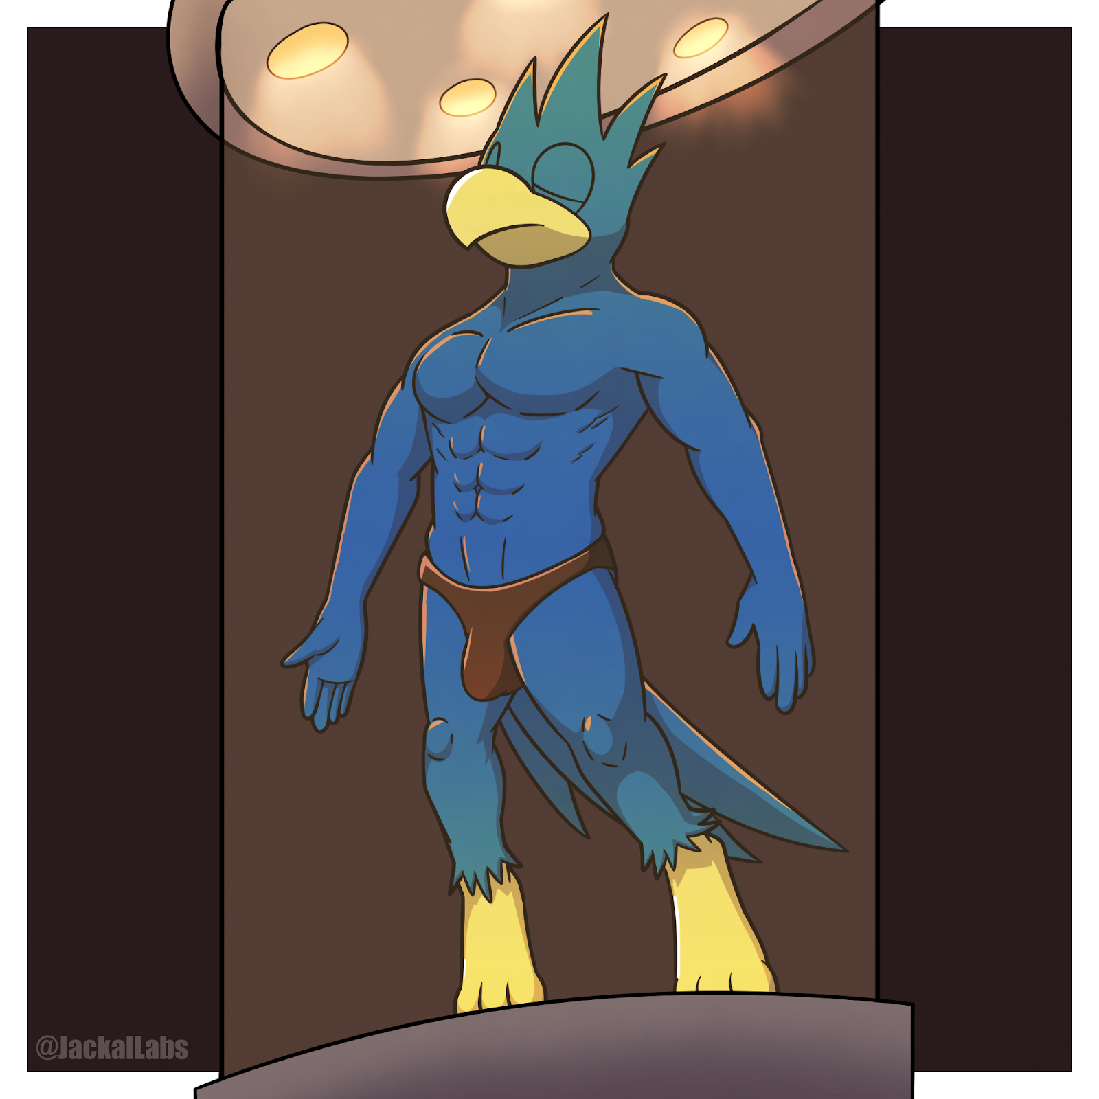

The jackal watched the spectacle in front of him, fascinated by the transformation of the superhero into a trophy. His lair could use a new centrepiece.
“Noise. Please.”
Ah. Kinesis.
He had almost forgotten about the pesky wolf. The fallen villain’s breaths were laboured and his face was scrunched up in agony. Noise walked over to the wolf.
“Crystal. Let’s get out.”
“Do you still have powers?”
“Huh?”
“Powers. Or are you useless now?”
Noise grabbed Kinesis by the neck and lifted him up into the air. The wolf struggled against the jackal’s grip as he gasped for air. The gem in his chest was cracked, and blood was flowing out from the fracture.
“With your Heart Gem broken, you’ve lost your powers, haven’t you?”
Kinesis shook his head desperately.
“Really? In that case, stop me from choking you to death. Go on, use your powers against me.”
The wolf kicked and squirmed, but to no avail. His weakened state was no match for Noise.
“I’m not feeling anything,” the jackal taunted with a grin. “Surely you don’t want to die, do you?”
As Kinesis ran out of air, his chest spasmed. Tears formed in his eyes as his vision grew dark and hazy. He was on the verge of blacking out when Noise dropped him to the floor. The wolf drew in a loud breath of much-needed air.
“Kinesis. Well, I shouldn’t even call you that. You’re just Decro now. Useless.”
The wolf’s eyes widened.
“N-no please!”
“Why shouldn’t I kill you now?”
“W-we’re allies! I held off Skyhawk for you. I helped you get the Electrum Crystal.”
“Electrum Crystal?” Noise chuckled. He whipped out a remote and pressed the button. With a deafening hiss, the steel column in the middle of the room closed shut, sealing the Electrum Crystal in the secure vault. “That was never the goal.”
“Then why did we—”
“I wanted to lure Skyhawk here so I could capture him. But it seems as an added bonus, I can get rid of you, too.”
“Why?” Decro scrambled to his feet and backed away.
“Stab them in the back before they can stab you.” The jackal grinned.
“But—please—I won’t—”
“I’ll give you a chance. You have a minute head start before I hunt you down.”
“I can’t… I can’t fight. Please don’t—”
“55 seconds.”
The wolf’s expression was pleading and desperate. He hastily headed for the nearest door, clutching his chest and limping down the corridor.
“40 seconds.”
Noise went over to the console panel and typed a few commands.
“Alarm triggered,” announced a synthesised voice. “Commencing lockdown freeze.”
White fog filled the corridors with loud hisses, seeping into the vault. Noise could feel the cold mist against his skin. It was chilling, but it was nowhere close to the temperature in the corridors, which had been cooled to sub-zero temperatures. Decro would’ve been frozen solid.
“And time’s up.”
Noise exited the vault and went down the corridor that the wolf had escaped into. Sure enough, there was the petrified figure of the wolf in the corridor. One hand was clutching his chest, and the other was raised in the air in an attempt to shield his face from the fog. His entire form had lost its colour, reduced to the pale blue-grey hues of solid ice. Frost had formed on the ice, adding texture to his otherwise smooth exterior.

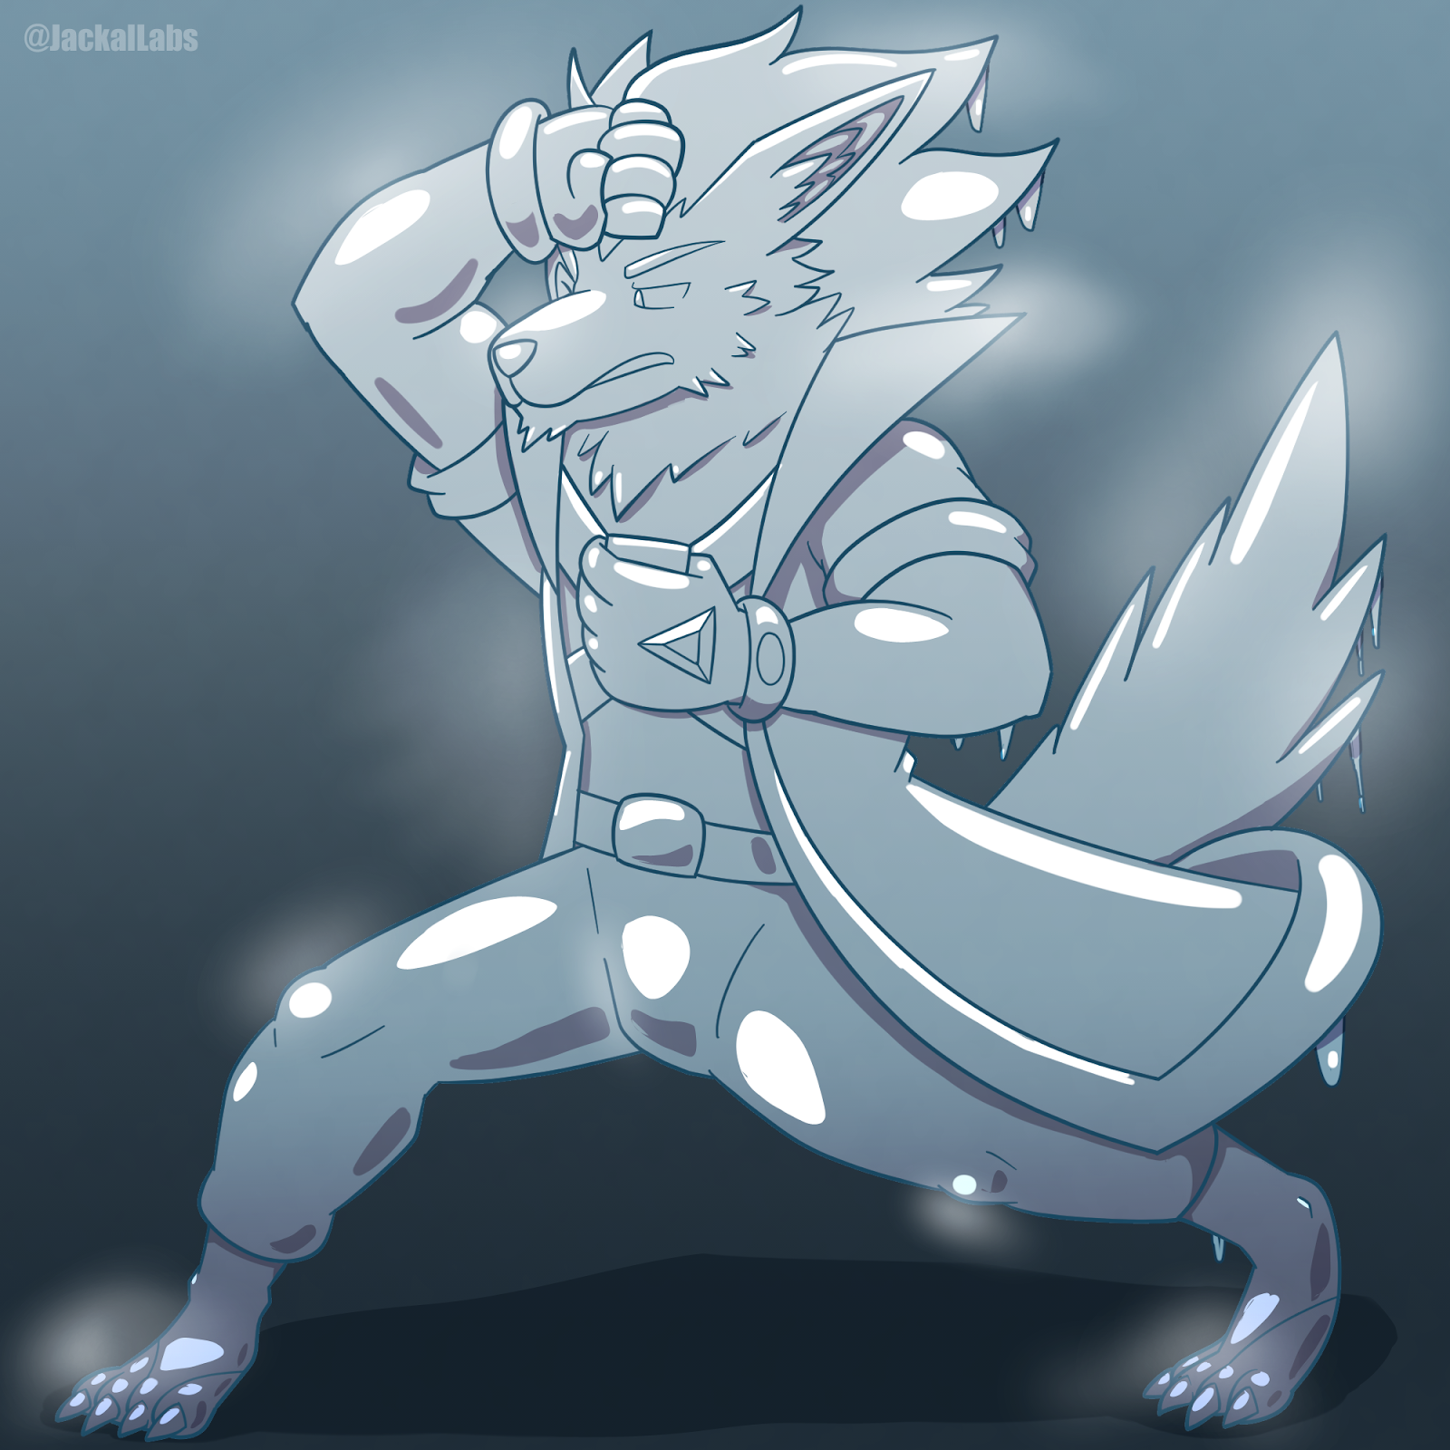
“Oops, looks like I’ve caught you!”
The frozen wolf neither moved nor responded.
“Heehee, at a loss for words, eh?” Noise chuckled. “It’s ok! I’ll give you another chance to escape. How does that sound?”
Again, there was no reply from Decro. If he was still alive, there was no sign of it.
“Not running? Giving up so fast?”
Noise stepped up to the wolf-icicle and peered closely into his eyes. They looked like a pair of glass eyeballs, lifeless and unmoving.
“Mm. Enough messing around. Frankly, Decro, I’m grateful for your help. You’re really quite capable in your own way. Unfortunately, you’re too dangerous to keep around, especially this close to me. And so I’m getting rid of you.”
The jackal rapped his knuckle on the wolf’s icy forehead, making a clinking sound.
“I’d like to imagine you’re still in there, begging for your life. Just as you should be, mutt.”
He watched the frozen wolf for a few moments, admiring the details of the ice-encrusted figure.
“But it’s all futile. This is goodbye, Kinesis.”
The jackal pushed the solidified villain. Decro’s feet had frozen to the ground, so his shins shattered instead. The rest of the wolf-turned-ice-statue smashed into the ground, breaking into a million shards of ice.
“The perfect cover story,” the jackal spoke to himself as he walked back to the vault. “Kinesis tries to steal the crystal, but he triggers the security system, gets frozen, and smashes into a million shards. The Electrum Crystal remains safe. And in the meantime, my hands are clean.”
He walked up to Mike, who was still encased in a pillar of clear crystal.
“And I get a new trophy.” He put his hand on the smooth crystal, feeling its cool surface beneath his fingertips. “I’m such a genius.”
He let out an evil laugh. His lips curled into a wicked grin and his eyes glinted with malice.
“You’re coming home with me, Feathers.”

~ End ~

