Just Another Demonstration
Gift for Liquid_latex_shark
Written by TwistedSnakes
Illustrated by Qundium

Alreker hated waiting. The dragon paced about the white laboratory with angry stomps. His reckless impatience had gotten him into countless trouble, but so what? Sure, this morning he may have been greedy and bet an astronomical amount of money on a poker game. After that, he may have punched the dealer when he was asked to pay up. And he may have put up a violent fight that sent four security guards to the hospital.
Everything worked out, though. The casino seemed to be happy with a simple resolution: take part in a demonstration, and they would absolve him of his debts and violence. No legal involvement, no black marks on his record. Fine.
But surely it didn’t need him to be stuck in this empty lab for so long. White, sterile panels formed the room’s walls, floor, and ceiling. The door was a weird rounded rectangle built into the wall that somehow faded out of existence for people to enter, before re-materialising into solid matter. The adjacent wall was taken up by a huge black glass panel. Alreker supposed this was how people would watch him for the demonstration.
How long had he been here? Hours? Days? Ugh. To be fair, it was probably only 30 minutes or so, but he didn’t like to be kept waiting.
“Hey. Hey!” he shouted again. “You dummies out there want to quickly get on with the demonstration?” He sneered before adding. “And I know you can hear me.”
Still no response. He contemplated testing out the door with the full force of his strength when it dematerialised. A white-furred wolf stepped in and the door reappeared behind him, sealing the two of them in the room. The dragon eyed him up and down. The wolf was dressed in a sharp tuxedo, complementing the white and greys of his neatly combed fur. Alreker snorted. He would not be intimidated, even if he was only wearing khaki pants and a T-shirt.
“Is everything ready for the demonstration?” the wolf asked.
Was that directed towards Alreker? He was about to open his mouth when hidden speakers in the room responded.
“Yes, Mr Castor,” said the unseen speaker.
Mr Castor? The Mr Decro Castor? Not that Alreker cared. Not that much, anyway. Just because the wolf was the owner of the Silver Serpent Casino didn’t mean Alreker was going to simp for him. He sneered again.
“Very good. Let’s not keep the audience waiting then.” Decro turned towards Alreker. “Please take off your clothes, if you don’t mind.”
“What?!” The dragon shook his head. “I’m not stripping!”
“Mr Alreker,” the voice on the speakers said, “please be reminded that you are required to recompense for—”
“Fuck this, I’m not stripping for this… this sick show!” The dragon took an angry step towards Decro. “Wha—?”
Mechanical arms rose out of the ground and grabbed Alreker by the arms.
“The fuck? Let me go!”
“There’s no need for physical force, Fabien,” Decro said.
“Sorry,” the voice on the speaker replied, “I thought he was going to hurt you.”
“No harm done. Let’s make up for lost time, shall we?”
“I’m not going to—”
“Very well, Mr Castor,” the voice interrupted.
A floor panel slid to the side and two mechanical arms rose out of the hole, each with a sharp blade at the end. With the whir of motors, they pointed the knives towards Alreker. The dragon struggled, tugging against the metal arm restraints with all the strength he could muster. The steel didn’t give.
“H-hey! Don’t hurt me! I change my mind, I’ll pay back in cash!”
He closed his eyes as the blades lunged for him. But there was no pain. When he opened his eyes again, the blades had already retracted into the floor and the panel was closed. The only trace of them was the shreds of cloth on the floor that used to be his clothes. He was embarrassed that he was scared for nothing, but that feeling turned into humiliation because of his nakedness.
“Thank you, ladies and gentlemen, for coming to this demonstration. I want to introduce the latest technology that we at the Silver Serpent labs have been developing,” the wolf said. “The LX Drone Orb series has been pretty popular, and so our engineers have been working really hard on it.”
“Drone suits?! Hey! I’m not your—” Alreker was interrupted as a metal arm snapped its clamps around his jaws. “Mfntt!”
A wall panel opened up, revealing a white sphere sitting on a circular stand. Decro picked it up in one hand, holding it towards the black window with a smug grin.
“This is our newest model of the LX Drone Orb, the LX-6001. All the features you know and love from the 5000, with a fresh upgrade.” He stepped towards Alreker, who thrashed violently against the unyielding restraints.
“Mnghth!”
With his free hand, Decro tapped the sphere with a finger. The solid orb turned into liquid, leaping out of the wolf’s hand towards Alreker in a jet of white. It splashed over the dragon’s chest, clinging to his scales with its sticky surface. The metal arms let go of him and he fell to the ground.
“What’s this?!” Alreker protested, tugging at the strange white liquid. It held fast to his scales, stretching but refusing to let go. His efforts only helped to spread the goo up his arms. “Fuck, fuck, fuck.”
“The new Orb comes with a polymer upgrade that’s stickier than the previous. This means the drone-to-be spends less time fighting the suit, and more time serving you.”
Scrambling about on the ground, Alreker fought against the spreading goo. It stuck to him relentlessly, refusing to let go despite his struggles. For something that appeared to be liquid, it was horribly tenacious. The dragon’s muscles were pushed to its limits as he yanked and tugged, but it felt as if he were tearing away at his chest, trying to pull his scales off.
“Grawrr!” he groaned in frustration.
He was on the losing end of this uphill battle, but he couldn’t give up. He’s heard the rumours about the drones in the casino; they were supposedly brainwashed gamblers who were turned into faceless latex drones for the rest of their lives. Alreker figured all of them were tall tales to sell the Silver Serpent mystic, but now he’s not so sure.
Either way, he needed to escape. He wasn’t going to let this thing turn him into some latex drone. The gooey latex was forming a smooth surface over his torso, spreading down his arms and legs. The liquid coated his cock and balls too, pulling them in so they formed a smooth bulge over his crotch.
“Fuck.” He squeezed at the bulge, feeling it push back with its firm, rubbery resistance. It was humiliating, having his proud manhood turned into a smooth bulge. It didn’t help that the snug grip on his drake-makers was uncomfortably arousing.
“—which I will show you in a bit. But let’s see how our new drone-to-be is faring.”
Alreker had forgotten that Decro was there until the wolf crouched down in front of him, examining him with a wicked glint in his eyes.
“Stop this right now!” the dragon demanded, before adding, “Please!”
The goo wasn’t going easy on him. His tail was now a smooth white appendage. The rubber had engulfed his wings too, forcing them against his back and concealing them beneath the sleek shine of latex. Apart from his head, every inch of scales was covered in the thick latex skin.
“Okay look, I’m sorry, okay?” Alreker pleaded. The goo was spreading up his neck, threatening to envelop his head. “I’ll work to pay it back, I’ll even—mfnt!”

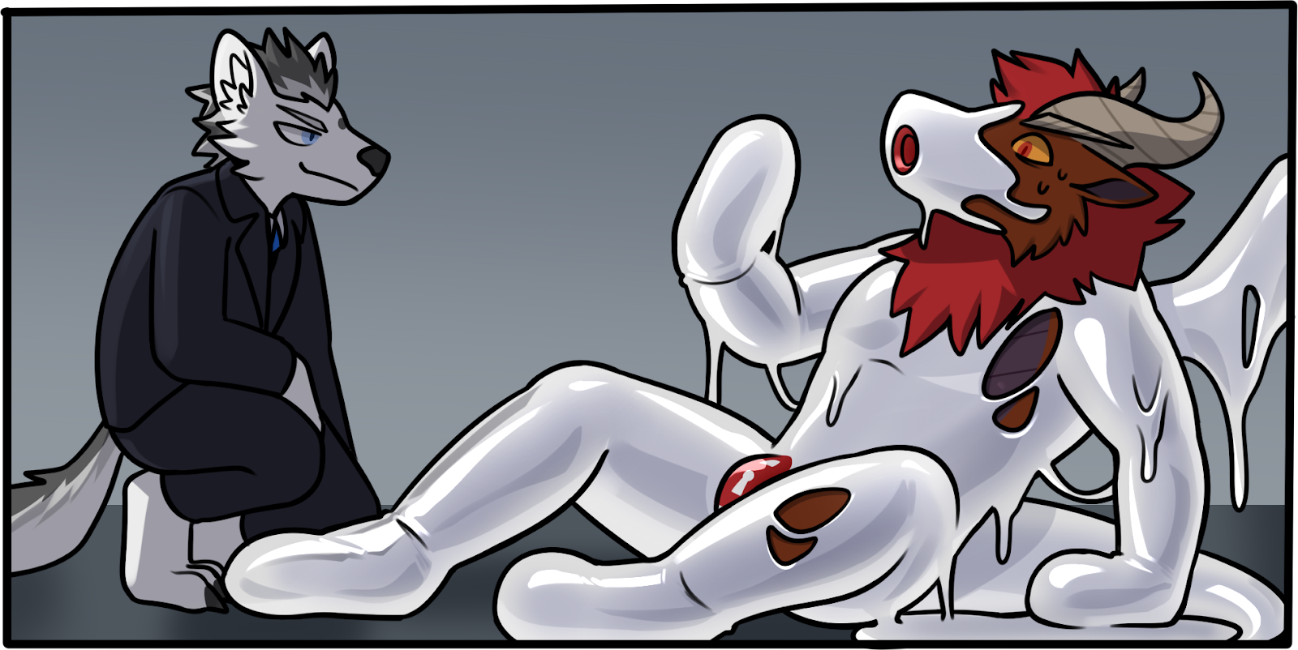
The goo thrust into the dragon’s maw and he gagged. His hands were turned into rubbery mitts, making it impossible for him to pry the goo out of his mouth.
“We kept the oral port from the previous models,” Decro explained. It felt like the wolf was taunting Alreker directly, rather than his unseen audience. “The polymer forms a tunnel made of silicone-like material, ensuring the drone’s mouth fits snugly over your manhood.”
No!
Alreker’s muffled protests grew agitated as thick latex engulfed the rest of his head. The goo over his eyes thinned out, forming a dark visor. His breaths were quick and distressed, coming out as huffing through the tube that had formed in his mouth. The goo around the tube had stuck to the insides of his mouth, fusing his jaws to the tunnel.
“I’ll be happy to demonstrate this once the drone has been reprogrammed.”
Reprogrammed?!
As if on cue, a word echoed through Alreker’s mind.
“OBEY.”
It wasn’t a voice speaking the word; rather, it was like the meaning of the word itself had penetrated his mind, seeping into every crevice of his consciousness.
“YOU ARE A TOY.”
“SUBMIT TO YOUR MASTER.”

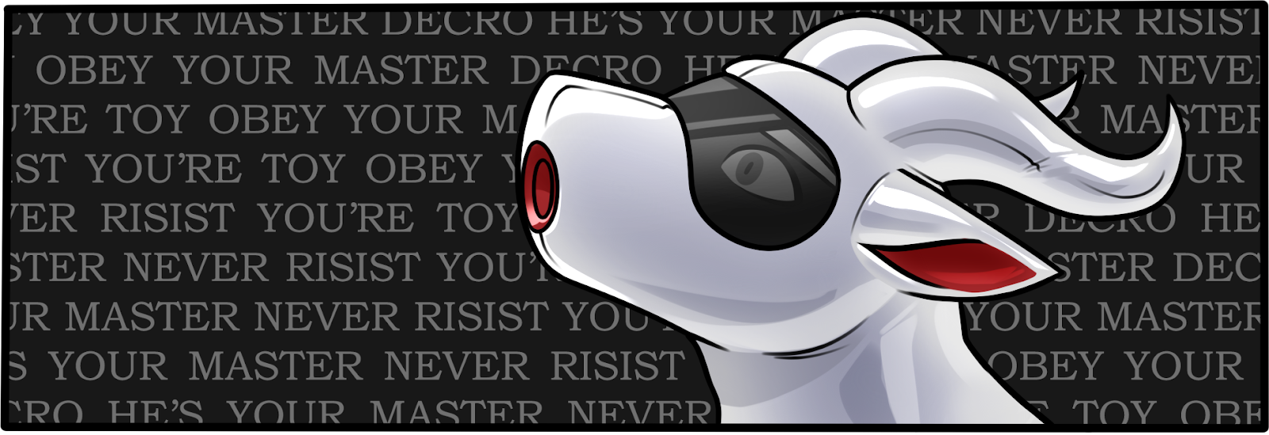
No! He would not!
Alreker grabbed his head, squeezing it as if it’s possible to wring the thoughts out of his brain.
“OBEY.”
“DO NOT RESIST.”
“YOUR PURPOSE IS TO SERVE.”
He wasn’t… he wasn’t a toy!
YOU ARE A SLAVE.
He needed…
YOU HAVE NO WILL.
…to fight…
YOU WILL OBEY.
Obey…
“Drone, suck me off.”
That was a command. He had to obey. He got into a kneeling position. Master Decro had unzipped his pants, revealing his erect mast. The dragon lifted his head up, positioning his oral port over the canine’s cock. He needed to fill his mouth tunnel with his Master’s meat. Just a bit closer…
Shivers of pleasure washed over him as Decro’s maleness filled out the length of his tunnel. He clenched his jaws over the silicone tube, squeezing and massaging the wolf’s rod with fervent enthusiasm. He needed to serve. He needed to pleasure his Master—

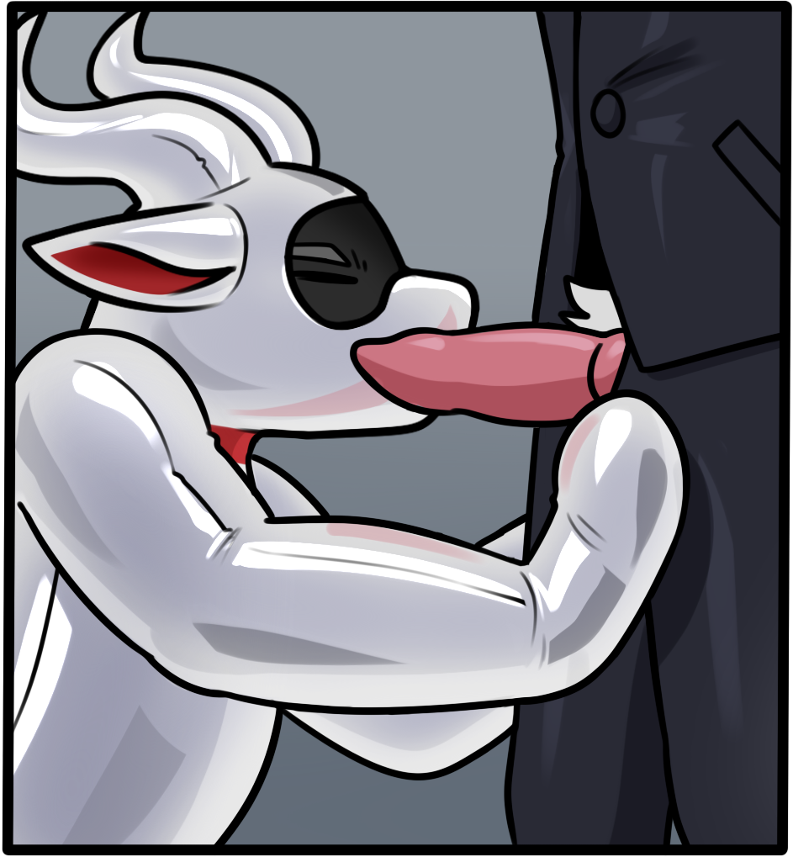
Lucidity struck like a jolt of electricity, and the dragon’s eyes widened.
What was he doing?
Despite the silicone separating his tongue from the other male’s shaft, he could still taste the disgust in his mouth. He hesitated.
“It looks like you need some encouragement.” The wolf grinned.
Decro grabbed Alreker by his horns and pulled the dragon in. The dragon choked as the tip of the wolf-meat pressed against the back of his throat.
What the fuck! He shouldn’t be giving a blowjob to this bastard. Using his mitted hands, he pushed against Decro’s thighs. He wasn’t just fighting the wolf holding him there. His body refused to listen to him, keeping him in the perfect position for an oral slut. It felt like he was fighting a powerful magnetic field that was holding him there despite his struggles.

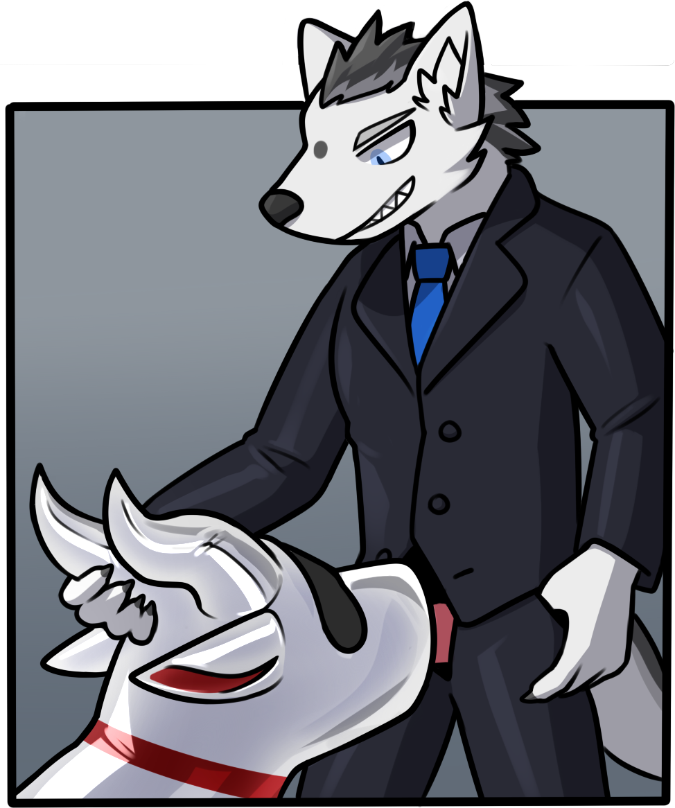
It was a battle of wills, his against Decro’s. He wasn’t going to lose. He wasn’t going to be turned into a mindless fuck drone. He needed to push and push and push—
He broke free of the wolf’s grip, falling backwards onto the floor. Saliva drooled out of his mouth tunnel and he hastily wiped it away. The wolf was sporting a smirk. Oh, how he wanted to wipe it off the fucker’s face. To tackle the wolf to the ground and punch the daylights out of him. Who did Decro think he was, trying to turn him into a slave for his sick entertainment.

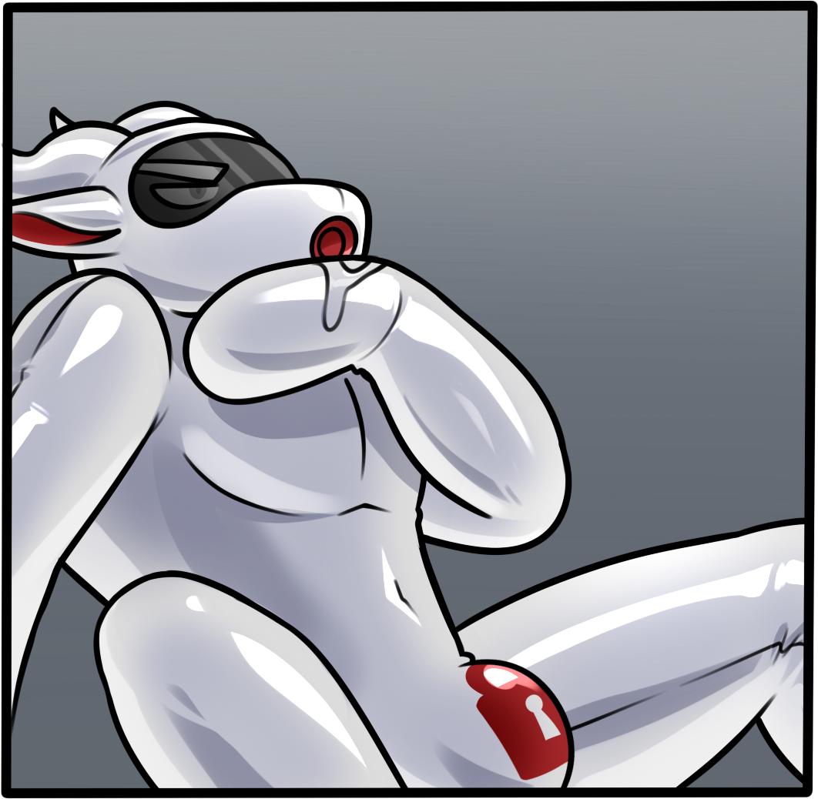
“One of the biggest concerns you have raised with the model LX-5000 drone suits is how it handles mentally resilient pre-drones,” Decro turned towards the black window and spoke. “Our engineers have made a new breakthrough, and it seems we have the opportunity to demonstrate it today.”
Wha—?
“Fabien, if you please.”
“Got it, Mr Castor. Commencing mental purge.”
Alreker steeled himself. He needed to fight this. He had won against the wolf earlier, and he’d do it again. If Decro thought he could brainwash him just like that, he was wrong. A dominant dragon like him would not fall so easily, especially to a scoundrel like this mutt.

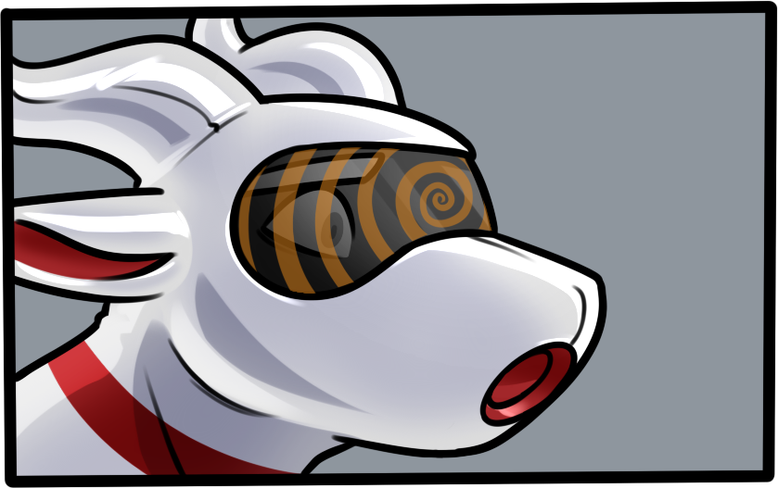
The visor began projecting spirals into his vision. Spirals that would confuse his mind, making it more perceptible to being rewritten. More vulnerable to be turned into a nice, obedient slut—no! He closed his eyes and shook his head violently.
Get out of his head!
Get out!
He didn’t want to be turned into a drone. He didn’t want to lose his mind. He didn’t want to look at the pretty spirals, spinning in his vision with its enchanting swirls, each stroke melding into the next one with their changing hues and pulsing bands, seeping deeper and deeper into his—
F-fight…
There was nothing to fight against.
He just… he just had to obey.
Obey who? No, he wouldn’t…
He wouldn’t resist.
Just—
Hngg.
Kneel.
See, that wasn’t so hard, right?

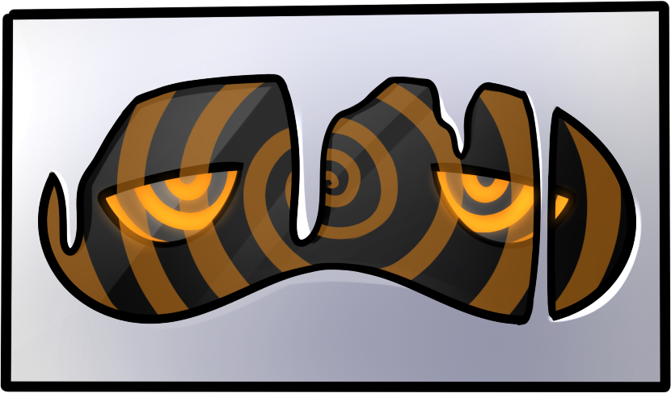
As you can see, the drone is no longer resisting, despite his earlier stubbornness. The LX-6001 has better mental penetration capabilities, as well as more efficient brainwashing algorithms. The longest time it took to reprogram a drone was only 3 minutes, and this one took only 2.
Once done, the drone has no more capacity for thoughts. No thinking of escaping, resisting, or fighting back. Even its internal thoughts are wiped. Head empty, clean slate, perfect for training.
Another thing you’ll notice is that the upgraded mode has also sealed away the visor, giving your drone the blank, faceless aesthetics of the DRN series models. An added benefit is that the drone won’t be concerned by distractions around it. All it needs to do is to serve its master.
Watch.
Drone, suck me off.

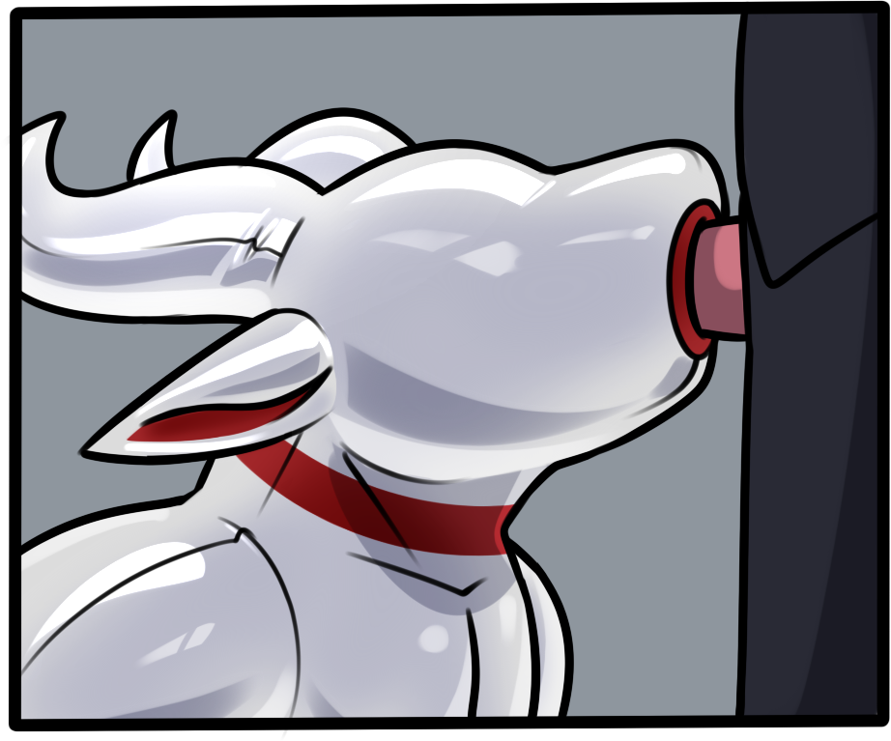
As you can see, there’s no more hesitance . If anything, it seems remarkably eager to put my member in his mouth. All the signs of an obedient drone: its knees on the ground, its hands on my hips, its mouth around my rocket.
You can’t see it, but the drone is more enthusiastic now. It’s using its oral tunnel extremely effectively by squeezing its maw with each thrust, massaging and milking my member for all it’s worth.
Ghnn-ahh. Pardon my indulgence here. If you were in my position, you’d understand why. There is something quite exquisite about a completely subservient drone serving you with all its being. We’re not talking about a slave who serves you throughout the day, then goes back to his quarters to grumble about his duties. No, we’re talking about pure, mindless drones whose only purpose in life is to serve you. Drones who have no concept of pleasure except for yours, who will not hesitate to suck you off for hours until you’re satisfied. Until you’re—hff—done with its eager—nfgtt—fuckholes.
Mnnn. That was a good one. Just goes to show how good these drones are.

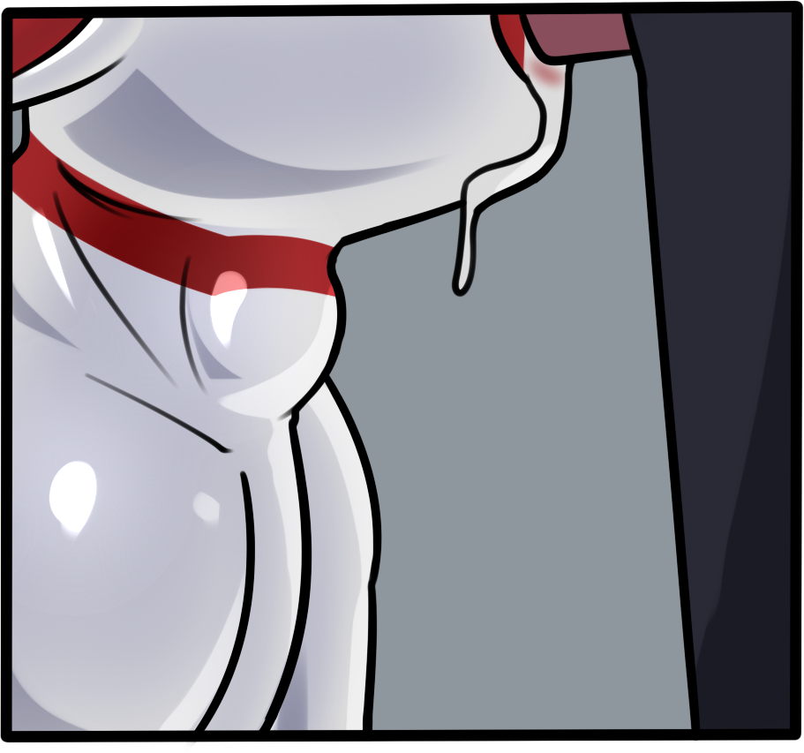
And look, without prompting, it has gone right ahead and swallowed every last drop of my seed. Let me just pull out, and there, perfectly clean. Our drones finish the job properly with no questions asked. That’s the LX-6001 for you: drones you can trust.
That’s it for the demonstration, and I hope you enjoyed the show. Now, do we have any questions?

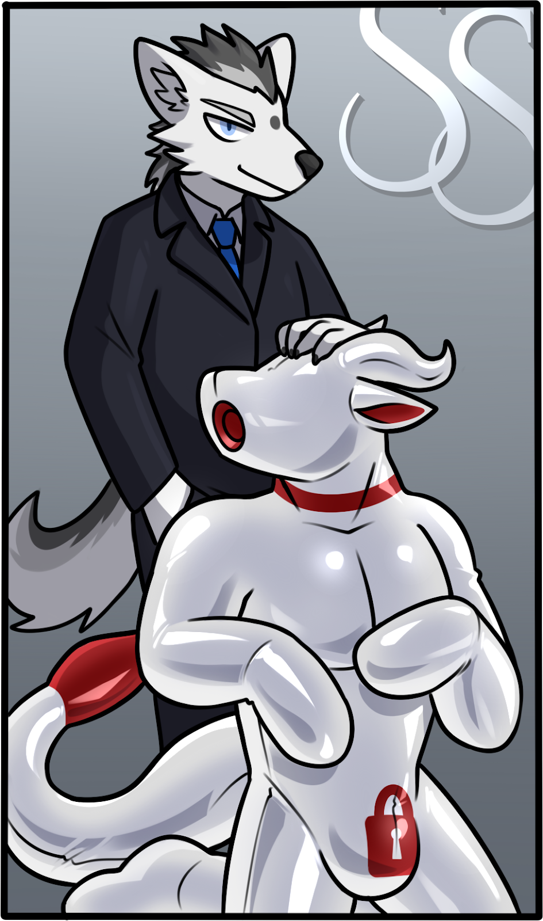

~ End ~

