Swallow Your Pride
Gift for KaijuBlue
Written by TwistedSnakes
Illustrated by Qundium

Recognise this gorgeous face? The signature flick of the hair? The million-dollar smile? Yup, it’s me, John LeRoux. You don’t recognise me? Seriously? I’m the face of so many brands. Luxury brands, mind you. Avel, Mauris Fletcher, Illumia, and many more.
So, this is the Silver Serpent? Eh, I’ve seen fancier. With all the hype, I was expecting something more grandiose. Ugh, whatever. Anyway, take my luggage and bring it up to my room.
Why are you still here, though? I don’t want to tell you how to do your job, but you shouldn’t hang around. Do you want an autograph or something? Can’t say I’m surprised, but I’m not doing autographs today. Us popular people gotta make time for ourselves. If I catered to all my fans’ requests, I’d never be able to enjoy my holiday here.
“Decro Castor”? Yeah, never heard of you. Take my coat too, it’s getting warm here. I’m off to gamble. If you’re interested in my fabulous life—which I don’t see how you could not be—follow me on Socialmo, Fanzon, and Nuvi. And here’s your tip. $50? Yeah, pocket change to me. You know, John LeRoux, a prominent celebrity and all. Don’t spend it all in one place. Ta ta~

Hey! Let me go this instant. I don’t care whatever bullshit numbers you’re coming up with, I’m not paying for your supposed “damages”. Whatever, I didn’t cheat, anyway. You can’t prove it, anyway. Why would I even need to cheat at your stupid games when I’m already rich? How do you explain that?
…
That surveillance video is too blurry to make anything out. You can’t pin this on me. I want my lawyer! Get me my lawyer, I’m not speaking to you until I—wait! Get your filthy hands off me. Where are you taking me?! W-what’s this place? This isn’t the Silver Serpent, is it? Why do you have all these labs?
Ow! You don’t have to be so rough with me. Why are you strapping me in? Look, we can discuss this properly. Negotiate something with my lawyer. You don’t have to—hang on. Is that… a latex suit? Wait, we didn’t agree to this. You can’t do this to me! I have my rights!
Get your fucking hands off me! No, no, no, no! Why is it sticky inside? Is that glue? What the heck, take it off! Stop it! It’s gonna ruin my fur! Please, no! Enough! Enough, please! It washes off, right? Tell me it washes off. No? You’re kidding, right? This… this can’t be real!
Look, I’ll pay up. Just stop this madness. I have fans waiting for me. They can’t see me like this! Don’t do this to me! Is… is that a gas mask with a gag? What the heck is going on? What even is this place?! I’ll report this place to the authorities. Everyone will know. G-get that away from me. No! Stop! Get your hands off—mghgft!
Fuck, I can’t talk now. That won’t stop me from protesting with muffled sounds though. They’re smoothing out the creases of the latex suit, stretching it across my body and pressing its glue-coated insides against my body.
I’m… I’m not scared. I’ll be fine. They can’t keep me here forever. People will come looking for me. Then word will get out. I’ll use my fame to make sure everyone is aware of the shady things that go on in the Silver Serpent.
They undo the straps for a moment to flip me over. But their grips keep me from escaping as they strap me down once again. They smooth out the latex suit on my back. D-damn, wait. They are inserting something into my rear. Get your hands off me! What the fuck?! But I can only make muffled sounds to protest. It’s… some sort of anal plug. Damn it, I don’t… fuck… they can’t violate me like that! This is sexual assault!
I’m screaming in pain. The plug feels incredibly intrusive and huge in my rear. Fuck, fuck, fuck. I gasp as the plug is shoved in as deep as it can go. As they smooth the latex over my rump, I shift my hips and clench my rear. The latex suit keeps it lodged within me, refusing to let go.
Oh god, what are they doing to me? This is wrong. This is very wrong. Okay, okay, I’m definitely scared now. They are pulling the latex flaps of the gas mask around my head. I can smell melting rubber. Are they sealing me into the suit? That would explain the glue. But I don’t believe this. This has all got to be a joke, right? Some celebrity prank show, or some social experiment. It’s not like there’s a reason to be suiting me up like this…
Wait, I’ve seen this suit before! The Silver Serpent has drones wearing this suit. They’re normally black, though, not white like the one I’m wearing. But… that would mean those drones aren’t people acting as drones. Maybe they were casino guests that were kidnapped and turned into drones. Oh fuck, that’s what they are doing to me right now!
“Suit is sealed.”
Someone’s finger probes my rear, and I realise the plug in my tailhole is a hollow tunnel. It keeps my rear entrance open and vulnerable. I know exactly what it’s for. It’s just a finger for now, but it’ll be someone’s dick in the future. Oh fuck. I’m not some toy to be used like a slut. I’m John LeRoux! They can’t do this to me!
“Rear port in place.”
Another person’s finger enters the hollow tube in my maw, and I can feel it through the soft silicone separating the inside of my mouth from the outside world.
“Not quite the cocksucker yet, huh?” a voice taunts. “Don’t worry, you’ll have loads of time to learn. Oral port in place too, let’s introduce our newest drone to his permanent job.”
They unstrap me from the table. I squirm, scream, and kick, but there is no escape for me as I’m taken away.

The visibility setting on my gas mask is turned to 0%, leaving me in total darkness, but I can still sense what’s going on around me. I’m bound on a raised platform, with my wrists and ankles forcing me on all fours. Forced into this doggy position, I’m at the perfect height for two people to fuck me from both ends. That’s what’s happening now: I’m in a sex lounge in the Silver Serpent, with cocks pounding relentlessly from both ends.
I can’t see them, but I can definitely smell the musk of the person in front of me. His masculine scent fills my nostrils, driving up my arousal. But my cock is trapped in the latex pouch in front of the suit, leaving my manhood no more than a round bulge for people to tease.
Meanwhile, embedded speakers in the suit play a voice in my ears.
“You are nothing but a drone.”
“A drone does not think.”
“A drone has no identity.”
“A drone has no other purpose than to serve its masters.”
“A drone will serve the cock it is presented with.”
At the mention of cocks, I get a good sniff of the dick in my maw and my cock tenses from within its latex bulge. Fuck, I was never such a slut, right? Right? My old life feels like a long time ago. How long have I been here? A week? A month? A year? Or just a day? Fuck, I can’t remember. I don’t know anymore. I just want this to be over. How long more before I’ve paid back what I’ve owed?
Letting out a moan, the guy in front of me shoots his load into my silicone-encased maw. I instinctively tilt my head back so his cum flows through my tube gag and down my throat. People seem to tip better whenever I do that, and even if I don’t, they’d usually force my head upwards to make me swallow, anyway.
As the guy in front of me leaves, another one takes his place with his cock already ready. He plunges his shaft into my cum-coated maw and ravages it. Before long, the person behind me orgasms too, pumping my tailhole full of seed. I feel the warmth of the excess fluids drip down my thighs. I’m nothing more than a fucktoy to be used and abused.
It wasn’t always like this, was it? I’m… I’m John… John Le… John Leroy? John Leon? Or was it Joe? Fuck, I can’t forget who I am. I need to remember. Just…
“You have no identity.”
I’m… John…
“Do not think.”
I can’t forget who I am…
“Stop thinking.”
I gotta—
“You will serve the cock that is presented to you.”
I—
“No thoughts.”
I’m pumped full of cum from both ends as the two men climaxed into my holes, leaving me dripping with white seed. I… I can’t remember what I was thinking about… Just need to serve more cocks…

I raise my hands and stretch my body with a sigh of relief. It feels good to be free. Business meetings have the unfortunate tendency to extend beyond their allotted time, but at least I’m done for now.
I head back to my private lounge where a premium drone awaits me. Unlike the regular drones, premium ones are much more well-trained. Every bit of their identity stripped away, leaving nothing to resist their masters’ commands. No refusal, no reluctance, no hesitation.

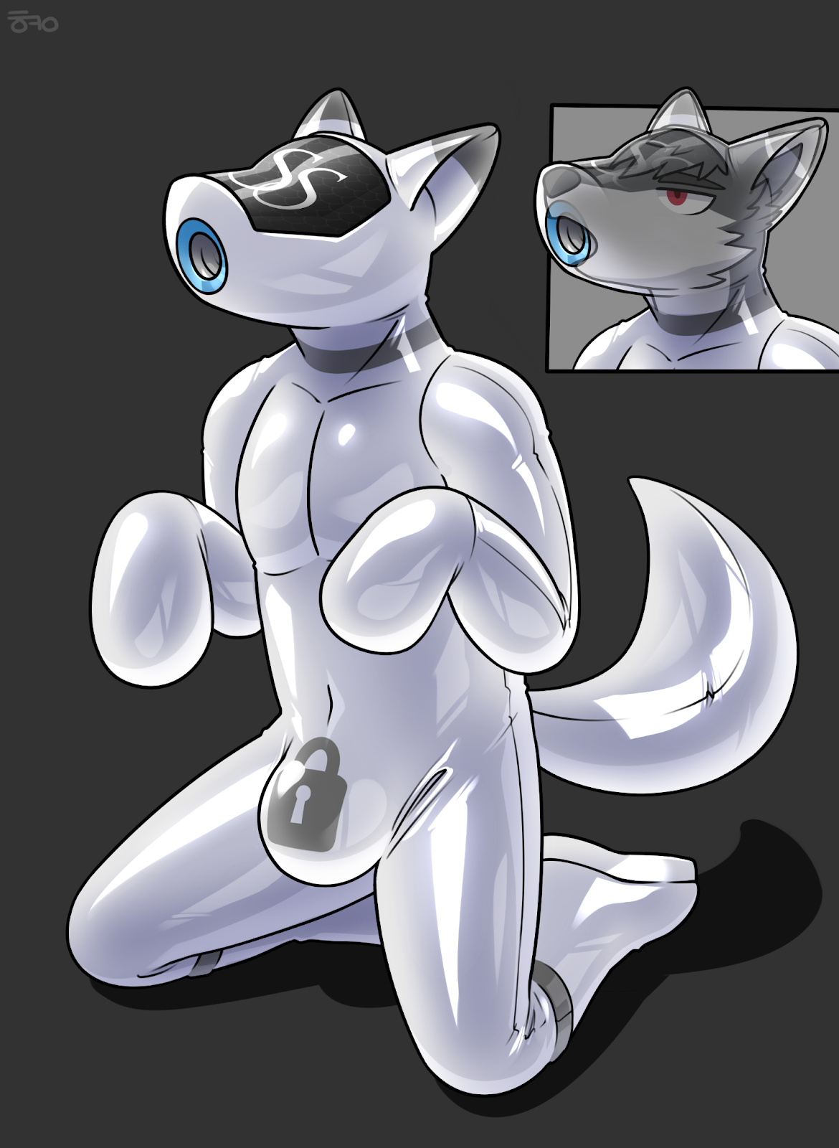
This drone has been kneeling throughout my meeting, completely unmoving and without complaints. Just as a good drone should be. Now to put it to good use. I unzip my pants and sit on my bed. The front of my underwear takes the shape of a sizable bulge. I give it a good rub before I pull the top of the elastic down, revealing my erect dick.
Following my lead, the drone comes over and positions its maw port over the tip of my shaft. I let out a soft moan as it lowers its head, engulfing my manhood in its silicone fuckhole. I lean back and let it do its job. Its hands massage my balls as it eagerly milks my cock. Fellatio feels so much better when a drone does all the work, leaving me free to fully indulge in the sensations.
Oh, god. The sensations are heavenly. This cocksucker knows what it’s doing. Every bob of its head, every squeeze of its maw, every lick of its tongue, all coming together into a symphony of sensations. Before I know it, my hands are on either side of its gas mask, guiding its head up and down faster.
It doesn’t complain. Instead, it takes the hint and devours my cock with increasing fervour. For a brief moment, I want to slow down and bask in the blissful euphoria. But the pleasure is too much to resist. The sound of my pants fills the room as my chest heaves up and down in time. My cock throbs against the silicone of the drone’s maw, feeling its tight hole clench repeatedly over the length of my cock.
I try to hold back the tsunami of arousal, and succeed for just a moment. Then the dam breaks, and I shoot load after load of seed into the drone’s waiting hole. Ah fuck, that feels incredible. As I let my cum flow, it milks my shaft with slow, sensual sucks. Only when I’m done do I let go of the drone’s head.
Without hesitation, it swallows every last drop of my spunk. Then, with its tongue, it cleans up the residual fluid from my half-erect mast. I take in the intoxicating sensations as I slowly catch my breath.
John LeRoux, were you not? Some “celebrity”, heh. Perhaps you should’ve behaved yourself. Then I wouldn’t have needed to… teach you a lesson. A simple hypnosis trick to implant the urge to cheat. Then getting caught and ending up as another drone for the Silver Serpent. I’m sure there’ll be loads of guests wanting to get their hands on a star like you. How much would they pay, I wonder, to get you to suck them off? Maybe enough to pay off your debts? Perhaps, but I don’t think so. You’re in too deep to recover from this.
And here’s your tip. $50? Yeah, pocket change to me. You know, Decro Castor, the CEO of the Silver Serpent and all. Don’t spend it all in one place. Goodbye.

~ End ~

