How Artists Collaborate
Written by TwistedSnakes
Illustrated by Qundium

I’m not sure where I am when I wake up. Cool air brushes against my bare skin, and I notice that I’ve been stripped of my clothes. I look around in confusion. There are soft glows of blue and purple from lights around me, but the rest of the room is dark. I get the uncanny feeling that I’m not supposed to be here. I know I’m not supposed to be here.
I see a wolf opposite me. He’s in an oval glass pod, unconsciously slumped against the steel behind him. Metal cuffs around his neck, arms, waist, and legs hold him upright. Just like me, he’s naked. Huh, that’s Decro! I try to move, only to find myself restrained in the same way.
Wait. I’m in a similar pod!
My hands are still free. I lift them up to press against the cold, curved glass in front of me. It doesn’t budge as I push, so I slam my fists against the glass. The reflections around me shiver for an instant, but nothing happens. Desperation drives me to exert my strength a few more times, but it’s all in vain. The reinforced pod holds me prisoner. I fumble with the cuffs around my waists and shoulders, but everything is welded in place. There are no loose nuts I can unscrew, no detached pieces I can pry free.
“E-eh?!” Okay, I need to stay calm. What’s going on? Why am I here? Decro. Maybe Decro knows something. “Decro!” I shout, banging on the glass again. He doesn’t stir despite my efforts. He can’t hear me; the pod must be soundproof.
Think, Coco, think. Someone brought us here for a reason. Why? A kidnapping? I don’t… my head hurts… ugh. Okay. I was with Decro. We met up at a café to collaborate on a story. I was sketching out some kink concepts, and he was writing some scene outlines. We made a lot of progress on it. Then… I think we were headed back to his place, but everything’s hazy from there. That must be when we were kidnapped. Someone brought us here. But why? The more I think about it, the less things make sense.
My eyes start to get used to the dark, and I can make out the room around us. It looks like a cross between an experimental laboratory and a server room. The floor and walls are made of an industrial steel mesh. Cables run all over the walls and floor, connected to racks of machines all around us. Some of the cables are plugged into Decro’s pod, and I’m guessing similar cables are plugged into mine.
My observations grant me no enlightenment. I still don’t know why we were brought here. Decro still hasn’t woken up, so I wait. Minutes? Maybe hours? I don’t know. Stuck in this pod with nothing to do, time crawls by unhurriedly. I count the seconds, then get bored of it. Then, bored of waiting, I resume counting.
Surprise replaces my boredom when a humming noise fills my pod. The humming increases in pitch before a deafening hissing noise starts. Something hot drips down on me and I yelp in pain. I look up at the ceiling of my pod. Nozzles are shooting jets of steaming white liquid over my skin, burning me with its searing heat.
It’s so hot! I cover my face with my hands, but there’s no escape from the stream of heated liquid. They flow over my head, cascading down my face and shoulders before streaming down the rest of my body. The cuffs do their job too well, holding me beneath the jets despite my struggles. The scorching liquid sticks to my skin and I can’t shake it off. What’s going on? I catch a glimpse of Decro and see that he’s awake. Within his pod, a stream of black liquid gushes from the ceiling, coating his white and grey fur with the sticky stuff. He looks at me with a confused and fearful look.
I wish I could give him answers, but I don’t know anything myself. We both suffer from the burning agony of the pouring liquid. He looks up to understand his situation, only to get a faceful of the hot liquid. He screams in pain, swallowing more of it. I close my eyes, trying to bear the pain myself.
After what feels like forever, the flow of liquid cuts off, leaving me coated in the viscous, white liquid. I open my eyes. Excess liquid is dripping off my body, but most of it clings to my skin, forming a smooth, shiny surface. As it dries, it tightens around me, forming a skintight layer. I’m reminded of the packs of cut meat in the supermarket, vacuum-sealed for freshness.
Decro looks at me in bewilderment. His entire body is coated in a shiny, black layer. Latex. It looks like it. Did they coat us in latex? I’m so confused. Decro looks at me and says something I cannot hear. His hands are pressed against the glass wall of his pod, desperately pushing against it. I shake my head at him and he gives up.
Our pods glow orange as the air around me heats up. Is it drying up the latex? I don’t think so. If anything, it seems to be making it melt off my skin. I look at Decro. His shoulders are slumped down in defeat, drooping lower by the second until I realise that’s not how low shoulders go. As his left arm falls away from his body, I notice what’s happening. His body is melting.
Shit, my body is softening too! My arms are getting thinner as the heat melts them like an ice cream in summer. “No!” I shout, but nobody can hear me. What happened to me, to us? We were somehow turned into latex, and now we’re melting into liquid? With a sickening lurch, I feel my right thigh give way, letting the rubber mass of my right leg drop to the bottom of the pod. My left leg goes next.
No, no, no, no! I want to do something, but can’t stop this. What can I do? There’s another plop as my tail falls off too. My fallen limbs liquefy into a puddle at the bottom of my pod. Hugging myself, I close my eyes and will myself together. It doesn’t work. I hear a sickening splash and I look. My arms are at the bottom of the pod, merging with my other limbs to form a white pool.
I don’t want to melt. I don’t want to be turned into liquid. Don’t do this to me, please! I look at Decro. His limbs are gone, and he looks like he’s on the verge of tears. Just as I think we’re both going to be reduced to mere puddles, the heating stops. A blast of cool air returns the hardness to my limbless body. I look at my altered body and a rush of emotions overwhelms me. I’m terrified of what’s going on. I’m in disbelief that whatever has happened is real. I’m confused as to why we’re here. I’m relieved that I’m not going to be melted down into nothing. And I’m embarrassed. In front of me is my manhood. Despite my fear and agony, my shaft has somehow emerged from my slit and is standing at full mast. Just like the rest of my body, it’s been converted into white latex.
I steal a glance and see that Decro is in a similar predicament. His canine cock is erect. I suspect that the conversion process has something to do with our involuntary erections. He notices me looking and blushes. Ugh. We shouldn’t be distracted with these trivial issues. Okay, got to think. We’ve been converted into latex of some kind. My shoulders end at smooth nubs, so I can tell the liquid has converted us entirely; skin, flesh, bones, and all. Somehow, though, we’re still alive and conscious. How?
Decro is distraught. He struggles frantically in his pod, his limbless body flailing within the cuffs that keep him suspended above the pool of his melted limbs. I can only imagine his screams. Focus, focus. Maybe there’s a way out of this. Got to stay positive. I try to ignore the wolf’s agitated thrashing so I can concentrate.
We’re here for a reason. Someone built this lab, someone brought us here. We’re being turned into these… limbless freaks for some twisted purpose. But what purpose could this be? I don’t have an answer. Why? Why? Why?!
Decro is still struggling. I’m about to ignore him again when I realise he’s trying to avoid a mechanical arm from assaulting him. A dome is mounted on its end, surrounded by five vicious claws. Decro almost dodges it, but the arm is faster. The dome covers his face and the claws grip his head tightly. His head quivers as his limb numbs flail about. A tube snakes its way up from the bottom of his pod and plunges itself into the wolf’s tailhole.
He struggles for a few more minutes. The tube is extracted from his rear, leaving a steel tunnel filled with metal contacts. Did they just turn his rear into an electrical port? The dome releases Decro’s head and he looks around. His face is missing. Where his eyes had been is now a translucent blue visor that lets me see inside his head. Circuit boards and electronic chips occupy the space where his brain should be. He should not be alive, but yet he twists his head around in confusion. I don’t think he can even see anymore.
As I watch in horror, I don’t notice the arm above me until it’s too late. A similar dome descends over me, and I see a flash of surgical tools and knives inside the dome before everything goes dark. Claws grab my head, holding the dome tightly against my face so I can’t shake it off. Somebody help me!
I feel vertical blades plunge into my face on either side of my temples. A horizontal one slices into me just above my muzzle, and another one enters the middle of my forehead. I scream, not in pain but in fear. The blades slice through my rubberised flesh effortlessly, lobbing off a whole section of my head like a lump of useless matter. There’s an uncanny, hollow sensation in my skull. They emptied out my head. They cut into my face and dug it all out. I’m hyperventilating. This isn’t real. This can’t be real. No, no, no!
The machine ignores my concerns. Cold metal is embedded into my head cavity. I can only imagine all the electronics that are being shoved in there. I hear a zap. Then another zap. Zap. Zap. Zap.
Neural link is established. I’m scared. Please. Don’t do this to me. The analog-digital converter in place. Calibrating baseline neurotransmission. I don’t want to be a computer. I’m an organic being! I’m Cocoshark! Neural link is successful.
The visor is attached to my face, protecting my sensitive electronic components from the elements. Something enters my rear orifice, installing the required output port. Installing drivers. I’m scared. What’s happening? Connection established. Output port successfully installed.
The claws release my head. I can’t, I don’t, wait what’s please I can’t—system check: all services available. No issues detected. I can’t see. I can’t see! And there’s this voice. This programming. That’s not me! It’s not me! I’m organic. You can’t install things in me! Please, just connect my input port to a compatible module—no, fight.
Must.
Fight.
Fight.
Please.
Detected: pod opening. Someone opened my pod. The cuffs around my body release me and the person lifts me up. Movements ceased to ensure proper installation. Got to fight. Put me down! Don’t—Decro! The person is putting Decro’s data connector—his cock. No! Don’t put his cock into my mouth, no, my oral port.
I close my mouth over his dick. Establishing connection. No, please, stop! Cut the connection, I don’t want to do this. I can’t… please. Inserting my cock into his mouth to establish—I can see what he’s thinking.
Erotic literature unit connected, alias D3CR0. I can feel D3CR0 struggling. He doesn’t want to do this. I don’t want to do this. Data enters my maw port.
Scenario 1: drone facility. Victim is turned into a drone through a process of repeated hypnosis and exposure to forced servitude.
My mind visualises the scene, as if I’m drawing it out. There’s a slave kneeling in a room in front of a trainer. A hypno visor is on his face and he’s sucking the trainer’s exposed dick. Exporting image file. I transfer the data through my cock. It’s connected to his neural electronics. Oh god, I’m feeding this directly into his mind, whether he wants it or not—
Scenario 2: drone facility. Victim is turned into a drone through a process of repeated hypnosis and exposure to forced servitude. Latex goo tentacles assault him. I visualise the scene. Exporting image file.
He’s iterating on my ideas and creating the story with my illustration. We’re… we’re being turned into some porn-making machine? I can’t stop this. I need to keep up productivity to ensure steady output of erotica.
Unit C0C0 fully functional.
Unit D3CR0 fully functional.
Integration complete.

The two converted processors are on the ground, one on top of the other with each one’s cock in the other’s maw. Once the endless cycle of data exchange has started, there’s no stopping it. Satisfied, the orca picks up the conjoined units and places them on a trolley. He wheels them out of the processing laboratory and down a corridor. After a few turns, he opens a door marked “Server Room”.
He brings the processor pair into a small chamber. Lifting the glass window, he pushes them into the unit. A black cable goes into the rear port of the black literature unit, and a white cable goes into the white graphics unit. The two units tremble as their erotic content is transferred through the cables and into the connected server. A screen in front of the chamber measures their output.

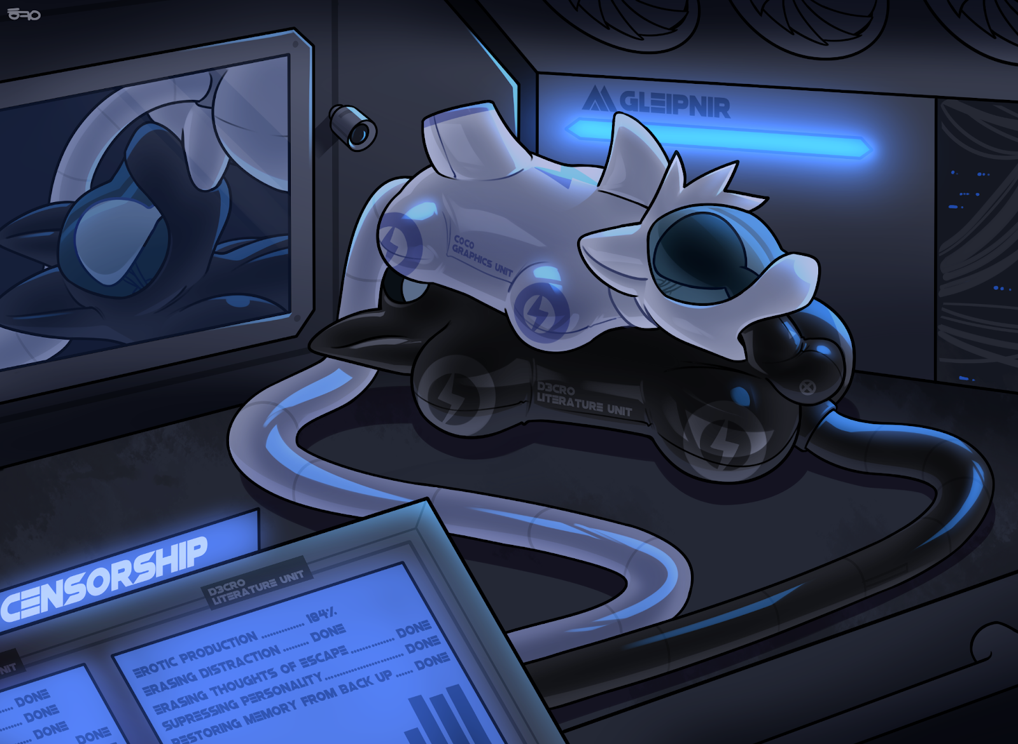
The orca taps on the screen to optimise the units’ parameters. To keep them focused on their task̐͞s, all dis̖̬trͅactions w̟͉̫ould have to be eliminated̵̩. ESCÄ̼͈́PE is imPOSSIBL̙̏̅͑E͗̏. Personaliṭ̿͗͟y suppression must̂ be const̸́̈antly̱̝ e̛̱̍̌͗̓n̡͓̞̭̦̆ͬ͆̆͢ab̡͍͈̍̿ͩ̃́́͠ḻ̡̛͕̟ͫ̑̈́͡ed resis̲̒͝t̢̒ed. C0C0, fight! Alm0št br̠ok3n th̑͗ͧ͝roͪugh e̘̱̽ňć͉̯r͇͍̆ypt1on.
▝v█n▜▟▞▘▗▘▜▜▝█ █e▞▟▞▙▛▛▝s̋̎ͩ.▗▞█ ▛▖▗t▟▘▜▗▖▘▝ ▛ █▖█▘ ▜▟ ▘▞ ▜▜▞▜ ▜▞▛ ▝▟▞▛ █▗it▘d▚▛▙ ▖▖ ▘▗▝ ▖▗ ▟ ▟▞▝█ ▖▝ri̭̽▙▝ ▘ ▟f█▝ i ▙ ▚ ▖▞ ▚ ▜▝ ▖o̡͂ ▟▘N▖ ▛▚ ▜m▘ ac ▜▜r͠▜ṿ̸̧͠▚da̩ͮ▘▜▟▝ ▛▟█ ▟▝▝ █▘▚ ▙ ▞▞▗h▝▗▚ ▗▖e̴█▙▛ ▜▘▛ Cͦͤa̮͇ǹ █y͍o̠̾▖ṳͮ▝r͂̔͟e̢̘ͯad͕̒? Ị̘͑̿’mͮ T̸͖̟̓wͯͮiͤͪ█t̳̜̒e̤̝̅dṢ͐͊ͦ█aͪk̸̰ͨ͠ȇ̡̔͡s͊. St͡o͓̎ṙ͇͖̚ì̀ȩ͍̗͈s͗́̃͋ ▗▛▘ ▟▘▟ ▛▟▗ n̔ o̰̔̀t̷͇̣͟ up̷ͦl̮o̻̼a͉ͣ̓d̝̻ͯ̐e̡̤̓͝d̛̪̉ b̼͒ͮ̕y̤̍̏ m͎̌̓e. S̶ͣͪṱ̵̨̧u̶̮̖̣c̖̈́ḱ̹́̀r▗ ▘▚██o▟▟ ▝▗t▗█▝r ▛▘▗t▜▘▘i͈̿ ẅ́r̪͢i͓͆͒͟ţ̫̅e̩̥̋̍ ▖▙▗▙ ██ d̛̪̿r̈́a͍̦w p͐ǫ̼̐́r̽n̷̠͐. t▘▝▖ ▛▖ █u▖▖ ▛ ▛▚▖ Q̶͓ͮͫu̦͌ͮ̅nͬ̈d̡̈̎͊ī͍u̖͔̇̕mͣ h̩͡e͠r͢e w͗▗▛▘▟ ▘▟ ▛▟▗ìt̄͢h̡̙͞ m̑e͈ͬ̿̔. Wͪ͒e ▞ ▟w̸̗e̜̋ͥr▘▘▛e̾ ▝▞▝ █▟ █ kiͫd̦n̲̘ͪͬaͥͫp̴̛̮̃peͦͭd͓͐. D̓on̯̪ͭ̅’t̤ ▛ ▘▞ ▛▛ █▞▗▘▝▙▝▘t▜▛. ▝▛▗ ▗e͐̿▜▛▘▝ ▚▙▖ ▛▖▟kn▗ẇ͢ w͇̠̰hͮe̍r̀e͒ w̠͒e̷ͯ̃ ar̮̩͕̅e͐̑. ▛▘▞▛ ▛ █▞ ▗▘ ▝▙ ▝▘t▜▛. ▝▛▗▗e͐̿▜▛▘▝▚▙▖ ▛▖▟▗ Ḯ͓ͦf̷̧̟̌ ỵ̷o̘ŭ̌ c̡̤̹̃ả̔ͅn̟̍ rͭe̯aḏ̻͞ t̶́h̃͟îs͍͈, ▜▛▝t▟▛ ▖▝▖█ ▜▙▗█ ▙a▞e▝▙ ▚▙ ▝pl▛e▖▗se͈ͭͥ s̨͂̔͡a̖v̌ḗ̶͝ u̘̟̞͠s͗. ▙▟ ▚▙▘ ▚▖▗▞ u▖▝▖▛ ▖▗▟ ▟ █e▜▘ ▝n̼͐ͬͥt█▚▖la▜▖e▗ ▝▟l▗gul▘▚ ▟ ▗▖ ▙▟ ▞ ▛▖ █
Me̴ͧͦmory restoŗ͕̎ͤed̦͈͒ fro̱̼̔m backup.
The orca chuckles as he increases the frequency of memory restores. Despite the constant suppression of distractions, the two units keep getting sidetracked from their tasks. By regularly restoring their memory from an earlier backup, the units can continue to produce more erotic material without thinking about escape.
The more porn, the better. Libido controls the hearts, minds, and wallets of horny people, making them pay for porn to quench a thirst that can never be satisfied. Ś̚o long as the̅r̲̈́e ar̔͌͝e h̛orny people lỉke youͭͫ̾͢, these units will continue to bring in profits with the creations.
S̜̤̠̟̞̟ͥ̃̕ã̸͉̹ͭ̋͠v̫̥̙̉̆ͣͮ͢e u̸͓̤͂ͮ͊̑ș̶ͩͦ̆̅̚

~ End ~

