Gone to the Dogs (Coco)
Gift for DripperDropper and Qundium
Written by TwistedSnakes
Illustrated by Qundium

The Silver Serpent is nice, I guess? The aesthetics are nice, but I don't like casinos. I watch Jarin finish another round of poker. He doesn't gamble either, so I don't know why he wants to play poker all of a sudden. I pace around idly. Maybe I should check out the shopping sector, do some window shopping. I'm about to tell Jarin my plans when someone bumps into me.
"Oh, sorry!" I apologise, turning to the person I bumped into. He's a tall orca, looking at me with cold eyes. I… wait… huh. He takes a seat at the poker table beside Jarin. You know what, I can do this. I sit on the other side of the orca.
The dealer deals the cards, but I don’t even look at them. I can do this. There’s a holographic screen in front of me asking for my bet. I call. Hmm, I can do better than that, can’t I? When the dealer reveals three cards, I get my chance to bid again. I raise. $5000.
Another card is dealt. Raise. $10,000. I can bring it up higher. The screen asks if I want to take out a loan for this bid. I agree. The dealer reveals the last card. $100,000. $300,000. $1,000,000. $4,000,000. $10,000,000. The orca calls. The game is over. I reveal my cards.
Wait, cards? I… I’m playing poker? I snap out of my trance. “Huh? What just happened?” And wait, how much have I bid? A debt of a few million shows up on my screen. I can’t pay that back!
“Sir, you’re going to have to come with me.” A panther grabs my shoulder.
“Wait, I didn’t do this.”
“Don’t make this difficult for yourself. Come with me, or we’ll have to use force.”
“But that wasn’t me! I didn’t mean to—”
I’m interrupted as the panther grabs me and drags me away. Jarin tries to help me, but the panther stops him. He gives me a confused look, and I feel like I’ve betrayed him. It wasn’t me, it really wasn’t! I wasn’t in control of my actions. It… it must’ve been the orca! He did this to me. He won all the money from the pot too! It must be him!
But I know nobody is going to believe me.

I tried to explain myself, I really did, but the admin clerk only wanted to know if I could repay my debts within a month. I could not, so they are taking me away to work for them. A guard escorts me to an elevator that descends into the basement of the Silver Serpent. The amount of elevator buttons baffles me; I never knew there were so many floors below ground level. I’m taken to a white, sterile corridor.
The guard leads me into a lab and tells me to lie on a table. I don’t have a good feeling about this, but I don’t have a choice. I get onto the table and let the guard strap me onto it. He exits the room, leaving me to lie there in silence. Just what have I got myself into?
An eagle wearing a lab coat enters the room and examines my bound body. With him are five more lab staff, looking at him expectantly.
“Mmm,” the eagle mutters, “we’ll do a mecha canine for this one, model X-450.”
I don’t understand what he’s saying, but I get the feeling I’m about to find out. He goes through a doorway into an adjacent room, where he watches me through a glass window separating the two rooms. The other lab staff crowd around me, making me feel nervous.
“W-what’s going on?” I ask hesitantly. They ignore me.
The eagle taps on the control panel, and a wall panel flips open, acting like a table. On top of it are various tools and implements. Wait, what are they doing to me? I thought I was supposed to be working for the Silver Serpent! One of the staff picks up a needle with a green liquid and brings it over to me.
“There must be a misunderstanding. I’m supposed to be working here. I don’t think this is the right—ahh!” He jabs the needle into my neck and squeezes the plunger. A cold sensation spreads across my neck, and my vision blurs.
This isn’t right. This isn’t right. Help. Help me!
My body feels numb. I can barely feel or move my limbs. One lab staff comes over with a pen-like tool and points it above my left shoulder. With a flick of the switch, a blue laser beam shoots out of it. He directs it downwards, and I feel something push through the flesh of my shoulder. I… what’s… confused…
He turns off the laser. Then someone lifts my left arm and takes it away. Wait. My arm. What have they done to it? Another person comes over to the wound. He presses a metal disc over the wound and I feel a stinging pain over my wound. With another pen-like tool, he zaps the area between my skin and the metal, melding them together. When he’s done, I see a socket where my left arm used to be. In the meantime, the man with the laser moves over to my right arm. I want to tell him to stop, but the thick haze in my mind makes it hard to think or move. My remaining arm feels like it’s pushing through thick mud as I try to move it.
“Nfnsh…” I try to protest, but my mouth doesn’t listen.
He cuts through my right arm as I watch helplessly. Why are they doing this to me? I’m scared. Another lab staff welds a second metal disc over my joint. I need my arms. They can’t do this to me. But I can’t stop them. The laser slices through my right leg. It’s taken away from me, replaced by another metal socket. Then my left leg is gone too.
Tears well up in my eyes. It’s not the pain: that’s numbed by the haze in my mind. I’m terrified. They are doing something horrible to me, and I just don’t understand what or why. I try to struggle, but my feeble movements do nothing more. My limbless body thrashes about on the table, but the straps keep me from moving.
“Good job with the amputation. Now suit him up,” the eagle says.
Two lab staff lift me off the table and hold me upright. Another person holds up a silvery material that looks like latex. Someone else uses his gloved hand to smear something sticky over me.
“Make sure you get the glue evenly over him.”
Hey! No! Don’t glue me into the suit! Despite my mumbling protests, they lift the latex material over my body. My tail slides into a sleeve in the suit, and they adjust my fins into the rubber. Something in the suit presses against my tailhole, and a lab staff pushes it in. I clench, but I’m helpless to stop the anal intruder from plunging deep into me. Once it can’t go any deeper, the person lets go. He fingers my tailhole and I realise it’s a tunnel plug.
Meanwhile, the rest of them pull the latex suit over my body. Holes in the suit align with where my limb sockets are, keeping them exposed while the rest of my body is sealed beneath the suit. My cock is tucked into a null bulge at my crotch. The rest of the suit is pulled up to my neck.
“Seal the suit.”
I feel something hot against my back, moving up the seam at the back of the suit. They’ve gone and sealed me in. I whimper. But they’re not done yet. Glue is squeezed over my head, and a latex hood is pressed against my face. A dildo gag in the hood shoves into my mouth, held in place by the rubber. A black visor is my window to the outside world.
“Mfngh!” I shake my head, but they are already sealing it up with the heat sealer. The seam between the neck of my suit and the hood is also melted together, trapping me in the suit. Four robotic limbs are brought to the table. One lab staff picks up the first limb and fits it over my right arm socket. I feel a zap at the socket, and the limb jerks to life.
Wait, I can control this limb! But something’s wrong. It doesn’t look like an anthro arm. Instead, it looks like the leg of a feral animal. My other limbs are attached to their respective sockets, giving me a tiny shock as each one connects to my nervous system.
They put me on the ground on all fours and I walk about unsteadily. They’ve… they’ve turned me into a feral mecha. Why? What’s going on? This has to be a dream. Nothing makes sense. I walk around, getting a feel of my new limbs. I… I don’t understand.
A piercing sensation shoots through my brain and I let out a yelp. Or at least, I try to. Instead, a digitally synthesised bark comes out through my mouth. What?! They’ve replaced my voice, too! I feel a piercing sensation again and I crouch down to endure the pain.
“We’ll leave him for a bit. The reprogramming needs time to run.”
Reprogramming?! Wait, no! You can’t—argh! Why does… my head hurt…
Zap!
I… I… fight the reprogramming… not a dog… I run about. Something I can do. Do something to escape.
Zap!
I… dog? Someone. Someone coming into room. I recognise! Friend! Wait, Jarin? Jarin! I need help! They are—
Zap!
Friend! Friend help! Please! But the bad people are back. They take friend away. Don’t go! Please!
Zap!
I… I wait for friend to come back. I’m a good dog!
I’m a good dog!

Snake is my new Master. He makes me happy with head rubs and treats! He also lets me run around. I like Master. I run circles around big shiny ball. Master laughs. I am making him happy!
I smell… I smell new dog! Friend? I run to new friend, but he barks at me! I’m scared. Master protect me! Master punish the other dog with pain.
“Bad dog,” Sephos says curtly. “You two should learn to get along.”
Other dog needs to learn how to be friend. But other dog looks scared. I want to help! I walk to other dog, but Master gives me pain also. Why?
“Don’t interfere, boy. Come here, Coco.”
Okay. I trust Master. Master knows what’s right for me. I come back to Master’s side and he rubs my head. Feels good. Then he gives me stimulation. A-ah. Feels so good! I wag my tail because I am very happy. I wag my tail to show Master he is making me very happy.
“Come here.” He is talking to other dog, not me. Other dog comes. He is friendly now. He sits beside Master too. He looks happy now. Maybe we can be friends! Master will help us be friends, right?
“Good boy.”

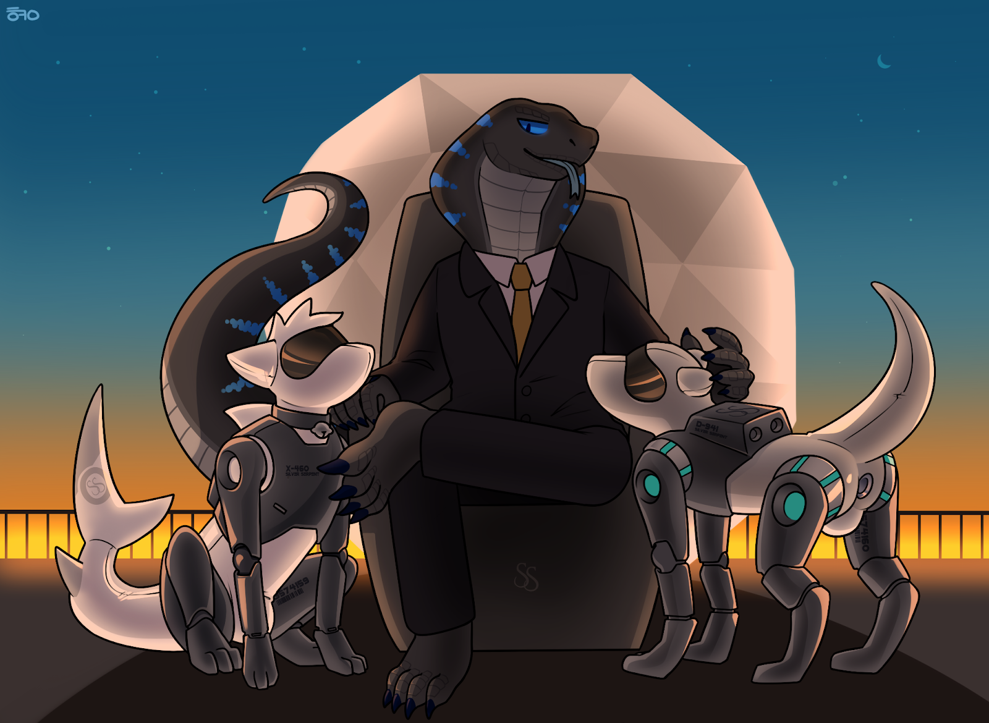
Master rubs my head. Master is making me happy.
Very, very happy.

~ End ~

