Ace of Sex
Gift for Bingturong and Karava
Written by TwistedSnakes
Illustrated by Qundium

“I don’t think I’m the target audience for this shop’s products,” Decro mumbled, trying to hide his blush.
“Nonsense! Everyone likes sex, right?” Karava grinned. He grabbed the wolf’s wrist with one hand and pushed the shop’s door open with the other. Before Decro could protest, the jackal pulled him into the air-conditioned interior of the shop.
“H-hey! Let go!” Decro grumbled and pulled his wrist free.
Karava was already looking around the shop. In the middle of the room was an array of dildos in different shapes, sizes, and colours. On the shelves were various toys for display, flanked by similar items still packaged in boxes. The shopkeeper, a tired-looking bearcat, watched them lazily from behind the counter.
The jackal was chuckling as he looked at the dildo display.
“What kind of dildo do you want to get?” Karava asked as Decro reluctantly joined him.
“I’m not getting one.”
“Fine, but if you were to get one, what would it be?”
“I’m still not getting one.”
“Ugh, you’re such a drag.” The jackal rolled his eyes. “Okay, let’s start with this. What’s your favourite colour?”
“Uh, black, I guess?”
“There are a lot of black ones over here. There’s a feline one, a canine one with a knot. Oh, this one comes with an internal tube. You squeeze the pump here, and then it shoots cum into your—”
“That’s enough.”
“Oh! Are you a top then? We could get you a fleshlight. They come with vibrators, heaters, and you can get them in different maw shapes—”
“Look, Karava. I’m not interested. I’m…” Decro hesitated. “I’m ace.”
“Ace? You mean like, asexual?”
The wolf nodded.
“Ah. Whoops, my bad.” The jackal looked away bashfully. “I was trying to help you. I thought you were just shy about the sex thing. Guess I fucked up, huh?”
“No, no! That’s fine. I mean, if you’re interested, good for you. And if you want to check the toys out, go for it. I’m just not comfortable with you asking me about these toys.”
Karava nodded awkwardly.
“Hey, no harm done, alright?” Decro consoled. “Why don’t you show me the toys you like to use?”
The jackal’s ears perked up. “Well, I’m a switch, so depending on my mood I’ll use either a dildo or a fleshlight. I like to throw in vibrators, maybe a bit of estim on the side.” He dragged the wolf over to a rack of vibrating toys. “Hmm…” he picked up a prostate massager and began examining it.
“So, Decro?”
“Hmm?”
“Can I ask you questions about being an ace? You don’t have to answer if it—”
“Yeah, sure.”
“Okay, so, does sex not turn you on at all?”
“No, not really.”
“So don’t look at a hot guy and think ‘oh I want to fuck him?’”
Decro shook his head.
“Hmm.” Karava pondered for a bit. “Have you had sex before?”
“W-whaa?” The wolf blushed, shaking his head.
“If you haven’t tried it before, how come you know you won’t like it? I mean, when I first had sex, it felt so good. I was bottoming, and the top’s cock was so—”
A ringtone interrupted him, much to Decro’s relief. Karava hastily handed the prostate massager to Decro, pulled out his phone, and put it to his ear.
“Hello? What’s up. What? Wait, it isn’t tomorrow?” He looked at his phone. “Oh shit, it’s Wednesday today!” He hung up the call and turned to the wolf. “I gotta go. Basketball practice. Bye!” He dashed out of the shop before Decro could say a thing.
Decro chuckled. Silly jackal.
As he looked around the shop, the wolf noticed that there was nobody in the shop. Even the cashier had disappeared. He’d best get going too.
He turned around to put the prostate massager back on the shelf, when two hands grabbed him from the back.
“Hey—!” he protested, but a knock to the side of his head left him disoriented. The prostate massager fell on the carpet floor as his limp body was carried to the back of the shop.
The wolf was barely aware of his surroundings as the door was shut behind him. He was tossed face-down on a cold steel table. Rough hands grabbed his wrists and bound them together with rope. His ankles were similarly bound, leaving him trussed up and immobile.
“H-hey,” Decro mumbled weakly. “Where am I?”
“Back of the shop. Bet you didn’t know I create all my toys back here.” The lights flickered on, revealing the bearcat cashier as owner of the voice. “Welcome to my workshop.” He grinned.
“Why am I here?” the wolf groaned. His throbbing head made it hard to think. “This is a kidnapping, isn’t it?”
“Hehh, not quite,” the bearcat chuckled. “See, I can’t help but overhear that you’re an ace who doesn’t like sex.”
“What does this have to do with tying me up?” The initial shock was wearing off, leaving fear in its place. Decro looked around the workshop frantically. The room had no windows, and the walls were covered with racks of cardboard boxes. Throughout the room were many industrial machines that the wolf didn’t recognise.
“You can’t do this to me. Let me go now. Help! Help!” he shouted for help.
His efforts earned him a punch to the jaw, followed by a long strip of duct tape around his muzzle, silencing him. He let out a helpless whimper.
“See, I’m also an ace.” His captor ignored his pleas as he looked through the racks. “But unlike you, I relish the sexual experience.” He pulled out a cardboard box and took out two gallon bottles. Through their white translucent plastic, Decro could see that one was dark purple, and the other was deep black.
Decro watched the bearcat quietly. His fingers reached for the ropes, but the knot was tied too tightly. No matter how hard he tried, he couldn’t get enough grip on the rope to undo the knot. “Hnfft…” he groaned in frustration.
The bearcat unscrewed the caps and poured the contents of both bottles into a metal bucket. With a handheld industrial mixer, he mixed the two liquids. Decro could smell a strong, acidic chemical coming from the bucket as the bearcat carried it over to the table.
“You’ve never tried having sex before, so what makes you think you won’t like it?” The bearcat chuckled as he set the bucket down beside Decro. “Oh no, I’ll make sure you get the full experience. Then you can decide if you still hate sex.”
“Don’t rape me, please!” the wolf pleaded mentally. His heart was beating frantically in his chest, and tears were escaping his eyes.
With a pair of scissors, the bearcat cut the back of his hoodie and shirt, and tore off the shredded fabric. His hands stroked the white and grey fur on the wolf’s back.
“I have no interest in having sex with you; I am ace after all. But I get sexual pleasure from BDSM. Breaking a person down and objectifying him brings me great satisfaction.” He cut away Decro’s pants and pulled it off, revealing the wolf’s ample rear.
“Mngg!” Decro protested as he lowered his tail in an attempt to preserve his dignity. But the bearcat grabbed his tail and lifted it up. A clamp hung from the ceiling by a steel chain, and the wolf’s tail was put into its solid grip.
“Hffft!” the wolf whimpered as the clamp’s teeth bit into his flesh and bone.
“I won’t spoil the surprise. You’ll find out my plan for you as we go along.” The bearcat grinned sadistically as he put on leather gloves. With a heave, the viverrid lifted the bucket over Decro’s body.
“Nhfff!” the wolf screamed from behind his taped maw as the dark, viscous liquid was poured over his back. It felt like it was burning his skin and eating into his flesh. He thrashed about on the table, banging his body against its steel surface. It poured over his back, covering his fur with a shiny coat of pitch black.
The bearcat moved the bucket down, coating Decro’s rump with the black fluid. He was careful to leave the tail alone despite the wolf’s violent thrashing. The liquid was like tar, rippling down the curves of the wolf’s hindquarters and leaving behind a smooth, shiny surface.
The searing pain spread to his legs as the bearcat carried on pouring. His thighs, calves, then feet were soon covered by the liquid. Decro’s struggles did nothing to soothe his agony. The liquid pain stuck to his skin like glue, and the burning sensations seeped into his flesh. It felt like strong acid had been poured onto his body, consuming him from outside in.
There was a clink as the bearcat put the bucket down on the ground. He walked in front of Decro and lifted the wolf’s chin up with one hand. With his other hand, he ripped the tape off the lupine’s muzzle.
“Argh!” the wolf yelped in pain as his fur was yanked off with the tape. “P-please! Help me,” he pleaded. “It hurts.”
“Sit tight.”
Decro’s tear-filled eyes looked up at the bearcat, only to see the bucket hovering over him. The tarry liquid gushed over his face, sending the wolf into a frenzied spasm. His yelps of pain were interspersed by agonised huffs as he begged for mercy. His pleas were unintelligible with his jaws shuddering in pain.
“Plu—” the wolf was interrupted as the bearcat held his mouth open and poured more of the liquid down his maw. His voice turned into gargles as he choked on it.
The bearcat put the empty bucket on the ground. With his gloved hands, he began smoothing the liquid over the thrashing body. Scooping up the puddles of black on the table, he smeared it on the wolf’s undersides, making sure the lupine’s front was entirely covered.
“We’re almost there, just hang on a bit more.” He grinned, giving the wolf’s rump a reassuring pat. He looked up at a clock on the wall. “Just a bit more.”
Decro could barely think. Every fibre of his being was trying to endure the torment his body was going through. It felt like he had been put into an incinerator to burn for an eternity. It felt like hell.
What did he do to deserve this?
The air in his lungs felt like boiling lava. His bones felt like they were being melted down in a fiery furnace. It felt like hours had passed before the agony gradually subsided.
“Alright, you should be ready now,” the bearcat walked over to the wolf, looking him up and down.
“P-please, help me,” Decro pleaded. His body trembled in fear and anguish.
“Let’s see.” The bearcat ignored him. With his finger, he poked the shiny, black surface of Decro’s back and pushed down. Instead of being stopped by the wolf’s ribcage, his finger created a depression in his skin, as if the lupine’s body was made of jelly.
The sensation was uncanny to Decro. As the bearcat squeezed, pushed, and kneaded his body, it felt like he was rubber putty in the viverrid’s hands.
“W-what’s going on?” Decro asked frantically. “What did you do to me?”
“The marketing term is ‘rubberised’, but more precisely your body has been converted to a bio-silicone of sorts.”
The bearcat looked around for a mirror. Spotting a dusty half-length mirror in the corner, he dusted it off and brought it over. Decro could see that his entire body had been turned into a black latex-like material.
“No,” the wolf said in exasperation and disbelief. “No, no, no! You can’t do this to me!”
“Already did.” The bearcat smirked as he put the mirror back.
“Turn me back, please!”
“Hush.” The bearcat picked up a blowtorch from a nearby workbench and came over.
“What are you doing with that?” Decro eyed the blowtorch with his black eyes. “No, wait! Stop!”
The viverrid lit the blowtorch and brought it close to the wolf’s face. Before Decro could turn away, the bearcat clamped his maw shut and brought the flame close to the side of his jaw. The direct heat melted the silicone, turning the wolf’s lips into liquid. As the bearcat took the flame away, the liquid cooled and solidified, forming a smooth surface where his lips once were.
“Mnffh!” Decro whimpered.
The bearcat ignored his victim’s pleas as he continued to seal his lips. Within the minute, the wolf had no maw left to speak. Decro let out a terrified whimper and resumed squirming.
This had to be a dream.
This couldn’t be real, could it?
But it felt very, very real. While he could still see through his eyes, his tear ducts no longer worked. He looked around him. The bearcat was off to the side of the room, setting up some machinery.
If he wanted to escape, now was the time. Although his wrists and ankles were bound, he could still squirm. His tail, however, was still clamped to the chain. Decro rolled over to his side, but his tail prevented him from falling off the table.
Not to be discouraged, he rested more of his body weight against his side, slowly yanking his tail free from the teeth of the clamp. It hurt, but not as much as the flesh-converting liquid from earlier. He could endure this. The clamp tore at his skin as he pulled, but slowly and surely it was coming out. Just a bit more…
“Nnfft!” Decro gasped in shock as his body rolled over the edge of the table and onto the dusty floor. Hastily regaining his senses, he looked around for the door and squirmed towards it. He felt like a worm, a rubbery floppy worm, as he wiggled towards the exit.
Without the use of his hands, how could he open the door?
But he had to try. There was no other choice.
“There you are,” the bearcat’s gloating voice made Decro freeze.
“Gnngg!” the silicone wolf pleaded.
“Nice try, but there’s no point in running.” The bearcat picked the squirming wolf up and brought him back to the table. He slammed the silicone mass back onto the table, this time with the wolf facing up. Picking up the knife he was preparing, he brought it down into the wolf’s shoulder.
Decro didn’t feel pain, but the hot blade digging into his shoulder joint was horrifying. The searing blade felt like a foreign object invading his silicone flesh. Yet the bearcat did it without hesitation, cleaving through the wolf’s body like he was slicing a cake. The blade emerged from Decro’s back as his left arm was cleanly separated from his torso. There was nothing the wolf could do as his other arm was separated in the same way.
As the bearcat cut the strings binding the wolf’s wrists, Decro was surprised to feel the rope come free. For some reason, his sense of touch in his arms was still working. He could feel them as the bearcat stacked them on a workbench like firewood.
The bearcat came back with the knife. Decro looked away, trying to block out the sight. He could feel the steel come in contact with his left pelvic joint. There was some pressure as its sharp edge pressed into his skin, then a “thud” as the blade exited his body on the other side and hit the table. A second “thud” indicated he had lost his other leg too. The shuddering wolf watched silently as his limbs were put into a pile.
“You can still feel them, can’t you?” The bearcat squeezed Decro’s dismembered left hand, and the wolf nodded fearfully. “Good. Then you’re going to experience the next part.”
The machine the bearcat was working on earlier had a funnel on top. One by one, the bearcat fed them into the funnel. Decro could feel the steel walls of the machine as his limbs dropped into its hot inner chamber.
Once in there, the wolf had trouble making out the sensations on his limbs. It felt like his sense of touch was spreading, mixing, and merging. Then, it felt like blades were pressing into his arms and legs, twisting and turning them together.
What was going on?
He looked around helplessly. His black, latex-like body looked back at him through the dusty mirror. Smooth silicone remained where his limbs used to be, leaving no sign that his arms and legs were ever there. His still-fluffy tail curled up around his crotch, preserving what little dignity he had left.
The machine went hiss as the bearcat pulled a lever. Decro could feel his liquefied limbs flowing down a pipe and into a tight chamber. Air pressure within the machine was forcing his limbs into the chamber, compressing it into an odd shape. It was as if his limbs were being crushed beneath a thousand pounds of bricks.
Decro squirmed, trying in vain to pull his non-existent limbs out from under the imaginary weight. His eyes were rolled back in shock, and his body was spasming on the table. The bearcat stroked his silicone chest admiringly while the wolf gave him a pleading look.
“While your new case is setting, let’s get you into position.”
Decro shook his head violently, but he was unable to resist. The bearcat picked him up and carried him over to another machine. Two cylinder halves were mounted on a base, and a pole stood between them. Atop the pole was a circular plate no bigger than the palm of his hand. In the middle of it was a ribbed steel bulb, reminding the wolf of the dildos in the shop front.
He wasn’t far from the truth, as the bearcat held him over the bulb. Decro thrashed around, making muffled screams as he protested. The cold steel of the metal dildo was pressed against his posterior. As gravity pulled the wolf down, his elastic pucker swallowed up the butt plug until it was fully hilted within him. His rump was resting on the tiny circular plate, stopping him from being fully impaled by the pole.
“I’m letting go. If you continue to squirm, you’re gonna fall over with your ass still stuck on the pole.”
The warning was enough to calm Decro down. He had to tense his malleable body to keep him from falling. His rear muscles clenched the metal plug tightly, feeling its ribbed metal surface push against his silicone tunnel. The bearcat left him standing there as he walked back to the first machine.
Decro couldn’t see what was going on at the other machine, but he could feel fresh air caress his limbs. He could feel the bearcat’s fingers on his...arms? Legs? He couldn’t tell, the sensations were confusing. It felt like the bearcat was gripping all his limbs and turning them over in his hands.
The bearcat turned around, and the wolf could see a black cup-shaped container in his hands. It was a cylinder that tapered before flattening out into a narrower tube, much like a flashlight. As the bearcat examined it in his hands, Decro made a sudden realisation.
Was that...his limbs?
He could feel the bearcat’s fingers grabbing its smooth, black surface. He couldn’t believe it. He didn’t want to believe it. But he couldn’t deny that he could sense what was happening to the cup-like container.
The bearcat saw his confused face and grinned. “Yup, that’s what’s left of your arms and legs. Melted down and moulded into this.”
Decro almost fell off the pole in shock, but he clenched his tailhole in time to keep him on his perch. He could feel a cold sensation as the bearcat picked up a spray can and sprayed the inside of the cup. The bearcat brought his limbs-turned-cup over to Decro’s machine and positioned it upside-down over the silicone wolf.
“Mnff?” the wolf asked in confusion. He was desperate for anything that could give him some comfort. Maybe the changes were reversible. Maybe there was a way out. Even just knowing the outcome of this process would give him some sense of understanding. The bearcat had left him to figure out his fate, but he could barely believe what was going on, much less comprehend it.
“We’re almost done,” the bearcat chuckled. He stood back and examined the setup.
The silicone wolf was mounted on a pole, flanked by half-cylinders on either side of him. What was left of the lupine’s limbs had been moulded into a cylindrical case and positioned above him. His tail, still made of flesh and bone, was curled around his crotch as if he had any shred of dignity left to keep.
“Hmm, one last thing.” He pulled Decro’s tail to the base of the pole where another clamp was conveniently placed. Its jaws were closed around the lupine’s tail and secured. “Now, for your dick.”
He pried the wolf’s silicone sheath apart, coaxing out the rubbery dick within. When Decro’s cock was at full mast, he went to fetch the knife again.
“You might want to look away if you’re a little squeamish,” he chuckled.
Decro let out a muffled whimper. He was scared. He wasn’t ready for this. But without his limbs to defend himself, he was rendered helpless to what the bearcat wanted to do to him. There was no way to resist. He forced himself to look away.
There was a pressure at his crotch as he felt his manhood separated from his body. A high-pitched whine escaped his throat and he winced. His body wasn’t feeling physical pain, but he was suffering mentally. The bearcat stepped back and put the silicone cock and balls on the steel table.
The wolf looked down to see a smooth surface where his maleness had been. If he could cry out, he would, but his mouth was nothing more than melted silicone fused together. It took everything within him to pull himself together and keep himself balanced on his anal perch.

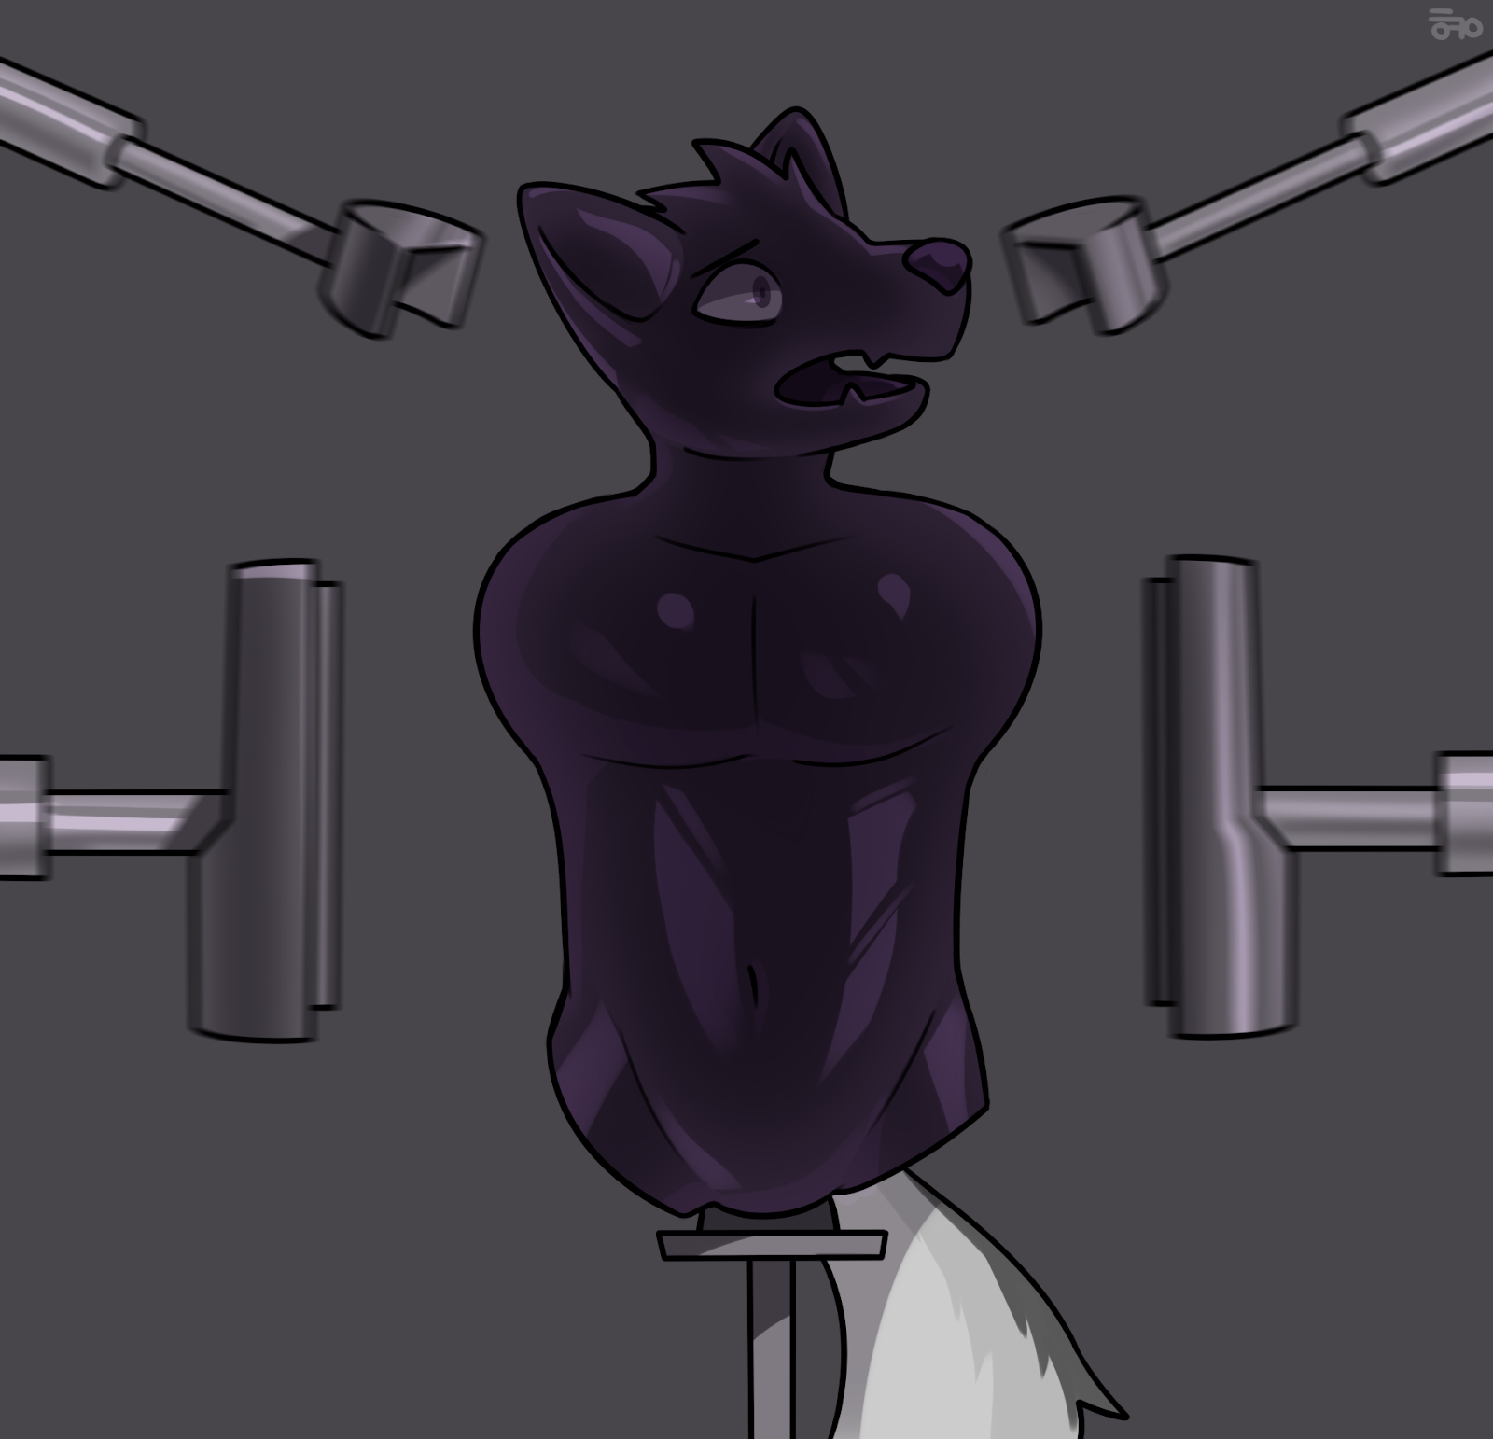
“Oh, don’t worry. I still have plans for your cock,” the bearcat chuckled. “But first, let’s deal with you.”
The bearcat closed the two halves of the cylinder around Decro, plunging him into darkness. There was the sound of latching, followed by a deafening hiss. There was no time to consider his situation as the inner walls of the cylinder began closing in on him. His desperation to escape was met with his helplessness to do anything about it.
As the metal walls compressed his elastic body, Decro turned his head up to prevent his muzzle from getting squished. The cylindrical walls continued squeezing him. If the wolf was still made of flesh and bone, this would be his breaking point. His clavicles and rib cage would have been cracked and crushed. But with a silicone body, the walls could compress him way beyond his biological limits.
The pressure got unbearable as Decro was further compressed. Steel walls flattened the natural curves of his muscles. The wolf could feel his mass push upwards along his cylindrical prison as his body was squeezed like putty in a fist.
With a second hiss, the machine stopped, leaving the wolf in a tube shape no wider than the circular plate he was sitting on. He tried moving his tail. It was still bound on the pole below him, keeping it out of harm’s way. The rest of his body, on the other hand, wasn’t so fortunate. Decro could feel his features slowly merging into each other. If he got out of this, his body would just be a smooth tube. He would still keep his facial features, but his ears were flattened against the back of his head, permanently fused to his silicone neck.
The process was still not over. With a jerk, the pole began ascending. Decro’s body rubbed against the smooth walls of his prison as he was forced up the tube. His muzzle pressed against something, and he could feel it on his arms and legs.
The cup!
He was being forced into the cup-shaped cylinder that the bearcat had made from his arms and legs. His muzzle was pushed into the narrower end of the cup, and his head filled out the rest of it. The machine, however, didn’t stop there. The pole continued forcing his rump up, attempting to compress him into the cup.
Decro whimpered. He wouldn’t fit in there. There was just no way. Yet the machine continued pushing him up with unrelenting force. He could feel the metal plug in his rear delve deeper into him as it pushed. As Decro was compressed into a smaller space, it felt like the plug was getting bigger within him. The ribbed metal dildo spread his inner muscles apart and pushed into his silicone intestines.
His shoulders were forced into his limbs-turned-case. His head was compressed in the narrow end, pressing his face flat against its bottom. The machine’s immense pressure was doing its job too well. The pole had pushed his torso into the cylindrical case.
The wolf struggled, but there was no place to go. His body was trapped in a prison too small for him, and it was getting smaller still.
The dildo was halfway up his body as it spread him open and compressed him over its form. It continued deeper into the wolf, filling out his chest. The dildo’s width was only slightly smaller than the column that Decro was squashed in. Its metal body was a mere inch away from the machine’s walls, leaving the silicone wolf’s body immensely compressed in the remaining space.
As the rest of Decro’s body was pushed into the silicone case, the dildo compressed his chest against the walls of his prison. Its tip spread his throat open and sat in his maw. The wolf could taste the warm steel on his tongue. The front of his sealed maw was pushed against the end of the case. As the pole’s circular plate touched the entrance of the cup, it stopped with a click.
There was no space left to move or squirm. His lungs had been deflated, making even the softest whimpers impossible. His facial features had been irreversibly smeared against his silicone casing, fused together by the immense pressure of the machine.
Helpless to do anything, Decro waited in silence. The bearcat hadn’t come for him yet. The wolf could feel his cock being handled elsewhere. There was the sensation of cold metal pressing against his balls. He could hear loud hiss elsewhere as the metal squeezed his nuts, flattening them out. Moulding. His manhood was being moulded like raw silicone material, just as the rest of his body had been.
“Now for the star of the show.”

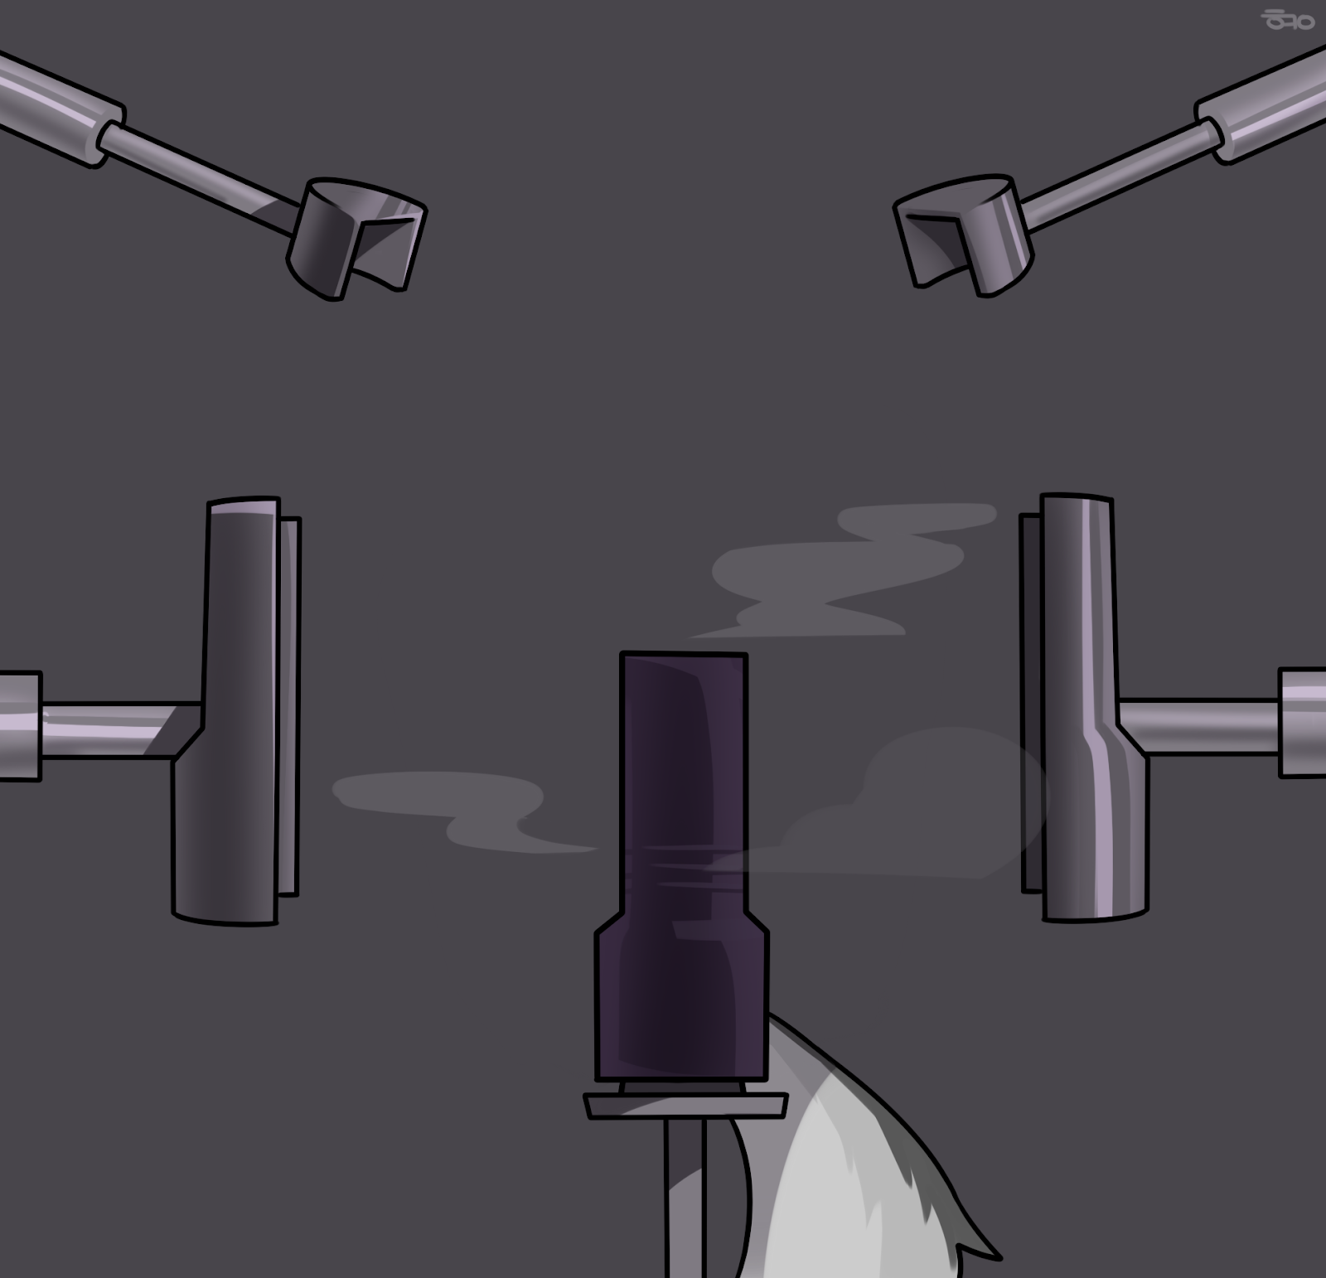
There was a hissing sound. The machine shuddered as the walls of Decro’s prison retracted and the pole descended back to waist-height. The cylindrical halves were unlatched and separated, revealing the black cup shape mounted on the pole. Unclamping the white tail, the bearcat slowly lifted the cup off the pole.
Decro could feel his insides stick to the dildo as he was lifted. His body had been compressed so tightly, the silicone was clenched tightly around the metal. As he was pulled free, his inner tunnel could expand just a little more, easing the constricting tightness he was feeling. Fresh air brushed against his exposed tailhole, although the rest of his body was squeezed tightly in the cup.
“If you haven’t already guessed, I’ve turned you into a fleshlight.”
The wolf whimpered mentally. The bearcat was stroking the rim of his tailhole, now moulded into the enticing entrance of a sex toy. His fingers entered the silicone lupine and explored the soft inner tunnel.
“Ribbed for pleasure.” The bearcat licked his lips.
Decro’s insides had been moulded by the ribbed dildo to form a textured tunnel, ready to clench and squeeze around the first throbbing dick to enter him. Even before he was a toy, the wolf didn’t want to be fucked. Why then would he want it now? He quickly pushed aside those dreadful thoughts.
“Let’s do something about that tail.”
The bearcat sat him down on the table. Decro’s tail was still at full length, completely disproportionate to the black fleshlight it was attached to. That was about to change. The bearcat rummaged through the shelves until he found a spray can. He gave Decro’s tail a generous coat of the liquid and waited for it to take effect.
Decro shook his tail in desperation. The liquid was seeping into his fur and flesh, making it feel ice cold. It was as if his tail had been dipped into icy water and left to freeze. As the spray did it works, the lupine’s tail shrank. Its size was gradually reduced to just half the length of the fleshlight.
The bearcat chuckled as he toyed with the frantically wagging tail. “How does it feel to have your tail reduced to a fleshlight accessory? For that matter, how does it feel to be a sex toy?”
He didn’t wait for an answer, not that the wolf-turned-fleshlight could respond anyway. He went back to another machine and opened the mould. Within it stood a silicone canid cock, proudly erect in all its glory. However, its accompanying balls were missing, having been pressed into a circular base.
Decro could feel the bearcat molest his dick as he brought it over. The bearcat’s fingers were all over his shaft, stroking his tapered tip, then fondling his bulbous knot.
But what had become of his balls? He could still feel them, but he didn’t understand the sensations they were feeling.
“Your cock is now a wonderful dildo,” the bearcat explained. “A matching accessory to your fucktoy of a body. Look, you stack together.”
The bearcat pushed the silicone cock into the fleshlight’s entrance. If not for his current predicament, Decro would be huffing in pleasure. His own cock was entering his tailhole. His inner muscles were squeezing against his shaft as he clenched, sending pleasurable sensations up his rod.
With his body compacted into the length of his dildo cock, it was no surprise that his dick filled him completely. The tip of his tapered cock went up his throat and sat in his sealed mouth. His sizable knot sat just inside his tailhole, spreading his entrance open.
The bearcat twisted the lupine’s cock, rotating it within the wolf’s fuck tunnel. Decro reeled in pleasure. It felt like his balls were being rubbed, his cock was being stroked, and his insides were being squeezed. Only when the spinning stopped did the wolf realised what was going on. His nuts had been moulded to form a cap to the fleshlight. The circular base was shaped with a threaded rim, meant to be screwed around the mouth of the fleshlight case. A small notch in the fleshlight allowed the wolf’s organic tail to escape the case, but otherwise Decro was fully trapped in the prison moulded from his limbs.
He shook his tail frantically, the only thing he could move. His efforts only elicited a chuckle from the bearcat. The bearcat picked the fleshlight up. Decro could hear footsteps as the bearcat moved. He could hear the sound of the workshop door opening. He could feel the cool air of the sex toy shop. He could feel the sunlight shining on his limbs-turned-case and balls-turned-cap.
The bearcat put the fleshlight down on a display shelf. Its fluffy tail was still waving about frantically, hitting against its own case and the shelf.
“You have spirit, kid. And that’s why I’ll love breaking you.”

“Hi Mister, have you seen my friend?”
Decro woke up as he heard a familiar voice. How long had he been asleep? He remembered the bearcat closing shop. Was it morning already?
“White and grey wolf, about my height. He was here with me yesterday.”
That was Karava! Karava would save him.
“Ah, I think I remember him.” That was the bearcat’s gruff voice. “He left right after you.”
“Darn, alright. This is the last place anyone has seen him. Are you sure?”
“Yeah. He left once you ran off.”
“I guess he’d do that. He’s not really interested in these kinds of toys. Do you mind if I look around for a bit?”
“Not at all, not at all.”
Decro wagged his tail. He needed to catch Karava’s attention. The jackal might even recognise his tail markings and get him out of here.
“Please, notice me,” he thought.
Karava’s footsteps approached the display shelf. The fleshlight wagged its tail even more vehemently.
“What’s that? That wasn’t there yesterday.”
“Oh, that? I was cleaning up earlier, meant to put that away.”
The bearcat picked the fleshlight up.
“No! Don’t let him take me away!”
“Can I take a look at that?”
“It’s a prototype fleshlight.” The bearcat shrugged, turning away from Karava. “It’s not for sale.”
“I saw it moving though. I’d still like to see it.”
The bearcat hesitated. “Fine.” He turned around and offered the fleshlight.
Karava took it and turned it around in his hands. Decro could feel the jackal’s familiar fingers all over his arms and legs. He shivered as his balls were stroked.
“What’s this?” The jackal grabbed the wriggling tail and felt its realistic fur.
“Fleshlight accessory. Gives you the full ass experience. An assperience, if you may.” He let out a chuckle.
“Uh huh.”
Decro was desperate. If he wanted even a chance to escape this situation, he needed to get out of the shop. He needed to go home with Karava. He shook his tail violently. Communication had never before felt so difficult, yet so crucial.
Did Karava understand him? Could the jackal recognise his tail markings at least? Decro cursed his generic markings. The jackal was looking him over, flipping him until the wolf was giddy within his fleshlight case. Karava put the fleshlight back on the shelf.
No! Did the jackal not realise it?
Decro was not ready to face a lifetime of being a fucktoy. He didn’t want to be left here. He didn’t want to be sold off to someone as a toy to be ejaculated into.
Please!
“You know what, why don’t you keep it?”
“Huh?”
“Take it home. Go have fun.”
“Uhh, that’s fine. I don’t think it’s my kind of toy”
“I insist.” The bearcat picked the fleshlight up and thrust it into Karava’s hands. “You can give it a go and tell me what you think.”
Karava nodded and put the toy into his bag. “Thanks. But yeah, I gotta look for my friend.” He turned to leave.
“Alright, good luck with your search. And come visit ‘Bing's Bangers and Boners’ again.”
Decro could not believe his ears as the shop door closed behind Karava. Was he actually out of that hellhole? He thought he’d never be able to leave. Luck was on his side today.
As Karava searched the town, Decro bounced against the jackal’s other belongings. There was time to think. Could he somehow tell Karava who he was? Could Karava find a way to turn him back? His limbs might not be salvageable, but what about his body? Could the rubberising process be reversed? Or would he have to live the rest of his life as a fleshlight?
He had to stay optimistic. He had to try. He was so close.
Karava was finally home. The jackal unpacked his bag and put away his belongings. The fleshlight with its wagging tail went into the box at the back of his closet, along with his other sex toys. He closed the closet door, leaving the fleshlight alone in the dark.

Time passes differently when you’re deprived of your five senses. Decro had no clue how long he had been here. Every few hours, he’d hear sounds of Karava moving about in his room. There would be hours of hearing a fan hum until his mind tuned it out. There would be periods of silence. Those were the worst. Did an hour just pass? Or was it only a minute?
All the wolf could do was to keep himself company with his thoughts. What he would do once he got out of here. The people he needed to reunite with. Take in the sights of the outside world. Move his body. Eat some delicious food. He ran through these fantasies over and over until even that got boring.
And so he slept. He let his mind slip away into the limbo of unconscious existence. At this rate, he’d be an object both physically and mentally. But what else could he do? Without a body, could he really be “alive”?
He waited.
“Decro? Decro, are you there?”
The wolf wagged his tail. Was he finally noticed?
“Heya!” His own voice spoke. “I’m not here at the moment, but if you leave a message, I’ll be sure to get back to you!”
Decro’s heart sank. That was his answering machine.
“Pick up, dammit,” Karava’s voice said. “Decro, are you alright? It’s so boring without you.”
“But…but I’m here,” the fleshlight thought. His tail swayed dejectedly.
Decro heard the closet door open.
“Since there’s nothing to do anyway…” Karava rummaged through the box of sex toys. His eyes fell on the fleshlight with the wagging tail. “Oh, the weird toy from that sex shop.”
He picked it up and considered it. Its tail started wagging excitedly, as if anticipating its usage.
“That tail is just so weird,” Karava muttered. Grabbing a roll of duct tape from his desk, he fixed the problem. Two rounds around the fleshlight and the tail was no more than a bump below the black tape.
The wolf wanted to cry. His last means of communication has been taken away from him, and his friend didn't even realise what had happened to him. The jackal grabbed his moulded nuts and unscrewed the cover. Decro’s cock twisted within his ribbed interior before being pulled out.
“Huh, it comes with a dildo too.”
“That’s my cock…”
Decro could feel himself being put on the soft cotton bedsheet while Karava went away. His silicone cock rolled on the bed while his fleshlight body bounced on a pillow. When the jackal came back, he jumped on the bed.
The jackal moaned softly as he lubed up his tailhole with his fingers, coating his entrance with the slick liquid. The wolf could feel the jackal fondling his cock. Cold liquid was squirted on his sensitive manhood, making his black silicone shaft shiny. Holding the base of the wolf’s dick, Karava pushed its tapered tip against his tailhole.
The wolf whimpered. He didn’t want to have sex in any shape and form. Not with his friend, and especially not as a dildo. If he could protest, he would, but his body had been squeezed and moulded into the internals of a fleshlight. He braced himself.
With a grunt of pleasure, Karava pushed the dildo in, letting it fill him up.
“F-fuck, you’re bigger than I thought you’d be.”
He slipped it in slowly, feeling its silicone shaft press against his inner muscles. Decro shuddered as the jackal clenched around his cock. This was the first time he was being fucked. The sensations were physically pleasurable but mentally repulsive. It felt dirty entering another person like that. He was hilted within Karava’s rump, and he could feel the jackal shiver in bliss.
“A-ahh…that feels good.”
Leaving the dildo in his rump, Karava picked up the fleshlight. Decro could feel a plastic nozzle invade his rear entrance. The bottle was squeezed, squirting a generous load of lube into his silicone interior. The jackal turned the toy about, letting the liquid coat all sides of the interior.
Decro quivered. Karava was getting ready to penetrate him but the wolf wasn’t ready. The jackal plunged into him anyway. The wolf’s inner tunnel was moulded to squeeze snugly against the cock within, which meant that Karava’s dick was spreading his tight rear open.
The cock impaled the wolf’s body, entering his rear, going through his body, then into his throat and maw. Decro felt like he was choking. The tip of the dick filled out his sealed maw, rubbing its pre-leaking apex against the silicone.
Up and down Karava pumped the toy. Decro’s ribbed insides stroked the jackal’s cock with each thrust. Decro was repeatedly spread and stretched against his will. The dick pushed his insides against the walls of his case, giving the feeling of immense compression. With his free hand, the jackal grabbed the wolf’s cock by its base, pulling it in and out of his tailhole.
Decro was distressed. He had been literally objectified and violated in all sense of the word. Despite not liking sex, he was being fucked by a cock the size of his compressed body. His own dick served as a dildo for the jackal’s pleasure.
Trapped in the dark, his other senses were enhanced. In his mouth, Decro could taste the aloe vera lube mixed with the jackal’s salty pre. He could smell it too. The sensations of Karava’s warm, throbbing dick filled his insides. There was the rhythmic slurping as the jackal’s cock repeatedly penetrated the fleshlight, accompanied by his pleasured moans.
Decro’s mind was reeling. Being pumped up and down the jackal’s shaft was leaving him dizzy too, making him feel even worse.
Block it out.
Think pleasant thoughts.
Don’t think about it. Don’t think about being fucked by your best friend. Don’t think about how you’ll never be turned back into a wolf again. Don’t think about anything.
The jackal was taking his time. Or maybe time felt like it was dragging on because of his repulsion to his predicament. The lube was drying up, so Karava squeezed more over his knot before plunging Decro’s rear over it.
If Decro wasn’t asexual before, he was now. The situation was utterly revolting. He wanted to close his eyes and drown it out, but there was nowhere to run from the experience. His entire being had been turned into a fleshlight, clenching around the throbbing sceptre of the jackal’s cock. His detached dick was a canine dildo meant to provide sexual pleasure, just like the ones on display in Bing’s sex shop.
Karava was close. With a shudder, he forced the fleshlight over his knot. Its tight entrance resisted, and the jackal let it squeeze his knot snugly. At the same time, he shoved the dildo into him, pushing the sizable knot into his rear.
“F-fuck…”
He relished the orgasm, shooting rope after rope of cum into the fleshlight. He gently tugged the toy off his dick before pushing it back. His breaths were short and shallow as he repeated, milking every last drop of cum from his balls. His rear tunnel clenched the dildo, squeezing against its shaft and knot.
Please…
Decro whimpered as he was forced to milk the jackal. The cum was disgusting in his mouth, and the last thing he wanted to do was to tease out more of the jackal’s seed.
He needed to stay strong. He needed to endure this. There would be a way out. There had to be a way out!
The jackal huffed as he laid on the bed, letting the fleshlight sit on his cock as he enjoyed the dildo in his rear. Finally satisfied, he got off the bed. He held the fleshlight over his manhood as he made his way to the toilet. The dildo was still firmly lodged in his rear as he walked.
In the toilet, he took the fleshlight off his cock and stood it beside the sink. Decro felt the warm cum dribble down his ribbed tunnel, pooling in his mouth.
Ugh…
Karava spread his legs and grabbed the dildo’s circular base. Giving it a gentle tug, he pulled the knot out of his wet hole. The black silicone shaft followed, leaving a string of lube behind. The dildo was left by the sink too. Stepping into the shower cubicle, he turned the water on and washed up. While he showered, the fleshlight was left to soak in cum and lube.
When Karava was finally done, he dried himself off on his towel. He picked up the fleshlight and held it under the sink. Decro waited eagerly. He wanted to be rid of the dirty fluids and properly cleaned.
“Eh…” Karava paused. “I don’t really think this toy is for me.” The jackal set the toy back down and considered. “I’ll throw it away instead. Sorry.” He apologised to nobody in particular.
No! Wait! Please!
Decro’s cock was thrust into his own tailhole. The cum and lube coated both his cock and inner tunnel as his shaft spread everything about. He couldn’t believe this. He didn’t want to believe this. He wanted, no, needed to be cleaned. He didn’t want cum inside of him.
But the jackal was gripping his nuts and twisting, screwing the cover back on.
“No, no, no! Please! Don’t do this to me!”
The jackal couldn’t hear his silent screams of horror. To him, the fleshlight was just a toy he would never play with again. Making sure the cover was screwed on tight, he tossed it into the trash.
In the bin, the fucktoy whimpered. His insides and cock were steeping in the jackal’s warm cum. He felt dirty inside. It felt like he had been raped. This was rape, wasn’t it? Or did it not count because he was now a fleshlight? An mere object for sexual pleasure.
This couldn’t be real. There was no way he could’ve been turned into a fleshlight. This was just a nightmare. He’d wake up the next day in his bed as a normal wolf. He’d hang out with Karava, and this would all just be a bad dream, right?
Please be a bad dream.
The bearcat had wanted him to find out if he enjoyed sex through experiencing it himself. He had his answer now, right? Maybe this was all just a silly joke. Now that the bearcat has had his fun, he would come looking for the fleshlight to turn him back. Decro would be angry at the bearcat for putting him through the entire ordeal, but at least he’d be back to normal. Forgive and forget.
Maybe being fucked by Karava wouldn’t be so bad. Better a friend than a stranger. He would just sit on the shelf until the jackal was horny. He would just have to deal with some unpleasant sex every now and then. There would be time to get used to it, anyway. Anything. Anything is better than being thrown away.
He didn’t want to be thrown away. He didn’t want to end up in a dumpster. He didn’t want to end up compacted in a pile of trash and incinerated. He didn’t want to die so young, much less as a sex toy. He wasn’t a sex toy.
He was Decro. This was just a bad dream. Just a bad dream.
Right?

~ End ~

