The PokéLatex Tournament
Written by TwistedSnakes

The crowd cheered as the floodlights in the stadium beamed their light over every inch of the battlefield. On it were eight Pokémon trainers. Having trained hard over the past few months, they’ve come to compete in this tournament to prove their mettle.
They will engage one-on-one in the elimination-style tournament, with each battle knocking out another trainer from the race. Only one will emerge champion. Who will win?

The Quarter-Finals

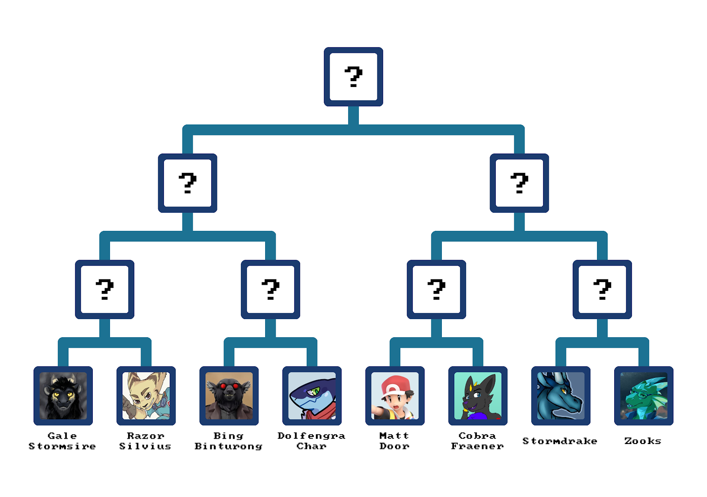

Gale Stormsire vs. Razor Silvius
[Battle in progress…]
[Battle concluded]
[Winner: Gale Stormsire]
“Well, good game I guess,” Razor shrugged as his Incineroar fainted to Gale’s Corviknight. He tried his best, and there was no shame in losing. He’d just have to train harder for next time. From the seats of the vast Pokémon stadium, the crowds cheered the winner of the match.
The lombax relished the idea of a hot shower back home, and getting some much-deserved rest. Having spent the past few weeks training his team from dusk till dawn, sleep felt like a welcome reward.
Suddenly, two metal arms rose from the platform he was standing on.
“Huh?”
Before he could react, they grabbed his wrists and held them apart. A third arm came up and cut through his shirt.
“Hey!” he protested. “What’s going on?”
The crowds were unfazed. Instead, they seemed excited as they watched the mechanical arms assault the lombax. His shoes were reduced to shreds on the platform, followed by his pants. His underwear was last, leaving him naked and vulnerable in front of thousands of watchers. Many more, if he was counting the viewers at home.
Another set of arms brought up a blue and black latex suit. Its torso was a cream yellow, with a rubber spike sticking out of its chest. Razor’s eyes widened and realised what it was.
A latex Lucario suit!
But it was impossible to resist as the arms held him in place. The neck of the latex suit was stretched open and his legs were slipped into the suit. Despite his struggles, the suit was quickly pulled over his feet. Black rubber feet replaced his clawed yellow feet. His thighs were thick and blue, matching the markings of a Lucario.
His tail was next, then his arms. Fingerless mitts forced his fingers to be balled up in a fist, making it impossible for him to use them. The rubber spike sat in front of his chest, matching the two on his arms. They were sharp, but their soft squishy form rendered them harmless. The arms released the suit, allowing the neck of the suit to snap around Razor’s neck.
“What’s going on?” the lombax looked around in a panic. “What’s the meaning of this?”
“Looks like our contestant hasn’t been paying attention to the finer details of the PokéLatex Tournament,” Aspen, the host and announcer of the tournament, boomed through the stadium through the loudspeakers located throughout the stands.
“What?!”
“Shame, isn’t it? It’s even in the name.”
Razor continued to struggle, feeling the skintight latex rub against his bare fur and skin.
“Well, for the benefit of the audience, I’ll explain the rules again. After each match, the loser will be suited in a PokéLatex suit and put under the winner’s ownership. If the winner goes on to lose to someone else, then him and his Latexmon will be handed over. Simple.”
“Wait, I didn’t—”
Razor was interrupted as a blue latex hood was pulled over his head. His ears were squeezed into the narrow triangles that formed Lucario’s ears. The lombax found himself looking through the tinted lenses of the suit’s eyes. A gag was pushed into his mouth, turning his earnest protests into muffled howls.
“Mnggh! Nghgn grwn hftt—”
He was interrupted once more as the gag inflated, filling out his maw and making it impossible for him to make a sound. The only sounds he could make now were the squeaking of latex as he moved.
A metal collar was snapped around his neck. There was a beep as the electronic locks engaged, sealing the suit. Razor the trainer was no more, leaving behind a latex Lucario.

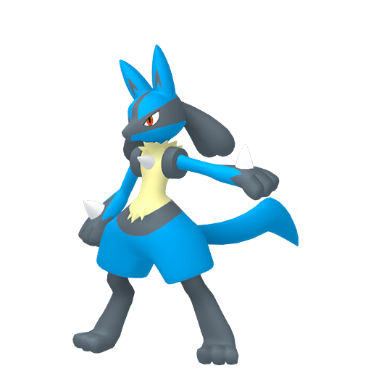

Bing Binturong vs. Dolfengra Char
[Battle in progress…]
[Battle concluded]
[Winner: Dolfengra Char]
Bing grumbled as he lost the battle to Dolfengra. The bearcat had spent a long time putting his team together, only to lose in the first round of the tournament. But a loss was a loss, and he waited for the Poké-suiting.
Sure enough, the platform came to life as the metal arms rose around him. A large claw grabbed him from behind, gripping around his torso and lifting him clean off the ground.
“H-hey!” he gasped in surprise.
The mechanical arms moved quickly. His wrists were forced backwards so that they were fully bent at the elbows. Thick, leather strips were strapped and buckled around his arms, securing them in place. His legs were similarly treated: bent at the knees so that the back of his shins were pressed against his thighs. More straps binded them in place. If the arms put him on the ground now, he’d be forced to walk on his elbows and knees.
But the arms had something else in mind. The platform below him split into half and separated. A white Solgaleo suit rose up from the opening. The back of the latex suit was open, revealing its padded insides awaiting the wearer.
Bing found himself liking it less and less with every passing moment, but there was no stopping this. By the end of this, he would be stuffed in the latex suit in front of the audience of thousands. His arms and legs went into the suit first. They entered the sleeves, sliding up to the elbow and knees of the suit. There were supports in the Solgaleo’s forearms and shins, giving the bearcat more height in the suit. After that, his fluffy tail was stuffed into the cat-like tail of the suit.
The zip was quickly pulled over his back, encasing him in the white rubber suit all the way up to his neck. The arms held up the final piece of the suit in front of him: a latex Solgaleo head, complete with its majestic mane.
There was no stopping it. The head was pulled over his head, and the inner latex walls of the suit hugged Bing’s face relentlessly. His maw was trapped within the narrow muzzle of the mask, making it impossible for him to make any sounds other than a feeble mewing. The world was blue as he looked through the tinted lenses of the suit.
A metal collar was clamped aorund his neck, sealing away the zipper and seams, making the suit a long-term part of Bing’s attire.

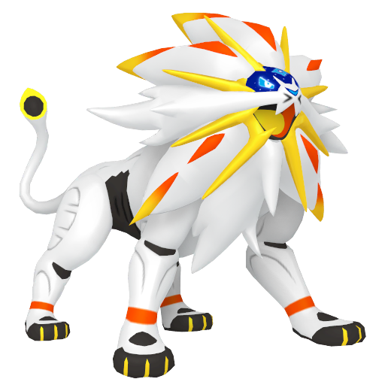

Matt Door vs. Cobra Fraener
[Battle in progress…]
[Battle concluded]
[Winner: Cobra Fraener]
“Dammit,” Matt grumbled. He returned his fainted Claydol back into its Pokéball and returned it to his belt. He had heard about the latex Pokémon penalty, but that was a joke, right?
He was about to find out. Metal arms grabbed him. Within seconds, his clothes were reduced to shreds as pincer-ended arms cut through them with quick and precise movements. A black, yellow, and red suit was revealed, to the cheers of the excited audience.
Matt frowned. Well, it would be unpleasant, but he could handle a rubber fullbody suit. It wasn’t like he was new to the latex scene. Unfortunately for him, he didn’t account for non-humanoid suits.
Metal arms with claws grabbed his feet and pulled them together. The suit was pulled up over them, holding them together in a bell-shaped latex form.
“Wait, h-hey!”
If not for the arms holding on to his wrists, he would’ve fallen over. He tried to keep his balance on his feet, but it was hard as the arms worked the suit over his body. His hands were squeezed into hoof-like fists, and his torso was trapped in an egg-shaped body.
Almost as soon as it began, it was over. A hat-like latex cap was put over his head, topped with two bull-like horns. A metal collar held the entire suit together, making it impossible to take off. With the suiting completed, the metal arms let go of his wrists, forcing Matt to keep his balance on his fused feet by flailing his arms. If he fell, there would be no getting back up.
“Ladies and gentlemen,” Aspen announced. “Our new Latex Pokémon, Tapu Bulu!”

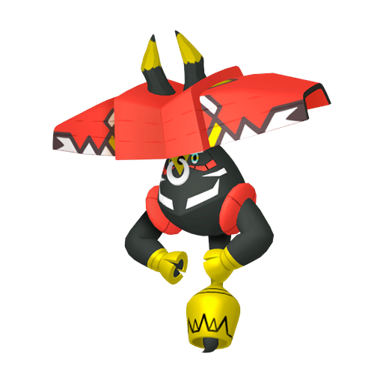

Stormdrake vs. Zooks
[Battle in progress…]
[Battle concluded]
[Winner: Stormdrake]
Stormdrake’s Lucario hit Zooks’ Blastoise with an aura sphere, sending the turtle-like Pokémon reeling. With a defeated roar, the Blastoise fell to the ground, unconscious. Zooks had lost. The green dragon hadn’t expected to win the tournament, but he didn’t expect to be knocked out so early in the game either. He could only hope his latex fate took the form of a convenient humanoid form.
The mechanical arms reached for him and held him tight. As with the trainers before him, his clothes were stripped. His wrists were pulled to his sides, and his ankles were held together in a vicelike grip.
The dragon squirmed. He knew it was safe, but his survival instincts drove him to struggle anyway. Still, all his strength was no match for the tenacity of hardened steel. More arms came up, each one holding a leather strap with a buckle. The first strap was wrapped around his ankles and secured in place, keeping his feet together with no space to move.
The next one was strapped around his shins, and the following one around his thighs. Zooks began to see a pattern, and he didn’t like where it was going. The next one was strapped around his waist and looped around so that his wrists were restrained to his sides. The other straps secured his upper body, keeping him standing awkwardly on the platform.
A black, gold, and purple suit was pulled up. It was made up of one long sleeve, ending in a pointed tail. The arms were swift in sliding the bound dragon into the Seviper suit. As his legs, followed by his torso, were encased in the rubber, Zooks could feel his movements being increasingly restricted by the tight latex.
He wouldn’t be able to move around in this suit! The restraints only allowed for feeble squirms that would get him nowhere. But before he could protest, the final piece of the suit was shoved over his head. Complete with gold markings and red fangs, the latex Seviper was complete. The steel collar was locked around his neck, sealing the suit.

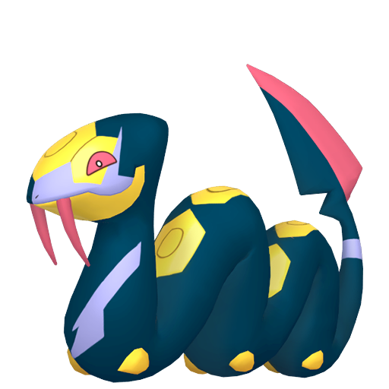

The Semi-Finals

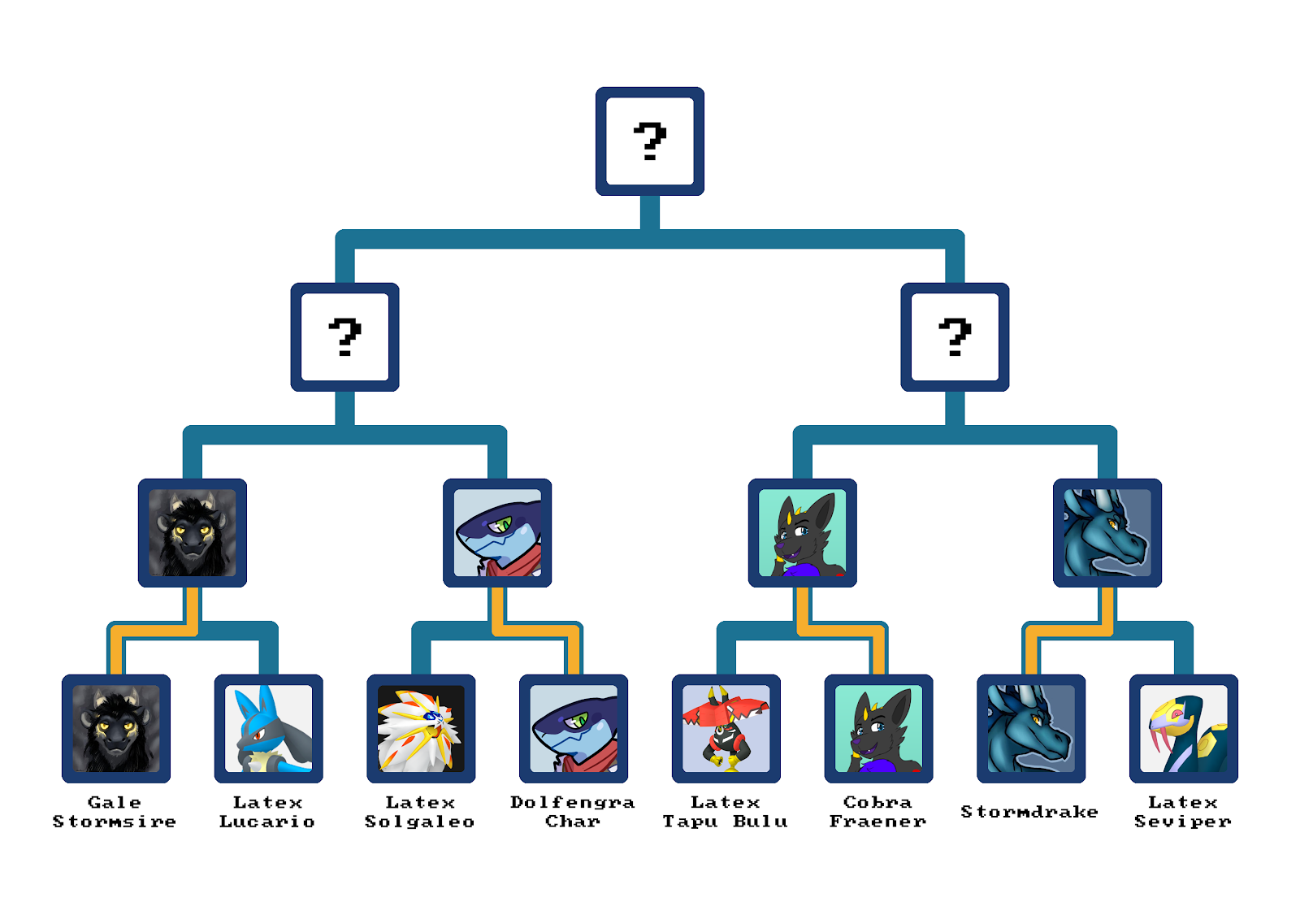

Gale Stormsire vs. Dolfengra Char
[Battle in progress…]
[Battle concluded]
[Winner: Gale Stormsire]
“Hey!” Dolfengra protested.
His opponent, Gale, was down to his last Pokémon too. But his flying-type Noivern was no match for an electric-and-steel-type Magnezone.
So close!
But close wasn’t good enough. He had lost, and his PokéLatex suit awaited him. The steel arms grabbed his wrists and pulled them away from his body. The scissors-ended arms made quick work of his clothes, leaving the poor shark bare and vulnerable. He blushed as he felt the eyes of the audience affixed on his naked form.
But that was soon remedied. A latex Noivern suit was revealed, and Dolfengra had only a few seconds to see it before it was pulled towards him. His tail was squeezed into the suit’s tail, and so did his legs.
The tight, muscular torso of the suit hugged his own sculpted form, leaving nothing to imagination beneath the shiny latex. His arms were slipped into the tight rubber sleeves, giving him the black and purple bat wings of the Noivern suit. A white latex neck fluff squeezed around his neck.
Lastly, his head was shoved into a Noivern hood. The world was tinted yellow through the yellow lenses of the head. In fact, the yellow colours seemed to move and shift. Almost as they were moving in slow, hypnotic spirals. Round and round and round…
…
…
“Gwarr? Noirr-verrnn!”
The latex Noivern paced around the round platform. He didn’t know why he was here, but that was alright. Noivern wanted to do Noivern things.
“Noivern!”

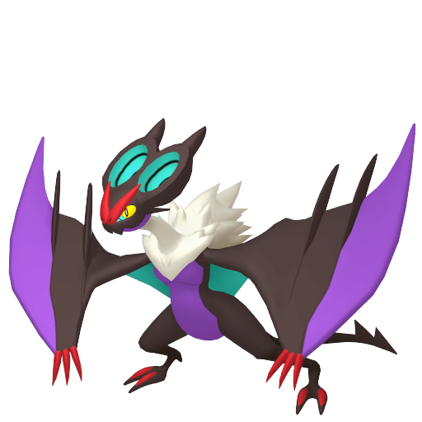

Cobra Fraener vs. Stormdrake
[Battle in progress…]
[Battle concluded]
[Winner: Cobra Fraener]
“No!” Stormdrake fretted as his Luxray fainted to his opponent’s Urshifu. After witnessing Zooks’ serpentine fate, he wasn’t looking forward to being reduced to someone’s latex Pokémon.
But he had lost, and there was no escape from the raised platform he was on. With nowhere to go, the arms grabbed the blue dragon and stripped him for the next part. Stormdrake immediately recognised the latex suit: the legendary Lugia.
The suit opened up the back, expectantly awaiting its new host. The dragon was shoved unceremoniously into its padded insides. His tail was slid into the suit’s tail with two blue plates near its tip. His legs were shoved into the heavily-padded legs of the suit, giving him Lugia’s thick and beefy thighs.
Stormdrake’s hands were slid into the arms of the suit where it ended in fingered gloves. It was a snug fit, and as he moved his fingers, he could feel the finger extensions move the fingers of the Lugia suit. It was cumbersome, but at least he still had use of his fingers, unlike some other contestants.
The back of the suit was zipped up, bringing the back plates together. The head of the suit was the last, and it was swiftly pulled over his head. A gag in his mouth turned his speech into muffled moanings. A metal collar sealed the suit in place, and the arms let go.
Stormdrake stumbled around, confused. He could still move and walk around, but the world around him was dark. Were the eyeholes not aligned to his face? But even if that were so, he’d still be able to see light enter the suit from the holes.
Then he realised the situation he was in: the Lugia suit had a blank face. His eye spikes were still there, but there were no eyes for him to see with. He was just a faceless latex Pokémon. Sure, he could still walk around; sure, he still had use of his arms and legs. But without his sense of sight, everything else felt useless.
Hopefully his new owner had a purpose for his new, useless, latex Lugia.

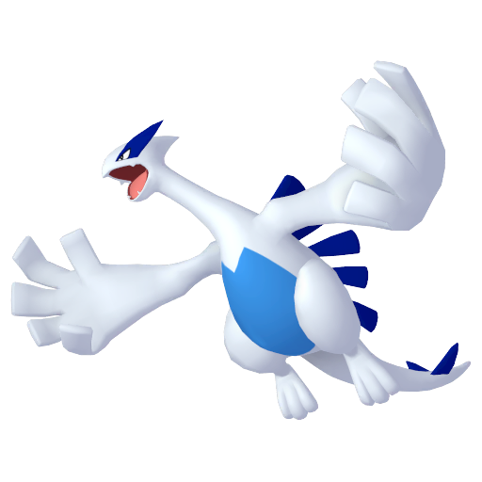

The Finals

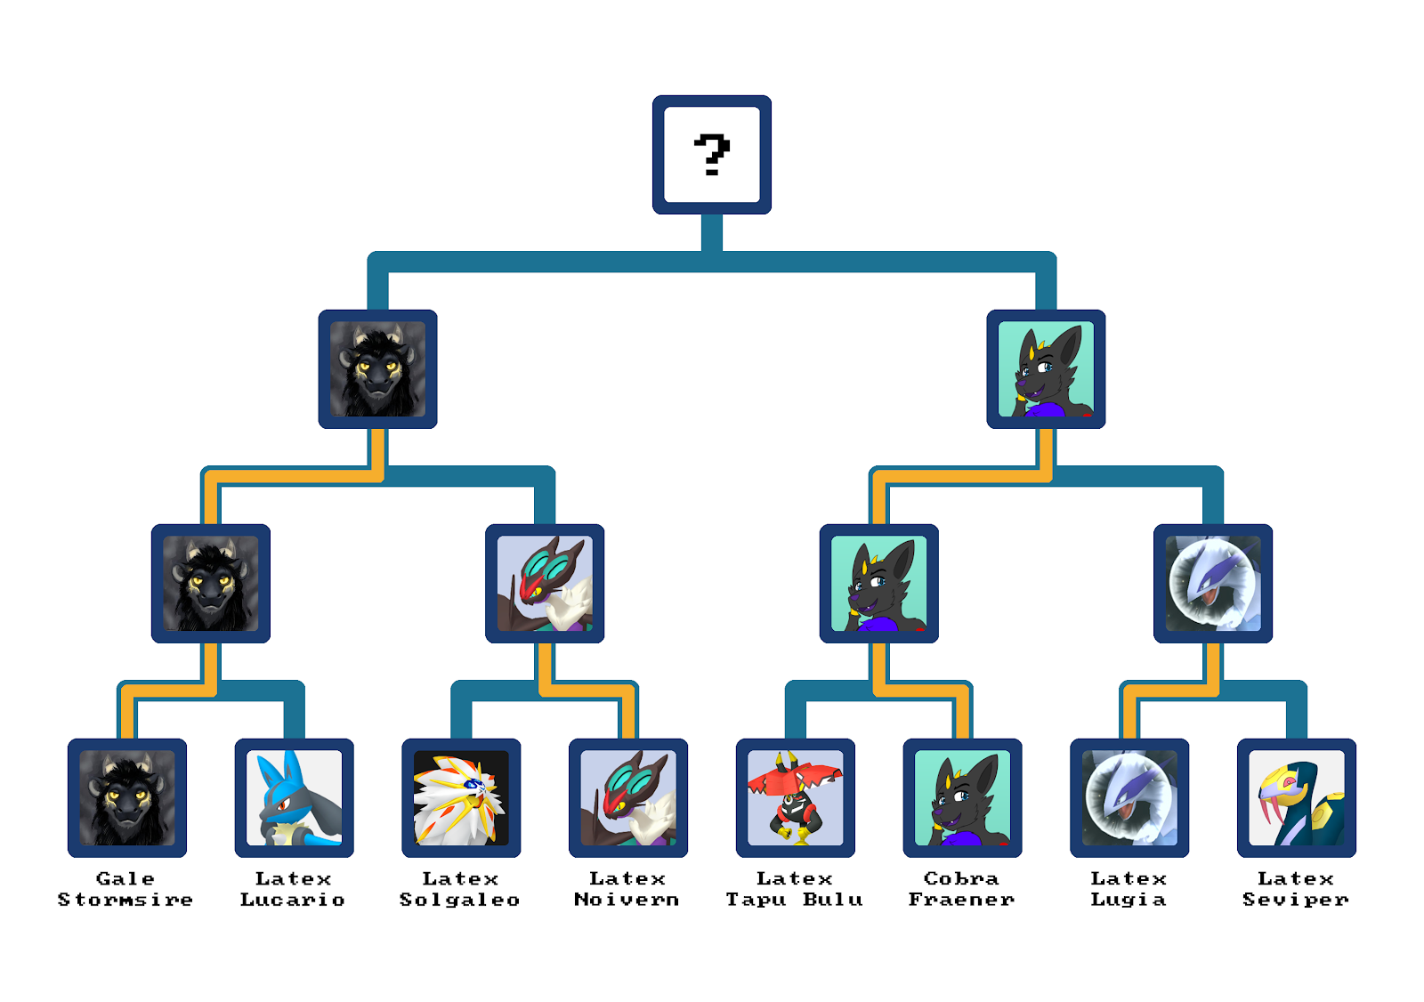

Gale Stormsire vs. Cobra Fraener
[Battle in progress…]
[Battle concluded]
[Winner: Cobra Fraener]
“No! That can’t be right!” Gale protested. “I have the best team! I’m supposed to win!”
Cobra smirked. “The tournament ends with this match. I win.”
“No! That’s wrong! I demand a rematch! I demand—”
The kobold was interrupted as a ball gag was shoved into his mouth. The straps were buckled behind his head, securing it in place. The kobold wanted to rip them off, but the metal arms were quicker. He soon found himself restrained and stripped to his bare scales.
“Mnfhght!” Gale howled indignantly.
The latex suit was ready for him. Blue and black, with the yellow highlights of a Luxray. In went his legs and his tail. Then his body and arms. He was now a shiny latex Luxray from his neck down.
The Luxray mask was ready for Gale, but he was not ready for it. He squirmed and twisted, pulling back as he tried to escape the inevitable. Another arm grabbed the back of his head and held him steady. The rubber hood went on, pressing against the kobold’s face and pushing the gag deeper into his maw. A metal collar sealed his fate.
The arms let go of him, letting Gale fall to the floor on his fours. He tried to get up to stand on his feet, but the latex suit resisted his attempts to stand. He could only pace around on his fours, just like a regular Luxray.
Furious, he let out a muffled roar.

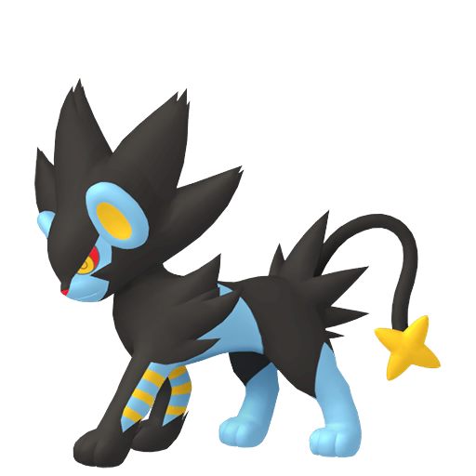

T̙͈̤͈͈̟̪ͬ͡h͚̩̓́̓ͮ̽̚͠ē͔̼̮̬̙ͦͭ̂̇ ̧̹͔̗͉͊͑ͨ͆T̑̇͒͆̏r̨͎̩ͪͯ͛u̻͐̿ͦͦ̀e̮͇͖̦̫̬̝̒̆̕ ̂F̡͔̩̫̦͉̖̄̇̚ͅi͒̓̎͌ͨͨ̚ń̻̠̹̗ͪͮͨͨa̩͉̤ͤl̙̂̑̏s̺̪̭̖̳̞̽

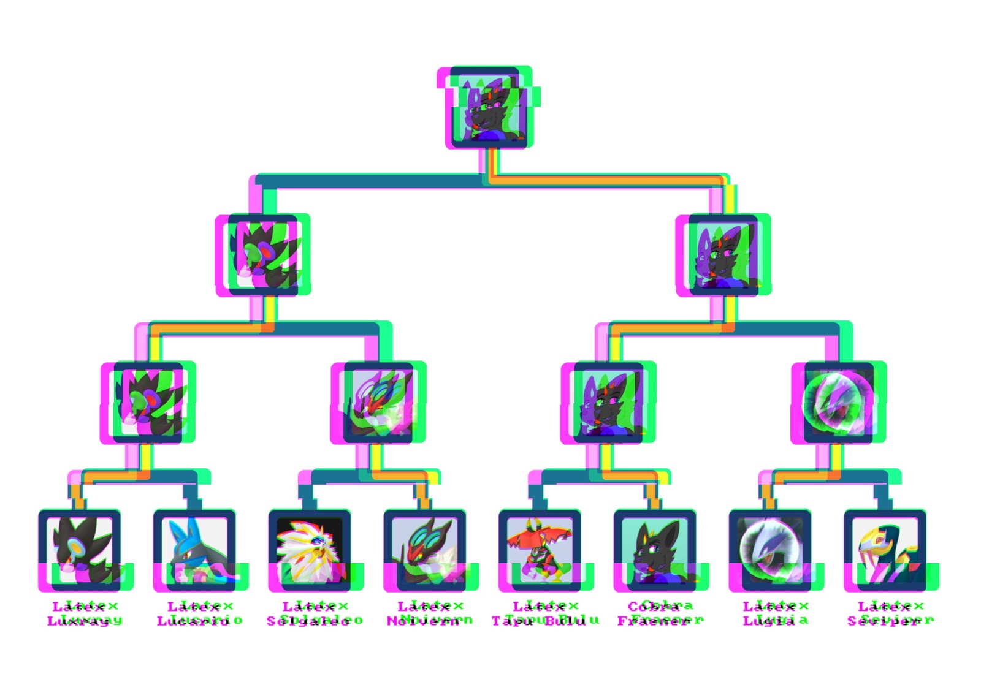

Cobra Fraener vs. Aspen Grey???
[Battle in progress…]
[Battle concluded]
[Winner: Ǹ̵̙Ơ̴̟T̴̳̈́ ̷̼̽Y̶͖͒O̴͈̕U̶̬̚]
“Hehh,” Cobra watched as the kobold-turned-Luxray’s platform descended into a hole in the stadium floor. “Guess I’m now the owner of seven latex Pokémon.”
“Not quite,” Aspen’s voice boomed through the stadium.
“Hmm?”
The platform opposite him was rising back up. The latex Luxray was gone, and a white-grey wolf was in his place.
“Aspen?” The wolgen was puzzled. “Aren’t you the host? Why are you here?”
“Well, I happen to be your last opponent. Win, and you walk away with your seven latex Pokémon.”
“And if I lose?”
“I walk away with eight.”
Cobra frowned. “This wasn’t part of the rules!”
“Oh, I assure you, it is. And I wrote them.”
“You can’t do that!”
[ R E D A C T E D ]
“Fine. This is the last battle. I win, and I walk away with my new Pokémon. Go Garchomp!”
Cobra threw a Pokéball, unleashing the powerful dragon-ground-Pokémon.
[ R E D A C T E D ]
“What the heck?! That’s not a valid—”
[ R E D A C T E D ]
“That’s not a fair game! You used a Staraptor, that was not a legal Pokémon for the tournament!”
“I did not,” Aspen smirked.
“You did! Thousands of people are watching right now. They can vouch for me.”
“I think not. Anyone going back and looking through the battle logs can see that my moves were entirely valid. Isn’t that right?”
“You’re lying! You can’t do this!”
The metal arms were already on him, restraining him and robbing him of his clothes.
“No! Stop! I won this tournament! You can’t change the rules like that!”
His legs were shoved into the Cinderace suit.
“Dammit! Get off me!”
His torso was next, followed by his arms. His struggling did nothing to stop the advancement of the relentless claws. The suit was pulled up to his neck.
“Let me go this instant! The authorities will hear of this!”
“I’ll have you know what I’m doing is perfectly legal. It’s in the contestant sign-up contract.”
“Lies! Lies! Someone, stop this madman!”
The final hood was left: a gigantamax Cinderace hood with long ears of incredulous proportions.
“No! Don’t put that on—mnfft!”
“Click” went the metal collar. The arms let go of Cobra, letting the latex Cinderace fall onto the platform, defeated.

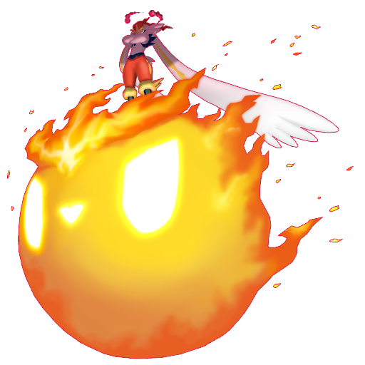

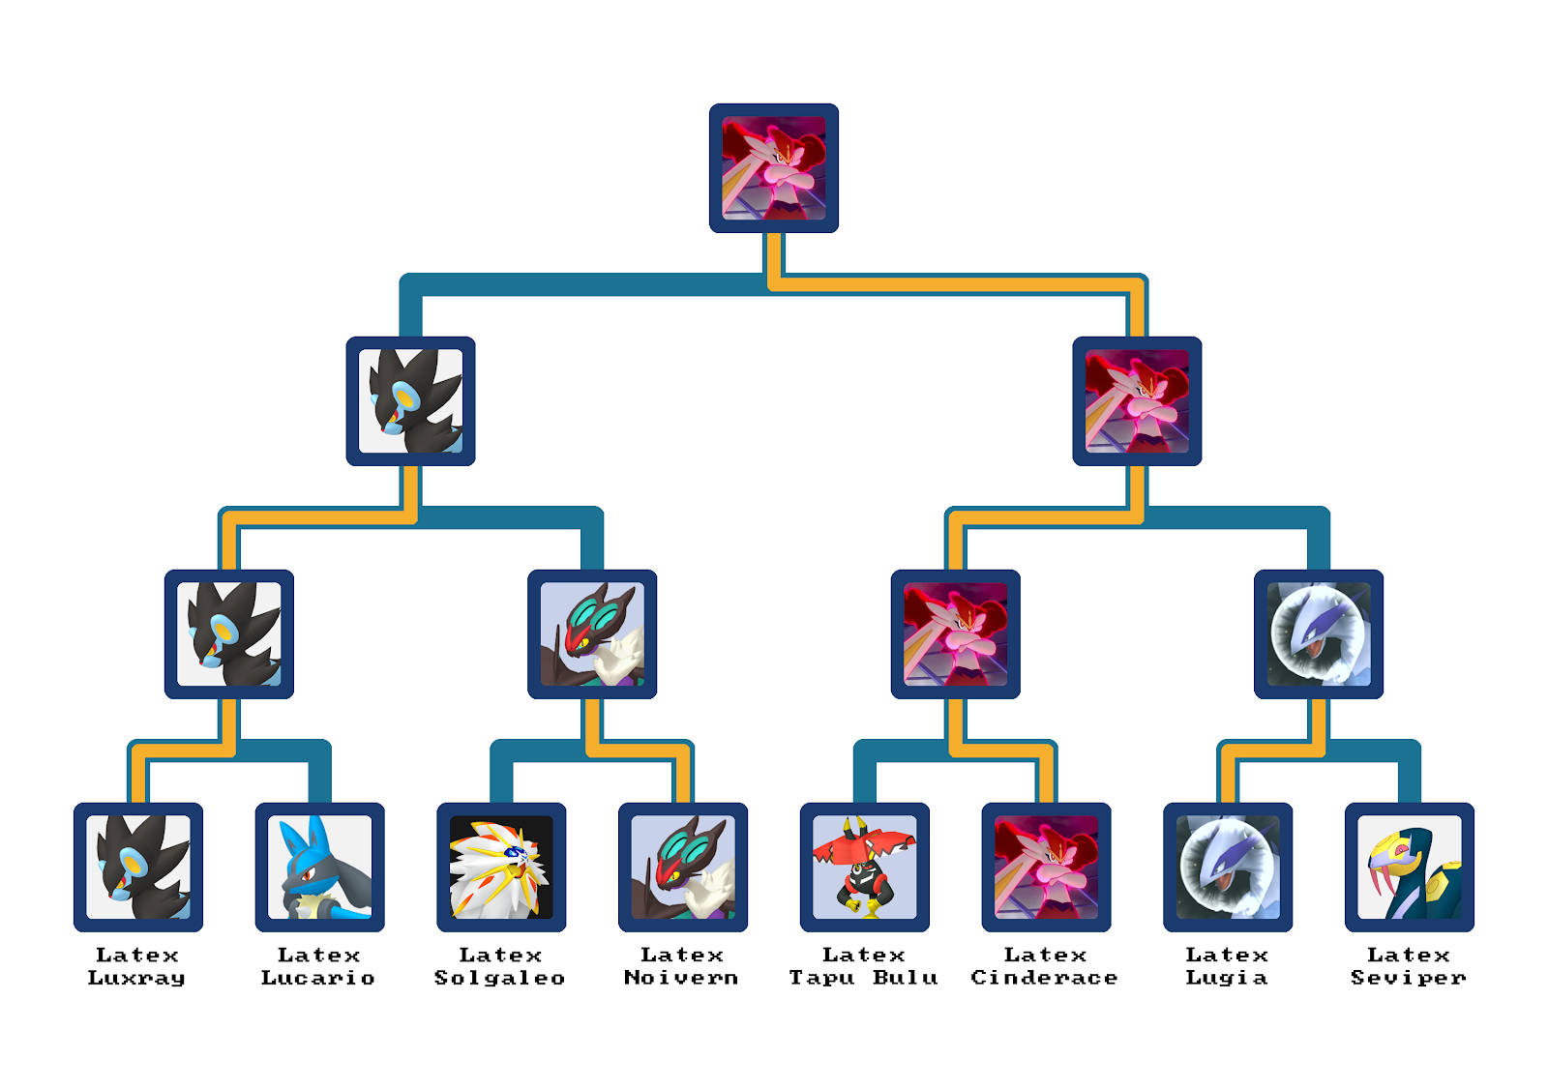
Dramatic fanfare played through the loudspeakers in the darkened stadium. The crowd was cheering as they waited for the big reveal.
Suddenly, a spotlight turned on, illuminating the middle of the battlefield. Aspen was in the middle of the spotlight, waving to the audience. There was another flash as more floodlights illuminated the stadium, revealing eight more Pokémon on the field.
However, unlike their regular counterparts, these Pokémon seemed a bit off. They moved in clumsy and awkward manners, and something about their anatomy seemed a bit off. Their skins were also extremely smooth, sleek, and shiny beneath the bright lights.
The Lucario, Cinderace, and Lugia were pacing around, although the Lugia seemed a little disoriented. On fours were the Solgaleo, Luxray, and Noivern. The Solgaleo and Luxray seemed annoyed, but the Noivern seemed happy at the attention of the crowd. A Tapu Bulu and Seviper were squirming about on the ground. Weren’t Tapu Bulus supposed to float in the air? And didn’t Sevipers slither rather than flop around like that?
Anyway.
With that, the PokéLatex Tournament came to a close, with a happy ending for everyone.

~ End ~

