Unleash the Beasts
Commissioned by Dolfengra
Written by TwistedSnakes
Illustrated by ONGI

Time was running out; the Hunter’s Moon was going to be revealed soon, but Decro wasn’t here yet. Dolfengra paced through the forest. Mist swirled around the shark’s body, caressing him with their chilling touch.
It was Halloween, the night where the world of spirits supposedly engulfed the world of the living. The shark, however, wasn’t superstitious. It was the night of trick-or-treating, and he was going to enjoy himself. But first, he had to wait. He had to show Decro something very important.
“Dolfy?” a timid voice called.
The shark turned around to see a wolf enter the clearing. Just in time.
“Why are we meeting in this forest? And why aren’t you in costume?” Visibly annoyed, he pointed at Dolfengra’s outfit: a simple T-shirt and jeans. The wolf was already in a tribal costume: topless with a loincloth. A tooth necklace, feathered headband, and a bone spear completed his outfit.
“Oh, don’t worry,” Dolfengra smirked, “I have a costume prepared.”
“Then hurry up, we’re already late for the party.”
“Not yet. Come here, I want to show you something.”
The wolf trudged reluctantly over to the shark. “What is it?”
“Look up.”
The wolf complied. The last of the clouds were slowly parting, bathing the forest in the full moon’s dim light.
“It’s just the full moon. Is this seriously what we met in the forest for? Dolfy? Dolfy?”
The shark was hunched over with a pained look on his face. The moonlight felt like fire searing through his flesh. He grunted and stumbled to the ground.
“Dolfy! Are you okay?” Decro rushed to his side.
Dolfengra did not feel okay. The heat was spreading through his body and sweeping across his chest.
“Give me…a minute,” he grunted between agonised huffs.
“You need a doctor. Stay here, I’ll go get help.”
Dolfengra shook his head. “No.”
“B-but—”
“I’m fine, trust me. I just need a minute.”
The wolf stood awkwardly by the side, unsure of how to help his tormented friend. The warm sensation engulfed Dolfengra’s entire being. His skin tightened as his body grew in size. The curves of his muscles gained definition, casting sharper shadows beneath the moonlight.
“Gnnggft…” he let out a grunt.
“D-Dolfy?” The wolf backed off fearfully, keeping his eyes on the shark. “What’s going on?”
“Just wait,” Dolfengra snapped.
“You’re changing!”
“Shut up!” the shark growled in a guttural voice. His voice was deepening. The aggressive heat made it hard to think, and it was difficult to focus with the immense agony he was in. The wolf stood frozen at the edge of the clearing, helpless to do anything but watch.
The muscles on Dolfengra’s back bulged outwards, stretching his shirt beyond their limits. Its threads came apart, leaving the shirt in shreds on the forest floor. His arms swelled in the same way, emphasising the sharp curves of his deltoids, biceps, and triceps. He dug his claws into the dirt as his feet grew.
Dolfengra’s head fin thickened as his transformation continued. Sharp scales pushed their way through his skin, forming ridged plates on his head. His brow ridges and jaw grew sharper with each laboured breath. Without thinking, he crossed his arms so that his left hand was gripping his right biceps and vice versa. His muscles swelled up beneath his grip as wild energy pulsed through the fibres of his being.
The shark tried to focus. He could slow down and try to control the transformation. It would slightly ease the burning sensations, but he’d rather get it done and over with. He tried to distract himself from the pain. What was Decro thinking, seeing him like this?
Dolfengra’s razor-sharp teeth grew more vicious in his snarling maw. More ridged plates pushed out from beneath his shoulders and forearms. Raw, feral strength coursed through his throbbing veins. It was as if a fountain of vigour had been released within him, unleashing a torrent of power.
The shark’s senses had also been enhanced with his transformation. As the pain cleared and his vision returned, he could see the forest with astounding clarity. Every leaf on the floor was as clear as the back of his savage hands.
A sixth sense was awakened within him too. He could sense the wolf’s mind from where he was standing. Decro was scared, and understandably so. For now, though, all was quiet beneath the calm night sky.
“Decro.”
Stunned, the wolf took a moment to find his voice. “Y-yeah?” he replied shakily.
“Come here.”
Decro hesitated before taking a cautious step forward. “Are…are you okay now?”
“Yes.”
Dolfengra could sense Decro’s apprehension as he approached. He perceived it as an aura, pulsating in the air like a fearful heart. It was a violent red-purple and left an aftertaste of savoury sweetness. A taste that made Dolfengra hunger for more.
No. He had to control himself.
“What’s going on? Why are you like…this?”
Decro was helping him up. The wolf’s concern was delicious: the satisfying taste of meat melting like butter on his tongue. His tender arm was on Dolfengra’s back as he attempted to support the shark with his smaller form. How could he resist the wolf’s succulent flesh?
But he needed to quell the urge. He had only wanted to give Decro a glimpse of his transformation. If he went too far, the mentality of a beast will take over.
“Dolfy?”
Dolfengra examined the wolf. The lupine looked cute when he was scared like that. His shaking body was struggling to support the shark’s enlarged form. Dolfengra wanted needed desired craved HUNGERED FOR THIS.
THE
WOLF
WAS
HIS.
His to consume in mind, body, and soul.
“Dolfy? Why are you looking at me like that?”
The wolf was afraid of him. Afraid of his power. Just a bit more and the transformation will be complete. Why stop here?
The shark absorbed the moonlight’s power, willing it to trigger his transformation. The burning sensation engulfed his body once more, turning his muscles into the physical manifestation of pure strength. More ridged scales pushed through his thighs and shins, and his feet claws grew sharp. With a ripping sound, his pants gave way to his widening hips. His sculpted form grew further, making him two heads taller than the wolf as he stood up and roared.
All coherent thoughts left the shark’s mind, leaving behind raw, bestial instinct. Primal urges surged through him like an endless flood, and he was eager to act on them. With a grin, Dolfengra turned to the wolf.
“I’m…I’m going to get help. Please, stay here.”
The wolf was going to run for his life, and Dolfengra would not allow it. In a matter of three huge leaps, he closed the distance between them, coming to a skidding halt in front of Decro. His bloodthirsty eyes gave away his intentions.
“D-don’t do this, plea—”
The shark beast pounced on the wolf, knocking him over and pinning him to the ground. Decro thrashed about frantically as Dolfengra held him down.
“Dolfy, please stop! I know you’re still there. Don’t do this.”
The beast was not to be denied. He was the predator, and the wolf was HIS PREY.
ALL HIS.
He bent down to lick the wolf’s face, but the wolf pushed Dolfengra’s claws off his chest. Within seconds, Decro turned himself over and scrambled away. Stumbling to his feet, he made a dash out of the clearing and into the forest. The beast’s massive weight did a number on him, and he clutched his chest as he limped away.
“Help! Someone, help me!”
Dolfengra wasn’t going to let him go so easily. The lupine’s fear was mixed with the aura of adrenaline, and it tasted gratifying.
NO MORE RUNNING.
HUNTER AND PREY.
NO ESCAPE.
As he chased after the wolf, he invoked his inner power.
Decro tripped, burying his face in the dirt as he hit the ground hard. He spit out the soil in his mouth and tried to get up, only to find that a glowing blue tentacle had wrapped itself tightly around his ankle. Another tendril reached for him and grabbed his other ankle. His kicks and struggles were futile; the beast was soon upon him, breathing his warm and humid breath on the lupine’s face.
More tentacles twisted themselves around Decro’s limbs. His tail was pressed against his spine, and his arms were crossed behind his back. The wolf was close to tears in confusion and fear.
“No, please,” the wolf sobbed. “Please don’t—”
A tentacle wrapped around Decro’s maw and clamped it shut. Thrashing face up on the ground, the bound wolf was helpless to the shark’s advancements.
JUST AS IT SHOULD BE.
PREY PRESENTED TO ITS PREDATOR.
Fear. Confusion. Despair.
Such a delectable aura. Such tasty emotions.
The tip of his member pushed through the entrance of his slit in anticipation. Ridges covered the topside and underside of his shaft. At full mast, his throbbing erection was monstrous and huge. A bead of precum leaked from its sharp, tapered tip.
Decro whimpered; the beast’s intentions were clear, but there was no way that girthy rod would fit into his tight tailhole.
Not without a lot of pain.
Pain.
Pain.
PAIN.
FUCK THAT TASTES GOOD.
Dolfengra leaned in and nuzzled his scaly muzzle against the side of Decro’s neck. His breaths were warm against the chilling nighttime air. The wolf shivered.
“Mnffgg…” his pleading cries were ignored. He was crying in terror, eyeing the shark with immense fear. Adrenaline fuelled his struggles, but the more he kicked, the more the tentacles dug into his flesh.
“You’re mine,” the beast growled with a deep and guttural voice that didn’t belong to the Dolfengra that the wolf knew.
The tendrils lifted the wolf up so he was level with the beast’s waist. The underside of Decro’s loincloth was the only thing left between the beast’s member and the wolf’s. Dolfengra dug his claw beneath the fabric and tore through it, revealing the wolf’s quivering pucker.
“Hffft!” The lupine’s panicked squeals were like music to the beast’s ears.
Dolfengra nudged a clawed finger against the entrance of the wolf’s tailhole. There was no need to wait. He wanted this now.
NO TIME FOR TEASING.
NO TIME TO BE GENTLE.
He thrust his finger in forcefully, digging his claw into Decro’s inner flesh. The lupine was tensing frantically as he tried to defend himself. His efforts only excited Dolfengra as the shark took in the vigorous squeezing. Twisting his finger, he made the wolf squeal and writhe.
The beast pushed in a second claw. Spreading his fingers, he loosened the tailhole aggressively. The wolf’s inner muscles were soft and fleshy, throbbing with his panicked heartbeats. Just a bit more…
Decro only got a moment of respite as Dolfengra pulled his fingers out. Pain then seared through his rear as the beast rammed his girthy shaft into him. The wolf threw his head back in agony. His back was arched as he tried in vain to break free. The shark’s flesh was incredibly deep within the wolf, throbbing tenaciously within his lower abdomen.
Dolfengra unsheathed his member from within the wolf before ramming it back in. The wolf let out a muffled yelp. His rear muscles tensed up as he tried to ease the pain, massaging the beast’s dick with a stimulating pressure. Dolfengra pulled out once more before ploughing through the wolf’s insides.
“Nff!” the lupine whimpered. With each thrust, the outline of the beast’s cock could be seen through his abdomen.
But that was not enough for the beast. He wanted more.
More.
MORE.
EVERY INCH OF THE WOLF.
The aura of the wolf’s emotions was just another thing for Dolfengra to consume and corrupt. He got ready to impale the wolf’s soul with his own.
“Achk!” the wolf choked as the beast forced his way into the lupine’s essence. His eyes rolled to the back of his head and his body trembled. The next mental thrust came in tandem with the physical one. Decro drew in a sharp breath as the beast penetrated him.
Dolfengra pounded the wolf relentlessly, satisfying his hunger for the wolf’s earnest aura and his own sexual cravings. The ridges of his cock scrubbed against the muscles of the lupine’s tailhole, leaving his flesh raw and tender. Each penetration of Decro’s soul darkened it with untamed bestial power.

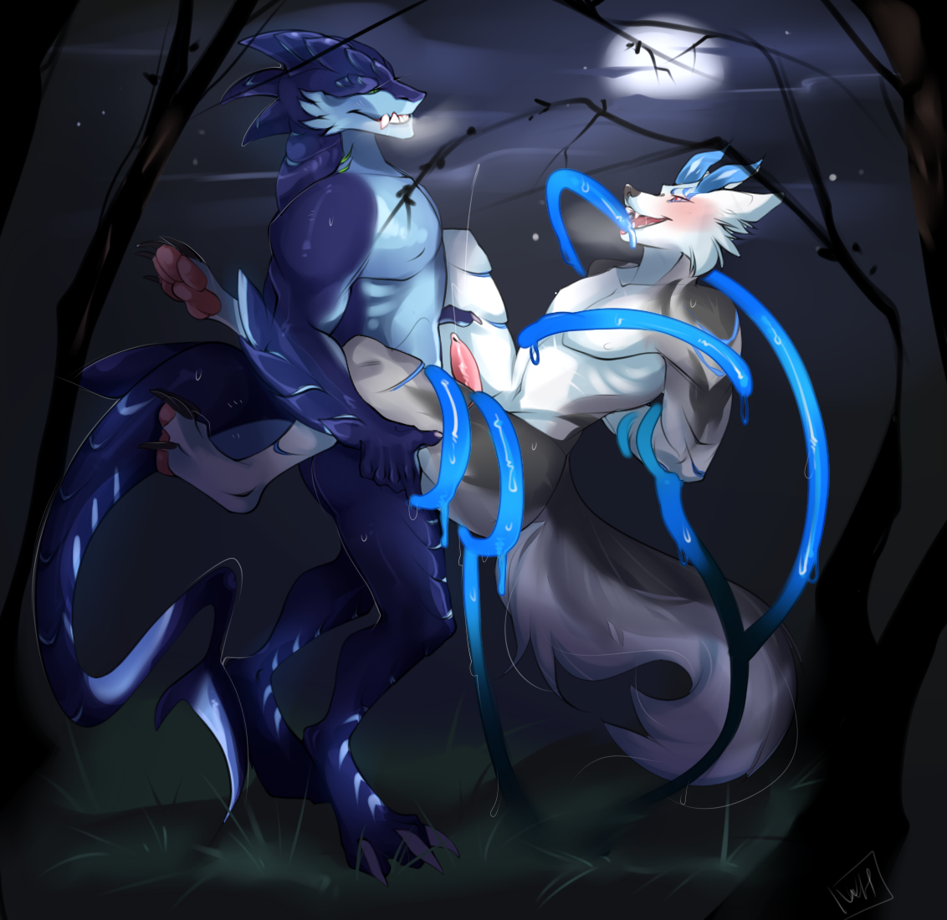
Decro’s mind was clouded. It was hard to organise a consistent stream of thoughts; thoughts of DEMENTED CRAVINGS interrupted the coherent sentences in his vulnerable mind. It was hard to endure the searing pain that Dolfengra was inflicting on him, so he should INDULGE IN THE PLEASURE AND TAKE IT ALL IN.
The wolf could not endure escape RESIST THE RAW ENERGY PULSING THROUGH HIS BODY. He needed to stop GIVE IN TO THE TRANSFORMATION. His trembling grew uncontrollable violent POWERFUL as he ACCEPTED IT AS HIS RIGHTFUL STRENGTH.
Just like Dolfengra, he TOOK IN THE POWER OF THE MOONLIGHT, LETTING IT SEAR THROUGH HIS BEING. His muscles swelled and throbbed with primal force. As his body grew larger, the shark’s dick became more manageable to take in his rear. Pain turned into pleasure, and his huffs exposed his desire for more.
Decro’s cock escaped his sheath, revealing a draconic shaft PULSING WITH SEXUAL PASSION. The features of his face grew sharper: his jawline had more definition and his ears tapered at the top of his head. Demonic horns grew from the top of his skull, forming smooth, streamlined curves above his head. Scales pushed their way out from beneath his skin, plating the fur on his forearms and shins.
DOLFENGRA,
GIVE
ME
MORE.
FUCK ME WITH ALL YOU’VE GOT.
The shark continued his fervent thrusts into the wolf’s rear. The two beasts INDULGED IN CARNAL PLEASURES, feeling the UNHOLY UNION OF THEIR DEMONIC FLESH. Their erotic arousal only grew greater with each plunge of the shark’s sceptre into the wolf’s muscular flesh.
JUST A BIT MORE.
CONSUMMATE THEIR INDULGENCE WITH AN ORGASM.
They let out roars of pleasure as they each let forth a copious stream of spunk. Dolfengra filled the lupine’s rear with his seed while Decro shot his load into the air.
FUCK.
THAT FELT GOOD.
The beasts panted beneath the moonlight. The rise and fall of their broad shoulders and muscular chest were sharply silhouetted in the darkness. The tentacles let the wolf down as they disappeared into the ground.
“That was great,” Decro rasped. His face was lost in a euphoric haze with a satisfied smile.
“Fuck, yeah,” the shark agreed.
The wolf stood up, this time much taller than before. He paced through the forest, getting a feel of the newfound vitality in his vigorous body.
HE WAS POWERFUL.
He flexed his sharp claws. With a smirk, he looked at the shark. “What now?”
THE POWER OF THE MOON RUNS THROUGH OUR VEINS. WE CAN DO ANYTHING. ANYTHING.
The wolf picked up his feathered headband and spear that had fallen among the undergrowth.
“We can still go for the party with our ‘costumes’. I hunger for delicious fear.”
THAT SOUNDS ENTERTAINING.
“Let’s go then.”
AND WE SHALL CONSUME THE FLESH OF THE OTHERS. WE SHALL CREATE BEASTS LIKE US.
OUR POWER IS UNSTOPPABLE.

~ End ~

