The Depraved Gamble - The Two Statues
Gift for Gymnos_Dungeon, Kahryl, KyuuGryph, and PotatoFurryAlt
Written by TwistedSnakes
Illustrated by Gymnos_Dungeon

The arctic wolf was dressed in a fine, silver suit that matched his white silky fur as he reclined in one of the velvet seats in the grand lobby. He was dressed in his best; after all, who would journey halfway across the intergalactic empire only to show up dressed like a slob? Certainly not him.
Sipping from the glass of wine he was holding, he glanced around him. The entire lobby, with its smooth arosphite stone floors and intricate oracium chandelier, was empty. Even the receptionist who let him in and served him his glass of wine had left him here alone.
But the wolf was fine with the silence. After all, he was here for a very special event. His thoughts wandered to his anticipation of what was to come.
Just then, the entrance doors opened and a gryphon stepped into the lobby. He was dressed in a suit too, albeit less formal than the wolf's fancy garb. His gaze explored the room in awe as he cautiously stepped in, making his way around the tall pillars and potted plants.
"Hey," the wolf nodded at the gryphon.
"O-oh!" the red-feathered gryphon looked confused for a second before he noticed the white-furred wolf, "Hi there."
"Decro," the wolf introduced himself, beckoning for the gryphon to sit on the seat opposite him.
"Kyuurin," the gryphon bowed shyly, taking the seat that the wolf had indicated to him, "So are you also –"
"Here for the Depraved Gamble?" Decro finished for him, "Yeah, yeah I am. VIP seats too?"
"Yeah."
The Depraved Gamble was a regular event that was broadcast to trillions of people all over thousands of planets, catering to people with deep, dark desires which should never see the light of day. On this show, people would watch often-unwilling victims be subjected to various forms of abuse. If a subject got off with getting raped while clad in a full latex gimp suit while suspended in the air, they would've gotten off easy. Most victims wouldn't make it out unscathed, with some of them getting locked in permanent chastity, and others being welded onto bondage benches to be used as a fucktoy for life.
But finding these victims was an incredibly impossible task, so the show had taken to selecting them from the viewers. To watch the show, people had to submit their names in a draw. With trillions of people watching the event, the chances of being picked were low, and they could carry on watching the show. But for the few unlucky ones who got picked, they were usually dragged away from their residences, screaming and kicking. After all, who would want to end up in a lifetime predicament like the many others who went before them?
Still, the idea of watching the fear in the victims' eyes as they were allowed their last, struggling moments of freedom before being sealed away completely appealed to the arctic wolf. And now that he was gifted a VIP ticket by the producers of the Depraved Gamble themselves, he could view the twisted show up close. The gryphon must've had some dark fantasies too, for him to have signed up for this.
"So Kyuurin," the wolf called, "I can call you Kyuu, yeah?"
The gryphon nodded.
"So Kyuu, what messed-up kinks do you have?" Decro asked coolly, "For you to be watching this fucked-up shit."
"Oh, erm..." Kyuu looked around awkwardly, "I...I kinda like seeing the gags and blindfolds. I don't know, but I get really...excited looking at them."
Decro let out a short but friendly laugh, "And you choose to watch this show when you could just buy actual gear for yourself?"
"It's contraband in my home planet," Kyuu sighed.
"Ah. Pity."
The silence hung in the air as Decro sat back comfortably in his chair, finishing his glass of wine and leaving it on the table. Kyuu glanced around the room nervously before finally asking, "How about you? What do you like?"
"Hmm..." the wolf looked up thoughtfully at the ceiling, "I guess heavy kinks just spark something deep within me. It's just so fascinating, engaging, on so many levels: physical, mental, emotional, erotic even. Don't get me wrong, I wouldn't want to get involved in these situations, nor would I wish them on any of the victims on the show. But they knew what they were signing up for, and since it's going to happen either way, I'll make the most of it and watch."
Kyuu nodded. Just then, two dragons entered the lobby through another door, one with blue scales and one with black.
"You must be Decro, and Kyurrin," the blue dragon waved to them, "I'm Klave, and this is Kahryl." He motioned to the black dragon who nodded silently back. "It's just the two of you, so let me escort you guys to the VIP seats now."
The wolf and gryphon followed the two dragons out of the lobby, down a corridor, and into an elevator lobby. An empty elevator was waiting for them, and Klave guided them in. The doors shut silently behind them, and the elevator began ascending with a soft hum.
"So, you guys won these... 'VIP seats', eh?" Klave chuckled out loud.
"Y-yeah," Kyuu stuttered. Decro nodded calmly in response.
The elevator doors opened and the four of them stepped out, with Klave still leading the way until they came to an unmarked door. "We have to be quiet when we enter, so I'm going to bring Kyuurin in first. Kahryl will bring you in next," he motioned towards Decro.
He opened the door and guided the gryphon into the room, closing it shut behind him. Decro was left with the black dragon.
"So what do you do here?" the wolf shrugged, making conversation with the reserved dragon.
"One of the punishers for the show," Kahryl answered gruffly.
"So is escorting the guests now a temporary position for you?" Decro quipped.
"Not quite," the dragon sneered, and the wolf could've sworn that he was hiding a grin behind it.
"Hmm?" the wolf asked suspiciously.
"Let's just say you'll get to experience the action up close," Kahryl smirked smugly.
Decro felt an uneasy feeling in his gut, and he was very sure he knew just why. Still facing the dragon, he began backing away towards the elevator. The dragon merely smiled and took a step towards the wolf for every step the wolf took back.
Fuck fuck fuck.
Decro made a mad dash for the elevator, scrambling frantically for freedom. If he could, he would've looked for Kyuu, but there was no point if it would lead to them both getting caught. He reached the elevator buttons and hammered it, and the elevator from earlier opened.
He rushed in, but the dragon was still behind. Panicking, Decro hit the button for the ground floor before mashing on the "Close Doors" button. The doors were closing, but they could not have gone fast enough. Kahryl was running straight for his elevator.
Please, please, please, please...
There was a slam as the dragon got his hands through the doors, preventing it from going down.
"Gotcha."
Kahryl grabbed Decro, dragging him out of the elevator and back down the corridor. The dragon was much bigger than the wolf, making it impossible for the arctic wolf to break free.
"Let me go this instant!" the wolf demanded, not that the dragon cared. He was dragged back to the door, struggling frustratedly as he was brought into the dark room that laid behind the door. The frantic wolf soon found himself dragged onto a wide circular stage, with spotlights illuminating its centre. There was no audience, no cheering masses, but he knew they were watching through the many, large studio cameras that surrounded the stage, pointed at him as his plight was broadcast to trillions across the galaxies.
Kyuu was there too, watching helplessly with his arms bound above his head to a sturdy wall that was set up on the stage.
"Decro!" Kyuu shouted, "We've been tricked! They're going to be using us as victims for the show!"
"Hfft!" Decro grunted, trying to break free, but Kahryl shoved him hard, causing him to fall face-first to the ground with a loud thud. The dragon then put a foot on top of the wolf's back, pinning him on the ground. "Figures," the canine replied dryly.
Klave stepped up onto the stage to join the other three with a grin across his face. "Ladies and gentlemen," he announced, turning towards the camera, "A round of applause for our victims for this round's Depraved Gamble!" The sound of recorded clapping played through speakers around the studio, simulating the unseen audience watching from the comfort of their homes.
"I'm Klave, and this is Kahryl," the blue dragon continued, motioning towards the waving black dragon. "I'd introduce our victims for tonight, but they wouldn't be people for much longer, so there's not much point, is there?" he said ominously.
"Fuck!" the wolf grunted, "Let us go!" His protests only earned him Kahryl's other foot over his muzzle, silencing him.
"I won't spoil the fates of these two victims for you eager watchers, but rather than keep you waiting, we'll get right to the action," Klave began taking off his shoes and socks, tossing them to the side off the stage. Still keeping his weight on Decro, Kahryl did the same before digging his clawed feet on the wolf's back and snout, eliciting a painful whimper. The two dragons didn't stop there, proceeding to take off their clothes and throwing them off the stage until they were both standing naked with their hanging cocks exposed.
"First, let's deal with the feisty one," Klave crouched down next to Decro, peering at the wolf as he growled back. Decro's snarls were interrupted as Kahryl put him in a chokehold, dragging him into a standing position as he struggled to breathe. The dragon released his arm somewhat, allowing the wolf to breathe while still restraining him from behind. With a smirk, Klave began undoing the buttons to Decro's suit.
"Hey, wait! No!" the wolf protested, but the blue dragon was ignoring his squirms, tearing the canine's coat off, followed by his shirt. Decro's shoes, socks, and pants followed, leaving him standing in his form-fitting trunks.
"Let's show the audience what you're packing," Klave teased, grabbing the arctic wolf's bulge roughly. "Quite the size, aren't you, wolfy?" the dragon grinned, giving the canine's manhood a firm squeeze before letting go.
"Hngg..." the wolf protested, but that only made the blue dragon all the more eager to have his way with the canine. Klave pushed his crotch against Decro's, proceeding to grind his semi-erect cock against the wolf's growing bulge.
"Hfft! Please!" Decro pleaded. He felt violated in all senses of the word, with even his aroused dick betraying him. His cock had emerged from his sheath, tenting beneath the trunks that hugged the outline of his length.
Klave erection was just as obvious, albeit more willing. His draconic cock was passionately rubbing against the wolf's smooth, silky trunks. Every ridge, every curve, grinding against the canine's reluctantly erect dick. The friction was heating things up, flesh against fabric against flesh, with the thrust of the blue dragon's hips facilitating it all.
The dragon then tugged the top of the wolf's trunks down, exposing his majestic cock and balls to the numerous yet unseen viewers across the universe. Crouching down so his head was on the same level as Decro's waist, Klave turned to the cameras, making sure that they had an excellent view of the smooth member as the dragon gave its tip a firm squeeze, milking drops of precum from its entrance.
"S-stop!" Decro whimpered, struggling against the black dragon who held fast to him in a vice-like grip, refusing to let go. With his unwilling victim still trapped, Klave stood up again and pushed his crotch against the wolf. His fingers adjusted both their cocks so that they were touching with their undersides pressed against each other.
With his right hand, he held both shafts together and his thumb pressed firmly over the wolf's sensitive cock head, eliciting a sharp cry of pain from him. That, however, only make Klave sneer as his thumb began circling the wolf's tapered tip, spreading the canine's precum over their dicks. Then he began stroking up and down, feeling the warmth of Decro's cock against his as he squeezed them together.
"Mfft!" the wolf protested, trying to hide both his blush and arousal but without much success. He was trying to fight the primal instincts within that told him to hump back. To work himself up. To earn that much-needed orgasm. But he felt the unseen eyes of his watchers eagerly awaiting his impending doom, and he held back.
He'd fight this. Even if he could not escape, at least he'd go down with his dignity intact.
Right?
Decro whimpered, feeling the orgasm rise within him as his pelvic muscles clenched. And then nothing. "F-fuck!" the wolf groaned. Klave had slipped a shiny metal ring over the shaft of his cock, pushing it past his knot until it sat at the base of his manhood. There, the inner walls of the mechanized ring contracted, tightening around his shaft and preventing his seed from spilling.
"Cock Meister 2600X," the blue dragon waved his hand over the canine's dick as if it were a display stand for a brand new product, "To keep your horny boys' orgasms in check. No climax for you, wolfie.
"Enough playing around, let's get down to business." Klave continued, fetching a suspicious-looking spray can that was sitting on a table offstage. "Do you know what this does?" he asked Decro tauntingly, fully aware that the wolf had no way of knowing the answer.
The wolf shook his head nervously. "Watch," Klave grinned, aiming the nozzle at his left arm and pressing down on it. A spray of metallic bronze liquid shot out of the nozzle, coating the dragon's arm with a coat of shiny brown. As the outside air came into contact with it, the liquid began to harden, forming a thick, solid shell on the surface of the dragon's forearm.
"A shiny, metal casing for whatever is below. But don't worry about me, it peels right off my draconic scales," Klave explained, scraping the solid chunk of metal off his arm effortlessly. "Once it comes into contact with fur, however," he began, spraying the liquid over Decro's left thigh. The wolf whimpered, trying to back away from Klave, only to be held still by Kahryl. The liquid was stingingly hot against his skin, cooling down as it hardened, Soon, his thigh was a solid hunk of gleaming bronze.
"Please, don't do this!" the wolf pleaded frantically.
"Let him go!" Kyuu piped up too, feeling uncomfortable watching what was happening to the wolf as he tugged against the cuffs that bound him to the wall.
"Oh? Does our gryphon friend want to join in some of the action too?" Klave approached Kyuu with a menacing grin. Kyuu shook his head vehemently, but the damage was done. The blue dragon took out a roll of tape and blindfold, ready to put them on the gryphon.
"N-no! Wai-mfft!" Kyuu's words were silenced as a generous strip of tape was wrapped around his beak, holding them together with no allowance for the gryphon to even open them a bit. The blindfold then went over his head, sealing his vision from the rest of the world.
In the dark, Kyuu could only feel what the dragon was doing to him. The sharp claws of the scalie were digging into his shirt, tearing down through it so that his chest was exposed. The gryphon let out a cry of surprise. His pants were similarly ripped. and the tattered shreds of cloth was torn off his body, leaving him naked too.
"Now, back to you," Klave turned back to Decro, returning to the canine's side with the spray can in his hand, "Let's start from the bottom up." He sprayed a generous coating of metallic liquid on Decro's foot, turning it shiny beneath the spotlights.
"Please! No! This must be all be a mistake!" Decro whined, trying to escape the blue dragon's reach. Once again, Kahryl's body got in the way, and the wolf could feel the black dragon's erect cock pressed against his back; his frantic struggles only served to arouse the sadistic dragon.
"Quit moving," Klave snapped impatiently, "Hold him down properly, Kahryl."
"Sure thing," Kahryl grinned. His hands grabbed Decro's waist, squeezing his torso tightly as he lifted him up. The wolf wheezed breathlessly as his breath was painfully forced out of him. His feet kicked wildly as he tried to support himself.
Then he was lowered back down. As he descended, a warm, tapered tip pressed against his sphincter. "Hff–" the breathless wolf couldn't make out a word as his tailhole was agonizingly spread open. Kahryl's girthy cock filled out Decro's insides as gravity pulled him down. The wolf's entrance was stretched until he was fully seated on the dragon's shaft.
Only then did the dragon let go, supporting the wolf with one hand beneath the canine's thigh, and the other hand back around the canine's neck. Decro winced as he tried to catch his breath, feeling the dragon's warm flesh throb against his inner walls. The dragon was at least a head taller than Decro, so the struggling wolf had to tiptoe so that his feet could touch the floor.
Even then, his toes could barely give him the much-needed support for his weight, meaning that the dragon's cock in his rump was holding up the bulk of his body mass. His tailhole was getting sore as he had to clench hard on the shaft just to keep himself upright.
"How does it feel?" Kahryl asked tauntingly from behind Decro.
"H-hurts..." the wolf groaned, shaking unsteadily on his anal perch. He felt the black dragon's cock tense up inside him; his suffering must've excited the dragon immensely.
"Good," Kahryl smirked.

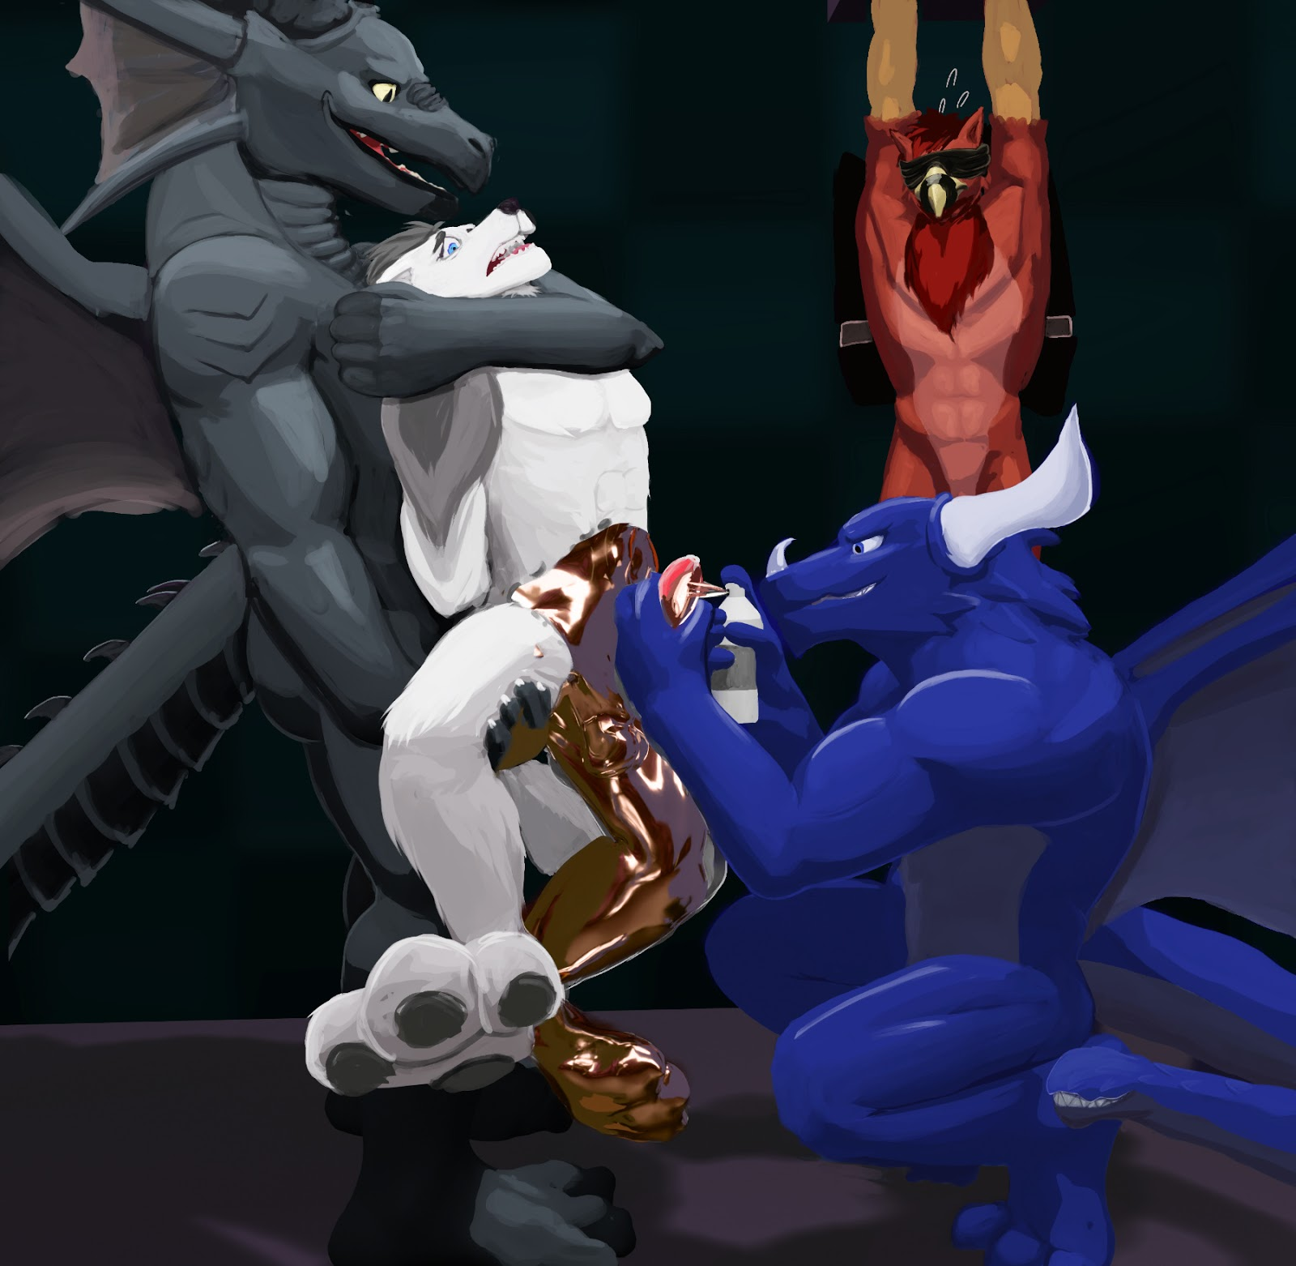
In the meantime, Klave continued with the spray can, turning the rest of Decro's leg into nothing more than a hunk of metal. Encased with no space to even wriggle, the leg felt like dead weight, pull him lower on the dick he was impaled upon. In the same way, his other leg was turned into bronze, heavy lifeless bronze. But all he could do was watch and whimper.
"Let's do his rear," Klave got up, satisfied that every inch of the wolf's legs was concealed. Kahryl nodded, slowly lowering the wolf until his solid feet were resting on the ground. Then he slid his girthy cock out of Decro's rear, leaving behind a gaping hole of sore muscles.
Klave wasted no time, spraying the wolf's insides with the liquid metal and forming a bronzen tunnel within. The wolf tensed his sore tailhole, only to feel it squeeze around the circular rim of the tunnel, keeping him spread open and vulnerable. His tail was coated next, stuck in a raised position so that his hole was exposed.
Kahryl held the wolf's hands above his head. Then more metal was sprayed over the wolf's lower back and abs. In this way, Klave circled Decro, moving up to his chest and shoulders, stopping at the canine's neck. Now, only Decro's head and cock exposed: everything else was solid bronze.
Decro closed his eyes in pain, with drops of tears escaping his eyes as he groaned. The heat was agonizing, made worse as his chest solidified, making it hard to breathe. Kahryl forcefully lowered the wolf's arms to his sides, allowing Klave to turn his arms into bronze, just like the rest of his statuefied body.
The wolf whimpered helplessly. Trillions of people were watching him, yet not a single one would lift a finger to come to his aid. He knew: he was once among their numbers too, watching the show's victims meet their nasty ends. It wasn't like he didn't know what he was getting himself into. Now his luck had run out, and his fate was sealed under thick, inescapable bronze. And all he could do now was hope for the best. He let out another pitiful whine.
"Aww, is wolfy hungry for my cock up his ass?" Kahryl teased, sticking his cock back into the gaping hole. Decro could feel the dragon's flesh rubbing inside him, but there was no way he could clench and force him out.
At the same time, Klave began jerking off his exposed member, working him towards a climax for the masses to watch. Decro closed his eyes and turned away, reluctant to watch his public humiliation. But he couldn't ignore the stimulation that his cock was receiving. Nor could he block out the friction of Kahryl's dick in his solid tailhole. Not to mention the orgasm that was rising from within him.
And he couldn't move his body. He couldn't escape. He couldn't hump back. All he could do was endure the demeaning display that was his suffering.
Decro's pelvic muscles tensed up and he felt his orgasm rising to the surface. Until the cockring contracted around the base of his cock, denying him his climax.
"Fuck!"
"No cumming until Kahryl finishes," Klave sneered, eliciting a whimper from the canine. But he didn't have to wait long. The black dragon was already close to his peak, thrusting into Decro's fuckhole with increasing speed. Then with a loud gasp, he shot his warm load into the half-completed statue. Kahryl basked in the afterglow for a good, long minute, before slipping his sloppy dick out of the bronzen wolf, leaving a stream of cum dripping from Decro's ass.
"Good wolfy," Klave encouraged sarcastically. With a beep, the digital cockring loosened a little, giving the wolf just enough release for him to orgasm. "Hfft!" Decro grunted, shooting his seed all over the stage. The wolf struggled to catch his breath and recover, but the metal constricting his chest made it difficult to do so.
Before Decro could come to his senses, Klave grabbed his cum-leaking dick and sprayed a generous helping of liquid bronze all over it, sealing the residual spunk in. "I hope you enjoyed that orgasm, because that's the last you're going to have for the rest of your life," Klave grinned, "And now to finish you up."
As if on cue, Kahryl pried Decro's jaws open with one hand. With the other, he forced a cylindrical tube down the back of the wolf's mouth, lodging it in his throat. Klave then sprayed the bronze in, turning the canine's throat into a permanent fuckhole. Decro's nose was covered, forcing him to breathe through his mouth. His frantic whimpers were silenced beneath all the bronze.
The wolf statue was almost done. Decro closed his eyes, getting ready for the rest of his anthronity to disappear beneath a layer of bronze. But the dragons had other plans in store for him. Kahryl pulled his left eye wide open with his hand, revealing the canine's distressed eyes, darting about the room. A translucent, bronzen lens was slid beneath Decro's eyelids, covering the entirety of his eyes. His right eye was next, turning his world bronze. Then a final spray of bronze coated the remainder of his head.
Klave and Kahryl stepped back from Decro, admiring their handiwork. The wolf statue was completed. And there was no rescuing him from this.
In the meantime, Kyuu struggled in his bonds. Without his sight, all he had was his sense of hearing to figure out what was going on. He listened as the wolf's cries turned silent.
Were the dragons done?
Was Decro alright?
Was he still alive, for that matter?
But his questions went unanswered as the sound of the dragons' footsteps approached him menacingly.
"Mm?" was all he could manage.

The park was bustling with life as the local citizens gathered around a new attraction to the place. A metal pillar stood in the middle of a large, circular disc that was embedded in the ground. Two furs, a gryphon and a wolf, were tugging against chains that bound them to the pillar in the middle, trying to break free of their bindings.
Around the statues, however, some of the more adventurous furs were already getting ready to make use of the new additions. After all, the wolf's mouth and tailhole were exposed holes, and the gryphon's cock was hanging in full view of its audience.

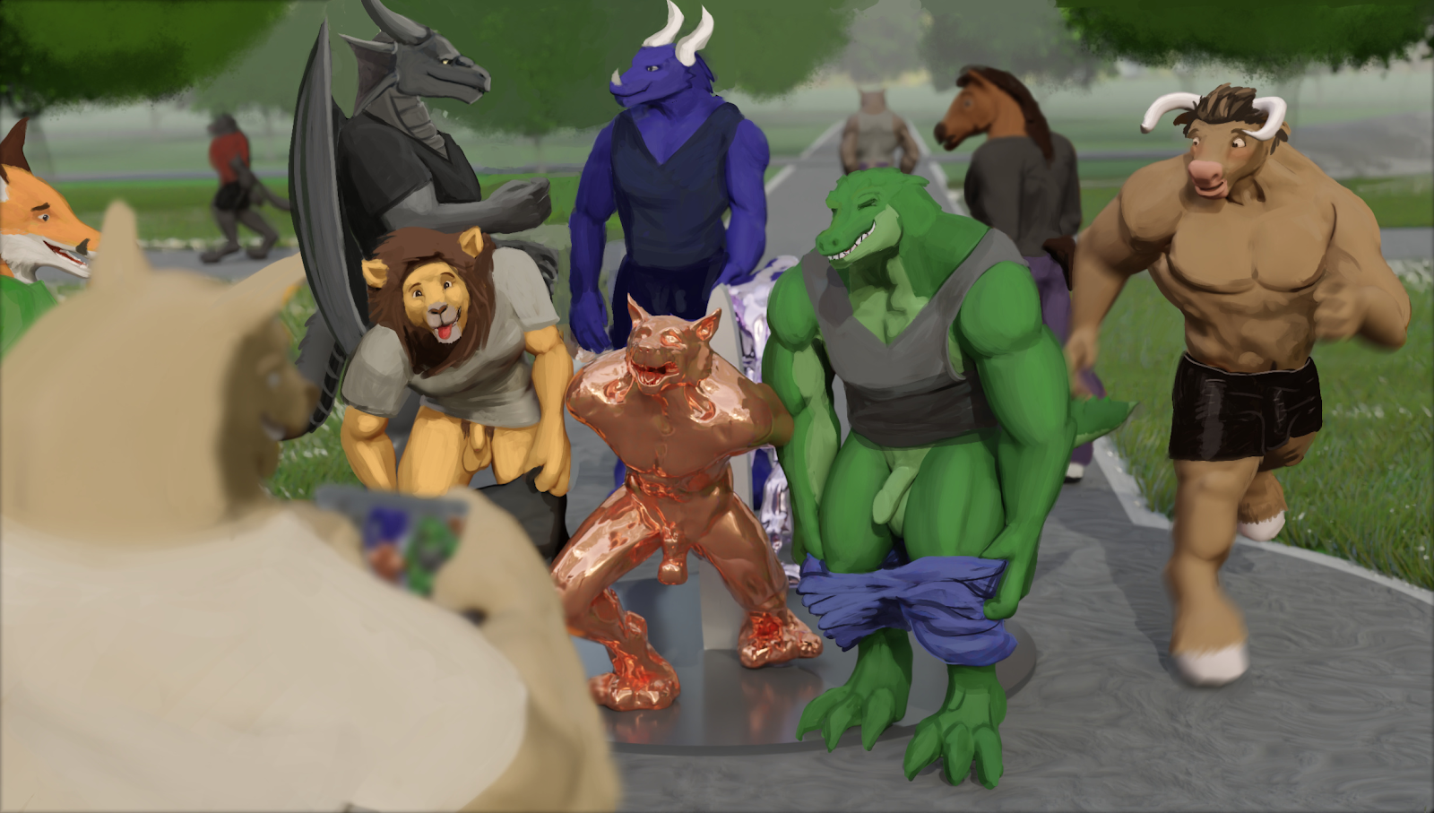
Inside the statues, however, were two very desperate furs. Kyuu was the gryphon statue. The dragons had left the blindfold on him as they coated him with silver, making sure that he would never see the light of day again. A chastity cage locked his cock in a constricting prison and a girthy plug spread his tailhole open beyond what was comfortable for his size. Both devices were sealed in place beneath the silver encasement before Klave had turned their vibrators on and they teased the avian at random intervals, working him towards orgasms that the devices would never let him achieve.
Meanwhile, Decro fulfilled the role of the wolf statue. When he was first mounted here, Klave had whispered into his ear, "You'll have to swallow if you want to breathe." He soon found out what that meant as his mouth was loaded with someone's cum, making sure that no air could enter his lungs until he finished every last drop of the seed.
Not that he could control it as his open throat allowed all the spunk to empty into his gullet. Whose seed he was swallowing, Decro didn't know. All he saw was the fur's abs as he slid his dick out of the wolf's mouth, zipped up, and went on his merry way. Once the load was cleared, the wolf got a much-needed breath. But before he could breathe easy, another cock was shoved into his mouth and down his throat, blocking off his oxygen until the dick's owner reached his orgasm.
The loads of multiple furs were dripping from his rear, having been constantly abused from the moment furs found out that his rump was nothing more than a fuckhole. Decro could feel the mixture of cum sitting in his tunnel, warming up his insides with their body heat.
Through his bronzen vision, Decro watched as dusk finally arrived. The crowd had gotten bored and went home, leaving the two statues to stand there for the night. The wolf sighed internally, relieved that he could finally catch a break.
But two figures came out from the darkness, approaching the statues. One stood beside Decro and crouched down so that his face was beside the canine's ear.

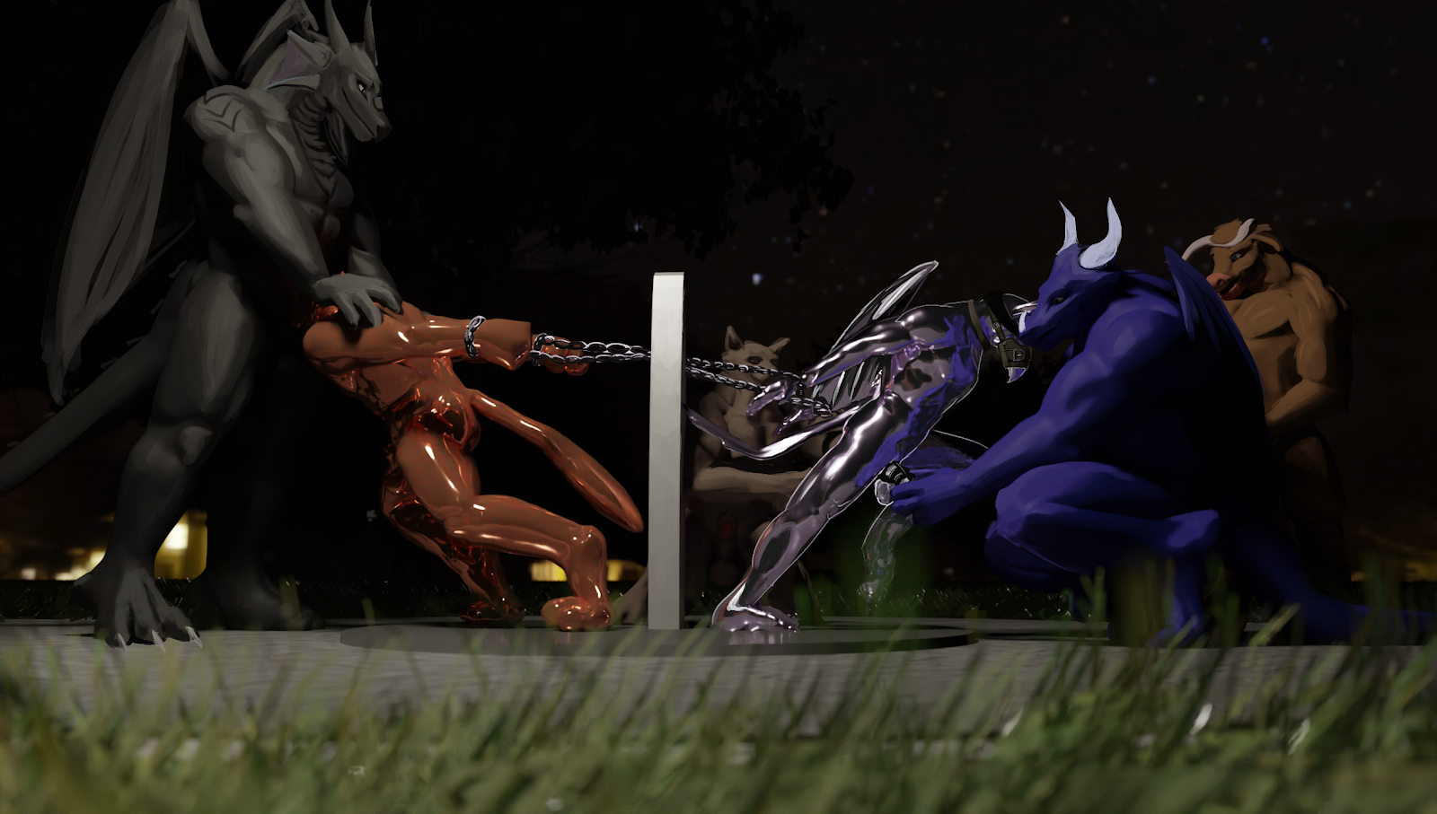
"You did two alright today," whispered a familiar voice, "But don't get complacent. Once the public gets bored of you...well...we can easily melt you down and mould you into something else.
"After all, what else are statues good for?"

~ End ~

