The Potent Protein Pump
Written by TwistedSnakes
Illustrated by Foster-Tony

Decro grunted as he strained against the shaft of the barbell that he was holding across his chest. He was lying face up on the weights bench with his feet on the ground as he did his bench presses with an impressive amount of weights on either side of the barbell. The barbell was raised slowly and steadily until the wolf's arms were straight before he set the barbell back on the rack with a clang.
"Six!" the wolf gasped as his arms relaxed and he got off the bench. His sweat dripped from his fur and onto the towel he had draped across the bench. He had just hit a new personal record. Now if only the gym had heavier plates for him to press with; the barbell was overloaded with the existing weights as is. He would have to give his feedback to the gym manager.
Decro grabbed the towel and wiped his face with it as he got off the bench, leaving the next lifter to stare flabbergasted at the sheer amount of weights on the bar. He made his way to the locker room and into the spa inside to enjoy his well-deserved rest.

The scent of the mint shampoo supplied in the gym toilets emanated from the wolf's fur as he stepped back into the gym with his black gym bag slung across his shoulders. His white and grey fur was clean and fluffy from the automated fur driers in the toilets that blasted him with gusts of pleasantly-warm air from all directions, leaving him feeling fresh and dry.
He was wearing a fresh set of clothes with a sleeveless singlet and trek pants. In his hand was a bottle filter with a milky mix which he shook, rattling the metal ball inside as it helped mix the protein powder with the rest of the health blend. Opening it, he drank half of the bottle's contents in one long sip before closing its cap and making his way to the front counter to sign out.
"Sign me out, Rex," Decro nodded at the gym manager who was manning the front as he put his gym pass on the counter.
"Hehh, sure," the cheetah grinned as he slid the pass off the side of the counter and tapped it against the scanner before handing it back to the wolf, "Still drinking your custom protein shakes?"
"Yeah," Decro replied casually as he pocketed the card, "Business as usual."
"LXR?"
"Nah, AceFit brand," he leaned on the counter nonchalantly. Seeing Rex's impressed look, he continued with a smug grin, "I throw in a mix of blended fruits and nuts too. Natural vitamins."
"That sounds really pricey," the cheetah stared with his mouth wide open, "Even without the extras. One full serving each time you come?"
"Every day."
"Whoa," Rex furrowed his brows and fiddled with the blue ballpoint pen on the desk, popping its cap on and off. There were a few seconds of silence as they let the sound of clanging metal weights hang between them.
The cheetah looked the wolf up and down before smirking. Pointing the tip of his pen up and down Decro's muscular form, he asked, "So, do you know how much of that protein is taken in by your body?"
"Eh, my biometrics monitor back at my place tells me it's about seventy percent. Seventy-two point six, to be exact," he shrugged.
"Whoa, but isn't it-" Rex started.
"You may not like it, but this is what peak performance looks like," the wolf grinned.
"Well...what if..." the cheetah began, trailing off with a curious look on his face.
"Hmm?"
"What if you could improve your protein intake?" Rex asked with an intent look on his face.
There was a loud guffaw as Decro found the idea amusing, ridiculous, even. People turned to stare but the wolf ignored them, turning back to the cheetah who had not returned the smile. "Seriously?" he asked incredulously, "I've tried a million and one ways. This is the maximum anyone can physically take in and that's with years of protein acclimatization."
"Hehh, that's because I have a secret method that can be used to reduce the amount of wasted protein that comes out of the body. Basically making you more efficient," it was the cheetah's turn to look smug as he teased the wolf with his secret.
"Yeah?" Decro prompted.
"Hmm, wonder if it'll work on you," the cheetah wistfully spun the pen around with his fingers.
"Hey, are you going to tell me, or are you just here to brag about your 'secret method' and what not?" the wolf growled.
"Patience, patience," Rex waved the pen around, "I want to make sure I share my secret to success with trusted people. Can't have anyone leaking it out to the casuals out there looking for a shortcut to getting ripped, can we?"
"Fine," the wolf sneered indignantly, "What do I need to do to prove to you I won't tell anyone?"
"Let me see if it'll work for you before I go about revealing my secrets to success," the cheetah tossed the pen to the side, "Do you drink?"
"Nope."
"Smoke?"
"Nope."
"Drugs? Steroids? Stimulants?"
"No, no, and no."
"And do you masturbate?"
"What the-"
"And how often?"
"Why are you asking me this?" Decro glared at Rex uncomfortably.
"Just answer the question," came the curt reply.
"Well, I guess it's quite-"
"You're quite the virile guy, got it."
The wolf stood in awkward silence and he nodded. To his relief, the cheetah didn't seem to think too much of it. "Here, come with me," Rex waved, leading Decro behind the counter and through a door that led into the staff quarters.
It looked like a small office with a carpeted floor, a work desk, some couches in front of a television set that had been hooked up to a gaming console. Against the furthest wall was a flight of stairs that led into the basement.
Rex headed for that, bringing Decro into a room that looked like the gym upstairs, except that the exercise equipment looked newer, some of them being the higher-end ones that were too expensive to be stationed upstairs, waiting for one inept user to put them out of commission for months. A stack of plates in the corner boasted the fifty-kilogram weights that Decro had been asking about for months. There was nobody else in the room except for the pair.
"Huh, what's this place?" the wolf asked as he looked around in awe.
"It's our secret gym for staff only. It's supposedly for testing out new equipment as it comes but I set it up as a way to reward my hardworking-staff and give my favourite gym members some perks," Rex explained.
"So...this is your secret?" Decro asked. If this was it, this wasn't of much use to him. After all, machines were machines. They could only do so much before the body's physical limits put a cap on how far he could go. In his case, his body had long stopped accepting the access protein from his diet, letting it go to waste as burnt calories.
"Pssh, you think my biggest secret lie in some machines?" Rex sneered. "Nah, it's much more than that. Stand here and take off your clothes," he instructed, motioning to the centre of an empty barbell power rack. The rack was a cuboidal frame that was welded together, ready to hold loaded barbells with its reinforced steel. Seeing Decro's perturbed expression, Rex added, "We need to measure some biometrics before I can cater your diet to your body capacity. There's nobody here anyway."
The wolf rolled his eyes resignedly as he put down his bag, took off his clothes and tossed them over his bag in a messy pile. He stood in his tight trunks, showing off his sculpted body in the middle of the gym.
Rex opened a metal cabinet at the side and took out a handheld device with a bundle of cables danging from it that ended in sticky pads. A pair of them were stuck to each of his hefty pecs and two more were placed on either side of his abs.
"Turn around," the cheetah motioned, "There ones go on your back." Decro complied, letting Rex stick two more on his shoulder blades and two more on his lower back on either side of his spine.
"So what's this supposed to measu — argh!" Decro screamed and crumpled to the ground as a strong electric shock surged through his body, incapacitating him. He was facing the ground with his muscles shuddering violently as the electric pulses overrode his nervous system, making his body convulse. The wolf's heart rate was irregular as his muscles contracted and relaxed involuntarily, controlled entirely by the device in the cheetah's hands.
After a few agonizing seconds, Rex turned down the power, leaving the wolf weakly shivering on the ground but otherwise still alive. He set down the electroshock device on the ground beside Decro as he went back to the cabinets to find something else. The wolf could see the device within arms' reach but his body could not respond to stop the pain. The cheetah came back wearing a pair of gloves with a spreader bar and a few coils of rope in his hands.
"What are you doing?" Decro whimpered as he tried to suppress his convulsing.
"Hmm? We're proceeding with your...new diet," the cheetah grinned maliciously as he grabbed the paralyzed wolf and sat him up, beginning to coil them in neat loops around the wolf's muscular body while careful not to tangle them among the wires of the electroshock device. Ropes were crisscrossed across the wolf's chest, torso, and arms, each loop yanked tight until it dug into his skin. It was a modified Hishi Karada tie that held Decro's arms behind his back, making his escape impossible even without the waves of electro-torture running through his body.
"Grrr, unhand me now — argh!" Decro winced in pain as Rex shut him up with a turn of the power knob.
"Hush now and let me do the work," the cheetah grinned, "Gotta earn my five-star service rating eh?"
Grabbing the wolf's left ankle and bringing them to his left thigh, Rex began looping them together in a frog tie near his knees. Another frog tie near his ankle secured it to his thigh and through the ring at the end of the spreader bar. He repeated the same process on the other side, securing the wolf's feet apart.
Rex then dragged the trailing ends of the ropes the metal frame of the barbell rack, pulling them up so that the wolf's spread feet were lifted off the ground. The cheetah continued to strain on the ropes, lifting the bound wolf up until he was suspended upside down in the middle of the rack.

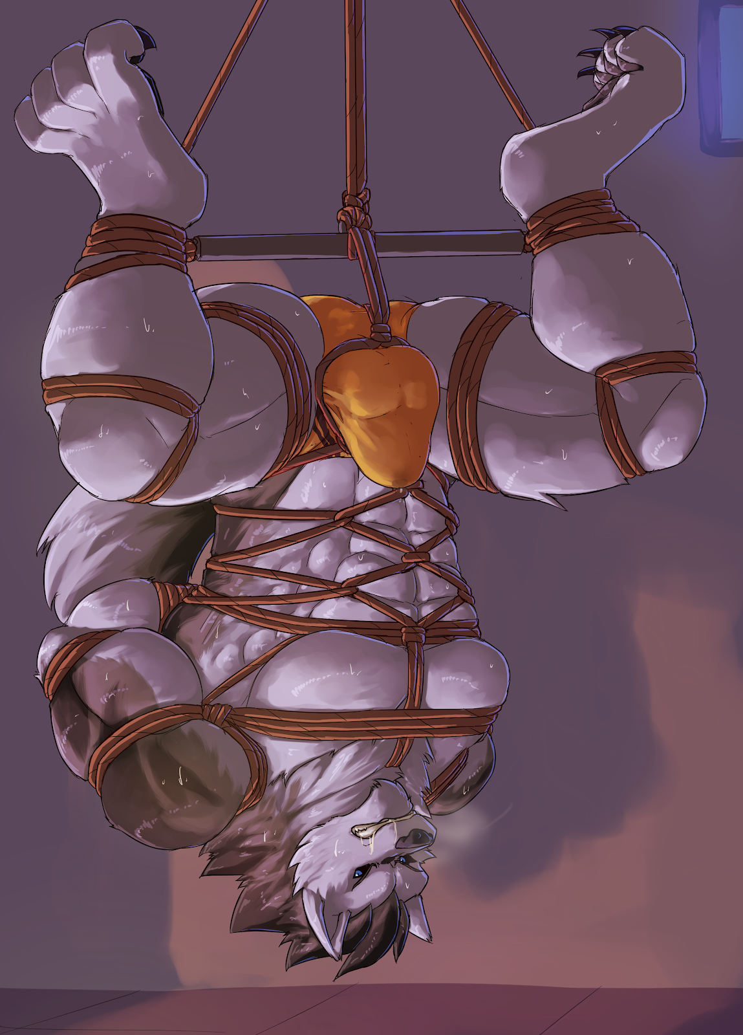
Decro was shuddering in his suspended pose, swinging back and forth as he dangled from the ropes that were tightening and cutting into his skin due to the weight of his body.
"Heh, it's nice to see a wolf bound up so nicely," the cheetah smirked as he caressed Decro's crotch with firm motions. Before he could stop himself, the wolf began to grow erect in his trunks, forming a sizable bulge in his tight trunks. Rex stroked a finger between the wolf's balls and down the underside his shaft where a spot of pre had already begun leaking.
"Mnggg..." the wolf groaned as both pain and pleasure rushed through his mind.
"What a virile specimen you are," Rex teased, slowly squeezing and massaging the hardening bulge in his hands, feeling the firm and trapped flesh in his palms as he pressed it down. "How long has it been since you last cranked one out? Three days ago?" Rex prompted, "Two? One?"
Decro glared at the cheetah who merely smiled back. "This morning, just before coming for your workout?" he smirked, noticing the wolf's gaze avoid his. "Just this morning, and yet all it takes to get you wet like a little slut is a bit of touching and groping."
He ignored the wolf's glares of protest as he threaded another length of rope through the bindings around the wolf's waist, pulling it upwards to loop around the bulge before Rex tied a knot. The tight loop tugged the wolf's cock and balls away from his body and stretched the fabric of his pants over his throbbing member, making the outline of his assets very obvious through the lycra. Without warning, Rex yanked the rope upwards, forcing the wolf to bend his knees to prevent the rope from biting into his sensitive crotch.
"G-gah!" Decro winced as he was forced into his uncomfortable position, having to support his entire weight by the strength of his thighs so as to lighten the load on his tender bits. His body began shivering, not from the electro but from the strain on his legs that were getting sorer and sorer with every passing second. The end of the rope was secured over the top of the rack, keeping him in place in the middle of the steel frame.
"I'm going to turn off the power," Rex notified Decro as he disconnected the electroshock device and pulled the sticky pads off the wolf's body.
"What the fuck are you doing to me?" the wolf began yelling as his body was free of the pain of the shocks, "Let me go now!"
"Whoa, we haven't even started," the cheetah grinned, as he brought another box of equipment from the cabinets. He gave the trapped bulge another squeeze, tracing the curves of the wolf's balls before firmly stroking his shaft. He firmly pinched the tip of the bound wolf's cock, milking out his generous precum into the absorbent lycra.
"Maybe you'll behave if you can't see what I'm doing," Rex shrugged. Bending down to look at Decro's strained expression, he shoved a thick leather blindfold against his eyes, careful to avoid the wolf's snaps at him.
"Gah!" Decro protested as his vision went black. He could feel the cheetah stand up and return his attention to his throbbing bulge. There was the sound of snipping scissors and his trunks were torn off from under the ropes, freeing his dick to stand erect with its tip glistening with his natural fluid.
Decro squirmed and struggled but the ropes didn't give. He felt a cold plastic nozzle forced into his pucker. Rex had shoved a syringe into his tailhole, pressing its plunger down and filling the wolf's tight hole with the cool, clear lubricant. The wolf instinctively clenched his muscles, expelling the liquid and inadvertently coating the entrance of his hole.
Rex picked up a girthy butt plug with a malicious grin on his face, smearing its tapered tip with the lubricant around the entrance of the wolf's wet hole. Satisfied, the cheetah pressed its tip against the wolf's tight ring. Decro clenched his muscles tightly but the presence of the lubricant only worked against him as it allowed the plug to force past his entrance and into his quivering tunnel.
"You're tight," Rex grinned, "Let me help you relax your tense muscles." He began fighting against the wolf's efforts, pushing it halfway into the canine's passage before letting the pressure almost push it out before he forced it back in again.
Decro whimpered helplessly as the plug was repeatedly plunged into his tailhole. He was struggling to keep his rump as high as possible to ease the tension on his cock and balls but the pounding on his ass was not helping his case.
With a strong push, Rex forced the entire length of the thick plug down, impaling him with its thick shaft. Decro clenched his muscles tightly in an attempt to force it out but the cheetah had secured it in place with another length of rope, leaving the tip of the plug securely wedged against the wall of his prostate. The wolf could not help but let out a gasp of unwilling arousal.

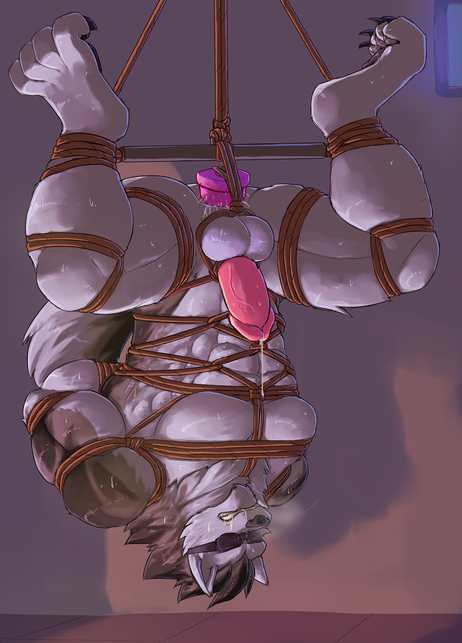
"S-stop!" Decro demanded, thrashing about blindly in an attempt to resist the unwanted intrusion, "This is sick!"
"Hey, why the attack?" he cooed in mock assurance, "I'm just giving you what you want."
"This? This isn't what I want!" Decro retorted. "What I want now is for you to let me—" he was interrupted as a leather muzzle was shoved over his maw and buckled behind the back of his head. Breathing through his nose suddenly got harder, forcing him to breathe through a small hole at the mouth of the muzzle.
"What did I say? Patience" Rex began stroking the sensitive but firm shaft of Decro's cock, teasing the wolf's anger with forced arousal. Decro was shivering weakly as his strength was giving out, dripping his copious precum all over the gym mat.
Satisfied that the wolf's dick was extended to its full length, the cheetah shoved the fleshy shaft into a glass tube that was just about wide enough for his girth. His balls were pushed into the metal loops that held the base of his testes soundly, keeping them separated in their individual sections. A clicking of a lock told the wolf that the tube was now secured firmly around his member.
Another tube was attached to the hole at the front of the muzzle that led into Decro's mouth. He could feel the air suddenly become thick as he was forced to breathe through the tube. A similar pressure could be felt on his dick as...
Wait! He was sucking on his cock through the tube!
"Mfftt!" Decro protested loudly at the sudden realization of his embarrassing predicament. His squirms, however, only satiated the cheetah's sadistic fascination with the muscular form of the wolf. There was something satisfying about seeing a strong, sculpted body being brought to its knees as it was pushed to its physical limits. He was toying with the extent of Decro's strength, endurance, and libido.
There was one last thing to do. He pressed a button on the remote control and the plug in the wolf's tight hole began to vibrate and pulse. Decro's protests were a mix of helpless arousal and sheer desperation. The stimulation against his sensitive prostate was making it worse for him as his cock throbbed in its glass prison.
The wolf was getting hopelessly pushed to the edge as his whimpering turned into moans of pure ecstasy. The blindfold made it easier for him to focus on the carnal pleasure he was deriving from both his abused tailhole and his self-fellated cock.
He needed to control, to hold himself back. But the intoxicating pleasure became too much for him to resist and he found himself sucking harder on the tube, letting his throbbing shaft push deeper into the chamber as he thrust his hips in the air.
Decro felt embarrassed, ashamed of the situation he found himself in. But there was no turning back. He gave his fervent efforts his all, bringing his arousal to its peak.
Just a bit more. And...
A burst of white filled the tube as he shot his load in a gasp of pure sexual gratification. There was a moment of silence as he heaved his chest and tried to catch his breath. Then the difficulty his breaths alerted him to what was happening: the cum was leaking down the tube.
Sure enough, his rich cum began flowing into his mouth, filling it with the taste of his salty seed. Decro could only whimper as he was forced to swallow every last drop as gravity acted on his spunk.

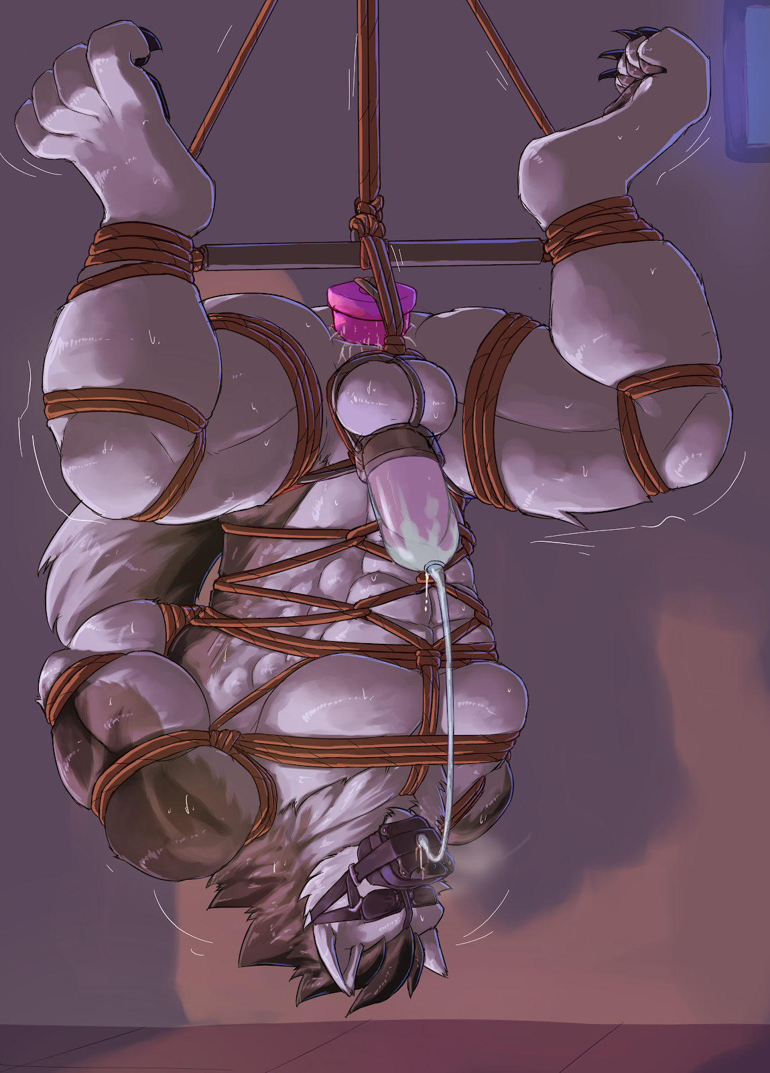
"See? No more protein wasted due to your...wasteful pleasures," Rex grinned smugly, stroking the glass cock tube as he watched the wolf's phallus throb within, leaking out its residual essence.
Decro panted, humiliated by the entire ordeal as he regretted his sinful succumbing to pleasure. He kept still, waiting for the cheetah to lower the ropes to let him down. And when he did, Decro would give him what for. But that moment didn't happen. Instead, Rex was examining his ropework, tightening any knots that were coming loose.
"Normally I'd let you go, but since you're such a virile, young wolf, I figured you'd be wasting more of your savoury cream in a few hours' time anyway," Rex explained with a smug on his face, "So I think it's best that you keep at it...say...another few more days or so? Let's aim for a hundred percent protein absorption rate, shall we? Treat it as a new fitness goal or something."
Decro protested loudly as he struggled against his restraints. The rope was cutting deeper and deeper into his skin, leaving red marks on them. But the cheetah was serious about leaving him here. Among the buzzing sound of the vibrator, the wolf could hear the cheetah go up the stairs and back to the gym above, leaving him in his predicament. His very erotic predicament.
Within minutes, the stimulation forced him to cum again and the system pumped his high-protein seed away, feed it into his mouth. This would go on for the next few hours, leaving his tailhole sore as it drained the wolf dry, feeding him every last drop of his natural protein broth.
The perfect diet for bodybuilders.

~ End ~

