Go Down Fighting
Written by TwistedSnakes
Illustrated by Qundium

Decro was in a fight. The white arctic wolf's body was poised, ready to guard against any incoming attacks yet ready to strike should the opportunity arise. The rest of the world might as well not have existed; his opponent was the only thing in his sight as the two fighters circled each other. The other fighter, ah black-furred panther, was watching him with alert eyes and Decro returned the glare.
The opponent threw a punch towards his face. Instinctively, the wolf raised his arms to block it, but a subsequent kick almost took him by surprise. Decro blocked the blow and took the opportunity. He threw one punch after the other as he took controlled strides forward, forcing the panther to retreat.
He swung his leg in a swift kick to his opponent's side, but the panther grabbed the wolf's ankle and thrust himself forward, making him fall backward onto the ground. Before the panther could attack again, Decro hurriedly recovered and resumed his defensive pose.
The panther grew more aggressive, throwing a punch, then a side kick, then another punch. Decro managed to block one after the other, barely keeping up with the attacks. Spotting a gap in his opponent's defences, he threw one punch to the left. As expected, the panther attempted to block it, widening the gap. Decro's second punch caught his opponent off guard, hitting him squarely in the chin.
The panther grunted, stumbling backwards but Decro didn't relent. He stepped forward and wrapped one arm around the panther's neck, raining blow after blow upon his opponent's abs.
With a heave, the panther broke free of the wolf's grasp. Taking half a second to recover, he dashed forward with fists ready. Decro used the panther's momentum against him, grabbing his arm and throwing the feline to the ground.
The sound of a bell ringing three times signalled the end of the round and the rest of the world came into focus. The both of them were in a boxing ring with a referee. Around the room, other Muay Thai students were cheering for him.
That should've been another ten points to him. He went to the corner of the ring where a fox was there to dry off his sweat with a towel. Another ring of the bell indicated the end of the rest break. Decro took confident steps back to the middle of the ring where the panther was already standing. He could sense his opponent's apprehension and he smirked back in response.
His victory was in the bag.

The Muay Thai gym locker was empty by the time Decro entered it. While the other students had washed up, he had been discussing his progress with his instructor. If he kept up his current rate, he'd be able to represent his gym in the national championships; his goal since he joined the gym five years ago.
The prospects filled Decro with a sense of elation as he opened the locker to take his duffle bag. Tossing it on the ground, he sat on a bench and started taking off his sweaty armour guards.
As he took off his shirt, leaving him only in his compression trunks, he heard the sound of footsteps behind him. Though slightly surprised that there were still other students still around this late, he ignored the newcomer as he shoved his gear into the bag.
A heavy palm landed on his shoulder.
"Decro," a deep voice called his name.
The wolf turned around to see the panther from the earlier match: Triden, another student two years his senior.
"Yes?" Decro raised his eyes quizzically with the air of mild annoyance. The hand on his shoulder gave him a rough shove forward.
"Don't give me that attitude, punk," the panther retorted.
The wolf snorted. "What do you want?" he glared at the panther standing over him. Behind the panther were two other students, a brown ram and a dark-blue dragon, giving him menacing looks. Decro recognized them as Raiko and Qi, two other students who joined only a few months earlier than him.
"I think you know what I want," Triden gripped Decro's shoulder harder.
"Sorry you lost to me earlier?" the wolf responded unflinchingly. His scathing remark earned him a punch to the abs.
"What was that for?" he barked angrily, getting up to return the favour. The other two students step behind him and grabbed his arms, restraining him. Decro growled irritatedly but he knew that starting a fight would not have been wise.
"So," the panther continued as if nothing happened, "I heard you talking to Sensei earlier. Something about 'National Championship'." He scoffed as if the idea was detestable to him, "In case you forgot, I'm a few years your senior. If anyone deserves to go to the National Championship, it's me, not you."
"I guess you must suck that badly at fight-hgnn!" another punch interrupted him.
"Shut it, mutt," the panther snapped angrily. He put one arm behind Decro's head and grabbed a fistful of fur, pulling it back so that the wolf was forced to look at him. "Listen carefully, junior," he emphasized the last word with a sneer, "I don't know who you think you are, but in this dojo, you're the new guy. Inferior to us experienced seniors."
Decro held his glare at the panther, trying his best not to snort at his laughable explanation.
"Here's what's going to happen: tomorrow, you're going to tell Sensei that you can't commit for the competition training," Triden instructed, "Then you'll tell him that he should've picked me to go instead. How does that sound?
"Dream on," Decro gave the other two students a violent shake, breaking free of their grip as he threw a punch at the panther. The blow caught him squarely in the chest, sending him falling backwards onto the ground.
"Why you-" Triden shouted. The ram and the dragon hit Decro, pinning him down on the bench and holding the struggling wolf's arms and legs.
"Fiesty one, aren't you?" Triden stood over the restrained canine, "I guess we got to show you your place." He turned to the other two with a smirk on his face, "Boys, tie him up. We're going to teach him a new 'syllabus'."
Decro did not like the sound of that but his struggles were futile. While the dragon held him in an armlock, the ram went to retrieve the training ropes from the equipment room. The both of them used the ropes to bind the wolf's body, circling his chest and pinning his arms to his side. The ropes were pulled taut, digging painfully into Decro's skin as they tied it securely.
His wrists were then bound behind him around his waist with more ropes, followed by his knees and ankles, leaving the wolf squirming on the bench. The panther stood in front of him with his arms crossed, enjoying the sight before him: his rival at his mercy, helplessly bound and struggling.
"Untie me at once!" Decro demanded but the panther only responded by stepping on the wolf's muzzle, holding it shut. He leaned over the white wolf and squeezed his round butt.
"Mfft!" the wolf protested as the panther continued to stroke his firm buttcheeks, exploring every curve and inch of his muscular flesh with carnal enthusiasm. Decro tensed up reactively as his privacy was unwillingly invaded but that only made his body more firm for the panther to enjoy.
"Don't be shy now," Triden teased as he gave the buttcheeks a last squeeze before stepping back, "You gotta show off that great ass of yours."
Using his sharp claws, he ripped down the sides of Decro's compression trunks, exposing his round and firm butt. Only his jockstrap armour hid his dignity, although not much of it was left as he was tied up and felt all over by his Muay Thai seniors.

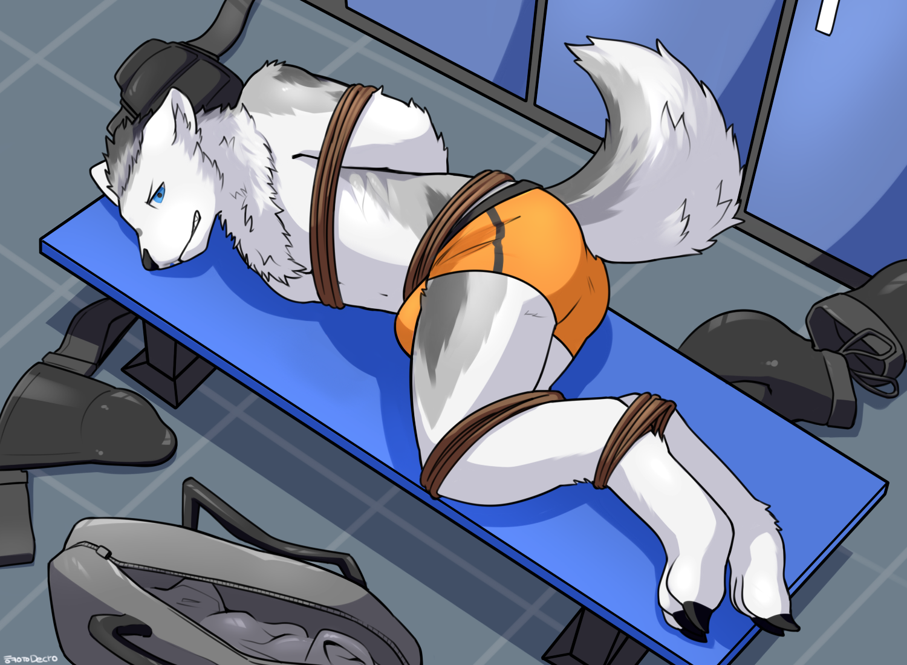
"Fuck!" Decro swore as he struggled with renewed vigour. "What the heck are you doing?" he yelled.
"Oh, you'll see," the panther smirked, grabbing the wolf's crotch and squeezing it through the stiff but flexible cup that held his manhood, "I already can tell we're going to have so much fun with you."
The feeling, however, wasn't mutual. Decro felt both angry and apprehensive as his bulge was massaged by the panther's skilful fingers.
"Don't you dare, sicko," he grunted, "Or I'll-"
"Or you'll what?" Triden clenched the bulge tightly, making Decro whimper as he doubled over, "Because it looks like you're starting to enjoy yourself too."
The wolf didn't want to admit it, but his own member had started to come out from its sheath, erect under his jockstrap cup from all the stimulation the panther had been giving him.
But that didn't mean that he wanted it!
It was all out of his control as his cock pressed against the hard shell of the armour, trapped tightly against his crotch in a hot buildup of tension.
"Gnggg..." Decro growled softly, trying his best to hold back his impulse to thrust his bulge against Triden's fingers.
"Look at him go, boys," the panther turned to Raiko and Qi, who grinned back in anticipation, "Can't wait to shove my dick into his tight ass."
"F-fuck you!" Decro retorted, "You better not do it."
"Do what?" Triden licked his lips, "You mean this?"
He tore through Decro's jockstrap, revealing his fully erect member. The wolf had to hide his embarrassment at his current predicament: fully naked and tied up in front of his peers.
"A-are you done?" Decro barked. "You've had your fun, now-mfft!" he was interrupted as his jockstrap was bundled up shoved into his maw, filling it up. "Ghrnft!" he protested, partly in surprise, partly in anger at the audacity. It was lodged behind his teeth, widening his jaw to the point that it was impossible to get it out with his tongue alone. He could smell his own musk in the jockstrap and the taste of his crotch sweat was filling his mouth.
This was humiliating!
He managed the angriest look he could muster at the three students but they were too busy admiring his form up and down. The dragon, Qi, was busy feeling up Decro's shoulders and pecs while Raiko the ram was giving his dick a light, teasing stroke. Triden, however, was engrossed in his tailhole.
"I don't like the look you're giving us," Qi spoke up, picking up Decro's shirt and rolling it up. Before the wolf could resist, he wrapped the sweaty cloth around his eyes. "All good to go," he declared.
"Help me get him up," Triden instructed, and the three of them turned the wolf so that he was on his knees. His head was still on the bench but his butt was propped in the air. Decro's tail was lowered as if to protect his vulnerable tailhole but they were not standing for that. Holding Decro's shoulders down, he pulled the wolf's tail towards him so that Triden could carry on without hindrance.
Between his legs, Decro's cock was still twitching as Raiko gently teased it, stroking his fingers down his entire length. Despite not wanting to admit it, he enjoyed the attention his dick was receiving. If only he could get some release from the tension. The past few weeks of focusing on his training took his mind off his cravings but now that he was cruelly reminded...
Gahh!
He should not be thinking about this. But his libido wasn't on his side. His hips slowly thrust against the ram's fingers.
"Good boy," the panther purred as Qi patted Decro's head, "You're going to keep humping as I shove my huge cock in your tight virgin ass."
Decro whimpered through the jockstrap in his mouth. His drool was mixing in with his crotch sweat, filling his mouth with its salty taste before dripping all over the bench.
But he couldn't help it!
If only they'd give him the chance to cum...
As if Raiko was reading his thoughts, there was a sudden touch of coldness all over his dick. The ram was pressing something metallic against his sensitive member. He wanted to ask but knowing them, he wouldn't be getting any answers. Not that the gag in his mouth would give him an opportunity to speak anyway.
All he could do was whimper for help.
The metal object was put around his dick. He could feel rings of metal wrapping around his shaft and knot, circling behind his balls as if caging them.
Wait. Cage?
His worst fears were confirmed as a click locked the chastity device around his member.
"Remember," Raiko teased, "We're your seniors, we look out for you. You've been pretty defiant this whole time so we're disciplining you by taking away your dick privileges. But that doesn't mean we're heartless." He stroked Decro's quivering flesh through the bars of the cage. "Just listen to us, and we'll reward you accordingly," he instructed.
Decro was filled with indignance, arousal, anger, betrayal, and fear; all of them mixing into a confusing ball of emotions. If he could free himself he would but with the three fighters pinning him down in his kneeling position, there was no escape for him.
His attention was suddenly drawn to the panther stepping over his shins to straddle the bench. Something warm and slippery was pressed between his two buttcheeks and it didn't take Decro long to guess what it was: Triden's lubricated dick, hard and erect.
His muffled cries didn't stop the panther; in fact, it only seemed to make him more eager to break the wolf. The tapered tip of his dick pressed against the entrance of the wolf's pucker, slowly feeling its way around the edges as if taunting him.
Decro's tailhole was tensed up as if to try to keep out the uninvited intruder but with a sudden shove, the feline's cock pushed past his tight hole and into his warm insides. The barbed dick rubbed against the wolf's muscles, making him struggle and whimper in pain. His squirming was quickly put to an end as Qi held him down against the bench even tighter.
Raiko wasn't about to be left out of the fun. He continued to tease Decro's caged member through the bars, giving him a cock massage against the canine's will. His member was quivering, struggling to burst through the extremely tight cage but the locks held. There was nothing he could do to help himself out.
The ram's deviousness, however, did not end there. He began jerking the metal-encased dick off, stimulating Decro through the gaps. The wolf could only imagine how good it would feel without the cage.
If only...
Suddenly, the pumping came to a halt. "You got to earn it," Raiko teased, "I want you to hump."
Decro hesitated. His libido was fighting with the last of his dignity and the latter was losing. His bowed head in shame as he began thrusting against the ram's fist. Inevitably, his rear was rocking against Triden's cock as he gave his tailhole up to the feline.
Triden began thrusting his hips too, filling Decro with his entire length. The satisfaction of putting a junior in his place only served to increase his arousal of fucking a tight ass. His thrusts grew faster and faster and he filled the air with his moans.
Decro, too, was moaning. His pent-up cock was relentless in tormenting him as he humped. Raiko had gotten down to give his caged dick a lick, sucking it off as he tried to fuck the ram's mouth.
Raiko's tongue explored every inch of his manhood, both flesh and metal. If he wasn't held down, Decro would've collapsed from the extreme sensations his body was subjected to. Instead, he continued to hump, fucking the ram's maw and the panther's cock.
The ram's tongue went up the underside of Decro's dick until it came to the open slit at the tip of the cage. He slipped his tongue in the gap and touched the tip of the wolf's dick, making him shudder and moan. With a huge thrust, he shot his load at Raiko. At the same time, Triden climaxed, filling up Decro's tailhole with his warm seed. He gave the wolf's ass a few last pumps, hilting himself deep in the canine's behind before finally pulling out.
The whole lot of them were panting, each of them recovering in their own positions. The realization of what had just transpired was filling Decro with shame. He could feel his cage leaking his cum and behind him, the panther's seed was seeping deeper into him. The musky jockstrap only served to add insult to injury.
He needed time to himself. The embarrassment was too much for him to bear and he whimpered behind his gag.
Triden stepped off the bench and Raiko pulled away. Surely they'd leave him alone now.
But the feeling of Raiko's dick pressing against his cum-filled ass told him otherwise. He was going to be their fuck slave for the night.

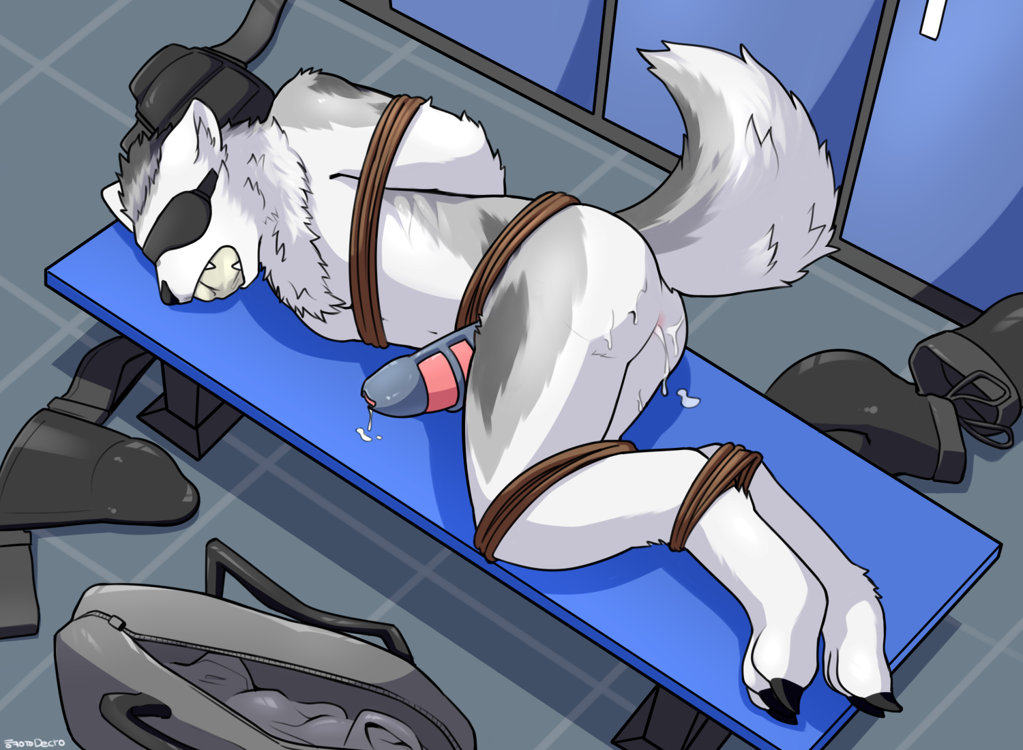
After what felt like forever, Decro was left quivering on the bench. After Raiko had used him, Qi had a turn with his tailhole. Then Triden came back for seconds.
Only after the panther climaxed were they finally satisfied. Leaving him on the bench, they took their fighting gear and headed for the door.
"Hmm, I think we'll leave you here for the night," Triden waved to the blindfolded Decro, "Let you simmer in our juices until you've learnt your lesson. How does that sound?"
"Mfft hgnnr grft!" Decro pleaded but the trio laughed it off.
"Glad you agree," Triden nodded. Turning off the lights, the three of them left the locker room and headed for the exit, leaving Decro tied up on the bench.
He wanted to take a shower. To clean up his abused tailhole. To clean up his spent cock. He felt dirty.
But with the ropes tying him down and his jockstrap in his mouth, there was no way he could get help. To add insult to injury, the chastity cage was encasing his knot and shaft tightly, making it impossible for his cock to retract into its sheath. Instead, he could feel his member tug against the metal, unable to be in any position other than publicly on display.
Would Triden find him and untie him tomorrow? Or would his instructor find him like that? Or would the other students find out and laugh at him?
He didn't want to think about it.
"Ngnn..." he whimpered.
From behind the blindfold, he broke down and started to cry. There was simply too much for him to handle that night. Only a miracle could save him now.
Decro was almost about to drift off to sleep when suddenly, the flick of the switch turned on the locker room lights.
"Hngg?" he perked up his ears. Who was it?
The sound of soft footsteps came into the room. It was the otter janitor!
The footsteps came forward and stopped as the janitor noticed Decro's bound form.
"Mfft!" the wolf struggled, trying to signal to the janitor for help. He had never felt so thankful to see the janitor before.
Over the past few years, he hadn't paid much attention to the otter. The otter would pick up the towels he threw on the ground, or clean up after he had left the benches sweaty. There were also a few occasions where he snapped at the otter for misplacing his gear while trying to clean up.
But this would all change. After this, he would treat the otter much better. He would clean up after himself. He would greet him daily. He didn't even know the otter's name. All this would change.
The otter's concerned footsteps came up to Decro.
"Nfft hgnr ruhh!" Decro nodded his head, asking to be freed.
Finally, he'd get to go free. The first thing he would do is to shower. Shower until he felt clean again. He had never felt so hopeful before.
But the otter wasn't untying him yet. What was he waiting for?
"Hnffg?" he asked.
But his question went unanswered in the silence as Decro breathed heavily.
Then the silence was broken by the sound of unzipping.

~ End ~

