One of Amath’s many epithets is The Painted Warrior. When I first uploaded his character sheet I had a lot of friends asking me about the meanings of Amath’s tattoos and warpaint. While they were carefully chosen (unlike some of the face paint,) and I only had a notion of what most of them meant and why he had them. But barring a few of them, I had never actually written out when or why he actually had them done, or what they explicitly mean. The overall idea for him being so painted, however, was one I was totally certain of: he would never be unprotected, be it in literal physical ways or spiritually. In being tattooed he took the protections of amulets, charms or bracteates into his skin instead. So, down below I’ve written out an itemised list of all of his tattoos and and their purposes and meanings.

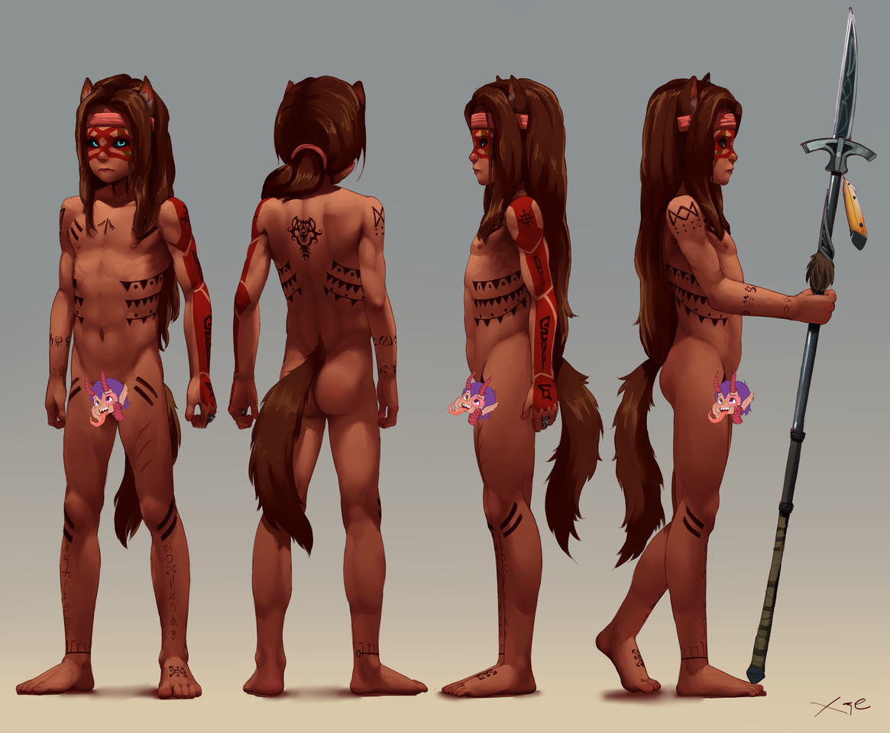
(Uncensored)

Face:
All markings on Amath’s face are actually just warpaint and can be washed off.
- The red ‘tear marks’ that begin around his eyes and extend down to his neck symbolise grief, while the red colour is emblematic of his role as an avenging warrior. If he ever applies any one warpaint, it’s always this particular pattern.
- The interwoven stripes interlaid over his entire face are mainly a fear tactic, meant to make him even more fearsome than he already does - what with the wolfish features.
- The earthy-green mark over his eye is a tradition of those with his totem, the hawk, and is meant to (symbolically, at least) give him a keen eye when using his bow.

Torso:
- The Hawk: Starting with one of the smallest tattoos, the dark line with the ‘wings’ between his pectoral muscles is another emblem of his hawk totem. It was the first tattoo he ever received, applied just shortly after the hawk made it clear that it watched over the young Sienn ( – Amath’s childhood name.) Sienn took exploring the Watolga Lands as a young boy: from climbing up cliffs and trees to swimming along dangerous rivers and playing alone in contested territory. A near fatal fall might’ve spelled an early death if not for the gift of a hawk’s feather. Found recently shed and laying upon his broken body, his Clan’s Grandmother used the feather as the inker and prime channeller when performing the healing ritual that saw him return to full health.
- “Double-Dash” Marks: There are actually three pairs of double-dash marks on Amath’s body – over his pectorals, on his thighs, and just under his knees. These marks were the second series of tattoos, and the first that he earned. Meant to bestow both artful stealth and speed, Amath earned these tattoos early in life as he trained under his clan’s scouts and hunters. The marks over the chest help breath, either while sprinting or when hiding, the ones on his thighs grant speed, and the ones under the knees assist with hiding, and soften his footsteps. They mark the clan’s best hunters, and very few earn all three pairs.
- “Wings” A series of three lines adorned with triangles extend from his back, around his sides to his abdomen, vaguely resembling wings. These are another symbolic gesture to his guardian totem. He had these done later in life has he grew closer to the hawk and the wind and found peace with his bestial wolf side. They’re the most recent addition.
(Like his eyes, this was lifted whole-cloth from Ratonhnhaké:tonin in Assassin’s Creed 3. I just liked the design that much, and had Xie expand on it to make it more personalised and different.)
- The Wolf: The striking visage of a wolf adorns Amath’s back. Unlike the other tattoos, this one was first carved into his skin with a sacred knife before being inked over, and it wasn’t done with his consent. This mark was carved forcefully into his skin during a ritual that bound Watokico'sumanitu-taka (“The Vengeful Wolf [Spirit]”) in mortal form, fusing his soul and the Wolf spirit, forever turning Sienn into Amath. It glows faintly during full moons, and it’s the one tattoo that Amath doesn’t show off – letting it be covered by his long mane when bare-chested.

Left Arm:
- “Armour:” The entire outer side of his left arm and hand is covered in a red tattoo that resembles plated armour. Normally earned by fighting without protection, Amath won this tattoo by going behind enemy lines, touching an enemy officer while he slept, stealing his horse, and finally cutting off their reinforcements all while completely naked and using only his hands. Meant to imbue the wearer’s skin with steel-like durability and strength, it served to double his physical endurance, already ‘blessed’ with the tough skin of a werewolf.
- Oyate'tateuyetopa Watolga (Left Shoulder): Applied at the same time as the runic knots below, the crossed sunburst was the unifying symbol of Amath’s culture. All but gone or scattered in modern times, he had the mark imbued over his shoulder, as well as the mark of his own clan on his right foot, so he would always remember his people and family. The paternal side, anyway. It has no magical properties.
- “Short Blade” (Upper Arm) & “Sword” (Forearm): Two of four Nordic Knot Runes, these tattoos were earned when Amath chose to fight without a shield when facing a powerful ice-borne beast to defend a Jarl and his hall in the Northern Lands. The tattoos are the same knots borne on a pair of duel blades, Fenris & Fenris’ Fang, which were gifted to him by the Jarl. Imbued by a seiðkonur with magic, they encouraged him to wield his blades with incredible speed and skill.
(Both of these Nordic Runes Knot, as well as the ‘Axehead’ listed later, were taken from my favourite weapons in TESV: Skyrim: the Nordic set as seen in the Dragonborn DLC. Dagger, Sword )
- “True Shot” (Hand): The third of four Nordic Knot Runes. A runic glyph meant to imbue the wearer with the ability to shoot their bow far and true, Amath uses this tattoo in conjunction with the traditional warpaint over his left eye. His eye sees far, while his hand, marked with this rune, holds the bow steady. The seiðkonur’s magic imbued in the runic knots on his arm reacted to his proficient use of the bow, and, over time, this rune formed upon his hand. A blessing of sorts from the God of Runes.
Right Arm:
- “Axehead” (Right shoulder): The fourth and final Nordic Knot Rune, this ‘infinity’ shaped Rune was gifted to Amath at the same time as the ‘Short blade & Sword’ knots. While Amath is proficient with using dual swords and spears, he favours using axes or hatchets for their simple elegance. Like the other runic tattoos, this one shares its knot with an axe gifted to Amath by the Jarl, and was named “Fenrir’s Bite” after he severed the ice-borne beast’s hand with it mid-battle. The magic the seiðkonur imbued into this rune inspired Amath to break both bone and steel with a single swing. The dots beneath the knot are an embellishment of his own, and harken towards his own culture’s aesthetics.
( This Nordic Knot Rune, as well as the ‘Short Blade & Sword’ listed above were taken from my favourite weapons in TESV: Skyrim: the Nordic set as seen in the Dragonborn DLC. War Axe )
- Enchanted Runes of Truast: A series of esoteric Watolga glyphs, the two rings of charms around his right forearm and wrist are perhaps Amath’s most powerful gifts. Gifted by the midewikwe of the Oterakut, a northern ethnic group of Watolga related to his own Oyate'tateuyetopa people, as a sign of trust, they were bestowed upon him once he awoke from his decades-long feral rage. They were given to him before he embarked on his travels. The charms are highly protective enchantments that bestow a number of gifts. They offer Amath guardianship while travelling, the inability to ever be lost or found if he so desires, fear in the hearts of his enemies, prevents him from being successfully fettered, protection from the elements and drowning, evil, foul magicks, and vaguely, the enemy colonial faiths. Even death may close its eyes to him. They’re heavily symbolic and might not be entirely literal. But with these, Amath strides with confidence and new trust in his people again after the betrayal.

Legs:
- Healing Runes (Legs): These runic sigils were tattooed onto Amath’s legs when he was still known as Sienn, done at the same time as the hawk on his chest. These are healing runes, inked into his broken legs by the hawk feather during the healing ritual, and were attested to glow as his bones mended. The runes, all healing-words, protect Amath from harm and promote good health. With them his bones are strengthened and, with his lycanthropic healing, he recovers from most injuries and illnesses incredibly quickly. And, as they’re separate from his lycanthropic nature, they also defend him against the few things that can actually harm him, such as specially blessed silver or the ice-borne beast.
- Torc (Right Ankle): One of the more recent additions, the torc was tattooed onto Amath’s ankle after completing several hunting trials. Like the similarly recent wings, the torc was done to show Amath’s closeness and faith in The Horned God. As he rarely wears any jewellery, Amath decided to have the torc tattooed on his ankle, ensuring that he would always wear it and honour The Horned God. Its enhancements are subtle ones; animals, both domestic and wild, tend not to see the predator wolf in him ever since getting the torc tattoo.
- Mazaska’na-zuspe'oyate Clan Insignia (Left Foot): Parallel to the Oyate'tateuyetopa symbol on his right shoulder, Amath has the sigil of his own clan – his family coat of arms, analogously – tattooed upon his foot so that his family is with him in every step he takes on his journeys. It has no magical properties.

