Hero Chronicle P: Is there something wrong with being a hero but captured in a dungeon and transformed into a cum dumpster?
Chapter 1
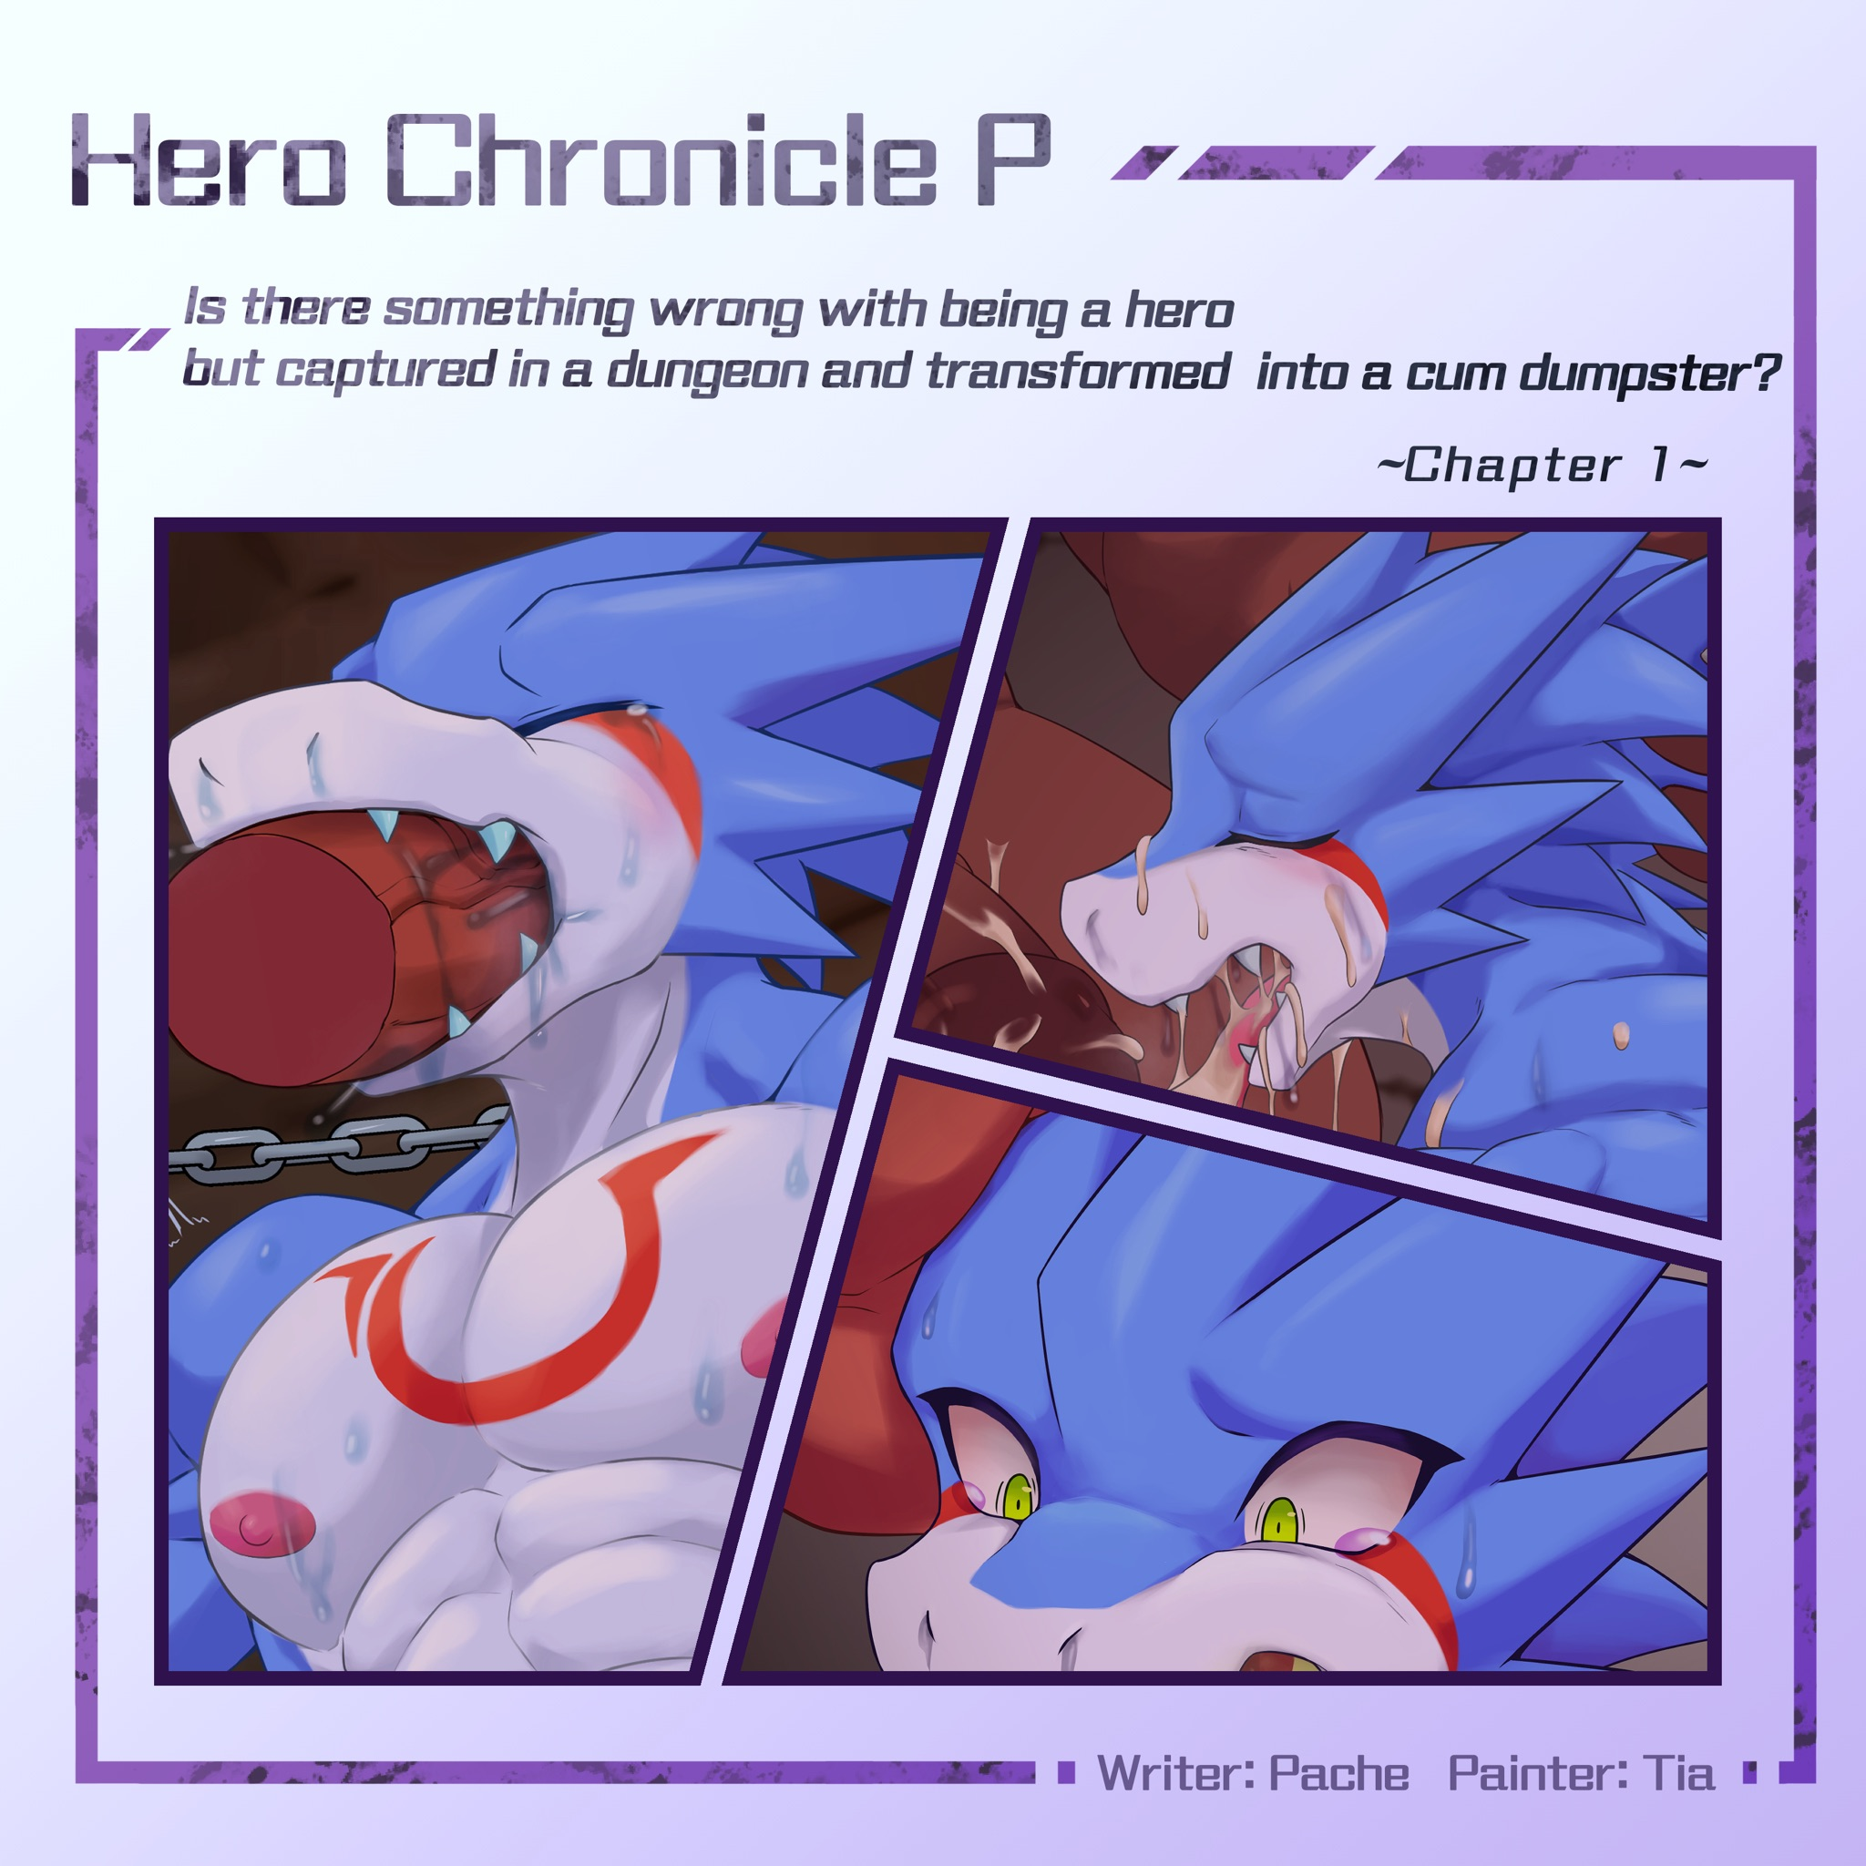

The Hero Shu was eating at the Adventurer's Guild when someone suddenly broke in.
It's not uncommon for people to break into the Adventurers' Guild, and it's not uncommon for people to come in covered in injuries. But the current situation is slightly more worthy of Shu's attention: the man who broke in was a tiger, and although he was covered in wounds, his tattered clothes could not cover his huge body, especially his crotch, which was only half covered, and it was a miracle it didn't fall off.
Shu quickly shook his head, telling himself that the person was already injured and it was obviously very urgent, he should not pay attention to that kind of thing.
The tiger stumbled up to the counter and filed a search and rescue request, Shu couldn't help but listen to the conversation, it seemed his teammate was in distress in a cave and wanted to request an emergency search and rescue mission.
"Then please present your adventurer's card."
“Card..." The tiger tossed and turned his body, but he didn't have much clothing at all, so he just lost a few more pieces of his already torn clothes. "It's dropped!"
"Where is your registration information?"
"I didn't register here..."
"But..." the desk clerk was stumped. "We can't help people who can't prove their identity to apply for a request. You know, there are always scammers and..."
"There's no time!" Tiger yelled at the counter. "Don't I look like this to prove it?
" I understand your anxiety, but we have our own position..."
"Please! They're going to die..."
The tiger's eyes are in tears, seeing this scene, Shu couldn't hold back.
"I'll help him."
Shu walked up to the counter, the counter staff was a little surprised.
"But Sir... such an unclear commission..."
"It's okay. Sometimes such accidents happen, right? If you don't help now, when will you help?"
"We can't even guarantee that the client will pay.
"That's not the time to talk about it."
Shu reached out to help the tiger. Although wobbly, he was even taller than Shu, so it was inevitable that he touched the area around his waist, and his clothes were falling off on that side.
"Where is the location?"
With a grateful face, Tiger told Shu the location.
"I got it. I'll get your team back, so rest assured."
"Thank you... thank you, Hero!"
Shu wondered if he should take him to his room, but soon realized he just couldn't let go of his hand. He blushed, but tried not to show it.
"Wait for my good news."
“Thank... thank you very much!"
Leaving the meal unfinished, Shu turned and left the guild. After he left, the tiger staggered toward the room, a smug smile on his downcast face.

Shu arrived at the target site, which was a very ordinary looking cave.
"I haven't heard of any monsters around here... did some monsters just take over this place recently?"
The cave was dimly lit and smelled of moss and rotting earth. Shu uses his ki to make the tattoo on his chest glow faintly. It is a family tradition that not only enhances physical abilities, heals injuries, and has various convenient uses, but can even make the family tattoo glow like this. By using this light to move forward, it is possible to find the traces of the team in distress.
Shu is not good at tracking, but the footprints on the ground are quite conspicuous and not difficult to find. And as he went deeper into the cave, he soon smelled a strong odor.
It smelled like a creature's body odor, very strong and a little nasty. Normally, it should not smell very good, but to Shu, the strong male body odor made him slightly excited. He also knew it was not the time to think about such things, and quickened his pace in the direction of the smell.
Soon he saw a certain kind of humanoid creature that he had never seen before, they had horns on their heads, red skin all over their bodies, almost the height of an average human being, but they were quite big and strong, each one was more robust than Shu. They were holding simple sticks and short barrels, without clothes, and not very intelligent at first glance.
Why are there such unseen... monsters? Subhumans? The presence of these subhumans here is quite worrying for Shu. It's not like there's another otherworldly gate, right? Such unseen creatures are usually creatures from other worlds that have come through the otherworldly gates. If so, it would be very urgent, because the otherworldly gate usually means that a demon or a demon lord will appear along with it. After saving the team members, he had to formally request an investigation from the guild.
Not wanting to be prejudiced, Shu tried to talk to the subhumans. However, before he could say hello, the red subhumans attacked him.
"Hey... don't attack!"
But the red subhuman ignored him, as if he didn't understand the language he was speaking. Shu had no choice but to fight back.
Fortunately, these subhumans are not very powerful, although strong but monotonous movements, Shu easily put them down. During the battle, some of the subhumans took short barrels of blowing air and fired arrows at him, Shu was hit by the arrows, but the wounds were superficial and he was able to heal them by using his ki.
But while it was an easy win, there was another difficulty for Shu.
These subhumans look dumb, but they are inexplicably well-built. The muscles are just the right size and the lines are nice and tight, not ugly like the common goblins or trolls. And they are in the fight when the crotch meat sausage are wiggling around, so Shu is hard not to notice. He kept reminding himself that his job was to save those team members, and after knocking out the subhumans, he charged forward.
Shu kept going deeper and deeper and found the sound of fighting coming from the depths of the cave. Maybe there was still help for those teammates! He picked up speed and soon reached a slightly wider space.
A group of red subhumans surrounded a dragon, which was much taller than Shu, with scales of dark red, giving a strong sense of intimidation overall. However, he has numerous wounds, his clothes are as tattered as the tiger, and the sword in his hand is broken. There are two human females on the ground not far away, not even moving, although not closely examined, but it seems that the possibility of still alive is not high.
Shu rushed up to help the dragon.
"Are you okay?"
He knocked down the red subhumans and came to the dragon's side. The dragon saw someone coming to his rescue and staggered to his knees. Shu rushed up to look at his wounds, which were purple in color and appeared to be poisoned.
There are still red subhumans appearing from the depths of the cave, but they seem to be wary of Shu and do not attack for a while. Shu hesitated, but thinking about life, he still took the hero ring off his hand and put it on the dragon's hand.
The hero ring has the effect of lifting the abnormal state, although the ring will quickly expire when it leaves Shu's hand, but for a short time it can still cure the poison. Shu has used this way to save many people. The wounds on the dragon's body quickly turned back to bright red. The dragon whispered his thanks, but Shu did not reply and turned his head to prepare for the red subhuman that was slowly approaching him.
He was in the middle of a fight when he felt a pain in his back. Shu turned around, the dragon was holding some kind of short blade, coated with a purple liquid that was clearly poisonous.
Shu couldn't believe it, but the dragon showed a fierce smile, and Shu fainted.

When he wakes up, Shu finds himself chained to the wall. His scarf and shorts had been stripped off and all his equipment taken, including his sword and hero ring. The chains were long enough to allow him to move his upper body somewhat, but before he could try to break free, someone was looking at him.
In front of him, the dragon was sitting on a chair, holding his head in one hand and looking at him lazily.The strange thing is that the dragon is not wearing any clothes and he lets Shu look at his crotch openly, Shu can't help but look at it more. The dragon is quite gifted, with a soft cock almost as thick as Shu's arm, with two balls hanging out as big as fists.
"Does it look good?"
Shu blushed and hurriedly took his eyes off the dragon's big cock. He re-examined the dragon, which was robust, probably nearly two heads taller than Shu, with dark red scales that were quite rough and even had tiny spines in some places.
His muscles were big, pectoral muscles were high and firm, waist was thick, abdomen was like many bulky buns, and his thighs were twice as thick as Shu's. However, although his body was attractive, his face was a gangly look, which made Shu feel uncomfortable when he looked at it.
"Why are you arresting me?"
"I asked you, does it look good? Answer honestly."
The dragon stood up and put the pile of meat in front of Shu's nose. It was hard for Shu not to look at it, and the smell that hit his nose was so strong that it was hard for Shu not to think about it.
"You're really a pervert who likes dicks. That's good, I couldn't stand it if the hero was a woman."
"What do you mean...? Why do you want to catch a hero?"
"Because the hero has a lot of experience."
"What experience?"
"You don't know?" The dragon looked a little surprised. "Do you know what I am?"
"Are you... a demon or a demon lord from the other world?"
"A demon or a demon lord? Well, that's not a bad way to put it. I'm the Dungeon Master."
"Dungeon Master...?"
"I am the one who is called to run the dungeon in this world. If someone releases their feelings in the dungeon, it can be transformed into my DP. You didn't know?"
"I didn't know. What's that got to do with me?"
"I mean, heroes generate a lot of DP." The dragon started slapping Shu's face with his rod. "Just like that."
Shu was slapped in the face with a meat rod, although he should feel humiliated, but he could not help but blush. He noticed that a little faint light seemed to fly out of his body, and it was immediately absorbed after flying towards the Dragon demon lord.
"This is DP. It is said that the DP of a hero is hundreds of times higher than that of an ordinary person. If this is true, you can earn a lot of DP if you catch a hero, so I found a way to catch you. Are you grateful to me?"

"You... that is, that tiger was disguised by someone of yours?"
“Right. Oni mage!"
The dragon demon lord waved his hand, a red subhuman dressed in clothes appeared, the subhuman looks similar to other subhumans, still tall and full of muscles, but by looking at his face it is clear that not as stupid as other. He knelt down in front of the demon lord.
"Transform into that tiger."
In response, Oni mage stood up and cast a few spells, then suddenly he took on the appearance of the tiger. Even the robe he was wearing turned into a tattered cloth, exactly like the tiger that came to the guild.
"I heard that you like males, so I'm sure you've taken the bait with this appearance of asking for help."
The dragon demon lord waved his hand and Oni mage changed back to his original form and took a few steps back.
"You... how do you know..."
"Well, almost everyone in town knows. I did a little research and they all told me. Do you want to hear what they said?"
"No, no..."
"Let's see, for example..."
Demon lord took a note out of nowhere.
"'Blue', 'Nice body', 'Obviously an exhibitionist dressed like that', 'Handsome but unfortunately like males', 'Wanna take home'. it seems that you are quite popular!"
Shu was red in the face, everyone in town knew about it? No one had ever mentioned this to him!
"What do you want to do to me?"
"Don't worry, I won't kill you. It would be a waste. Didn't I just say that? As long as the feelings flow out in the dungeon, it will becomes DP. Although I have heard that the strongest feelings are before death, it is best to let the adventurers die inside, but that is not killing the eggs? I was wondering how to make people continue to generate a lot of feelings. Then, it was your sexual fetish that reminded me."
"What... what does that mean?"
"That's what it means!"
The dragon demon lord pushed his cock into Shu's mouth, the soft feeling was so good... but it quickly expanded and filled Shu's mouth. The demon lord's cock was absolutely gigantic, pushing Shu's jaw open and his throat into the shape of a meat stick. shu felt the cock almost in his stomach and he couldn't breathe, but the demon lord started thrusting.
Without mercy, the demon lord slams his belly hard against Shu's nose, filling his nostrils with his male scent even though he can't breathe in. The taste of cock spreads in his mouth, and while Shu certainly doesn't like being invaded, his body inevitably reacts. His rod was slightly hard, but the demon lord didn't notice - he did notice the DP flowing from Shu's body.
"Looks like you're really enjoying it!"
The demon lord put his big hand over Shu's nostrils, making his mouth tighten around the demon lord's huge shaft. However, this made Shu's breathing even more difficult, he could still draw in a little air when the demon lord withdrew, but now there is no way.
The air in his chest was getting less and less, he wouldn't have suffocated if the hero ring was there, but now the ring was taken away. Shu's heart begins to panic, and this intense emotion also makes his body sprout a lot more DP.
Unfortunately, the demon lord thought this was a sign of Shu's pleasure and not only did he not back off, he even increased the speed of his thrusts.
"People in town say you're a pervert, but I think you're just a masochist, right? You can even get off like this!"
Shu struggled desperately to deny it, but of course to no avail. He rolled his eyes as the oxygen was getting low, then the Oni mage who was watching suddenly knelt down.
"Master, I'm afraid the hero will die if this goes on."
"Hmm?"
The demon lord paused and looked at Shu for a few glances. At this point Shu has begun to twitch.
"What, a hero can choke? How incompetent!"
As the demon lord retreats, Shu coughs and wheezes, desperately trying to inhale air. When he could easily get his breath back, he struggled, "If you hadn't... taken my ring, I..."
"Hmm? That means you won't suffocate with this ring?"
The demon lord took the ring off his hand and put it roughly on Shu's. Shu perked up, as long as he got his hero ring back, he would have a little more hope of escaping. At least this way there is no fear of being put down by poison. And this mood also turned into a small amount of DP flying towards the demon lord.
"Then I'll go on!"
"Uh-huh!?"
The demon lord grabbed Shu's mouth again and thrust his huge cock harder. This time the demon lord has even no mercy, not caring about Shu's feelings at all, as if Shu's mouth and neck were simply used as a flashlight. However, with the ring, Shu does not have to worry about choking, being so penetrated, his cock actually hardened.
This scene did not escape the eyes of the demon lord.
"Hey, this hero is really a pervert."
The demon lord waved his hand and called for several red subhumans - in the demon lord's words, these monsters are called Oni.
"All of you, go fuck him."
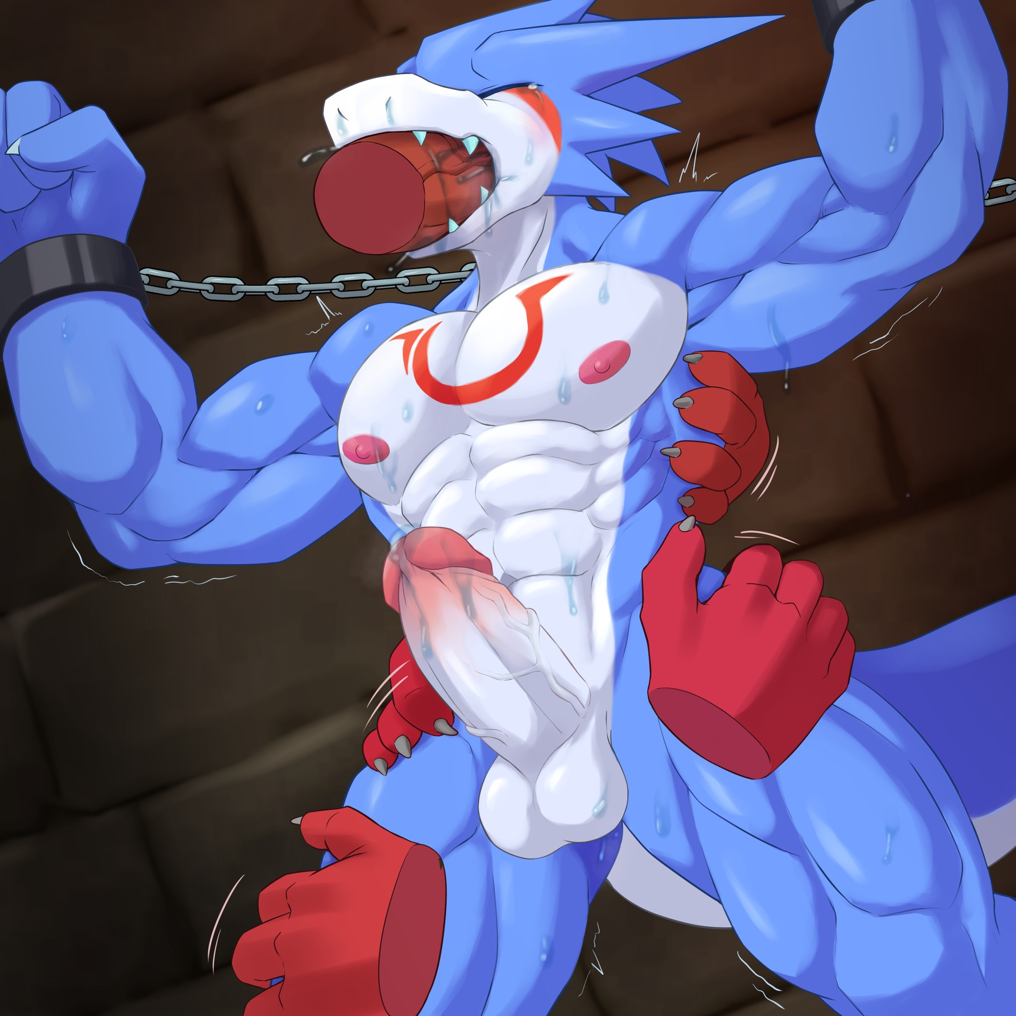
The group of Oni also seemed to be very excited, swarmed to Shu, several pairs of large rough hands on Shu's waist, buttocks, thighs touching. It didn't take long for those Oni's dicks to get hard.
Although Shu could not see behind him, he heard what the demon lord was saying. The thought of the Oni waving their rods in their crotches, the fear of having these rods inside him, and at the same time the slight excitement. His dick started to flow, even his rear hole was slightly wet.
"Damn!"
But the reality is not as good as it seems, these Oni don't even know how to prep, they just thrust in without any lubrication. Shu was in pain, his rear hole was torn, some blood got on the Oni's shaft, and of course the Oni didn't stop there, the rough rod kept going in and out, making Shu's anal fissure more and more worse.
Shu hurriedly used his ki to heal his wounds. Fortunately, this healing method is very inconspicuous, the demon lord does not seem to notice - those Onis simply do not care.
However, the wound is healed, which means the body can continue to enjoy it.
Shu's throat is being fucked by the demon lord while being surrounded by the Onis' rods, and the Onis have nothing to stop them from cumming in Shu's rear hole in minutes. The vibrant semen poured into Shu's intestinal walls and made Shu accidentally cum.
The pleasure of the orgasm hit Shu's head and also flowed into the demon lord as a large amount of DP. The demon lord of course noticed it.
"Hahaha, it works! Looks like a hero should be used as a cum-dumpster!"
Shu felt humiliated, but couldn't refute his body's reaction. Onis' cum kept pouring into Shu's body as the cock withdrew and was immediately replaced by the next one.
The demon lord was unusually long-lasting, waiting almost a dozen Onis to cum internally before the demon lord came in Shu's mouth. He buried Shu's head deep in his crotch, the huge shaft bounced in Shu's throat, and his semen poured directly into Shu's stomach. When the demon lord withdrew, Shu couldn't help but cough furiously, and his face turned blue after not breathing for a long time.
The dragon demon lord looked on with satisfaction at the DP that continued to flow out of Shu's body.
"Good, you guys keep fucking him. Don't stop, understand?"
The Oni roared in response, and they also ran to fuck Shu's empty mouth. demon lord looked and seemed to feel inadequate, went to a crystal ball on a pedestal, operated it, and soon after a group of Onis appeared next to the crystal ball out of thin air.
"All of you, go fuck that hero and don't stop until I say so."
"Woo-gah!" Onis shouted and rushed towards Shu. The demon lord nodded in satisfaction and left.

The demon lord wakes up after a good sleep and comes back to the dungeon hall to see Shu, who is still being gang-banged.
The hero Shu is covered in semen, his stomach is swollen like a pregnancy, his eyes are closed and he seems to be unconscious, yet he still has an Oni rod going in and out of his mouth. His body is no longer emitting DP, so he seems to be really unconscious.
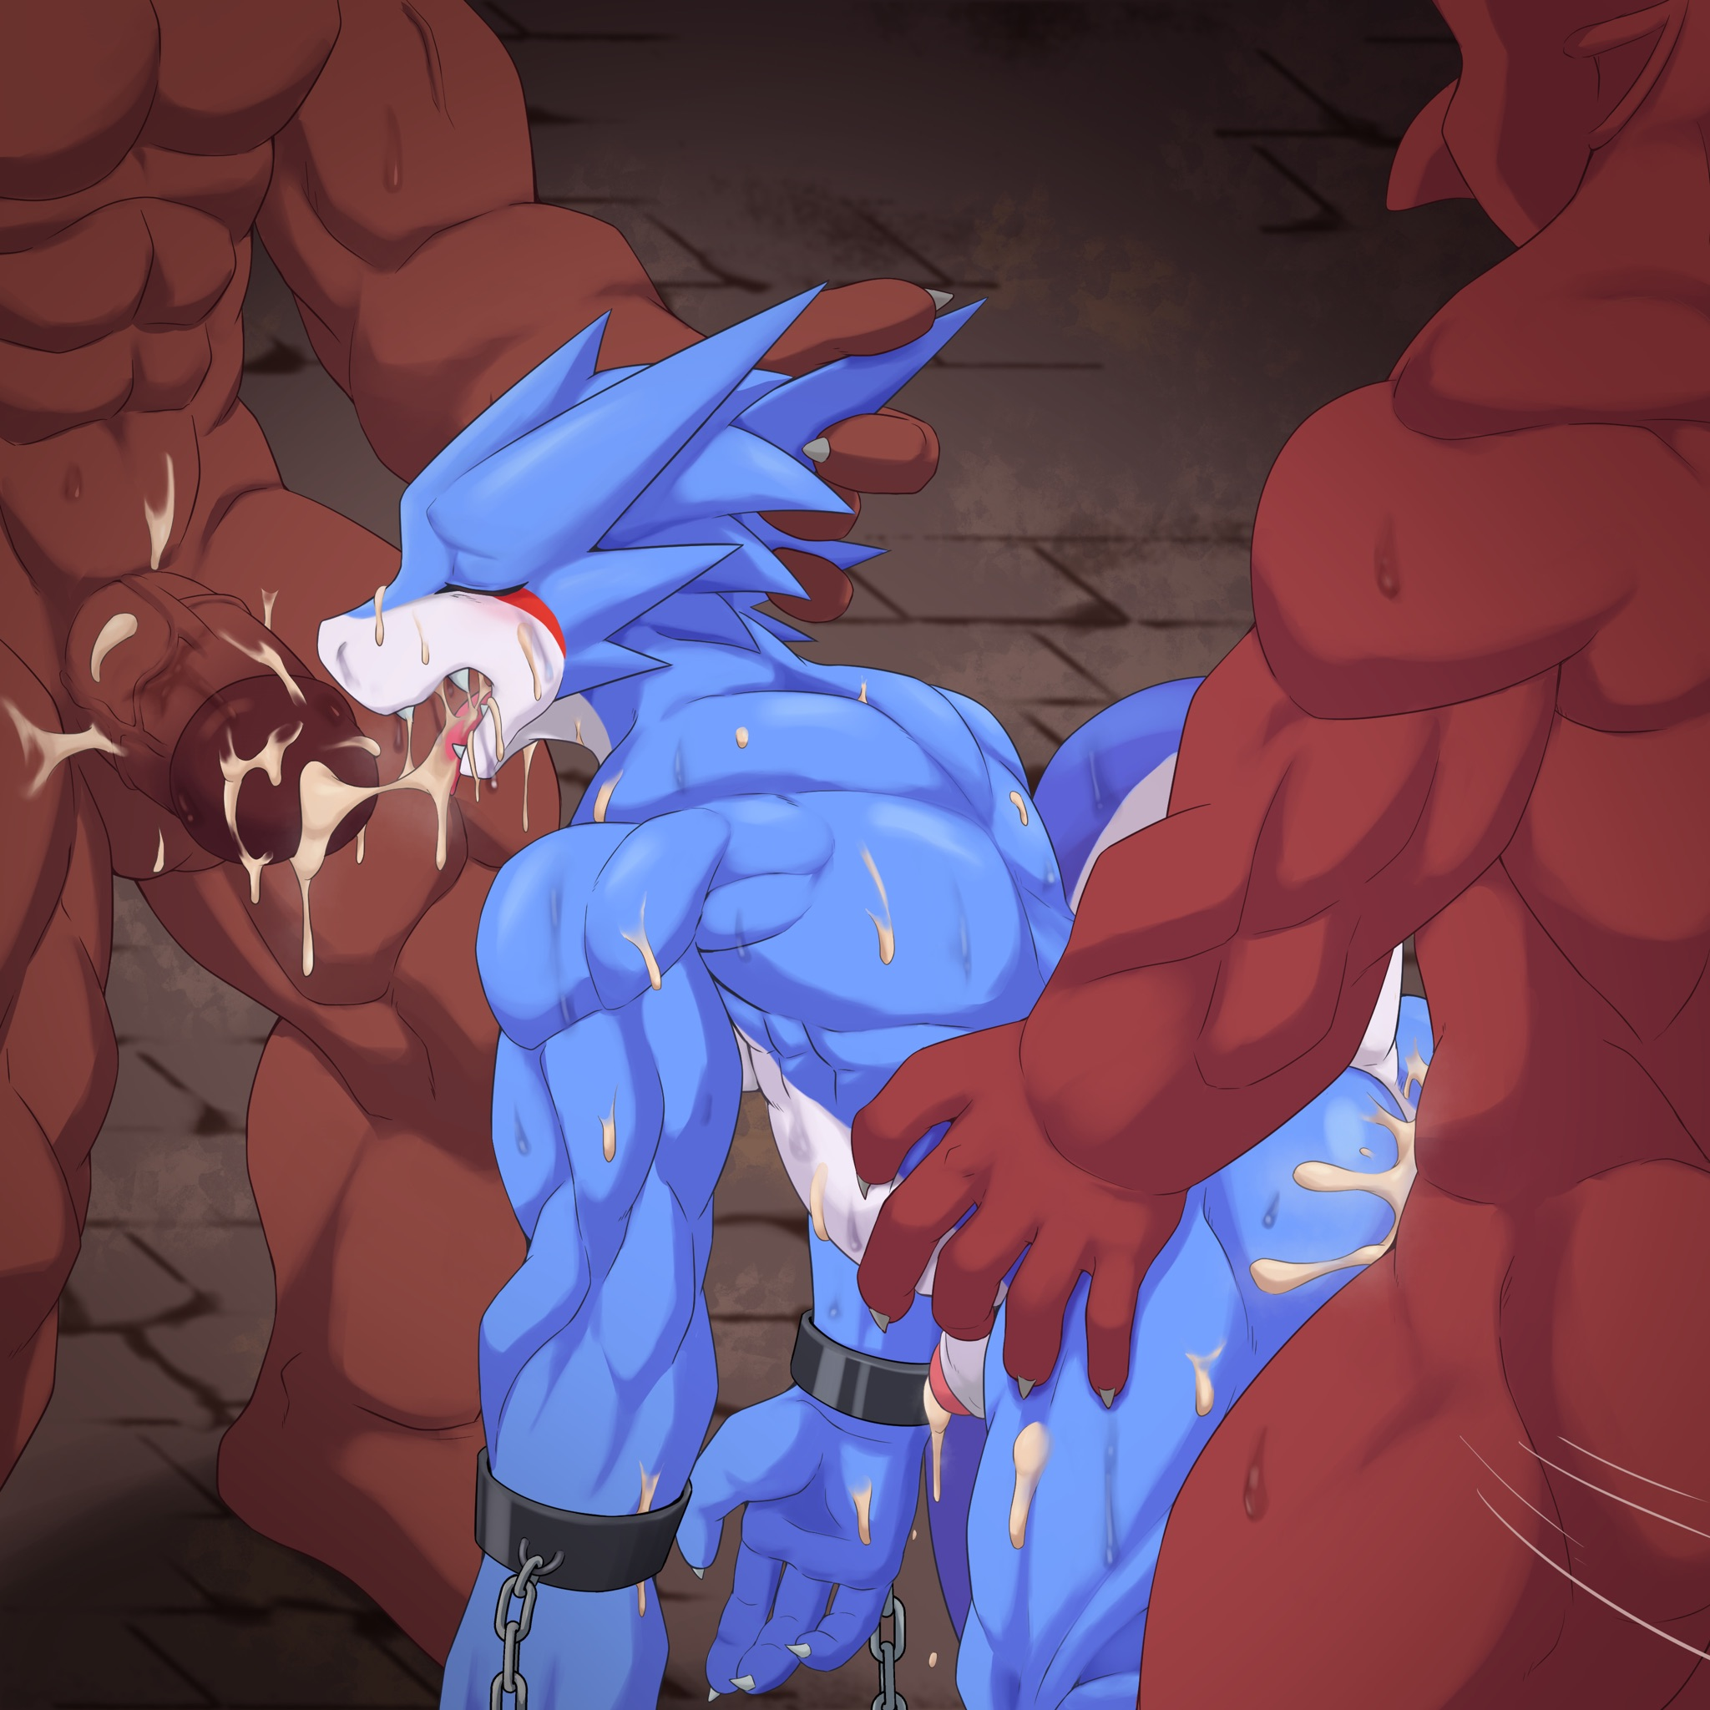
The demon lord went to the crystal ball to check the night's harvest.
"Not bad! In one night we earned enough to buy dozens of Oni's DP... although it's only a little more than the DP before the adventurers died... but it's much more stable than the adventurers who only get one in a dozen days."
The demon lord told Oni who was fucking his mouth to back off, went in front of Shu and grabbed the dragon horn on his head and gave him a slap.
"Hey, get up! You can't provide DP while you're sleeping!"
Shu was awakened by the slap, but from the look of his drowsy eyes, he was still in bad condition. The demon lord shook Shu vigorously and suddenly smiled at his sleepy face.
"Hey, I've just woken up and I'm having a hard time holding my pee. You know what? I don't have enough DP to buy a modern bathroom, but I don't want to dirty up the core room. So I'm going to have to ask you to help me out, Potty Hero?"
The demon lord shoved his cock into Shu's mouth, and his semi-erect cock easily entered his throat. The demon lord started to pee deep in Shu's throat, not considering whether Shu could swallow it or not. The excessive amount of urine made Shu choke and cough, but it was all blocked by the demon lord's huge shaft, and only a little leaked out. When the demon lord finished, he took it out and shook it twice in Shu's mouth and cupped Shu's face to make him suck up the remaining urine.
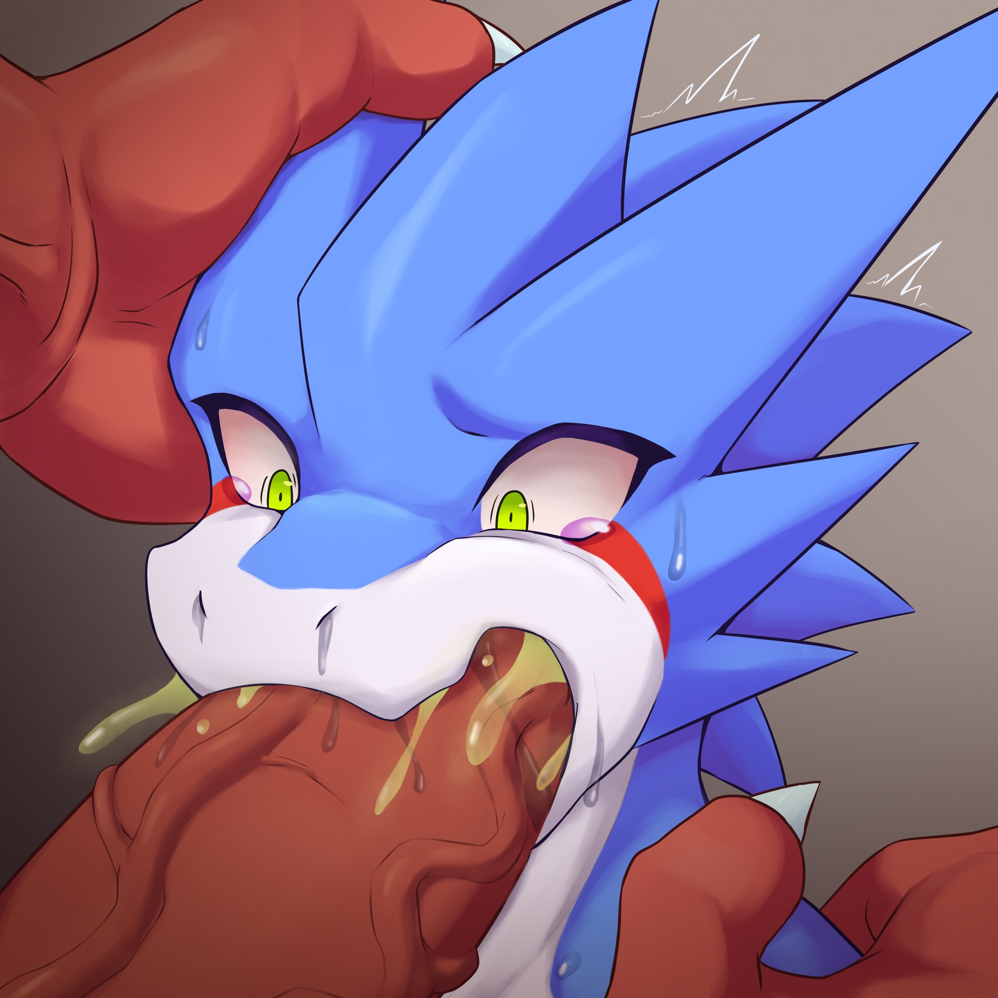
Just then, Shu bit down hard on the demon lord's cock.
"Fuck!"
The demon lord pulled his dick out in a hurry, lucky for him, as a demon lord, his natural defenses were high, leaving only teeth marks and scratches on his dick. Nevertheless, the blow just now still made him almost think his dick was going to be bitten off.
"Damn it!" The demon lord slapped Shu in the face. "You can't bite! I'm making you feel good, aren't I? What are you so unsatisfied about?"
"You... you grabbed me... because you wanted me to give you... power, didn't you?"
"So what?"
"As a hero, I will never... help the demon lord with his power..."
The demon lord looked at him coldly.
"Take his teeth out. I don't want my minions to get their dicks bitten off."
Just as the Onis were surrounding him, the demon lord called Oni mage.
"Find a way to solve this problem. Let him be more cooperative... Wait, that's not bad? If he resists, DP will be more." The demon lord thought about it again. "No, you try it first. I don't believe that pleasure can provide less DP than this. And the struggle for pleasure must be generating DP too, right?"
Oni mage bowed and the demon lord turned away to treat his dick. The Oni mage walked towards Shu and by this time the Onis had already started punching Shu's face and knocking out Shu's teeth while the Oni mage treated his face and the wounds from the fallen teeth. When Shu's teeth were all smashed, even with treatment, his face was almost beaten to the point of being inhuman.
But it didn't end there, Oni mage took the teeth that fell on the ground and used Shu's blood to draw some kind of pattern on his belly...

In the Adventurer's Guild, the desk clerk looked at the door with some worry.
"Shu hasn't been back for two days..."
"What, you mean that shy hero?" In front of the counter, a werewolf adventurer gulped down his mead. "It's normal for adventurers not to show up for a few days, right?"
"But Shu was helping rescue the stricken team yesterday." The worry at the counter was not lessened. "He hasn't come back, I don't think..."
"Come on, he's a hero anyway. He couldn't have lost to a monster nearby."
"Could there be an otherworldly gate?"
The wolf adventurer frowned.
"If that's the case, it's really dangerous. But he wouldn't even know to look for help, would he?
"What if there's an accident?
"Not really?"
"The tiger who came for help was gone." The desk clerk looked uneasy. "Raymond, I'm worried..."
Raymond drained his mead and slapped the clerk on the shoulder.
"Ask the others if they've heard from him. If something does happen, we'll help."
The desk clerk sighed as he rubbed his sore shoulder.
To be continued

