"Okay. You’ve seen the thieves’ quarter. [i]Now[/i] can we go back to the palace?” Iago squawked. Jasmine was grateful he’d come along, but she wish she’d brought earplugs!

"No. Do you know what Aladdin called me? ‘[i]Princess!’”[/i]

"Offend not my delicate ears with such language!” the parrot theatrically joked. Jasmine rolled her eyes, but Aladdin was right. She [i]was [/i]a princess. She didn’t really understand the poor.

"Look. I have to do this. Aladdin and I will be married someday. I have to understand this part of his life. I’m spending the entire day as a street rat if it kills me!” she said, dramatically, stepping past a dark alleyway.

Iago had a bad tendency to talk to himself. "Which it just might — Oh!”

A big, bald man with a huge, black moustache grabbed Iago right off her shoulder! Jasmine turned in shock, looking up at the man who must have been three times her size.

"An ugly specimen, but he may be worth a shekel or two,” the man said, appraisingly.

Jasmine ripped Iago away from the thief. "He isn’t worth [i]anything![/i] He’s mine!”

Iago’s eyes bulged from her pull, and he coughed and sputtered, "Ah! Would you care to rephrase that?”

The thief was about to speak, but did a double take on the beautiful young woman before him. "Wait. I have seen you before. You are no thief!”

[i]Oh no, he recognizes me![/i] "O...of course I’m a thief!”

"You are a [i]beggar![/i] We don’t like beggars in the thieves’ quarter...” he glowered down at her.

"No! I’m a thief, really!” Jasmine protested, hands on her hips. Why was she saying that? She never planned to steal. But something about this man reminded her of Aladdin’s words: [i]How could you possibly understand what it’s like to be a street rat?[/i] Why did everyone think so little of her?

The big, ugly thief grimaced. "You take me for an imbecile!? Prove it!”

"You think I can’t!?”

"You’d better! Or else,” he said, looming over her.

Jasmine was too angry to feel threatened. "Just watch,” she said, walking with far more confidence than she felt.

Jasmine needed something steal, still in view of the obnoxious thief. There was only one vendor in sight. [i]Fair enough[/i], she thought, walking in the general direction of the stall nonchalantly.

The bird was on her shoulder again. "This is where we make a break for the palace, right?” Iago trembled. His cowardice was only tempered by his greed.

"No. I wanted to be a street rat today; [i]this[/i] is what street rats do.” Jasmine angled herself to walk right past the stall, like she had places to go. [i]This will work,[/i] she thought.

"Look. This is crazy. You know that? You don’t know the first thing about stealing. Now, let me fill you in on some of the finer points,” the parrot bloviated loudly. The blasted animal was going to blow her cover. She quickened her pace.

"What finer points? I’ll just take this,” she said softly, grabbing the first thing she saw. It was a beautiful blue mirror. Jasmine walked quickly away, ears straining for any signs that she’d been noticed. [i]None[/i], she thought, proudly.

Iago was speechless, but speechless for that bird was awfully noisy. "But — You can’t just — Hey, you know there’s an art to this!”

She smiled secretively to Iago and whispered, "I’ll come back later and pay for it.”

"Talk about unclear on the concept...” the bird said, as if there were a vast audience floating in the sky. Sometimes the princess wondered if the parrot was mad.

Jasmine was about to walk into the alley, when a strong hand wrapped around her upper arm, causing her to gasp. [i]Caught![/i] she trembled.

An old man held her aside, his eyes covered by a cloth. A blind man had seen her steal the mirror? His deep voice rang out, "A word of warning to the young and inexperienced. Those who do wrong may find themselves punished by mysterious forces.”

Jasmine pulled away from his grasp, retreating away from him. Then, she heard the sound of whooshing air. Looking back, she could see neither hide nor hair of the strange man. "Look!” she said, her heart beating heavily in her chest.

Jasmine stepped behind some boxes, panting. [i]What was that all about?[/i] she wondered. Still, she’d gotten what she’d come for, pulling out the blue mirror with pride.

An arm pulled her into the street. Grabbed again! "So! So, you are a thief! I am Wadi Yathouin of the thieves’ guild. You have 30 days to obtain a guild permit — a mere 50 dinari. My card. If you are short, we can arrange a payment plan. Good day!”

As quickly as that, the thief left her holding a small, reed papyrus.

The parrot squawked in amused surprise, "Wow, you need a permit for [i]everything[/i] these days!”

"You see? I am a street rat!” she smiled triumphantly, looking into the mirror.

Iago, on her shoulder, was ever the pessimist. "Don’t make me laugh! If you’re a street rat, [i]I’m[/i] a frilled lizard!”

Even as the two of them looked in the mirror, it began to glow. "Oh!” Jasmine gasped.

"Uh oh,” Iago agreed.

Jasmine was covered in the blue light, until she felt blinded by its sapphire radiance. Reeling, she felt like she couldn’t stand anymore, collapsing to the ground. She couldn’t see anything! It was like the sun had gone out, and she couldn’t breathe. A thick cloth covered her. [i]Odd[/i], she thought, scrambling at the heavy material. Finally, she managed to pull herself out of the enormous tarp.

"I, I feel so strange!” she said, out loud. Maybe that damned parrot’s madness was contagious. Yes, yes, she was definitely mad. Everything seemed bizarrely large — the merchant’s stall had never been [i]that[/i] big. Jasmine looked down at her hands, but… but they were — "My hands!” she exclaimed, so startled she brought the strange, clawed appendages to her face. Her normally smooth cheeks were covered in hair...

"My [i]face![/i]” she squeaked. [i]What is going [/i]on? she panicked. She flicked her tail. "My...[i]tail?”[/i]

She turned to Iago, and her eyes went wide. A giant monster stood where he had been. A frilled lizard, even larger than she was! She was in serious trouble...

Until the lizard spoke, sounding exactly like Iago. "Uh, princess...do I look different to you?”

They gasped at the same time, the words only slightly different. Their reactions may have been surprise and mortification shared between them, but Iago’s exclamation still made Jasmine even more horrified:

“You’re a lizard!”
“You’re a rat!”

Jasmine clapped her paws to her mouth. "That merchant! He said ‘mysterious forces punish those who did wrong!’”

Iago’s new frills bristled. "So why did [i]I[/i] get zapped? [i]You’re[/i] the one who stole the...”

Together, they gasped, "The mirror!”

Jasmine spoke in a rush, "I said I was a street rat!”

"And [i]I[/i] said I was a frilled lizard!”

Jasmine flicked her ears, looking around frantically on the ground. "We have to tell it to change us back!”

The search was short, but longer than otherwise thanks to Jasmine’s tiny stature. At least Iago was roughly the same size as before. He spotted the mirror first. "Look!” he said.

The blue mirror lay smashed on the ground, shards of glass everywhere. [i]Oh no![/i] Jasmine hurried over to the shattered device, glancing at her reflection as best she could. "I’m a princess. A princess!”

The lizard stood beside her, the same urgency on his voice. "I’m a parrot! A devilishly good-looking parrot!” The mirror glowed, but the light flared away, broken. Iago sighed, "We just got seven years bad luck!”

Jasmine shook her head, fear making her voice tremble. "Rats and lizards don’t [i]live[/i] that long...”

* * * * *

[i]He just tossed me aside like a...like a rat[/i]. The words still rang in Jasmine’s ears. She and Iago had happened to glimpse Aladdin and the snooty prince who had come to court her in the market. When Jasmine had tried to plead with her fiancée, he’d only heard squeaks and only seen a lowly rat. He’d grabbed her gently enough, but tossed her away, like garbage.

"Well? We’re doomed,” whined Iago, his frills drooping.

"No. We can handle this,” she replied, thinking quickly. The more she tried to solve the problem she faced, the less time she had to worry about what she’d become. "We’ll just have to go to the palace and summon the Genie ourselves.”

"Sure! Go to the palace. We’ll just use the ‘rats and lizards’ entrance,” he [b][i]hissed[/i][/b], sarcastically. She was starting to miss his sarcastic squawks.

"Let’s go,” she sighed, heading toward the palace.

Travelling to the market from the palace would normally take less than thirty minutes. Now, on four, tiny feet, the return trip had already topped two hours.

"We’ve...been...running...forever!” gasped Iago, panting behind her. Apparently lizards weren’t known for long-distance running. She sighed, slowing down for him.

"We’ll never make it at this rate,” she chided him.

"That’s what I’ve been [i]trying[/i] to tell you!” he cried.

"What would you have us do? Wait around here and hope the genie magically appears?” she [i]clucked[/i], thrashing her tail.

"Just...a break...maybe some food?” he asked hopefully. "What do lizards eat, anyway?”

She paused. "Bugs, I think.”

"[i]Terrific[/i],” he hissed. "I’m a lizard, I’m starving, and I eat bugs.”

Jasmine sighed, easing up on the poor, former parrot. He wasn’t used to walking [i]at all[/i], much less on four legs. She said, "Fine, we’ll wait here until you’ve regained your breath, then we’ll try to find some food. I know, no bugs!” she added when he gave her a disparaging look.

Jasmine panted, for the first time since her transformation having time to think. It wasn’t a pleasant experience. She was...a rat. A disgusting creature, designed for wallowing in filth and stealing food. Iago hadn’t changed much, to be honest. He was the same size, but now he couldn’t fly or talk. Except to her. However the mirror worked, she could still speak to him. Hopefully that meant that other magical creatures would understand her, too.

What would she do if the Genie didn’t recognize her? What if his semi-phenomenal, nearly-cosmic powers couldn’t reverse the mirror’s magic? What if she never even [i]made[/i] it to the palace?

Rats didn’t live long. Three, four years? What point was there in contemplating such a life; she’d rather be dead, wouldn’t she? If there were no hope of returning to her old life. She knew that parrots could live as long as humans, but not lizards. Did Iago feel the same way?

She looked the frilled lizard over. He was still panting, his tail twisted in knots. He had one scaly claw on his chest to stabilize himself, too used to standing on two legs to stop now. Her eyes dropped further, and realized with a sudden blush that she was looking between Iago’s legs. There were no feathers now, to obscure his opening. There, between his scaly legs, was a short, thin...vent. Iago, of course, was used to being naked.

Jasmine’s blush doubled. She realized two things at the same time, and shortly after that, a third thing. First, [i]she[/i] was naked. She had been naked this [i]entire[/i] time, and only just now realized it. Second, she also kept standing up on two legs. With a gasp, she clapped her paws between her legs, covering up the tufted fur of her mound. The third thing she realized is that she’d done exactly the [b][i]opposite[/i][/b] of what she’d intended to do: by covering herself up, she drew Iago’s attention to her trembling paws.

And her paws did nothing to cover up the rows of teats on her belly. She froze.

"Jasmi -” he started, until he saw her new pose.

His jaw dropped. Perhaps he too hadn’t realized yet that she was naked. Or maybe he had all along. Jasmine shuddered, recalling that, multiple times throughout the scorching afternoon, Iago had grabbed onto her tail as she dragged him along. How could he [i]not[/i] have noticed, when his only view of her was her rump, tail raised?

"Uh...uh...princess,” he started, failing miserably to look away from her cupped paws.

Jasmine felt like her face was on fire, but there was something else...another sensation. This time, the feeling came from her paws, buried between her legs. It felt...warm. Like the heat in her face, only… [i]good[/i]. The tighter she squeezed, the better she felt. The feeling was so unlike anything she’d experienced as a woman. Touching herself felt good, yes, but this feeling was addictive. Controlling.

Even as she watched in horror, something pink and fleshy began to emerge from that small vent at the base of Iago’s lizard tail. Why didn’t she turn around...run? Her hands seems glued between her legs, more for the pleasure than the humiliation. Iago spoke again, stammering, "You d...don’t h...have to d...do that...” He walked awkwardly toward her.

Jasmine [i]squeaked[/i]. There they were, just to the side of a bustling Agrabah street, and Iago was coming closer! Finally, she broke his gaze, trying to run backwards as fast as she could.

[i]Thwump![/i] The princess tripped on her tail and fell backward immediately, landing in the dirt on her back. Her furless tail spilled out in front of her, pointing at Iago. Worse, she’d used her front legs to brace her fall, which meant nothing was protecting her tufted mound!

She met the lizard’s eyes again, but he was looking lower...right between her legs. Jasmine trembled...no one had ever seen her naked before, except her father of course, and even then, not in [i]years[/i]. Sure, she was a rat, but she didn’t feel any less self-conscious. Her cheeks were positively glowing in her shame as the former parrot gazed at her glistening jewel.
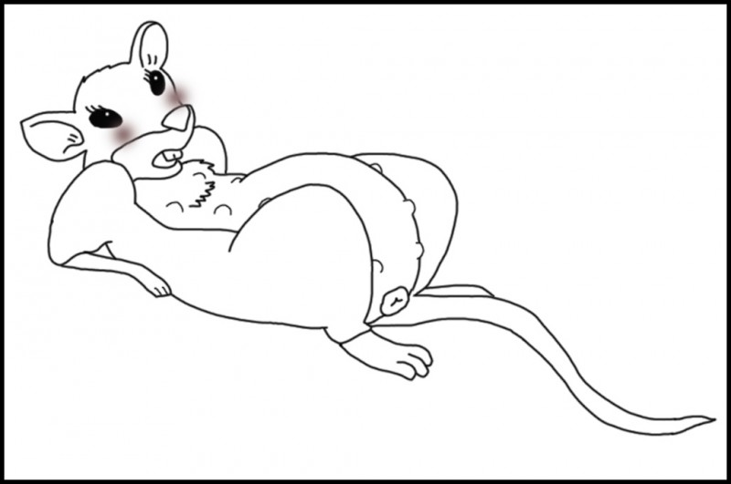
"S-stop looking at me like that!” she demanded, summoning her most royal tone.

Iago kept walking closer, ignoring her. He hissed with a whisper, "It’s okay, princess. I won’t hurt you...”

[i]Hurt me!?[/i] What was he talking about? "Oh, God!” she cried, realizing his intent. She tried to roll onto her legs, but Iago’s bulk was fitting perfectly atop her, grabbing her spread hindlegs in each, scaly claw. He was crouched there above her tail, lifting her hindquarters into the air. Jasmine could only watch in horror as she was pulled closer and closer to the fleshy...[i]dual-pronged[/i]...erection.

"Iago, as your princess, I [i]command you[/i] to let me go!”

His twin tips now brushed up against her quivering mound, making her whimper in a mix of pleasure and fear. She wasn’t ready for this, but her [i]body[/i] was. Iago flicked his long, flat tongue, and groaned, "Sorry, Jasmine… but you said you wanted to be a street rat, and destiny made you one. It’s time you learned what street rats do.”

"What!? But not with [i]liza [/i]—!”

He cut off her protest, shoving his hips forward. And like that, she lost her virginity. Not to Aladdin, as she’d always dreamed, but to Iago...! She dropped her jaw and [i]squealed[/i]. Strangely, it didn’t hurt like she’d been warned by her governesses. No, a shock of pleasure tore through the center of her core; it felt… good — [i]unbelievably[/i] good!

She glanced down her body, past her budding teats, to see that the lizard had rammed his entire hemipenis between her puffy, swollen lips. She stretched, trembling, around him, the bulge of each tip plainly visible in her belly. Iago finally released her legs, rocking his hips forward in another thrust that sent hot waves of sensational fulfillment coursing through her small, fragile body.

Every bit of her transformed self shuddered in an extended moan that left her breathless. Desperately she reached out with her paws, hoping for something... [i]anything[/i]... to grab onto, but there was only dirt. She reached out vainly with both paws anyway, [i]squeaking[/i] with each thrust, her eyes clenched shut.
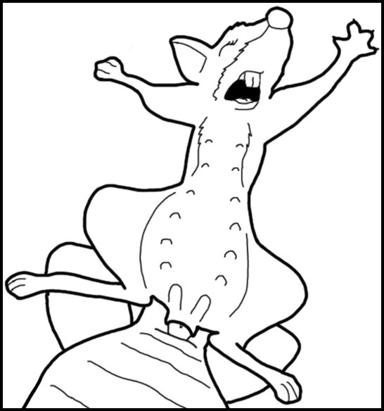
Iago [b][i]hissed[/i][/b] and [i]grunted[/i], rolling against her in a regular pattern. He could tell she wasn’t trying to escape anymore, and placed his wide claws on her belly to rub Jasmine’s many teats. Sometimes, his hard nails would gently scratch one, making the rat chirp. And always, his fat, double cock pushing in and pulled out of her. As much as she wanted to deny it, she was in [i]heaven[/i].

"Oh, Iago!” she squealed, rippling her abs as she began to hump up against him, meeting his thrusts with equal vigor. Something felt right about his cold, lizard body looming over her, taking control of the smaller rat.

"Princess, I’m -” he started, but his words turned into an extended moan as he leaned over her, cradling Jasmine’s body desperately and hammering himself deep.

[i]Splurt![/i]

Both tips twitched within her, sending hot gushes of lizard seed into her convulsing passageway. She [i]squealed[/i], clenching down around Iago. Her cheeks still burned that her first time had been with Iago, and that it had been as a rat, but suddenly, none of that mattered. She shook visibly in his arms, squeezing around Iago’s erupting cock, humping up and down wildly as she milked him.

Iago wrapped his claws around her slender midsection, pinning her down as he [i]hissed[/i] and moaned, using the young princess’s newly transformed body. "Don’t stop!” Jasmine cried.

But eventually, he had to. Perhaps only a minute later, he stopped rocking back and forth, planting himself inside of her as his cold, scaly body shuddered to a halt. Jasmine reached both hands around the back of his neck, though all she could see was his face and frills. He looked so silly, his beaklike lizard face, with his post-orgasmic expression of stupefied bliss. She smiled up at him, and Iago blushed.

Perhaps if his frills hadn’t obscured her vision, she would have seen the danger earlier. As it was, she didn’t notice the desert horned viper slithering up behind the pair until Iago pulled himself out of her, his seed dripping out of her onto the dirt. The moment she saw the enormous, venomous snake, she screamed, "Look out!”

Iago jumped aside, narrowly avoiding the snake’s rapid strike. Jasmine, on her back, was not so lucky. She turned away, but one massive fang grazed her side. Jasmine hurried away, but the sharp pain was followed by a pooling, numbing feeling that immediately began to slow her. She barely made it three steps before her legs gave out, and she collapsed on her side in the dirt.

"[i]Jasmine![/i]” Iago cried, as the snake darted across the dirt toward his meal.

"Run, Iago!” she yelled. She could feel the poison spreading. Even if the poison didn’t kill her, Iago couldn’t drag her limp body away and still escape the viper!

She’s not sure what the former parrot was thinking. Maybe he felt guilty for breeding her. Whatever it was, the frilled lizard suddenly charged the much larger snake, [i]hissing[/i]. Jasmine watched, amazed, as Iago for once in his life, acted in the best interest of others. [i]No, that’s not fair[/i], Jasmine thought, as the venom reached her head. He’d helped them defeat Jafar, and every once in a while, Iago revealed that he had a better heart that he’d ever admit.

[i]Chomp![/i]

"[b][i]No![/i][/b]” wailed Jasmine, though the words were muffled as her jaw refused to act properly. The desert horned viper hadn’t even hesitated, immediately striking the approaching lizard, and sinking both fangs into his scaly flesh. Jasmine watched in horror as Iago wilted, collapsing in the dirt.

Somehow, Jasmine felt confused. How could this be happening? Iago had overcome selfishness and fear to help another, and rushed boldly to her defense. He [i]deserved[/i] to save her. He [i]deserved [/i]to be fine. Indeed, a thousand times Jasmine and the others had faced adversity, and through the power of determination and friendship, had persevered against all odds.

No, something would happen. She [i]knew [/i]it. Aladdin or Genie would come flying to save them at the last minute. Of course, they had no idea where, or [i]what[/i] they were, but she had faith. Unfortunately, her muscles paralyzed, she could only wait for their savior, in whatever form, to come.

Whatever it was, it had better come quickly. Jasmine watched mutely as the snake lowered its head to Iago, who looked as stunned as she felt. Iago whimpered, helpless as he was drawn head-first into the predator’s gullet. It had drawn its fangs back to swallow the lizard, all too quickly engulfing his head.

[i]There![/i] she thought, triumphantly. The snake reached Iago’s upright frills, and couldn’t get around them! The spiny flesh made Iago nearly three times the size. Again and again the snake banged its nose against the frills, thwarted. Jasmine’s eyes quickly scanned the skies, looking for Aladdin on Carpet to come swooping in at the last second!

She saw nothing.

Indeed, the venom already seemed to be doing its work, Iago’s frills lilted badly. The limp lizard lost his last resort, rippling muscles pulling him deeper. He couldn’t even struggle as the snake swallowed him down. Before her eyes, Iago was reduced to two dangling legs and a long tail, the rest of him comfortably bulging in the viper’s throat. 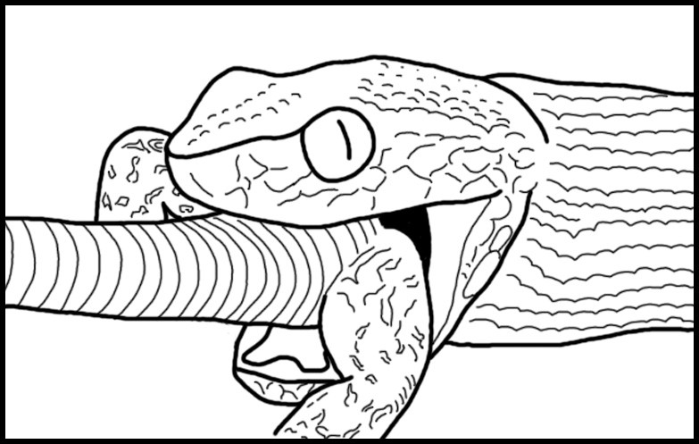
A chill went down her spine that had nothing to do with venom. In fact, she found she could already twitch her paws weakly. The grazing blow hadn’t completely paralyzed her like Iago. Still, at the rate she was recovering, the snake would be long finished with Iago and on his way to her. She watched, almost hypnotized, at its flicking tongue, tasting its meal as it gulped eagerly.

[i]No, not a meal. Iago![/i] Only the lizard’s lower legs and tail peeked out of that gaping maw now. [i]Gulp! Gulp![/i] Inch after inch, the former parrot disappeared. Jasmine was increasingly worried that this disappearing act would be his last. [i]Aladdin...you’ve [/i]got[i] to come![/i]

Lifting his great head, which was almost as large as Jasmine herself, the viper tilted his head back, letting Iago slide the rest of the way down. Rippling muscles tugged, and even as Jasmine watched, Iago’s legs disappeared down the predator’s red tunnel. Only his tail peeked out. Three loud [i]gulps[/i], and he was gone, nothing more than a satisfying bulge in the snake’s throat.

[i]No one is coming[/i], she thought suddenly.

The monster slid toward her, slowed down by his recent, large meal. People rushed down the busy street, oblivious to the battle for life and death being waged no more than 10 feet away.

[i]Iago is gone.[/i] Tears came to her eyes.

The desert horned viper reached her, and she was still too paralyzed to move. She felt his tongue tickling her feet, the beady, emotionless eyes regarding her.

[i]I’m next[/i].

...

[i]I’m food.[/i]

[i]Crash![/i] A watermelon cart went spinning out of control, losing a wheel and spilling the large fruit all over the alley! The pink wheel went careening toward Jasmine, alerting the viper. One moment, it had been about to swallow her, and the next, it was gone, dragging a hefty bulge that had once been Iago with it.

"Oh no!” the wagonmaster cried. "These melons were supposed to be at the palace hours ago!”

[i]The palace![/i] The man was so hurried, he didn’t even notice the motionless, sopping rat when he grabbed the wheel to repair his cart. [i]I have to get on that cart![/i]

Iago already forgotten in the desperation of the moment, Jasmine picked herself up. She could barely move, but she was getting better with each step. She dragged herself through the dirt toward the wagon. The man worked fast, replacing the wooden wheel and beginning to hammer it all together. [i]I’m not going to make it![/i]

The cart was too far away, and too tall for the injured rat to scale anyway. Jasmine instead veered over to one of the watermelons, and clawed desperately at its surface. The soft skin gave way easily under her claws. With the last bit of energy, Jasmine dragged herself into the sticky, wet, watermelon.

The busy man didn’t even notice the hole as he hurriedly picked up the watermelon to put it on his cart, and set off for the palace.

Jasmine collapsed, gladly choosing unconsciousness to escape the memories of Iago, who had saved her...but at the highest possible price.

