Misinterpretation

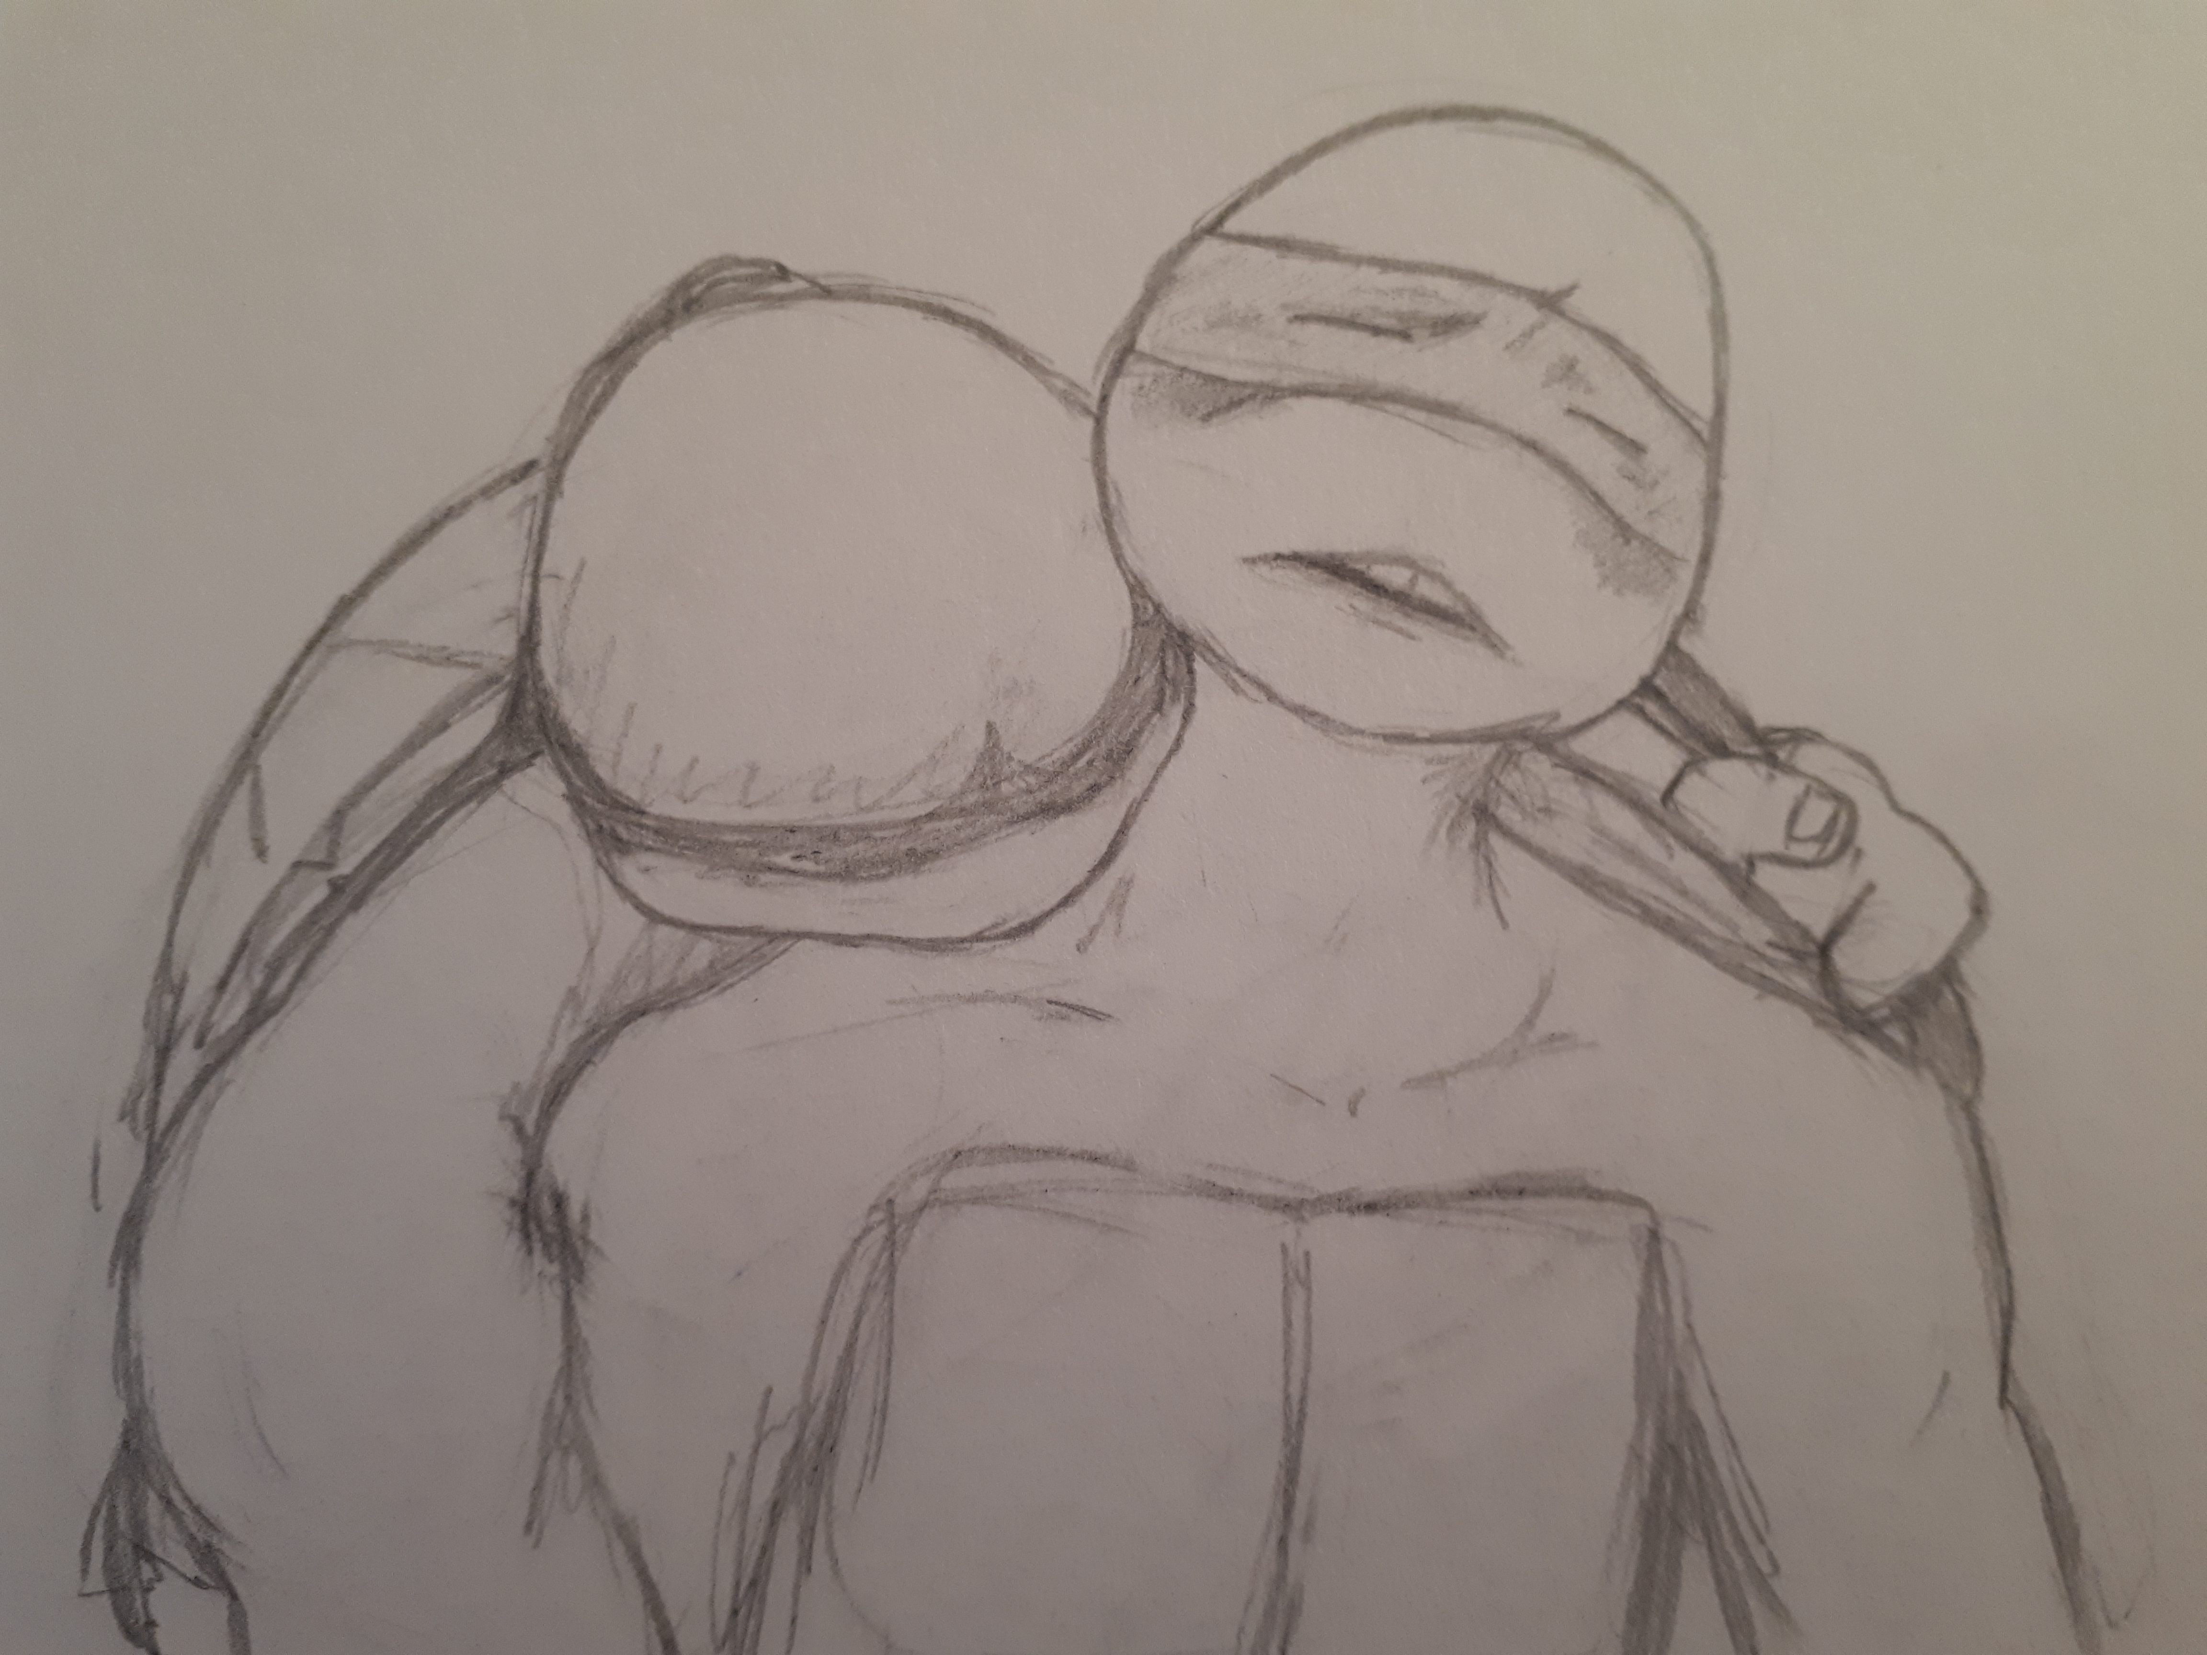

Leo had been rummaging through the kitchen cupboards for his preferred blend of herbal tea after a soothing meditation session when he discovered Donnie’s sealed petri dish nestled in amongst the various packets of tea and jars of instant coffee, no doubt absentmindedly left there after brewing a coffee with his brain on too many projects at once. Leo vaguely remembered Donnie muttering about culturing different organisms and he wrinkled his beak at such a gross specimen of what appeared to be algae floating inside the dish, glad that it was sealed tight. He lifted the post-it note stuck to the top in Don’s unmistakable, unintelligible doctor’s scrawl labelling it a… ‘strange organism’? At least, that what Leo thought it said. Donnie’s handwriting was appalling. He sighed as he imagined Donnie; brewing his coffee with one hand, balancing his experiments in the other, no doubt also balancing some unfished trinket in the crook of his neck. As it all became too much he must have jettisoned the small glass dish to free up his hands and forgot all about it.
“Hey Raph,” Leo called to Raphael as he saw him ambling past the kitchen, “pass this back to Donnie would you please, and remind him that our place of food is not a storage area for his mould, organisms, or whatever this is”.
“What did ya last slave die of?” gruffed Raph in indignation, starting to turn away. “Give it ta him yourself”.
“Oh you’re passing right by his lab anyway,” Leo said, knowing Raph would be heading toward the dojo to hit the weights at this time. He tossed the dish to Raph who caught it more out of reflex than trying to be helpful. “I’m busy”. Leo turned back to the cupboard, apparently satisfied that his orders had been given and set in motion. Raphael snorted and rolled his eyes. Goddam Fearless giving his orders again. He had half a mind to hurl the dish at the back of Leo’s head but instead he strode past the kitchen with a scowl and into the living area where he saw Michelangelo, arms full of comics heading towards the stairs.
“Hey Mikey,” Raph called gruffly, fulling intending to pass the buck onto his younger brother, “take this up to Donnie’s - ”
“Sorry brah!” Mikey interrupted over his shoulder as he kicked it into high gear and disappeared upstairs at an impossibly fast ninja speed reserved especially for when someone was about to assign him a chore or when Raphael was chasing him for beat down. “I’m really, like, super busy right now, you should maybe ask…..” and his voice trailed off to quietly inaudible as he retreated up and away from Raph, sticking his tongue out for good measure. A faint bang could be heard as Mikey kicked his bedroom door shut behind him.
“Oh no, you don’t,” thought Raph. He had a date with his weights and didn’t want to be tracking down Donatello who could be either all the way over in his lab, or even further up the garage. He followed Mikey up to his room, opened the door and tossed the dish into the lap of his surprised younger brother.
“Hey!” Mikey yelped, dropping several comics as he scrambled to stop the glass dish from sliding off the comics stacked on his lap into the floor. “What’s this?”
“Something you need to give Genius,” Raph replied, turning to leave. “Leo said.”
Mikey squinted at the post-it note atop the dish. “What’s this note, like, instructions?”
“Yeah, yeah,” Raph said dismissively, “Very important that Donnie gets exactly that. Er, Leo’s orders. See ya.” And with that Raph was gone from the doorway, leaving a confused Mikey staring that the dish, trying to decipher Donatello’s writing. Leo’s orders? Mikey wasn’t sure why Donnie needed this so urgently, or why at all, but his experiments were beyond Mikey’s understanding and if Leo was insisting……
Mikey brushed the comics off his lap and set off in search of Donnie.

“I can feel you hovering, Mikey,” Donatello said, not looking up from his laptop where he was steadily typing, seated at his desk. Mikey shifted from foot to foot in the doorway for a minute before entering the lab. After a moment’s hesitation he shut the door behind him.
“Hey dude, I just came to…uh…” Mikey trailed off as he considered Donatello. He trailed his eyes over his long, taut body, currently leaning forward slightly as he gazed intently into the screen. Donnie frowned slightly but didn’t look up or stop typing.
“Spit it out, Mikey,” he said, distractedly. When Mikey didn’t speak for a minute, Donnie didn’t seem to notice. Mikey was sure if he stood there long enough that Donnie would forget he was there altogether. After another minute’s silence, Mikey cleared his throat and stepped toward Donnie, standing behind his chair.
“I came to give you this,” Mikey said, placing the petri dish on the desk beside Donnie and tapping the post-it note meaningfully. “I know how important your experiments, research or whatever is to you, and Leo insisted aswell….so….” he trailed off.
“Mmm hmm” Donnie hummed, briefly glancing at the dish, still typing and only half paying attention.
“So, uh. Yeah.” Mikey stood unsure for a few seconds before placing his hands on Donnie’s shoulders.
“So, it’s not good for you to slouch forward like that bro,” he said. “You’ll get kinks in your neck”.
“Mmmmmm.” Donnie replied. He continued typing for a while before he noticed that Mikey had not removed his hands, and was slowly rubbing his shoulders with the palm of his hands, moving from the tops of Don’s arms to the base of his neck and back again.
“What are you doing, Mikey?” he asked, glancing away from the screen sideways for half a beat.
“I’m helping you out dude,” said Mikey. “So just sit back”. He gripped Donnie’s shoulders tighter and pulled him back against the chair’s back rest, applying firmer pressure as he kneaded his brother’s shoulders with his fingers.
“Mmmmmm,” Donnie hummed again, slightly closing his eyes as he realised just how tight his shoulders had become and how nice it felt having them being massaged. All the turtles had strong hands and firm grip but Mikey had especially strong fingers and wrists from the nature of using his weapons and Donnie could feel his muscles starting to give that pleasurable ache as the lactic acid build-up released.
“Ok then, maybe for just a minute”, he said, letting his hands drift away from his keyboard. Mikey massaged his purple banded brother for a good 10 minutes, kneading away the knots and kinks, and drawing the occasional hum and grunt out of Donnie. His eyes had drifted closed and he was noticeably more relaxed than before. Mikey started to run his hands down Donnie’s arms, half massaging and half squeezing his biceps. He then ran his hands across Donnie’s collar bone, massaging the front of his shoulders and just above his plastron.
“You’re good at that,” Donnie grinned softly, without opening his eyes. Mikey leaned down close to the side of his brother’s head. “You like that?” he murmured, his warm breath ghosting over Donnie’s neck.
Donnie opened his eyes as he felt a flush creep through him at Mikey’s low tone. It was only a few short months ago that all four brothers had awkwardly and haltingly discussed their growing desires for one another, and they were still quite shy and unused to each other’s touch. No-one had progressed further than a bashful kiss and a longing glance, so Mikey’s proximity gave Donnie sudden butterflies in his gut.
“Uh, yeah. You were right….my, uh, back was feeling a bit…..stiff,” Donnie said. It was only a massage….. right?
Mikey began running his warm hands up and down Donnie’s chest, applying pressure with his palms in some places, and dipping his fingers into the grooves between scutes in others. Donnie flushed a little more as his body started softly buzzing at Mikey’s new touch. Mikey’s hands roamed all over Donnie’s chest and sides as he leaned over him from behind, never moving his head far from the side of Donnie’s.
“I can do more things you’ll like” he murmured into Donnie’s neck and began softly kissing it as his hands continued to roam across Donnie’s body. Donnie let out a small groan as he tilted his head slightly to the side to give Mikey more access. He had fantasised about a moment like this for so long but had been far too bashful to make it happen himself.
Mikey noticed that Donnie’s lower plastron had begun to bulge in response to his attentions, and trailed his right hand lower, trickling his finger down Donnie’s centre line. Donnie gasped softly and squirmed slightly in his chair as Mikey’s hand gently rubbed over the bulge.
“That’s it Donnie,” Mikey whispered into his ear slit, “Get yourself nice and hard for me”.
Donnie’s chest rose higher as he started breathing harder, his cheeks flushing a deep shade of red. Mikey’s hand felt so good and gave him nervous butterflies deep in his gut. However, Donnie also felt self conscious at this sudden onset of attention, and while his body responded, his mind started to whir at what was happening, what it could mean, possible repercussions, the others’ reactions, where all this was suddenly coming from. He continued to squirm slightly and made a stuttering noise.
“M..Mikey….” He started.
Mikey could tell by the way Donnie was holding back that he was unsure. He knew the way his brother’s mind worked. Donnie wasn’t used to listening to his body and being ‘in the moment’ and the little squeaky noises that were starting to build in his throat indicated that he was on the verge of a case of serious overthinking. To nip this in the bud Mikey brought his left hand up to the back of Donnie’s neck and entwined his fingers in his brother’s purple mask tails. He wrapped them firmly around his fist and pulled his hand to the side, forcing Donnie’s head to follow. Taking Donnie’s exposed neck and shoulder into his mouth, Mikey bit down and held Donnie firmly between his teeth. Donnie gasped again at the sudden display of dominance.
“I said drop down Donnie,” Mikey commanded in a deep guttural tone, his thumb rubbing circles around Donnie’s barely contained bulge and his other hand pulling at Donnie’s mask, keeping his head tilted to the side. “I want you hard for me. Now. Get hard for me Donnie”.
Donnie let out a short whimper and panted out a couple of shallow breaths before dropping down into Mikey’s waiting hand with a small moan. He started squeezing and releasing the arm rests of his chair as Mikey gripped his swollen dick and began slowly rubbing his closed palm up and down the length.
Seeing Donnie’s reaction to his command, and how he had instantly changed from apprehensive to compliant, made Mikey realise that his brother liked to be submissive. Yes, he was naturally the least aggressive out of all them, and Mikey realised with a wicked smile that Donnie reacted rather favourably to obeying commands in an intimate scenario as well as on the battlefield. His own lower body started to tingle and twitch at the thought of dominating a compliant Donatello. That was a delicious thought indeed. (Is this how Leo felt every single day?). Mikey knew now how he planned to blow Donatello’s mind. They always said he was a talker. Well now he was going to put that skill to good use.
“That’s it Donnie, good boy,” Mikey murmured in a deep, smooth tone. He swirled his thumb over the top of Don’s swollen penis a few times, collecting the pearls of pre cum and using it to slick the shaft. “You get nice and wet for me Don,” Mikey continued, gently biting up Don’s neck. He continued to pump Don’s rock hard dick, a shlicking sound forming from the juices leaking from the tip.
“You hear that, Donnie?” Mikey asked, pumping faster, continuing his low tone against Don’s neck as he felt Donnie tremble slightly underneath him. “You’re enjoying that aren’t you?”.
Donnie gave another soft moan in response and gripped the arm rests. Mikey’s hand felt so good, he’d wanted this for so long. But his mind still had trouble trying to shut down. His body and mind were at odds and he still had the tiniest amount of trouble letting go. Even though it felt so good. Donnie half opened his eyes. “Mikey - ” he breathed.
“I’m gonna make you cum Donnie,” Mikey cut him off, increasing the speed of his hand. Donnie’s eyes rolled back and he closed his eyes as a spike of pleasure spasmed across his gut at Mikey’s words. “I’m gonna hold you here, and stroke you, and kiss you, and bite you, until you cum real hard.” Mikey said gruffly, again biting down on Don’s neck.
Don whimpered as the last of his thoughts gave up the fight. Against Mikey’s show of dominance and commanding dirty talk he felt his gut tighten and breathing get heavy as Mikey’s hand continued to send waves of pleasure across his lower region. Obviously Donnie had pleasured himself on many occasion, but he had never experienced someone else’s hand, someone else’s technique. And Mikey’s technique was extremely skilful, as he pumped Don’s slicked shaft, twisting his hand, squeezing the tip, getting steadily faster. Don began to pant, a loud, rolling chur erupting from his chest.
“Uhgg….Mikey…” Don panted and arched his back into the chair. He tried to pull his head back level but Mikey held onto his bandana tails and pulled a little harder, making Donnie go weak all over. He felt held down and helpless as his brother used his hand to build up a pleasure wave which was growing in intensity and threatening to crash. And it was the most turned on he’d ever felt in his life. Donnie let out another long moan, losing himself to the sensation.
“Oh yeah Donnie, show me that you like it”, Mikey breathed, painting a wet stripe across Donnie’s jaw with his tongue, his fist pumping Don firm and fast. “Let me hear you lose your shit and cum so hard into my hand”.
Donnie started to moan louder as his control slipped completely away and all he could focus on was the spiralling pressure. Mikey’s attentions were relentless and whenever Don’s brain attempted to start up a dialogue, the sensations across his body shut it down with ever increasing throbbing waves, building, building….
“You close Donnie?” Mikey could tell that he was, lightly nibbling at his jaw, murmuring in that smooth, low tone that was making Don’s legs shake. “You getting close?”. He listened with great satisfaction to the breathy wanton moans as his brother writhed beneath him, now helplessly lost to the feeling of Mikey’s hand, twisting, squeezing, rubbing, pulling him to the brink.
“Uuuughh….mmm….so close….” Donnie breathed, panting shallow and fast.
“Good boy Donnie,” Mikey whispered against his cheek, “cum hard for m - ”
With a cry, Donnie arched his back as far as his shell would allow and spurted his load onto his plastron, his cum shooting out so hard it flew right over Mikey’s hand. Mikey continued slowly rubbing and pumping as Don’s dick throbbed and pulsed in his hand. Mikey had never heard such wanton, raw sounds of pleasure from his brother as he rode the waves of his orgasm. Shell, it was sight to behold and made him feel tingly all over.
After about 5 minutes, Donnie slowly came back to Earth, his body relaxing and he opened his eyes.
“Shell Mikey”, he said, having not quite caught his breath. “That was……. shell…” he sighed, rolling his head back and licking his lips. “Just….wow…”
“Excellent,” Mikey beamed. He turned as if to leave, paused for a second, then turned back and leaned down to capture Donnie’s flushed lips with his own. “I am so doing that again dude”, he smiled into Don’s mouth. “That’s a project I can totally get on board with.” And with a soft caress to Donnie’s cheek and a flutter of orange mask tails he was gone, out the lab, closing the door behind him.
Mikey saw Leo in the living area, sat on the couch reading a comic, while Raphael sat on the far end playing a video game.
“I did it”, Mikey announced with a grin. “Mission accomplished.”
Leo looked up from his reading. “Did what?” he asked.
Mikey presented the post-it note to Leo, as if proof of execution. “Raph said you told me I needed to give Donnie this, on the note,” he said. “For his experiments or research or something?” Mikey danced a little on his toes, obviously pleased with himself. “Let’s just say I met the request, and then some. You’re welcome.”
Leo took the note in mild confusion at Mikey’s triumphant twinkle and glanced at it again. “Ok, cool,” he said, “so you gave Donnie his dish of organisms?”
Mikey’s self satisfied demeanour faltered a little as he asked, “his dish of what?”
“Organisms”, Leo repeated, turning the note around to face Mikey. “Donnie’s handwriting is appalling but I’m pretty sure that’s what it says: Strange Organism”.
Raph stopped playing his game and looked between the two as Mikey’s face fell into a mortified expression.
“What?” Raph asked curiously, taking the note from Leo so he too could read Donnie’s doctor’s scrawl.
“Du - ude!” Mikey squeaked, his voice growing breathier and higher with the realisation that he had completely mis-read Donnie’s note. “I thought that said Strong Orgasm’!!!!!
Raph burst out laughing as Mikey’s hands flew to his face in embarrassment. Leo’s mouth fell open in shock.
“Dude!!” Mikey whined from behind his fingers, “Raph told me you told me to give that to him. I thought it was, like, an instruction! For one of his projects or something!”
Leo stared at Mikey with wide eyes. “So you…. gave Donnie a……?”
“STRONG ORGASM!!!!” Raph roared, positively howling with laughter.
After a beat, Leo too erupted into uncontrollable laughter as Mikey fled the room, his brother’s howls of mirth ringing in his ears all the way to his room.

