SS 4dis – Sonic Sonic: Living 4 dis moment

[Sorry if something is wrong with the grammar. Comment if you think a sentence needs to be fixed]
[Original Word File has images, everytime a character talks, a small photo with the face and expressions they are making appears next to their dialogue. Download original file for watching them]

PART 3: PARTY CRASHER
The night was just starting for Sonic. He has been sneaking into his family’s home for the last three nights just to sleep. It seems he couldn’t pay the rent for his new apartment, so he got kicked out. Only Tails and Sonia know about it, and Sonic feels like if he tells the rest of his family about it, he’ll get a heavy lecture about how he is still not mature enough for the “real” world.
Sonia was in her room chatting in front of her computer, listening to her favorite music, just as another normal night. As mentioned before, she knew about Sonic entering in the house during the last nights (Sonic made a little mistake when he felt hungry, going to the kitchen and finding Sonia in the stairs at his way back to his room) so she was expecting to see him soon.
Suddenly, her phone made a noise, she got a text message. It was laying on her bed, so she had to stand up and pick it. Sonia unlocked it’s screen, it showed it came from her brother Sonic, saying:
“SIS, OPN YOUR WINDOWw yoU MUTS SEE THIS!!!!!!!!!! ”
Sonia rolled eyes and walked towards her window. Her room was on the second floor, she was a little bit curious. Yesterday, Sonic surprised her scratching the glass while saying “Tonight is your last night missy Mua-hahaHA!”. She got so scared she left Sonic hanging there until he apologized. “Those kind of jokes are not very funny, Sonic!!” she yelled.
Sonia peeped outside her window, she just saw Sonic standing outside, putting his finger on his mouth as if he were saying “Shh”, letting her know to be quiet and not to make much noise. Then he took out his phone and texted her
“OPEN THE INDOW I SAID”
Sonia felt a little uneasy and opened it. Sonic waved his hand, telling her to move out of the way. As she did, he quickly made a very long jump and entered into the room making an amazing trick!
 -AAAAAND SONIC WINS THE GOLD MEDAL… AGAIN!!!
 -Shhhhhh! –said Sonia, not very impressed.- Manic or mom are going to hear you!!!
 -Ah! I forgot! –Sonic said, while quickly putting both hands on his mouth as if it were going to mute all the sounds in the world.
Both remained there without moving a single muscle for a few seconds, listening carefully to their own silence.
 -Geez Sonic… If you don’t want to talk to mom about this, I’ll end up doing it for you…
-No Sonia! You can’t let her know about this! –Sonic said nervously.- There is still a crazy bunch of things I want to do before returning with you guys, crazy bunch of things mom doesn’t want me to do!
-Shhhhhhh! –she covered his mouth- You’ve been out of home for YEARS already, having all kind of adventures with your friends… don’t you think it’s time to seriously come back, stay with us and finish school maybe?
 -School? Come on Sonia! All this years of playing “being normal” has made you boring… -He said while jumping to her bed, lying down and relaxing.- Heroes don’t go to school! –ended, with his typical joyful tone.
Sonia sighed. Making Sonic return to school was impossible, even if the entire family tried it.
 -Either way, Sonic… what is this bunch of crazy things you want to do, but mom doesn’t like?…. Hmm… Sonic, don’t tell me you are into illegal stuff.
 -WHAT? NO WAY!!! –said while laughing- Sis, you know me! I am in the side of the good things in life!
 -Such as… not going to school, do extremelly dangerous moves at high speed, not paying rent and hide stuff from your dear family? –Sonia sat next to him.
-You make it sound really bad when you say it that way… -he made a pause, then he continued.- I did a great job in giving lil’ Tails a good example, just look at him! You can’t say I wasn’t an influence!
-A very negative one. If he were able to study more, he could be able to reach higher places, Sonic…
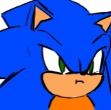-Man there is a reason of why I don’t like living with you! –Sonic crossed his arms and just stared into the roof. Both of them remained silently for the next minutes. Sonia returned to her chat in her computer, playing the music she likes. It was a catchy pop tune. Sonic relaxed quickly and started moving his head at the music’s rhythm. Beside the music, the only sound they could hear was Sonia’s keyboard.
An hour went by, Sonic was already sleeping on Sonia’s bed, and Sonia was still on the computer, making giggles from time to time. She has stopped the music so Sonic could sleep better.
Manic was in the next room,he had already figured out Sonic’s situation, and he could hear his annoying joyful voice tone coming from the other side of the wall some hour ago. He kept himself in his room thinking about the facts, and then he made a decision.
Manic took a deep breath.
Silence.
Focus.
Then he walked towards Sonia’s room, slowly opened the room, she got surprised.
 -Manic!
But his face showed no expression, he just kept walking, not towards the sleeping hedgehog.
Manic stood next to the bed, just starting at him.
My, what an intense glare.
His glare was so intense, Sonia started feeling as if the air in the room slowly became poisonous.
Silence.
More silence.
…
…
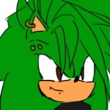 -Sonic… brother, wake up. –said Manic with a gentle voice.
Sonic’s ears twitched, and he slowly opened his eyes.
 -Huh…. Manic?
Manic gave him a warm smile.
Then he punched Sonic in the face.
Sonia made a weird noise of surprise.
Manic punched him with such speed not even Sonic expected it. It had so much strenght on it the blue hedgehog fell off the bed.
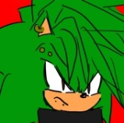 -Give me back my Orbe! Give it back now! –yelled Manic.
-HEY! That was uncool! –said Sonic while getting up from the floor, with a big red mark on his face.
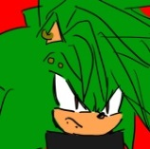-What? You don’t have enough yet? Give me back my Orbe!
-SHHH! You are making so much noise! Mom is going to find out! –Sonia quickly went to close her room’s door.
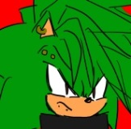-I just want my Orbe back!
-Bro I seriously don’t know about any orbe!
-Hey Sonic… you don’t remember Manic’s Orbe? The last time you ate dinner with us, Manic had just returned from an “adventure” just like you, he spent the entire dinner time talking about it! –stated Sonia, crossing arms, and talked in a very low volume. – Seriously… when he showed us his Orbe, you even said “Wow can I keep it? It’s so pretty I might steal it from you some day!” so just give it back already…
Sonic’s brain started working back again.
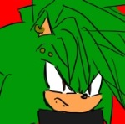-And you don’t even remember my story? No wait, of course no one remembers my story, everyone is fucking occupied giving prizes to Sonic the Hedgehog!
-Manic, don’t curse… we know Sonic, he never takes nothing seriously.
-Wait that’s a lie! I am a grown up adult now! Manic, I am sorry about your Orbe! But I didn’t take it from you –Sonic said while standing up. The red mark in his face started hurting, hidding it with an embarrassed smile.- …when did you become this fast anyway…? He-heh, lets have a race soo
Before finishing the sentence, Manic punched him again. Sonic didn’t had the chance to see him move once again.
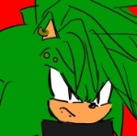-This is serious! The orbe I had is very important! The fact that you are not the one who took it makes the issue even worse! Don’t you remember it’s function?!
Took a few seconds for Sonic to talk.
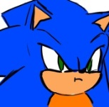-Forgive me brother… but ok, I admit I don’t have any idea about this Orbe thingie! –said, a little bit uneasy, laying on the floor, watching stars and chillidogs float around his head, that punch was still fierce.
-Sonic, you FOOL!! My legend begins in the 12th century…
-Don’t say it just as if you begin every morning with a cup of coffee!!!
A minute later.
Manic sighed in anger, walked around the room, scratched his head, looked outside the window, he just thought about about it a lot until he finally calmed down and sat on Sonia’s bed side. Sonia kept her eyes on him all this time, very worried about all the noise they make.
Sonic finally stood up and sat next to him, his face felt as if it was on fire, but he acted cool about it.
-The Orbe of Worlds… -Manic finally said, crossing both arms and legs, getting ready to make a long explanation to his care-free brother.- It holds all information about all dimensions and it’s different time lines, if you find it, you are able to make a wish, any wish. I heard it has a shaft, but that one is out of our reach, it’s not in this universe… -he made a long pause.
Sonia sat on her bed with them, she already knew the story, unlike Sonic who wasn’t paying attention to his brother the first time he told it.
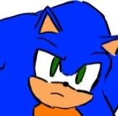-… And you found it. Ok I get it! So what kind of wish did you ask for? –Sonic rub his face while saying this.
-My wish… I am not telling.
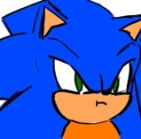-… … … ………….. … Will… I ever know?
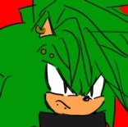-No! Let me finish! –the Green Hedgehog started talking slightly louder, as if he were scolding Sonic.- It took me a lot of effort to find it! Of course, this happened when you were dealing with the Furious Five and the Dragon Warrior! So no one noticed my adventure!
-They were called the Deadly Six, Manic, there was no Panda between them –said Sonic with a little laugh at the end.
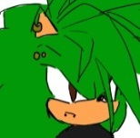-I don’t care. I just can’t never be recognized at nothing and it’s your fault… in school, everyone knows me as “Sonic’s brother” instead of my name! I am sick of it! And you aren’t even that good! I mean, just look at you, you can’t even pay your rent! It’s unfair! Me and Sonia are trying really hard, and you get all the claps doing something you almost see as a game! Your whole life is a game!
Sonic made a shrug, he did felt a little bit sorry about it, but it wasn’t really planned to be like that; Sonic just made what was correct all this time, having a good time with his close friends, he never imagined it would have such a negative impact on his family, on Manic particularly.
Sonia shared the feeling a little bit. Being shadowed by the good hero wasn’t always nice.
Sonic is such a good boy, no doubt about it, so he suddenly felt an urge to fix everything with his family, he even wanted to make Manic feel better about losing such important object.
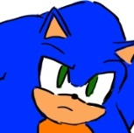-… is there something I can do to make you feel better, Manic?
It was the very first time Manic and Sonia ever heard Sonic said something with such a serious voice. Maybe, just maybe, he was indeed becoming an adult. Manic thought about it for a moment.
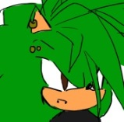-I won’t tell you what to do, if you really want to do something for us, think for yourself.
Then Manic stood up and walked out of Sonia’s room.
_________
The time has passed, it’s finally Saturday!
Everyone is moving in Westopolis City’s main Garden, in front of the Presidential Building. The party for Sonic is finally ready to start, though this event officially starts at 7 p.m. Sonic has arrived early to help, though his main purpose was to “customize” some things so it could seem more welcoming, and less formal.
He was just in the entrance speaking with the Organizer lady.
-…And when everyone enters, you give them their present! Remember, each box has a silver watch, a letter thanking their presence, a chocolate cookie and a party cone hat!
Sonic was quite excited that day. All the people he ever knew was invited to the party, even his old rivals or old friends.
-But Mister Sonic… don’t you think the last two things in the present box are a little bit… uhm… childish? –the organizer wasn’t very sure about Sonic’s modifications.
-Childish? No, it’s a party after all!
The organizer just sighed and continued reading the things they needed to check. It was almost time to start. The first people to arrive are Sonia and their mother.
-Oh hey welcome!! –he quickly handed them a present box.
Aleena took it and opened her arms, giving her son a big warm hug.
-People say my kid’s accomplishments leaves much more pride in me than my own accomplishments! I think that’s true, congrats Sonic!
-Just don’t brag about it, brother!
-Hey don’t think much about it, I just do what I do best! Anyway, where is...
Sonic was just about to ask for his brother Manic when he saw someone else in the entrance. This “figure” also entered in the garden, feeling a little bit unconfortable in that fancy suit.
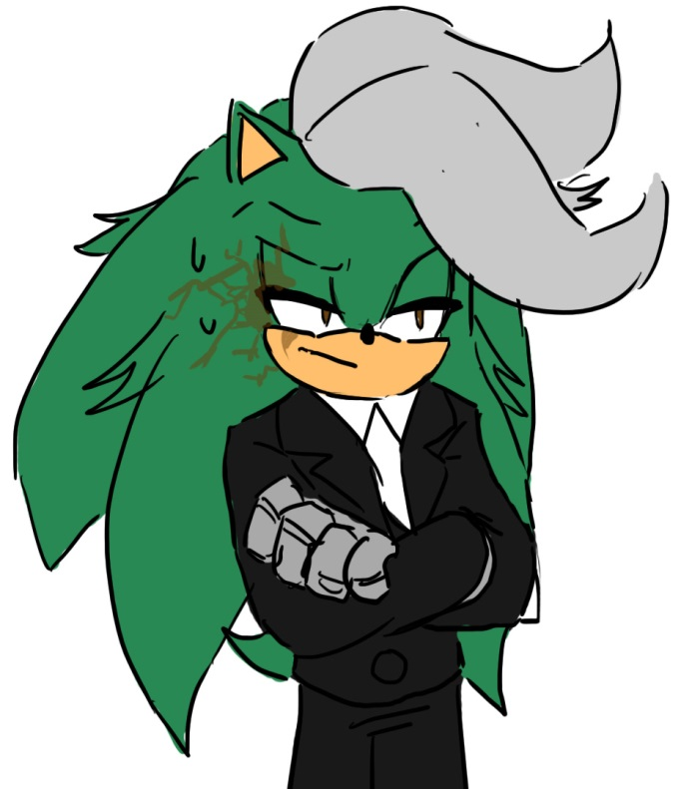
It was Jules Zokar, also known as the first “fastest hedgehog in the world”, also known as Sonic, Sonia and Manic’s father.
-Sonic my baby, guess who is with us today?
Though Sonic don’t needed to guess, he knew it was him. Then Jules spoke:
-This party has a lack of bouncing castles.
It was the first time in years Sonic heard his actual voice.
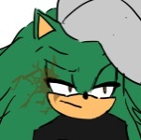-Sonic boy, haven’t seen you in quite a while, do you still wet your bed?
Instead of feeling happy to see his father, Sonic felt quite angry inside, but decided to play it cool as always. Jules was never home, just like Sonic, and the last occassions Jules spent with his family, his body was robotic.
-Jules! Woah nice look! What happened to you? You are back to normal!
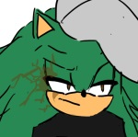-I’ve been… doing stuff. I am not fully flesh and bone, my arms are still heavy pieces of steel, I think they look pretty awesome. And ouch, why none of my children likes to call me “dad”?
-Umm… -the Organizer interrupted.- Welcome to Westopolis’ Main Garden, I have an assigned table for all of you! Would you like to follow me? The main ceremony will start at 9:00 p.m., so relax and order something to eat…
Sonic stayed there in the entrance, still a little bit surprised. It took him a second to realize Manic was not there. “So he’s still mad with me?” is what Sonic thought. Then he started wondering if uncle Chuck would also come to the ceremony if he could still be here…
The others followed the organizer, she had prepared a special table for Sonic’s relatives, almost in the front. Sonia was very impressed while looking at the other tables, they were all reserved to very important people around the world. Her brother was indeed famous!.
The minutes passed, the President of the United Federations was finally there, accompanied with Commander Tower. They both went to introduce themselves to Sonic’s family before receiving more guests.
-Nice to meet you, and thank you for being so kind with my son!
-Nice to meet you! Wow to think I am able to greet you personally makes me feel like a celebrity!
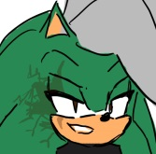-Hey so you are the big fishes here? I wonder how big your houses are…
-Dad, don’t say such things!
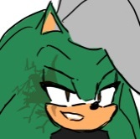-oh my you called me “dad” I’m so happy.
Slowly, the tables started to get full. Each country’s representatives felt very welcome when receiving the box presents, and they thought it was a nice touch to add a cookie and a party hat.
Speaking of important representatives, Princess Elise of Soleanna has just arrived. She received a present box like anyone else, Sonic got quite happy to see her even if she had no memory of him, she definetly looked very grown up now! Princess Sally Acorn had also arrived, though she did not wanted to see Sonic, so she just walked forward her table… I wonder what happened between then. Everyone was wearing fancy clothes.
It was an open event, all kind of people was there, not just representatives, even citizens of Westopolis and some Media companies are gathering.
He received everyone at the door with the President, just as planned. Sonic got a little bit impatient when his good friends Tails and Knuckles were not there yet… He even saw Shadow and Rouge enter, but not as guests, as security reinforcement. Shadow had a brand new pair of “shoes”, they looked a lot like Eggman’s work.Rouge spoke to him for a second, saying just “Congratulations big blue. Yes we are invited, but the Commander has decided we deserved to work tonight… sigh, I even had a new dress for tonight” she seemed pretty upset about wearing the common G.U.N. uniform, then they left. It all seemed like the Commander Tower planned on not letting Eggman crash the party or the ceremony, there is a whole bunch of agents surrounding all areas. Sonic thought for a moment that there was a hidden agent under each table!
Some minutes has passed, it looks like everyone in the list is already here, except for Tails and Knuckles… okay, also Eggman. The President decided it was almost time to start the event.
-Young Sonic, it is time for me to get ready, you should go sit with your family for now.
-Alright sure Mister President! I am feeling a little hungry, I hope my mouth can eat as fast as my feet can run…
The President made a little laugh and left behind the stage they got ready for the occassion. Sonic sighed and thought “Oh man are Knuckles and Tails really coming here?” while walking towards the table where his family is.
He sat next to his father, he had a few questions to make him.
-Yo Jules! So you’ve been seeing mom latelly?
-Yes, and the fact that I am back to normal makes her happy. I want to spend some time with my… family before dealing with something. I wanted to say this as a surprise for you and your brothers, I have been sneaking into the house for the past few nights, it’s something quite fun to do, actually!
Sonic got shivers down his spine, for a brief moment, his father sounded just like him.
-Almost as fun as getting punch by your brother… Sonic, don’t you have something to say to mom?
The blue hedgehog was caught off guard. Being Jules Zokar also a free-spirit, he knew what his son was hidding from his dear mother, he was able to see through his son.
-HUH?! –Then Sonic remembered to act cool, and maybe change the subject.- You mean… you want to stay with mom for a while and then leave again? You may be the one who needs to say something to mom!
Jules knew what Sonic was trying to do, so he made a care-free laugh. Aleena just kept listening to them carefully, trying her best to find the true meaning of their words.
-Me? Sonic, that sounds like you are trying to blame me for something! Chill down, your mommy knows I’ll be leaving again anytime. I am a guy who likes adventure…
Mom made a slightly sad face. Sonic felt a little bit angry. Being a man of adventure doesn’t mean he is completely free to avoid the people who loves him the most… wait, wasn’t Sonic following the same path?
-You are still a kiddo!
Before Sonic could get a feeling about it, the Organizer got on stage and started talking using the microphone.
 -Good night and welcome! Tonight we are celebrating that the world has entered in a time of peace! We need to thank everyone around the world, but there is also someone who has highly contributed to bring peace, and that is also why we are all gathered here! Tonight we are giving a token of appreciation to someone we all know for being brave, good-hearted and fast!
Everyone started clapping. Sonic felt very happy!
-And to start, I will present you the President of the United Federations; Mister Harold James!
[Author’s comment: even if the President has appeared in a couple of games, his name is never mentioned, so I invented one for him]
Everyone clapped, all camera men was ready to record all the things he says.
Then the President got on stage, he was carrying something heavy, though it was covered with cloth. He reached the microphone, cleared his throat and started talking with that famous firm tone of his.
-I am very grateful to know you all accepted my invitation for tonight! I hope you are all having a pleasant night, I got my party hat ready for when the music starts. –then he took his colorful paper cone hat and showed it to the audience. Everyone laughed and waved their party hat in the air. Sonic felt very good with his choice. Then the President Harold continued.- Yes indeed, just as mentioned before, we are here to celebrate peace, and thank someone specifically for it! We know him, his name is Sonic the Hedgehog!
Everyone clapped even harder. Sonic got all hyped. The President made a gesture that invited him to get on the stage, he got there in a second.
-Sonic the Hedgehog, as a token of our apreciation and gratefulness, I have decided to give you this!
The President took of the cloth that was covering the thing, it was a very strange golden trophy with a small square piece of glass in the center, it had the size of one of Sonic’s legs and was shaped like a regular stick. Sonic has never seen something like this.
The audience looked at it with curiosity, waiting for the President to explain what it is.
-Ladies and Gentlemen, this is the Tool of Heroes!
Sonic looked at it closely, it all just seemed very old.
-It has the ability to become any tool you need! But, it can only be used by those whose heart is pure, so Sonic, I am giving it to you, I am sure you will find it useful! .- Saying this,he handed it to Sonic, it sure was heavy. All people started clapping with excitement. Aleena, Sonic’s mom, even stood up just to clap.
Then the President made him a sign so he could get close to the microphone to say some words. Sonic knew he needed to say something at the end, but he just never really figured out what to say. He took a few seconds to think, then he finally said:
-Wow, this feels great! You are all so kind! But, there is something I want to make clear, I have never been alone. I rely on a lot of people, I wish I could bring them all with me here! … .- he took a moment to look around the audience, he first looked to the table where his family was, then he searched for Sally, then he saw many more familiar faces: Amy, Rouge, Shadow, Vector, Charmy, Espio, Wave, Jet, Storm, Professor Pickle, Bonnie, Princess Elise… then he searched for Knuckles and Tails, which could not be found yet. He also thought about Manic.- Um… So actually, even if I am the one getting the prize, this party is dedicated to everyone who I have met so far! Thank you for those great experiences! I mean, I would even thank Eggman if…
Sonic was just about to end his little speech when he saw how, finally, Tails and Knuckles arrived. Knuckles looked all angry, as if he was being kept waiting. Tails was followed by people who worked with him in his workshop. They made almost everyone turn around just to see them, Tails was also well known, and very popular recently. Everyone started talking between them just to mention Tails’ late arrival. Sonic had to wait a moment for the public to be in silence again. Tails looked at him and made a sign of apology. Knuckles just had a dumb smile on his face now.
Then Sonic finally continued:
-Uh… anyway… Thank you everyone! .- He took his prize and raised it to the air with a big smile on his face, even if the thing was heavy, everyone clapped. A lot of photographers took shots of that. Then Sonic left the prize there so it could stay for the show of others until the night ends. He walked off stage and went back to the table where his family is, that received him with smiles and claps.
Minutes passed, some people wanted to go up and say some words for Sonic, people like other presidents or representatives from other places he’s been in, not just from that continent, everyone was grateful with his efforts and kind heart. Even Sally stood up just to say how good childhood friends they used to be. Knuckles got up there just to tell jokes, everyone was laughing, he ended just saying “oh and thanks for the good times, blue one”.
At the end, the organizer took back the microphone just to announce the party was ready to start! A band went on stage and started playing catchy music. In the middle, the Tool of Heroes was still at the sight of everyone.
Some people ordered food, some others stood up to dance. Some representatives went to Sonic’s table just to shake his hand and tell him they count on him, also so they could get a photo with him. Aleena and Sonia are very excited.
After going through a bunch of hand shakes and photos, Tails finally had the chance to come close to Sonic. Being followed by a boy, Tails spoke to Sonic.
-Congratulations on getting the Tool of Heroes, Sonic!
Tails seemed quite excited as well, the boy behind him smiled too.
-Man you missed part of my speech! What happened?
-Well… we got a little bit carried away with work. Uhm… -Tails made a small pause to look behind him.- I want you to meet someone!
The boy gave a step towards Sonic.
-This is someone I met when picking Eggman’s metal scraps, we call him Cliff! We have the same age, and we both like the same things, he’s so smart!
-Nice to meet you! Tails tells me a lot about you, Sonic! –Cliff said with a big smile.- I have been wanting to meet you for so long!
-Oh really? So you two have been hanging out? Cool! Now I can rely on two smart dudes and not just one
-Heheh! OH! I almost forgot! –Cliff took a small package out of his pocket.- I made something for you! Congrats for the prize!
He handed the package to Sonic. Tails seemed like he already knew about it. Sonic got happy and quickly opened it, it was a collar, with a blue ring attached to it.
-Before you think it is some legendary object, I should tell you it’s something I made –said Cliff, very proud of himself.- it’s very simple, I heard that keeping at least one ring with you is important, so I made a blue one for you! It also works as an antenna, you’ll be able to communicate with everyone everywhere, no need to worry about bad reception!
-Wow what’s with everyone giving me extra useful stuff I wish I had early ha ha?! –Sonic put on the collar and smiled. He made poses as if he were modeling it.- You know? It fits good, thank you bro!
Sonic heard how Tails spoke a lot about how both him and Cliff had built many toys so far. Sonic felt good knowing Tails finally had a friend who could understand those smart things. During the conversation, it turned out Cliff was now living in Eggmanland with his family, hearing the school will open there will only be for those who are very smart and are interested in science, either evil or good… :P .Later, Sonic asked Cliff’s real name, but he decided to keep it secret for now.
Everyone in there was having a good time, the band was still playing catchy music, it was music Sonic liked, some people was dancing and some other was enjoying a good meal. The President Harold was eating something, sitting next to other Presidents, just having a casual chat. Sonic’s family had just eaten early, so both Aleena and Sonia are dancing a little. Jules was still sitting with his arms crossed, just enjoying the music.
Everything was going fine.

Until
Red fireworks started shooting, but not from the ground.
A giant ship appeared from the sky, with beam lights pointing to the ground, the motors are making big noise.
Eggman!
Eggman’s ship!
It was him!
Everyone got alarmed!
All G.U.N. Agents are ready and in position, Commander Tower kept his calm and focused. He had enough security to bring down the ship, but that would just be absurdly dangerous in such crowded area, so he waited for Eggman to do the first move. Meanwhile, he choose a group of agents so they could send everyone to the safe spots placed in that same street.
All people started to leave with order and keeping the panic under control, then they heard Dr. Eggman’s voice through the ship’s speakers.
“Where is everyone going?! Isn’t this a party?! Is my big entrance such an intimidating thing?! I honestly find this funny!!”
Everyone looked up, the ship landed in the nearest clear spot: the car road next to the park. Good thing the streets nearby are closed to vehicles, or else he would have made angry to some drivers. All people was just looking at his enormous ship, not moving a single finger.
The main door opened and two plain Egg robots walked out.
Hurry! Sonic, with his incredible speed, ran and knocked both robots!
All people clapped to him in excitement, go Sonic!
Then he heard a voice coming from inside the ship, a voice that wasn’t Eggman’s.
-Aww, I had just repaired those!
It was a woman with small height, almost as tall as Sonic, she was wearing a fancy red dress under a white lab coat. Behind her, inside the ship, there are a couple of docens of people.
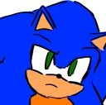-Huh? What’s going on here? –Sonic was very confused.
-Ah, Sonic the Hedgehog! –Eggman appeared, coming down from a small elevator inside the ship.- This is the part where I would say something like “Seems like this party needs fireworks” and just start shooting rockets away, but…
All the people came down the ship, all happy. “We made it in time, the party is still not over!” they were saying. Some robots came down the ship too, but they are just walking around instead of causing destruction.
-I had a greater entrance prepared for tonight! But some silly citizens of Eggmanland insisted in coming to the party with me! What a bother!!
Commander Tower came to the conclusion that even if Eggman was crashing the party, he wasn’t there to cause destruction, so he told everyone it was safe to go back and relax. He stayed very alert to all his movements, though.
Everyone relaxed down, even Eggman, who just had to sit next to the other Presidents, he didn’t seem very happy either way. The other Presidents felt a little but nervous, but tried to act nice.
His ship kept the door open just in case.
The music band went back to stage, still a little bit in shock, and continued the music.
Sonic was still surprised. He walked towards the lady in the lab coat, he wanted to ask her something, so he sat next to her.

Perfect timing.
The music got interrupted again, someone spoke in the microphone.
-Well! Seems it is my time to get your attention! Who would think I used to be a good hearted hero just like my son?! –it was Jules Zokar, Sonic’s dad. He spoke while picking up the Tool of Heroes.- Sorry Sonic, but I am taking this!
Being very fast too, he jumped off the stage, dodged everyone and got into Eggman’s ship, stealing it.
-WHAT?!?!?! YOU WON’T GET AWAY WITH THAT!!! –Dr.Eggman took out a small control out of his pocket, it controlled the robots around.
They all started jumping to the ship, trying to hold onto it, but Jules moved much faster, even in that big heavy thing, even some G.U.N. Agents nearby tried to run to it, Sonic was able move fast and almost grab one of the wheels, but the ship left everyone behind.
The ship disappeared into the black sky, with Jules and the Tool of Heroes.
The crowd was in commotion. Aleena was speechless, Sonia was furious, she waved both arms in the air and yelled:
-JUUUUUUUULES!!!!!! YOU ARE THE WORST!!!!!!
-Jules, that was totally uncool! –Sonic was angry too.
Everyone in there was in such shock! No one expected that! Not even Commander Tower! In the middle of the confusion, Eggman, and Rouge the Bat got close to where Sonic and the Commander are. She told them to calm down.
“No need to worry here. Shadow teleported into the ship before it left”
They are surprised, but now in a possitive way.
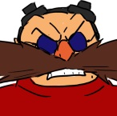-SHADOW, GET MY SHIP BACK FROM THAT PEST!! –yelled Eggman to the sky, as if Shadow was able to hear him.
-My…!! My mother was still inside the ship when it got stolen!! –the woman with the lab coat spoke behind them. The Commander and Sonic made a worried face.- But no need to worry, I am sure I can contact her, plus she is a very smart woman too!

[Continues in Part 4]

