A couple of creepy bastards and a Very Naughty Vixen proudly present:
Vulpine Confessions: “Sister Swap”
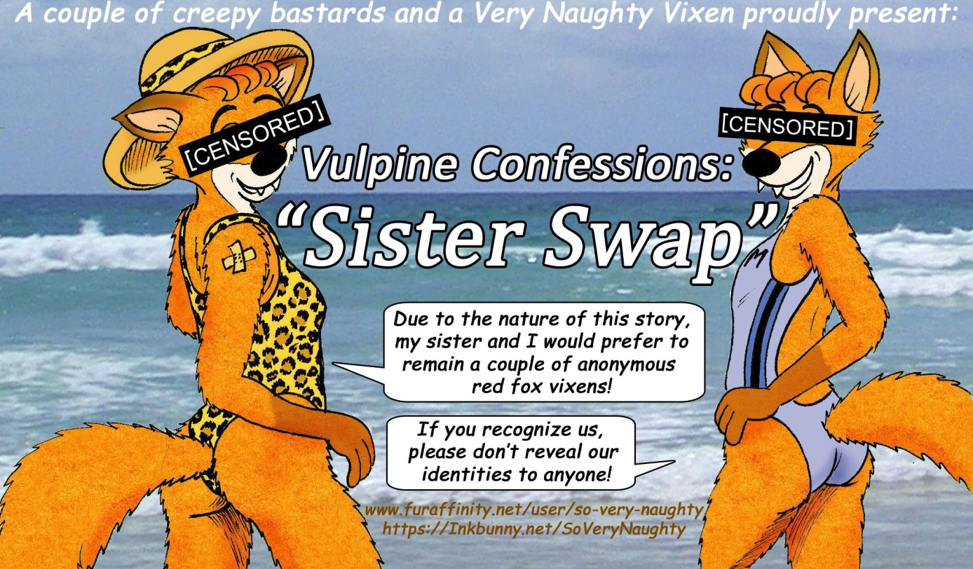
Hello, there! My name is M********. (Due to the nature of the story I am about to tell you, my sister R******* and I would prefer to remain anonymous. I’m sure you‘ll understand! Should you recognize us, please don’t reveal our identities to anyone!)
I am a happily married red fox vixen in my early forties. I don’t consider myself the promiscuous kind of a vixen, but ever since my wild twin sister married a leopard, I have wondered what it would feel like for a vixen to have sex with a feline.
I mean… Their private parts aren't exactly compatible! It must be very painful when he inserts his barbed feline penis in her tight vulpine vagina, I thought. I couldn’t help wondering…
Well... now I know! It feels so weird to admit it, but I have actually had sex with a leopard! Believe it or not, but when I asked my sister what it was like, she actually offered me to try out her husband’s penis!
"You wouldn't believe me if I told you," she giggled. "You have to try him yourself!"
Yes, you heard right, but it isn't quite as strange as it may seem. Let me explain...
You see, my husband once mistook my twin sister for me and had sex with her by mistake, so my sister offered her husband to me, so that I could get even. Fair is fair, and all that…
Naturally, I told her no!
"No! NO! A thousand times NO! I don’t want to cheat on my husband and I can't have sex with a member of a different species! It is considered unnatural and disgusting!"
My sister sighed,
"I have sex with my leopard husband all the time! Do you think that I am disgusting?"
"NO, but I would die of shame if I got caught having sex with a member of another species! I couldn't possibly face my neighbors if they find out that I had had sex with a leopard!
"So, you would die of shame, you say? I don’t think so! A year ago, you were caught with a human... and you are still very much alive! I saw you with my own eyes, remember?"
How could I ever forget? I felt so, so ashamed! My sister’s words made me so embarrassed that I could hardly think. Trying to come up with a coherent thought was almost impossible! I just wanted the ground to open up and swallow me!
“That... incident... was... DIFFERENT! That dirty human beast took me by surprise and practically raped me! It may have looked like I enjoyed most of what he did to me, but you promised to never ever mention that particular occurrence! Besides, Leo isn’t the ordinary promiscuous kind of a leopard! He would never have sex with anyone but you!"
My sister smiled, "Don't worry, Sis! No one but us two will ever know, not even Leo!"
I was very embarrassed, but my sister had a cunning plan. She told me that no one, not even her husband, would know that he had sex with me. My sister and I are not identical twins, but not even my own husband could tell us apart, apparently! If we swapped clothes, no one would tell the difference! We look alike in every way, but my wild sister looks just a bit more worn…
"But, what if Leo gets suspicious?"
"Don't worry! If we are wearing nothing but each other's swimsuits, we could swap back again in no time!" my sister told me.
My sister was always wearing her signature leopard-patterned swimsuit to the beach. It excited her husband beyond belief to fuck her while she was wearing it. He had actually fucked my sister right in front of me on several occasions! Their naughty bits had been under the water surface, but I knew what they were doing, and they knew that I knew…
My sister and I also knew that if I was to wear the leopard swimsuit in front of her husband, it wouldn't take much teasing, before he would have his way with me! He would probably fuck me anywhere, anytime in front of almost anyone!
I had always thought that interspecies sex was unnatural and disgusting, but I have always been a curious vixen. A couple of weeks ago, I finally agreed to seduce my sister's leopard husband.
I can't believe that I actually went through with it! I am not THAT kind of a vixen!
Did I really do it? If my aching pussy is any sign, I really did. It feels like I have been raped by an elephant with a sandpaper cock! My pussy is still burning, but it burns in a GOOD way!
It happened like this: My sister invited me to accompany her husband and her to the beach...
On the way to the beach, we made a pit stop at the local convenience and my sister and I switched swimsuits. I was now wearing my sister’s leopard-patterned one and she was wearing my lavender one. Both of our swimsuits had high cut leg openings, but my sister’s swimsuit had also a thong back that showed most of my furry foxbutt! It was extremely embarrassing to show so much fur in front of Leo, but he didn’t seem to notice the switch.
The skimpy swimsuit was just barely covering my naughty bits! I knew that I had to walk carefully, or else my nipples would slip out, and the narrow piece of cloth that covered my lady parts would disappear between my pussy-lips! Not that it would make much difference! The swimsuit was made of a very thin material! I was sure that my sister had picked her skimpiest swimsuit for me to wear in front of her husband, just to embarrass me!
At first, I was embarrassed as Leo caressed my bare butt in public. Very embarrassed, indeed! But I then realized that everyone that saw me in my sisters signature swimsuit would assume that I really was my sister, so I didn’t have to worry about my reputation! Not even if someone caught me in the act with Leo!
For the next couple of hours, I was going to be his wife, as far as anyone knew! At first, I had reluctantly agreed to have sex with my sister’s husband, but by then, I had decided to give him the fuck of his life!
Leo couldn’t take his eyes from my foxy little body. He had a noticeable bulge in his swim-trunks! He didn’t seem to suspect anything, so I figured I ought to get things started...
"Anyone feel like swimming?" I asked, and took his paw leading him into the water. As we I got into the water, I wrapped my arms around his neck pulling him toward me.
I whispered seductively in his ear, "Drop your shorts. I want you NOW!"
"Now? Right here, in front of your sister?" he asked, his voice quivering.
"I want you," I whispered. "Do you remember when you fucked me here in the water, right in front of my sister?"
I was standing in chest deep water, hugging my sister’s husband. So far he didn’t seem to notice any difference between us. I was brushing my paw along his cock outside of his swimming trunks and he responded by caressing my little foxbutt with both of his paws. His cock was hard already. Leo looked at my sister and she smiled and waved at us!
He kept looking over at his wife to see if she were watching, as he continued to trace the folds of my pussy through the thin material covering my private lady parts. I hoped that he wouldn’t feel any difference from his wife’s pussy.
Leo was so turned on at this point he never noticed our tiny differences. He positioned himself behind me, pulled my swimsuit to the side and placed the head of his feline cock against my wet vulpine vagina. As he took his position behind me I was a little worried that he might hurt me. My sister had learned how to fuck his barbed cock and had gotten somewhat used to it, but if I overreacted, Leo might get suspicious!
This was the moment of truth. It was now or never to back out. I bent forward and raised my tail. Before I knew what happened, I felt the head of my in-law’s cock plunge into my inexperienced pussy and I yelled like a bitch in heat!
Leo had pushed only the head of his cock into me, but I realized that I had acted as if he had already hurt me. To my great surprise, it didn’t hurt at all! I pushed back toward him as he sunk his cock deep within me.
"Oh yeah, baby! You're so tight today!" Leo grunted.
"Please, be gentle Leo, your cock feels extra big today," I moaned.
As the barbed cock began to move in and out of me, the spines hurt me a bit every time Leo pulled out. I realized that his was going to hurt for a bit! But it hurt so GOOD! The spines on his feline cock was grinding so good against my vaginal walls. I was loving it more than I ever imagined!
I quivered and shook with an intense orgasm, but Leo didn’t seem to notice it. He just continued to fuck me throughout my orgasm!
Leo liked it hard and fast! He was fucking me harder and faster than my husband ever had fucked me. I moaned loud as he was punishing my pussy with his barbed cock! I was getting used to the spines and starting to really get off, cumming almost continuously.
This leopard sure knows how to fuck, I thought as he emptied himself inside of me!
I must have passed out of sheer bliss! When I woke up, I was lying next to my sister on the beach. Leo was now sucking my tits with a finger in my wet vulpine vagina.
"Welcome to the World of the Living Vixens! Ready for another ride?" he asked.
"Again? My sister is less than a meter away! You better cool it! What's gotten into you?"
"Your sister is asleep! She doesn't know what we’re doing, and no one else is around..."
I starred at Leo’s barbed dick. It looked monstrous! I couldn't believe I had allowed him to put that thing inside me! And, now he wanted to have another go! I never thought I could take it!
"Oh my God, he's going to kill me with that thing!" I thought.
I was sore downstairs, but I really had to let loose or Leo would figure things out...
"Okay, but hurry up, before my sister wakes up!" I whispered.
I clenched my teeth as Leo impaled me on his monster dick. He nibbled at the back of my neck as he slowly fucked my pussy with that monster cock! I couldn’t believe that my sister was taking this cock in her vulpine pussy on a daily basis! I didn't know if I ever could get used to this thing! I'd never had anything like this; it hurt, but it hurt so good!
"Are you ready for number two?" Leo asked. "You seem excited enough!"
I had no idea what he was talking about. I just moaned with delight as he turned me around and continued to fuck me in the perverted missionary position. Suddenly, I felt a sharp pain in my little fox-butt. Leo had shoved his tail inside my anal opening! It went deeper, and deeper inside my poop-hole! I was grateful that I had taken the opportunity to dump a huge load of shit when my sister and I swapped swimsuits. (Oh yes, contrary to popular belief, fox-girls actually do shit, just like the males of the species! They are just more discrete about it!)
My sister’s husband was now fucking me in two holes at the same time! The barbed head of his feline cock and his fuzzy tail was grinding on everything inside me! It felt like his long tail was about to come out through my mouth. I felt sick, and I was about to vomit when he slowly began to pull out the tail.
Luckily, it was the second time Leo fucked me and he didn’t last for long. I soon felt his adulterous cum splashing inside my married pussy. He threw his head back and grunted and roared as I felt his cock erupting inside me for the second time. When he pulled his barbed cock out of me, I thought he was going to tear my tight little pussy apart! Yet, I had my most powerful orgasm ever!
"Oh, Leo… Nobody has ever fucked me like that, you're incredible." I whispered, as we cuddled afterwards.
"What do you mean? Why do you sound so surprised? I fuck you like that every day!"
"Oh... Of course, you do! Y-You know what I mean! None of my exes fucked me so, so good!"
We cuddled until Leo fell asleep. I left him on the beach and went for a swim. My sister joined me in the water. I couldn’t possibly take more leopard-cock, but my sister was hornier than ever before, so we switched swimsuits under the water and swam back to the beach. It was my turn to pretend to be asleep, while my horny sister practically raped her poor unsuspecting husband. Twice!
After a couple of hours of rest, we were heading for home. My sister was used to Leo’s cock but I could hardly walk, my poor pussy was so sore! On the way home, I tried to walk a step behind Leo. Maybe, if I was lucky, he wouldn’t be aware of what he just had done with me.
I had hoped that Leo wouldn’t suspect anything, but I thought that he had a strange look on his face when he dropped me off at my den. When I looked at my reflection in the mirror, I noticed that Leo had left noticeable bite-marks on my neck when he fucked me from behind like wild animal! When I looked down, I realized that the crotch area of my swimsuit was soaked. Leo had left two sperm deposits inside me, and his potent seed was still dripping from my aching vagina, and it was making its way down along the insides of my hind legs.
Surely, Leo must have noticed this and realized that he had fucked both his wife and her twin sister in rapid succession! I was ever so embarrassed the next time we met, but it was obvious that Leo had decided to pretend that nothing naughty had happened between us!
He is probably still secretly hoping that my sister and I will try to trick him once more. All I know is that just before he left, he squeezed my butt and whispered in my pointy ear,
“You must be one of the horniest little vixens on earth! Your husband sure is a lucky fox!”
Leo might have figured out that he had sex with me on the beach, but as far as I know, he has never mentioned it to anyone. The sex was great, but I hope he’ll never come back for more! His barbed dick made me walk funny for weeks!
During the last couple of weeks, my sister and I have talked about this adventure many times, both of us agreeing that it were a onetime experience, but we'll never forget it and we will continue to talk about it amongst ourselves for years to come. Well, at least until one of us has experienced something even naughtier. Meanwhile...
Do you want more vulpine naughtiness? Of course you do!
You will find other naughty stories and pictures at
www.furaffinity.net/user/so-very-naughty
https://Inkbunny.net/SoVeryNaughty
P.S. These are fictional stories, none of it is true.
I do NOT have sex with my sister’s leopard husband,
and ESPECIALLY NOT with random HUMAN BEASTS!
As far as anyone knows,
My sister and I are nice, NORMAL vixens!
Wink, wink! Nudge, nudge!

