By SilverTail
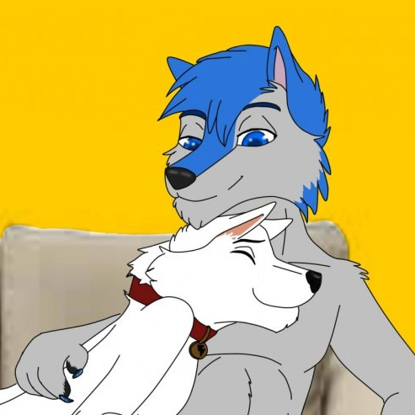
Art ©KellyBlackWolf

In a small, well kept flat in South Shields North East England, the smell of bacon and sausages are drifting out the open kitchen window as Silver Tail prepares tea in readiness for his mate returning from work, as he is doing this the phone rings and he dashes out to the lounge as fast as he can and grabs the phone diving on the couch in the process giggling. “Hey Thundy !! I’ve got tea on so hurry back” he is met back with a sigh and the sound of a unhappy Thunder “Erm hi b-babe I’m going to be late again tonight they wanted me to stay back late to finish a job, and well the van has broken down again, so it be half hour before I’m there sorry” After hearing this Silver stops giggling sensing the tiredness in Thunders voice “Oh ok hun hope your ok just looked out window and those clouds don’t look good, I’ll put the dinner in the microwave when you get back”. Thunder sighs again “I’ll let you know when I’m near, bye hun love you”. After putting the phone down Silvers ears drop and his tail stops wagging as he sits staring out the window as rain starts to splash on the frames.

About 2 hours have passed and Silver is starting to panic as he has not had any messages off Thunder saying where he is and if he is ok. By this time the curtains have been drawn and he is watching TV, when out the corner of his eye he notices the glow of orange flashing lights and the sound of a familiar voice, his tail starts to wag again. Then the door opens, he runs out the lounge into the passage to be met with a very wet and frustrated Thunder his tail drooping and rain dripping off his ears, his work shirt virtually stuck to his body with his chest showing through, Silver Squeaks “OH BABE IM SO GLAD YOUR BACK I WAS GETTING WORRIED!!!”, Thunder sighs and looks down “Hey cutie” as walks into the lounge and slumps in the chair. Silver watches him and slowly closes the door then stands at the entrance to the lounge “babe you ok? You don’t look too happy has something happened?” Thunder looks up at him and then back down “nothing I’m fine just tired that’s all... well oh doesn’t matter” Walking slowly in and sitting beside Thunder and taking him by the paw Silver looks into his eyes “babe there is something bugging you and you can tell me ill try my best to help”. Squeezing Silvers paw Thunder gives in and starts to explain what happened earlier that day tears begin to fall down his cheeks and snuggles, Silver using his tail to wipe them away as both his paws are firmly on Thunders. “Hun your back home now and you can put that all behind you, I promise ill sort it in the morning, now how bouts I get some dinner down you” Thunder nods shyly and gives Silver a big sloppy lick on the cheek as he walks off to the kitchen.

As Thunder is having his Tea and watching Big Bang Theory a show Silver hasn’t yet got a grasp of yet, Silver peers round the door to the lounge from the passage and sees that Thunder is content, he then hatches a plan to make the evening better. Five minutes later whilst the adverts are on Thunder’s ears twitch as the sound of running water grows louder and the addition of Silver crashing about in the bedroom, growing suspicious he gets up and walks towards the crashing and splashing and knocks on the bedroom door “Silver! What you up to in there?” the crashing stops along with the splashing shortly followed by the sound of light feet running across the room. The door opens and Silvers head pops round blushing deeply, Thunder grins “and what exactly are you doing in there?” trying to peer round to see what’s going on. “Nothing” Silver squeaks and quickly closes the door again the sound of crashing starts again then goes quiet.

Thunder, still wondering what is going on, starts to head back to the lounge when he is grabbed around the waist and dragged through the bedroom and into the bathroom. Startled he turns round and is met by silver standing with his paws by his side and one leg in front of the other, his tail flicking from left to right. Thunders eyes move up and take in the tight little maids outfit that silver secretly bought earlier that day. Thunders tail begins to wag furiously & his ears perk up; his eyes brighten then lets out a little wolf whistle “helooo sexy!!” Silver Blushes deeply then walks across to dim the lights bathing the whole room in a gentle glow of candlelight “I thought you might want to relax in style tonight hunky” Thunders jaw drops and then tries to take it all in “babe you didn’t have to...” before he had finished Silver had already pounced him and taken his shirt off exposing his masculine chest & revealing the lightning bolt down his left side, his brilliant white fur shimmering in the yellow glow of the candles. Silver then proceeds to undo his work pants and lets them drop to the floor followed by his boxers, Thunder looks down and sees his cheeky omega nosing his bulging sheath and then stands in front of him, Silvers fur turning slightly pink. “Well do you like it?” “Oh I love it babe” Thunder shouts lifting Silver in the air and giving him a big cuddle before putting him down then climbing into the warm bath and immersing himself in the bubbles.

“Would my alpha want a drink?” Silver shyly asks doing a little curtsy and winking, Thunder giggles hatching a plan of his own “if you’re asking go on then”. Shortly after Silver returns with a tray with thunders favourite drink, but as he leans over Thunder grabs him and pulls him in the bath with him smiling mischievously. Silver catching his breath, looks up between Thunders legs, moves his hair from his eyes sticking his tongue out & then sits up and looks at his outfit “now what am I going to do it’s all wet” Thunder tries to hold back a giggle and pulls Silver towards him kisses him deeply, unbuttons the dress then throws it across the room “we won’t be needing that now will we?” He then begins to run his paws down Silvers back making him squirm and whimper softly. Silver then gets out and walks towards the bedroom and round the corner beckoning Thunder to join him.

Thunder then climbs out of the bath smiling lustfully, his sheath bulges and his deep red tip showing through, he then follows his Omega. As he walks in Silver pounces him and pins him to the bed then slowly starts to move down his chest kissing softly till he reaches what he was waiting for, licking his lips he noses at his mates large balls then licks his sheath and watches his deep red cock slide out. Looking up at Thunder he licks the shaft then seals his lips round and begins to take it inch by inch till his nose is touching his lover’s belly. Thunder lets out a slight moan as he feels Silver start to suck, his tongue licking round the base. “Oh babe!!! You really know how to make a shep happy” Silver his mouth full just looks into his eyes and winks then continues sucking, cupping Thunder’s balls in the process. Thunders cock starts to twitch and without warning he shoots his load into Silvers muzzle, his cheeks start to grow as the warm cum floods his mouth. Swallowing Silver looks at Thunder cum dripping from his lips “is that all you got?”

In a flash Silver is then flipped onto his back and his legs spread wide, Thunder looking down and grinning “that sounds like someone being cheeky” Silver nods shyly and wags “well then why don’t you teach this bitch a lesson” before he could finish Thunder pressed his cock into Silver’s tight tail hole his full length was deep inside, feeling a sense of fullness Silver gasps and whimpers loudly as Thunder thrusts faster and faster stretching his tight tailhole and bumping his growing knot against him, Thunder then slowly leans over and kisses Silver deeply then moans as he is getting close “IM GONNA CUM” Silver shouts as Thunder buries his knot tightly into Silver tying them together & starts to shoot his warm sticky seed deep inside his lover, Silver moans loudly as he feels wave after wave of his lovers seed wash over every inch of his tailhole.
Once Thunder had emptied his balls of every last drop of cum Silver looks up at him with a satisfied grin “looks like we’re gonna be here a while” Thunder winks & giggles softly “best make ourselves comfy then” the pair then lay down on the bed spooning each other & basking in their warm glow.

The End
Thank you for reading
Silver Tail
Credits
Proofreading: Thunder

