THE GREAT SWITCH
A story written by Sen using the character Norithics Kusemurai. Expect pervertedness.

Chapter 1: Job interview
The waiting room to Dr. VonZeppelin’s office was pretty much as he expected. TV regularly reported about the self proclaimed doctor and his perverted antics. And so it was no surprise that the waiting room was decorated with pictures of voluptuous women and well hung men, most of the time in some state of intercourse. Following this erotic theme, the tables and lounge chairs were shaped like the genitals of various species. They were surprisingly comfy though.

But that was not the really the main reason why Sen was nervous. The waiting room had one more remarkable feature that made things... hard: The secretary. She was dominating the room in more than one meaning of the word. Despite all the blatant porn hanging on the walls, it all seemed rather harmless due to her presence. She was dressed in a white, faux-leather BDSM angel costume. All the things usually hidden behind fabric were well in sight. And she had much to show. Rarely had the donkey seen a female where the description ‘hour glass figure’ was so accurate. The fact that she was a hyena added another ‘little’ detail to the whole package.
But even that would not have been a problem; After all you don’t try to get a job as Dr. VonZeppelin’s minion unless you are a kinky bastard yourself. It was the fact that the only thing he was wearing at the moment was a neon green speedo. A tight fit even before his penis became erect. He could do nothing to hide from the glances the secretary threw at him every once in a while.
After being trapped in this pornographic nightmare for over an hour the donkey felt as if his penis was on on the verge of exploding. The (usually white) spots on the black shaft had turned an intense pink. But then salvation came in the form of 6 words “The doctor will see you know.”
Sen was on his hooves in a second and with a mumbled “Thank you.” pushed the door open to the main office. This part of the building looked almost normal. A big desk, some chairs, shelves on the walls to hold folders and trinkets and a black, comfy swivel chair, which just now swung around to reveal Dr. VonZeppelin himself: “I have been expecting you.”
“Uh... I should hope so. I made an appointment with you.”
“So you did! Great! Now let’s see if you are minion material.” with a disinterested and professional look he straightened a bunch of porno magazines as if they were important documents and put them aside on his desk.

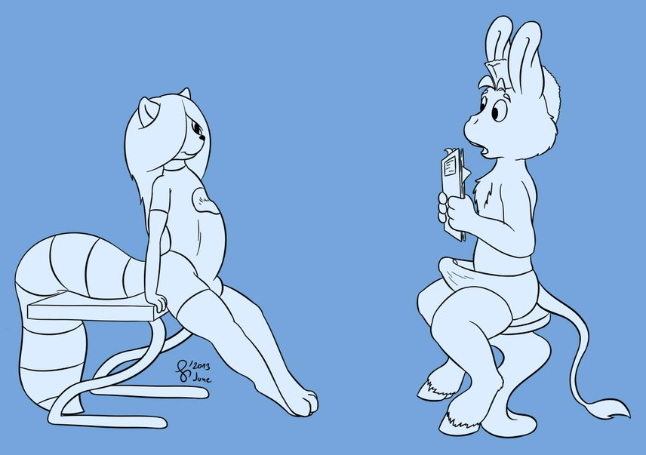
Then he stared at Sen, scanning the donkey’s body from head to toe until his eyes came to rest on the stretched out speedo. He smiled for a second and the donkey was sure he saw him lick his lips before he spoke again.
“I see you followed the dress code for new applicants.”
“Y-yes? However it seems the larger sizes ran out. I hardly managed to fit into this one.”
“Oh really? Heh, I guess I will have to punish my secretary for that later.”
“I didn’t mean to-“
“Silence!” Zeppelin cut him off and slammed his fist on the desk “Now comes the questionnaire! Take a seat.”
“Qu- Questions? Your website didn’t mention any questions. I didn’t prepare for...”
“Not being prepared is part of the test. Although to be honest, you are not doing so good at the moment.”
“What?” Sen shouted nervously.
“Anywho: First question. What is your favorite color?”
Sen breathed a sigh of relief. Maybe this wouldn’t be so hard after all “Yellow with a tint of orange and bluish purple.”
“Hm… interesting.” the raccoon got up from his chair and slowly walked through the room. This was the first time Sen saw him up close in full. Oh, he was on TV often enough, but they usually pixeled out Zeppelin’s belly and he had always thought it was because of some offensive imagery on his suit. But alas, nothing of that sort. Just plain orange with a white spot in the middle. It was simply that the raccoon had an enormous cock sprouting from his crotch and the suit he wore was a very tight fit. He might as well have gone naked.

“Second question: What is the cubic root of 36 926 037?”
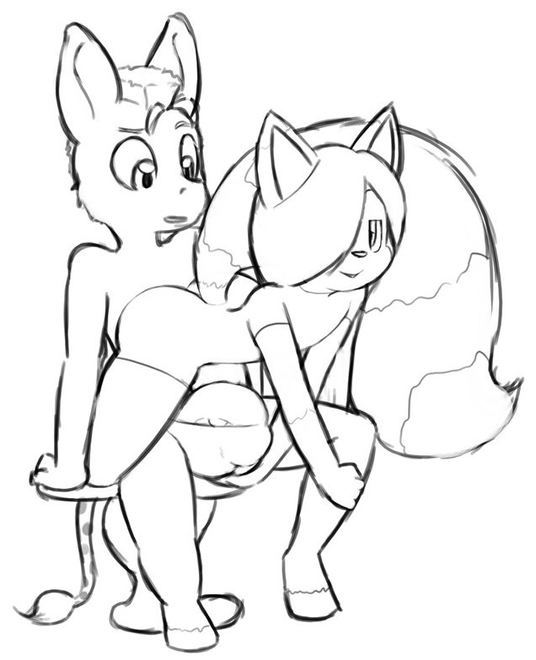
“Meep!” was all Sen could say as he was pulled back from staring at the raccoon’s boner and into harsh reality.
“Very interesting answer.”
In the meantime Dr. VonZeppelin had moved all the way up to the donkey and put one arm on his shoulder. Then, with one single elegant move, the raccoon managed to opened his suit at the front, place himself on Sen’s lap and wedge his cock into Sen’s already stretched out speedo.
While cock rubbed against cock Dr. Von Zeppelin looked over his shoulder and said calmly: “Third question: How do you handle pressure?”
“Is... there a spoken answer for this?”

“Apparently... there is.” He said disappointed and pressed his butt against the grey furred chest of the equine while his fluffy tail wrapped around his head.
“Question four: The boss of an internationally known crime syndicate is rubbing his ass against your chest. What do you do?”
An odd mixture of feelings had taken a hold of Sen. Hornyness and nervousness had been at war ever since he set hoof into that waiting room. But as his sex drive finally got the upper hand the answer became clear.
“I fuck him as hard as I can.”
“Bingo! We have a winner!” and within a single second Dr. VonZeppelin was gone and someone else appeared. “Took you long enough. Most people jump Greta after 5 minutes.”
“Well I... I had some mandatory self control classed after an... incident.”

“Less talking more fucking! I have been watching you on my monitors since you came in and worked up quite an appetite. I hope you are durable.” And with that the raccoon ripped off the speedo and the donkey’s cock finally got a taste of freedom. It was covered in precum and throbbing painfully.
Still sitting on Sen's lap, the raccoon bent forwards and wrapped his lips over the equine shaft to get a taste of his newest minion.
After he swallowed half the shaft and licked it clean he came up again only to say: “You are hired by the way. And call me Nori.”

The short oral treatment from the raccoon left Sen hungry for more. He grabbed the round buttocks wrapped in rubber and gave them a firm squeeze and buried his muzzle in-between. “I like it when they are so eager. Why don’t we take care of those aching blue balls of yours hm?”
With that Nori stood up again, walked to his office table and bent over. The material of his suit stretched thin as the large hindquarters pushed even harder against it.
Sen jumped up from his seat and took a few steps till his groin bumped against the raccoon’s double airbags. His shaft easily wedged between the two buns and he rubbed it up and down between them.
“You better lose the suit if you want some backdoor action.”
“No need. You can fuck me through the suit. It’s very stretchable.”
“Oh... okay.”

This was new territory for the ass. He rarely used condoms and this outfit felt just like one. But he was always open for new things and so he grabbed his wang and steered the tip towards where he could see the puffy anus through the form fitting rubber. The flared tip of the equine shaft was already engorged, but if only half of the things were true about Dr. VonZeppelin then he would not have problems taking it to the hilt.
“Oh yeah. Come on big boy. Show me who’s boss.” Nori encouraged him further.
And with much less resistance than he expected the tip of his donkey dong vanished in his new employer’s behind.
“Fuck yes. And by the way... I am still your boss. Now pound me hard!”
“Yes Sir!”
Sen pushed further and he felt the plastic material stretch around his boner, allowing a surprisingly deep penetration. Each of his thrusts buried the cock farther inside until the large butt of the raccoon stopped his anal invasion. Then he began pounding, each thrust smacking hip against butt cheek.
Nori made sounds of delight as he felt the donkey enter deeply into his backdoor and tickle his prostate. His own massive erection was slapping against the office table every time the ass thrusted forward. He was surprised how much he was enjoying this. The donkey was certainly not the largest he ever had, however what he lacked in size he made up with enthusiasm.
Not even a minute in, the pelvic movement created a sizzling noise from the static electricity buildup of fur rubbing against synthetics. “Electrifying!”
Just because something was good it did not mean it could not be made even better. So the doctor pushed the intercom button and called for his secretary.
“Greta? Please come in. I need your assistance.” – “Right away Sir.”

Sen didn’t pay attention to what was said, totally focused on burning some rubber. Not even as the doors opened and an angel from hell entered, he took notice.
What he did notice was something hard being shoved up his bum. Greta had taken position behind the two going at it doggy style and turned this thing into a ménage á trios. Her hyena pseudo penis was a very dark brown and fat as a leg and Sen cried out in the first moment when the tip parted his anal ring.
With a mischievous smile Nori turned his head around to see his new minon’s face as it got anally impaled.
“Mr. Grisane, meet Greta. My secretary and personal domina.”
“P-pleased to meat youuuu!” Sen called out as just at the end of his sentence Greta rammed her engorged clitoris all the way into the donkey’s ass. Luckily she had lubed it beforehand.
“Oh! That got him hard! Continue Greta!” – “With pleasure doctor!”

True to the nature of their species, Sen was now the prey caught between two predators. He was little more than a plaything. The hyena was very strong and grabbed the donkey’s ears like reins and used them to pull herself hard against him. It felt as if he had an arm shoved up his ass… actually, considering her size her arm was probably an easier fit.
Despite being on the bottom Nori was still dominating the donkey as well. Whatever the ass did it was not enough and the raccoon constantly ordered that he be ‘rammed harder’. However due to the overwhelming strength of Greta’s jackhammer, Sen had little choice in the matter. Basically it was Greta fucking Nori, with Sen acting as a buffer between the two.

Gladly he would have lasted longer, but with his prostate squished by the large fem-boner and his dick milked by the tight raccoon butt, he came much too early.
With a loud neigh of lust he emptied both barrels into Nori’s behind, where it was promptly stopped by the rubber suit.
That was not the end however. Greta quickly reacted and reached between Sen’s legs to squeeze hard around the base of his cock, to prevent it from going soft.
“Don’t you dare cheating your boss out of an orgasm!” and kept pounding him.
“S’ okay. I... I am close as well. Should not have fapped while watching him. You can pull him out!”

Still a bit groggy from his intense climax, Sen does not react fast enough for Greta’s taste and so she pulls him back. The donkey wang slips out of the behind and cum oozes from the hole.
His boss didn’t let him enjoy the view though. He turned around quickly and in typical porno movie style, he finished off with a money shot. Pumping his 11 inch monster of a dick he fired his cum at Sen’s face moments later.
“Open up wide!” commanded Greta and directed the donkey’s muzzle in the direction of the incoming airborne seed. Much of it got wasted on eyes, ears and face, but enough of a load collected in Sen’s mouth that he had to swallow.

“There you go. Now you are a full member of my staff.” Nori said with a smile and tickled the donkey under the chin. Greta finally pulled back out of the donkey, still erect.
“Anything else Sir?”
“Nah. I think we are done here. I see you left a lasting impression on our guest.” Nori complimented as he noticed the spread open rear end of the ass. “Just prepare for our next appointment.”
“The girl scouts?”
“Yes.”
“I’ll get the ball gags.”
“Excellent!”

Chapter 2: The plan

To be continued.

