Dizzy, Riggs and Peri in…
Alone in Space And No Suits At ALL!!!!!
A Cobalt Core NSFW fanfiction by Roksim!!
Disclaimer: this fic is not meant to be “canon” at all!!!! The personalities of the characters were adjusted and parts of their backstory – made up entirely to allow for all this to happen!! SOME facts are taken directly from canon, so, obviously spoilers for a couple of character-specific Cobalt Core endings!!
This is written for fun and for pervy folk, so, if you’re NOT, then you don’t have to read it! If you ARE pervy, then… Hope you enjoy it, and have fun!!!!!
P.S. Wanna reenact this fanfic in-game?? Download my NoSuitRiggs and NoSuitPeri mods! Links lead to my Newgrounds Dump, it’s very safe! Installation instructions attached!
https://www.newgrounds.com/dump/item/7d8b6104879bad8a52138db019721a18
https://www.newgrounds.com/dump/item/bd9808392cf7301ab90cb7abe8a685bb
https://www.newgrounds.com/dump/item/0e7c2fe3a0b3f73b53260b42a61ef14a (bonus mod: Oh NO Evil Riggs Is A Pervert!!)

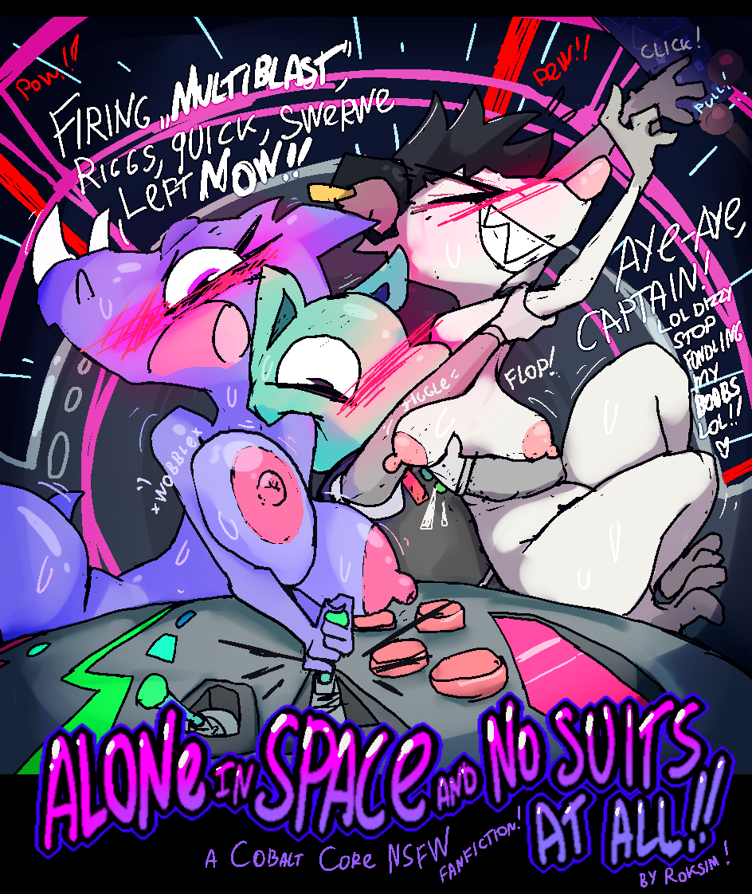

What loop was it now?.. For all his smarts and analytical approaches to problems, Dizzy had absolutely NO CLUE each time before the Cat.exe informed them of the number. 600?.. Waow… For SO LONG they have been doing this. Apparently. He didn’t feel like that about it at all – surely that by now he’d be used to the cramped space he was stuffed into alongside his crewmates and best friends, flying off into the cosmos on Artemis in order to pursue the rogue Core and hopefully maybe save the world? This pocket dimension of the world?.. Where… Where were they, anyway?.. He was saved from going down on one of his mental rabbitholes by a sudden sound of the latch shutting and then a shocked “WHOOPSIEE!!..” coming from the shower bay immediately followed by furious yelling and then arguing.
He recognized the voices easily. The “Whoopsie” came from Riggs – their main pilot, a good friend and snack connoisseur, who had apparently been infiltrating the Core ship that they have been working in with a goal of stealing the Core itself, much to Dizzy’s dismay and shock once he learned it… Though, Riggs confessed to it promptly and with regret, admitting that she didn’t really know anything about their work and was just trying to get out of her dangerous delivery pilot job, anyway! He wouldn’t have trusted her again if she wasn’t doing her best to make up for it, having since saved them all with her piloting skills five times over and generally doing everything to correct her own dismissive assumptions about their work being “just another rich people science fair”. For all his profound dorkiness and apparently “unhealthy” interest in performing “dangerous” scientific experiments, Dizzy was usually good about reading other people. He had a feeling he could trust Riggs again.
The other, outraged voice though, currently explaining earnestly how Riggs was the most irresponsible one out of anyone the owner of the voice ever met… It was his most trusted friend and also his overseer, Peri, the head security officer who had been making sure he didn’t do anything completely kooky to the Core. Dizzy thought she was pretty lame for that!! Science requires taking risks – everyone knows it! However, he also understood her concerns, and that she just wanted to make sure nobody does something they’d regret forever, such as blow themselves (or their clueless friends!) up… Over every loop they did, he DID sort of get a sense of reliability from her and by now, trusted her sometimes even more than himself – at least, when it didn’t come to “worrying” (awesome) scientific experiments!
Peri still hasn’t forgiven Riggs for her initial deceit. Dizzy could sense that she kind of blamed her for what happened with the Core, or, wanted to, at least – her own guilt was just too much to bear for her, that much was obvious. So, it was no big surprise that she was now yelling so LOUD, Dizzy could hear it right through the steel door to the shower bay – of course, that didn’t make him enjoy it more. He wished there was something he could do to help ease Peri’s burden… She probably needed SOMEONE to. He sighed. Nothing worked so far, not even teaching her how to play Space Chess, with all the fireballs and all. He’d wait for them to finish their argument and then speak to them when both of them cooled down.
----
Hmh. It was… Ten minutes since they’ve been in there. Everything was quiet. Dizzy has gotten up from his seat, his anxiety rising slowly – what if something had happened while he was just loafind around? Trusting the autopilot to do its job and guide them to the next space station, he walked over to the shower bay door, which was barely five steps away from his seat – there wasn’t much space in the ship at all, and he had almost tripped on Riggs’ box of tea supplies before knocking on the closed door. “Uh… Guys?..” No response. “Is… Is everything okay? G-guys?? Ummhh-“ Dizzy had just started his usual mental preparations for having a mini-panic attack when suddenly, the door slid open, and Peri hurriedly stormed past him into the cockpit, fuming. She was completely nude.
Dizzy felt like he was in a parallel universe, sensing his legs nearly give out from underneath him, trembling like twigs in the wind. His cheeks all of a sudden felt SO hot, he felt feverish – his most trusted superior Peri really was there, furiously digging through the various junk piles on the desk, looking under seats and control panels, and she really didn’t have anything on at all whatsoever. She was using one of her hands to reach for yet another pile of science junk (all his) while using the other hand to cover her… Erm… T-to cover her… Breasts.
She actually had a really big chest.
Dizzy had absolutely no idea. He felt like he had just entered some bizarre creep dream about his friends being naked where they had the most random body of them all – she never had breasts, erm, that is, surely she had a body of a female specimen of her species, Dizzy could guess that much, but, he never thought… They were so round. Swaying from side to side after each and every movement she did, clearly making her wince when her supporting hand failed to prevent them from bumping into something pointy in the piles… Purple, just like the rest of her, but, slightly paler… As if they didn’t get exposed often at all, if ever - all of that Dizzy was instinctively picking up as he stared blankly at the pink circles peeking out from under her trembling hand.
It was nearly nowhere enough to hide them. Dizzy knew that scientifically, they were called “areolas”.
Peri was nude in the cockpit alongside him, huffing and puffing barely 2 steps away, and apparently she had giant boobs which he had no clue about.
Dizzy finally managed to embarrassingly turn away, stung suddenly by the guilt for even conjuring these obviously INAPPROPRIATE words in his head (giant BOOBS?? Come on Dizzy WHAT), and apparently there behind him was Riggs, standing in the doors of the bathroom and looking bashfully guilty as all heck, and she was also very much fully nude.
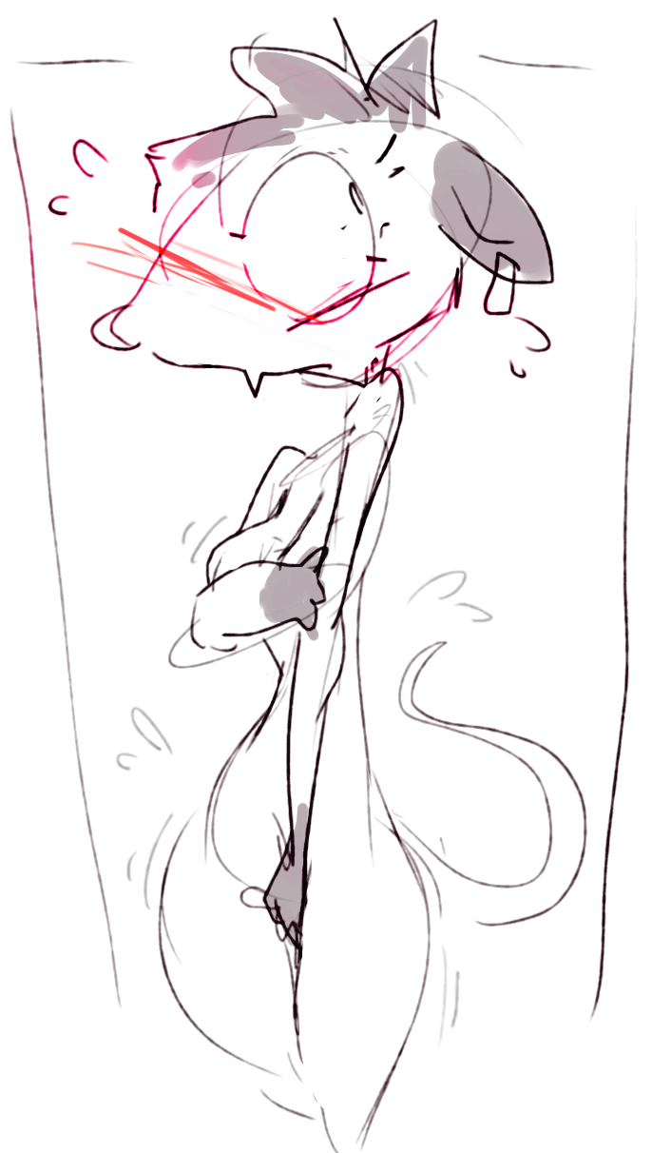

N-no, no no no no no. What is going on. What is HAPPENING? What is… What is?.. What is happening???.. Dizzy ‘s thoughts quickly darted towards five of his most favorite tenants of science – he could recall them just as easily as always. So, he didn’t lose quite all of his mind just yet, some of it was still SOMEHOW clearly in place. B-but… Surely… Surely this wasn’t happening. No, no. This is some sort of a mirage, SPACE mirage, if that is a thing, and none of it is real. Riggs wasn’t standing there in the doorway, cheeks totally flushed and gaze drifting somewhere to the side, in a pose most defensive, covering herself with her hands as her slim body trembled slightly, hips closed and long pink tail twitching every now and again.
Then, she looked at him, gaze suddenly very apologetic yet trusting and bashful at the same time… “Um, Dizzy… I vented out our space suits”.
“She DID!! Oh my god, she did. Dizzy. Dizzy, can you believe her?? She pressed the WRONG button!! Aghh, I can’t BELIEVE she did that!!” - there she was, coming to stand right next to Riggs, looking utterly defeated. His best friend Peri, covering herself just like Riggs did, completely relieved of her usual officer space suit, her pink areolas still flashing themselves at him from behind her hand, lewdly, obscenely. “And we apparently DON’T have ANY OTHER clothes AT ALL.” She shot a destructive glance at Riggs. “Aghh, and I just started to get used to you – t-to ACCEPT you here – AHH why, why, n-not noww, ahh, t-this is… Grhh…” Taking a deep breath, she exhaled loudly again and readjusted her awkward grip on her breasts, clearly entirely aware and obviously humiliated at her failing attempts to cover all the bright pink, yet not willing to turn around from Dizzy and thus admit that she was just SO bothered by it. Dizzy didn’t understand that.
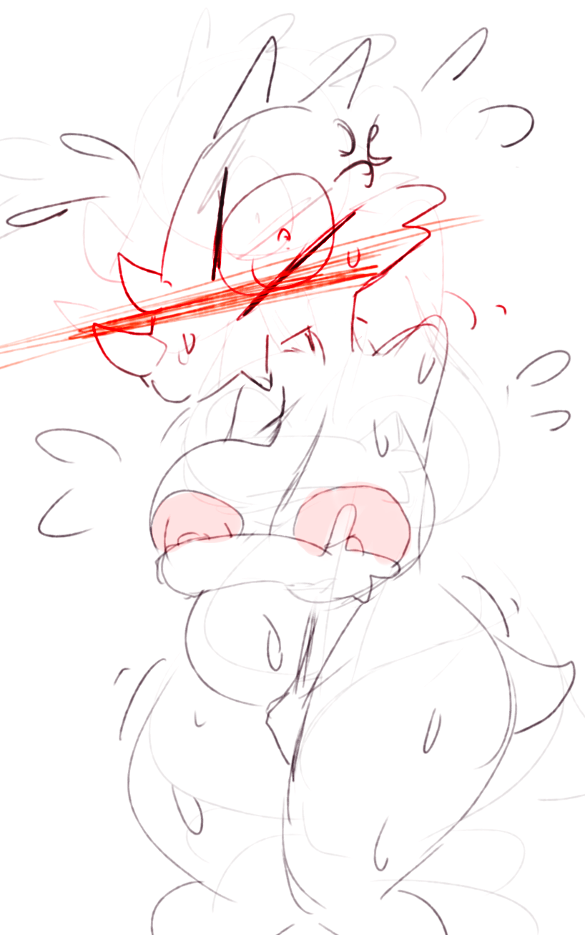
“Ahhh, yes, yes, I messed up, okay! I, um… Those buttons are just, FAR too similar – why were they NEXT to each other anyway?? OBVIOUSLY I wanted to press “dry-clean”, like… Ghahh, you didn’t STOP me did you??” – Riggs heaved, flustered. “I just, I, I’m not USED to this ship yet, it’s even smaller than my delivery one – why is everything NEXT TO EACH OTHER HERE??”
“Well maybe if you had less JUNK lying around – agrhhh, FORGET it!! What are we gonna do NOW?? We’re making Dizzy un… uncomfortable!!..” – Peri responded, glancing at him awkwardly. That reminded Dizzy that he, in fact, still existed here in this cramped room, standing SO close to both of his friends that he could feel their bodies shuddering. “G-g… G-guys… Um… I-I’m fine!.. Ermhh… I-I can give you MY suit!.. I’m… I’m so sorry for what happened!” – he managed to blurt out. He really was willing to do that. He wasn’t even thinking about what it would mean for himself – all he could feel at this moment was intense empathy for both of his friends being so deeply uncomfortable with their bodies being so exposed. He never really thought of them as GIRLS, but, he knew that this… This here wasn’t a situation that anybody would want to find themselves in. ESPECIALLY girls – he at least knew THAT. This WASN’T cool, and he wanted to do something about it.
“Dizzy, thank you… For your offer. R-really.” – Peri responded. “Sorry, um… I-it’s just too small, though. For either of us. We wouldn’t fit. And we wouldn’t want to make you uncomfortable too… This was our fault. Riggs is right – I should have taken the responsibility for the laundry.”
“N-no, no, you’re actually right, Peri… I’m sorry. This is my mistake. I really am sorry.” – Riggs interjected, looking as guilty as she initially did, when Riggs just saw her coming out of the bathroom. “You were taking a shower anyway, there was no way you could see… Um. W-well, what I was doing.”,
“Y… Y-yeah. I g-guess I couldn’t. Still, though.” – Peri responded, her eyes lowered in shame.
They stood like that for a bit. Peri was soaked, having obviously jumped out of the shower at the sound of the space vent. Riggs looked fluffy – completely dry, she was likely the one to take a shower first and probably managed to fan her fur before trying to turn on the laundry machine. Dizzy had a hard time not thinking about how vulnerable they both looked, being exposed like that. Poor guys. He just wanted to make it all right again, to somehow… Fix this. But all he could do was stand there with an expression of worry on his face, ears respectfully lowered.
“Well. We’ll arrive at the next space station is in two months. I GUESS. ” – Peri exhaled. “I suppose we’ll just have to… Mm. Learn to LIVE like that.” The flash of sharp teeth, as if she wanted to bite off that last part and chew on it until it becomes untrue and not actually what they’ll have to do. She took a deep breath and turned to her crewmate.
“Hey, Riggs… Um… C-could you… Brew me some of your boba tea? I’ve got a lot of… Thinking to do.”
------
Dizzy has not gotten up from his seat in what felt like three hours. He was tucked into his corner of the ship, trying to make himself as small as possible to free up space for his other crewmates, and also, to not look in their direction by accident – of course, they couldn’t just rely on autopilot forever, they had to… Use controls, too. With their hands, which just couldn’t be used to CONSTANTLY keep them at least somewhat decent. They were still very much nude.
He thought about how he’d feel himself, were he to end up in that situation. For him, bodies were just something a specimen uses to survive, limbs and internal organs and all, and, he thought it shouldn’t be DIFFERENT for himself and his friends too… It should be the same. It SHOULD be. Yet, every time Peri got up from her seat to check the statistics at the back of the cockpit… Every time she sat back down into her seat… he heard it. He couldn’t avoid it. “Plap”.
He couldn’t stop his mind from processing the sound.
A brief mental image of Peri’s heavy sagging breasts softly plapping against her body and wobbling a bit as they calm.
He felt his whole body tense.
His hips.
With… Some kind of feeling.
Everyone was quiet for the rest of the day.
-------
It was day 2 since The Space Vent Incident, as Dizzy has scientifically dubbed it. He still pointedly tried to avoid glancing at his friends if possible, but, by now, he has found himself a new issue.
Turns out, when you’re stuck in the same cramped cockpit with two other dorks, and these dorks are totally naked, mm… Well… He inhaled the air.
It felt… Full. Heavier than usual. He gulped silently. They both were much more responsible than himself when it came to taking care of their bodies, using the shower regularly, but… It just couldn’t be helped, he knew it. Everyone has a scent, it was just unavoidable. He inhaled again. He felt his cheeks flush.
Was he… not minding it?..
He felt heavy beneath his belly. Hufffff. Hufff. He couldn’t help it. He couldn’t stop. He looked away from them to avoid exposing his expression. His tongue lolled out. Huffff. Mmmffhh. Gosh. This wasn’t okay. Not cool at all, Dizzy, nope, no. Have some RESPECT.
Huuufffhhhhhhh. He felt his legs spread before he even realized it. He felt… Dizzy. Hufff. Mffhh. Huff. Hopefully Peri and Riggs just think of it as a nonchalant change of pose.
In truth, he was losing it. Thankfully, they managed to avoid conversation, being too busy with ship logistics for the remainder of the second day. Dizzy was thankful.
-------
Day 3. They had a run-in with pirates. They decided to not go on comms, since the visual feed would be a little… Unusual to transmit, so, they dealt with it silently, interchanging only the smallest of commands – from Peri to Riggs, from Peri to Dizzy, from Riggs to Dizzy. A maneuver, then another. Peri fired a Multishot Blast. Riggs swerved the ship out of the way of the missile, again. Saving them again. Dizzy was so amazed with her focus! He himself couldn’t focus at all, because in truth, while he could stay his thoughts for a bit about it, he couldn’t stay his ears.
It was more like: A maneuver, then another. Plapp. Peri fired a Multishot Blast. Plapp, plap. Riggs swerved the ship out of the way of the missile, again. Huuuffhhh – that one was his nose, and just as she was pushing Peri into him at that – plappp. This one was against the side of his face. Oh my gosh. Peri’s breasts smelled amazing... Huff, huff, hufffffffhhhh. Riggs saving them again. Because he was too busy being flustered and dazzled by all the scents and sounds.
They spoke a little over the cups of boba tea Riggs has made for them after their victory. It was mostly accessing the damage to the ship – minimal, thanks to Riggs – and making sure they collected all the salvageable parts from the destroyed pirate ship. Dizzy was watching Riggs’ tail. It was always hidden in the suit before. It was so… Pink and a little thick and moving excitedly whenever Riggs said something. He blinked away from it. No, no, nononononono. Not cool, Dizzy.
He dreamed of Peri and Riggs playing Space Chess with him and completely smoking him as if he wasn’t a total pro at the game.
--------
Dizzy really had thought he was not like that. He hadn’t quite assumed he was asexual – he just never really thought about exploring his identity like that to begin with. His life was all science and maybe sometimes having fun playing videogames. Then, it was all science and also having to listen to Peri about this awesome Core that he wanted so badly to put into one of his machines just to see what happens. Perhaps this lack of experience is why he had faltered then, badly.
It all happened by circumstance. Dizzy was just getting up from his seat to go wash his silly face, and, it just so happened that Riggs was returning from the tiny nook at the back of the ship where one could boil water to brew tea, and, she held a tray with three cups of her favorite bubble tea on it – presumably for all of them, ALSO, Dizzy was far too focused on avoiding glancing at PERI in the middle seat, so… Riggs and Dizzy would have certainly bumped into each other and spilled the tea all over the cockpit, had he not raised his hands instinctively and softly stopped their momentum by bracing against her with his palms.
Far too softly.
Oh gosh, her nipples were so warm.
What.
Dizzy flushed, hard, his heart sinking. What has he done what did he do HOW COULD HE. Riggs jumped slightly when they stopped, now staring back at him, her eyes wide-open. The tray she was holding was below his hands, his fingers hovering above the cups, clasping her breasts.
He was actually holding her breasts.
That’s when it happened. It was as if ever since The Space Vent Incident, a glass box had closed him off entirely from the rest of the world, and for the last two days, he was just slogging through things, unable to connect the circumstances to reality.
The glass had just shattered.
Before he could even consider anything analytically, his fingers were already moving, squeezing both of her adorably saggy, soft breasts with suuuch hungry desire, he felt himself tear up. Hufffhhh- kneading her softly, fitting her entire chest into his hands – Riggs’ small, saggy boobers, he thought with twistedly pleasuring affection – he lolled out his tongue before his thoughts caught up with him, inhaling the scent of her soft fur, her body, and it was only then that then he froze, SHOCKED at himself, ready to vent himself right out of the ship as soon as Riggs starts furiously slapping him over the head with the tray and demanding Peri to send him right after the space suits.
She didn’t pull away.
She was looking at him, cheeks flushed.
Her tongue was also out. She was panting softly. She nodded at him, barely noticeable.
He started panting too. He couldn’t handle it.
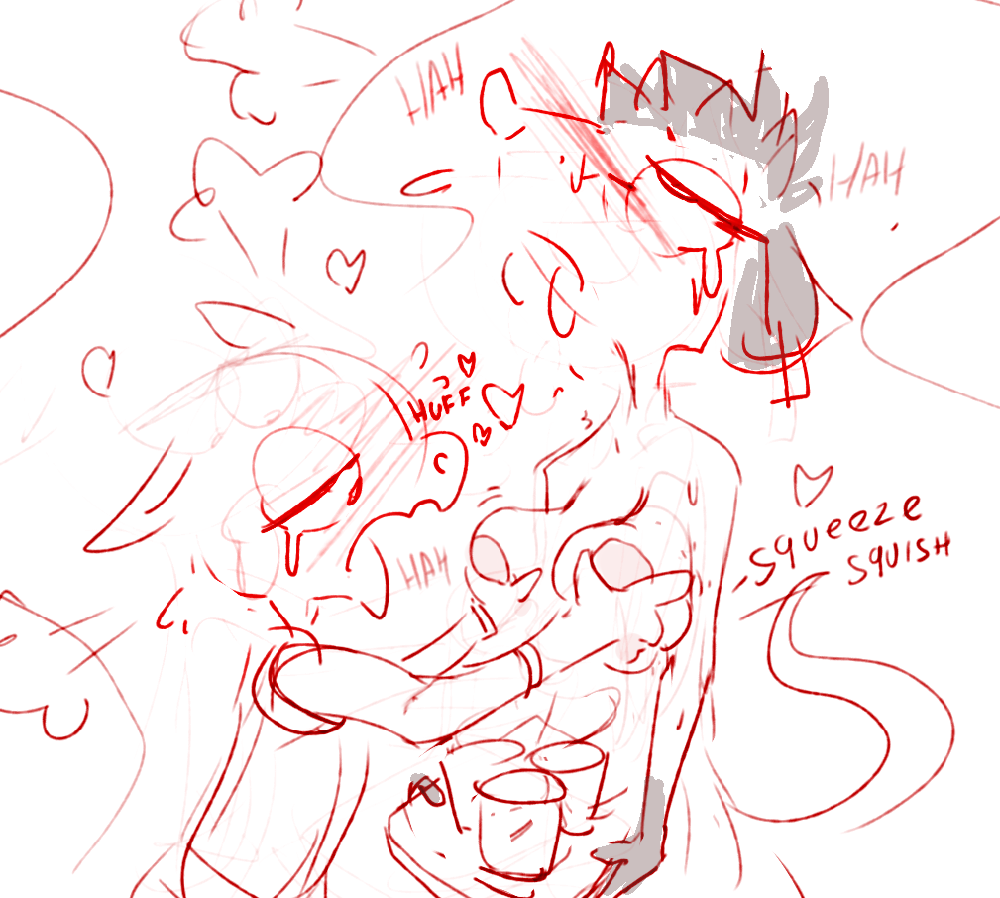
They were so soft. It was unbelievable just how malleable they were to his fingers. He squeezed them again and again, hands trembling with a mix of guilt and excitement and hungry curiosity and AFFECTION and more GUILT, and then he wrapped his fingers around the base of each breast and just flopped them up and down silly, quickly hardened nipples rigidly bouncing around, sooooo pink and so furless, and gosh, her breasts were SO satisfying to play with, lightly furred and lovingly round, and then he grasped these nipples and twisted them gently to the sides, watching the breasts jiggle lightly, panting at the sight... Riggs gasped hard at that, and a single long moan escaped her as she just… Stood there. She was letting him do this. She was just standing there holding the tray while he plapped her breasts together, and then again and again and again, loudly, audibly, huffing and puffing and exhaling with heat in his tongue, exhaling STEAM, ahh goshh, he wanted to SUCK them so BADLY – WHAT he didn’t just think that—no no—they were SO warm in his hands, and oh gosh, Riggs’ tail was swaying around erratically, jerking from side to side at each squeeze… She was just so wonderful and precious and gentle, and, he really did know – she actually trusted him, he didn’t feel any hesitation or doubt coming from her, she just… She was so acceptive.
Slowly and with great reluctance, he let go of her breasts… He had to. Feeling like he was about to melt right through his space suit, he looked up at her. She was smiling excitedly, tongue peeking out. Then, she spoke, looking right at him, into his eyes, directly.
“Ummh… I… I know you probably feel bad about it, Dizzy, but, It’s totally cool, dude. Really. Um…” She paused for a second, looking to the side… “Y-yeahh. Totally okay. Um. T-thanks for like… not being grossed out or anything. I know it must’ve been very weird for you… I’m just happy you are feeling okay.” She smiled again, with what looked like such wonderful, affectionate empathy in her gaze.
And then her words finally got through to him, and he felt the blood rush out from his face. All along he has been worrying about how they feel, and, trying to avoid them to give them space… He didn’t even stop to think about actually communicating with them about it. They probably just thought he was grossed out at them streaking around the ship without anything on.
“U-ummh!!.. Omygosh, no, y-you’re awesome!!” – he immediately blurted out. “S-seriously omygoshh, um, I’d n-never, Riggs!! I just, um, I wanted to give you guys space, m-my goodness, I’m, oh gosh, you probably thought – ah, I’m sorry, I’m – I’m, sorry…”
Riggs grinned at him. “Goshh, you’re a doofus. Thanks for thinking about me, silly guy. Whewwwhh, I mean, I didn’t THINK you’re grossed out, b-but… Honestly, it’s a big relief! To just know for sure. Waooowwwww, you really just went for my boobs just like that. Peri, did you see that?”
Peri. Peri was behind them all along, watching him act like a total pervert. Dizzy whirled his head around to look at her, to meet her gaze – he had to let her know too, she was still his best friend forever – and found her looking back at him. With a gaze that was… Confused. But also, somehow... understanding.
Dizzy felt so relieved at that. At the very least, she didn’t look like she hated him… He could explain… He started to think of what to say…
And then, he had noticed that her hands were resting on top of her chest, awkwardly clasping together.
Not covering it. Omygosh her nipples were adorably plump and so round.
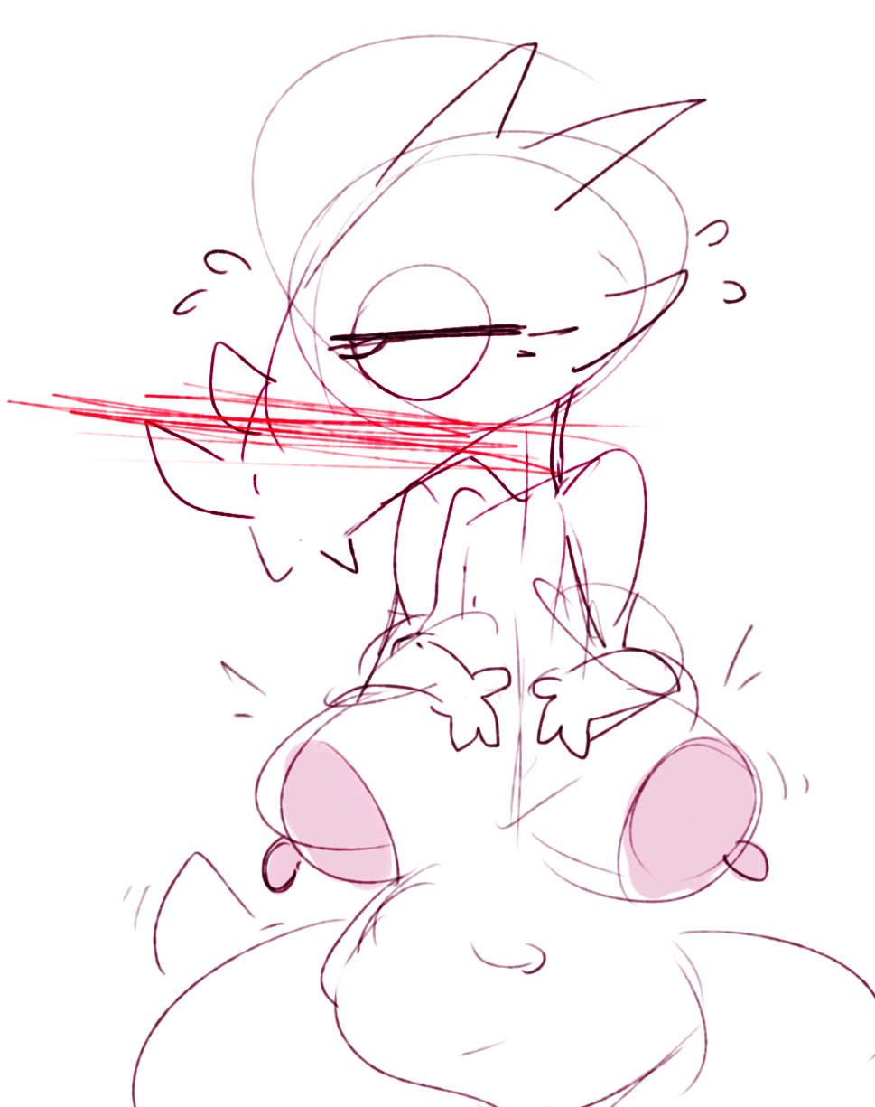
She shifted in her seat just a bit, clearly nervous… Then, she quickly stuck out her tongue at him and pulled it right back, gaze dropping down for a moment.
WHAT.
Her cheeks flared bright red, and then she was right back to her usual self, the usual hint of sternness and measure returning to her gaze. “A-alright… You guys. You’ve had your fun, but, I’m still waiting for my tea over here. Come on, there are some signatures on the radars I’d like you both to check out.”
Her nipples were still lewdly poking out to the sides. She just let her breasts hang out, just like that. Like it was no big deal to her anymore… Except Dizzy could tell, from all the time he knew her, that it was a big deal. Her shoulders were shaking. He… He nodded, hoping he looked open and empathetic.
Gosh, her breasts were totally covering her navel. How did she still manage to look so commanding. Peri is amazing.
Dizzy didn’t even get lost in their scent for the rest of the day. He was just far too happy that he had his friends back again.
--------
Day 4.
“Hey, Dizzy. Check this out.”
Dizzy looked up from his cup and saw Riggs grin at him. Lewdly. Then, she clasped her breasts and squeezed them, pulling them to the sides opposite of each other.
“Aren’t boobs weird? I mean, they really just dangle in front of me like all the time. I guess it took me three days of not wearing clothes to really think about it, huh? I meeean, usually I never think about my body like that, but… Like, boobs are dumb. Look, they go in all directions!” – and she raised them upwards, showing him their underside by switching her grip to just hold them by the nipples. Then, the let them drop casually, plapping against her body explicitly, and returned from sipping on her tea.
“…Um…” – he heard himself say. His whole brain seems to have invited itself out for a walk and replaced itself with just endless images of Riggs’ breasts flopping around. “…I… G-guess… Y-yeah, they’re a little weird… I mean… Why so big, relative to other less intelligent species? I mean, it’s… Um…”
Peri.
“Oh, s-sorry, I didn’t mean to, um, say it like that!!” – he corrected himself hurriedly. Peri was sitting with them drinking tea too, remaining silent and simply glancing over from Riggs to him and back to Riggs again, her expression vague. “B-big breasts are awesome!! I m-mean, y-yeah, it’s just… Waow, yours are… U-ummhh, n-not that I would compare at all!! It’s just your body, that would be… WRONG, and…”,
“Not awesome” – interjected Peri. “It actually is kind of… Tough, to say the least.”
Dizzy paused, looking at her, trying to channel what he felt, out and into his pose and expression – endless kindness for Peri, who was still trying to remain mostly ignorant of her body (even if she for the mooost paaart wasn’t covering it much anymore), unlike Riggs, who was very excited and felt vividly freed since yesterday, almost dancing around the cockpit to brew them the tea they were now drinking.
He noticed Riggs doing the same as him, looking at Peri. She was curious too, he noted. He didn’t know how they felt around each other at the moment, he just realized. Was Riggs… Trying to show Peri the same emotions he did?.. Her gaze was kind and inquisitive.
Peri sighed and looked downwards, where her chest was resting calmly, maybe just a little lewdly. “It has been tough… Pretty much always. All it ever did for me was get in the way. In the way of my hands… In the way of my relationships. I just…” - she glanced at Riggs, then at Dizzy – “I just wanted to have a normal body. I didn’t think of my chest as anything other than a nuisance. You know those suits Riggs- I mean… those suits that WE vented?.. The compression suit. That was mine.”
It made so much sense to Dizzy now. That explained his surprise – she used her space suit to appear differently. He felt a stab of guilt for his initial reaction – some best friend he is, just covering away in his seat, having no idea how Peri felt about her secret being out in the open.
“When I first walked out there in it, I just felt… Right. That was what I wanted all along – to help other people, to protect them. I didn’t want to think about my own body at all. The suit let me do that.”,
“Aw, Peri…” – Riggs whispered ruefully.
“Dizzy, um… I’m sorry that I was out of it last three days. This was a lot for me to take in. But, I feel stronger now. I’ll make sure you guys reach the destination” – Peri went on. “Do please excuse me if I falter a bit here and there.”
Dizzy had nearly forgotten about her being nude whatsoever. This was just his friend Peri here, vowing to protect them even after all the stress she must have felt. He reached out and grasped her palm in his hands, gently rubbing it. “Aw, Peri, it’s cool… You’re still the best to me. Really, I was acting like such a dork – I’m the one who should be apologizing. Really, I don’t mind your body at all! I think you’re amazing, and so brave and caring and you were right about the Core’s danger, too, and you’re so heroic all the time, but… You’re still a person, you know?.. You are allowed to struggle… I had no idea you felt this way about yourself – um, I personally think you’re just as cool as in your suit… Maybe even cooler, because now I know at least in words about what you went through to get here… I can’t even imagine it in feelings. Peri, I admire you so much.”
“Aw… You doofus…” Peri smiled, eyes glistening. Her hand lay in his palms, letting itself be squished by them slightly, and they sat like that there for what felt like forever. Friends, reunited in feeling.
“Peri, if it helps – your boobs are like, mega-awesome” – Riggs RUDELY chimed in, excitedly wiggling her body to make her own boobs flop around freely. Plap-plap-plap. She was totally into it now, Dizzy thought, flushing. He wasn’t exactly against it either, his eyes ogling their movements with a sudden lurch of new hunger. What is going on with him… They’re so floppy. “I get that you haven’t seen yourself in that way yet, but, I mean… We have two months ahead of us. And Dizzy over here is like, totally high on us. Did you know he sometimes huffs in our scent like his life depends on it when he thinks nobody is watching?”
The rush of horror that Dizzy felt at that unwanted reveal must have reflected on his face, because Peri immediately scooted over to him and hugged him by his shoulders. “Oh, Dizzy, Dizzy, it’s okay, it’s fine! Right, Riggs?” – she said pointedly, and Riggs quickly nodded, giggling. “You’re so caring and accommodating… I’m totally okay with that admission. And, um… Riggs is… Riggs is right. Thank you, Dizzy, for being my friend. You really… You really put my mind at ease, for this moment.” She was smiling at him kindly, her face right next to his… Her eyes gazed into his, the mutual trust assured.
“Alright, let’s get Dizzy out of his space suit”, exclaimed Riggs, got up and went around the table, swaying her hips affectionately.
--------
Dizzy had no idea how he did not find that weird at all. All he could think of, as Peri watched Riggs with a hesitantly concerned expression, the possum swiftly unlatching the locks on his suit and easing it off of him, was that this was the most fair thing to do anyway – this would let Peri get more comfortable with her thoughts as the focus is taken off of her, it would even out the balance within the ship… Yet, when the top part of his suit came off and exposed his rather meek figure, he couldn’t help but feel defenseless and embarrassed, finding that it was his turn now to look at Peri for support.
“Awww, Dizzy, getting shy now? Hehehe. Here, let me help you.” – Riggs said nonchalantly ,grasping his hands and, much to Dizzy’s confused shock, confidently placing them right onto her breasts just like yesterday. “You can fondle me for a bit, dude. You don’t have to like, be big and strong or anything, you know that, right? I suppose it sort of runs deep in some guys – but, I just want you to know, if somebody ever gives you heat for how you look, I’ll cleave them in two with a huuuge +5 Flame Axe, just like I did that one time in Space Chess. You didn’t judge either of us at all, and, you gave us space when we could use it, so, just know that I think you’re an awesome guy, so like, don’t sweat it, you pineapple.”
Her breasts were so gentle. Dizzy did feel quite a bit better holding them. These were Riggs’ gentle, vulnerable parts, and he was trusted to do anything he liked with them. He squeezed them softly, making Riggs gasp excitedly. “Heehee, there you go! I trust you, dude! Fondle me all you like – you obviously seem to enjoy it, so, you have my permission!”
Dizzy looked at Peri again. She didn’t look concerned now – she looked at Riggs with what Dizzy could discern was quite an uncharacteristic look of… Being impressed?.. She looked back at Dizzy and… Stuck her tongue out again! Gosh, she looked so cute doing that, Dizzy thought!.. He totally missed the moment where Riggs bent down towards him and slid off his pants.
Dizzy gasped, suddenly extremely aware of the fact that he was surrounded by two of his favorite people being totally nude, with one of them letting him hold her breasts in his shaking hands. He looked down in disbelief… And indeed, saw what both of them were now looking at – Riggs with a lewdly satisfied expression, lolling out her tongue and eyeing it seductively, Peri with an expression of polite respectfulness, poorly masking the feelings that her cheeks showed off for her, changing her face color from purple to entirely red, blowing out a steam with her nostrils. His penis was obscenely throbbing, standing upwards and making his legs squirm with this weird hunger, balls – bawdily flopped out between his legs, feeling heavy… So very heavy. He felt so very heavy… He felt tears turning up at the corners of his eyes. He wanted this. He couldn’t even think. He wanted this so badly.
Riggs casually wrapped her fingers around his length and squeezed hard, pulling down at the same time.
The moan that came out from inside his whole being shook him and made him exhale every last bit of pressure he was unconsciously keeping up ever since his friends first came out of the shower bay without their suits on. He saw his legs spreading before he could even will them, felt himself thrust his hips into Riggs’ firmly tightened hand, saw Peri holding her hands up to her face, covering her mouth, her eyes – as wide agape as he’d ever seen them… “Ohh boyyy, Dizzy… Alright, let me help you with that” – he heard Riggs whisper, as she unlatched his fingers that were still desperately holding onto her breasts and lowered herself down on the soft carpet floor they’d installed just so they could lounge on it during breaks. Then, she just pushed her nose riiighhhttt into Dizzy’s awkwardly flopped-out sack and just huuufffeeed, huffed his scent in so audibly and loudly, Dizzy was afraid she will start coughing. But instead, she just whimpered softly and nuzzled herself farther in, letting out pleased squeaks and getting comfortable. “Alright, I’m starting to get you and your scent addiction… This is amazing.”
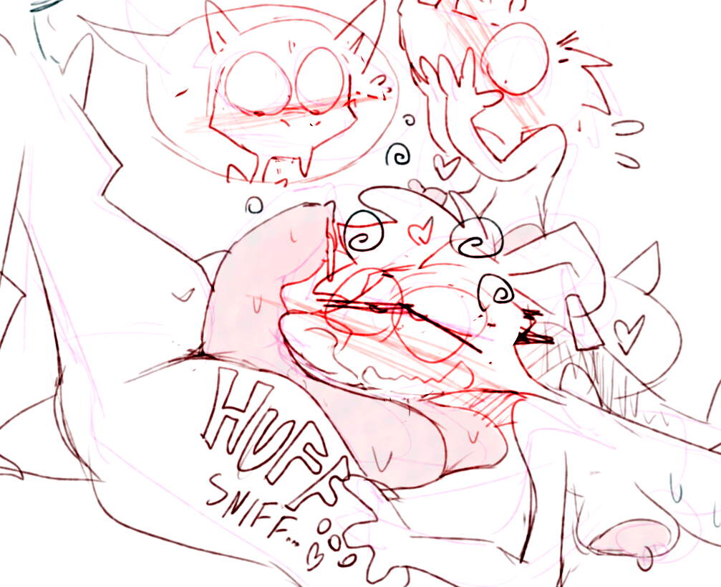
“Mmffhh…” – Dizzy has heard a soft moan to the side. “Umm, R-Riggs, Dizzy, g-guys…” – Peri said slowly, her voice suddenly deeper, with a hint of something slowly wriggling itself free, a stifled and withheld-back emotion finally breaking out. Her eyes were now half-closed, gaze intently set on Riggs, on her huffing. “I f-feel… W-weird… Mmffhh…” Oh my gosh, was she okay? Dizzy couldn’t get up even if he wanted to, but, if Peri wasn’t feeling well… He had only just mustered enough willpower to squeak something out at her when Riggs interrupted his train of thoughts by saying, “Oh yeaaaah, Peri? How do you feel about me doing… This?..” And then the raised her head, opened her mouth wide-open and gave Dizzy’s foreskin a gooood liiiick.
“Mmmgohhhh… Mm… G-gosshhh, Dizzy, it’s sooo salty… Mmmffhh. Peri, you wanna try? We could both take turns sucking off our little scientist over here until he faints like a dork he is, heeheehee. Come on, get over hereeee. Get up. Get to me. Peri, go on.”
Dizzy heard maybe 3 words from that. He was too busy trying to stop his teeth from clattering, his whole body shaking violently. What color was his own face? He didn’t know. Riggs really just lick it. Oh my gosh. Oh my goshhhh. Her tongue was rough, and so warm, and sssooo wet. Oh my goodness. He was heaving. He looked to Peri for support. She was right there.
Right next to him.
She was panting heavily.
That concealed feeling seems to have finally broken free.
-------
Slorrp, sluurppp, slap, sloooorrpppp. Plap, plapp. Riggs’ mouth was wrapped tightly around his length as she was heaving her entire upper body up and down, up and down, her chin plapping against his strained , full orbs as she sucked him off, sloppily, grossly, extremely LOUDLY, IT WAS SO LOUD, her breasts swinging around wildly below her as she braced herself with her hands against his legs for support . Slrooooorrrppp, slurrrppp, huff, huff, sloooorrrpppp. Peri was panting quickly right next to them, her hands rubbing her glowing cheeks as she watched Riggs’s lustful efforts, tears of emotional release streaming down from her face. Her breasts sagged down and covered her navel, nipples so hard, they looked swollen, begging for touch. Receiving it – from herself, as she suddenly squeezed them and pulled on them and did forward motions while shaking perhaps just as much as Dizzy did. She looked nothing like Dizzy’s best friend at this moment… And yet, she looked perfectly like herself. She looked like she has finally found herself in the trust they both gave her. Dizzy couldn’t take his eyes off of her lovely, wonderful face as he gasped and moaned, his hands – on Riggs’ ears, squishing them in a fierce grip which Riggs seemed to not mind at all. Slorrrppp, slurp, slorrrrppp. He didn’t last very long.
His hips felt like the heaviest he’d ever felt them, and, he fell over onto his back in panic, in his dizzy lustful hunger as Riggs exclaimed excitedly and happily, mouth agape and catching the powerful streams of his seed spurting out. “Ahhh, mmff, yes-yes you nerdy hero omghhh mfff g-gross omghh it’s so gross!! Hahahaha!!” – she reeled lividly, her tail doing wagging movements, her hips – wiggling as she got her cheeks sagging with her seed and then grabbed his member and turned it Peri’s way. Dizzy could only gasp as he saw Peri flinch a little, his thoughts briefly flashing him panic signs before Peri growled softly at Riggs and suddenly opened her own mouth, next spurt of seed hitting against her tongue and splattering across her cheek, then – another, this time going directly into the back of her mouth, which Peri immediately gggguuuulped down heavily. She looked like she was going mad.
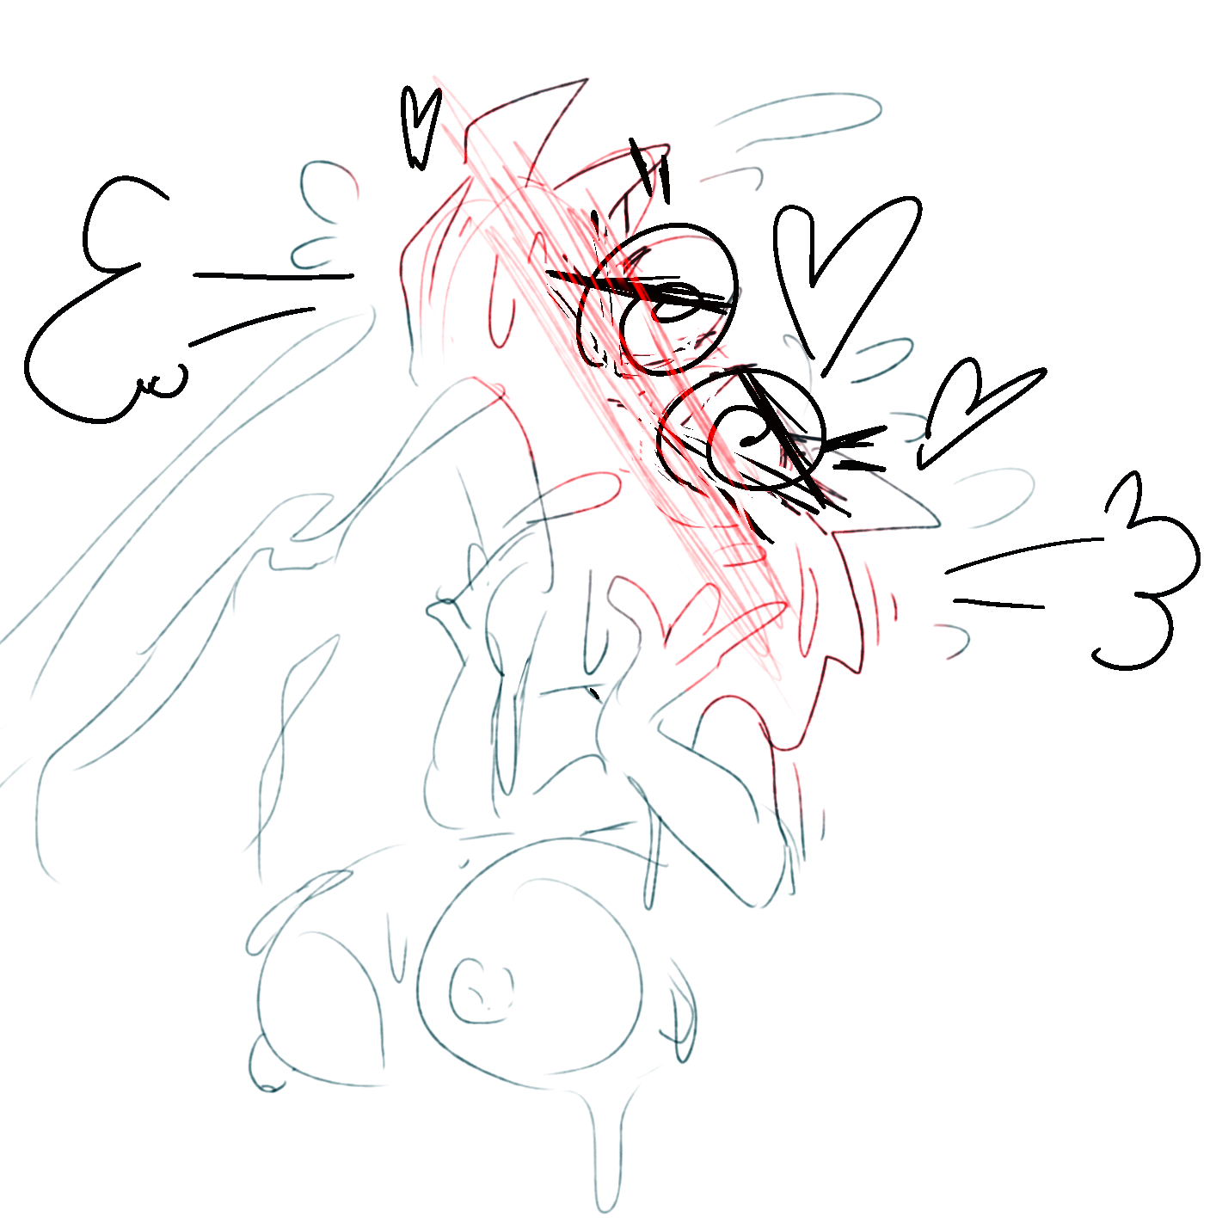
Then, panting quicker and quicker, she hurriedly plopped down on all fours and caught his throbbing penis in her own mouth, just like Riggs did. Her eyes were rolled upwards, powerful throat growls vibrating against his skin.
”Omygoshhh, Peri you greedy!! Hahaha, omy goooshhh” – Riggs was hollering, slapping Peri’s hips gleefully, to which Peri responded by moaning and raising her tail reactively, wobbling her rump and pushing it towards the laughing possum. “Oh my goodness, you’re actually… Dizzy, you GOTTA have sex with her next, you HEAR ME?? Like, obviously not now, hahaha, goshh, you’re totally out of it by now, huh… But like, waow, she NEEDS it so BADLY. Omygooosh, Peri is totally OWNABLE, Dizzy. She NEEDS to be OWNED. She probably needed to be owned for years.” Peri needed to be… owned?.. That didn’t make sense to Dizzy at all. Nothing made sense to him at this moment, his seed finally depleted, Peri still suckling lightly on his penis while looking like it was the best thing that ever happened to her. The only thing he could think of was that she wasn’t even trying to argue with Riggs this time around.
-----
Day 7.
“Hey Dizzy, you want me to get something?” – Riggs cheerfully asked him as she raised herself from her seat, more peppy and bouncy than ever before. She smiled at him as he nodded, and he found himself smiling back at her. Lovingly?.. Yes. He dreamily watched her grin at him and then reach for the middle seat where Peri was plotting their course, her fingers immediately wrapping around one of Peri’s nipples lazily poking to the side and yaaaanking it hard while twisting it slightly. That got a surprised moan from their security officer – yet, she didn’t reach for Riggs’ hand in order to throw the possum over her shoulder, instead she just turned her seat towards her, fake-pouting as Riggs’ grin grew even wider, the possum taking her second nipple into her other hand and casually bouncing Peri’s boobs about for a bit. “Peri, you’re suuuch a slut. I always knew you needed someone like ME to keep yourself in check – hey Dizzy, want me to command her to suck your balls for a bit? She’s so desperate!”
“I-I’m not!! I’m your security officer, and, if you don’t stop this behavior-” – Peri protested, flushing profusely.
“Yeah, yeah. Dizzy, you want this?”
Nod. He actually nodded. And, he was okay with it now. He would have never nodded before, had it not been for the last 2 days.
He and Riggs had sex, the possum – a giggly, happy mess looming above him, doing quick situps above his waist, pleasuring herself with his cock, making sure he saw her boobs flopping around wildly. Gosh, Riggs absolutely LOVED having sex. She was so obsessed with his penis, playing with it all the time, bending over at him and doing such gestures with her hand from her pilot seat while letting her mouth hang open, even Dizzy couldn’t interpret them as anything other than “Look at me this is how much I wanna suck your cock Dizzy let’s blow this pirate ship up quick so you can cum in my mouth mmm cock cock sucking cock and then we’ll HAVE SEX.”
He and Peri had sex, usually initiated by Riggs toppling her over and calling over to him “Hey Dizzy come come fuuuck her, omghhhh she’ll NEVER ask you I have to ASK you for HER” and he did and he entered his best friend for the first time ever as she was moaning and spreading her hips so lustfully, not even trying at all to tell Riggs to go stuff it.
He jerked off to Riggs and Peri having sex in front of him. Riggs really had her way with Peri, Dizzy noted. Gosh, she made the experienced security officer squeal and squeak even cuter than Riggs could, and Dizzy was so embarrassed watching it and he loved it and his hands just moved on their own and he was just watching them. And then, they both sucked him off, and Riggs pulled on Peri’s snout horns, and she made her fall on the carpet awkwardly, and then she forced Peri’s legs apart in front of Dizzy. And then he had sex with Peri again, while Riggs was sitting on her face and calling her such things that Dizzy had to close his ears with his hands.
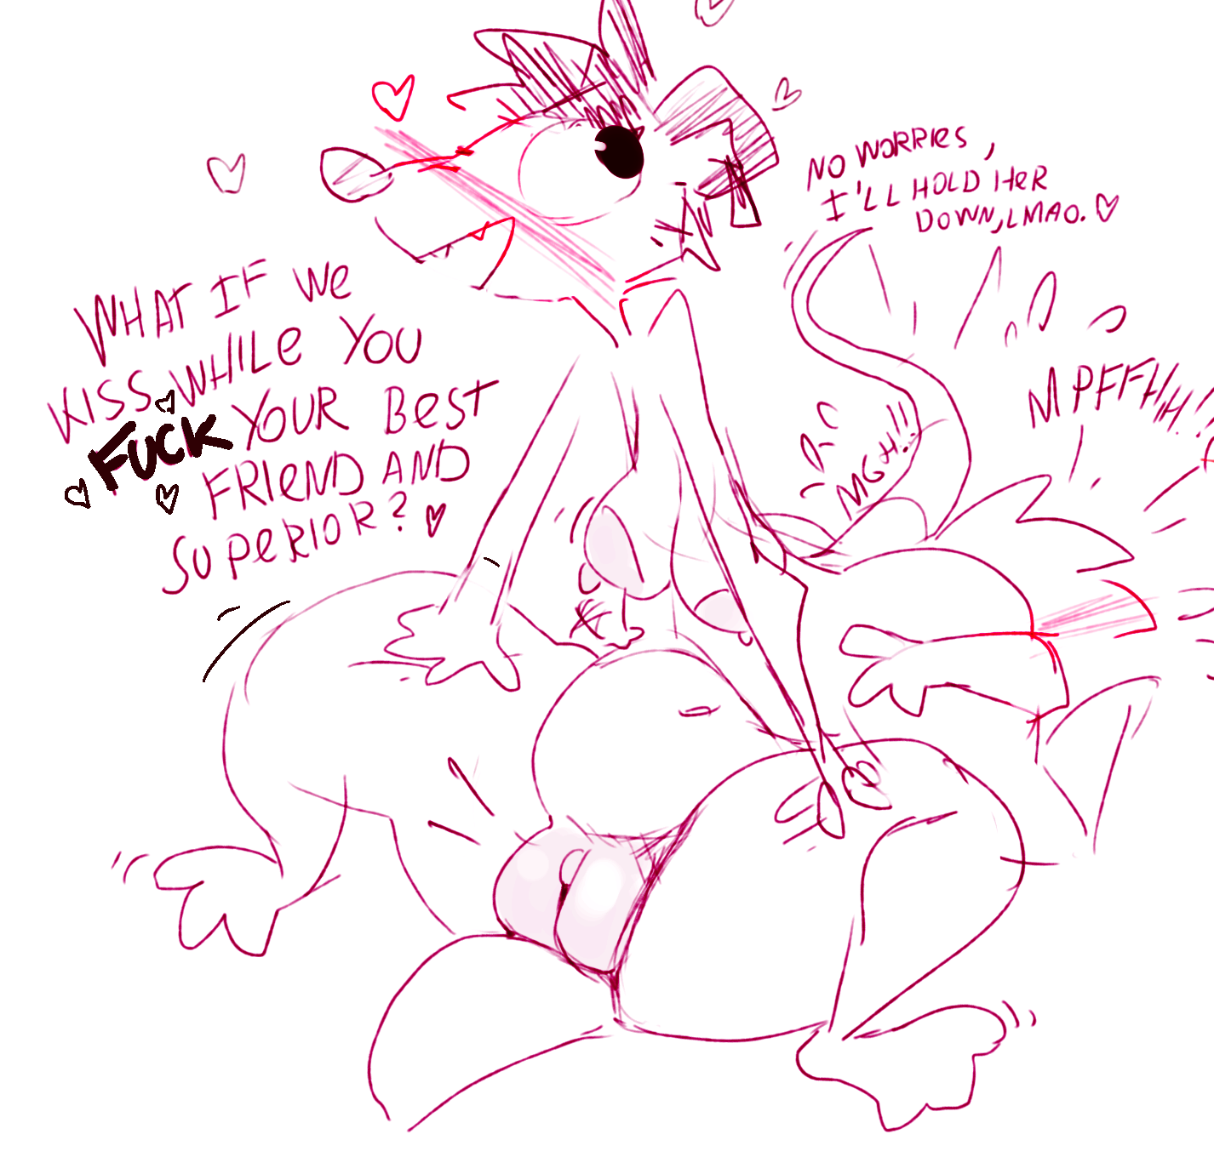
He nodded because somehow, he knew that Riggs understands Peri intuitively and entirely.
“Alright you fat purple slut, get down on all fours and let Dizzy fuck you in the ass while I’m brewing us tea. I want to hear you growwwling, you powerless plaaaything. Do it.”
Peri growled and she protested and she made remarks about how Riggs was the new girl on the ship anyway, so she shouldn’t put her nose where it doesn’t belong, and that she would never ever do something as ridiculous. She was also there on the carpet, awkwardly leaning onto her middle seat and swaying her rump at Dizzy, tail raised, exposing her entirely. “Ah, Dizzy, come onnnn… J-just get it over with – can’t BELIEVE Riggs is MAKING us do this…” – she hissed at him, angrily.
He knew she wasn’t really angry, though. Her shoulders were shaking with giggles. She was breaking the character for him, to let him know it was totally fine and she wanted it, and so he got up from his seat.
----
Plap-plap-plap-plap-plap-plap-plap-plap-plap. His hands squeezing her sids, Dizzy pushed his hips forward forcefully, slamming them against Peri’s own as he exhaled loudly in pleasure, hearing her moan in turn, then, he pulled his hips back in arcing rhythm and slammed them into her again, his belly bumping into the underside of her tail. Riggs was watching them with an expression that Dizzy could only understand as “I’m the real boss here now”, lustfully wiggling her body and making her small saggy boobs dance around at him as she was his glance, then spreading her legs unashamedly and leaning back against the counter – “I may be the boss, but you can still totally fuck me silly anytime too, you know”. He loved her, and he loved Peri, and, he just felt it – they both loved him back. And, maybe, they even loved each other.
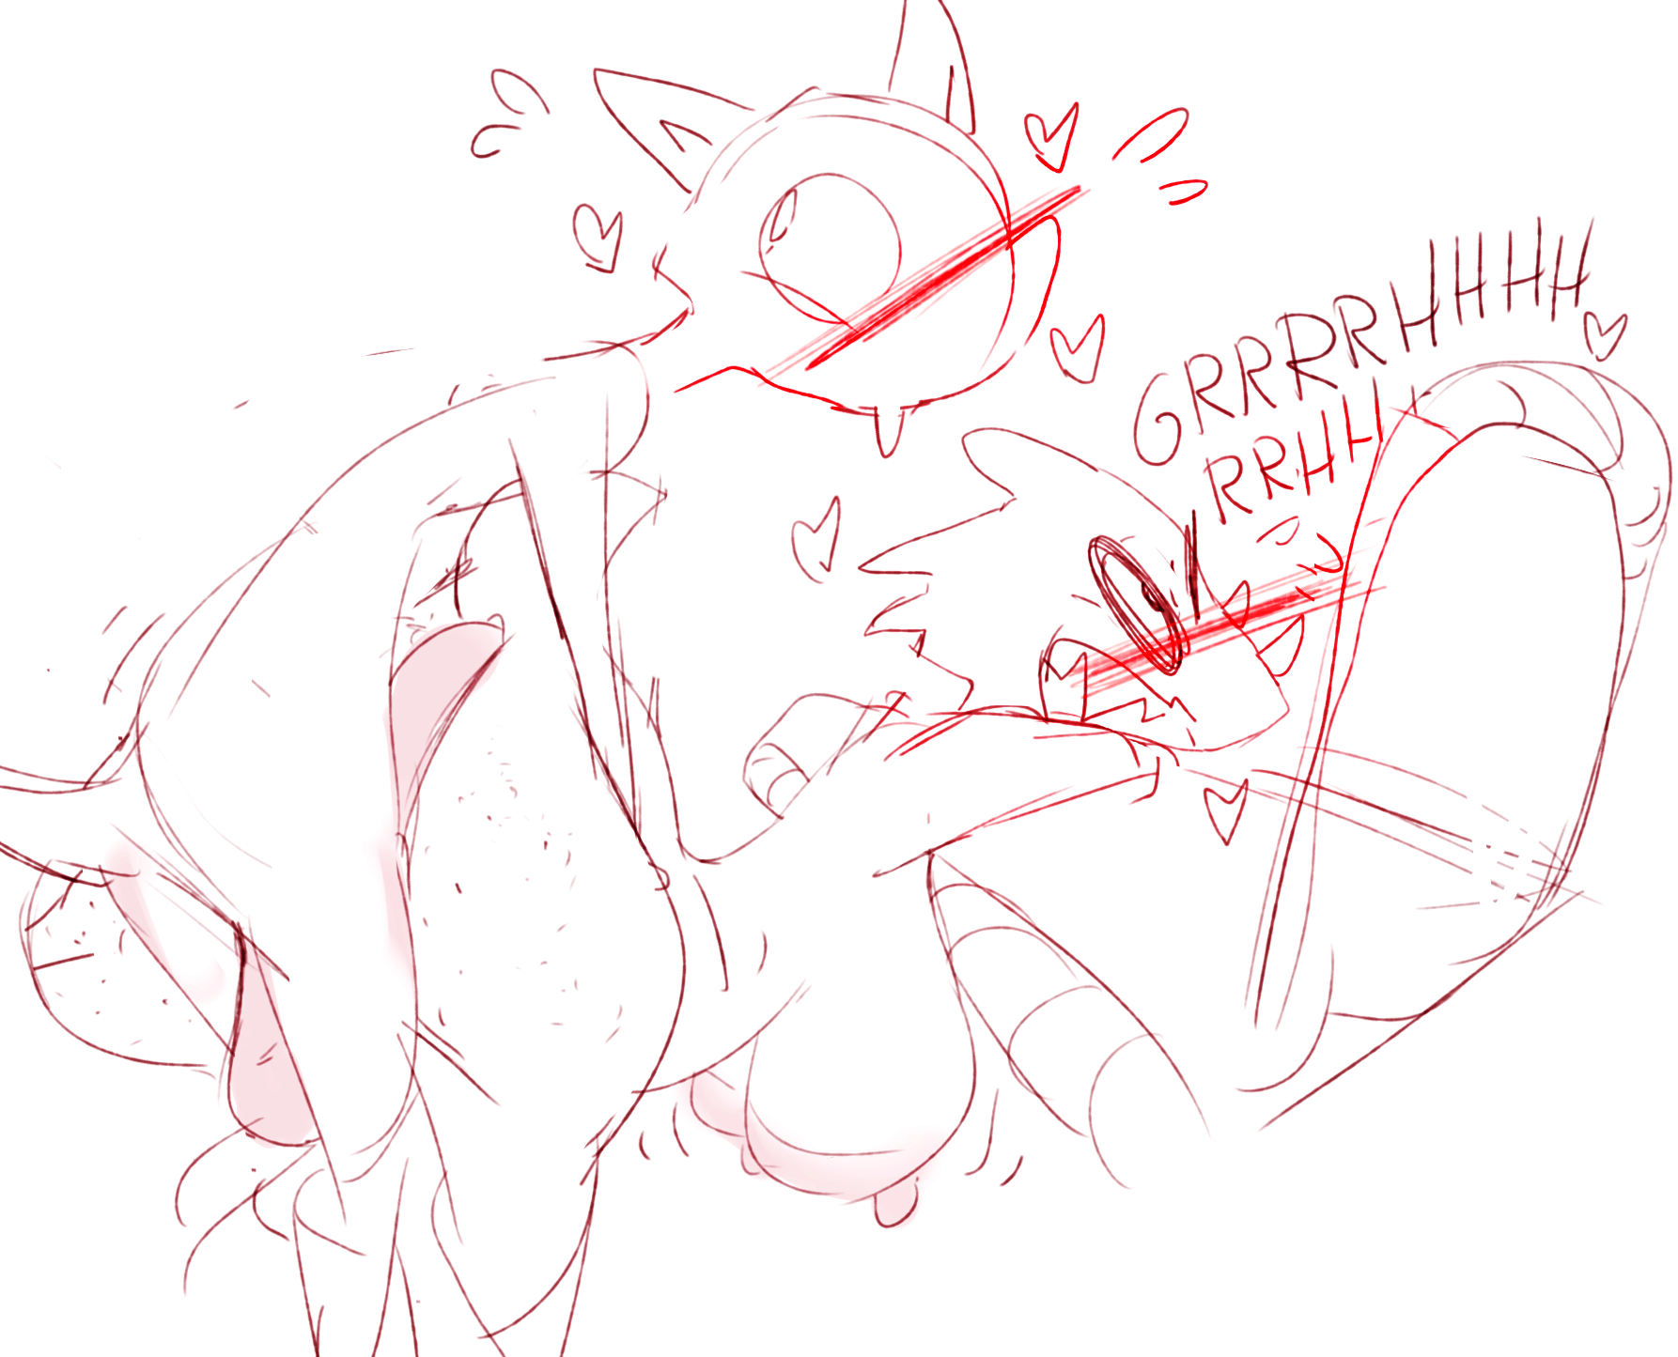
He couldn’t believe it was only the first week into this. The cockpit smelled of bubble tea, cum and of his friends. He slammed his hips into Peri one last time, locking themselves tightly close as his member started throbbing wildly, spurting out seed into his superior’s belly. Riggs walked over to them, tossed a packet of Space Chips onto his seat and grabbed Peri by her snout horn forcefully, her other hand suddenly slapping her on the side of her face loudly. Smackk. “Well, at least you know how to behave, sluuut. Always wanted to do this.” Peri growled at her angrily, her cheek flaring red. Not really, though. She was flushing so profusely, panting so eagerly. Dizzy had heard them talking about it before: he knew Peri was the one who asked for the violent slap from the possum in the middle of Dizzy totally owning her, at least just once oh please Riggs do this please. “Alright, Dizzy, when you’re done teaching this slut her place… We gonna play Modern Chess or what??” – Riggs went on. Both Dizzy and Peri nodded excitedly, and Dizzy released her, watching Riggs helping her getting up, dropping the act now to make sure she didn’t overstep, that Peri didn’t have second thoughts... Peri smiled back at her, the happiest Dizzy has seen her. They hugged tightly.
Dizzy exhaled in satisfied exhaustion. Okay, this… This was kinda amazing. He went on to collect his Chess set, thinking about just how light he felt at his soul. The world of the outer space may be rough and even cruel sometimes… But they now had each other And the world suddenly was full of happiness.
