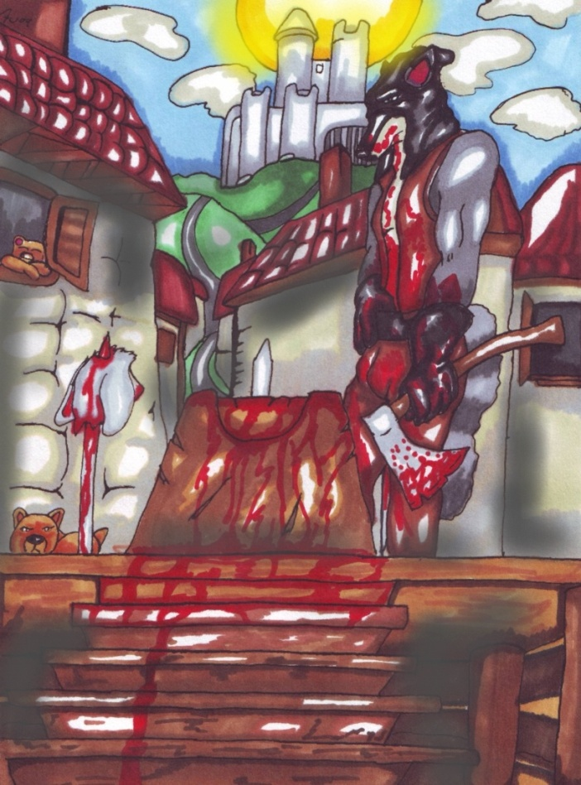
E
X
E
C
U
T
I
O
N

AT

DAWN

By Diego

From beyond the jagged peaks of the unsettled horizon, the final hours of twilight were burned away by morning’s first light. The star’s gentle glow gave way to the gentle warmth of lucence. It rolled heedlessly over plain and valley and finally to one small town it breathed life. With crisscross shades, it defined the cobble stone streets of the main thoroughfare. While interlocking back alleys and slums were coated in capes of shadow.

Overlooking this rolling memorial a solitary rusty-coated fox gazed out dreamily. His vantage point a small barred window, no more than a breath away from the towers battlements. His paws rested on the grey stonework, while between the bars he rested his snout, his features drawn and sagging. Robert had watched the sky both darken and pale from here. He had so dearly wanted to sleep, but his soul was tormented of the promise that lay before him. For this one poor fox, the sunrise that warmed his face was to be his last.

Today, he was going to be executed.
Today, he was going to be beheaded.

He remained slumped against his barred window cell for a while longer. Behind him there was little else, save dusty granite slabs and a cot that gave a new horror to poverty. The sounds of civilisation echoed up to him from the streets of the city that he surveyed. For those who had futures to look forward to, it was the start of just another day. Idly he rolled his eyes down to look into the courtyard of his prison. Something until now he hadn’t the stomach to do.

In the centre of the walled off earthen grounds was a well-built wooden dais. The wooden planking was bleached with age and well weathered. Its mottled surface - a patchwork of dark stains- told an unsettling story. However, these details were lost on the sombre faced fox. His attention was instantly drawn to the headsman’s block, which rested a short distance from the front edge. He gulped hard, the chipped stone unpleasant against his throat that bobbed against it.

Though soon destined to face the grim reality, he began to imagine what was to come. In his mind he was knelt ready, chest pressed into the recess at the edge of the block. While over the notched wooden surface, his neck laid bare, muzzle resting snugly in the groove. For a time he lost himself to these dark thoughts, until movement below caught his eye and tore him away from his morbid daydream.

A brutish figure walked around the periphery of the raised wooden platform. Moving with purpose they strode towards the steps and ascended them. A dark bushy tail with a single white band swung behind them, betraying the bearer’s mystique. It was a raccoon that stood upon the execution dais and his well-built physique left little doubt as to why he was here. In front of Robert was his executioner, making preparations for the event at hand.

Having seen the headsman at work before, he knew what to expect. Terms often got used like killer, machine and tool. The raccoon’s policy was said to be one strike, one head. The fox began to focus on the headsman’s activities below, rising from his current docile position to attention. Having been slouched against the window all night, joints clicked and the entirety of his body ached as his straightened.

The headsman strode about his duties, scattering hay over the dais and lightly sanding down the block. Robert mused on how it was like watching a craftsman at work. He maintained his tools and took pride in his artistry. For a moment, the fox felt a little at ease, until the figure below disappeared and soon returned with his axe at hand.

Seeing the shimmering crescent blade glint in the light made his heart sink. He started to shiver and sweat, like a poor animal caught in a fever. Tears welled up as the headsman made his way back on top of the dais and took his place at the side of the block. Robert shook is head in denial and at the world in general. In disbelief, he watched as the headsman held the axe across the block to take a practice swing. Robert began to sway, his strength failing him. Finally, as the axe was raised high, the fox dropped onto his knees. With his eyes clenched shut, forehead pressed against the craggy wall, he began to weep. At first softly, a few gentle tears sliding down his cheeks. Then as the sound of a dull thud echoed through his cell, those gentle tears turned to a torrent.

Time drew on and Robert remained huddled on the floor below the window, back against the wall. Unable to cope with the present he began to sink into his memories. He wanted nothing more than to recall the colourful world of his childhood, where the city was a land of adventure and the sky was bright blue. Or to his years as an apprentice, when he was young and hopeful. Back in a time when he looked forward to the blank pages of his future and felt he was the author.

But he didn’t get far; it was as if this cell was more than just a prison of the corporeal. As he began to remember the events of last night, phantoms of his past leaps from the dark corners of the cell. Slowly they coalesced into an all too familiar shape, leaving the broken fox starring at a visage of himself. This ghost stood erect in the cell. Stalwart and strong, he cradled in his arms his weeping mate. He hushed her cries with bitter sweet lies and promises he could not keep. He whispered to her that everything would be ok, while gently brushing her tears aside.

Robert cringed at the spectacle, remembering the pain that he had felt inside. It was all so fresh. After been sentenced to death, it was seeing her that he feared the most. However, despite the tears and the homeliness of her appearance, his heart throbbed at the sight. Fondly he remembered the sound of her laughter. The feel of her soft burgundy fur against his paws and those beautiful wide hazel eyes. Almost daily he had lost himself to those emerald depths.

All too soon the crushing weight of reality fell once more. Bleary eyed he blinked and reawakened to find himself alone once more. The past, though comforting and familiar, offers no sanctuary. From outside came the sound of a crowd gathering. Robert slowly scrambled to his feet and peered outside. Now in the formerly vacant courtyard was a throng of spectators. What more caught his eye were the three wooden spikes that had been driven into the wooden decking. They were in a row across one side of the dais and he knew what they were for. He hadn’t known that two other heads were to be lopped off with his own. As distasteful as it sounded, he pondered on where in the procession he stood.

Footsteps echoed down the hallway outside, accompanied by the soft chink of metal. It was the unmistakable march of soldiers. Their pace was fast, but not nearly as fast as the beat of Roberts’s heart. It began to race in his chest, while his mind was filled with a single solitary thought.

He was out of time.

They didn’t knock before entering. The footsteps having come to a rest outside his door were soon followed by the eyrie screech of rusted metal scraping together. When the key turned the lock rolled over with a resounding click and the heavy studded door swung open, its hinges creaking under the strain. Down below in the courtyard the ever growing mob erupted into a roar. Robert caught a quick glance of what was happening before the guards accosted him. A chained rabbit, his white fur marred by encrusted filth was been led up the dais. Before he could see any more, a heavy gloved hand seized his shoulder. Forcefully he was turned and pushed against the wall.

The stone walling was rough and cold against his cheek. The weight of two soldiers behind him deterred any resistance. As they shackled his paws together he grunted and snorted. He heard a firm click as the manacles were locked. With little ceremony he was turned towards the opening of the door. Before departing, the realisation washed over him that there was complete silence outside. As they walked out of the cell, he heard a familiar sound. It was a dull thud, followed by a fanfare of cheering.

From now, the axe would raise and fall twice more.

Walking down the prison corridor was a trialling feat. From behind each door came the sound of another soul in torment. Wails and moans were commonplace, as were cries for mercy and release from their perpetual solitude. Robert tried to turn a deaf ear as he was led out. His escort forced a brisk pace, which he met, head hung low in submission. This isn’t how he imagined it would be. During the night, he had thought on how he was going to face his execution. While starring out over the darkened city, he had so idealised this moment. Walking out nobly, his head held high, a paragon of courage and valour. Most of all, he wanted to be the man he presented to his mate. To have the strength and audacity he had shown while holding her in his arms.

As they reached the bottom of the tower, the world became saturated in a golden hue. The fox’s ears twitched, as the hellish cries of the other inmates faded to silence. The once daunting walls melted away. Doors to the cells they walked past and to swung open. Through each of these now open arches, Robert gazed in to see a chapter of his life. Beyond one door he saw children playing, all huddled under a bunk bed. Sounds of innocent giggles and childish laughter filled his ears and he smiled. Other doorways gave glimpses into other cherished memories. The last opened up into his own bedroom. There he saw himself lying back with his mate huddled next to him. His arms around her in a loving embrace.

At that very moment he wanted nothing more than to see her again.

It was the second falling of the axe and the blood thirsty roar that followed, which broke him away from his dreamy bliss. All too quickly the sounds and smells of the tower came flooding back. He looked down the passage again and could see the light of day. The promising scent of a fresh breeze washed over him, but it was mixed with the sickly scent of blood. The heckling cries of the crowd called for him. It was his turn to face the axe.

One step followed another and he emerged into the sun drenched execution grounds. The noise of the assembled masses was deafening. A hundred different voices boomed in his ears. They all cried out in unison, demanding the same thing. It was not him they were after, but his head.

As he was walked around the side of the raised plinth to the stairs, he caught a glimpse of the slender spikes. The furthest and closest to him were already taken, the rabbit he saw earlier starred back at him through half lidded eyes. While further away an unfamiliar feline starred out coldly across the crowd below. Her features were slender and pleasing to the eye, except for the vacancy of her expression. Her tongue hanged out of the side of her mouth which was wide open. A keen eye could glimpse the point of the wooden spike which her severed head had been impaled upon.

Robert whimpered at the sight of the impaled heads and the vacant spot between them. Worse still were the two limp bodies on the floor below. The body of the rabbit faced straight towards him, the open neck still seeping blood. Over the headless corpse was that of the feline. It had clearly just been tossed on top of the other. One of her legs was bent over the rabbits shoulder. The gory spectacle left the fox wishing to vomit. His stomach churned and tears began to well in his eyes once more. Having stalled in place, he was given a swift boot to the backside. Forcefully he stumbled on and to his surprise found himself at the base of the stairs. Slowly his gaze wondered up the rickety steps and then into the eyes of the figure that stood waiting. From atop the dais, his executioner looked down upon him.

Gore ran down the front of the headsman, two fine sprays of blood had coated his arms and thighs. From there it had dripped down to his boots. His right arm was the most bloodied. The once black gloves were now crimson and the parts that were bare fur had now clumped together and matted. The fox looked back to see a row of soldiers behind him. With no way back he softly whimpered to himself and slowly climbed the stairs. With deliberate steps he strode up, the panelling below him creaking. It seemed appropriate for the weight his spirit was been forced to bear.

With one final step he stood upon the dais, face to face with the raccoon headsman. A steely blue gaze met the sorrowful and bagged eyes of the fox. Neither said anything to the other, the headsman merely nodding to the two guards who stood behind him. The raccoon walked off and Robert was once again man handled, forced to follow behind. Below the crowd continued to shout and heckle at the condemned. Steadily he was walked to the blood stained block. It had already been coated twice.

Frantically Robert looked out over the crowd, desperately searching for his mate. He was torn, he had told her the night before while holding her in his arms not to come. But part of him wished for nothing more than to see her face. He yearned so much to mouth to her his love. To utter under his breath those three magical words, which no living creature can ever disdain.

With no sign of her he turned his attention back forward. With one more step he was left before the block. The sight of it made his blood run cold, bitter and icy, like serene water smothered in frost hewn mist. Ruthlessly he was forced down onto his knees, but not yet bowed over the block. With it so close the aroma of blood became overpowering, even nauseating. He gazed down at the block and over the side to the woven basket below. He realised that it too, was full of gore.

Behind the knelt fox came a voice, it was dignified and commanding. Robert held his tail flat against the wooden flooring and looked now vacantly forward. The voice behind started to read out the crimes he had been convicted of. As each one was announced the crowd hissed and booed. The headsman he realised had now taken his place at the side of the block. He too stared forward, seemingly lost in his thoughts while the magister addressed the crowd. A flood of hatred washed over Robert as he gazed at raccoon. He silently raged inside his own mind at the still figure before him. It seemed beyond comprehension how he could stand there so uncaring. With the reading of the last conviction, the sentence was declared;

“Death, by beheading”

One may have expected the crowd to erupt into another uproar, but they did not. A chill ran down Roberts’s spine as the courtyard fell silent, he wished they had kept cheering. The only figure to speak and move was the headsman, which came to life from his statuesque pose. Almost mechanically, he turned and looked down at the Fox, speaking in a voice that bellowed quietly;

“Have you any final words?”

The fox’s mouth filled with venom, he had thought so long and hard last night as to what he would say. The hatred and revulsion that welled up in his soul begged to be released. But as he confronted that emotionless gaze, all the hatred he felt was washed away, leaving him with a single question…

“Do you actually care?”

The raccoon grunted and though physically he remained firm, his eyes told a different story. A few nervous laughs emanated from the crowd but were soon devoured hollow silence. Time stretched out while those in the courtyard fell into limbo. Atop the dais the condemned fox started up into the eyes of his executioner. While he in turn met the gaze back, his gloved paws twisted around the shaft of his axe that he leant against. Tension filled the air, it was almost tangible. The spell was ultimately broken by the magister with a sharp cough. He shook his head sternly at the headsman who looked back in contempt.

To the surprise of all gathered the executioner looked back down at the fox and nodded, softly saying to him “I do… now please take your place”. Robert was taken back, his eyes swivelled down to the block and he shuddered. The plaza was once again swept up in silence. Not a single nervous cough or the shuffle of fidgeting feet could be heard. It was a true deathly silence. Timidly Robert lent forward. The thin recess in the edge that his chest rested against was rough and uncomfortable. Blood that had settled on top was sticky and cold. He nestled his snout into the groove, which cupped his chin firmly. However, the little comfort that provided was soon taken away as he opened his eyes and saw the basket. It rested just below, placed there for the sole purpose of collecting his severed head.

Looking into that woven wicker basket made his heart race more than it ever had before. His vision started to go hazy as little star like snow flakes pirouetted across his vision. Every part of his living being went numb and the vile aroma of blood seemed to fade into oblivion. Robert felt like he had been plummeted into a sunken dream, he was nowhere and it was terrifying. For a moment, he believed this may be death. A hazy world that is dead of all sensation. Then he felt the cold steel of the axe on the back of his neck and he was alive again. The world he knew returned.

Once more he was looking down into that bloodied basket. He held is breath in anticipation, as the headsman held the axe to the back of his neck. It shifted up and down, searching for its mark. The cold blade kissed his warm neck each time it settled. Resting low down near his shoulders, the blade stopped its little dance. The fox gulped, which rippled over the top of the block. There was the sound of creaking leather as the headsman tightened his grip on the shaft of the axe. Floorboards strained as he parted his stance.

Soon, the axe would fall.

This is not how he wanted to die, a thought which had plagued him all through the ordeal. It was all too much, he didn’t even know how he had got this far. Tightly, he screwed his eyes shut; causing a single tear that had been welling up to fall.

It ran down his cheek,
And he felt the blade of the axe leave his neck.

Falling from hair to hair, it drifted down to his nose,
And the headsman held the axe up to the heavens.

It tickled his nose, hanging there for a moment before finally falling,
And so did the axe.

Without hesitation, the headsman swung, his muscles rippling as his arms and hips brought the axe down. Robert held still through it all, though the moment the axe fell he knew it was coming. There was silence and then there was the dull thud. The blade of the axe cleaved through the fox’s flesh, bone and flesh again. The thud came as it was buried into the block, making yet another notch. The only signature a victim is allowed to leave behind. Swiftly and silently his head fell down into the basket. Softly it rustled as it came to a rest, but this fine detail was lost to the third fanfare of the day. Like the two heads that were severed before, Roberts did drop into the basket amidst the roar of the crowd.

His body died with dignity, which is not afforded to all. While on one side his head fell, chased by a spray of blood, on the other the now headless body slumped forward. What remained of his neck fell against the axe that rested embedded in the block. A twin font of blood shot out with each dying heart beat. The fox’s bushy tail shot up, standing on end in shock. It remained erect for a moment and then fell limp between the two still legs. A moment later and the headless corpse of the fox relaxed, falling sideways onto the wooden decking. A pool of gore formed where the bodies head should be. The crimson ichors spread out and started to drip through the cracks in the floor.

With no emotion the headman stared down at his axe resting in the block. It was like everything else, covered in blood. He was covered in another fresh spray that coated his chest. He wiped a small amount away from his eyes and off the hood. He was a single quiet vessel, upon a sea of noise. Watching in silence as the gore of the fox ran down the block to the floor. Taking a single step forward he peered down into the basket, gazing upon the severed head. From the bottom of the basket, Robert starred back at the headsman. His maw was slightly agape while his eyes were wide open.

Taking hold of the fox’s head by one of his ears, it was raised out of the basket. Then held tightly between two paws, the raccoon held it up to the light. The cheering of the crowd reached a final crescendo at the sight. However, for Robert and the headsman, it all meant so much more.

Still slightly lucid, the severed head of Robert looked into the light. However, he couldn’t see the cheering crowd; he could only hear them, though muffled by the blood in his ears. None of that mattered, because she was stood in front of him. Her burgundy coat was vibrant as ever and her eyes dreamy. She was surrounded in an aura of broken light. He wanted to smile but he couldn’t. But it didn’t matter, she was there and softly she touched a paw to his cheek and leant forward to kiss him. Robert closed his eyes and felt the kiss.

At the same time, while the headsman held the head up, he pondered. On what he had been asked and what he had said. From the corner of his eye, he saw the eyes of the fox’s head close. Not like the half-lidded eyes he was used to seeing. They closed peacefully and remained shut. Though no one else would say it, he took the peaceful passing of the fox as a thank you.

With a heavy heart he handed the head over to one of the soldiers, who took it over to its final resting place. Between the head of the rabbit and feline, the fox’s was impaled. Skewed on the last of the wooden spikes, it would be left there to rot. Along with the other two, the fox’s body was tossed down onto the ground. It landed on top of the feline and rabbit, their arms and legs mangled together in a still orgy.

Minutes and hours spun on, seeing the people that made the crowd disappearing off to their regular lives. They would chat about the days events in the past tense, uncaring and unfeeling to the truth of what occurred. While a weary headsman returned home to wash the blood and gore off his himself and his clothing.

The sky darkened once more into darkness like it always would. Inside the courtyard that saw the passing of thee lives, a solitary figure moved about. The raccoon no longer dressed as a headsman looked down at his block. Most of the blood and gore had been cleared from its crude wooden surface. It had taken some time and next to him was a bucket of red tinged water. Satisfied with the result he knelt. He knelt in front of his own block. Taking hold of it between his paws he lent forward. Stretching his grey furred neck across the block, he closed his eyes and imagined the cheering of the crowds. To no one, at all he said;

“I do care”

Fin

