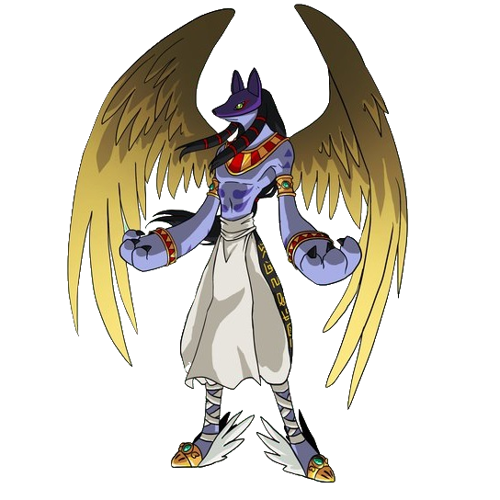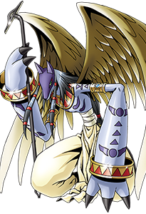

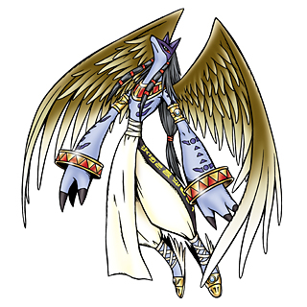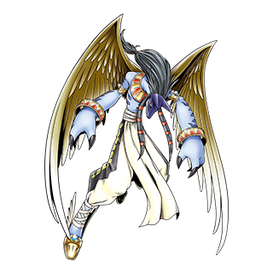

So, what I’m wanting is a modification on the standard version of Anubismon/Anubimon named Antinubismon. Like its origin, Antinubismon is roughly jackal shaped, thick, long arms, rings around wrists and ankles and jackal mask like his base. Unlike Anubismon, however, Antinubismon does not have wings, instead of pants he wears a Shenti (marked with an upside-down Ankh), walks barefoot (three toed feet), has three fingers and a thumb on each hand, instead of bangles on his forearms, he has an extra set of rings around his ankles and varied colorations/ markings.
His base coloration (compared to basic Anubismon) is charcoal gray (in place of Anubimon’s blue-gray), with lighter gray accents in place of purple (the mask should likewise be the same color) and silver hair in place of black. Antinubismon’s eyes are stark red, and is often looking distinctly mad/insane. In place of the Hitatsudomoe-like markings on his stomach, the red spiral design (below), and in place of the triangles and designs down the arms, the twisted rope design from shoulder to wrist (also below) with the zig-zag (also also below) on either side.

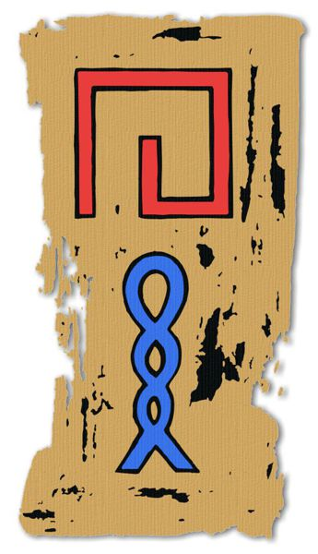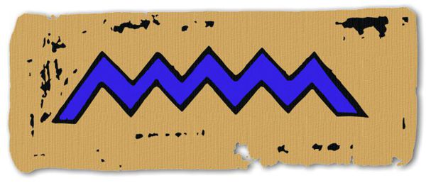

The rings around the Antinubismon’s wrists, ankles and braids (and the necklace on his chest) should be gold, with the alternating pattern in black.
Antinubismon’s Shenti (design below) should be plain, bright white fabric around the thighs, and a long white trailing sash down (to knee length) the front marked with the upside-down Ankh in black mentioned above.
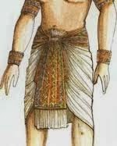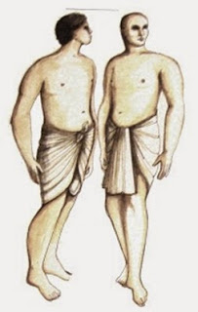
Antinubismon’s feet are bare, except for a strip of cloth connected to a ring around his middle toe going up to his ankle (similar to Renamon’s arm-sleeves)
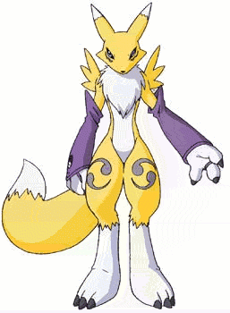
LEWD STUFF AHEAD
Antinubismon, beneath his Shenti, is very well hung (down to his knees), and uncut, very thick. The skin is gray, like the rest of him, but the head beneath is lighter (the same color as his markings). He has rather heavy testicles hanging beneath as well. Behind, hidden by his Shenti, he has a very well-used hole.

