PonyFans Poo
By: Red Rocktober
The puple-skinned 18 year old girl moaned softly on the bed, on her hands and knees with her bare ass in the air. She looked over her shoulder at the camera she had set up on her dresser. Twi pushed her glasses up on her nose and smiled, waving her perky butt side to side as she squeezed her abs tight. Her puckered pink butthole opened enough to let out a loud fart, the buzzing “brraapp” carrying on for a solid five seconds. The camera was far enough back that her viewers would be able to see her entire ass, but zoomed in enough that the opening of her hole was visible, a dark circle in the center of her otherwise pink, crinkled muscular ring.
“Ooh,” she said with a giggle. “That one really stinks!”
The room filled with the smell of sulfur and something not too far off from rotting meat.
“I bet there’s more in there. Shall we see?”
She bit her lower lip, tossing the long ponytail of her dark blue hair, with its purple and pink stripes, over her back. Twilight arched her back low, pointing her ass as high as she could, and pushed again. She screwed her eyes shut, exaggerating the effort she was putting into letting out her gas.
“Ohh!” she moaned as her tight asshole opened up again.
This one started out almost silent without the soft globes of her cheeks to vibrate, spread as they were. There was a quiet, but audible “pffff” that transitioned into a noisy fart. It ended suddenly, however, when her body instinctively clenched her hole shut. Her bowels had started to move, and the tip of her shit bumped the inside of her anus. Twilight made a show of waving her hand in front of her nose.
“Oh my god, that smells terrible!” she said with a bit of a laugh; it really was quite stinky, carrying the foul odor of her poop with it.
Her laughter forced out one more poot, the odor joining the noxious cloud already filling the room. She straightened up, her white blouse falling partway down her ass, the hem landing just a couple inches higher than her hole. Twi was still on her bed, upright but on her knees. She scooted back so that her lower legs were hanging off, knees right on the edge. Turning to face the camera once more, purple eyes glancing quickly at the screen she had set up next to it so she could see what the lens was seeing, she grinned.
Bending forward just the slightest bit to poke her bare butt out, the blouse lifting the tiniest bit, she pushed again. One more poot slipped out before a soft little cylinder followed, the light brown turd tapering from the end into a log about as thick as two fingers poking almost straight out from between her cheeks. She clamped her hole shut and pinched it off. It fell from her ass and landed on the floor with a soft thud. She had placed a towel there for easier cleanup, but it was out of view of the camera.
“Oops,” she giggled, making eyes at the camera. “It just slipped out!”
Twilight turned and hopped off the bed, walking over to her dresser and grabbing the phone off of its perch.
“Hello all of my PonyFans, I hope you’ve enjoyed this so far. It absolutely reeks in here.” She waved a hand, wafting the air to her nose. “Earthy, honestly a bit musty? But very eggy! I’ve definitely got more for you. I have had quite a bit of coffee this morning and let me tell you it is going right through me. From both ends.”
She gave the camera a wink, making sure to hold it high enough that her cleavage was visible. Twi walked to the top of the stairs in her one-bedroom townhouse. She sat down, gasping as her butt made contact with the cool hardwood. The girl put her feet a few steps down and spread her legs wide, exposing for the camera the trimmed purple bush in her crotch. One hand holding the camera up and out, she used the other to spread her lips with two fingers. Twilight “winked” for the camera again, only this time it was her pussy that she “winked” by clenching her inner muscles.
With an ease that came from practice, she relaxed herself enough to begin peeing. Her piss came out in a loud, hissing spray, the internal pressure on her bladder forcing it into an arc that cleared almost three steps before falling, splattering loudly against the wood stairs.
“Ooh, that’s better,” Twi cooed at the camera, sighing and moaning as her bladder emptied. “My, my, I really had a lot, didn’t I!” she said after pissing for almost a minute.
Bringing the camera in close between her legs as her stream started to subside, she pushed. The twisting strand of golden liquid renewed its force. With her lips spread, the extra flow opened her pisshole enough to be visible to her viewers. She felt a slight shift in her stomach heralding the arrival of a more gaseous waste billowing up from the depths of her bowels. Twi tilted the camera downwards, careful to keep it clear of her pee stream, onto the pink ring between her cheeks.
pbbtffffbrraaaAAPP
As she pushed out the monstrous fart, the air rushing out of her anus buzzed the crinkled exit, increasing in both volume and pitch as it tapered towards the end.
“Excuse me!” the girl said. “Even a lady has to let out a little toot every once in a while.”
Taking her hand away from her pussy she nibbled on the end of a fingernail, feigning embarrassment.
“You’ll all forgive me, won’t you?” she asked, blinking her purple eyes innocently at the camera, before her brow furrowed and she frowned.
“Oh gosh, that is toxic she said with a laugh as the smell hit her nostrils.”Phew! That must be from all the sausage I ate yesterday.”
Twilight made a show of giving it a whiff, like a sommelier taking in the aroma of a fine wine.
“Mm, and shot through with something sharp, probably the mustard. And there’s a hint of nuttiness, I wonder what that’s from!”
Her pee stream had finally abated, the last of it clinging to her cunny and running down to drip off of her ass. She didn’t bother with anything to wipe, letting it trickle down her inner thighs as she stood up.
“Well I don’t know about you all, but that got me absolutely riled up,” she said, holding the camera so that her upper half was in its view.
Her nipples were clearly hard under her white blouse, the top three buttons left undone to show her cleavage. Biting her lip as she looked up at the lens, she groped herself, squeezing her breasts. After a moment, Twi shook her head, long ponytail swinging behind her.
“It’s still so stinky! I’ve gotta get out of this cloud I’ve made! C’mon, let’s go somewhere else.”
She walked down the stairs, pointing the camera down as she descended so that it could capture the mess she had left on the stairs. Little puddles of pee had formed on the stairs, rivulets dripping off onto the steps below. She made no effort to avoid them, stepping into her liquid waste with quiet splashes, getting it all over her bare feet. As she made it past where her arc had carried her pee, she left a trail of wet footprints about a dozen steps into her living room.
Twilight paused the recording so she could get the camera set properly. She went back upstairs, once again walking through her own piss and tracking more of the quickly cooling liquid around. Grabbing the little tripod with its bendable legs she got the camera mounted on a chair leg so it would be pointed upwards at her ass but out of the line of fire. Standing just off camera she hit record once more.
She put one foot up on the seat of the chair, grabbing the top of the back and climbing on she squatted slowly. Twi was facing the back of the chair, her ass hanging off over the edge. As she bent her knees her cheeks spread open, revealing her pink hole to her viewers. A little smear of brown was visible around the her exit where she hadn’t wiped after her earlier dropping.
Twilight slid her hand down between her legs, slipping two fingers through the short curly hair covering her cunny. She closed her eyes, probing herself, pushing her digits into her tight little hole, moaning as she began to masturbate. She smiled as pleasure began flowing upwards from her crotch but stopped for a moment with her fingers buried knuckle-deep inside herself. The purple-skinned girl relaxed, trying to allow the shit she knew was filling her colon to come out on its own without pushing.
“I hope all you fans are ready, I haven’t pooed in days and I just know this is going to be a big one!” she said, turning to look down towards the camera so it would catch her voice. “See if you all can guess what I’ve been eating.”
As she stayed still, squatting on the chair, her bowels began to move. Twilight’s asshole relaxed from its pucker, then began to open as the firm brown tip began to push out. There were a few quiet puffs as she farted around the thickening log. Twi groaned then started pumping her fingers into her pussy again, really enjoying the sensation of her big shit stretching her open. The tapered cylinder was a little hard, almost knobbly, as it had been sitting in her for a few days while she held it for her PonyFans content.
“Oh god yes, that feels sooo good,” she cooed, finger fucking herself while she let her poop drop out onto the floor.
It crackled as it grew, sticking several inches out of her anus before breaking off and falling to the ground with a soft thud. Several kernels of corn were visible in the cross-section of shit visible just past the stretched ring of her asshole. It was just shy of painful for her.
She picked up the pace of her fingers, the smell of her arousal only covered up by the smell of her poop on the floor. Her evacuating intestines increased in pace as well, now that the harder poo almost blocking the way had cleared. It started to slide out in a more continuous soft snake of shit, shifting from the dark brown to a lighter tan, nearly yellow.
“Mm, that smells so so foul. I wish you all were here to smell it with me, my goodness. It’s…it’s almost sharp!” she giggled, “that must be from the spicy curry.”
The crackling got louder, puffs of her intestinal gas escaping around the softer rope of rancid refuse. It was sliding out faster, the growing feeling of emptiness inside her an erotic relief. Little strands of orange could be seen going by, shredded carrot from her curry. Spots of green as well, various undigested vegetables making their way out of her body the same state they went in.
Twilight was breathing hard, nearly empty. She put a thumb on her clit and began rubbing herself in little circles as she noisily fucked herself with her fingers. Surrounded by her own stench, she came as her turd tapered back down. Her hole reflexively clenched itself shut, pinching the log off. The purple-skinned girl shivered as her orgasm washed through her, the tensing up of her abs forcing out a final fart, the loud expulsion a wet blast accompanied by a brown squirt that sprayed beyond the pile she had left on the floor.
As her ecstasy subsided, she pulled her fingers out of her slit, grabbing the camera and turning it downwards to view the heaping, coiled pile of poop on the floor. The stench was so strong, it was almost visibly steaming from the brown mess. She climbed down off the chair, unconcerned with where she stepped. Twilight’s foot went feet right into the soft, hot pile, with the warm poop squishing between her toes.
“Thanks for watching, everyone,” she said for her viewers, grabbing the camera off of its mount and bringing it around behind herself. “I hope you enjoyed that as much as I did. And remember, the biggest gifter gets to choose where I poop next! Ciao!”
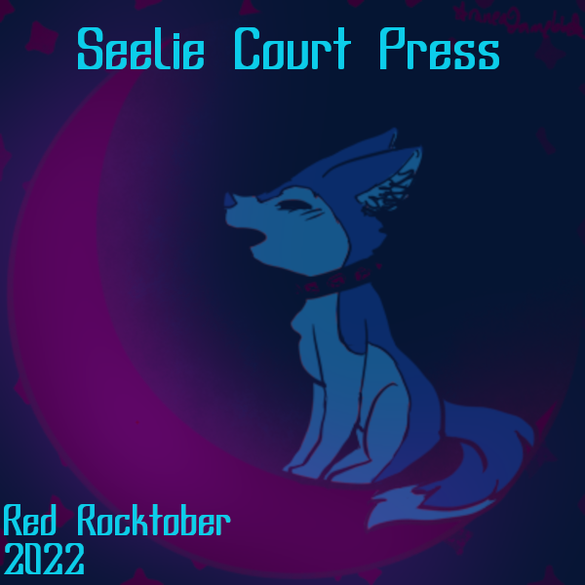
She punctuated her farewell with a big fart, her free hand gripping her soft, purple-skinned butt cheek and pulling it to the side. The camera was close, its lens filled with the view of her messy hole, leftover streaks of brown smeared around the stinky ring. Twi hit the big button on top of the camera, ending her video on that particularly rancid note.

