Sawyer’s Fan Male
By M. E. Vehnt
April 5, 2013

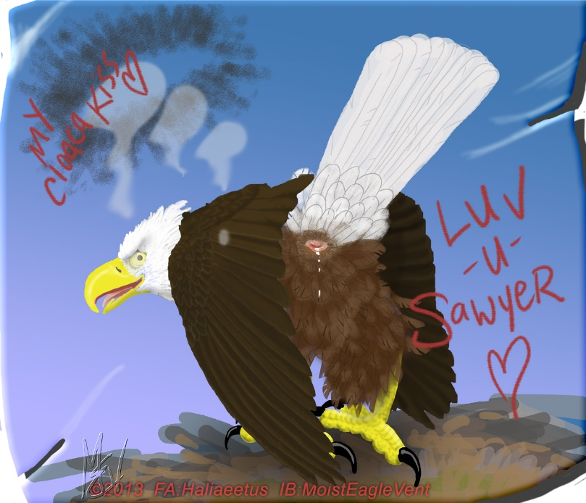

WARNING! WARNING! WARNING!
This is an adult story (readers 18 years and older only please) and contains acts of forced and consensual sexual intercourse between adult feral birds.

©2013 by M. E. Vehnt aka MoistEagleVent
DO NOT COPY OR POST ELSEWHERE WITHOUT EXPRESS PERMISSION

Sawyer soared over the green fir trees and blue waters of Puget Sound searching for the landmarks he was given. Somewhere below was a hot male bald eagle going crazy with desire to meet him. Sawyer had built up quite a fan club since his porn career started 8 months ago. With the help of his pimp and best friend, ferobird and “uncle” Haliaeetus, his exposure had increased. He developed quite a fan club of hot and horny eagles, vultures, and condors. One of his most prolific fans was a male bald eagle by the username of “hothornyeagle69” on all the eagle porn internet sites. His emails and generous comments really boosted Sawyer’s moral. You see, Sawyer gets pounded in the butt by a lot of uncaring vultures and sometimes feels like he’s just a piece of meat to them and his porn fans at large. Sawyer has largely ignored the fan mail full of lusty invitations but the persistence of this particular fan got his attention... that and the juicy photo that was sent. The photo featured HotHorny bent over, tail high, pink vent drooling, dirty smile on his beak. It made Sawyer’s jaw drop and he almost cummed his feathers as he imagined the fun he could have with this slutty bird. This caught Sawyer’s interest enough to prompt him to fly out to keep this eagle company.

Soon Sawyer found the right spot and descended down towards a large fir tree at end of a point of land. The spring air was mild and a slight breeze tickled the tops of the trees. The evening sun slanted over the Olympic Mountains in the distance. Sawyer circled over the tree and scanned the area for white feathery heads. He had been told that HotHorny frequented this particular spot... a favorite place to spread his wings in the afternoon sun and digest a meal of tasty salmon. Sawyer set his wings and side-slipped down, pulled up into the wind and lit softly onto a large branch in the fir tree. It was nice to rest so he pulled up one foot and preened his neck feathers.

“Oh myyyy... you are taller than I had imagined!” came a voice from the deep shadows of the fir tree.

Sawyer whipped his head around and flashed his pupils, trying to penetrate the dark shadows. Sawyer is a tall, handsome golden eagle with excellent gold hackles and the loveliest smooth brownish-gold eyes. “Who is that? Is that you HotHorny?” cackled Sawyer, his hackles rising and a smile coming across his beak.

A high-pitched series of chirps cascaded out of the shadows, like laughter, ending in a humid “...yeah, non other!” and with that an adult eagle hopped out of the shadows and onto the branch where Sawyer was resting. HotHorny was big for a male bald eagle with clean white neck hackles that ruffled in the breeze, pale yellow eyes and riveting pupils, and fine dark body. He hopped onto the branch about 15 feet from Sawyer and surveyed him with a big smile as his eyes adjusted to the brightness. Sawyer looked back, his hackles up from the horny chill that shot through him, his eyes wide, his beak dropping open slightly, and his feet clutching the branch tight. His pulse quickened and he salivated and swallowed.

HotHorny focused his intense eagle gaze squarely on Sawyer and sauntered down the branch, swaying back and forth as he came. Sawyer just stood there, staring, locked on to the sexy fluffy figure coming towards him... riveted, like he was watching a porn video on BurdTube. He followed the eyes towards him, his peripheral vision catching every nuance of feather flutter and tail waggle... and HotHorny’s walk was so seductive that Sawyer could feel his vent pulsing to life already.

As HotHorny got closer he moved faster and quickly plunged his beak straight into Sawyer’s neck fluff on the left side. He wrapped his neck around Sawyer’s neck tightly, hugging Sawyer against him and snuggling his beak up to Sawyer’s right ear. Sawyer jerked back slightly out of surprise but then he felt his knees weaken and he gave in to the warm hug, leaning forward against this fluffy friend. HotHorny’s feathers smelt so clean and fresh and they were so comforting... Sawyer closed his eyes and listened as HotHorny breathed into his right ear... “Are you ready for the time of your life honey? I’m gonna make this trip really worth your while. I promise that you’re gonna learn new ways to cackle, you sexy burd!” Sawyer’s vent loosened up and he his feathers fluffed out all over his body as he felt his libido take over.

“Your tired, hon, so I’ll start this show... just relax and let HotHorny preen your cares away...” and HotHorny began preening deep into Sawyer’s neck. He carefully grasped a feather at a time and gently worked it from base to tip with the tip of his beak. At the same time, he swung a wing down over Sawyer’s back and rubbed his hips and tail. Sawyer let out a soft moan and he squirmed with delight from the back and tail petting... precum began to build up in his softened cloaca.

HotHorny noticed the moan and the squirm so he gently slid his closed foot up between Sawyer’s fluffy legs. He felt Sawyer’s soft, warm, relaxed vent and slid the knuckle of one toe into the juicy orifice and worked it around in wide circles. Sawyer’s head pulled up uncontrollably and he pressed down against the welcome penetration. “Oooooohhhh” he moaned, a grimace of pleasure twisting the corners of his beak. He slowly ground his hips and cloaca down over HotHorny’s foot, lubricated with clear precum that flowed down between HotHorny’s toes. Sawyer, his eyes closed, dropped his beak open and began to pant and drool as his cloaca pulsed and flowed with juice. He slid up and down HotHorny’s foot, feeling the smooth bumps of the scales slide across the membranes of his winking cloaca. Soon his brows furrowed up and his tongue hung out. HotHorny licked that tongue and grasped Sawyer’s chin in his own beak... letting Sawyer’s drool run down into his open mouth.

Sawyer began to tremor and his cloaca spasmed. HotHorny could tell that his vent was becoming very sensitive to the stimulation so he changed tactics. He slid his clenched foot out from Sawyer’s vent and held it up between their bodies, glistening with precum. He licked it slow and sexy, with a smile on his beak. Sawyer joined in and tickled between HotHorny’s toes with his own pink tongue, panting and grinning. When the cleaning was done, they began to lick each others beaks and slide tongues into each other’s throats. Sawyer loved the feel of HotHorny’s barbed tongue as it slid up and down the roof of his mouth. His tail and vent spasmed again and a pulse of clear precum drooled out of his butt feathers and was blown into shining strands by the wind.

“Now you’re ready, my love” whispered HotHorny in a tender tone of voice. “Here’s that hot ass that brought you all the way out here... and it’s all yours, lover.” Keeping close, he brushed against Sawyer with his feathers as he slowly turned around, tail high. As he stopped turning, a soft breeze assisted in blowing aside the undertail fluff and exposing a pink, soft eagle vent... pouting with glistening precum in the corners. HotHorny smiled invitingly and shook his tail slightly to make the fluff jiggle.

It was irresistible to Sawyer and he eased forward and rubbed the top of his beak and forehead against the hot pillow of flesh. HotHorny moaned slowly and rubbed his vent down against Sawyer’s head. Sawyer rubbed his beak and head in wide circles and HotHorny’s vent lips swelled and pulsed to the stimulation... he began to pant and chitter softly. Sawyer pressed up firmly with the smooth curve of his upper beak, right up against the inside of the HotHorny’s cloaca. HotHorny’s tail quivered and spread, he chirped, and drips of precum spurted down around Sawyer’s beak. Sawyer pulled back and softly licked HotHorny’s exposed cloaca and then nibbled softly on the lips of the vent. The sun lit the vent well and he was getting really turned on by the juicy pink tissue puckering and relaxing, over and over, before him. As he made his way around the vent, HotHorny settled forward onto his breast on the branch and began to moan long and high. The moans were soft at first but then became louder. With each long call, the vent puckered outward and the cloaca relaxed for mating. The time was right so Sawyer spread his wings and climbed up onto HotHorny’s back. He balled his feet and stroked and rubbed HotHorny’s sides, like a cowboy spurs a horse. HotHorny reacted by cackling among the long high wails. Sawyer’s tail swished back and forth across HotHorny’s rump, smearing clear, slick precum all over the feathers. Neither bird cared about feathers right now. Their brains were alive with pleasure from the tips of their beaks to the tips of their talons... right down to their vents which were now seeking each other out... drooling and thirsty for sucking against each other.

Sawyer’s tail wrapped around and under HotHorny’s and their cloacas touched. “AAAAaaaaaaaaaAAAAhhh” was HotHorny’s response followed by “Fuuuuck me Sawyer!” and further eagle screams. Sawyer could only stutter out “Uh huhhhh... Uh huhhhhh... u-u-u-u-uhhh huhhhh!” Their two vents were open and sliding across each other back and forth as the tails swished together, thirsty for the other’s cum. They slaked each other faster and faster as Sawyer ground his ass forward into HotHorny’s fluffy rump until... Sawyer’s eyes opened wide and he straightened up tall. His wings quivered and his tail stretched and pressed hard into HotHorny... and HotHorny moaned as cum spurted out around their tight embrace and ran down his belly. Sawyer slowly lowered his head into HotHorny’s neck fluff. Sawyer was panting heavily with his eyes closed and cum oozed out of his soft, satisfied hole. “Huh, huh, hummf, ooohhh... how are you hottie?”

HotHorny tipped his head back a little and glanced up sideways, smiling, at his mounted lover: “I feel wonderful, Sawyer, but I’m not done with you yet...” With that, HotHorny rolled his shoulders and Sawyer slid off, flapping and screaming from HotHorny’s back. But in the same continuous motion, HotHorny rolled off with Sawyer, clutching both of his feet in his own. The two tumbled down through the air flapping and spinning until they flopped into the salal brush at the base of the tree with a crash. HotHorny landed on top of Sawyer who was laying on his back, and the two sat there facing each other, clutching feet, panting in the dark, dirty leaf litter under the tall salal bushes. Sawyer could see that the mischief in HotHorny’s eyes was good-natured and that this was going to be fun. So he relaxed and smiled back.

HotHorny, still clutching his golden-feathered prey by the feet, pressed Sawyer’s legs to the side and lowered his dripping vent down against Sawyer’s. Sawyer’s cum had everything all lubed up and slippery so there was no need for further foreplay. HotHorny let go of Sawyers feet and moved his legs up to either side of Sawyer’s breast and clutched deep into the leaf litter under Sawyer’s back. He began to slide his vent up and down Sawyer’s belly... forward up the belly then back down, across the relaxed pubic bones, across Sawyer’s juicy hole, and then down around the base of Sawyer’s tail. He moved forward and back smoothly, smearing Sawyer’s cum and his own precum up and down Sawyer’s belly. Soon Sawyer was quivering his wings and moaning to the sound of the slathery squishing sounds made by the vents rubbing past each other. HotHorny slid faster, arching his head back with eyes closed... his tail flexed wide open so that it stirred up leaves and dirt around Sawyer’s tail. Feeling the climax approaching, he brought his smiling beak down and panted into Sawyer’s beak, which opened and licked back at his lusty lover. The smell of spunk was in the warm air under the brush, mixed with the musty smell of leaf litter and fir needles. Sawyer was getting so dirty but he didn’t give a damn... he just let himself get smeared from above and ground deeper into the dirt below. HotHorny began to chitter uncontrollably and his wings spread out, rocking the bushes and knocking down spider webs and loose leaves on top of them. Then he stiffened up and flapped hard, causing a terrific crashing sound in the bushes, which almost muffled his long eagle shrieks. He ground his vent down hard against Sawyer’s. Sawyer felt the warm, welcome feeling of cum spurting into his cloaca as HotHorny’s vent spasmed and sucked against his exposed membranes... he quivered with pleasure.

They lay there for a few moments panting. Then HotHorny stood up and back away a little so that he could tenderly lick Sawyer’s vent and belly. He helped to clean up the mess he had made. As he did so, Sawyer motioned for HotHorny to turn around. Sawyer scooted under HotHorny’s belly so that his face was under HotHorny’s vent. He began to lick HotHorny’s vent softly, savoring the hot, loose membranes and sticky fluids. The feeling was cool and soft to HotHorny and he purred softly. After a few minutes of tenderly licking each other’s vents, HotHorny snuggled back down at Sawyer’s side and they slept the night away together in their own private hideaway in the bushes, completely satisfied.

