Themes: Portal sex, voyeurism, tentacles
Words: 1,345
Pages: 10
Title: Eastbone 1: Evil & Sexy Magic
Author: Midnasterspine

Eastbone 1: Evil & Sexy Magic
Synopsis: Lune and Poppy finish a 3-legged race and then magic sex shenanigans ensue at home.

“Honestly, I have no idea what I’m doing,” admitted Lune, the bird.
“Come on, girl! You gotta ‘wing’ it. Get it? Have some confidence in your stride,” said Poppy back.
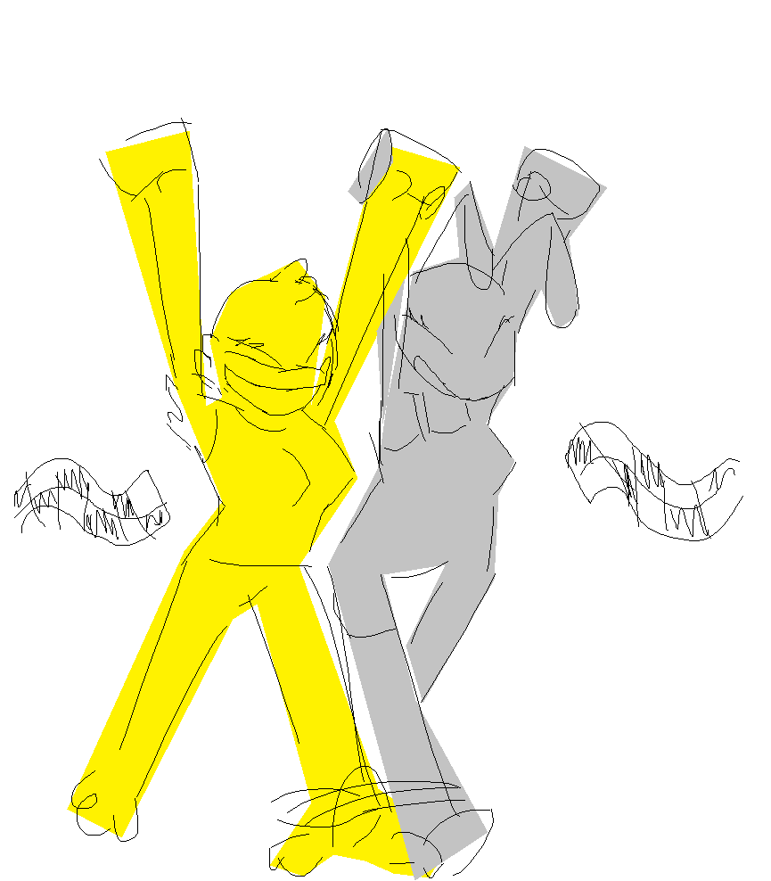
Lune groaned at the bird pun. She was a bird. She’s heard this before.
Lune and Poppy were participating in a 3-legged couples race in Eastbone Park. It was some sort of charity event, and the winning prize was a $20 burger gift card. It was the last stretch, so they were making the last push.
“Hey,” shrugged Poppy,
“I’ve got wings too, so it’s fair.”
“Whatever,” Lune chuckled playfully with a smile.
They cut the finish line first and, with much fanfare, they claimed their $20 burger gift card.
—
Back home from the park, sweaty and exhausted, Lune and Poppy unwound.
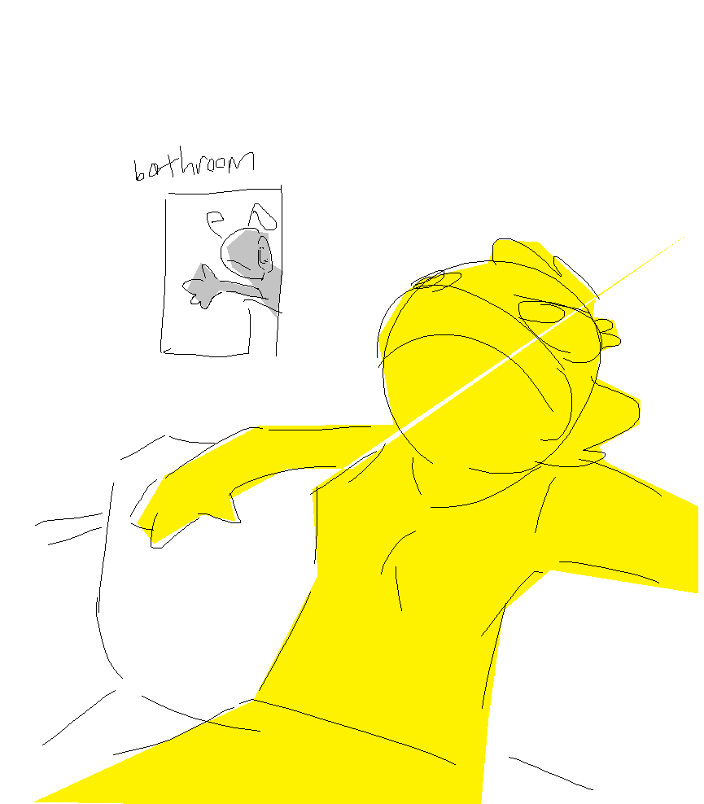
“Dibs on the shower,” claimed Poppy, making a beeline (ha) towards the bathroom.
Lune could barely get a word out before Poppy had already locked the door. Disgruntled, Lune slouched on the couch and from there listened to Poppy hum a tune in the shower.
That was when Lune noticed something on the table. Poppy’s book of EVIL and SEXY magic caught Lune’s eye. It was a thick book, chock full of potentially evil and sexy spells, its cover bejeweled with ancient crystals of amber and amethyst.
“Poppy always takes the longest showers. Surely this book can entertain me,” thought Lune.
Lune was correct. Eventually.
For the time being, it was like reading a cookbook with no ingredients; almost all the spells required components that Lune did not have.
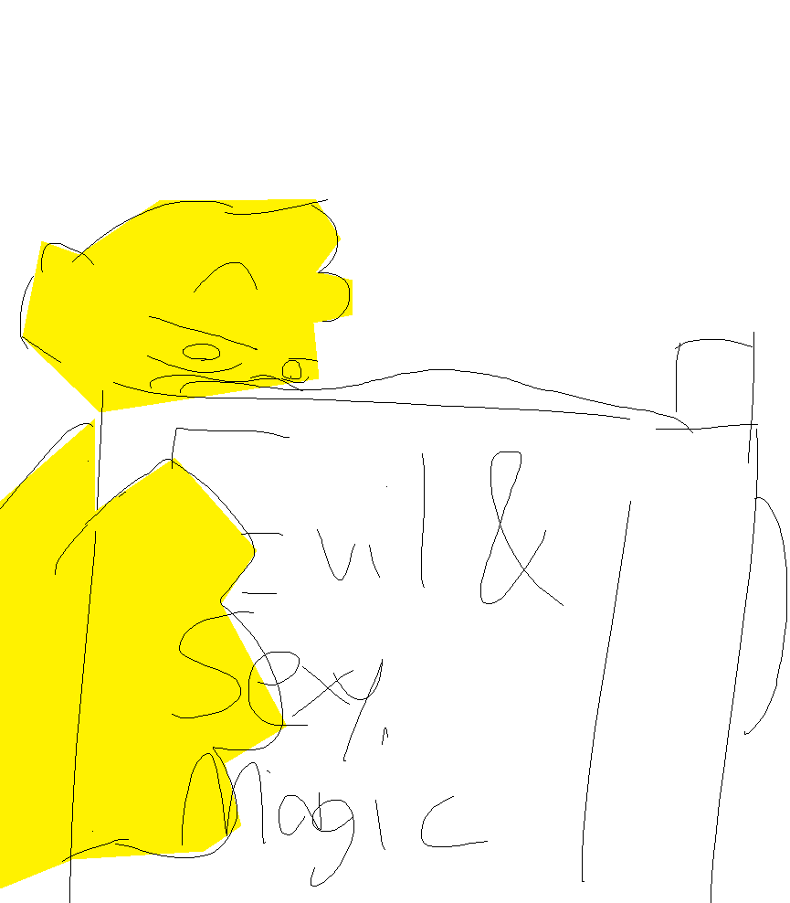
“Hey, that one looks neat,” thought Lune as she pointed to a spell that only required a verbal component.
“Fuck Dimension,” the spell was called.
Lune moved to the center of a large carpet in the living room, waved her hand, and uttered the words on the page.
“Phallum tendrum-sanguis. Siphilium bile. Tellus. Tellus. Tellus!”
The rug around her glowed. She only needed one last word to finish casting the spell.
“Seskipple- uh… ses… quippa… shoot.” Lune fumbled the last word, but she got the first half of it well, which counted for something, apparently. A small circle of carpet caved under her. She fell into it but got jammed after it engulfed her lower half.
The portal tightened enough that it wasn’t discomforting but Lune could not lift herself up with her arms. Lune was stuck. She stared at her missing bottom half in disbelief.
“POPPYYYYY!” cried Lune.
“Whaaaat?” yelled Poppy back, voice muffled by the shower.
“I got stuck!” cried Lune.
“Sorry, I can’t hear you! I’m almost done!” responded Poppy.
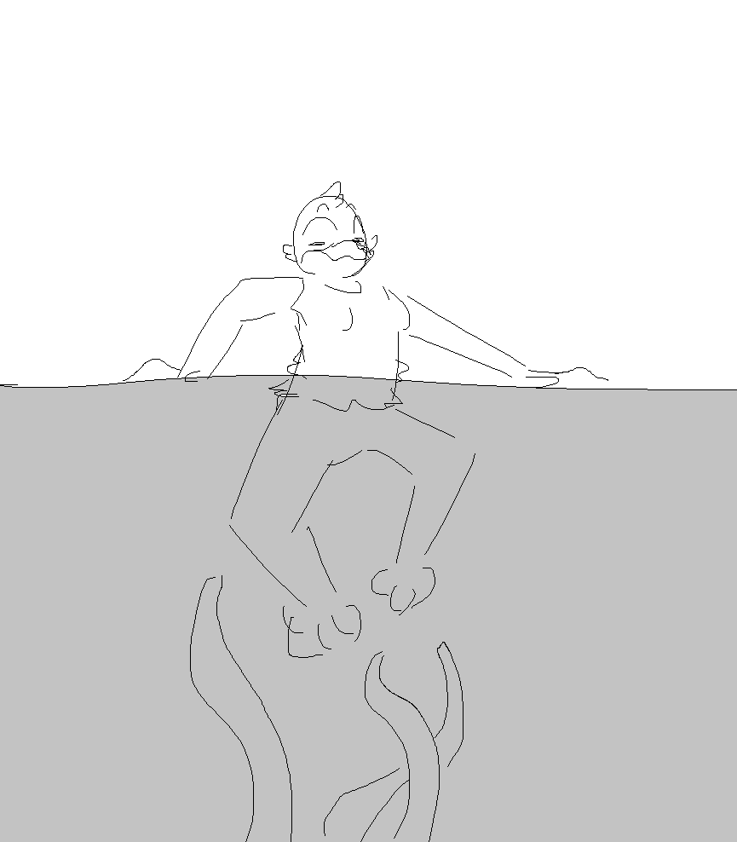
Meanwhile, on the other side of the interdimensional portal that Lune had managed to plug herself into, curious tendrils poked and prodded at her legs.

“Oh, fuuuuuck…” muttered Lune in regret as she felt the unseen creature explore her lower half.
The tendrils were warm, meaty, and moist. They were as hard as cured rubber but flexible and slick enough to snake along the inside of Lune’s pants.
The slime trailed by the tendrils left a tingling feeling where the tendrils traveled across Lune’s skin.
Lune grunted as she tugged her legs away from the tendrils but they did not yield. They coiled around Lune’s legs under her pants. They smeared their aphrodisiac juices all over her legs.
Lune began breathing heavily. The title did NOT lie—this was evil and sexy magic.
The tendrils massaged Lune, expressly avoiding her pussy. They squeezed and worked in her pants. It sent shivers up her spine. Lune shuddered from the pleasure.
Lune took deep breaths, trying to handle the sensations. She whined under the intense pleasure. At this point, she began squirming into the tendrils, urging the tendrils to go further.
It felt amazing and Lune was losing her mind.
Poppy, done showering, opened the bathroom door draped in only her drying towel to see the upper half of Lune, back bent, drooling and panting.
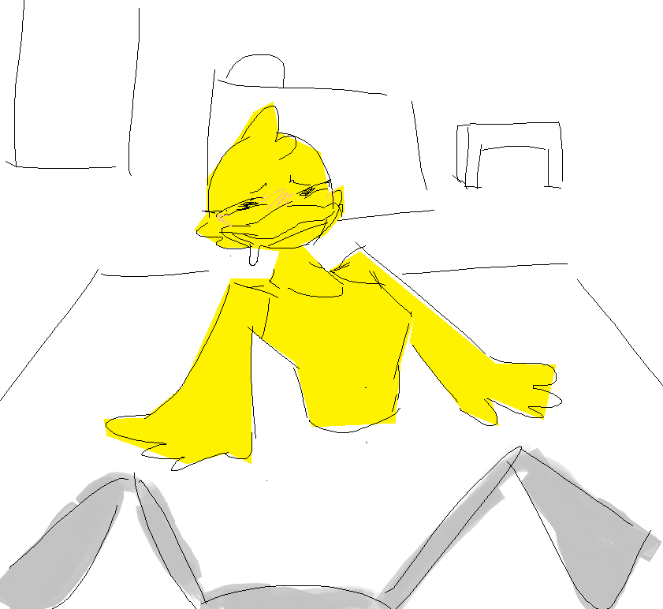
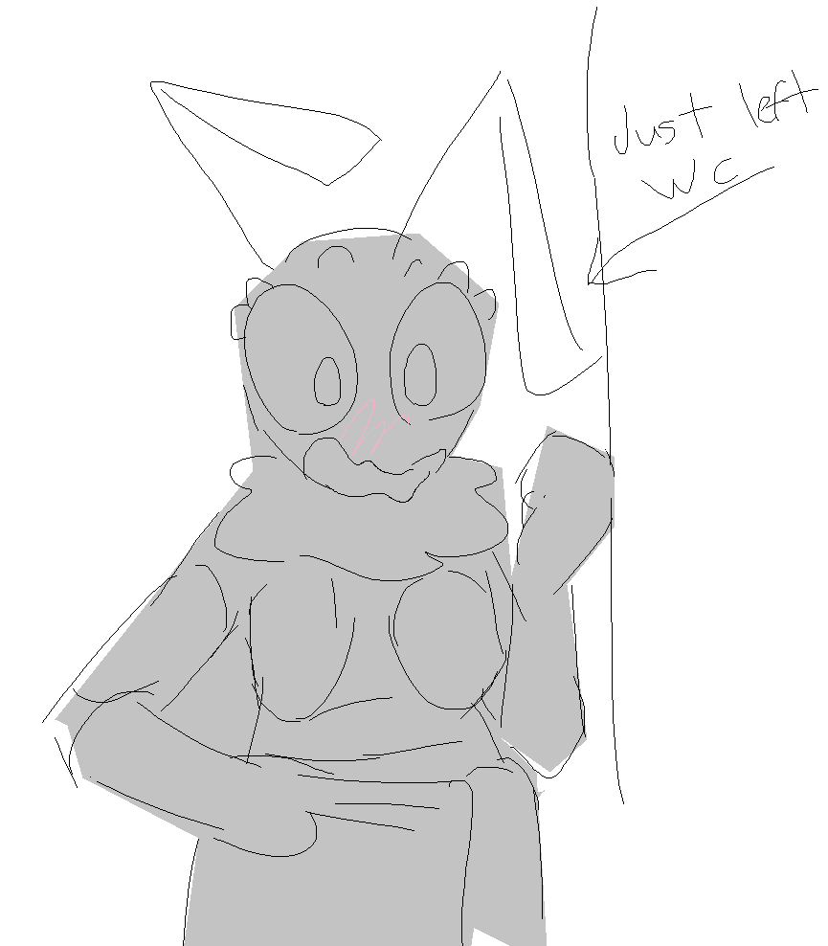
“Alright, Lune what was it that you—OH, I SEE.”

“Hey, Poppy,” groaned Lune.
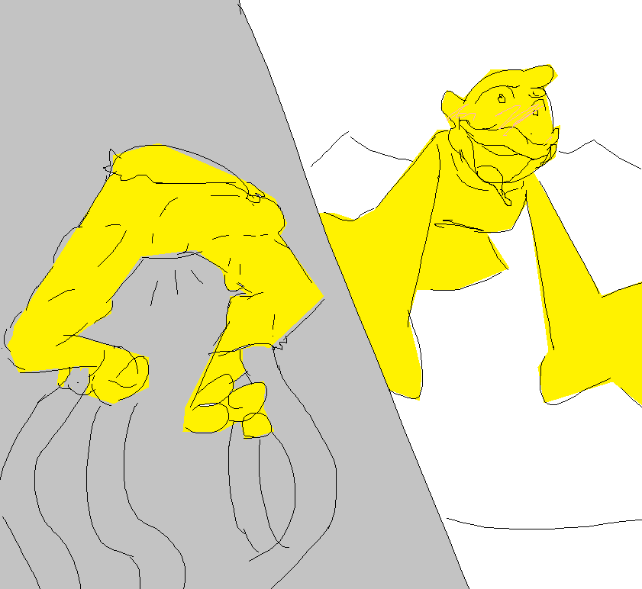
Down under, one tendril snuck from Lune’s lower abdomen, down into her panties, across her clitoris, and hooked upwards into her soaking wet hole. The thick meaty texture of the tendril sent shocks up Lune’s nerves. Lune shook and grasped at the ground as she was racked with the sensation. Her voice cracked as she almost shrieked from the feeling. Lune was left panting; she was already close.
“Oh my god,” exclaimed Poppy, witnessing and somewhat aroused by the situation. Poppy looked around, bent down to Lune’s ear, and whispered, concerned, “Is this hot?”
“Yeah,” answered Lune, with a slight grin through panting and heavy breath.
“Safeword is, ‘petunia,’” whispered Poppy, deeper, almost purring.
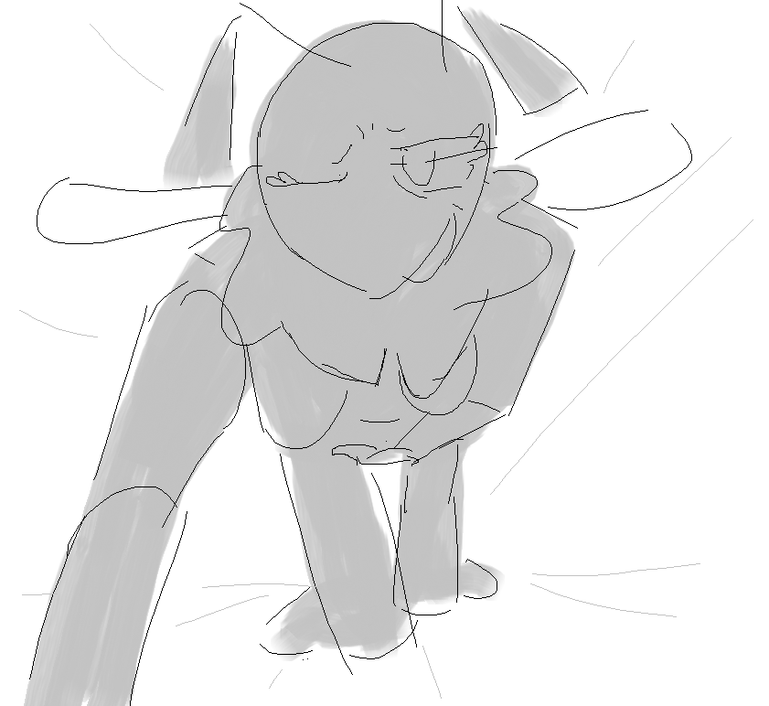
Poppy got comfortable on a bean bag facing right towards Lune and began touching herself, getting a good view of all of Lune’s adorable orgasmic expressions.
Beyond the portal, tendrils took off all Lune’s clothes below the waist, leaving her tangled legs and ass exposed to the world below.
“Oh?~”
Then, the tendrils began thrusting into Lune’s tight pussy, slithering across her clit both in and out.
“OH-“
Lune gasped and moaned. One tendril drove into Lune and dragged itself out at a perfect pace while others held Lune tightly by the ankles and some others caressed Lune’s hips and legs. Poppy witnessed Lune heave up and down, head thrown forwards, tightly grabbing the rug, arms shaking, and mind broken as she tipped closer to the climax.
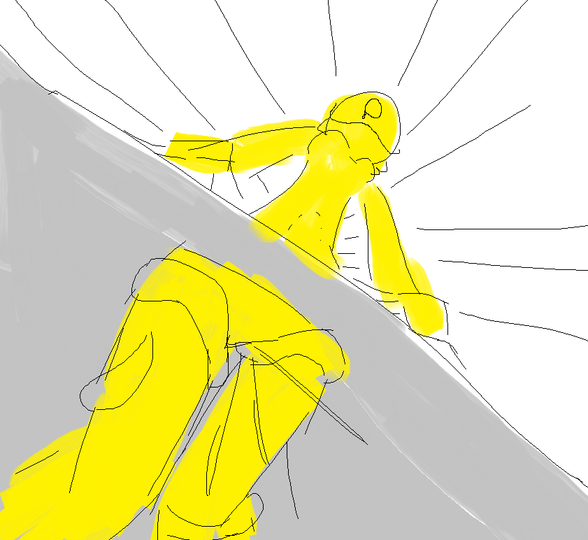
The tendrils sped up and Lune began crying and wailing, lost in their erogenous touches. Lune’s voice was quivering. Her entire nervous system lit up with ecstasy as her unseen half was remorselessly fucked hard and good, a feeling amplified by the tendril’s secretions.
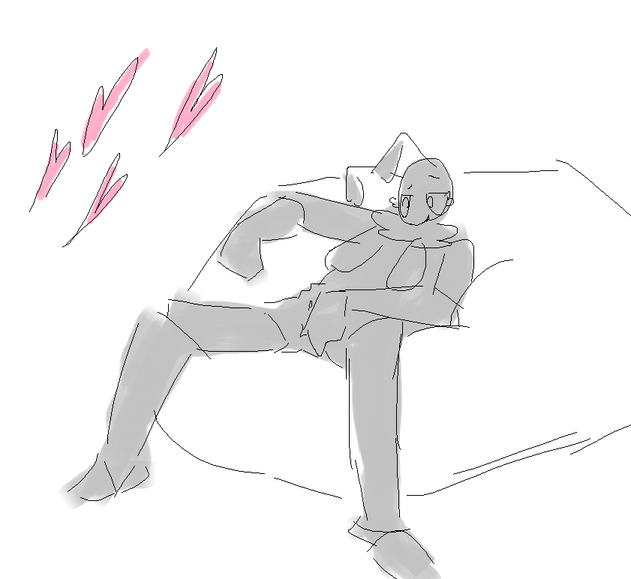
Poppy knelt down to Lune and held her cheek with one hand, still masturbating with the other. Lune looked back with her half-lidded unfocused, euphoric eyes. Poppy felt Lune’s breath on her face becoming heavy and picking up speed. Lune’s voice rose. With this erotic spectacle of her own wife, Poppy, too, was close to the edge.
“You’re too cute, Lune.”
The tendril made one final long thrust. Lune grabbed Poppy’s shoulders as her own body tensed up with orgasmic bliss. Poppy watched Lune’s eyes glaze over and jammed her fingers into her own pussy, cumming herself.
Lune and Poppy pressed together in a kiss, moaning into each other’s mouths in a shared orgasm, sucking and tonguing until the endorphins tapered off.
—

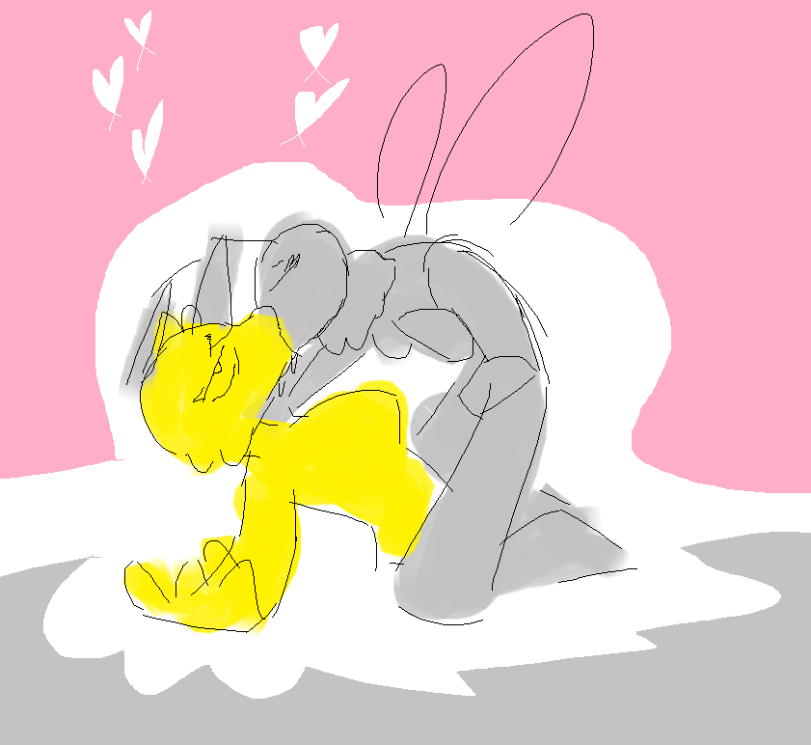
Poppy then uttered some magic words and pulled Lune from the portal. The tendrils slithered away. Lune let out a little whimper when they left her pussy. She was dripping wet and exhausted.
Poppy flashed a grin, then got serious. “But really, Lune. I let it slide because it was sexy today, but you should know better than to just cast whatever you’re reading in the book of evil and sexy stuff. There can be REALLY dangerous stuff in there.”
Lune let out an exhausted chuckle “Okaaaay…”
“Hey, I’m serious. You’re lucky you messed up the way you did and picked a spell that gets you fucked (good) and not… fucked (bad).”
“Yeah, yeah I get it,” muttered Lune.
“Anyways, let’s get you cleaned up,” said Poppy, slinging Lune over her shoulder and heading into the bathroom.
—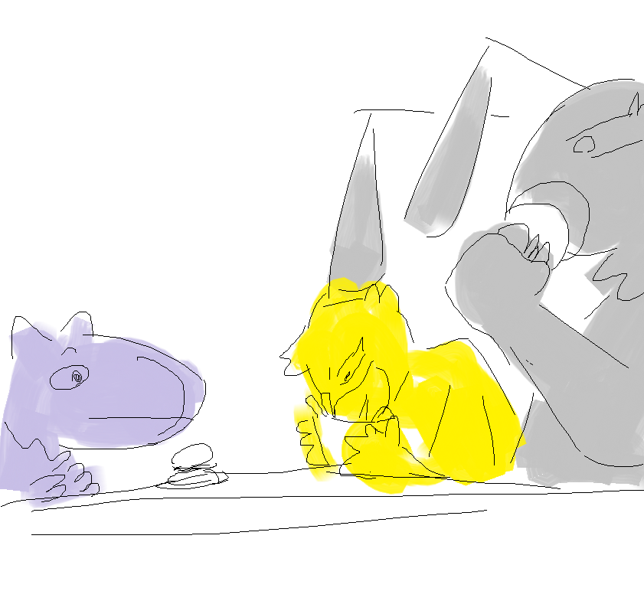
The day after the incident, they cashed in their burger coupon at a burger place. They also brought along their monster roommate Psyth, who was a purple alien that they were sheltering as a maid, though that’s a long story for another day.
They got two combo meals, but they gave all the fries to Lune, who would peck them into nothing.
“You girls going to Kohl’s costume party tomorrow? The whole block was invited,” said Psyth.
“Oh shoot! I forgot… I don’t have a costume,” admitted Lune.
“Hell yeah. I ordered my costume online a while ago,” said Poppy, before casually yoinking one of Lune’s fries. “Maybe you can be a witch because you just love casting spells so much,” teased Poppy.
“Pshhhht, shut up,” snapped Lune, playfully.

