The Poacher
By M. E. Vehnt (aka moisteaglevent) April 24, 2018
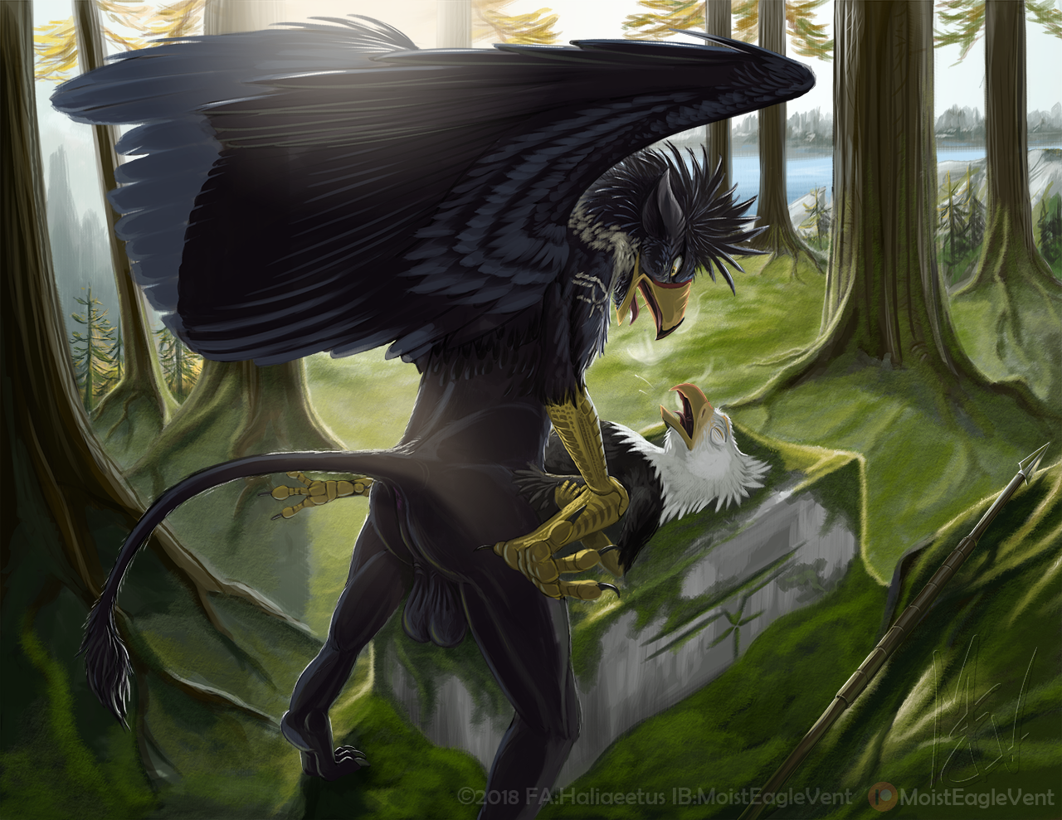
WARNING! WARNING! WARNING!
This is an adult story (readers 18 years and older only please) and contains acts of consensual sex between anthropomorphized animals.
This story is an non-commissioned fan-fic written to accompany an art piece commissioned by Storm Gryphon.
DO NOT EDIT OR REPOST WITHOUT PERMISSION
Aetus knew he shouldn't be hunting there. He saw the markers indicating that the wood was reserved grounds for the Fiyrah, the gryphons that dominated this region. Aetus didn’t know what the penalties might be for hunting there. The gryphons were enlightened and could be helpful, even generous. But they were also fiercely protective of each other and whatever was theirs. One did not take from the gryphons without it being paid for or offered as a gift. However, it had been a hard, long winter and Aetus was very hungry.
Aetus owed no allegiance to anyone. He was a firm, slim anthroeagle, descended from bald eagles with the white tail and head feathers of his feral ancestors. And he lived as free and independent as his wild cousins. Well, excepting that he couldn't fly away from trouble. He had arms like a man except that they were covered in brown feathers to the elbows and yellow scaled skin on the forearms and hands. Aetus didn't let this stop him though. He could stalk as quiet as a heron, swim as smoothly as an loon, and climb trees as skillfully as a woodpecker. There were other places he could hunt but he yearned to see what fat game may be hiding in those forests. Surely the gryphons wouldn't miss a few small creatures that would be mere morsels for the massive birds.
And right he was. He stayed for a day, 2 days, a week... nary a sign that any gryphon was wise to his presence. He tracked, he killed, and he lived lightly on the land, sleeping in the forest canopy and burying prey remains and his casted pellets carefully. He was even careful to hide his whitewash lest the keen-eyed avian owners see them. He hunted small prey that would be less missed and casually explored the wood all the way to the frontier of the nearest gryphon settlement before turning back on the 12th day. The rich food and easy living had replenished his fat reserves and his gonads grew larger with the lengthening days of spring. He felt the swelling deep in his body and his hormone-laiden thoughts turned towards breeding and nesting. It was time to head back to safer lands and seek a mate.
He knew every good hunting spot now so he moved quickly, stopping to hunt only once each day. Within a few days, he was within sight of the wide river that separated Fiyrah from unclaimed wilderness. He consumed two ground squirrels that evening and rested with a full crop in the wide branches of a Douglas fir.
The morning came with the haunting melodies of varied thrushes and a damp fog that had rolled in from the river delta. Like his ancestors, he didn't like moving in the damp fog so he waited until it began to burn away and he could see far and clear before he quietly scaled down from his roost.
Perhaps it was his hormonal urges clouding his senses and his judgment, or else it was that he had grown too complacent, having thrived on gryphon lands for more than 2 weeks. Aetus failed to notice the silent figure watching him as he picked his way down. The gryphon was perfectly still in a thick tuft of hemlock saplings, his dark feathers and fur blending in perfectly with the mute morning shadows. He waited until Aetus made his last look around and dropped softly to the moss.
As Aetus rose back up from his last drop, Storm was already in mid air coming straight at him. Aetus was knocked senseless and toppled over, skidding as the hulking gryphon engulfed him and ground him to an immobile position in the fir needles and moss.
Aetus’ couldn’t move under the enormous weight of the gryphon. He simply didn’t have the strength or body mass to resist. The gryphon growled low and pressed his beak, which was 3 times as massive as Aetus’, against Aetus’ face. Storm’s gilded eyes stabbed Aetus like a brand searing into calf’s hide. It might as well have been a brand for Aetus was now the possession of this gryphon.
“You are trespassing!” the gryphon grumped. “I’ve been following you for three days! I saw you taking prey!” He held up a rabbit bone from one of Aetus’ meals. “What say you?”
Aetus gulped and held his yellow hands up in a non-combative gesture. “I’d say that you are an excellent tracker, sir.”
“Humf!” The gryphon pushed a massive yellow hand up under Aetus’ throat as his other hand slide down to the leather bag strapped under Aetus right wingarm. He felt inside and found some coins, a feather, some bone awls, and sinew. Under the other wing he found a sheathed knife. “Nothing else? No weapons?”
Aetus shook his head.
The gryphon smiled a disbelieving smile and slid his hand down over Aetus’ belly, his legs, and lastly his crotch. He felt the eagle squirm and wink the plump warm lips of his vent. His hand paused a moment as he watched Aetus’ spasmodic breathing and third eyelids fluttering. He pulled his hands away and stood slowly, jerking Aetus up by one arm to his feet. He spun him around and wrapped one thick arm around the eagle’s throat from behind while holding one of his arms by the elbow. His dark ears relaxed forward and he pressed his beak up against Aetus’ right cheek.
“I’m impressed… you live off the land well. It wasn’t easy tracking you. Not many of your kind can hunt and live so well without weapons. You left hardly a trace on our land, something I can admire. But you still violated our lands and took without asking.”
Aetus relaxed slightly, figuring that at least he might stand a chance to reason with this gryphon as they had something in common-- they were both hunters.
Aetus’ breath steamed as he replied: “Would you have allowed it if I had asked?”
Storm gruffly chuckled. “Not knowing your skill? Not knowing your worthiness? No. Your kind are respected as fishers but not as game hunters. You would have not impressed us.”
“And now that you know?...”
The gryphons ears flattened back and his brow wrinkled a moment. Then he relaxed. “Now that I know, yes, I would allow you to hunt here… perhaps at the price of teaching our gryphlets your skills. But now you have a penalty that must be paid!”
“Sir, please, I apologize. I didn’t think you would miss a few small game animals and--”
“Quiet! Be silent and take your punishment!” Storm pushed Aetus forward and simultaneously released him. Aetus turned and watched as Storm walked back and picked up his spear from the ground. His round muscles slide back and forth under his glossy feathers and fur, accentuating each motion and yet the gryphon didn’t plod or thud as he walked. He gracefully strode through the trees, picked up the spear with no wasted effort, and returned. He held the spear with half-cocked arm as though with a flick he could send it straight through Aetus’ heart.
“Over there!” Storm motioned with his spear towards the river and an area where the trees thinned out and more sun came through to the forest floor. They walked towards the spot and as they entered the area, Aetus saw that there were old rotted timbers and stacked sculpted rocks. There were Gryphonic glyphs and animal shapes carved into toppled slabs of moss-covered stone. And there in the center of the overgrown remains was a block of granite surrounded by moss covered earth and pavers. The center of the block was cut into a v-shaped trough, as though for channeling fluids. Aetus stopped at the block and scuffed the ground with a foot. Under the moss were bits of charred wood and bone. He had an uneasy feeling and the feathers of his nape erected.
“Do you know what this place is, thief?” growled Storm.
“Uh, looks like someone used to cook animals here?” Aetus was hopeful.
“Heh. In a manner of speaking, yes. We sacrificed here to please our gods. It’s time to make a sacrifice of another kind.” Storm pressed the tip of his spear to the small of Aetus’ back. “Face me and lay back on that stone!”
Aetus turned slowly around and stared back at his captor. “I can’t believe you’d kill me for hunting on your land! I’ll pay you back. Please let me teach your gryphlets.”
“Heh! How can I take the word of a thief? Lay back!”
Aetus pressed forward and placed a hand on the spear. “I’m not going to die that easily! I’ll fight you to the death before I lay d--”
“Silence!” Storm squawked, the chilling screech stopping Aetus short. Storm jerked his spear out of Aetus’ grasp and tossed it onto the ground nearby. He cracked his knuckles and shifted his weight to widen his stance. His tail pumped and Aetus saw a flash of purple between the gryphon’s legs.
Aetus’ shoulders dropped with his sinking gaze. “Ohhhhh… so you’re not going to kill me, you’re going to breed me?”
Storm snorted and lumbered forward like a wall of muscle. “Don’t look so relieved!” He shoved Aetus back onto the stone with a thud. Storm grabbed Aetus’ ankles and jerked him closer crumpling his white tail feathers against the gryphon’s thighs. Storm’s breath puffed out like the fire of a dragon as his passion grew less patient.
Storm’s cock was swollen out to its full 27 inches. He jerked Aetus even closer, grinding the bird’s wide open crotch against his own hot loins. Storm flopped his fat heavy member down on to Aetus belly and shook it with his hand.
The feel of that hot meat bouncing on his tight belly gave Aetus an unexpected thrill inside. He had only ever mated with other eagles. Some were males but none of his kind had a penis. He pelvic canal ached and his pulse quickened as he realized he would be discovering something he never knew he missed. He moved his hands down between his legs and caressed the massive purple cock. It was throbbing and moist as he pushed the sheath back that was still covering its base. He wanted that inside him. But could he take the whole thing? He was essentially a virgin when it came to penis. His eyes were wide as he contemplated its girth.
Gruff gryphon croaks broke his concentration. “Nervous? I can still kill you if you prefer.” The gryphon was inhaling loudly through his nares as Aetus softly stroked the dripping member.
Aetus smiled up at him. “Oh, no, I think I prefer this… punishment.”
Storm roared out “Then let’s begin!” He seized Aetus’ knees painfully tight and spread the tense legs out wider. Storm pulled his own hips back and let his cock tip slide down into the eagle’s ass fluff. He felt Aetus shudder and his vent lips wink and kiss his cock.
Aetus inhaled sharply. “Uh! OHH! Wait--!” Before he could protest further the gryphon shoved hard, tightening his rock-hard buttocks into knots of muscle as his member penetrated the eagle’s tight hole.
Aetus screeched out in a mixture of shock, pain, and pleasure. His tight gnarled hands gripped his own ass feathers and his eyes closed as a wave of heat rose up over his eyeballs. After a moment his insides relaxed and he took a breath. His shaking fingers felt his vent lips, stretched smooth, taut, almost to the breaking point, around the gryphon’s throbbing cock. The cock tip reached so far into his belly that it pressed against his gizzard which was still wet and heavy with the fur of last night’s meal. There was a brief wave of dull nausea but then his cloaca relaxed further around the hot cock filling it and a wave of sexual desire tingled up his spine. He panted as he hastily brushed back the feathers around his vent opening, preparing himself for whatever came next.
Storm flinched his anal muscles a few times in strong kegels causing his cock to swell and bounce inside of Aetus belly. He looked down and then pulled his hips back, watching as Aetus’ pink ring of cloaca folded outward around the puple dick. Between the vent stretching and the sliding, sucking sensation of the moving cock against his ejaculatory ducts, Aetus couldn’t resist letting out a high-pitched moan. There was a wet flirt as his thighs tightened and his cloaca spat out the cock and a spurt of clear sticky pre. Storm huffed and pressed his cock tip back against the clenched sphincter until he felt it obey and relax.
Storm pressed slower this time, watching Aetus’ eyelids flutter and his irises pin tight as the gryphon phallus filled him a second time. He pressed hard for the last few inches, jamming his grimacing beak against Aetus’. He watched with glee as the eagle struggled to breathe with almost two and a half feet of gryphon shoved up his ass. At last Aetus coughed sending a shockwave of pressure through his airsacs and around Storm’s cock. The gryphon’s body twitched and he spat out a short chirp, his cock involuntarily bouncing from the delightful cloacal spasms. Finally he pulled back and watched Aetus’ body relax, the breath flowing out of him in a gush of steam.
Aetus’ beak tilted back and his eyes closed. He weakly protested. “Wait. Give… me a minu--”
Storm shoved in again, more abruptly. Then, as Aetus was in mid screech he withdrew bruskly. Before Aetus could breathe he plowed him again, then again, and again and again. The eagle bounced and writhed on the mossy stone, clawing at his hips in alternating fits of misery and ecstasy, coughing and chirping. With each ragged thrust, Aetus caught up with the rhythm and his screeches grew faster and faster until they melded together in a long high cry that cracked into silence.
Aetus’ body tensed and bucked and his cloaca seized tight. Storm stopped, his eyes rolled back as his cock was squeezed firmly. Aetus’ swollen ejaculatory ducts gushed out blobs of thick eagle seed around the fat dick and Storm felt the waves of new lubrication. He pulled back and saw white foamy fluid dribble out around the space between his cock and the stretched vent. He smelled the rich scent of sex and it made his beak clench with more desire.
Storm jammed his member back into Aetus’ backside and savagely thrusted over and over, more rapidly. At last his thighs shook and his back quivered. His tail arched and bobbed in unison with his winking butthole. He croaked out with each explosive emission thick cum deep inside the tight confines of the eagle’s belly. There were sex strong ejaculations and then they became weaker and longer. He counted 12 in all as he stood there, eyes closed, concentrating on each release, pushing out every drop of his justice into the thief’s belly while Aetus whimpered and clutched at his now tender hole and bruised tail.
After a few minutes of huffing and staring at his prisoner, feeling every wrinkle of his cloaca around his detumescing cock, every spasm of pain and pleasure, Storm slipped his cock out. There was a sloppy emission or air and cum drained onto Aetus’ trashed tail feathers. Storm wiped his slimy cock on the hapless eagle’s belly feathers. He picked up his spear and quietly growled, “Crime atoned. Next time, ask. Be prepared to pay the same fee.” He scowled down at Aetus then turned and walked away.
THE END

