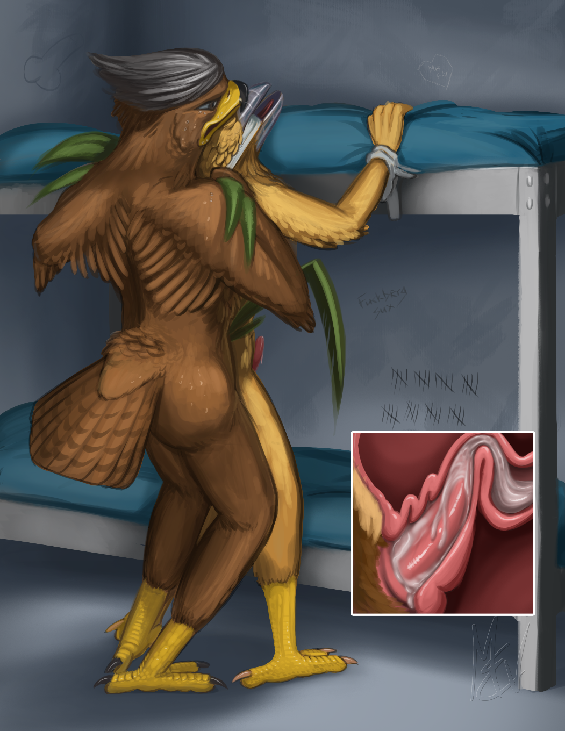

Prison Break
By M. E. Vehnt
Falcon Graves and Steelbeak make unlikely partners in prison. But each has something that the other needs.
This is story contains adult sexual content intended for audiences 18 years and older. Please do not post anywhere where the material may be accessible to minors.
Graves was fed up with his cell mate and it had only been a few hours since they were forced together. The idiot wouldn’t shut up. To Graves he was just a big, yellow, dumb rooster with a need to make himself look important. Which probably meant he was pretty low on the totem pole in the crime organization he claimed to be a part of.
“Hey! For the tenth time already. I don’t give a fuck! So unless you want a beating, shut your beak!”
The bottom bunk made a steely squeaking sound as Steelbeak sat down on it. Falcon stared out the bars at the front of their cell, his eyes closed, listening to the background noise of brooms sweeping, inmates whistling, and random footsteps and quiet conversation in the large hall that all the prison cells faced into. It was his first day in this joint, having been convicted of multiple counts of theft and scams. He mind was swimming with how quickly it had all come down after being apprehended at the “It” event. If it hadn’t been for some kids and the detestable Mark Beaks, he would be soaking in tropical sunshine sipping fruity cocktails and getting a blowjob from an exotic duck that could barely speak English. He adjusted his crotch at the thought of it.
Meanwhile the bed started squeaking rapidly as Steelbeak nervously jiggled his leg and chewed on his nails.
Graves punched the bars, “Goddammit! You really want me to kick your ass don’t you?”
“Just try it, asshole. I’m an experienced cock fighter I tell ya. I’ve taken on bigger pricks than you!”
Graves turned around, cracking his knuckles. He pulled up his sleeves and bulged his thick arm muscles.
Steelbeak stared in awe, but not at Falcon’s arms. He broke into a snicker, staring at the huge bulge in Falcon’s pants. “Jeezuss! Look at the size of that thing! Who were you thinkin’ about, hmm?”
Falcon blushed and reached down to adjust his pants and calm his trouser snake. “No one! Nothing! Forget about it!”
Steelbeak sprang to his feet and stood in front of Graves, a teasing look on his metallic beak. “Ooohh must be a hottie. Or are you sweet on ol’ Steely?”
Falcon leered with disgust. “Please! Behave yourself! You annoy the piss out of me.”
“Oh really? Then why is your cock still hard?”
“Er. It’s not! I—” Falcon quickly turned away, reaching in his pants to adjust his underwear. “It’s the new prison underwear. It’s too tight, dammit.”
Steelbeak dropped his voice to a husky octave. “Hey, big boy. It’s not a sin ya know. We’re gonna be together for a while... we might as well be friends.”
Falcon’s eyes darted around the hall, wishing there were an escape. “Leave me alone.”
Steelbeak crept up behind Falcon and spoke very quietly, “You can gag me while ya do it. You know, shut me up for a while?”
“Grmmff!” Falcon crossed his arms. “Keep yappin’ and I’ll beat you until you can’t speak.”
Steelbeak’s voice dropped to a whisper and he put his beak very close to Falcon’s ear fluff. “Tell ya what... I told you I’m with F.O.W.L. and you claim you don’t know that that is... but we’re very powerful. I’m getting’ outta here soon. Treat me right and I’ll make sure you get your freedom too.”
The rooster’s whiny voice had dropped into the backwaters of Falcon’s mind as he imagined his tropical tryst again. Just as his cock was swelling again, he heard the word “freedom” and it snapped him back.
“What was that?” Falcon turned his head slightly and looked at the chicken’s grinning face.
“Yeah, really! Ain’t my first time. They’ll have me outta here in a month or less. Just takes a little spin by the lawyers and, if that doesn’t work, a jailbreak does. You show your value to me and I guarantee I can get you a job with us.” Steelbeak put his hands on Graves’ shoulders.
Graves spun around, clutched Steelback by the throat, and shoved him up against the bunkbed. His other hand was around Steel’s clamped beak. He pushed his face close to the chicken’s ear and whispered, “You better be serious! I’m about two heartbeats away from flushing you down that toilet over there.”
Steelbeak nodded his head quickly and spoke with a muffled, hollow sound through his clenched metal beak, “Honest. I mean it. No bullshit.”
“I don’t trust ya.”
“Hey, big fella, what’s the problem? All I ask is that you fuck my brains out. Not askin’ ya to suck my cock or anything... unless, of course, you wanna do that too. In which case...”
“Shut the fuck up!” Falcon smacked Steelback on the side of the head and tightened his choke hold. He felt something touch his dick and looked down. He had a huge throbbing erection that was almost tearing his orange jumpsuit. Steelbeak’s crotch was equally bulging and moist, apparently encouraged by the rough treatment. The two men’s bulges were touching and the fabric moistening already.
Steelbeak smirked and looked like he might say something but he wisely thought better of it. The truth was obvious anyway.
“Shit!” Falcon seethed through gritted his beak. “I should be in the Caribbean right now poking my cock into the fluffy tailfeathers of some beach bimbo. Hrrrnnngggg... but you’ll have to do!” Falcon released Steelbeak’s throat as he unzipped his own jumpsuit and began shrugging it off. He dropped his clothing around his ankles and kicked it into the corner. He wasn’t wearing any underwear.
Steelbeak was enjoying the spectacle, his wattles and comb a bit redder than usual. When he saw Falcon’s splendid member bounce into view he jeered at him, “You Liar!”
Falcon’s eyebrows lowered and his beady eyes shifted. He was focused on fucking and let the smart remark go. He grabbed the front of Steelbeak’s prison suit and jerked hard enough to unzip it. In an exhilarating instant, the rooster was laid bare with his jumpsuit wadded around his ankles. Falcon’s eyes dropped down from the rooster’s stupid grin to his fat cock, pink and glistening as it hung in mid-air out of his feathery sheath. He wasn’t wearing any underwear either.
The rooster started explaining, “Hey, ya know, it makes it quick and easy to have sex if you don’t—"
Falcon spun him around and kicked his legs apart. “Let’s just get this over with!”

“Hey, not so fast, Romeo. Aren’t you forgetting something? You’ve gotta tie me up! And where’s the gag?”
Falcon clapped his hand against Steelbeak’s firm thigh and pressed his member up against the rooster’s clenched vent.
Steelbeak whimpered and compressed his buttocks. “No way, man. I’m not lettin’ you in till you tie me up.”
Falcon’s talons scraped on the concrete floor as he clenched his toes. His fingers clawed into Steelbeak’s sides, pressing painfully into his ribs. He shoved his beak up against Steelbeak’s ear fluff and growled out, “I don’t see any rope? How about I gouge out your entrails and tie you up with those, hmm?”
Unfazed, Steelbeak smirked and swished his tail against Falcon’s belly. “Uhhnnn... mmm... I like your style, Graves. But no need to go full feral on me.” His hand slipped under the top mattress and pulled back with strips of cloth made from linens. “Use these, big fella. Make ‘em tight!”
Falcon huffed as he jerked the linens from Steelbeak’s hand. He pushed the big bird from behind, forcing his chest hard against the steel bunk frame. “Tight ya say? How’s this!?” Falcon yanked Steel’s right arm brusquely out to the side and he responded with a high-pitched gasp.
“Ooohh... yeah! That’s it!” Steelbeak’s cock lifted up stiff and straight, wobbling around as Falcon tersely tightened the bond around his wrist.
Falcon’s dick was fully engorged and slapped against Steelbeak’s buttocks as he swung around to tie his left arm. He tied the cloth around Steelbeak’s wrist, looped it though the bed frame, and yanked, stretching his arms out tight. Steelbeak lifted his beak and moaned. His deltoids quivered from the overextension and his tailfeathers shook from sexual tension. His cock dribbled precum that drooled down his shaft and moistened his sheath feathers.
“Graves... you predator... you chicken fucker... I bet you’d fuck your own mother, wouldn’t ya?”
Graves’ thick eyebrows rustled and pressed together. He was a serious, non-nonsense bird and tended to take conversation literally. So, for a moment, he wasn’t sure if Steelbeak was being casually disrespectful, or purposely trying to antagonize him.
Steelbeak spoke again, in a mocking tone, “Nice tying job for a big, dumb hawk or whatever you are. Clearly you know your knots. But that’s how you predators are. Quick to immobilize and kill but you don’t know shit about making sex last longer than 2 seconds. Let’s make a bet—I’ll bet you can’t make me jizz hands-off. You do, and I’ll suck your cock every day for a week.”
Graves dug his fingers into Steel’s sides again and made him flinch and gasp in pleasure. He pressed his hot, throbbing cock up into the rooster’s ass fluff and poked against his back door.
Steel’s eyebrows creased together as his cheeks flushed and his beak corners frowned. Falcon smirked as he saw the rooster swallow a sexual moan.
“Hmmf... nice try, but I’ll bet you’ll only last a few seconds with my cock inside you before exploding. Hell, you’re ready to cream yourself already.” Falcon slide his fingers down Steel’s front and pressed them under his sheath, bouncing his cock and making the rooster groan.
Steelbeak pressed his head back against Falcon’s cheek. He panted out, “Gag... I want the gag... use the towel.”
Falcon ripped the towel from the peg by the sink and twisted it up. “With pleasure! I won’t have to listen to your stupid lip.” He gripped Steelbeak’s upper bill with his fingertips and pulled his head back until his mouth opened.
“Aaanngggg OOOHhhhh... uhhhnn!” Steelbeak writhed and bucked in his restraints, his cock bouncing and dribbling thicker strands of precum as Falcon slipped the rag into his maw and pulled the ends back behind his head.
Falcon had drops of sweat on his brow. It was hard to resist the pleasurable sensation of the big bird’s firm muscles and soft feathers bumping and grinding back against his front and tickling his cock. He was liking this more than he would have cared to admit at first. He decided to see how far he could tease this rooster... maybe he could even embarrass the loud-mouthed cock into ejaculating before he even penetrated him. He couldn’t go anywhere now so Falcon could take all the time he wanted.
Falcon began by gripping the gag towel behind Steelbeak’s head with one hand and gripping his thigh with the other. “Legs apart, scumbag!” He kicked the chicken’s legs apart with his own. He moved his other hand down under Steel’s tail, inching his fingers closer to the deeper, hotter regions. “Time for your cavity search... got any contraband in your cloaca?”
Steelbeak whimpered and shook his head.
Falcon’s fingers found the bird’s moist slit and pressed the lips apart. Steelbeak arched his back and stiffened his tail like a hen welcoming a rooster to mount. His cock throbbed and drizzled a thin stream of cloudy precum. He clenched his vent and bent his knees, trying to restrain himself from ejaculating.
Falcon knew he was winning. He stroked the tip of his finger, light and tender, back and forth across Steelbeak’s lower vent lip until the poor bird’s thighs were tremoring and he was emitting short, urgent moans around his gag.
Falcon smiled and pressed his beak against Steel’s cheek. “You fucking slut. I guarantee you’ll be sucking my cock. All I gotta do is press riiiiiiggghhht here...” Falcon slid his finger slowly up into Steel’s plump opening. Steelbeak’s legs tensed and his beak went straight up as his eyes opened wide. The finger slid further, even as the passage gave its first pre-ejaculation spasm. When his finger pressed against the bulge of Steel’s prostate, it was all over.
“HHHNNGGGG! NNNNNNNNNNNFFF!” Steelbeak jutted his hips forward and his cock spurted, plastering rooster semen against the concrete wall. His cock pulsed again and dropped a thick load on the blanket, then once more in a smaller puddle.
But Falcon wasn’t through. He growled, “What a big dumb slut you are. You nutted before I even fucked ya.” He rubbed his finger up and down in Steelbeak’s cloaca, massaging the softening knot of his prostate. “I’m gonna wring you dry!” Steelbeak whimpered as his cock pulsed again and again, with each stroke, unable to resist, until his knees gave out and he sagged against his wrist restraints.
Falcon gave it a few more strokes, but it was clear that the cocky bird had been drained. His cock hung limp and dribbling clear fluid for the last few massages. The bed was soaked in steaming puddles of cum.
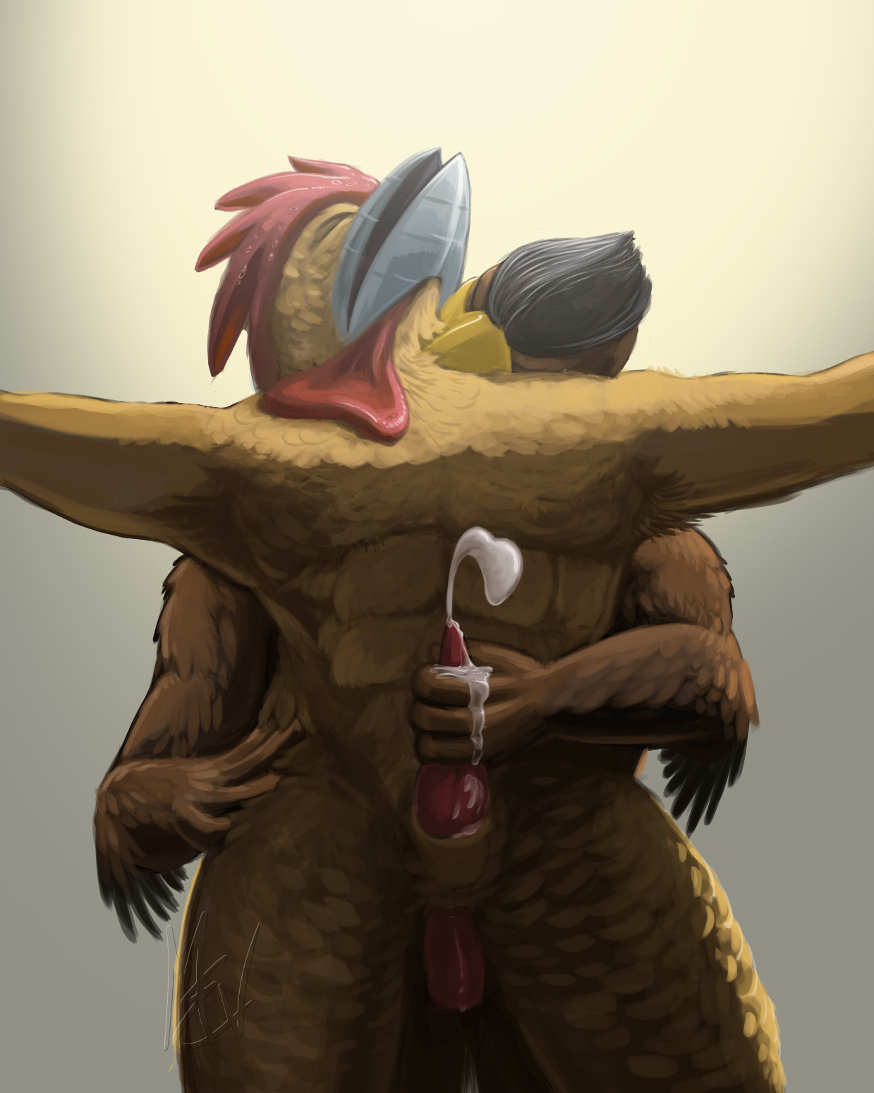
Steelbeak panted and hung his head, his eyes closed and sweat dripping down his metallic beak. He had lost but it was never his intention to win. The very thought of licking Falcon’s pole every day made his mouth water.
Falcon eased his finger out of Steelbeak’s moist hole and gave Steel’s cock a delicate stroke. He brought his fingers up to the rooster’s beak, smelling of cloaca and cum. Steelbeak whimpered his approval. Falcon gripped his own hard cock and pressed the tip up against the chicken’s loosened vent lips.
“You really are a bottomy bird, aren’t ya?”
Steelbeak nodded his head and gave a pathetic, affirming whine.
“I’m Surprised I didn’t find anything in there.” Falcon squatted slightly and pressed his hips forward, causing his cock to start sliding into Steelbeak’s loose hole. “Time to fill it!”
Steelbeak arched his back and gave a muffled croon of delight. His cock revived partially, bouncing as his tail feathers fanned against Falcon’s belly.
Eyes closed, Falcon tilted his hips back and forth, causing his tail to sway as his cock threaded deeper into the rooster’s butt. His beak clenched and his pelvic canal spasmed, causing his tail to bob up and down slightly as his vent winked. Inside Steelbeak’s cloaca, a stream of hot, salty falcon fluid issued forth and lubricated his passage.
With a hungry grunt, Falcon growled, “Mmmm... nice, deep bird hole you have. Not as loose as your mouth, thank goodness.” Falcon slid his finger into Steelbeak’s crotch and gripped his half-erect cock. Steelbeak moaned and bucked forward, sliding his penis deeper into Graves’ curled fingers. “What a cloaca whore! I drained you but your stiff cock proves you’re ready for more.” He pulled back and jabbed his dick back in, slapping his groin against Steelbeak’s sweaty ass cheeks.
Steelbeak jolted and moaned at a higher octave and his cloaca spasmed. His cock bounced and dribbled spent semen.
Falcon pressed his beak into the rooster’s fluffy throat feathers and demanded firmly, “Wink your vent, you gay cock! Make it worth my effort!”
Steelbeak wiggled his hips and squatted, taking Falcon’s cock deeper in his desperate ass. His tail fanned and surrounded Grave’s sweat-slicked abs.
Falcon’s muscular buttocks tensed and his tail spread and shook. “HNNGGGG!” He groaned and shoved against Steelbeak with another loud clap of moist feathers and flesh. “Fuck yeah!” He jerked the towel gag back until his knuckles blanched as he began a series of climactic thrusts into Steelbeak’s clenched ass.
“Take! That! You Fucking! Filthy! Loudmouth! Roos-TER! HRRGG!”
Along with each epithet, every penetration was annunciated by the slap of flesh and Steelbeak’s muffled whines. He let out a shrill, throaty trill as his head and body feathers flared to full erection. His cock bounced and throbbed but could only ooze small blobs of watery bird spunk, so draining was his prior ejaculation.
But Falcon made up for it. For on the last deep shove, his tail pressed down hard against his thighs and shivered while inside Steelbeak’s ass his cock exploded in a creamy load. Steelbeak felt the rush of hot, sticky fluids, going where it was never meant to be. He felt dirty and used and he loved it immensely.
“TS-K!” Falcon tried to withdraw but his excited pelvic plexus had other plans. His muscles tightened again and his hips thrust immediately back into Steelbeak’s ass. His tail pulsed again and his cock delivered another load. He stayed there this time, letting his prostate throb and throb and throb again until his nuts were drained and his lower back, where a bird’s internal testes are situated, pleasantly ached from satisfaction. He sagged back onto his halluces and his cock pulled back but didn’t drop completely out. Steelbeak groaned as his cloaca contracted, forcing a spurt of milky cum to ooze down Falcon’s cock and dribble to the floor.
Falcon wanted to chastise his cum dumpster for making a mess, but he was too euphoric and too tired to care. Instead, he released the gag and hugged his arms around Steelbeak’s middle. He tenderly fingered the rooster’s detumescent dick and slathered his jizz around in his moist crotch feathers.
Steelbeak purred like a pleased hen and tipped his head back against Falcon’s hot beak. Falcon was feeling remarkably sated. It had been so long, he’d forgotten how hot buttsex could be. He hugged his mate firmly, his cock still planted in the rooster’s cloaca. He nibbled at his fluffy cheeks as he fondled his sticky, limp member.
Falcon softly whispered, “Mmman I needed that more than I thought,” and nuzzled Steel’s neck.
Steelbeak sighed approvingly and inhaled the rich scent of cloaca mingled with rooster and falcon jizz. “That... that was the best. Forget what I said before. You are the stud.”
Falcon’s beak glowed from sex and the affirmations of his prey. “I won’t retract a word I said. You are a slutty, gay, whore of a rooster.”
Steelbeak chuckled and poked Falcon teasingly with one of his spurs.
Falcon pressed his face into Steelbeak’s neck fluff and mumbled, “But it’ll be our secret.” He pushed his plump cock upwards and felt the hot creamy mess inside the rooster’s cloaca. “Mmff... Even if we get outta here. And you better keep it a secret too or I will hang you with your own entrails.” He rubbed his beak into Steelbeak’s neck feathers and punctuated his remark with a firm bite.
Steelbeak tensed under Graves’ nip but then curled his neck over Falcon’s nibbling beak. “Our secret, boss.”

