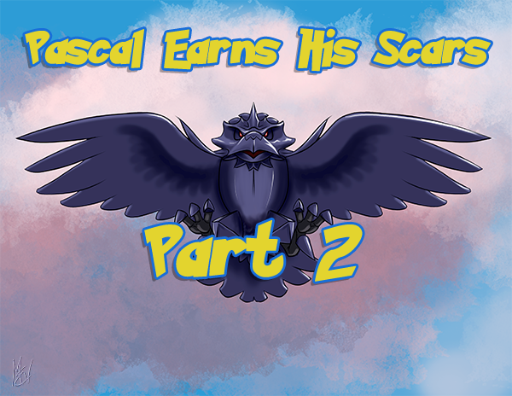
Pascal Earns His Scars – Part 2
By M. E. Vehnt
This is an adult story intended for audiences 18 years and older. Please do not post anywhere where the material may be accessible to minors.
Pascal screeched out “You better Stop! Or else!”
“Ha ha! I’d better whaaaat? Staaahhp?” Rok’s humping slowed only slightly. “How about I fuck youuuuu then eat youuuuu? Or flip you overrrrrr and scar up your baaaack as I fuck you? What a dishonorrrrrr that would be for youuuuu. A Braviary can only gain honor with breast scarrrrrs. Sooooo, why not relaxxxxx and enjoy the riiiiiide? It’ll be our little ssseeeecret. You get yourrrr scarrrrrs and I get my biiiiiitch!”
Pascal winced and wrinkled his nares, his beak clamped shut in defiance. He tried to ignore the smearing, smooching lips pressing to his but it was getting harder to block it out. His vent was getting tired and finally it relaxed just a moment. He immediately felt a wave of intense pleasure as their buttery smooth membranes made contact.
“Ah! Oh!” Pascal chirped, but his eyes snapped open and he remembered how wrong this was. His vent clenched shut again.
“Very wellllll... I willlllll fuck you like a bitch thennnn...” Rok lifted his vent abruptly off of Pascal’s and strands of milky fluid connected them. A wave of moist sex smells wafted over Pascal and made his mind swim. Just as Rok was lifting a foot to flip Pascal over, he chirped out in a panic.
“Stop! Please! I give up! Please don’t scar my back.”
Rok smiled wide and hissed as he licked his beak. “Eggcelllllenntt! Open wide my preeeey... your beak and your egg hole!”
Rok plopped his moist ass back down on Pascal’s and started to rub again with new vigor. At the same time, he turned his head sideways and locked beaks with Pascal, inserting his thick dark tongue into his throat.
Pascal gagged at first but this only made his cloaca wink open again and the Corviknight pressed his cloaca in firmly. So firmly, in fact, that it everted outward and pressed Pascal’s opening wider. Pascal jolted from the intrusion but that drove him further into the deep beak kiss and so it was that he was trapped firmly between deep, thick tongue at one end and pulsating copulatory organs at the other.
The Corviknight hunched down harder and made shorter thrusts. His breath washed out in moist pulses over Pascal’s head feathers, tossing them about like leaves in a windstorm. His steely tail slapped hard on the rocks and kicked up sparks that punctuated the air with acrid smells of burnt metal.
Pascal’s cloaca was alive for the first time in his life. At first his logic of avoiding death and dishonor allowed him to cooperate. But as his membranes juiced up and his own ejaculatory ducts plumped and pressed outward, he began to wonder if he was actually lucky. Braviaries were an uptight, caloric species, more interested in techniques of battle than in learning the fineries of romantic love-making. He had become genuinely curious how far this pleasure could go.
Pascal gripped the earth in his talons and pressed back against Corviknight with each thrust. The ravenlike bird’s eyes opened with surprise and he emitted a pleased growl.
Then Pascal pressed out against his cloaca and everted it so that their ejaculatory ducts were fully exposed and rubbing. His colorful head feathers erected and his pupils pinned. He felt a tingling race up his back and down his beak. His throat tightened around Rok’s tongue and his vent contracted around his own everted cloaca. He felt himself lose control at that moment as his back arched his chest into the Corviknight’s spiky feathers. His nuts contracted and his cloaca exploded in a powerful spurt of cum. The air hissed out of his throat, bubbling around Rok’s tongue and he spurt a second time, this time the excess erupting out onto their pressed belly feathers. Just when he thought it was over, his tail pulsed and he came again, a weaker but voluminous pulse that drained out between their holes like lava from a volcano.
Rok was energized by the pulses of rich creamy sex. His thrusts became shorter and tighter, his breaths were faster and moist. The thrusts hastened until at last his whole body shuddered and his neck extended forward until his dark throat fluff buried Pascal’s face. His cloaca widened even further and his two plump nubs of primed ejaculatory tissue pressed up into Pascal’s cloaca.
Rok opened his beak wide and cawed so loud and long that it blasted stones over the edge of the cliff rocked the canyons like a clap of thunder. At the same time, he blasted a thick jet of hot creamy seed deep into Pascal’s virgin cloaca. He cawed again and another long pulse of cum entered into Pascal. The third pulse was longer and Pascal felt his cloaca tighten from the load that had no where else to go but out. And then came a fourth stream that he couldn’t contain. He kicked his legs to hold it in but it was no use. The Corviknight’s creamy gift bubbled out between them and oozed down Pascal’s tail.
He didn’t know if it was his own sexual release or the concussion of the orgasm caws, but Pascal felt both electrified and completely drained. He lay there while Rok licked his beak and slowly rubbed their vents together, pasting Pascal’s feathers with the cum and scent of both birds.
It was odd, but Pascal had never felt more relaxed or at peace or so close to someone before. He actually didn’t want the Corviknight to lift off of him.
As the big bird finally lifted up, cum draining from his red, swollen hole, Pascal smiled up at him.
The Corviknight smiled back down. “Youuuu have your scarrrrs of honorrrrr and I have had my pleasurrrre. I will tell nooooo one. You are freeeee to gooooo.”
Pascal reached felt his breast with a wing and pulled it back, bright with blood. He had been so wrapped up in the orgasm that he hadn’t even felt the pain of being wounded. He looked back up at Rok.
“What is your name, Corviknight?”
“Rok! And beforrrrre you assssk... the answer is yessssss. I’ve done this manyyyy times with the bravesssst of your kind. But we all keep it a seeeecret. And so must youuuu.”
“Actually... I was going to ask... when can we do this again?”
The Corviknight’s eyes glowed bright and his smile widened...

