Making of a Burd
Part 3: Laying Burd
By M. E. Vehnt
August 23, 2013

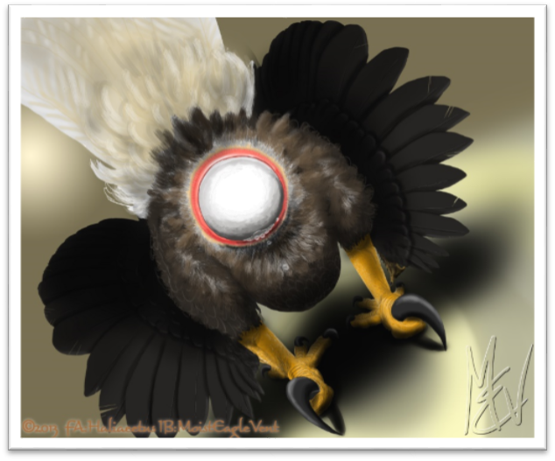

WARNING! WARNING! WARNING!
This is an adult story (readers 18 years and older only please) and contains acts of forced and consensual sexual intercourse between humans transformed into anthropomorphized birds.

Keywords for the series: Forced transformation, imprisonment, feral, anthro, forced sex, bondage, rimming, oral, cloacalingus, fluids, consensual sex

©2013 by M. E. Vehnt aka MoistEagleVent
DO NOT COPY OR POST ELSEWHERE WITHOUT EXPRESS PERMISSION

Mark woke up in a new room. White walls... a stainless steel sink attached to a wall. Instead of a toilet, there was a stainless steel sheet on one wall with a trough at its base and a large, screened drain hole. Then there was the door with a slot and peephole, and the camera apertures in each ceiling corner. There was no bed, just a padded circular depression in the floor. The padding resembled memory foam and conformed nicely to his new body. When he awoke, his head was sprawled out in front of him, his legs under him, like he was laid down carefully but quickly.

Mark vaguely remembered being fucked. He reached his head back and looked under his tail. He reached down with his hands and felt around... the vent was there and his belly was damp like he’d been cleaned up hastily. He stood up slowly, shakily. “Knocked out and knocked up... who knows how many times in one day” he thought to himself. His head pulsed from standing up and he began to lose consciousness for a moment... then his blood pressure returned and his vision cleared. There was food in the door again... this time it was a whole raw salmon with part of the side filleted open exposing the deep orange flesh. Mark knew his sushi and this was primo stuff!

His beak watered at the sight. But he had to take care of something first... and how to do it? There was no toilet, but this trough thingy on the wall looked like the right spot. Mark faced the wall and started to try to squat down and push his butt down between his legs... but that was going to be messy. Then he turned around and squatted a little, raising his tail. That felt natural. He let nature take over from there as he spread his belly feathers, clenched his vent a little, then pressed with his abdominal muscles and splurt a pressurized stream of white liquid against the stainless steel wall. “That’s better” he thought as he stepped away and an automatic cascade of water flushed the wall clean.

Mark turned to that salmon. His beak and nares watered in anticipation and he swallowed some juices in his mouth. His gut croaked in anticipation of a meal, his stomach juices began to churn. He wasn’t sure whether to stand on this fish and tear it up... which would be very messy in this room. He felt very birdlike but still had a desire to be fastidious. He daintily picked up the fish with his beak, head first. He bolted his head forward and back a few times and flipped the fish up into his mouth. “Awww.. fuck it!” he said to himself and he bolted one more time so the head was in his gullet. He wasn’t grossed out by the faint fishy odor. Indeed, the fish felt cold, wet, and delicious in his mouth. He nommed it slightly with his beak and felt it slide down into his esophagus. The fish slid down into his crop. Then he felt the urge to extend his neck a bit, which lifted the fish up a little and collapsed his lower throat. It was a weird feeling as the fish began to slide a second time down into his body and disappear from sensation. As the fish bottomed out in his belly, Mark felt very satisfied... a warm glow came over him as he washed his beak and hands in the sink and settled back into his nest. He preened his feathers, for a while and then napped with his head on his back feathers... his wingarms folded to his sides, hands tucked under the feathers at the sides of his breast.

Mark napped off and on for hours and at some point the lights faded lower and lower and went out in a simulation of evening. He slept solidly all night long. Finally he awoke and sat in the dim light feeling his cloaca about to burst. He slowly got up and relieved himself against the wall again just as the lights reached a normal daytime intensity. After he emptied himself, he felt curiously plump still. He felt his belly with his hand... it was similar to how a huge meal might have felt when he was a human. Actually, it seemed bigger. As the day went on, Mark grew concerned because this feeling of fullness was not subsiding. Despite shitting repeatedly, his abdomen felt more and more tight and full. As the lights dimmed that evening, Mark realized with horror what was happening. The round fullness in his belly had hardened. He also felt his vent loosening... it was taking more effort to hold his droppings in. Despite being barely able to hold in his urine, he had an increased desire to drink too and felt like he had drunk gallons of water that day. He barely slept that night... just feeling that sickening bulge smolder there and fearfully wondering what would come next.

As Mark sat in the dark and felt the approach of morning he began to feel the urge to defecate. But, no, this was something different. He waddled to the wall and lifted his tail but he immediately regretted that as the hard egg pressed against his insides. Instead he had the urge to drop his belly and hunch slightly. Contractions came over his insides every minute or so and he would slowly exhale, gasping quietly as the egg moved down a few millimeters at a time. His vent was stretchy and compliant, but he didn’t feel ready to press hard... the egg was still too high. He waddled back to the nest where it was soft and warm.

Soon Mark’s tail pulsed and ached at the base and he could feel cool air as his insides pressed out through his vent. He tucked his head between his legs to see what was happening. The scene was amazing, uncomfortable, yet sort of hot at the same time. His cloaca had pushed out through the stretched ring of his vent. The vent lips were stretched to the point he felt they were going to tear. The egg was white... and it was about ⅓ exposed, partially shrouded in red, pulsing membranes. He began to feel more of an urge to press now instead of just going with the automatic contractions. With each press and groan he gave, the egg moved a few millimeters. Warm mucus dripped down around the egg and dampened his inner thighs. Mark could feel the egg moving bit by bit but it seemed to be taking forever. There were some sharp pains but also some satisfaction each time it moved, like taking a gigantic dry dump. Then right when he felt like he was going to burst, he felt the egg start to slide faster. “OOOOOOOOOHHHhhhhhh....” he churred out as he felt the egg slip down through his vent and flop into the nest, rolling against his left foot. Mark stood there a moment, breathing heavy and gingerly winking his stinging vent. It felt very good to be free of that load.

In a few minutes, Mark opened his eyes and turned around to examine his unholy offspring. The egg was as big as a small watermelon. Mark contemplated that as he massaged his sore throbbing vent. “I guess I better sit on this” he said as he folded his legs under him and rolled the egg back and forth between his tarsi. His concave, feathered belly fit around the egg nicely and it felt soothing to brood it. He napped most of that day, pausing only once to eat another fish that had appeared while he napped. When he awoke the next morning, the egg was gone. Mark was sad that the egg was gone and felt more lonely than he had ever felt since his ordeal began. Although not very interactive, that egg was another life and he felt good caring for it. As the day went on he felt another egg form and he laid it the next morning. It, too, disappeared the following night. After that, he felt no further eggs form and he spent the following days alone, becoming more and more quiet, depressed, and hopeless about his situation. There was nothing to do except eat, shit, sleep, and for a brief span of time, lay eggs. He was curious about the huge eagle, probably anthroid like him, that had copulated with him. He worried about his friends and family, wondering if they were looking for him. He enjoyed his new body but realized that his life, as he knew it, was over. He wanted answers but had no way to get them.

Mark scratched a mark in the paint of the wall with his talon... a tally mark each morning he awoke. It was on the 14th tally that things finally changed.

