Making of a Burd
Part 2: Doing Burd
By M. E. Vehnt
August 15, 2013

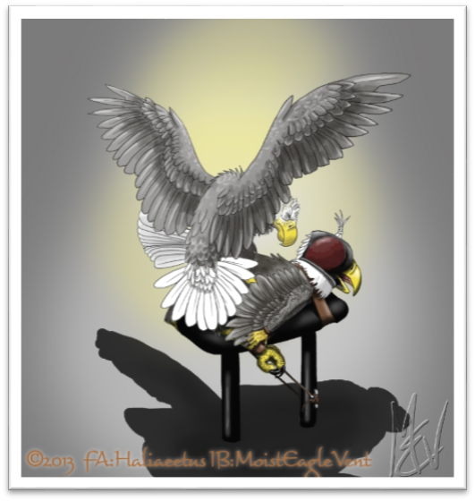

WARNING! WARNING! WARNING!
This is an adult story (readers 18 years and older only please) and contains acts of forced and consensual sexual intercourse between humans transformed into anthropomorphized birds.

Keywords for the series: Forced transformation, imprisonment, feral, anthro, forced sex, bondage, rimming, oral, cloacalingus, fluids, consensual sex

©2013 by M. E. Vehnt aka MoistEagleVent
DO NOT COPY OR POST ELSEWHERE WITHOUT EXPRESS PERMISSION

Mark slowly drifted back into consciousness... he felt floaty. It was dark, even though he was pretty sure his eyes were half open and dry. He blinked a few times to reassure himself that his eyes were indeed open. He could hear someone breathing behind him and he could see a hint of dim light through some seams around his beak. His head was in a large helmet or hood, with a leathery smell but his beak was free to open and close. The air was cool, and he could feel it blowing softly on his beak and, oddly, on his backside. As his sense of orientation returned, he felt like he was laying on his belly on a padded table with his chest strapped down and his ass in the air, slightly higher than his body. He tried to move his wing-arms and pull up his legs but they were strapped with what felt like leather restraints. “Hey!” he screeched, “What’s up here? Hey! Who’s in here? What’s going on??” He felt someone lift his tail and insert a warm, lubed, gloved finger into his cloaca and probe around. “What the FUCK?!! You can’t do this!! I have rights!” Mark shrieked. There was no response. He felt the presence of a warm body behind him... and feathers. Mark thrashed against the restraints but found that he didn’t have much stamina. it could have been drugs, but being strapped down limited his chest from swinging in and out, which was how his new bird body breathes. Pretty quickly he was panting hard with his yellow beak open and his soft, upturned belly and vent pumping in and out with each heave.

The unseen burd placed a foot on the bed on each side of Mark. Mark could feel the hot scaley skin against his flanks. He heard large wings flapping slowly as the burd lowered its belly down to Mark’s back. He could hear a deep excited sigh with each wing flap and the tarsi (lower legs) that gripped his sides began to thump up and and down a bit as the burd positioned himself carefully and excitement built. The toes clenched then and the balled up feet press firmly into Mark’s love handles. “Oooooooh man... nooooooo, please, noooooo!” Mark moaned nervously. He had yiffed in a fursuit before and this reminded him a lot of that. He was disturbed, but also very excited now. Whatever this thing was that was about to fuck him, it knew just how to turn him on. It was pressing into some erogenous zones that Mark didn’t know existed. His eyes rolled back with the pleasurable tickling and he kicked his legs a bit in the restraints. As his arousal increased, Mark instinctively fanned out his belly feathers and raised his tail up and to the right, clearing the path for mating.

The cock that climbed upon began to chirp in a voice similar to his... short wailing chirps. Mark felt the air from this mounting bird’s wings blowing his feathers around... he felt the tail pressing and swishing back and forth against his right rump... then work its way down around to his belly and vent. Mark felt hard... but he didn’t have a cock anymore. Instead, his vent unpuckered, the lips thick, moist, and hot, wanting the kiss of another bird. Precum collected on the lower lip and dripped in clear strands to the floor. The searching bird’s vent found his and excitement shot like an electric charge from his ass through his body as the hot membranes kissed. Mark can’t help it... he shakes, moans in a high wail, and cums, pressing back against his mount, feeling the juices slather around as the two exposed cloacae slake and grind together. He panted and huffed as he felt the mystery bird’s tail feather swishes get firmer and shorter, firmer and shorter, it’s chirps growing higher and quicker, finally culminating in the bird leaning its vent in hard into Mark. Several things happened at once then... there was the tail fanning and termoring on Mark’s belly which tickled very pleasantly. There was spasming and clenching tarsi on Mark’s sides, grinding in and making him arch his back with pleasure. And there were quaking vent lips which tickled him better than any lips had ever felt on his cock, followed by a warm filling sensation as this other burd’s spunk filled Mark’s cloaca.

Mark panted for a few moments... then asked quietly “Did you guys turn me into a bird just to fuck me?? What kind of sick bastards are you? That felt really good, but what the fuck? Take this hood off and show yourselves! Tell me what the hell is going on! I can handle it.” The burd above him grunted low and lifted his ass off of Mark’s, then hopped off with some wing flaps to the floor. There was another fingering of his cloaca and he heard a satisfied, analytical “mmmm... mhmm.” A few moments later he heard someone flick their finger against a syringe and he felt a sharp prick in his thigh. “Oh fuck! Not.... ag... ain.....” Mark mumbled as he lost consciousness.

