Making of a Burd
Part 1: Making Burd
By M. E. Vehnt
August 8, 2013
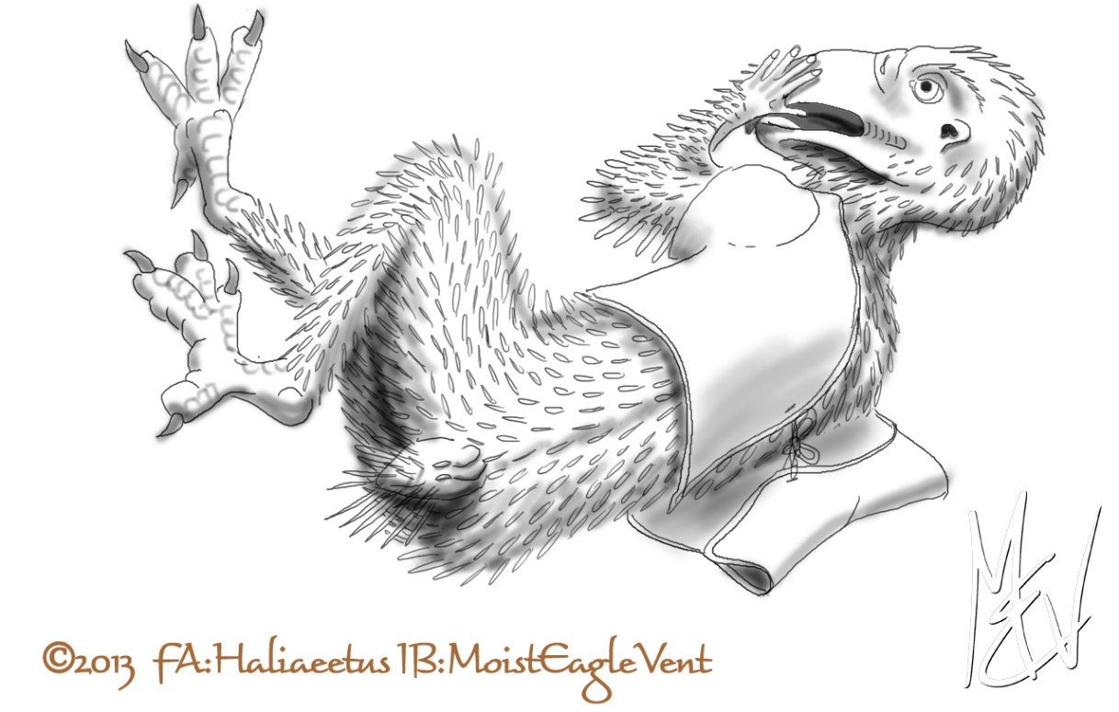

WARNING! WARNING! WARNING!
This is an adult story (readers 18 years and older only please) and contains acts of forced and consensual sexual intercourse between humans transformed into anthropomorphized birds.

Keywords for the series: Forced transformation, imprisonment, feral, anthro, forced sex, bondage, rimming, oral, cloacalingus, fluids, consensual sex

©2013 by M. E. Vehnt aka MoistEagleVent
DO NOT COPY OR POST ELSEWHERE WITHOUT EXPRESS PERMISSION

Mark had a hell of a time at the furry party. His head was spinning from all the drinks. “Wow... this is worse than my usual drunk!” It felt like he had a mouthful of sand and he could barely swallow. There was a dull ache in his brain and joints and the feeling of millions of needles behind his eyeballs. He opened his eyes and the world was rotating slowly back and forth so he closed his eyes again. Then his brain caught up with him... “this isn’t my hotel room!”

It was quiet except for the whir of some ventilation. “This smells like a hospital. What the fuck happened last night?” Mark said to himself. He opened his eyes again and the world was spinning a little less. There was a fold-down bunk attached to the wall and a sink and toilet on the opposite wall. The door out of the room was solid steel with a tiny peephole for looking in... not out! There was also a sliding metal slot on the door for passing items in and out. The slot had a square plastic container in it. Soon he noticed a dark black triangle at the top of each corner of the square room, probably closed circuit camera fixtures.

“Oh shit!” Mark exclaimed, “This looks like a jail cell. What sort of trouble did I get into!” He thought hard. The last thing he remembered was having drinks with other people in fursuits. It was a party at a pub just for furries. He had done the responsible thing and booked a room in a local hotel-- this furry party happened regularly and it had a reputation for being a wildly fun time. He didn’t know everyone there but he was having fun dancing with some guy in a cute eagle suit. He’d never seen that fursuit before. None of his friends knew him. The guy in the suit didn’t say much but he danced well and hugged and cuddled nicely. Moreover, his suit was the most realistic that anyone had ever seen. Mark’s fursona was a bald eagle but he didn’t have anywhere near the detail of this suit. The feathers seemed real and each wing-arm ended in yellow-skinned/scaled human hands, hands that were warm and supple as they stroked Mark’s sides and neck. Mark didn’t make a habit of allowing others to buy drinks for him, but he couldn’t resist after a while... and that’s where things got hazy. He could not remember how he left the place.

His suit was gone. He was wearing an unlabeled hospital gown. “Maybe this is some sort of jail sick room? But I don’t feel anything other than a hangover” which by now was starting to clear with the shocking sobriety of the situation.

Mark slowly gathered himself up and got several drinks of water from the faucet. The sink was situated in a solid metal counter and bolted to the wall with no exposed plumbing. He was getting very hungry as his nausea began to subside. He looked closer at the door. He tried to open the sliding hatch but couldn’t and he couldn’t see anything through the peep hole except light. He picked up the plastic container, which was warm and heavy. He popped the lid off and found it filled with scrambled egg. “Hmm, this must be breakfast” he mumbled to himself. There were no utensils but he was hungry so he ate it with his fingers. It was bland and unseasoned, but hit the spot. He followed it with several big slurps of water and then laid back down on the bench, feeling fatigued with the activity. He could have spazzed out and yelled for someone... but he knew the drill, it would do no good. They would come and get him when they’re goddamn good and ready. He laid back, feeling a little cold suddenly. He pulled the covers over him and curled up, shivering.

SHUNK! Mark was startled awake by a metallic noise in the door. It took him awhile to remember where he was and he was reluctant to open his eyes for the pain behind them. His arms and legs felt weird... heavy and prickly. He had no idea how much time had passed and he was starting to freak out. He opened his eyes and was startled to see that the room had changed. It was the same room, but the white walls seemed brighter and the edges and textures of the surfaces were too intense. He felt like he had just drank a Mountain Dew and a pot of coffee as his heart raced and he felt very cold... goose bumps on goose bumps. He opened and closed his eyes several times staring at the ceiling and then he looked to the door and saw some pills in the dish. He pushed the covers back and looked at his arms and hands. What he saw made him scream in horror. There were bluish pin-like growths coming out all over his arms, with particularly big ones coming out of the outside edges of his hands and arms. They... were part of him. They looked like the growing feathers he had seen on young chickens at his family’s farm growing up. His heart was pounding audibly and he felt a wave of terror and adrenaline surge through him. He kicked the covers off and found that his whole body was covered in these pin feathers. His skin was becoming wrinkly and soft... all except his bare feet and hands which were developing thick yellow skin. His feet were also elongating and his toes spreading apart... except his smallest toe which seemed to be shriveling up. His hands were still basically the same except for the thick yellow skin and darkening nails. Mark was panting and gasping while taking this all in.

“AAAAAAAAaaaaaaaaa.... !!!” he cried. “What the FUCK is happening to ME!” It hurt to brush or strike the growing feathers, which seemed to be growing longer as he watched. He wanted to tear this stuff off but something stopped him. Some of the hesitation was not wanting to inflict pain and... but there was a growing desire to preserve and care for this new flesh. It was a strange new sensation... wanting to poke and examine these feathers with his face, like his life depended on it.

His face! He had no mirror so he couldn’t see what was happening. But his eyes felt farther apart and his nose and jaws seemed elongated. He looked down at his pillow and saw all of his hair lying about. ALL of his hair! Mark’s breathing hastened and he whimpered as he pawed at his head with his hands. “Oh my God! Oh my God! Oh my God! Nooooooo!” He began to sob, very confused and hoping that this was just a scary dream. He tried to get up but as he did so pain shot through his feet and legs. He fell on the floor and a fresh wave of pain swept his joints and body. “ARRRRRRGGGGG!” He moaned and twisted on the floor as the pain wracked his body... he could feel his bones surging and twisting and reshaping. “AAAAAAAAAAAAA!” he screamed and convulsed.

A distorted electronically-altered voice came over a hidden speaker “TAKE YOUR PILLS! THEY WILL STOP THE PAIN!”

“Who are you!” Mark shouted. “What the fuck have you done to me?!”

There was no answer and another wave of pain shot through Mark’s body... starting from his toes, shooting up his legs, hips, spine, neck, through his forehead and down his muzzle-like face... then sweeping back down to his chest. He tried to shout to his captors again but he could only shriek out “KAAAAAAaaaaa!!!” He wasn’t prepared to ask any more questions and squirmed his way over to the door. He could barely get his face to the pan in the door and instinctively pushed his face in and snatched up the large pills in his muzzle and swallowed them whole. The sink was full of water already and he threw his head in, closed his mouth, and bolted it back spattering water down his front and onto the floor. The gulp of water was delicious so he repeated this three more times until another wave of pain and nausea swept him and he fell to the floor moaning.

His vision remained clear, painfully clear. He flailed his arms and threw off the backless hospital gown and looked over his body as the wave of pain subsided. Down was emerging everywhere and drying into a fluffy white layer. The pins were now maturing into contour feathers and he could see the colors of his new plumage taking shape. It looked like he was going to be very darkly feathered. His feet were very bizarre... no wonder he couldn’t stand! Nothing was recognizable now... the toes were replaced with three large toes in front and a large one behind. Each one was tipped with a big black sharp talon. The body of his foot was stretched out and distorted, narrowing into the lower part of a bird leg. His thighs were thickening and shortening. He stretched his right foot out and clenched his new talons. Maybe it was the drugs... he felt a little floaty and euphoric now and started to laugh out loud as he opened and closed his toes. It reminded him of the last joint he smoked in college... like his toes were disconnected from the rest of him. He laughed so hard that he doubled over on his left side, his foot stretched out into the air.

He looked at his arms and they too felt strangely separate and yet he was controlling them. They were now completely feathered in dark greyish-brown with long flight feathers maturing from the tips and trailing aspects. “Hooooolllly SHIT! What the hell! Can I fly now??” Mark thought to himself. “Oh man, whatever the fuck I took, this sure is one helluva dream and I hope I get to fly before I wake up!”

He brought his hands to his face. His muzzle was even bigger now and turning yellow. It felt big but not heavy... sort of like when he had his wisdom teeth pulled and the dentist numbed his whole face with Novocaine. His hands felt his face and brought shape to his mind of what was happening. The muzzle was actually a huge curved beak with a sharp point. The beak was smooth and hot and his nose was gone... replaced by a pair of nares set in a fleshy pillow at the base of his upper beak. He put his fingers in his mouth and found that the beak was sharp on the edges from about halfway out to the tip. His tongue was thick and dry. He stuck his tongue way out and he could see it with his eyes! It was long and he could push it way out. This triggered another round of screechy laughter and Mark fell onto his back with his eyes closed, shaking with belly laughter.

Mark suddenly felt very itchy on his back. He rolled onto his chest and whipped his head around and grasped at his lower back with his beak tip. He preened feathers there for a few seconds and then stopped and said out loud “What the fu--??” How was he able to reach there with his face?? And he saw that he had a handsome white tail of 12 huge feathers. The itching returned and he didn’t give a shit about the bizarre changes... he had to preen those feathers and peel off all these itchy pin feather sheaths, which were now breaking open all over his body. He furiously pinched and picked and ran his feathers through his beak, finding muscles and positions to his body that he never dreamed were possible. After an hour of feverish preening he began to calm... he stood up on his muscular bird legs and stretched upwards. He stared down at his talons as a wave of goose bumps swept his body from his head to his toes. His head feathers lifted... then all his feathers erected from his body so that he was flared out in a huge fluffy mass. He shook vigorously and flapped his wing-arms. As he flailed his wing-arms the whole mess of hair, skin, and feather particles stirred up and blew around the room like snow. He slowly lowered his body off his toes down onto the main pads of his feet, and his feathers smoothed back down.

He looked down his wings and hands... then down his chest, which had puffed out now into large pectoral muscles and keel-shaped shaped chest. His fluffy abdomen bellowed in and out in opposite rhythm from his keel as he breathed in and out. The feeling of breathing had changed now too... as he drew air in it rushed into his belly and as he breathed out it seemed to puff into his chest and some back out through his mouth. He felt light and airy inside. He loved his stocky muscular look and his tight, concave belly. His stout softly feathered thighs and shins were also pleasing... but there was something missing.

His beak dropped open... “Where...is...my...dick?” he said out loud in a high screechy voice. He slowly reached his beak down between his feathered thighs and probed around... nothing there. He fanned his belly feathers out for a better look and reached his hand down to feel around. There was one hole... ONE HOLE. The lips were fleshy and oriented horizontally. His mind flashed back to those chickens he saw as a child on his family’s backyard hobby farm. “Yep, just like a chicken butt” he thought to himself. He pushed his fingers inside the lower rim of his new vent and felt around. It was hot and sticky. It tickled... pleasantly. So he pressed out a little, causing the outer part of his cloaca to pooch out around his fingers. Fascinated, he forgot about the cameras in the corners and reached in a little deeper with his hand. It felt good to tickle his insides, especially when he rubbed the area just inside the lower lip of his vent... He tightened muscles like he used to make to flex his hard cock. Instead of any cock flexing, he felt the floor deep inside his cloaca contract upwards which forced the lower lip of the vent to roll outward and expose some red, glistening membranes... membranes that were very sensitive and slippery. “Oooohhh... that feels interesting!” he said to himself. He moved his crotch up and down against his hand and, soon, hot precum drooled out and made it even more slippery. “UUUMMFF!” he grunted... and he flexed his tail and began to bend up and down at the hips and knees, rubbing his hand with his everted vent. He found that he could pucker and unpucker his vent too, moving those membranes in and out. It really didn’t take him long to climax since this was all so new and hot. “HHMMMPPFFFF!” he groaned as he pressed in one final time and his tail spread and shuddered... and he orgasmed, spurting thick white burd cream against his hand. He stood there panting for a moment, smearing the cum around his winking vent and slathering his soft down and belly feathers. “Wow... I didn’t realize that burd sex could be so hot. No wonder those roosters were so randy in our chicken yard!”

Suddenly there was a thud in the unseen corridor behind the door. Mark quickly reached to the sink and rinsed his hands off. He took some toilet paper and wiped his messy crotch, but there wasn’t much time. Then he noticed that the ventilation had started blowing harder... and there was a sweet smell in the air. “What the...” he said and the world started to spin. “Oh, fuck!” Mark said as he toppled over, bouncing off the bed and onto the floor. “What are they going to do to me now?...” Mark thought. The last thing he heard was his own raspy moans as his eyes close and the world faded to black.

