Not All Angels Fly on Feathered Wings
By ModestWold
Well, I found myself walking the road. And it was the road I finally chose to go by myself. But I made light of it, despite how much it broke my heart. I know I chose this, but it felt like I was here because of things beyond my control.
The grey suburb of my wasteland county was now far behind the overgrown, tangled brush, covered by the golden leaves that autumn’s exhausted trees had shed. My shoes were damp from the viscous dew of that grim field. Drops from the grey skies became annoying squatters in the refuge of the foliage. those piles of leaves were thick. It was enough a chore to walk through.
I could have been in a rush, or on the contrary, holding back. It all felt the same. I felt just as stagnant as I did before I left my doorstep. Maybe I didn’t know what I was doing no matter how I felt.
I knew I was right about the world outside my home. Nothing to look forward to. Just a notion of grey streets, with ominously empty rooms, and careless, dark figures. The field was just a miserable gap between the edge of those things and the horizon ahead. And now, even anything I had going for me behind the walls of my home was disintegrating.
I grumbled as the rain thickened. The zippers on my backpack jingled as I dragged through the deadweight on the field. “I always end up hating fall,” I said to myself. I had gotten pretty good at talking to myself over long, lonely periods. “Every year, it’s the same damn thing. ‘this year, I’m going to love October, right up to Halloween!’ And what do we have here? Just the same as last fall, yay! I’ll say it again. I always end up hating fall.”
I did love fall, and especially Halloween. But the crap I was treading through wasn’t the reason I wound up resenting the season. If I wasn’t alone, this would be a celebration of the season. They tell you that your twenties are supposed to be the prime of your life. But they also say happiness is worth nothing unless shared. I was in my mid-twenties with no local friends and a strong belief that I was unworthy.
I thought I skipped a beat while I was deep in thought, because dead matter under my feet was thinning. It was even drying. But then the leaves on the ground became green. The grass was growing livelier. The ground was spongy with lush, emerald-green moss patties. I stopped. Song birds sang. Their calls ruminated in the space around me.
“What the hell?” I whispered.
I looked up. The light grew very radiant. My eyes widened as I saw the canopy above me. I found myself immersed in an absolutely fantastic forest. I shouldered my bag and gawked at the golden light filtering through the lush roof of lime-green leaves. The trees had beige, porcelain trunks with a faint, green glow. I could almost imagine them gently moving like soft skin. Brooks babbled in the distance, joining the resonating birds in song and rhythm. I closed my eyes and felt the cool, moist air on my skin. I parted my lips and took a deep breath. There was a feeling of peace that I had forgotten years ago.
“What are you doing here?” squeaked a young voice behind me.
My eyes widened. A girl, maybe between the age of ten and twelve confronted me, arms crossed. The little thing was covered in soft, brown fur. Her ears were quite the size. She had little snout with an upright pink nose. Everything inhuman about her just screamed, “bat”. Even bat wing webbing on her arms and a little “wick” of a tail.
But Something was very human about her, besides her shape. Maybe she seemed a little too human to me at that moment. Her eyes were very gentle with deep, blue irises, and her smile lit up the space between us. It was like she was happy to see me, and just because I was there with her. And she looked very comfortable on top of it.
Two “wonky”, golden-orange earrings hung from her ears. They were shaped like ghosts, with festive faces. Her shirt was faint but vibrant green, almost glowing like the trees. It was ruffled at the waste, with two puffed, short sleeves and a little “V” in the center of the collar.
She wore plain shorts, colored a very lively, rich brown.
She put her hands on her hips. “Are you just going to look at me or say something?”
“What’s it to you kid?” I said. I planned to answer as few questions as possible, especially for someone so young.
She sighed and rolled her eyes, still smiling at me. She cocked her head and narrowed her eyes, with a face that spoke, “come on, work with me.”
“I’m just trying to get somewhere… And, well, now I’m here somehow. Where am I?” I responded. “And who and what are you supposed to be kid?”
“Hmph.” She said. “I don’t have to tell you any of that, mister,” she responded with a cocky expression and a wink. “But my name’s Dayna,” she said, folding her hands behind her back.
“That’s great buddy. But I don’t think I’ll have to remember that too long. If you give me a hard time, your name is going to be ‘Little Miss ‘it’’. Sound fair?” I said.
She giggled. “I like your sense of humor,” she said. I rolled my eyes at her. “No, really. I do,” she said kindly.
maybe I wasn’t really trying to be rude when I said that. It was a crude thing to say, but I had a crude sense of humor, and I had forgotten that some people enjoyed it.
“Thanks, I guess,” I said, awkwardly breaking eye contact. “Look, I just have someplace to go. So, can you point me out of here?” I said with a sigh.
“I might be able to get you there quicker,” she said. “There’s a catch though,” she said with a cocky expression.
I raised an eyebrow and cringed a little. “okay little miss ‘It’ you’re already agitating me. so, I’m gonna pass on that.” I said, stepping back.
“Well, anyway, I don’t know why you’re here, but I’ll help… under a condition. If you don’t meet it, you’re on your own. And by that, I mean to find the way back to where you came from, because you won’t be welcome here,” she said.
That last bit was a little pungent to me. “Okay... Condition?” I asked.
“There are very ill people outside this place. They bring sick intentions without knowing it, and I don’t want this place, or me to have to deal with them. But if you’re not a toxic person, I’m very alright with you.” She said. She gave me a wide smile, showing her little fangs.
I laughed. “Sweetheart, I think I fit the definition of, ‘bringing sick intentions.’ And I do know it very well. So, this was weird but I’m just going to find my merry way out and around this place, if I even can.”
She sighed. I didn’t faze her though. “So, what’s in the bag?” she asked.
“None of your business. That’s what’s in the bag,” I said. “But if you knew, you’d stop talking to me and tell me to get the hell out of here.”
But she just narrowed her eyes again, tilted her head down, and giggled softly under her breath. “Mmmmm, I think I’ll be the judge of who you really are.”
“What? You want to get a cup of coffee? Talk about life?” I snapped. “Kid, you seem sweet, but you’re naïve. And you need to mind your own business.”
“Just relax,” she said, walking up to me. “And humor me.”
I would have expected myself to just turn away. But as much as it embarrassed me, I didn’t want to. Her kindness kept me where I stood. I didn’t even sigh. I just waited for whatever she was going to do. I felt her tiny palm on my chest, and heard her take a deep breath.
It’s funny. Even though we know where our thoughts and feelings manifest really exist, when you feel someone touch us above the heart, it feels like they’re giving affection to our very being. But that was just the least of what I experienced then. It was like she was stirring within me. My face went numb. she saw the thoughts and feelings I had brought with me first hand. And Dayna was feeling them as she searched.
She made me feel that she understood what she saw. she slowly traveled parts that I felt unfamiliar with, and brought me along with that experience. And for the first time in too long, I remembered what they felt like, despite being so out of touch with them. I thought they were just my good qualities, which I had learned to deface. But in hindsight, they were what I had to live for. I didn’t know exactly what she had just learned about me, but I was certain she knew that much.
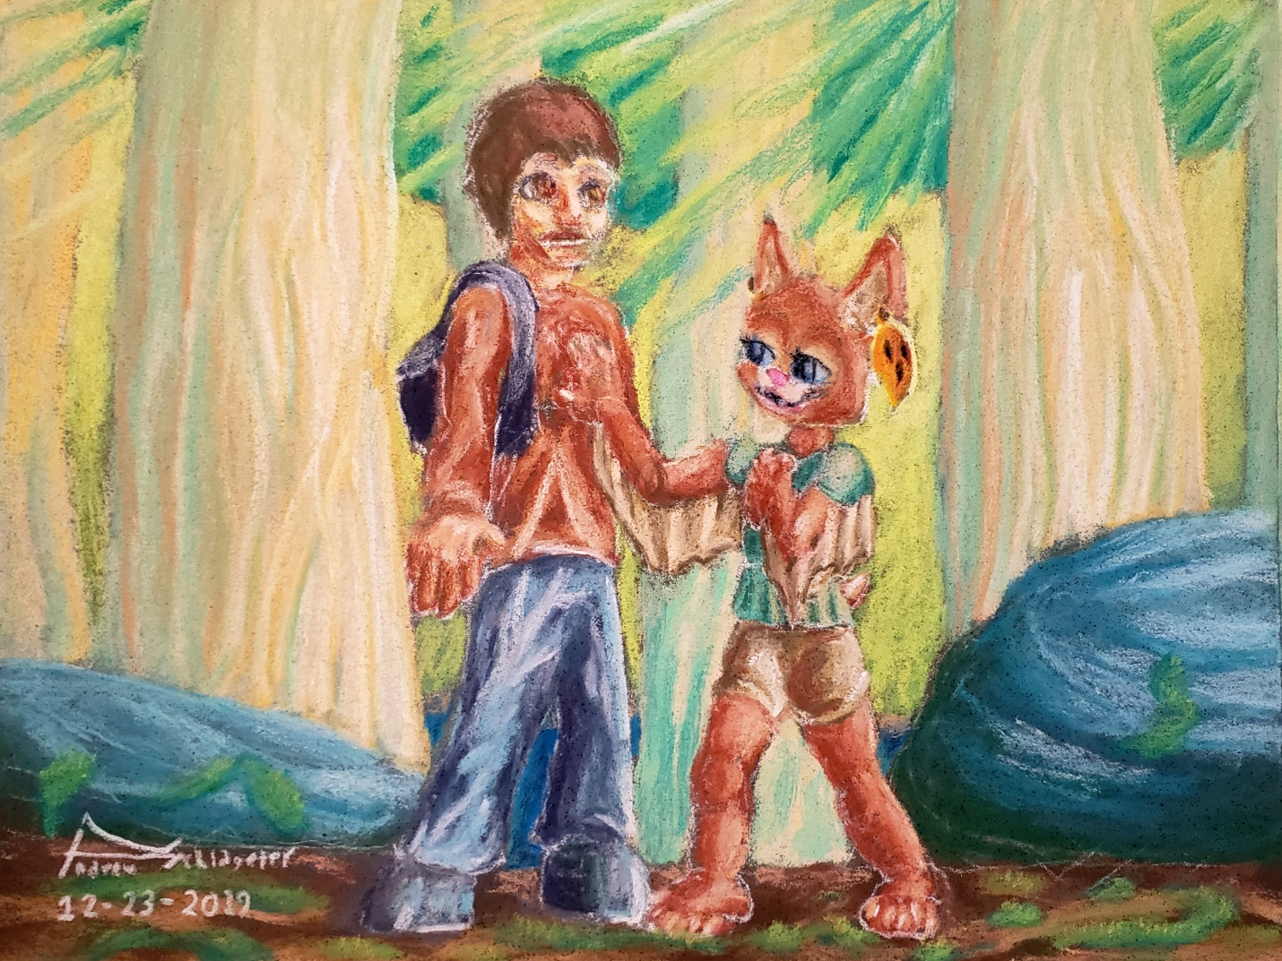

“Ok,” Dayna said as she took her hand off of my chest. “I know why you’re here.”
I shook back into focus. “Pardon?” I asked.
Dayna grabbed my hand and aggressively pulled. “come on. It’s late. Don’t you wanna rest a bit?”
“Late? What are you talking about?” I said. The bright light began to turn dark and teal. “Oh lord,” I cursed. But the forest took on a more intense life. The trees pulsed with green glows, and looked like soft ivory.
“Yep. See? It’s late. Now come on.” She dragged me. I didn’t know this little, batty, annoying thing. But I followed her. She looked over her shoulder and gave a wide grin. “You’ll spend the night here,” she said.
“I don’t know where I am but I’m not in freakin’ Kansas anymore,” I said to myself. “I’d rather follow a yellow brick road. Not little miss ‘It’ here.”
Dayna took me to a clearing in the forest with a mossy floor. “Alright, we can sleep on this tonight,” she said patting an emerald moss bed. The pile of that moss was tall enough to be a spongy mattress. But…
“Ok… See, you sleep here, or I sleep here. ‘We’ don’t sleep here,” I said.
Dayna dropped my hand and sat down. “I don’t bite, even though I have these,” she said, showing her fangs in a wide smile. I rolled my eyes.
“Kid, you need to let up. It’s creepy,” I said.
“Just trust me,” she said.
I sighed. I didn’t put up any more of a fight. I didn’t have the energy. And the ground was soft. I put my bag down and lay next to her.
Dayna tried to snuggle into me. “Nope. Nope,” I said, shoving her. “that’s crossing the line by a mile.”
Before I even wanted to say more, she put her hand over my heart again. I sat with that warm feeling. Dayna wore her smile, but her eyes said something else. I saw urgency, worry, and a bit of sadness. I didn’t know what she saw in that earlier moment, but I could see how terrified she was that I wouldn’t let her show me. I don’t think she knew what I was planning, but I could see a devastation of the idea I would leave oblivious of what she thought she found.
“It’s ok. Everything is,” she said. “really, everything is. Just trust me.”
I felt nothing ill. I didn’t know what she was about to do, but I couldn’t deny her that chance. She was a kid, and I couldn’t make her feel powerless. And maybe she wasn’t at all. So, I let her wrap her arms around me and tuck her head under my chin. I held her snugly.
Dayna’s grip tightened as I closed my eyes. I heard her take in a deep breath, and release. I felt so convinced that I was worthless and unlovable. But a creature like her wanted to give me her deepest affections, empathy, and love. All it took to know that was her resting palm above my heart. I couldn’t lie to myself, and I didn’t want to. I really wanted that. I would never turn it away. I wouldn’t even if I felt I still had something to lose or gain in this world. I knew that I needed to humor what would come next.
***
A warmth grew inside my chest and I could see it behind my closed eyes. It was like I was watching from above. a dim-glowing, red pool with sharp, black ridges faded into view. Those sharp ridges combed from the center outward in rings. Tendrils outstretched, cast unmoving in a delicate, shimmering, glassy purple.
Dayna’s appeared next to mine, a perfectly round, brilliant white. Her edges flashed and jittered bright red and blue. Her side stretched toward my edge, and softly separated into rippling, shining threads of the entire color spectrum. She brushed against me. I could feel a sinking feeling in my throat as she did. Dayna was struggling to get past. those ridges put up a tough fight. I felt myself actually whimpering. She was fragile, but determined.
Had I really become so closed off? I used to think of myself as an open book. And I wanted her to see everything behind those constantly outward-moving walls. Maybe I relied too much on someone to breach those walls for me. The ridges still forced to the outside to be replaced by the next growing swell. I held Dayna tighter.
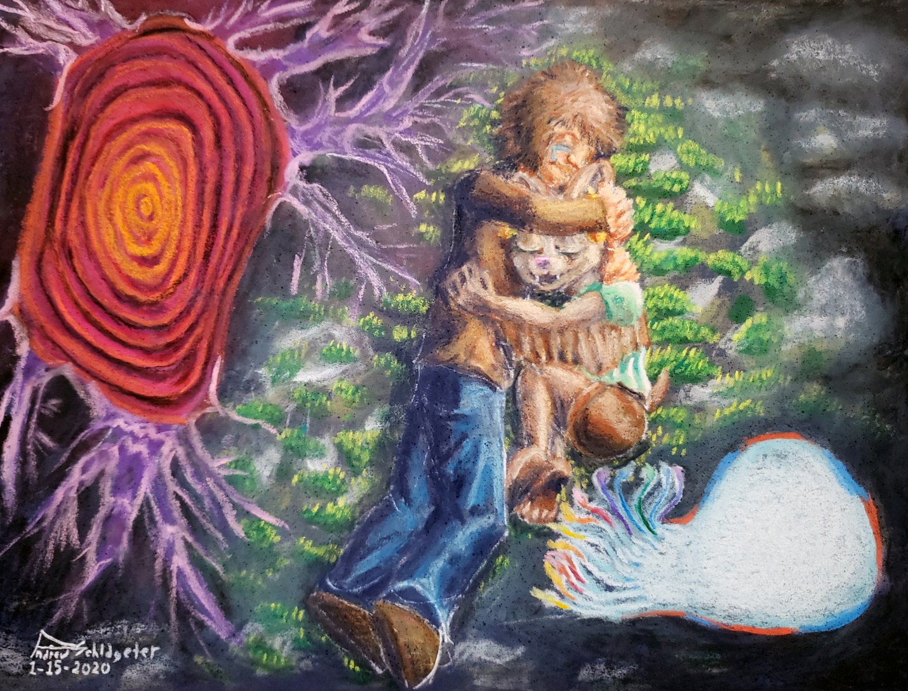
Her colorful fringes stopped and rested securely against me. I thought she was waiting for my permission to enter. I felt so powerless. I had no idea how to actually give her that permission. Dayna nuzzled tighter under my chin. She didn’t even seem inconvenienced. She wasn’t asking for anything. She already had my permission. She was trying to tell me she gave her consent to go inside.
I’d let down the drawbridge, but hadn’t opened the door. I was too prone to begging for support. So now that someone wanted in, I wasn’t doing my part. The door was hard to open, but I still knew that I was still able to. I knew I was about to take that initiative. I cried heavily for Dayna. The fear of her despair turned to gratitude.
Those black ridges began to sag. They thinned and faded to light brown. Dayna squeezed me as hard as she comfortably could. She began to flow around and over those ripples. She rested, and then flashed blue and white, then expanded and traced through my morbidly colored, froze outcrops. Dayna stopped a moment when she reached the visible edges, I felt chills.
“I hope you remember what I find in here, because I can see it with my own eyes. You’re going to explore it all with me. And what we’ll find is just the least of it,” she said.
Vibrant blue rampantly shot over thin capillaries. I may have never seen them without Dayna’s light. Branches thinned to threads, and then swirled and overlapped in millions of directions. There were an uncountable number of channels. Dayna’s light grew brighter as the channels grew thinner and thinner. each channel had even more capacity for that warmth as it tapered. I could no longer distinguish them. Yet I could still feel one pathway separate from another. They crossed over more and more until all I could see was the glowing shape of my body. I couldn’t believe I’d forgotten this much of my capacity.
I was looking at the back of my eyelids again. All I could feel now was Dayna and the mossy ground beneath me. She comfortably loosened her grip. “Have a good night’s sleep, and sweet dreams, ok?” she said.
I held her loosely. I was in shock. Now I had a feeling of safety from something heinous within. What had Dayna gotten me into? Why was she being so personal? Everything she had shown me was something I desperately wanted to forget again. I just couldn’t take the pressure as I grew torn between going as planned or going home. I honestly wanted to throw Dayna away from me and run in panic.
“Settle down,” she said softly. “You have the rest of the night to sit on your thoughts and feelings. You don’t have to do anything until morning. Just stay in the moment and get comfortable.”
“Why are you wasting your time on me?”
“Because I want to help a new friend. Simple as that.”
“you don’t know me. And I promise, that you don’t want to know me. I’m screwed, ok?” I was begging that she’d give up.
“Well, I know you way better than I did. And I wanna know more. So tonight, I’m going to learn even more about you,” she said.
“How?” I snapped.
“Get through the night, ok? Tomorrow’s a new day. You’ll understand in the morning,” she said sweetly. “Now you know how to let your guard down, so don’t mind me. like I said, I don’t bite, even if I look like I do.”
I sighed. I was beginning to give into the idea of “trying again”. I didn’t know if it would be enough to turn me around. This was too much of a reminder of something good. “goodnight kid, whatever you are.”
I vaguely remember my dreams that night. Dayna was there though. Do you know that good feeling you get when you show someone what you’re proud of and they love it? I remember feeling that in my sleep. And I remember Dayna’s face as she saw pieces of my ambitions, values, and even the wildest things I dreamed to do one day. We were beside all the things I had lost hope for, because I felt like my life was souring with age. How I wanted to excel in the visual and language arts and make them my livelihood, or my desire simply experience love and make valuable connections with good people, or how I just wanted to share the best and most personal fruits of my creative passion, just so someone could enjoy them with me.
I remember her eyes lighting up, and her smile glowing. It was strange to me how anyone could find these things interesting. Dayna gasped over them. It was like she’d never seen qualities like mine. I could no longer say that my aspirations didn’t exist. They were there, and I could see them clear as her. And that was going to make this so much harder.
***
Day broke. Dayna was waking in my arms. She gave a soft grunt and stretched. “Good morning,” she said with a smile. “did you sleep well?” she asked, squirming to get upright.
“Yeah. Thanks,” I said, rubbing my eyes.
“Is there anything you wanna chat about?” she asked.
I looked around at the forest. It didn’t have the vibrance to keep me there anymore. And I remembered the grey beyond it. I had a feeling in the pit of my stomach. “I think it’s time for me to go, Dayna,” I said.
“Alright. If you’re sure, then I’ll walk you out,” she said, taking my hand. I was surprised she didn’t put up a fight. But we walked maybe two minutes before we were at the edge of the forest. “Well, do what you need to do, alright?” said Dayna. “I’ll be waiting for you when you come back.”
That sinking in my stomach grew. I prepared myself to look down at the deep-blue eyes of that little soul, and tell her the cold, hard truth. “Look, Dayna-“
“And when you come back, I’ll take the forest closer to your home,” she interrupted. “You know? for a more pretty walk back, with a whimsical companion to walk you back?” She said with a giggle.
“Of course, you know where I live.” I said with a plastered smile.
“I learned a lot about you last night,” she said with a warm smile. “I know where you live, the important things you’ve experienced, the most important people in your life, the kinds of people who will come into your life, the types of places you’ll go, and the kinds of experiences that you’ll have in your life.”
The air felt cold. “Dayna, I really don’t even know what you are, or what any of this was, but you’re an incredibly beautiful soul, and a very special one. And I know that you’ll carry that with you forever. I don’t want to tell you this, but I only have one experience left. I won’t be coming back, because where I’m headed, that’s the last place I’ll ever go Dayna.”
“Well, I know where you were headed, so I brought you there,” she said, pointing behind me. I looked over my shoulder, to see the edge of the woods marking my destination. “Don’t forget your bag,” she said. She held my backpack in her right hand. I went cold in a feeling of shock I had never experienced before. “well take it,” she said, still smiling.
“Dayna… You know what’s in there, right?” I asked, concerned.
“I don’t have to tell you anything, mister,” she said with a wink and a giggle. “I’ll be waiting,” she said, folding her hands in front of her.
“If you know, then you know I’m not chickening out. I promise you that.” I said.
“No, you won’t chicken out. So, go on,” she said.
I had no response. I just slung my bag over my shoulder and walked toward the woods. I didn’t even look back, passing the trees at the edge. I let out a long sigh and walked on.
It took some time to get to my destination. I just pictured that cute face with those big, blue eyes and the tiny little fangs behind its gentle smile. She didn’t solicit a goodbye. None of this made sense. It shook me into panic and confusion. Maybe that was fitting for this moment. Nothing needed closure anyway. I was here because everything stopped making sense to me a long time ago.
And there it was. That sturdy tree. The one with the thick limb, hanging high above the brook where once upon a time, I sat and drew things that I was proud of. To think those things seemed to build something from within me that could have been great one day. That memory was golden, but the spot was just a fossil of that ambition and passion. That time of wondering what I could be some day was destroyed.
My head hung low as I sat and looked ahead of me. The sound of that brook would be the last I would hear. My eyes were heavy as lead. I slowly unzipped my bag. It was time to take out my prepared, good old-fashioned noose. I held the sturdy rope in my hand for a moment. I was actually proud of my craftsmanship. I slid the slipknot up and down and wondered how it would feel around my neck. I traced the loop with my fingertips, then bit my lip.
I looked at the far branch. Tears streamed down my face. How was I going to get up there? The rope was long enough to reach, but it was an impossible jump, and a tricky climb. I stepped under the lowest point of the sturdy limb. But the rope slung above and around just fine. I looked up and started to pull a loose knot together to secure it.
It took a short while to fasten. I still didn’t know how I was going to get my neck into the damn thing. I was put in deep thought, watching it sway. I just thought to myself, “There it is. Everything’s ready. So why the hell can’t I picture myself dangling?”
I looked at the empty loop for a few more seconds. It was almost enchanting. I took my boots and socks off and wandered into the cold stream. But I still couldn’t imagine putting my head into it. I couldn’t even imagine climbing to that branch and jumping off. This was convincingly my final experience. I was fearless about that. But the same thing within me that wanted to give up kept me frozen. And just stillness kept me just standing there. I knew I came here because I’d given up. But I was beginning to wonder what “giving up” really meant. It was all set up, but now I only wanted to sit there. What did “giving up” really mean to me?
I spent about another hour at the bank of the stream ruminating. I was obsessing about dead connections, dead motivation, dead dreams… Just being dead still. I looked over my shoulder at the branch closer to the ground.
I remembered when me and my friends would scale the trees in my front yard, and how I could never catch up to them. I cracked a smile at that. Then I was enticed to climb onto that branch. But I knew I couldn’t climb up.
“well that hasn’t changed,” I joked to myself.
I looked at the noose again. It gave me an obscure idea. I pulled the noose off the high branch, but didn’t undo the loop. I pulled the loop tight around my foot, and used it as a boost up for that other branch. And there I was, sitting comfortably on that limb. I could picture those friends. things had changed. Yes, some were gone because of falling outs, busy schedules, and long distances. But the very few good ones stayed in my life. They loved me enough to stay connected.
I didn’t notice the sounds bellow me beyond my nostalgic trance. The branch snapped. I was terrified that I had broken my drawing hand in the tumble down. It was fine, and I realized that I cared about it a lot about that hand for someone without a desired future in my passions. I sat a long time, remembering all the good things that had come in and out of my life.
I knew that after graduation, autumn would come and I would feel powerless. But I couldn’t picture anything after that. I was used to telling myself that I wouldn’t be ready to move on to my career for years. That I would have to live in Manhattan to have a consistent livelihood to amount to anything. But I didn’t think about how many days were in two years. I was in a bad place, but I had no expectations beyond this autumn. If I lived on, what could happen each day?
Dayna had reminded me that there was so much of myself I had forgotten, but not lost. I was the one setting expectations for myself and who I should be, turning my mind into a constant nag, without having any gratitude for yesterday, or any of the yesterdays before that one. I had myself so convinced that there was nothing beyond my walls except grey and filth and emptiness. And this was supposed to be the greyest place of all. I saw rich, brown soil, emerald green moss, and brook shimmering like diamond. I heard the leaves shifting gently in the breeze above, and the trees creaking. I smelled the musk of the woods, and the fresh water. There was color in this world, and a lot of it.
A few calm hours passed before it was getting dark. The entire time was filled with mindfulness and serenity. The last thing I did before leaving was undoing the noose. But I put the rope back in my bag. I had walked away from the edge several times before. But this time, I had never felt so powerful. I needed a reminder of today, and a bit of a trophy.
It was a stressful walk out of the woods, but Dayna and her forest were barely fifty feet ahead of me. She stood there with a loving smile that said, “I told you so”.
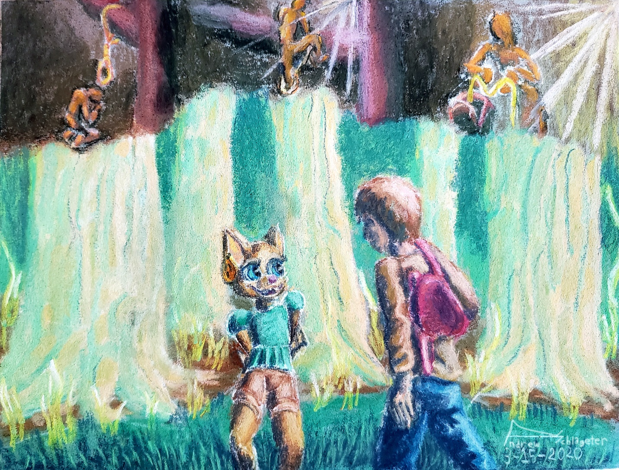
“You didn’t move a single inch, did you?” I asked.
Dayna rolled her eyes. “It’s dark. How about a comfortable place to sleep?” she teased
I just smiled. She grabbed my hand, and we started walking. We came to that same mossy bed. I don’t think Dayna expected me to be open to affections, so she was a little startled when I grappled her into my arms. But how could she be opposed?
“Alright kid, you were right. I came back,” I said. “And like you said, I wouldn’t chicken out.”
“Yeah? So then what’d I mean by that?” asked Dayna.
“I didn’t just walk away from the edge. I actually asked myself why I walked toward it. And this time, I walked away excited to build on myself.”
“Good boy,” she said.
The next morning, the sun shown green and gold through the forest, casting strong beams in the misty air. Dayna and I took our sweet time getting out, enjoying every last moment we had to talk. I told her about what I was looking forward to, and what I loved in life. I figured she already knew. But I knew she wanted to hear it from me.
We stopped at the edge, just looking ahead of us.
“I know it’s not all going to happen at once,” I said.
“There is no, ‘it’,” Said Dayna.
I almost rolled my eyes at her “fortune cookie” response. But she was one hell of a fortune cookie. Dayna looked up at me, waiting for me to respond to that.
“There never will be, will there?” I said. Dayna gave me a wide smile. “That’s something I’ve been doing wrong.”
Dayna giggled. “Well, everyone does that. Even when they say they have a future; they don’t know what that means. But they don’t need to.”
I felt warmth and relief. I skimmed everything Dayna showed me about myself. There was a reason I kept losing gratitude for those things, or why I would forget them. And it felt so freeing to know why now.
“I’ve been telling myself that there’s something to look forward to in my future. I’ll have a chance to exist and function in this world, and live. So, what the hell am I doing not starting now? Right?” I said.
Dayna grabbed my hand and looked up at me. “You’re going home, right?” she teased.
“Yeah, Dayna.”
“What are you doing tomorrow then?” Dayna asked with a smile.
“Yeah, I get it. One day at a time. You can stop trying to be cute now,” I said ruffling her ears. “One day at a time. And it feels good to say too.”
Dayna hugged me. She put her hand over my heart one more time. The pressure of her little hand filled me with a feeling of love. “It’s gonna be a curvy, but busy road. And at some point, it won’t be so lonely.” Dayna looked away a brief second. She sniffled and wiped a tear from her cheek. “I love my life here. I always will. But it gets lonely. I’m gonna miss you,” she said, looking back at me with sad eyes.
“yeah,” I said “I’ll miss you too Dayna. I knew you less than two days, and I’ve never wanted anyone to become a part of my life so much. You’re an incredibly gifted young lady.”
Dayna cracked a smile before drying another tear. “Thanks,” she responded. “I don’t know if we’ll ever see each other again, or hug, or talk. But whenever you think about me, I’ll know, even though I won’t know what your thinking. I don’t know why or how that happens, but it does. So please don’t forget me, ok?” she said. Tears started pouring down her face.
I gave her a tight squeeze. “I’ll think about you a lot. Hell, I know I’m not immune. There’s gonna be so many dark moments ahead. But that’s when I’ll think of you the most. That’s a promise, got it kid?”
Dayna looked up with a smile and eyes that just spoke joy and love. “thank you.” She ruffled her tear-matted fur dry.
“I asked if you got it, buddy,” I said with a cock of the head.
“Yes,” she said with a soft giggle. “I got it.”
I drifted into a sad thought. “Will I know when you’re thinking of me?” I asked.
Dayna slowly slid out of our embrace. She folded her hands in front of her with a troubling expression. “I’m not sure.”
That wasn’t easy to hear. “Well, I guess we’ll find out one day at a time?” I joked. “If I don’t, At least I’ll know you’re thinking about me when I think about you. Deal?” She smiled bashfully. We squeezed the breath out of each other one more time. “It’s kinda hard to forget about a little bat girl I met in a fairytale forest, especially in the middle of a depressing, Upstate New York field on a cold, rainy autumn day. You don’t need to worry”
And then we parted. I looked over my shoulder as that tiny creature became smaller and smaller. Then came the waterworks. I knew that after our profound experience, I wasn’t going to move past this easily.
“Hey!” she called to me. “When you do this right, you’re going to do it wrong a lot! But you got this!”
I smiled one last time and waved before she turned away. She looked over her shoulder and then she was gone. I knew that it was possible I would see her again, but I couldn’t count on that. I found it soothing that it wasn’t truly goodbye. Like she said, she would know when I thought of her. Even as we departed, I knew she felt it.
***
When I got home, my dad had no interest in where I had been. I expected nothing different, so I just sat on my couch. It felt like nothing happened. But I couldn’t make light of that lie. Dayna lead me to the jumping off point. The rest was on me. If she knew as much as she claimed, then she knew that I would suffer. I knew that too. Still, a strong sense of serenity flowed through me, trusting that I could bring the best of myself forward. it wouldn’t happen in an instant, and that was relieving. “Just take it one day at a time.” I told myself to do that for a week.
Then a month passed. I did do it wrong some days. I ruminated. I obsessed about shortcomings. But every day, I told myself to do my absolute one day at a time. It became an easy habit over that month. I learned gratitude from the days I told myself I was falling short. I was beginning to learn that I wasn’t behind. Very few people told me that. The latter was the opposite, and a lot of things beyond my control helped create more nameless expectations to ruminate about. But I would learn how that’s no way to live.
Months passed, and just living became automatic. It was never a goal to work on myself, but I made so much progress. And Things did come in and out of my life my life, for better or worse.
I didn’t aim for the situation that “would make me happy” anymore. And I still suffered. I suffered different intensities for long and short periods. I still excelled in my suffering, whether I appreciated it or not. And I always got back on the horse. I had moved past the idea of “I should be” and left behind the habit of making my choices out of fear. Rather, I connected more with myself and what I wanted to do. That drew to me many good things.
Four years passed since I met Dayna, and I thought about her a lot. I would have occasional fantasies that she was my daughter, or my sister, or at least some important kid in my life. I wanted her to be proud of me. I knew she would be. I never expected what my life became over those years. that was a blessing. I knew how different my life was from my expectations when I was 26. And I couldn’t have asked for a different path.
I could have supported myself doing illustration, but was more successful as a fine artist and writer. One of my most personal projects was published and gained attention I didn’t expect. My artwork made it into several exhibitions, and began to generate more than my bread and butter work. Illustration was becoming more of a hobby.
My fiancé and I met at a coffee shop. We were both regulars. A mutual obsession over mythological sea monsters broke the ice, of all things. We loved our dorky conversations about Scylla and Charybdis, and who’s interpretation of them was the most accurate… Or our favorite prehistoric aquatic creatures… Or the REAL version of kraken. It wasn’t strenuous when we developed feelings and became a couple. When I proposed, I thought I was about to hear an answer I always felt unworthy of. But after she said yes, she told me she was pregnant. I was worthy of making someone feel loved, protected, nurtured, and healthy. I couldn’t have wanted more than that in my entire life. Everything changed when I knew I was going to be a father
I still held onto that rope. I felt it was time to retire it. I never wanted to forget what happened. Why would I want to forget that batty moment? Memories of Dayna almost made it difficult to get rid of the thing. But I thought I should retire the trophy at a moment convincing of how little it mattered that I was a late bloomer, and how much of a sincere, grateful man I had become. I was going to New York to join the Society of Illustrators. I never got around to doing it, and that just shows how spectacularly things didn’t go as planned. I went to Central Park, and found an ash tree. I wore a P-coat and a grey Irish cap. Somehow, this tree just felt right. I brought some scissors to add to the ritual. A few incredibly crisp, satisfying snips, and that moment was ready to be retired.
It was a miserable autumn, grey and rainy just like that day three years ago. Yet, birds sang. I closed my eyes, just to remember Dayna. Maybe I never needed that sweet thing, but I was so grateful that I met her. I knew that she felt me thinking of her, wherever she was. I really wished I could show her my smile.
I listened to the birds chirping. They were so rich. The chill of autumn felt cool and calming. I don’t think I ever would have noticed that when I was younger. And then, the singing grew resonant. The wind was gone, and I could hear the echoing streams in the distance. The light became brighter through the lids of my eyes. I smiled widely and began to shed tears. I could feel cool, humid air on my skin. You wouldn’t feel that in Manhattan.
Dayna cleared her throat. I opened my eyes. She was barely a few wide steps ahead of me, standing on the rich, mossy soil, no longer surrounded by ashes. Rather, I was between lively, faintly glowing, porcelain-beige trees.
Dayna looked shy. “I wanted to check in once in a while. But I knew you’d be doing great.”
She hadn’t aged a year. I dried my eyes.
“Jesus. How long is ‘once in a while’?” I asked.
“I don’t need to tell you anything mister,” she said with a wink.
I smiled wider. With a giggle, she ran up to me with an enormous hug. I held her to my chest. She began to shed tears.
I was happy to see that smile with little fangs as she nuzzled into me. “I don’t know how much you already know, but I have so much to tell you,” I said, looking down at her.
“I want to hear it all from you,” she said, squeezing me. “I’m sorry I didn’t come sooner. I was scared you wouldn’t want to see me after all this time. I knew you’d grow into yourself anyways,” she sniffled.
“Oh lord Dayna. Never be afraid of me,” I said gently. Maybe Dayna had been falling for that same trap she helped me climb out of. This was my chance to bring her into my life. She better damn well know she was worthy of that. “Please pop in sooner next time. I’m gonna have a wife and kid. You’ll break my heart if you don’t meet them Dayna. I mean it.”
“Really?” she said, looking up at me with her gentle eyes. I heard her ghostly earrings jingle in her excitement.
“Really.”
I crouched down to get a tighter grasp on her. My hands brushed past the smooth, leathery membrane of her flightless wings as I pulled her in. I still didn’t have a clue what Dayna was, but as cheesy as it sounds, she was the closest thing to an angel I had ever met. And not all angels need to fly on feathered wings…

